Meeting Dinner, Thursday,22 November, 2018, 18:30

Restaurant:
Kulatak Pilsner Urquell Original Restaurant
Address: Vitezne namesti 820/12, Prague 6, Czech Republic
http://www.kulatak.cz/en/
https://www.tripadvisor.co.uk/Restaurant_Review-g274707-d1896019-Reviews-Kulatak_Pilsner_Urquell_Original_Restaurant-Prague_Bohemia.html

How to get there:
About 15 min walk
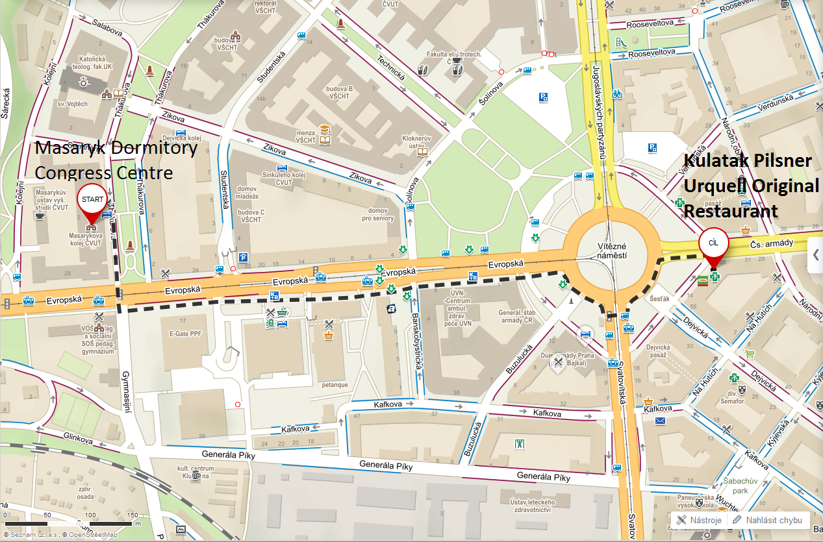
https://mapy.cz/s/3e1Mz

