PSS0 Document of Documents

 | Name | Role/Title
Owner | Stuart Birch | ICS/ Senior Engineer for Personnel Safety Systems, Protection Systems Group
Author | Meike Rönn | ICS/Technical Documentation Specialist for Personnel Safety Systems, Protection Systems Group
Reviewer | Morteza Mansouri | ICS/ Lead Integrator for Safety Critical Systems, Protection Systems Group
Approver | Annika Nordt | ICS/Group Leader Protection Systems Group, ICS

Table of content | Page
1. Purpose 4
2. Documents 4
2.1. Concept of Operations 4
2.2. Requirements Specification 4
2.3. Design Description 4
2.4. Architecture Description 4
2.5. Interface descriptions 5
2.6. Integration plan 5
2.7. Operation and maintenance documents 5
2.8. Verification Plan 5
2.9. Verification Reports 5
2.10. Validation report 5
2.11. CE marking and or Declaration of conformity 6
3. Relation between the documents 7
Summary 8
4. References 9

List of FIGURES
Figure 1: Flow and relations of the PSS0 documents 7

Purpose
This document provides an overview of the Personnel Safety Systems 0 (PSS0) documents delivered for the Safety Readiness Review (SRR).

Documents
This chapter describes the list of PSS0 documents with respect to requirements in ESS System Documentation prior to a Safety Readiness Review [1].

Concept of Operations
The concept of PSS0 is described in the following document:
ESS-0134492: | PSS0 Concept of Operations Document

Requirements Specification
The requirements for the PSS0 system are detailed in the following documents:
ESS-0414418: | PSS0 Overall Safety Requirements and Initiating Events
ESS-0231390: | PSS0 SIL Assessment Report
ESS-0238059: | PSS0 Safety Requirements Specifications
ESS-0407101: | Software safety requirements specification for PSS0
ESS-0118213: | Hazards and risk assessment of the ion source and LEBT
ESS-0229491: | PSS0 Hazard Register

Design Description
The design of the PSS0 system is describes in the following documents:
ESS-0237557: | PSS0 Software Planning Document
ESS-0151602: | PSS0 Electrical circuit diagrams design
ESS-0237967: | PSS0 Hardware Design Document
ESS-0151602: | PSS0 Mechanical Design Drawings

Architecture Description
The architecture is described in the following document:
ESS-0237967: | PSS0 Hardware Design Document
ESS-0364105: | PSS0 Software Design Document

Interface descriptions
The interface between PSS0 and the ion source is described in the following document:
ESS-0237562: | PSS0 Ion Source Interface Document

Integration plan
The integration plan is described in the following document:
ESS-0268277: | Final report of the PSS0 CDR
ESS-0134492: | PSS0 Concept of Operations Document
ESS-0316778: | PSS0 FIT (Final Integration Test)

Operation and maintenance documents
Operation and maintenance are described in the following documents:
ESS-0134492: | PSS0 Concept of Operations Document
ESS-0290888: | PSS0 Maintenance Manual
ESS-0367794 | Operations Manual for PSS0

Verification Plan
The verification plan is described in the following document:
ESS-0233615: | PSS0 Verification and Validation Plan

Verification Reports
The verification reports are detailed in the following documents:
ESS-0379331: | PSS0 Software Pre-FAT Document
ESS-0237899: | PSS0 FAT (factory Acceptance Test)
ESS-0237906: | PSS0 SAT (Site Acceptance Test)
ESS-0316777: | PSS0 SIT (Site Integration Test)
ESS-0316778: | PSS0 FIT (Final Integration Test)

Validation report
The validation report for safety and supporting systems is described in the following document:
ESS-0401876: | PSS0 Validation and Handover

CE marking and or Declaration of conformity
This can be found in the following document:
ESS-0237967: | PSS0 Hardware Design Document

Relation between the documents
Figure 1 shows the flow and the relations of the PSS0 documents. In line with IEC 61511 overall safety lifecycle [2], this is to show the intended reading order of the PSS0 documents.
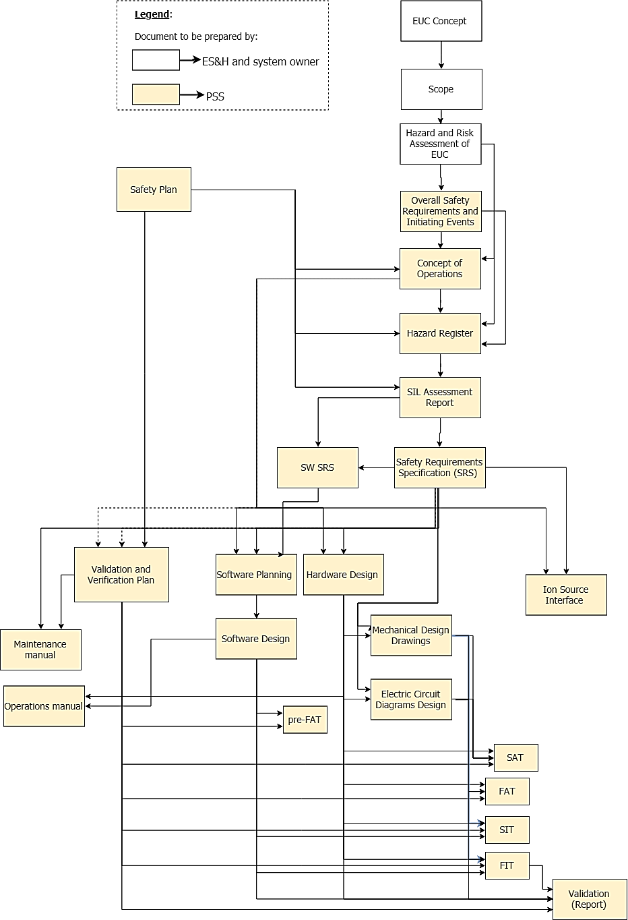
Figure 1: Flow and relations of the PSS0 documents

Summary
This document gives an overview over the PSS0 documents delivered for the Safety Readiness Review (SRR). It also shows the interactions between the documents to show the intended reading order.

References
- ESS System Documentation prior to a Safety Readiness Review (ESS-0177837)
- IEC 61511:2016 Functional safety – Safety instrumented systems for the process industry

Document Revision history
Revision | Reason for revision | Date
1 | Creation of Document, first issue | 2018-08-14
2 | Updated document structure after comments by ZHAW on PSS0 documentation. | 2018-11-01

List of Authors | List of Reviewers | List of Approvers
Meike Rönn | Morteza Mansouri | Annika Nordt

This document was not prepared by PSS

