Hardware Design Specifications for Personnel Safety System 0

 | Name | Role/Title
Author | Morteza Mansouri | Engineer for Safety Critical Systems, ICS
Owner | Stuart Birch | Senior Engineer for Personnel Safety Systems, ICS
Reviewer | Viktor Fred | Lead Engineer for Electrical Installations, Machine Protection System, ICS
Approver | Annika Nordt | Protection and Safety Systems Group Leader, ICS

Table of content | Page
1. introduction 6
1.1. Purpose of the document 6
1.2. Applicable Standards and regulations: 6
2. PSS0 Equipment CE Marking 7
3. PSS0 Architecture 8
3.1. Network architecture 8
3.2. Physical topology 8
3.3. ISrc System block diagram and PSS0 interfaces 8
4. PSS0 Hardware Description 9
4.1. General layout 9
4.2. PSS0 equipment operating voltage 9
4.3. High voltage grounding relay 9
4.4. PSS0 racks and rack mount equipment 9
4.4.1. PSS0 rack design 9
4.4.2. Cable entries 10
4.4.3. Wiring colour codes: 11
4.4.4. Field cable terminations 11
4.4.5. Grounding 12
4.4.6. Power distribution 12
4.4.7. Normal power: 12
4.4.7.1. Backup power: 12
4.4.8. PLC modules 13
4.4.9. Network communication modules 15
4.4.9.1. PSS0 HMI 15
4.5. PSS0 Field devices 15
4.5.1. Grounding and short-circuiting equipment 15
4.5.2. Search equipment 17
4.5.3. ISrc HV OFF button 19
4.5.4. Position monitoring switches 20
4.5.5. Door lock and key exchange system 22
4.5.6. Warning lights 23
4.5.7. Contactor relays and contactors 24
4.6. PSS0 Cable Support System 24
4.7. PSS0 cables 24
4.7.1. Signal cables: 24
4.7.2. Fibre Optics cable 26
5. Abbreviations 28
6. References 29
Document Revision history 31
7. Appendix 1: PSS0 Network Architecture 32
8. Appendix 2: PSS0 Physical Topology and the overall system architecture and physical layout. 37
9. Appendix 3: PSS0 Interfaces with ISrc 43
10. Appendix 4: PSS0 Equipment Distribution 44
11. Appendix 5: ISrc HV PS Circuit Diagram 45
12. Appendix 6: HV OFF BUTTON PLACEMENT 46

list of tables
Table 1: PSS racks specifications. 10

list of Figures
Figure 1: Cable containment fixed to PSS0 enclosure. 11
Figure 2: Sliding cable entry to PSS0 enclosure. 11
Figure 3: PSS0 HV grounding relay. 16
Figure 4: HV grounding relay specifications 17
Figure 5: Grounding rod 17
Figure 6: Illuminated search button 18
Figure 7: Signal column; search light and sounder 19
Figure 8: ISrc HV OFF button 20
Figure 9: Mechanical safety switch with separate actuator 21
Figure 10: Non-contact magnetically operated safety switch 21
Figure 11: PSS0 key exchange system 22
Figure 12: Light panels 23
Figure 13: PSS0 Signal Cables Specifications 25
Figure 14: General composition of PSS0 signal cables 25
Figure 15: PSS0 FO Cables Specifications 26
Figure 16: General composition of PSS0 FO cables 27
Figure 17: PSS0 Network Architecture. 32
Figure 18: Hardware setup for PSS0 SIF01. 33
Figure 19: Hardware setup for PSS0 SIF02. 34
Figure 20: Hardware setup for PSS0 SIF03. 35
Figure 21: Hardware setup for PSS0 SIF04. 36
Figure 22: PSS0 Physical Topology 37
Figure 23: ISrc Safety Fence - view door side (from outside) 38
Figure 24: ISrc Safety Fence - view door side (from inside) 39
Figure 25: ISrc Safety Fence - view beam output side (from outside) 40
Figure 26: ISrc Safety Fence - view inner left side (by regards beam direction) 41
Figure 27: ISrc Safety Fence - view inner right side (by regards beam direction) 42
Figure 28: PSS0 Interfaces with ISrc 43
Figure 29: PSS0 Equipment Distribution. 44
Figure 30: ISrc HV PS Circuit Diagram. 45
Figure 31: ISrc HV OFF button 46

introduction

Purpose of the document
This document provides an overall hardware design specification for the Personnel Safety System 0 (PSS0) at European Spallation Source (ESS) ERIC in Lund, Sweden. The objective is to describe the detailed requirement specifications for the PSS0 hardware.

Applicable Standards and regulations:
- PSS0 is a low- voltage protection and monitoring system. Therefore, according to [1] the system electrical design is chosen to suit the requirements in SS-4364000, which is a Swedish standard for Low-voltage electrical installations [2].
- It’s strongly recommended (as much as reasonably possible) to use hardware components in PSS0 for which there is sufficient information in order to facilitate a demonstration that the E/E/PE safety-related system complies with IEC 61511 [3]. Such components should be accompanied with a safety manual where all the information required to enable the integration of the compliant item into a safety-related system, in compliance with the requirements of IEC 61511 [3], is documented.

PSS0 Equipment CE Marking
PSS0 equipment are all commercial off-the-shelf products, unless stated otherwise. The list below shows the manufacturers of PSS0 equipment and the CE marking certificates for the PSS0 equipment.
- Siemens: all safety and automation products are CE marked [link] [4].
- Fortress Interlocks: The locks and key exchange products are CE marked [link] [5].
- Shroff: Electrical enclosures are CE marked [link] [6].
- Phoenix Contact: The terminal blocks for electrical connections in PSS0 enclosures are CE marked [link] [7].
Note:
The only exceptions, which are not CE marked, are the HV grounding relay and grounding rod. These two components are manufactured by ROSS Engineering. The ROSS engineering products certifications can be found in this [link] [8]. It should be noted that ROSS Engineering is the only manufacturer of HV grounding relays with a rated voltage of 120 kV DC.

PSS0 Architecture

Network architecture
PSS0 is built using two identical Siemens PLC and distributed I/O systems with redundant sensors and actuators. This is also known as “two train system”; distinguished as “red train” and “blue train”.
Appendix 1 details the network and hardware setup of PSS0.

Physical topology
PSS0 network is built on a hybrid topology where there is a Fibre Optics (FO) ring backbone connecting all PSS0 racks. The nodes (PLC CPU and distributed I/O modules) are connected to this backbone ring in a bus topology. The ring fibre optic backbone will be routed in separated cable routes. The main advantage of this setup is the redundancy in FO cable connection and as a result higher reliability of the system network. Appendix 2 details the PSS0 physical topology, FO cable connector types and the overall system architecture and physical layout.

ISrc System block diagram and PSS0 interfaces
To mitigate electrical hazards for personnel arising from operating the ISrc and LEBT test stand, PSS0 will interface ISrc subsystems, as shown in the block diagram in appendix 3.
PSS0 will interface with ISrc equipment below:
- ISrc HV PS
  - Interfacing the mains incoming power to the HV PS with two contactors in series.
  - Interlocking the HV PS through ISrc interlock PLC.

- ISrc HV platform
  - Grounding relay connecting the HV platform to ground.
  - Grounding rod connecting the HV platform to ground.
Note:
- As part of PSS0 operation, before any access to the PSS0 controlled area, PSS0 requires to turn off the ISrc HV through PSS0 interfaces. In order to prevent the hard shut down of ISrc HV PS, before PSS0 moves from HV ON mode to Access or Alarm modes, PSS0 will disable the permit signal to ISrc interlock PLC.

- ISrc safety fence
  - Interface with the ISrc HV safety fence
  - Interface with ISrc HV safety fence access door
Appendix 3 details the PSS0 interfaces with ISrc subsystems.

PSS0 Hardware Description

General layout
The PSS0 racks are installed in G01-FEB-Level 90 and on the ISrc HV platform in G01-accclerator tunnel. The PSS0 field devices are installed in G01-FEB-Level 90, ISrc HV safety fence, and ISrc HV platform. Appendix 4 details the general layout of PSS0 racks and field devices in accelerator building.

PSS0 equipment operating voltage
The operating voltages for PSS0 rack-mounted equipment and field devices are as below:
- 230 VAC:
  - Incoming mains power to PSS0 rack-mounted power supply.
  - Two rack-mounted electrical sockets.
  - Supply voltage to HV grounding relay control coil.

- 24 VDC:
  - The operating voltage of all PSS0 rack-mounted equipment and field devices, unless stated otherwise.

High voltage grounding relay
According to the PSS0 concept of operations [16], the opening of two contactors interfacing with the mains incoming power to ISrc HV PS, a grounding relay should connect the ISrc HV platform to ground in order to ensure that the stored energy in ISrc HV PS capacitors and output cable will be discharged. Based on the power rating of the ISrc HV PS [75 kV DC nominal (100 kV max.) and 150 mA (max.)], a 120 kV DC grounding relay will be installed to connect the ISrc HV PS to ground when there is access to PSS0 controlled area.

PSS0 racks and rack mount equipment

PSS0 rack design
- The PSS0 components such as PLC modules [20], network communication modules, power supply, UPS, battery, MCBs, etc. are housed in a Schroff (Varistar type) steel floor standing double door enclosure, with two mounting plates (front and rear).
- In addition to requirements mentioned in [1], the following points have been considered for the PSS0 racks design.
  - PLC modules[20], relays, power supply, UPS and battery unit are installed on the front mounting plate, and MCBs, SPD, power distribution units and terminals (for field devices cable termination) are installed on the rear mounting plate.
  - The equipment with operating voltage of 230 VAC are installed only in areas mentioned below, and marked accordingly:
  - The 230 VAC MCBs, SPD, RCD, power sockets and contactor relay in the first top row on the rear mounting plate.
  - The terminals for input power to power supply on the front mounting plate.
  - Both doors are equipped with ASSA cylinder and key system. The keys can only be used to open PSS racks, and ICS/PSS team is in possession of the keys.
- Were applicable component selection will be in line with standard ESS component list [21]

- The ambient conditions at the G01-FEB-Level90, where the PSS0 racks are installed are described below [10]:
  - Room temperature: +22,5°C ±5°C
  - Humidity: Max 70% RH

The detailed specifications of PSS0 racks can be found in table 1.
Table 1: PSS racks specifications.
Material | Steel frame and steel cladding
Type of Protection [IP] | IP 55 (IEC 60529)
Height x Width x Depth [mm] | 2200 x 600 x 1000
EMC shielding | 60 dB at 1 GHz, 40 dB at 3 GHz (IEC 61587-3)
Static load-carrying capacity [kg] | 400 (IEC 61587-1)
Shock test | Maximum acceleration: 5 g Duration: 11 mS (IEC 61587-1)
Vibration test | Frequency: 5 Hz -100 Hz Acceleration: 1 g (IEC 61587-1)
Cooling | Air cooled (3 fans on top cover as air outlet, and front half-perforated door with dust filter as air inlet).
Colour | RAL 2000
Components installing options | Mounting plate (2 off) and 19"

The 2D panel layout of the PSS racks can be found in PSS0 Electrical Circuit Diagram document [11].

Cable entries
The enclosures are designed for top cable entry. Cable entry will be non-glanded and will be designed so that cables will go directly from the cable containment to the enclosure via a sliding plated opening on top of the enclosure. The cable containment will be attached to the enclosure top to keep the EMC integrity of the cables containment. The cable containment installation on top of PSS0 enclosures and sliding openings for cable entry are shown in figures 1 and 2 respectively.

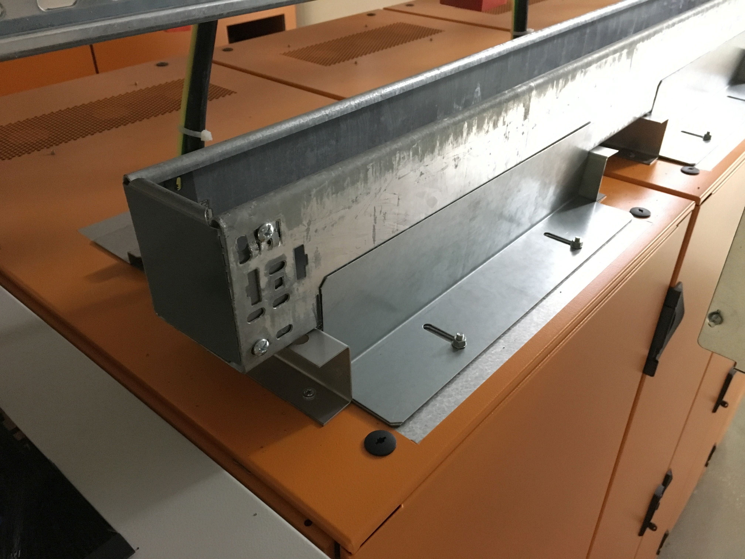
Figure 1: Cable containment fixed to PSS0 enclosure.
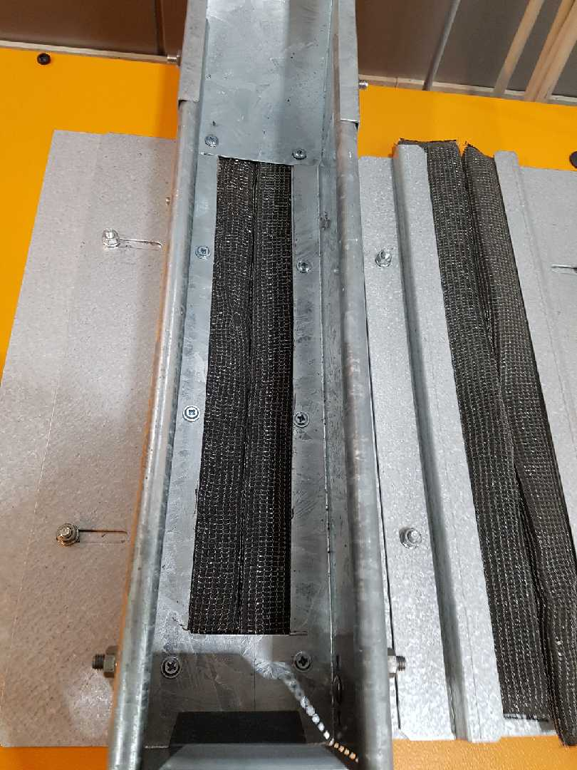
Figure 2: Sliding cable entry to PSS0 enclosure.

Wiring colour codes:
- The colour coding of wiring inside PSS0 racks comply with SS-EN 60204-1.
- The letter codes for colours comply with IEC 60757.

Field cable terminations
I/O signal cables are terminated in terminal blocks on the rear mounting plate of the PSS0 racks. The terminal blocks specifications are as below:
- Knife disconnect terminal block
- Terminals rated voltage: 400 VAC
- Terminals rated current: 20 A
- Terminals connection method: push-in connection
Terminal blocks product are manufactured by Phoenix Contact, and the product numbers can be found in [1].

Grounding
Two grounding bars are provided on the rear mounting plate of PSS0 racks, in order to terminate the incoming mains power ground wire (PE), grounding all field cables screens (FB), ground panel metalwork and internal equipment (PB).

Power distribution
The PSS0 racks are provided with 230VAC supply. The supply configuration is TN-S.

Normal power:
- The 230VAC supply is fed to the PSS0 rack main isolator switch. The OFF state of the isolator switch ensures no equipment, within PSS0 enclosure, with operating voltage of 230 VAC remains live. The 230 VAC will be distributed to other equipment, within PSS0 enclosure, through a 6KA, 1+N (the neutral conductor is only switched; no independent overcurrent or short circuit detector for neutral current), type C, 16A Miniature Circuit Breaker (MCB).
- In order to prevent highly destructive energy from lightning and/or overvoltage generated by operations or incidents on the electrical network, a type 3 (T3) surge arrester (Surge Protection Device) is installed in each of PSS0 enclosures.
- 24 VDC is internally provided in the PSS0 enclosures for all the PSS0 equipment and field devices (other than HV grounding relay).
- In conjunction with a 24 VDC power supply, a selectivity module is used to distribute power to PLC modules within PSS0 rack. Faults in the individual branches caused by overload or short-circuit are detected and selectively switched off, so that the fault does not impact the other load circuits. This means fast troubleshooting and minimized downtimes. The selectivity module is a SITOP PSE200U 3 A, 4-channel input, with input: DC 24 V/12 A, and output: 24 V DC/4x 3 A.

Backup power:
PSS0 is a failsafe system, and upon power outage to PSS0, it will transition into safe state i.e. the ISrc HV PS is tripped. However, all PSS0 racks are equipped with a UPS and battery. The acquired benefits of having PSS0 backed up with UPS power are as below:
  - Not losing the searched state of the PSS0 controlled area in case of AC power failure.
  - Keep monitoring the status of all PSS0 equipment during AC power failure.

Siemens SITOP Selection Tool [link] [12] was used to select the power supply, and find the matching uninterruptible power supply (DC UPS) based on battery technology for PSS0 racks.
The inputs to the tool and the results are as below:
- Requested (by PSS0 designer) values for each PSS0 rack:
  - Buffer time: 60 min
  - Nominal current: 6 A
  - Minimal buffer voltage: 21.53 V
- Result:
  - Power Supply : SITOP PSU100S 24 V/10 A
  - DC UPS with batteries:
    - UPS: SITOP UPS1600 24V/10A
    - Battery : SITOP UPS1100 BATTERY MODULE WITH SERVICE- FREE SEALED LEAD BATTERIES FOR SITOP DC-UPS-MODULES 24 V 12 AH DC
- Performance Characteristics:
  - Buffer time at requested values:
    - brand-new: 1 h 1 min
    - at end of lifetime : 19 min 20 s
    - Reload time after discharge : 3 h 31 min
  - Lifetime of accumulator (app.):
    - at 20 °C 4 years
    - at 30 °C 2 years
    - at 40 °C 1 years
    - at 50 °C 0.5 years

The details of powering scheme in each PSS0 enclosure is shown in detail in PSS0 Electrical Circuit Diagrams document [11].

PLC modules
PSS0 is built using Siemens Safety PLCs (S7-1518 F CPU). Siemens fail-safe CPUs allow the processing of standard and safety programs on a single CPU. The Siemens Safety PLCs are certified to satisfy the Safety Integrity Level SIL3 in accordance with IEC 61508:2010.
The PSS0 field devices are controlled through Siemens ET 200 SP standard and safety distributed I/O modules. The ET 200 SP interface modules connect the I/O system to PSS0 PROFINET network and exchange data between the higher-level controller and the I/O modules. With the SIMATIC ET 200SP, safety-related communication is also possible via PROFIsafe.

The following PLC modules are used for PSS0.
- CPU: SIMATIC S7-1500F, CPU 1518F-4 PN/DP (6ES7518-4FP00-0AB0)
- Interface module: PROFINET INTERFACE MODULE ET 200SP IM155-6PN (6ES7155-6AU00-0CN0)
- Digital Input modules:
  - SIMATIC ET 200SP, DIGITAL INPUT MODULE, DI 16X 24VDC STANDARD (6ES7131-6BH00-0BA0).
  - SIMATIC DP, ELECTRON. MODULE F. ET 200SP, F-DI 8X24VDC HF, UP TO SIL 3 (6ES7136-6BA00-0CA0)

The F-DI modules have following capabilities [13]:
- Short circuit test:
The short-circuit detection switches off the sensor supply briefly. The length of the deactivation period is equivalent to the configured "Time for sensor test". If a short circuit is detected, the F-module triggers a diagnostic interrupt and the input is passivated.
The following short-circuits are detected:
  - Short-circuit of input to L+
  - Short-circuit of the input of another channel when it has a 1 signal.
  - Short-circuit between the input and sensor supply of another channel.
  - Short-circuit between the sensor supply and the sensor supply of another channel.
Short circuit test is enabled for all PSS0 F-DI modules. To enable the short-circuit detection for the channels of the F-DI module, the "Internal sensor supply" is set.

- Digital Output modules:
  - SIMATIC ET 200SP, DIGITAL OUTPUT MODULE, DQ 16X24VDC/0.5A STANDARD (6ES7132-6BH00-0BA0)
  - SIMATIC DP, ELECTRON. MODULE for ET 200SP, F-DQ 4X24VDC/2A, UP TO SIL 3 (6ES7136-6DB00-0CA0)

The F-DQ modules have following capabilities [14]:
- Dark test:
For a dark test, a test signal is switched to the output channel while the output channel is active (output signal "1"). This output channel is then briefly disabled (= "dark period") and read back. A sufficiently slow actuator does not respond to this and remains switched on. If the expected signals (P-readback and M-readback) could not be read back correctly after expiration of the readback time dark test, the output channel is passivated.
- Switch on test:
During the switch on test, the P-switch and M-switch of the output channel are alternately closed and read back when the output channel is inactive (output signal "0"). Contrary to the light test, no power flows through the connected load during the switch on test. This parameter allows one to set the time for the readback. If the signal was not read back correctly once the time has expired, the output channel is passivated.
- Light test:
Overload and wire break are detected with a 0 signal at the output. For a light test, a test signal is switched to the output channel while the output channel is inactive (output signal "0"). The output channel is switched on briefly during the light test (="light period") and read back. A sufficiently slow actuator does not respond to this and remains switched off. In contrast to the switch on test, the P-switch and the M-switch switch at the same time during the light test and power flows through the connected load. If the readback signals are incorrect, the signal is present for the configured readback time at the output channel before the fault causes passivation of the output channel. If the signal was not read back correctly once the maximum readback time switch on test has expired, the output channel is passivated.
The parameters activated in PSS0 F-DQ modules are described in [15].

Network communication modules
As shown in PSS0 network architecture (appendix 1) and PSS0 physical topology (appendix 2), there is a FO backbone connecting all PSS0 racks. The PSS0 network comprises of the following equipment:
- Siemens SCALANCE XC206-2SFP manageable layer 2 IE Switch (product number: 6GK5206-2BS00-2AC2). The switch configuration supports the ring topology of the PSS0 FO network. The SCALANACE switch includes
  - 6x 10/100 MBit/s RJ45 ports
  - 2x 100/1000 MBit/s SFP
  - 1x console port
- FO patch panel which is a metal housing (DIN RAIL mountable) used for splice management for up to 12 fibres and includes a 6-slots. The FO patch panel is manufactured by CORNING and the product number is SPH-01P-DIN.

PSS0 HMI
The two PSS0 enclosures housing the PLC CPUs have SIMATIC HMI Comfort Panels mounted on the front door of the enclosures. The HMI shows the PSS0 mode and will be used by PSS team for diagnostic purposes of PSS0.
The HMI is a 15" widescreen TFT display with PROFINET interface, and 24 MB configuration memory.
The HMI product number is 6AV2124-0QC02-0AX0.

PSS0 Field devices
Appendix 4 details the general layout of PSS0 racks and field devices in accelerator building.

Grounding and short-circuiting equipment
- HV grounding relay
According to the requirements mentioned in [16], a grounding relay is installed within PSS0 controlled area to connect the ISrc HV platform to ground (during access to PSS0 controlled area), in order to ensure that the stored energy in ISrc HV PS capacitors and output cable will be discharged in a safe way.
The operating output voltage of the ISrc HV PS is 75 kV DC. However, the rated output voltage and current of the HV PS is 100 kV DC and 150 mA respectively. The peak test rating of high voltage grounding relay was chosen to be 1.2 times the ISrc HV PS rated output voltage. Therefore, the peak test rating of HV grounding relay is 120 kV DC.
The HV grounding relay is a Ross Engineering product (product number: ED120-NC-120-2-31-BD). The grounding relay type is fail-safe, i.e. loss of power to grounding relay control coil results in closing the grounding relay contact via gravity return. The HV grounding relay is installed inside a transparent polycarbonate box. Figure 3 shows the HV grounding relay.
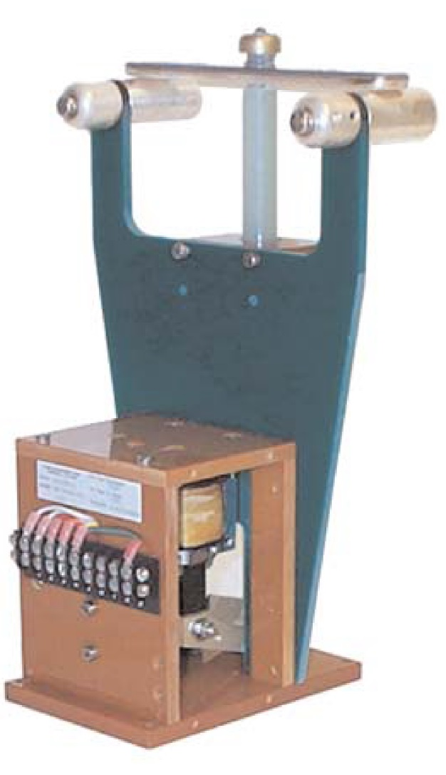
Figure 3: PSS0 HV grounding relay.

HV grounding relay selection criteria:
The stored energy is mainly in the HV PS capacitors, and the HV cable between HV PS and HV platform. The HV grounding relay should be able to bear the discharge energy from the HV PS and HV cable to the ground potential.
The circuit diagram of the HV PS output stage is shown in appendix 5.
The calculations below show the stored energy and RC time constants to discharge the stored energy in the ISrc HV PS and the HV cable in two conditions:
- There is 10 MΩ resistance between HV platform and ground:
- The smoothing capacitors in the HV PS output stage has a capacitance of 2.5 nF. Therefore, the stored energy in smoothing capacitors is 12.5 J, and the RC time constant is 25 mS.
- The cascade capacitors in the HV PS have a capacitance of 25 nF. Therefore, the stored energy in cascade capacitors is 125 J, and the RC time constant is 250 mS.
- The HV cable length is 15 meters, and according to the HV cable datasheet, cable capacitance is 1.5 nF. Therefore, the stored energy in cable is 7.5 J, and the RC time constant is 15 mS.
- The HV grounding relay connects the HV platform to ground (10 MΩ resistance is short circuited):
- The smoothing capacitors in the HV PS output stage has a capacitance of 2.5 nF. Therefore, the stored energy in smoothing capacitors is 12.5 J, and the RC time constant is 3.4 µS.
- The cascade capacitors in the HV PS have a capacitance of 25 nF. Therefore, the stored energy in cascade capacitors is 125 J, and the RC time constant is 200 µS.
The HV cable length is 15 meters, and according to the HV cable datasheet, cable capacitance is 1.5 nF. Therefore, the stored energy in cable is 7.5 J.
Figure 4 shows the grounding relay specifications in detail
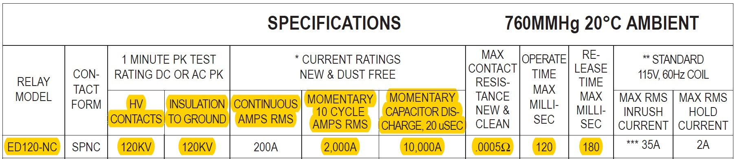
Figure 4: HV grounding relay specifications
- Grounding rod
In addition to the HV grounding relay, a grounding rod (requirements mentioned in [16]) is used to temporarily ground and discharge any stored energy in the ISrc HV PS capacitors and output cable. The grounding rod is a Ross Engineering product (product number: ACC1-8WHH-20-A-8).
The grounding rod is installed across the access door to PSS0 controlled area. Upon access to the PSS0 controlled area, the operator shall remove the grounding rod from the rest place (across door) and hook it to the ISrc HV platform.
The grounding rod includes a holder with interlock micro-switches, which is installed next to the access door to PSS0 controlled area. The micro-switches, connected to PSS0, ensure that the grounding rod is removed from the ISrc HV platform prior to PSS0 permit to energize the ISrc HV PS.

Figure 5 shows the grounding rod.

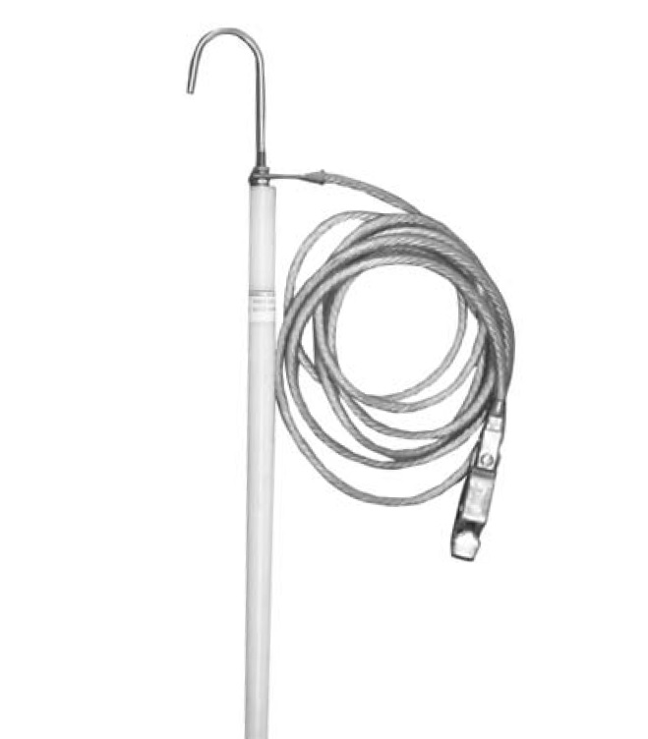
Figure 5: Grounding rod

Search equipment
- Illuminated search buttons
Two illuminated search buttons are installed in PSS0 controlled area, which are used during the formalised search [17]. Search buttons are placed at strategic locations around the PSS0 controlled area.
These are non-latching illuminated push buttons with a metallic body installed in a plastic cubic enclosure. Each search button will contain 2 NO contacts and 1 LED unit.
The search buttons and cubic enclosure are manufactured by Siemens, and the product numbers are SIE.3SB3501-0AA61 and 3SB3801-2AA3 respectively.
Figure 6 shows the search button in PSS0 controlled area.

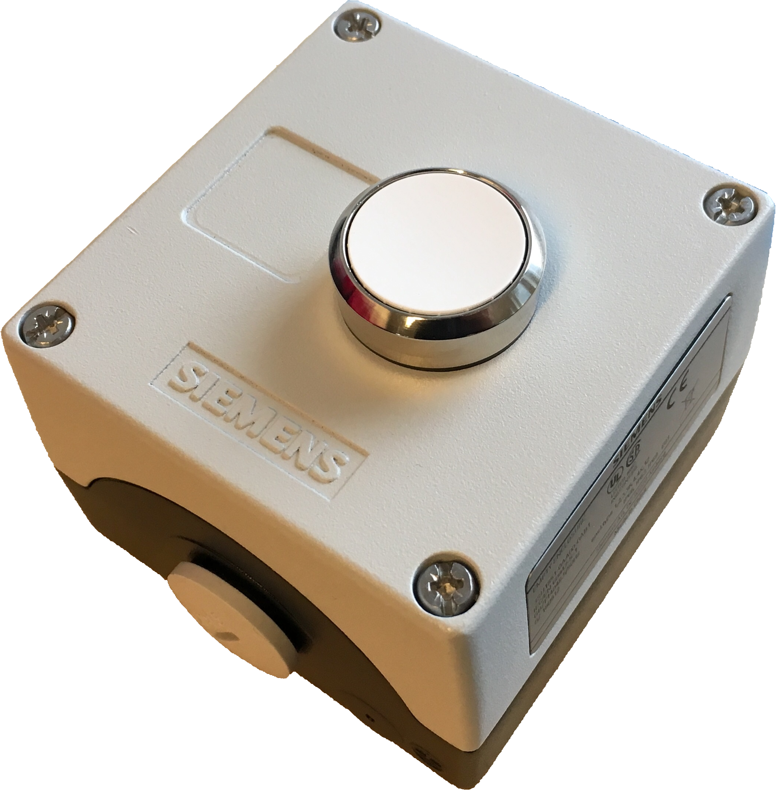
Figure 6: Illuminated search button
- Search light and sounder
A Siemens signal column is installed on the outer side of HV safety fence. The signal column includes a green LED light and white LED light and a sounder. The lights and sounder are used to provide information to the operators and personnel about the search sequences during the formalized search of PSS0 controlled area.
The green and white LED lights and sounder are manufactured by Siemens, and the product numbers are 8WD4420-5AC, SIE.8WD4400-1AE and 8WD4420-0EA2 respectively.
Figure 7 shows the signal column installed on the outer side of the ISrc HV safety fence.

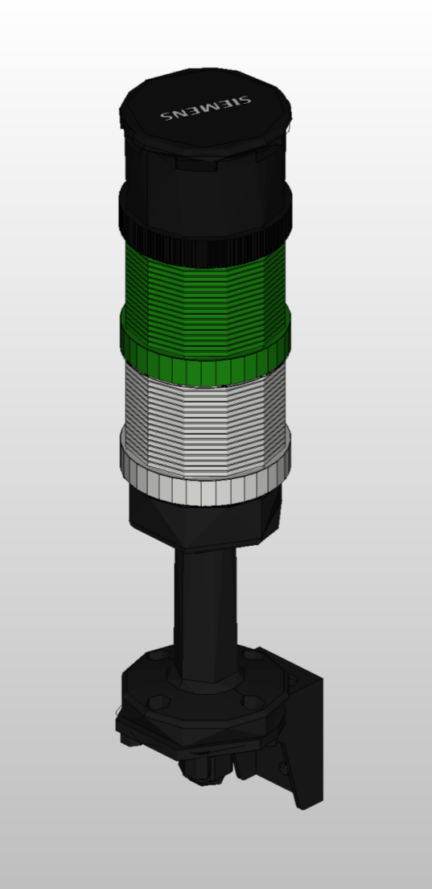
Figure 7: Signal column; search light and sounder

ISrc HV OFF button
An ISrc HV OFF button is installed outside the PSS0 controlled area, see appendix 6 for the location. The button is a SIEMENS mushroom pushbutton, shiny black, Ø 40 mm, positive latching (rotate to unlatch) - Rittal stainless steel pushbutton box, painted in orange RAL2000 Dimensions W100 x H100 x D90 mm. It has 4 NC contacts and 1 red LED unit and have a protective metal guard to prevent them being pressed accidently. 2 NC contacts of the button will be connected to each train of PSS0.

The ISrc HV OFF button, metallic enclosure and protective guard part numbers are SIE.3SU1050-1HB10-0AA0 (Siemens), RIT.2384010 (Rittal) and SIE.3SU1950-0DL80-0AA0 (Siemens) respectively.
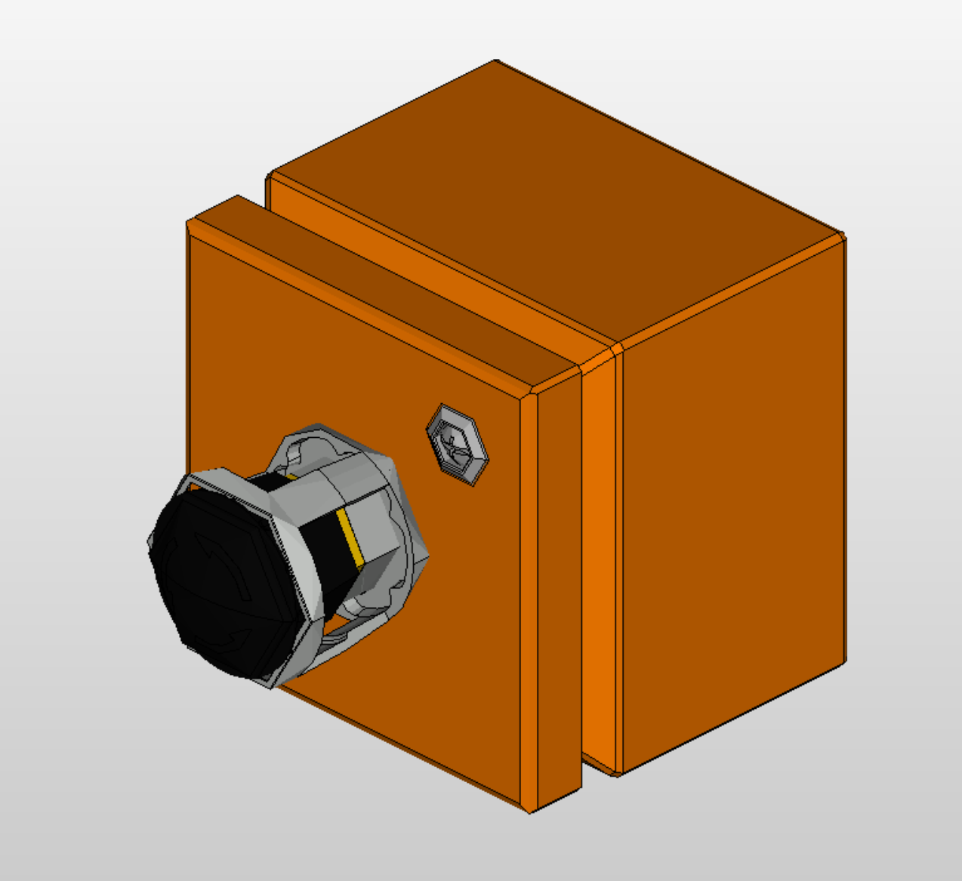
Figure 8: ISrc HV OFF button

Position monitoring switches
There is only one access door to the PSS0 controlled area, and PSS0 will monitor the position (open/closed) of the access door, using two safety switches with different technologies.
- Mechanical safety switch with separate actuator
The mechanical safety switch has Positive opening (→) operation. The NC contacts of the switch are forced open mechanically, positively-driven and reliably by the plunger. (an internal mechanism forcibly separates normally closed contacts and prevents them from welding together - allowing the safety circuit to open. Requirements in IEC 60947-5-1, Annex K prevent the reliance on spring action alone to separate the contacts.)
The switch itself is mounted on the frame (fixed part) with the actuator fitted on the door. The switch has 2 sets of NC safety contacts, each connected to one train of PSS0.
Figure 9 shows the mechanical safety switch with separate actuator.
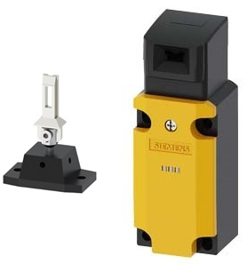
Figure 9: Mechanical safety switch with separate actuator
- Non-contact magnetically operated safety switch
A magnetically operated switch comprises a coded switching magnet and a contact block (sensor unit). The magnetic safety switch has the following features:
- Tamper-proof protective door monitoring
- Small footprint
- SIL 3 acc. to IEC 61508, achievable with single switch pair
The switch itself will be mounted on the fixed part with the actuator fitted on the door. The switch will have 2 sets of NC safety contacts (built-in Reed switches), each connected to one train of PSS0.
Figure 10 shows the magnetic safety switch, and its operation.

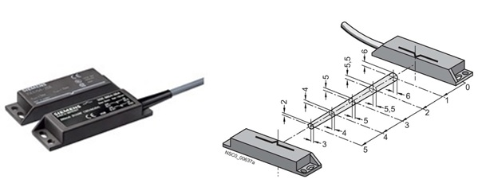
Figure 10: Non-contact magnetically operated safety switch

Door lock and key exchange system
- Access door lock
The access door to PSS0 controlled area will using a standard Fortress amGard proLok. It’s a heavy duty, solenoid controlled (energise to unlock) switch interlock. It will be unlocked only when the solenoid is energized by PSS0 PLC, and the Safety key is removed from slot 3. The specifications of the Fortress amGard proLok are as below:
- The lock is a “SHORT KEY ASSEMBLY FRONT FACING AUTO HEAD ASSEMBLY PUSH IR, WITH KEY RESET, 40MM SAFETY KEY ADAPTOR”. The product number of the Fortress amGard proLok is TK1T6R1SKR21AKR21SR414MPB1.
- The Fortress amGard proLok provides two safety circuits to PSS0 red and blue train systems. Each safety circuit can independently confirm the position of mechanical actuator (i.e. IN/OUT), and the lock solenoid (i.e. Energised/De-energised).
- A mechanical override key can be used to unlock the Fortress amGard proLok from outside in case of emergency. The same key can be used to reset the lock after pressing the escape release button. The procedures on how to use the mechanical override key is detailed in [17].

- Key exchange system
The PSS0 key exchange system (Trapped Key Interlock Switches) will be used to ensure that a predetermined sequence of events takes place in order to remove the electrical hazard before personnel get access to PSS0 controlled area. This system ensures that the access process to PSS0 controlled areas is followed and cannot be circumvented or short cut. The unit will contain stainless steel mechanical lock modules with uniquely coded keys.
There are two keys in the PSS0 key exchange system; “Access Key” and “Safety Key”. The Access key is installed inside an enclosure in G01-FEB-level 90 near the ISrc HV PS. The sequence of actions to grant personnel safe access to PSS0 controlled is detailed in [17]. Figure 11 shows the components of PSS0 key exchange system.
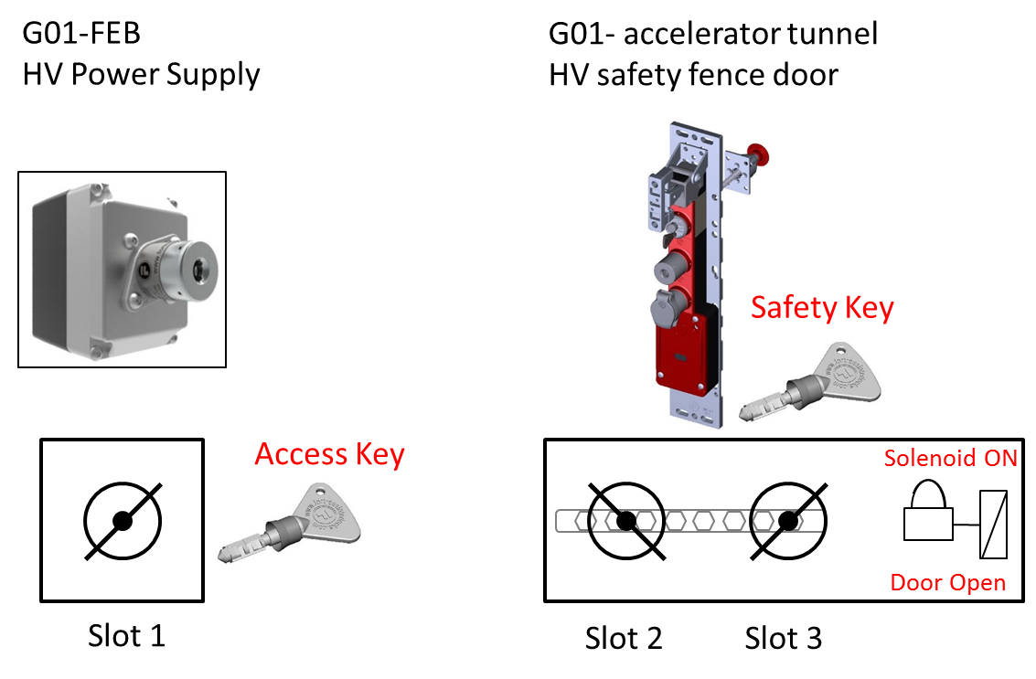
Figure 11: PSS0 key exchange system
Each key in the exchange system, delivered to ESS, is uniquely coded. The code is engraved on the key, and documented by ESS and supplier (Fortress Interlocks), in order to prevent getting the same key number twice (from different suppliers) or that two key numbers are too close to each other.
The key numbers for PSS0 key exchange are as below:
- “Access key”: 1321500
- “Safety key”: 1514404

Warning lights
Two light panels are installed on the outer side of the ISrc HV safety fence as warning lights.
- “High Voltage ON” light.
- “Beam ON” light.
The light panels operating voltage is 24 VDC, and are controlled by PSS0 PLC.
Figure 12 shows the light panels.

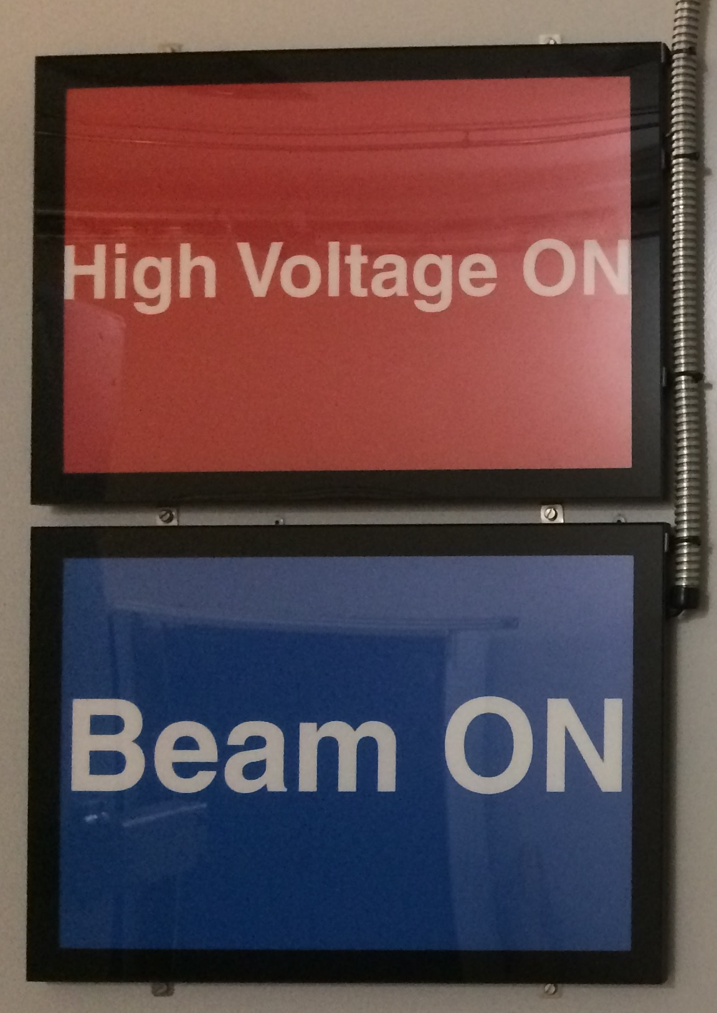
Figure 12: Light panels

Contactor relays and contactors
As described in [18], PSS0 will interface the ISrc HV PS by installing two contactors in series on the 3-phase mains power cable feeding the ISrc HV PS.
The technical data of Siemens contactor relays and contactors to be used for PSS0 interface with ISrc HV PS is as below:
- Siemens contactor relay, DC 24V, 2NO+2NC, 4-Pole, Size S00 with Integrated Diode, Screw Connection (product number: 3RH2122-1FB40).
- Siemens contactor, AC-3 30 kW/400 V, DC 24V, 2 NO + 2 NC, 3-Pole, Size S3, Screw Connection (product number: 3RT1044-1BB44).

Since there is not a contactor available on the market, that has two control coils, PSS0 will use a contactor relay in each train, which provides the possibility for each PSS0 train to disable both contactors (open power contacts) at any time. The contactor relays also prevent damage to PLC failsafe output modules caused by the closing power of contactors’ magnet coils. Therefore, each of the PSS0 trains will control and monitor both contactors, which supply mains power to ISrc HV PS.

In order to use the Siemens Contactors for “Safety” applications, the contactors are provided with positively driven (mirror) contacts which meet or exceed the criteria for "Safety Contactors” according to IEC 60947-4 Annex F. When applying Safety Contactors in safety circuits, the NC auxiliary contacts must be wired in series or parallel and must be used as monitoring contacts with feedback to the safety evaluation device (i.e. safety relay or failsafe logic controller).

PSS0 Cable Support System
In line with requirements in IEC 61511 for preventing common cause failure, there is a physical separation between the two independent PSS trains to reduce the possibility of the PSS being affected by the same external events. Therefore, in PSS0 the cables of each train (from sensor to logic solver to actuator) will run through two separated enclosed, sealed and marked containments/conduits. Moreover, running PSS0 cables in sealed and grounded metallic containments will considerably reduce the effect of EMI on PSS0 signal cables. The detailed drawings of PSS0 cable support system can be found in [19] and [20].

PSS0 cables

Signal cables:
- Signal cables specification:
Considering the requirements such as temperature, ionising radiation, EMI and RFI at various levels in Accelerator tunnel, the signal cables used for PSS0 are radiation resistant (up to 1000 kGy), high temperature (up to 125 °C), and low frequency industrial cables. The PSS0 signal cables will have an overall screen to mitigate the EMI effect. The signal cables are RADOX 125 and are manufactured by HUBER+SUHNER. RADOX 125 has a life span of 20,000 hours at a conductor temperature of 120 °C, which is approx. 2.5 years. If used at another temperature (e.g. 80 °C), the cable lifetime will be 320,000 hours.
Figure 13 shows the specification of signal cables installed for PSS0.

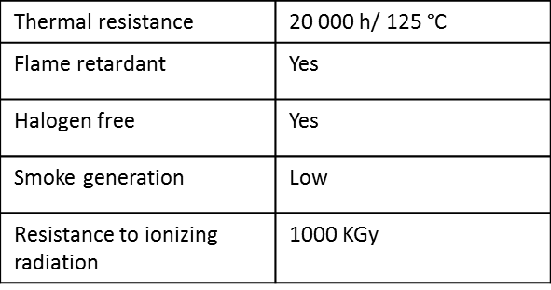
Figure 13: PSS0 Signal Cables Specifications

- General composition of signal cables:

Figure 14 shows the general composition of PSS0 signal cables.

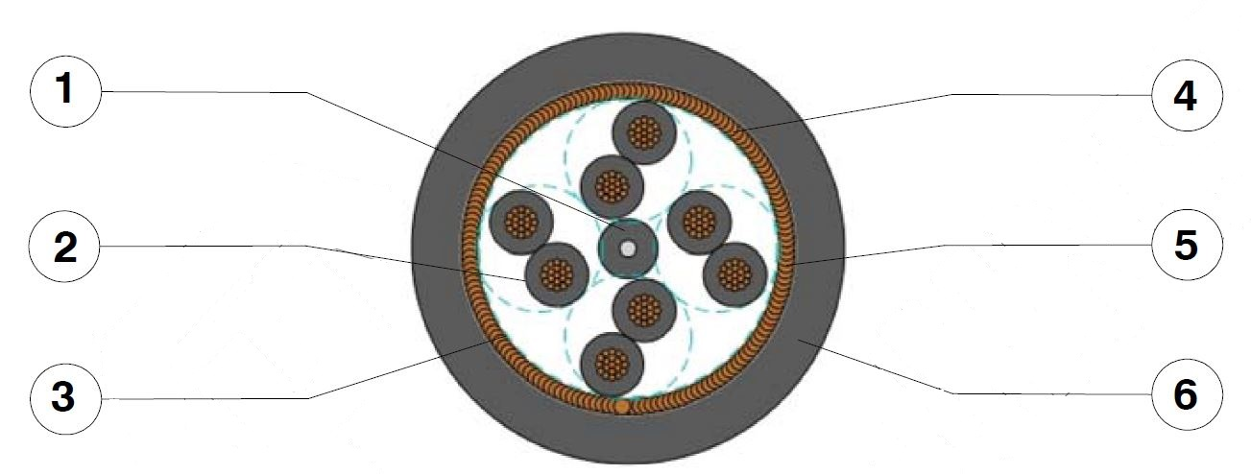
Figure 14: General composition of PSS0 signal cables

- Center / Filler: RADOX 125
- Cores: Conductor: stranded tin plated copper
Insulation: RADOX 125: extruded irradiation crosslinked polyolefin
Two cores twisted
Colours: black, yellow numbered
- Wrapping: Tape
- Screen: Tin plated copper braid, opt. covering :  80%
- Wrapping: Tape
- Sheath: RADOX 125 M : extruded irradiation crosslinked polyolefin
Colour: black

- Signal cable standards
The signal cables pass the following tests:

Fire protection in buildings . . . . . . . . . . . . . . . . . . . . . . Fulfilled . . . . . . . . . . . . . . EN 50525
Vertical flame spread . . . . . . . . . . . . . . . . . . . . . . . . 50 < L ≤ 540 mm . . . . . . EN 60332- 1- 2
Vertical flame spread, bunched . . . . . . . . .. . . . . . L ≤ 2.5 m . . . . . . . . . . . . . EN 60332- 3- 24
Smoke density . . . . . . . . . . . . . . . . . . . . . . . . . . . T ≥ 60 % . . . . . . . . . ……… . . . EN 61034- 2
Corrosivity of combustion gases . . . . . . . …. . . . . . pH ≥ 4.3, C ≤ 10 mS/mm EN 50267- 2- 2
Amount of halogen acid gas . . . . . . . . . . … . . . . . . . HCl + HBr ≤ 0.5 % . . . . . EN 50267- 2- 1
Content of fluorine . . . . . . . . . . . . .. . . . . .. . . . . HF ≤ 0.1% . . . . . . . . . . . . EN 60684- 2, 45.2
Approach to . . . . . . . . . . . . . . . . . . . . . . . . . . . . . . . . . . . . . . . . . . . . . Def Stan 61- 12 Part 5

The product number of PSS0 cables and list of cables can be found in [11].

Fibre Optics cable
- FO cables specification:
PSS0 backbone network is built using 12-core, single mode, glass type fibre optic cables. Figure 15 shows the specification of signal cables installed for PSS0.
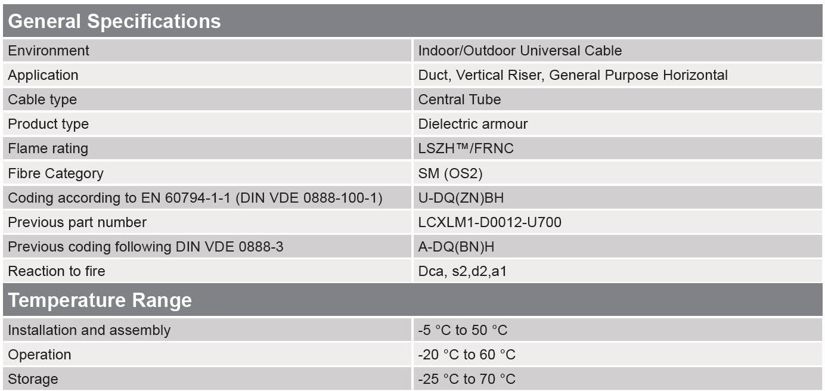
Figure 15: PSS0 FO Cables Specifications

- General composition of FO cables:
Figure 16 shows the general composition of PSS0 FO cables.
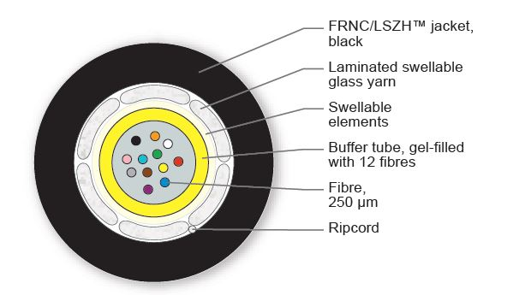
Figure 16: General composition of PSS0 FO cables

- FO cable standards
The FO cables pass the following tests:
- Flame retardant to IEC 60332-1-2 (single cable)
- Reaction to fire according to EN 50575 and EN 13501-6
- Low Smoke to IEC 61034 and Zero Halogen to IEC 60754-1
- Non Corrosive to IEC 60754-2

Abbreviations
AC Alternating Current
AD Accelerator Division
CE Conformité Européenne
CPU Central Processing Unit
DC Direct Current
EMC Electromagnetic Compatibility
EMI Electromagnetic interference
FB Functional Bonding
FEB Front End Building
FO Fibre Optic
G01 Accelerator Tunnel Building
HMI Human Machine Interface
HV High Voltage
HV PS High Voltage Power Supply
ICS Integrated Control System Division
ISrc Ion Source
kV Kilo Volt
M Mega
MCB Miniature Circuit Breaker
NC Normally Closed
NO Normally Open
PB Protective Bonding
PE Protective Earth
PLC Programmable Logic Controller
PSS Personnel Safety Systems
PSS0 Personnel Safety System for ISrc and LEBT Test Stand
RCD Residual Current Device
SPD Surge Protection Device.
UPS Uninterruptible Power Supply
V Voltage

References
[1] ESS Rules for electrical design (ESS-0015433), 2018.
[2] Low-voltage electrical installations - Rules for design and erection of electrical installations (SS 4364000), 2017.
[3] Functional safety – Safety instrumented systems for the process industry sector (IEC 61511), 2016.
[4] Siemens (https://www.industry.siemens.com/topics/global/en/safety-integrated/machine-safety/safety-standards/tabcards/pages/ce-mark.aspx), 2018.
[5] Fortress interlocks (https://www.fortressinterlocks.com/international-approvals), 2018.
[6] Shroff (https://schroff.nvent.com/wcsstore/AuroraStorefrontAssetStore/espots/services_literature_espot/ShroffCatalog-English/12_appendix/12_e_appendix.pdf), 2018.
[7] Phoenix Contact (https://www.phoenixcontact.com/online/portal/gb?1dmy&urile=wcm:path:/gben/web/main/products/technology_pages/subcategory_pages/Safety/152e2fdb-2f77-410e-bdb3-52d3ed77aa29/152e2fdb-2f77-410e-bdb3-52d3ed77aa29), 2018.
[8] ROSS Engineering Corporation (https://www.rossengineeringcorp.com/certifications.html), 2018.
[9] Statement of Work-Supply, Design and Installation of Rack Cabinets (ESS-0085695), 2017.
[10] PSS0 Electrical Circuit Diagram (ESS-0151602), 2018.
[11] Siemens SITOP Selection Tool (https://mall.industry.siemens.com/spicecad/sitop/default.jsp?), 2018.
[12] Siemens Manual, 07/2013, A5E03858068-01, 2013.
[13] Siemens Manual, 07/2013, A5E03858037-01, 2013.
[14] PSS0 Software Planning Document (ESS-0237557), 2018.
[15] European standard; Operation of electrical installations – Part 1: General requirements (SS-EN 50110-1), 2013.
[16] Concept of Operations For the Personnel Safety System 0 (ESS-0134492), 2018.
[17] Interface Control Document for Personnel Safety System 0 and Ion Source (ESS-0237562), 2018.
[18] ACC-FEB-ELEC - PSS Cable trunks G01 - FEB LVL90 (ESS-0149416), 2017.
[19] ACC-FEB-ELEC - PSS Cable trunks G01 - Tunnel LVL9 (ESS-0149419), 2017.
[20] ESS Standardized PLC Equipment, ESS-012727
[21] ESS Approved Electrical Standard Components, ESS-0102876

Document Revision history
Revision | Reason for and description of change | Author | Date
1 | Draft | Morteza Mansouri | 2018-02-07
2 | First Issue | Morteza Mansouri | 2018-05-24
3 | Equipment updates, and updates after external review by ZHAW. The information about monitoring the position of the HV platform doors is removed. | Paulina Skog | 2018-09-27

Appendix 1: PSS0 Network Architecture
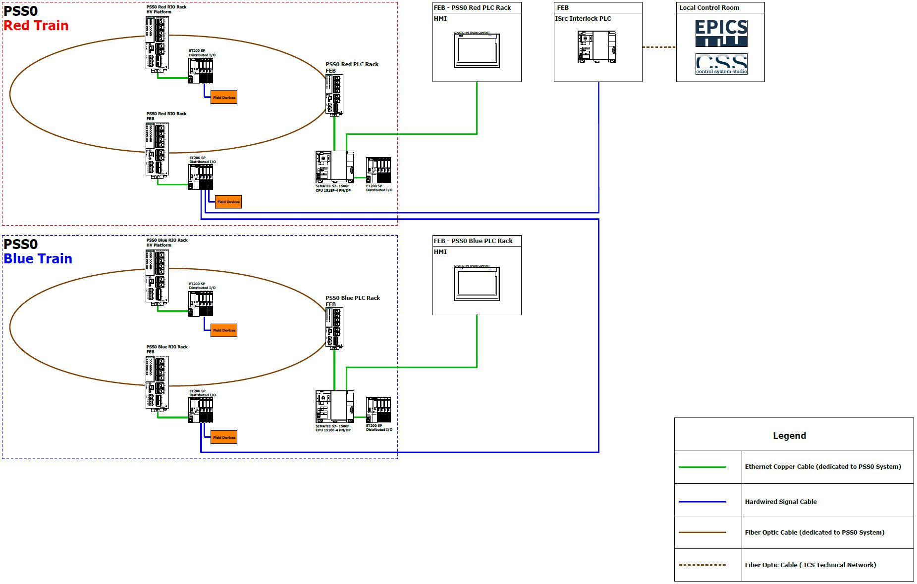
Figure 17: PSS0 Network Architecture.

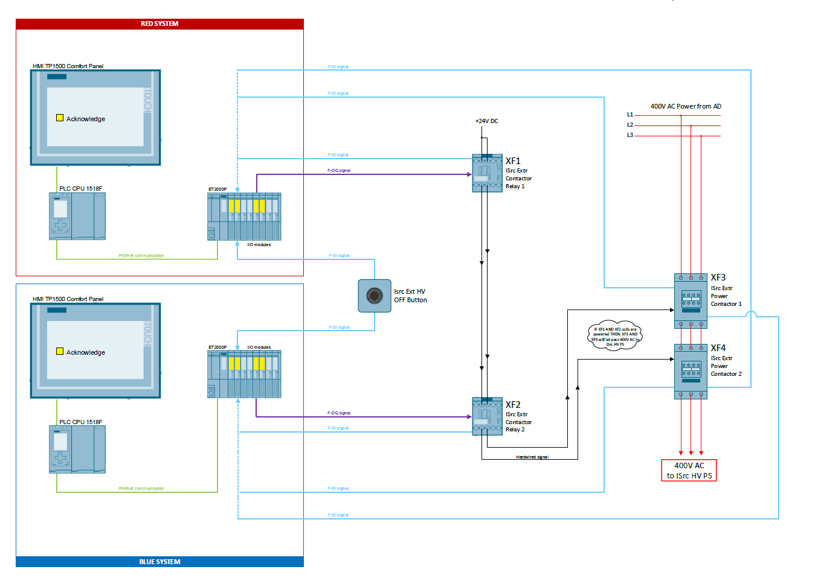
Figure 18: Hardware setup for PSS0 SIF01.

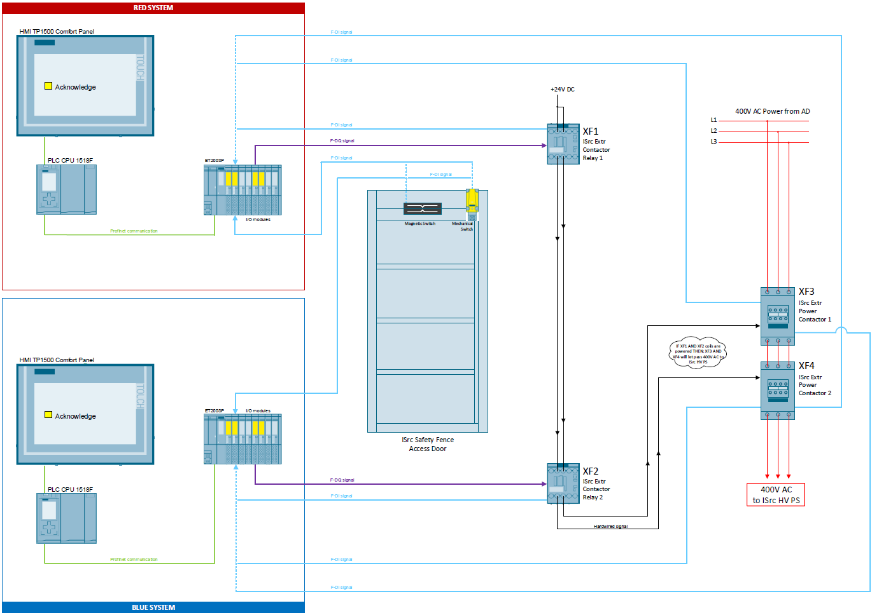
Figure 19: Hardware setup for PSS0 SIF02.
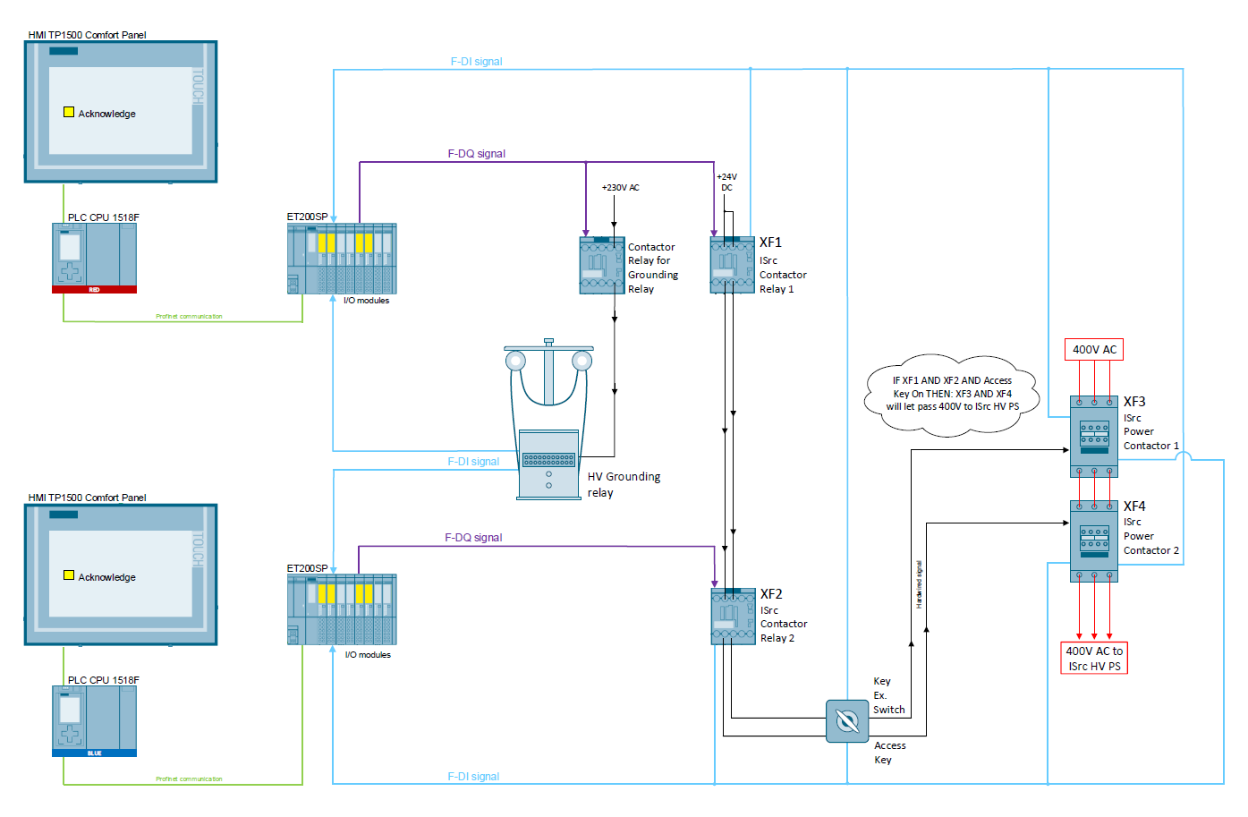
Figure 20: Hardware setup for PSS0 SIF03.

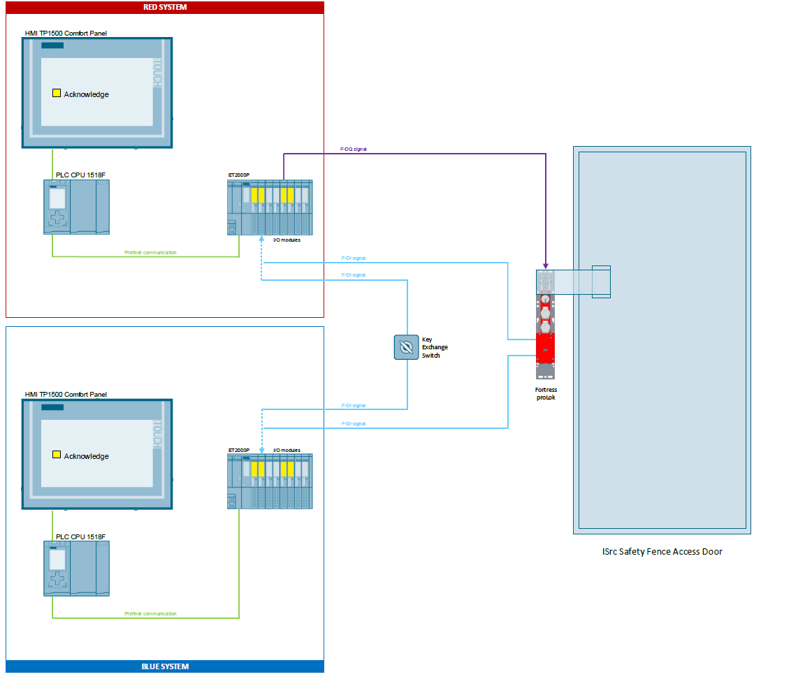
Figure 21: Hardware setup for PSS0 SIF04.

Appendix 2: PSS0 Physical Topology and the overall system architecture and physical layout.
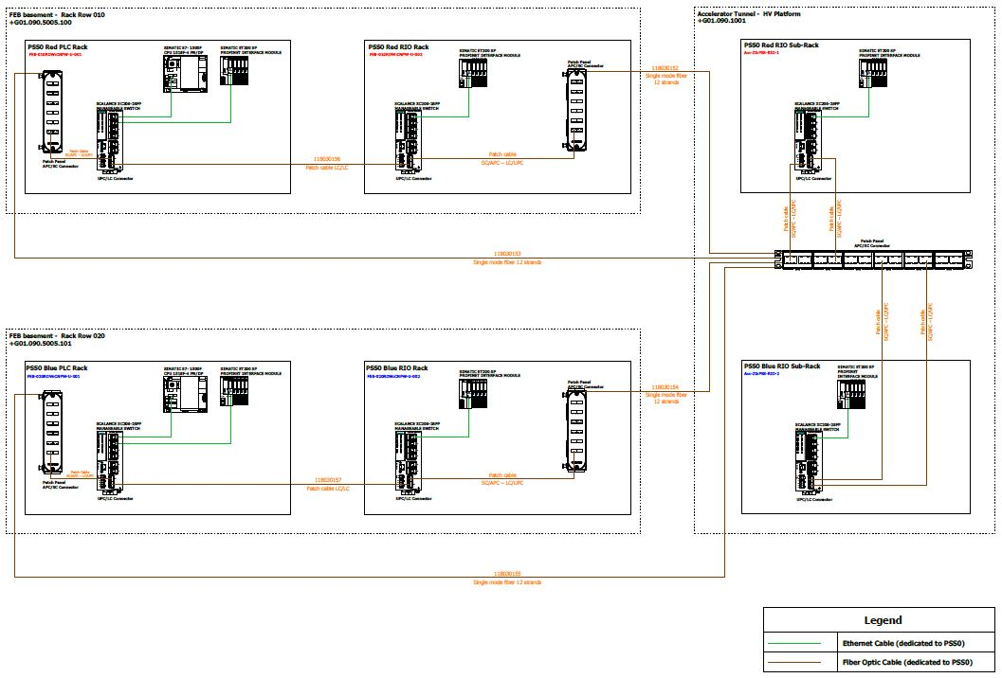
Figure 22: PSS0 Physical Topology

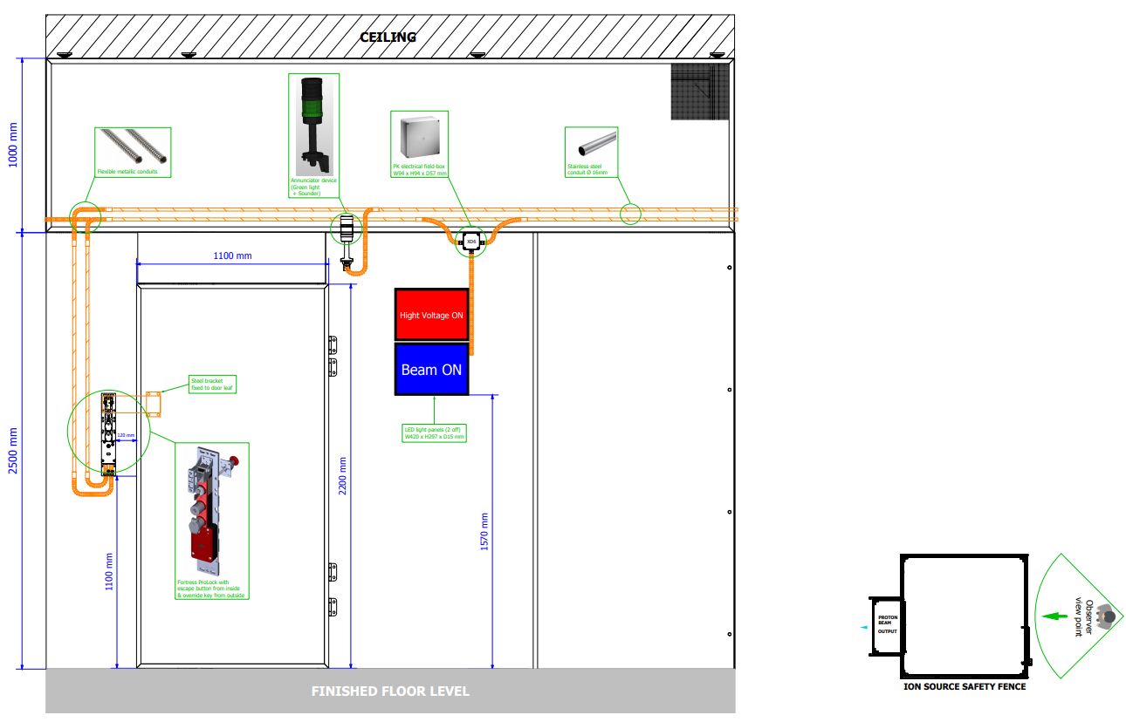
Figure 23: ISrc Safety Fence - view door side (from outside)
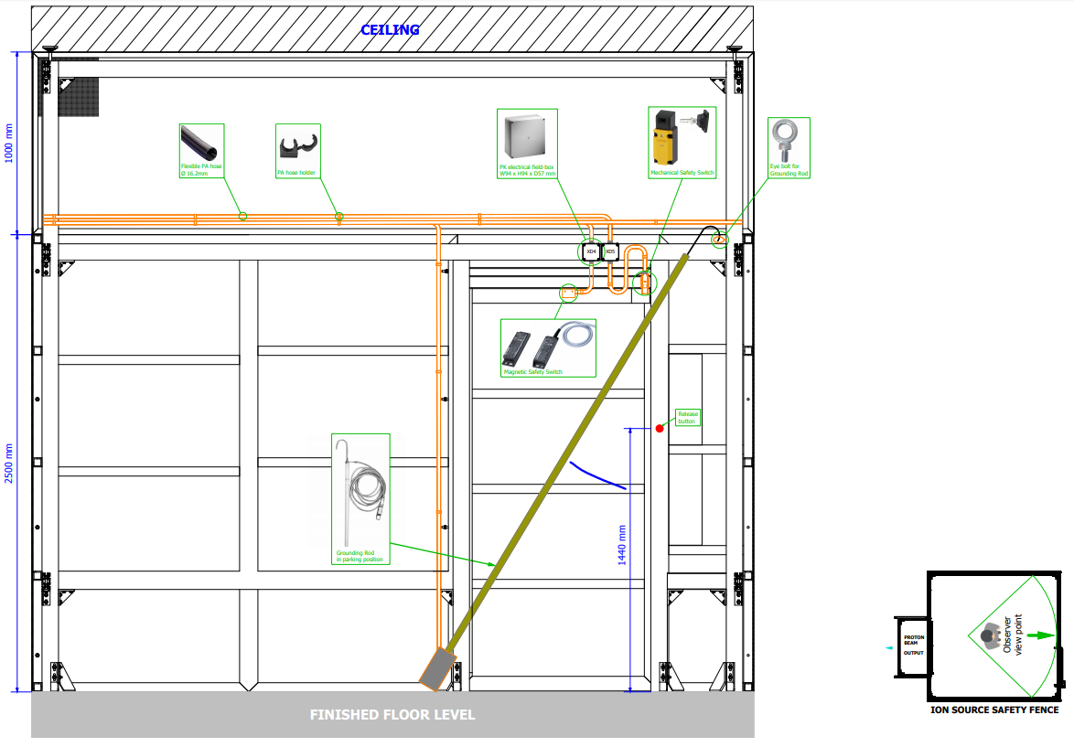
Figure 24: ISrc Safety Fence - view door side (from inside)

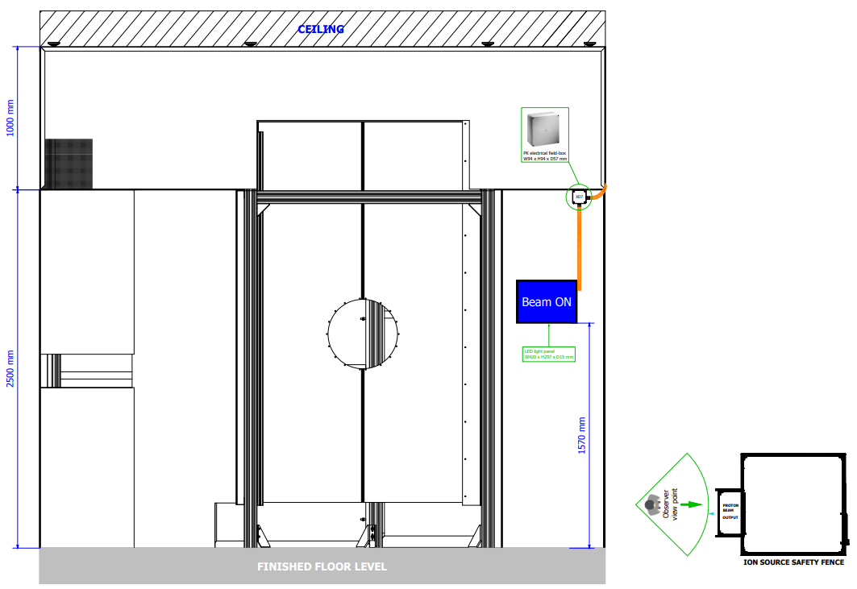
Figure 25: ISrc Safety Fence - view beam output side (from outside)
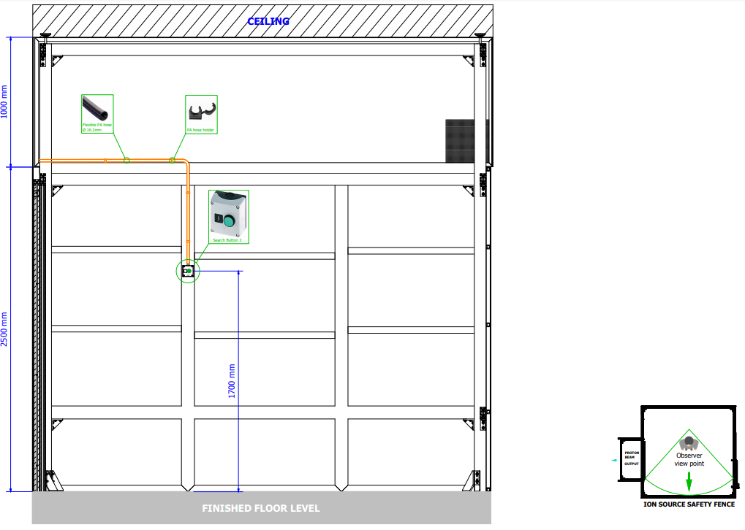
Figure 26: ISrc Safety Fence - view inner left side (by regards beam direction)
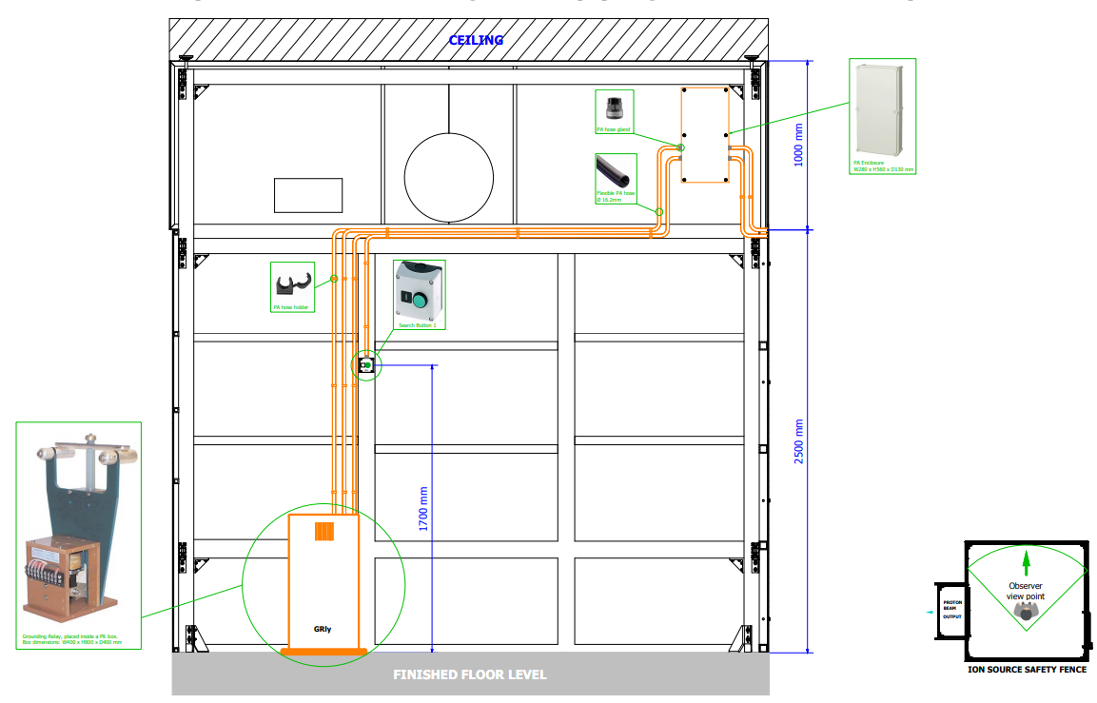
Figure 27: ISrc Safety Fence - view inner right side (by regards beam direction)

Appendix 3: PSS0 Interfaces with ISrc
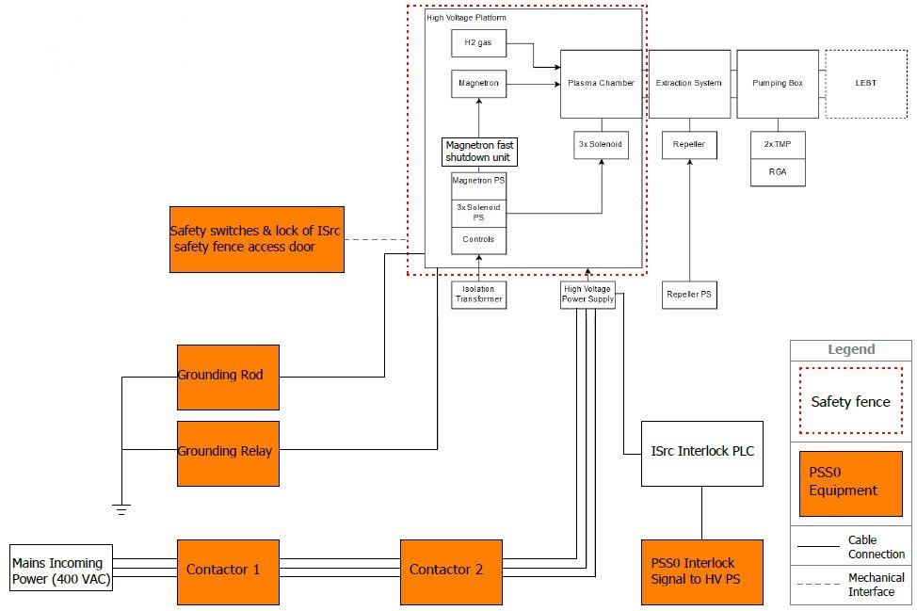
Figure 28: PSS0 Interfaces with ISrc

Appendix 4: PSS0 Equipment Distribution
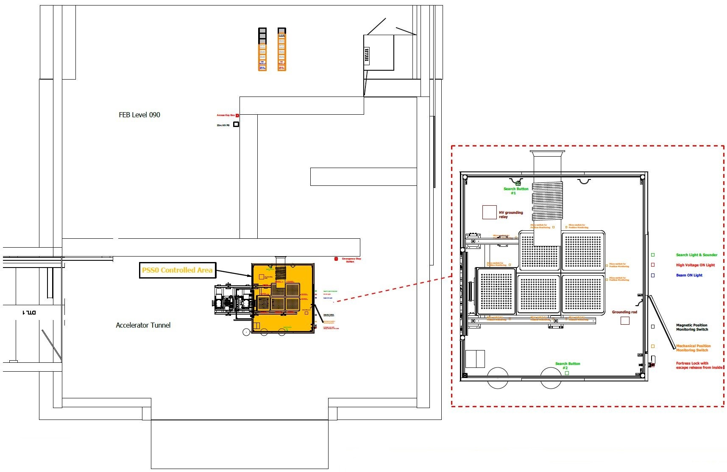
Figure 29: PSS0 Equipment Distribution.

Appendix 5: ISrc HV PS Circuit Diagram
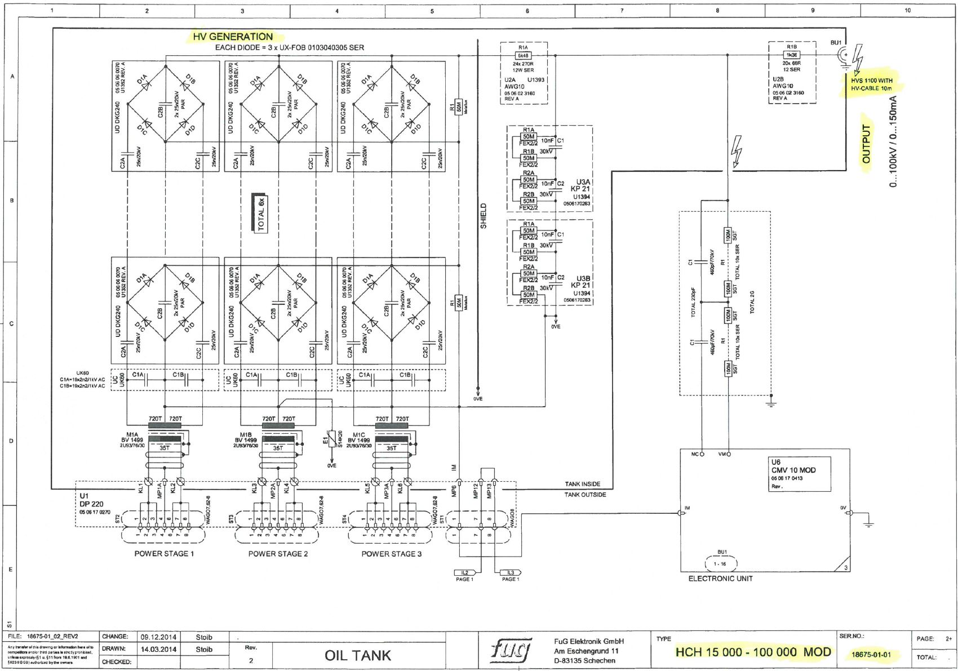
Figure 30: ISrc HV PS Circuit Diagram.

Appendix 6: HV OFF BUTTON PLACEMENT
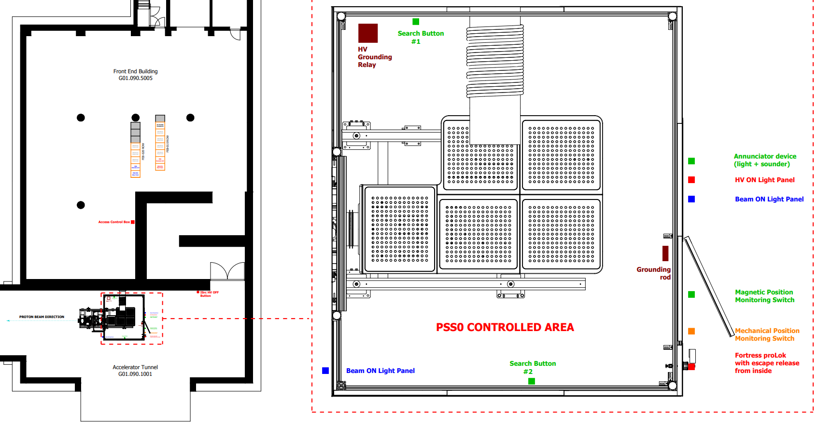
Figure 31: ISrc HV OFF button

