FACTORY ACCEPTANCE TEST report for PSS0:
PLC rack BLUE system
ACC.F01.K01.U9

 | Name | Role/Title
Owner | Stuart Birch | Senior Engineer, Personnel Safety Systems
Author | Alberto Toral Diez | Technician
Reviewer | Mattias Eriksson  Morteza Mansouri | Technician  Lead integrator Engineer for safety critical systems
Approver | Annika Nordt | Protection Systems Group Leader

VALIDATION DATA
Facility Breakdown Structure (FBS):

=ACC.F01.K01-U9

ESS name:
FEB-020Row: CnPw-U-001
CONTACTS
Test and Validation Coordinator: Stuart Birch
Test Leader: Alberto Toral & Mattias Eriksson
PLC Programmer: Morteza Mansouri
ROLES & RESPONSIBILITIES
ROLES |  | RESPONSIBILITIES
 |  | Tests to be performed | SIGNATURE | DATE
Test team |  | clause
- Test and Validation Coordinator | 7 |  | 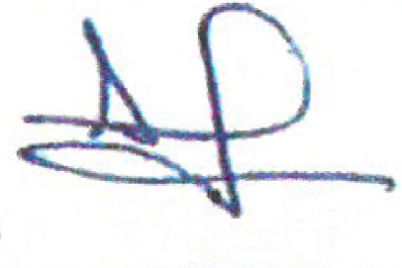  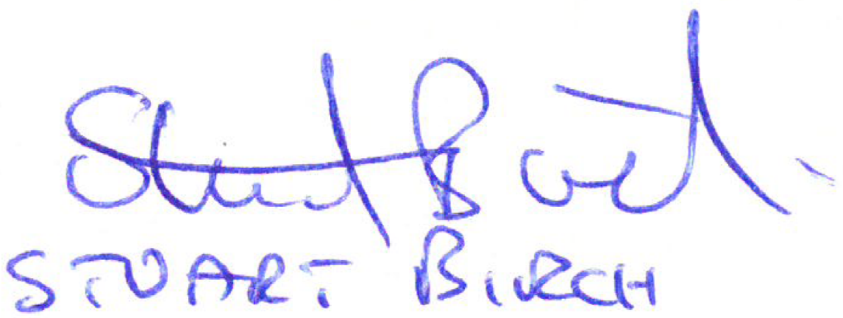  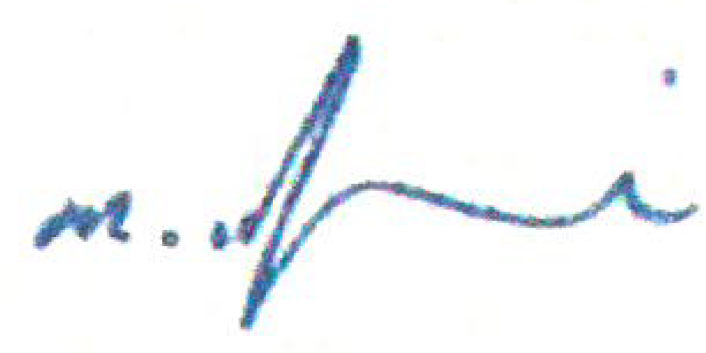 | 2018-02-16
- Test Leader | 1, 2, 3, 4 & 5 |  |  | 2018-02-16
- PLC Programmer | 6 |  |  | 2018-02-16
 |  |  |  | 2018-02-16
 |  |  |  | 2018-02-16
 |  |  |  | 2018-02-16
 |  |  |  | 2018-02-16
 |  |  |  | 2018-02-16
 |  |  |  | 2018-02-16
10. |  |  |  | 2018-02-16

LIST OF REFERENCE DOCUMENTATION
- PSS0 Electrical Circuit Diagram (ESS-0151602)
- ESS Rules for electrical design (ESS-0015433)
- ESS Generic requirements for marking and labelling (ESS-009409)
- SS-EN 62381 Automation systems in the process industry – FAT, SAT and SIT.
- SS-EN 60204-1 Safety of machinery – Electrical equipment of machines – Part 1: General requirements.
- ESS Site Acceptance Test template (ESS-0113711)
- ESS Guideline for Validation Factory Acceptance Test and Site Acceptance Test (ESS-0094204)
LIST OF TEST EQUIPMENT
- Windows laptop with TIA portal installed (V14 SP1)
- FLUKE 705 Current Loop Calibrator 24mA
- FLUKE 375 FC Clamp Meter
- FLUKE 789/IR3000FC Multi Function Calibrator 1A
- FLUKE 1507 Insulation Tester
- Flexible measurement probes

VALIDATION APPROVAL
APPROVED | REJECTED
SIGN: | SIGN:
DATE: 2018-02-16 | DATE: 2018-02-16
TESTS TO BE PERFORMED  Tests to be performed may be adjusted as applicable |  | SUMMARY FINDINGS
 |  | Passed | Not  Passed | NA
      - Check that the electrical equipment complies with the documentation for manufacturing. (according SS EN 60204-1)

      - Check that conditions for protection against indirect contact by automatic disconnection are fulfilled. (according SS EN 60204-1)
      - Check insulation resistance. (according SS EN 60204-1)
      - Check for disruptive discharge occurrence by voltage tests.
(according SS EN 60204-1)
      - Check for residual voltages. (according SS EN 60204-1)
      - Check functions. (according SS EN 60204-1)
      - Punch list.

DETAILED FINDINGS APPROVAL
Check that the electrical equipment complies with the documentation for manufacturing
APPROVED | REJECTED
SIGN: | SIGN:
DATE: 2018-02-16 | DATE: 2018-02-16

Check that the electrical equipment complies with the documentation for manufacturing

Tests to be performed may be adjusted as applicable
- Conductors inside control cabinets (colour, type, end sleeves) mounted according to the documentation for manufacturing
N/A Remark Approved
- Marking of components shall be according to manufacturing documentation. The marking shall still be present even if the component is replaced, which means that the marking is to be located beside the component.
N/A Remark Approved
- Function Markings e.g. above the actuators, operator panel, instruments, etc.
performed according to manufacturing documentation.
N/A Remark Approved
- Components selected according to the manufacturing documentation.
N/A Remark Approved
- Placement of components inside control cabinets made according to production documentation. Mounting layout shall be compared with the control cabinet. For approval the components shall be positioned so that no confusion of components can be made in comparison with the mounting layout.
N/A Remark Approved
- Functional separation inside control cabinets made according to production documentation. Mounting layout shall be compared with the control cabinet. For approval conductors shall be located in the designated conduit / cable path.
N/A Remark Approved
- Marking of equipment a nameplate shall be mounted adjacent to the incoming supply point (main switch or terminal), according ESS-0015433 Rules for electrical design, Clause regarding Marking of cabinets.
N/A Remark Approved
- IP-class shall comply with documentation for manufacturing
N/A Remark Approved
- IP-class 21 (touch-proof) shall be fulfilled inside control cabinet.
N/A Remark Approved
- Functional bonding. Mounting plate shall be galvanized. Colour at connection points for functional bonding must be removed. Connection points for functional bonding shall be threaded and spring washer positioned adjacent to the screw head.
N/A Remark Approved
- Cable Markings shall comply with documentation for manufacturing.
N/A Remark Approved
- Routing of installed cables shall comply with documentation for manufacturing.
N/A Remark Approved
- Cable types shall comply with documentation for manufacturing.
N/A Remark Approved
- Connections of installed cables shall comply with documentation for manufacturing.
N/A Remark Approved
Additional Remarks

Not approved Approved

Not approved Approved

Not approved Approved

Not approved Approved

Not approved Approved

Not approved Approved

DETAILED FINDINGS APPROVAL
Check that conditions for protection against indirect contact by automatic disconnection are fulfilled.
APPROVED | REJECTED
SIGN: | SIGN:
DATE: 2018-02-16 | DATE: 2018-02-16

Check that conditions for protection against indirect contact by automatic disconnection are fulfilled.
Tests to be performed may be adjusted as applicable

Check continuity of the protective bonding circuits
N/A Approved Remark

Check conditions for fault loop impedance by checking that conductor length and area comply with calculation
N/A Approved Remark

Check settings and characteristics of the associated overcurrent protective devices
N/A Approved Remark

Check conditions for protection by reducing the touch voltage below 50V by checking that conductor length and area comply with calculation. NOTE – Equipotential protective bonding conductor area do not need to be larger than 25mm²Cu.
N/A Approved Remark

Additional Remarks

Not approved Approved

Not approved Approved

Not approved Approved

Not approved Approved

Not approved Approved

Not approved Approved

DETAILED FINDINGS APPROVAL
3. Check insulation resistance.
APPROVED | REJECTED
SIGN: | SIGN:
DATE: 2018-02-16 | DATE: 2018-02-16

Check insulation resistance.

Check insulation resistance @ 520

LN Measured value > 500 Mohm Not approved Approved

LPE Measured value > 500 Mohm Not approved Approved

NPE Measured value > 500 Mohm Not approved Approved

Additional Remarks

Not approved Approved

Not approved Approved

Not approved Approved

Not approved Approved

Not approved Approved

Not approved Approved

DETAILED FINDINGS APPROVAL
4. Check for disruptive discharge occurrence by voltage tests.
APPROVED | REJECTED
SIGN: | SIGN:
DATE: 2018-02-16 | DATE: 2018-02-16

Check for disruptive discharge occurrence by voltage tests.

Check for disruptive discharge
N/A Approved Remark

Additional Remarks

Not approved Approved

Not approved Approved

Not approved Approved

Not approved Approved

Not approved Approved

Not approved Approved

DETAILED FINDINGS APPROVAL
5. Check for residual voltages.
APPROVED | REJECTED
SIGN: | SIGN:
DATE: 2018-02-16 | DATE: 2018-02-16

Check for residual voltages.

Check for residual voltages
N/A Approved Remark

Additional Remarks

Not approved Approved

Not approved Approved

Not approved Approved

Not approved Approved

Not approved Approved

Not approved Approved

Not approved Approved

Not approved Approved

DETAILED FINDINGS APPROVAL
6. Check functions.
APPROVED | REJECTED
SIGN: | SIGN:
DATE: 2018-02-16 | DATE: 2018-02-16

Check functions.

Tests to be performed may be adjusted as applicable

Test Supply disconnecting device by switching on and off. In off position, all electrical supply to the controlled equipment shall be isolated. Selected electrical points are measured and checked that no electrical voltage is present. In on position, all electrical components shall be electrically supplied, and CPU, OP, etc. shall automatically go into RUN mode. (Orange conductors are not covered by the test).
N/A Approved Remark

Emergency Stop Function shall disconnect electric supply to equipment according to risk assessment.
N/A Approved Remark

Active-unacknowledged, active-acknowledged, acknowledged inactive- alarm is indicated.
N/A Approved Remark

Equipment shall not restart automatically after power failure. Example, if a local disconnecting device to a motor is operated, etc.
N/A Approved Remark

Additional Remarks

Not approved Approved

Not approved Approved

Not approved Approved

Not approved Approved

Not approved Approved

DETAILED FINDINGS APPROVAL
6. Check functions.

PLC Test of digital inputs N/A
The digital inputs are activated by simulating an activation via the terminals, push buttons, turn feedbacks on solenoids, pumps (contactors), etc.
The activation of a digital input is controlled via the programming tool by checking its status and the applicable functions via the operator panel (e.g. alarms).
Module | Physical address | Description | Approval
KF3 | F-DI0 | fail-safe digital input | N/A Approved Remark
KF3 | F-DI1 | fail-safe digital input | N/A Approved Remark
KF3 | F-DI2 | fail-safe digital input | N/A Approved Remark
KF3 | F-DI3 | fail-safe digital input | N/A Approved Remark
KF3 | F-DI4 | fail-safe digital input | N/A Approved Remark
KF3 | F-DI5 | fail-safe digital input | N/A Approved Remark
KF3 | F-DI6 | fail-safe digital input | N/A Approved Remark
KF3 | F-DI7 | fail-safe digital input | N/A Approved Remark
KF4 | F-DI0 | fail-safe digital input | N/A Approved Remark
KF4 | F-DI1 | fail-safe digital input | N/A Approved Remark
KF4 | F-DI2 | fail-safe digital input | N/A Approved Remark
KF4 | F-DI3 | fail-safe digital input | N/A Approved Remark
KF4 | F-DI4 | fail-safe digital input | N/A Approved Remark
KF4 | F-DI5 | fail-safe digital input | N/A Approved Remark
KF4 | F-DI6 | fail-safe digital input | N/A Approved Remark
KF4 | F-DI7 | fail-safe digital input | N/A Approved Remark
KF5 | DI0 | standard digital input | N/A Approved Remark
KF5 | DI1 | standard digital input | N/A Approved Remark
KF5 | DI2 | standard digital input | N/A Approved Remark
KF5 | DI3 | standard digital input | N/A Approved Remark
KF5 | DI4 | standard digital input | N/A Approved Remark
KF5 | DI5 | standard digital input | N/A Approved Remark
KF5 | DI6 | standard digital input | N/A Approved Remark
KF5 | DI7 | standard digital input | N/A Approved Remark
KF5 | DI8 | standard digital input | N/A Approved Remark
KF5 | DI9 | standard digital input | N/A Approved Remark
KF5 | DI0 | standard digital input | N/A Approved Remark
KF5 | DI11 | standard digital input | N/A Approved Remark
KF5 | DI12 | standard digital input | N/A Approved Remark
KF5 | DI13 | standard digital input | N/A Approved Remark
KF5 | DI14 | standard digital input | N/A Approved Remark
KF5 | DI15 | standard digital input | N/A Approved Remark
KF6 | DI0 | standard digital input | N/A Approved Remark
KF6 | DI1 | standard digital input | N/A Approved Remark
KF6 | DI2 | standard digital input | N/A Approved Remark
KF6 | DI3 | standard digital input | N/A Approved Remark
KF6 | DI4 | standard digital input | N/A Approved Remark
KF6 | DI5 | standard digital input | N/A Approved Remark
KF6 | DI6 | standard digital input | N/A Approved Remark
KF6 | DI7 | standard digital input | N/A Approved Remark
KF6 | DI8 | standard digital input | N/A Approved Remark
KF6 | DI9 | standard digital input | N/A Approved Remark
KF6 | DI0 | standard digital input | N/A Approved Remark
KF6 | DI11 | standard digital input | N/A Approved Remark
KF6 | DI12 | standard digital input | N/A Approved Remark
KF6 | DI13 | standard digital input | N/A Approved Remark
KF6 | DI14 | standard digital input | N/A Approved Remark
KF6 | DI15 | standard digital input | N/A Approved Remark

DETAILED FINDINGS APPROVAL
6. Check functions.

PLC Test of digital outputs N/A
By forcing the digital outputs via the programming tool, the corresponding objects connected to the digital output are activated. Is no object connected to the digital output, the output's activation is controlled by a multimeter connected to the last junction of the output.
Module | Physical address | Description | Approval
KF7 | F-DQ0 | fail-safe digital output | N/A Approved Remark
KF7 | F-DQ1 | fail-safe digital output | N/A Approved Remark
KF7 | F-DQ2 | fail-safe digital output | N/A Approved Remark
KF7 | F-DQ3 | fail-safe digital output | N/A Approved Remark
KF8 | F-DQ0 | fail-safe digital output | N/A Approved Remark
KF8 | F-DQ1 | fail-safe digital output | N/A Approved Remark
KF8 | F-DQ2 | fail-safe digital output | N/A Approved Remark
KF8 | F-DQ3 | fail-safe digital output | N/A Approved Remark
KF9 | DQ0 | standard digital output | N/A Approved Remark
KF9 | DQ1 | standard digital output | N/A Approved Remark
KF9 | DQ2 | standard digital output | N/A Approved Remark
KF9 | DQ3 | standard digital output | N/A Approved Remark
KF9 | DQ4 | standard digital output | N/A Approved Remark
KF9 | DQ5 | standard digital output | N/A Approved Remark
KF9 | DQ6 | standard digital output | N/A Approved Remark
KF9 | DQ7 | standard digital output | N/A Approved Remark
KF9 | DQ8 | standard digital output | N/A Approved Remark
KF9 | DQ9 | standard digital output | N/A Approved Remark
KF9 | DQ10 | standard digital output | N/A Approved Remark
KF9 | DQ11 | standard digital output | N/A Approved Remark
KF9 | DQ12 | standard digital output | N/A Approved Remark
KF9 | DQ13 | standard digital output | N/A Approved Remark
KF9 | DQ14 | standard digital output | N/A Approved Remark
KF9 | DQ15 | standard digital output | N/A Approved Remark
KF10 | DQ0 | standard digital output | N/A Approved Remark
KF10 | DQ1 | standard digital output | N/A Approved Remark
KF10 | DQ2 | standard digital output | N/A Approved Remark
KF10 | DQ3 | standard digital output | N/A Approved Remark
KF10 | DQ4 | standard digital output | N/A Approved Remark
KF10 | DQ5 | standard digital output | N/A Approved Remark
KF10 | DQ6 | standard digital output | N/A Approved Remark
KF10 | DQ7 | standard digital output | N/A Approved Remark
KF10 | DQ8 | standard digital output | N/A Approved Remark
KF10 | DQ9 | standard digital output | N/A Approved Remark
KF10 | DQ10 | standard digital output | N/A Approved Remark
KF10 | DQ11 | standard digital output | N/A Approved Remark
KF10 | DQ12 | standard digital output | N/A Approved Remark
KF10 | DQ13 | standard digital output | N/A Approved Remark
KF10 | DQ14 | standard digital output | N/A Approved Remark
KF10 | DQ15 | standard digital output | N/A Approved Remark

7.PUNCH LIST.
Any incomplete work or nonconformities shall be recorded on the FATpunch list and categorized as follows:
- To be cleared on the spot, FAT to be continue after rectification
- Ongoing rectification during FAT
- FAT to be repeated
- Modifications to be made after FAT, before the system/cabinet/controllers are considered ready for next step
- Remaining work to be rectified
ITEM | DESCRIPTION | RESPONSIBLE | TYPE | COMPLETE
1 | 1.7 Marking of equipment. Missing nameplate | PSS | e | YES
2
3
4
5
6
7
8
9
10
11
12
13
14
15
16
17
18
19
20
21
22
23
24
25

FAT CERTIFICATE

ACCEPTED NOT ACCEPTED

Customer | European Spallation Source ERIC |  | ICS Division, PS Group, PSS - WP14.9
Project | Accelerator Personnel Safety System 0
ESS Name | FEB-020Row:CnPw-U-001 | High level function (FBS) |  | =ACC.F01.K01.U9
Vendor | Processkontroll AB,  AE Actemium Instrumentation | Venue of FAT |  | 444 02 Stora Höga
FAT finished on | 2018-02-16

No punch list items were found | Punch list items were found  (See remarks below or at punch list)
Re-Check necessary | Re-Check NOT necessary
Remarks: Item at punch list corrected
System ready for shipment

Authorized representatives:
Date | 2018-02-16
Name | Alberto Toral Diez | Lars Roswal | Morteza Mansouri | Stuart Birch
Signature | 