KFM 1067 and 1076 - Covers, Penetrations & Monolith Vessel and Proton Beam Window Port Block and Vessel

 | Name | Role/Title
Owner | Anders Andersson | Work Unit Leader, Monolith Systems
Reviewer | Mikael Möller  Mikael Beise | Structural Analyst, Target Division  QC Representative
Approver | Sara Ghatnekar | Work Package Manager, Monolith Systems
INTRODUCTION
An Equipment Specification (or corresponding type of specification) consists of a Design Basis Mechanical (Swedish: Konstruktionsförutsättningar för Mekaniska anordningar, KFM) and a Design Specification Mechanical (Swedish: Konstruktionsspecifikation för Mekaniska anordningar, KSmek).
This document constitutes the Design Basis for system 1067, Covers, Penetrations and Monolith Vessel and system 1076, Proton Beam Window Port Block and Vessel.
The information given herein constitutes the input required for the structural assessment of the system or component.

Table of content | Page
1. System Description 5
1.1. P&ID 5
1.2. System parts 5
2. LEVEL OF IRRADIATION 6
3. APPLICABLE CODE & CLASSIFICATION 6
4. LOADS & OPERATING CONDITIONS 6
4.1. Design pressure and design temperature 6
4.2. Operating pressure and operating temperature 7
4.3. Maintenance pressure and maintenance temperature 7
4.4. Loads at SF1 operating conditions 8
4.5. Normal operating incidents- loads at SF2 operating conditions 9
4.6. Loads at SF3 operating conditions 10
4.7. Loads at SF4 operating conditions 10
5. LOAD COMBINATIONS 11
5.1. Load combinations system part A 11
5.2. Load combinations system part B 11
5.3. Load combinations system part C 12
5.4. Load combinations system part D 12
5.5. Load combinations system part E 13
5.6. Load combinations system part F 13
5.7. Load combinations system part G 13
5.8. Load combinations system part H 14
6. Glossary 14
7. references 15
8. APPENDIX A SYSTEM PARTS 16
9. Document Revision history 16

list of tables
Table 1. Design pressure and temperature. 6
Table 2. Operating pressure and temperature. 7
Table 3. Maintenance pressure and temperature. 7
Table 4. Loads at SF1 operating conditions. 8
Table 5. Loads at SF2 operating conditions. 9
Table 6. Loads at SF3 operating conditions. 10
Table 7. Loads at SF4 operating conditions. 10
Table 8. Load combinations for system part A 11
Table 9. Load combinations for system part B 11
Table 10. Load combinations for system part C 12
Table 11. Load combinations for system part D 12
Table 12. Load combinations for system part E 13
Table 13. Load combinations for system part F 13
Table 14. Load combinations for system part G 13
Table 14. Load combinations for system part H 14

list of Figures
Figure 1 System 1067 and 1076 PFD 16

System Description
For detailed description see reference to System description and/or project specific description/specification, see [1] and [2].

P&ID
See P&ID for system 1076 [3].

System parts
The systems are divided into a number of parts according to Appendix A.
- System part A: Lower and Medium Vessel (LMV)
- System part B: Connection Ring (CC)
- System Part C: Vessel Head (Head)
- System Part D: Proton Beam Window Port Block (PBWPB)
- System Part E: Proton Beam Window Vessel (PBWV)
- System Part F: Moderator Cap, including flange (MCF)
- System Part G: Target Monitoring Cap, including flange (TMC)
- System Part H: Area around the connection between the Connection pipe and the Monolith Vessel (CA)

APPENDIX A SYSTEM PARTS only reports current system limitations and should not be considered complete as a Piping and Instrumentation Diagram (P&ID). For current version see P&ID [3] or the Process Flow Diagram (PFD) [4].

LEVEL OF IRRADIATION
Calculation of irradiation for the system is found in [5], section 6.3.2.
Irradiation for all parts (System parts A-G) of system 1067 and 1076 is considered negligible according to RCC-MRx [6], Subsection Z, Appendix A3.3S.33.

APPLICABLE CODE & CLASSIFICATION
The design work started in accordance to the code framework for safety classified mechanical components (MQC1-3), i.e. RCC-MRx, [6]. However, in the final stage of detail design, the classification was changed to MQC4 [7], [8] and [9].
As a result, EN 13445 and harmonized standards apply for the following stages (installation and operation.)
Since the system parts, described in 1.2, are manufactured in accordance with EN13445, it needs to be demonstrated that the design fulfils the analysis requirements of EN13445-3. If a complete analysis according to RCC-MRx has been conducted, a delta-analysis is sufficient to demonstrate compliance with EN 13445-3.

LOADS & OPERATING CONDITIONS

Design pressure and design temperature
System part | PD (bar(g)) | TD (°C) | Ref. | Remarks
A – LMV | 1 / Vacuum | 80 | [10], [11], [12]
B – CC | 1 / Vacuum | 80 | [10] , [11], [12]
C – Head | 1 / Vacuum | 80 | [10] , [11], [12]
D – PBWPB | 1 / Vacuum | 80 | [10] , [11], [12] | PD for cooling channels = 6 bar(a)
E – PBWV | 1 / Vacuum | 80 | [10] , [11], [12]
F – MCF | 1 / Vacuum | 80 | [10] , [11], [12]
G – TMC | 1 / Vacuum | 80 | [10] , [11], [12]
H – CA | 1 / Vacuum | 200 | [10] , [11], [12] | Preliminary value
Table 1. Design pressure and temperature.

Operating pressure and operating temperature
System part | PO (bar(g)) | TO (°C) | Ref. | Remarks
A – LMV | Vacuum | 50
B – CC | Vacuum | 50
C – Head | Vacuum | 50
D – PBWPB | Vacuum | 50
E – PBWV | Vacuum | 50
F – MCF | Vacuum | 50
G – TMF | Vacuum | 50
H – CA | Vacuum | 150 |  | Preliminary value
Table 2. Operating pressure and temperature.

Maintenance pressure and maintenance temperature
System part | PM (bar(g)) | TM (°C) | Ref. | Remarks
A – LMV | 0 | 35 |  | Max temperature guaranteed by HVAC
B – CC | 0 | 35 |  | Max temperature guaranteed by HVAC
C – Head | 0 | 35 |  | Max temperature guaranteed by HVAC
D – PBWPB | 0 | 35 |  | Max temperature guaranteed by HVAC
E – PBWV | 0 | 35 |  | Max temperature guaranteed by HVAC
F – MCF | 0 | 35 |  | Max temperature guaranteed by HVAC
G – TMF | 0 | 35 |  | Max temperature guaranteed by HVAC
H – CA | 0 | 35 |  | Max temperature guaranteed by HVAC
Table 3. Maintenance pressure and temperature.

Loads at SF1 operating conditions
SF1 operating conditions are normal operating conditions.
Load | Description | A | B | C | D | E | F | G | H | Ref. | Remarks
PO | Operating Pressure |  |  |  |  |  |  |  |  | [1]
TO | Operating Temperature |  |  |  |  |  |  |  |  | [1]
DW | Dead Weight |  |  |  |  |  |  |  |  |  | Loads associated with masses of mechanical devices. Refer to drawings for systems 1067 and 1076.
SF1_NL | Nozzle loads |  |  |  |  |  |  |  |  | Pipe support analysis, not available today | Demonstrating that nozzle is stronger than connecting pipe is acceptable as an alternative to formal stress analysis.
Table 4. Loads at SF1 operating conditions.

Normal operating incidents- loads at SF2 operating conditions
SF2 operating conditions are normal operating incidents, including maintenance.
Load | Description | A | B | C | D | E |  | F | G | H | Ref. | Remarks
SF2_ML | Normal Maintenance Loads |  |  |  |  |  |  |  |  |  | [14] | Loads from equipment, Lifting actions, Machinery actions, Placement actions, Heavy transports, Exchange of heavy components, Process related actions.
SF2_NL | Nozzle loads |  |  |  |  |  |  |  |  |  | Pipe support analysis, not available today | Demonstrating that nozzle is stronger than connecting pipe is acceptable as an alternative to formal stress analysis.
SF2_EQ | Expected Seismic event, H2 |  |  |  |  |  |  |  |  |  | [16] | Ref [16] reports H4 seismic spectra. The H2 seismic spectra may be taken 5 % of the H4 spectra.
Table 5. Loads at SF2 operating conditions.

Loads at SF3 operating conditions
There is not a demand for SF3 verification due to radiological aspects or governmental requirements, however due to economical and operational demands the design shall withstand a H3 event.
Load | Description | A |  | B |  | C |  | D |  |  | E |  | F | G | H | Ref. | Remarks
SF3_NL | Nozzle loads |  |  |  |  |  |  |  |  |  |  |  |  |  |  | Pipe support analysis, not available today | Demonstrating that nozzle is stronger than connecting pipe is acceptable as an alternative to formal stress analysis
SF3_EQ | Seismic event |  |  |  |  |  |  |  |  |  |  |  |  |  |  | [16] | Ref [16] reports H4 seismic spectra. The H3 seismic spectra may be taken 20 % of the H4 spectra. N.B. This is not a formal requirement but an additional requirement.
SF3_TB | Confined System break, release of inventory |  |  |  |  |  |  |  |  |  |  |  |  |  |  | [11]
Table 6. Loads at SF3 operating conditions.

Loads at SF4 operating conditions
There is not a demand for SF4 verification due to radiological aspects or governmental, economical or operational requirements. The SF4 shall be simulated but with no demands on integrity.
Load | Description | A | B | C | D | E |  | F | G | H | Ref. | Remarks
SF4_NL | Nozzle loads |  |  |  |  |  |  |  |  |  | Pipe support analysis, not available today | Demonstrating that nozzle is stronger than connecting pipe is acceptable as an alternative to formal stress analysis.
SF4_EQ | Seismic event, H4 |  |  |  |  |  |  |  |  |  | [16] | The design does not have to withstand this load. However, it shall be analysed.
Table 7. Loads at SF4 operating conditions.

LOAD COMBINATIONS
The sum of the normal operating load group shall be combined with each transient load.

Load combinations system part A
Combination | Rule for combination | Event class | Criteria level | Remarks
A01 | (PD+TD+DW) | SF1 | A
A02 | (PO+TO+DW) | SF1 | A
A03 | (PO+TO+DW) + SF2_EQ | SF2 | A
A04 | (PM+TM+DW) +SF2_ML | SF2 | A
A05 | (PO+TO+DW) +SF3_EQ | SF3 | C
A06 | (PO+TO+DW) +SF3_EQ + SF3_TB | SF3 | C
A07 | (PO+TO+DW) +SF3_TB | SF3 | C
A08 | (PO+TO+DW) +SF4_EQ | SF4 | D
Table 8. Load combinations for system part A

Load combinations system part B
Combination | Rule for combination | Event class | Criteria level | Remarks
B01 | (PD+TD+DW) | SF1 | A
B02 | (PO+TO+DW+SF1_NL) | SF1 | A
B03 | (PO+TO+DW+SF2_NL) | SF2 | A
B04 | (PO+TO+DW+SF2_NL) + SF2_EQ | SF2 | A
B05 | (PM+TM+DW) +SF2_ML | SF2 | A
B06 | (PO+TO+DW+SF3_NL) + SF3_TB | SF3 | C
B07 | (PO+TO+DW+ SF3_NL) +SF3_EQ + SF3_TB | SF3 | C
B08 | (PO+TO+DW+ SF4_NL) | SF4 | D
B09 | (PO+TO+DW+ SF4_NL) +SF4_EQ | SF4 | D
Table 9. Load combinations for system part B

Load combinations system part C
Combination | Rule for combination | Event class | Criteria level | Remarks
C01 | (PD+TD+DW) | SF1 | A
C02 | (PO+TO+DW+SF1_NL) | SF1 | A
C03 | (PO+TO+DW+SF2_NL) | SF2 | A
C04 | (PO+TO+DW+SF2_NL) + SF2_EQ | SF2 | A
C05 | (PM+TM+DW) +SF2_ML | SF2 | A
C06 | (PO+TO+DW+SF3_NL) + SF3_TB | SF3 | C
C07 | (PO+TO+DW+ SF3_NL) +SF3_EQ + SF3_TB | SF3 | C
C08 | (PO+TO+DW+ SF4_NL) | SF4 | D
C09 | (PO+TO+DW+ SF4_NL) +SF4_EQ | SF4 | D
Table 10. Load combinations for system part C

Load combinations system part D
Combination | Rule for combination | Event class |  |  | Criteria level | Remarks
D01 | (PD+TD+DW) |  | SF1 | A
D02 | (PO+TO+DW+SF1_NL) |  | SF1 | A
D03 | (PO+TO+DW+SF2_NL) |  | SF2 | A
D04 | (PO+TO+DW+SF2_NL) + SF2_EQ |  | SF2 | A
D05 | (PM+TM+DW) +SF2_ML |  | SF2 | A
D06 | (PO+TO+DW+SF3_NL) + SF3_TB |  | SF3 | C
D07 | (PO+TO+DW+ SF3_NL) +SF3_EQ + SF3_TB |  | SF3 | C
D08 | (PO+TO+DW+ SF4_NL) |  | SF4 | D
D09 | (PO+TO+DW+ SF4_NL) +SF4_EQ |  | SF4 | D
Table 11. Load combinations for system part D

Load combinations system part E
Combination | Rule for combination | Event class |  | Criteria level | Remarks
E01 | (PD+TD+DW) |  | SF1 | A
E02 | (PO+TO+DW+SF1_NL) |  | SF1 | A
E03 | (PO+TO+DW+SF2_NL) |  | SF2 | A
E04 | (PO+TO+DW+SF2_NL) + SF2_EQ |  | SF2 | A
E05 | (PM+TM+DW) +SF2_ML |  | SF2 | A
E06 | (PO+TO+DW+SF3_NL) + SF3_TB |  | SF3 | C
E07 | (PO+TO+DW+ SF3_NL) +SF3_EQ + SF3_TB |  | SF3 | C
E08 | (PO+TO+DW+ SF4_NL) |  | SF4 | D
E09 | (PO+TO+DW+ SF4_NL) +SF4_EQ |  | SF4 | D
Table 12. Load combinations for system part E

Load combinations system part F
Combination | Rule for combination | Event class |  |  | Criteria level |  | Remarks
F01 | (PD+TD+DW) |  | SF1 | A
F02 | (PO+TO+DW) |  | SF1 | A
F03 | (PO+TO+DW) + SF2_EQ |  | SF2 | A
F04 | (PM+TM+DW) +SF2_ML |  | SF2 | A
F05 | (PO+TO+DW) +SF3_EQ |  | SF3 | C
F06 | (PO+TO+DW) +SF3_EQ + SF3_TB |  | SF3 | C
F07 | (PO+TO+DW) +SF3_TB |  | SF3 | C
F08 | (PO+TO+DW) +SF4_EQ |  | SF4 | D
Table 13. Load combinations for system part F

Load combinations system part G
Combination | Rule for combination | Event class | Criteria level | Remarks
G01 | (PD+TD+DW) | SF1 | A
G02 | (PO+TO+DW) | SF1 | A
G03 | (PO+TO+DW) + SF2_EQ | SF2 | A
G04 | (PM+TM+DW) +SF2_ML | SF2 | A
G05 | (PO+TO+DW) +SF3_EQ | SF3 | C
G06 | (PO+TO+DW) +SF3_EQ + SF3_TB | SF3 | C
G07 | (PO+TO+DW) +SF3_TB | SF3 | C
G08 | (PO+TO+DW) +SF4_EQ | SF4 | D
Table 14. Load combinations for system part G

Load combinations system part H
Combination | Rule for combination | Event class | Criteria level | Remarks
H01 | (PD+TD+DW) | SF1 | A
H02 | (PO+TO+DW+SF1_NL) | SF1 | A
H03 | (PO+TO+DW+SF2_NL) | SF2 | A
H04 | (PO+TO+DW+SF2_NL) + SF2_EQ | SF2 | A
H05 | (PM+TM+DW) +SF2_ML | SF2 | A
H06 | (PO+TO+DW+SF3_NL) + SF3_TB | SF3 | C
H07 | (PO+TO+DW+SF3_NL) +SF3_EQ + SF3_TB | SF3 | C
H08 | (PO+TO+DW+ SF4_NL) | SF4 | D
H09 | (PO+TO+DW+ SF4_NL) +SF4_EQ | SF4 | D
Table 15. Load combinations for system part H

Glossary
Term | Definition
SSM | Swedish Radiation Safety Authority
P&ID | Piping and Instrument Diagram
PFD | Process Flow Diagram
PD | Design Pressure
TD | Design Temperature

See also the official ESS Glossary [15] for further information.

references
- ESS-0042429 – SDD-Sol, System 1067
- ESS-0040693 – SDD-Req, System 1067
- ESS-0145028 – P&ID System 1076
- ESS-0060677 – PFD Monolith Vessel overview
- ESS-0028465 – ESS Target Materials Guide
- RCC-MRx – Design and Construction Rules for mechanical components of nuclear installations: high-temperature, research and fusion reactors. Ed 2012
- ESS-0491827 – 2018-12-06 CCB Minutes of Meeting
- ESS-0047989 – Rules for Quality Regulation – Mechanical Equipment
- ESS-0099097 –Classification Report System 1067
- ESS-0129228 - Thermal and structural analysis of the PB Port Block
- ESS-0390039 – REPORT - teknisk-not-p201804-not017
- ESS-1104434 – Design pressure and design temperature of Monolith Vessel
- ESS-0093301 – Drawings, Lower and Mid Vessel
- ESS-0147192 – Maintenance loads
- ESS Glossary: https://access.esss.lu.se/glossary
- Scanscot PM scte_pid13416_Preliminary_Monolith_ISRS_150820.pdf
- ESS-0006207 Seismic Ground Motion Hazard rev 2

APPENDIX A SYSTEM PARTS
System parts shown below are for information purpose only, to identify system parts.
Before use of Process flow diagram below, please verify its validity in CHESS, see [4].
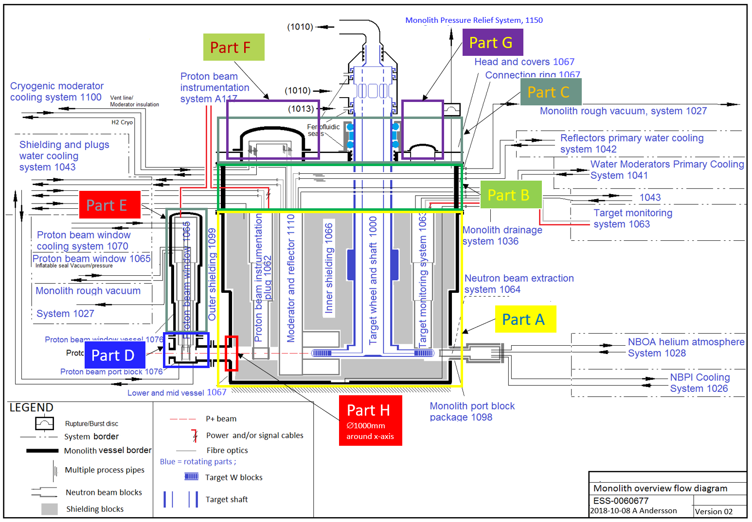
Figure 1 System 1067 and 1076 PFD

Document Revision history
Revision | Reason for and description of change | Author | Date
1 | First issue | Markus Andersson | 2018-05-25
2 | Update of system numbers and references. Change from MQC3 to MQC4.  PD changed from 2 bar(g) to 1 bar(g).  System part H added with a local TD of 200°C.  Notes added to sections 4.2, 4.5, 4.6 and 4.7. | Anders Andersson | 2019-05-14

By scaling H2/H4 bedrock spectra in [17].
By scaling H2/H4 bedrock spectra in [17].

