V20 Beamline Tests Towards DMSC Milestone A2146887130

 | Name | Role/Title
Owner | Andrew Jackson | Instrument Scientist, Neutron Instruments Division
Reviewer | Tobias Richter  Jonathan Taylor  Ken Andersen | Group Leader Experimental Control and Data Curation, Data Management and Software Centre  Head Data Management and Software Centre  Head Neutron Instruments Division
Approver | Shane Kennedy | NSS Project Manager

Table of content | Page
1. Overview 3
1.1. Beamline configuration 3
1.2. Scope of testing 4
2. Test results 5
2.1. Setting Instrument Parameters 5
2.2. Reading Instrument Parameters 5
2.3. Displaying Instrument Status 5
2.4. Performing Simultaneous Actions on the Instrument 5
2.5. Starting and Stopping Data Recording 5
2.6. Displaying detector and monitor output 5
2.7. Performing Scans of Detector and Monitor Counts as a Function of Instrument Parameter 7
2.8. Running a Predefined Sequence of Commands 7
2.9. Recording Data to Disk 7
3. Conclusions 8
4. Glossary 9
5. references 9
6. Document Revision history 9

Overview
This document reports on tests done to validate the neutron instrument control, data acquisition, data processing and data storage systems as being ready for operations. In particular these tests relate to the DMSC transition milestone A2146887130 [1]
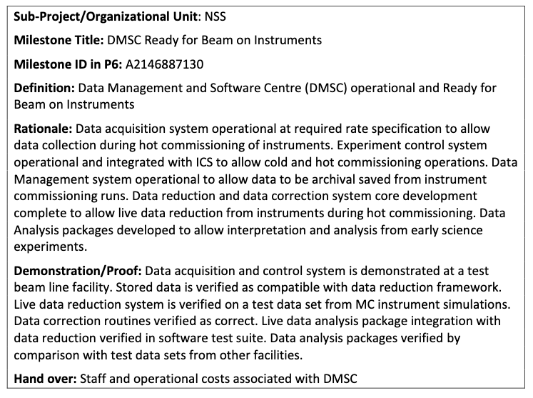
These tests were intended to examine the readiness of the following items from the DMSC transition milestone:
Rationale
- Experiment control system operational and integrated with ICS to allow cold and hot commissioning operations.
- Data Management system operational to allow data to be archival saved from instrument commissioning runs.
Demonstration/Proof
- Data acquisition and control system is demonstrated at a test beam line facility.
The tests were performed on the 6th & 7th September 2019 using the V20 ESS Test Beamline at the Helmholtz-Zentrum Berlin BER II reactor facility.

Beamline configuration
The V20 beamline was configured for powder diffraction as follows:
- 14 Hz, single pulse mode (wavelength frame multiplication choppers parked)
- Bandwidth of XX Å
- Slits at XX m and YY m from source choppers
- Beam monitors at XX m and YY m from source choppers
- Sample position at XX m from source choppers
- 4 samples mounted on a linear translation stage at the sample position :
  - V rod
  - Ni sample in V can
  - NaCaAlF sample in V can
  - Empty V can
- Denex delay-line area detector at 90 degrees from incident beam direction
The experimental control, timing, motion control, detector readout, data streaming and data recording systems were all ESS systems. The chopper controls were not integrated with the ESS controls system.

Scope of testing
The scope of the testing was based on the preliminary design specification of the experimental control project and considered the following :
- Setting instrument parameters
- Reading instrument parameters
- Displaying instrument status
- Performing simultaneous actions on the instrument (e.g. move multiple motors at the same time, move a motor and collect data at the same time)
- Starting and stopping data recording
- Displaying detector and monitor output
- Performing scans of detector and monitor counts as a function of an instrument parameter
- Running a predefined sequence of commands with control logic (“scripting”)
- Recording data to disk in a format that can be processed into a scientifically meaningful output – i.e. the data recorded contains all the information needed to reduce the data.
Additionally the following aspects of the system, not specifically required for the subset of milestone demonstrations considered here, were also tested:
- Processing of the recorded data into a scientifically meaningful output (“data reduction”)
- Live processing of the streaming data into a scientifically meaningful output (“live data reduction”)

Test results
Commentary on the tests performed is given below with an indication of whether the test has passed or failed. A green PASS indicates no caveats or issues were found, and orange PASS indicates that the test was passed with caveats or issues, and a red FAIL indicates the test was failed.

Setting Instrument Parameters
The NICOS experimental control software allowed the setting of instrument parameters and was successfully used to move the linear stage holding the samples to a specific location and to set slit openings. PASS

Reading Instrument Parameters
The NICOS experimental control software allowed the reading and output of instrument parameters and was successfully used to read and output the current position of the sample stage and to read and output the current positions of the slits. PASS

Displaying Instrument Status
The NICOS experimental control software displayed the current status of all of the devices on the beamline, as well as the status of the data writing system. The status updated when the device parameters or system status changed, and provided useful feedback of the current state of the beamline. PASS

Performing Simultaneous Actions on the Instrument
The NICOS experimental control software allowed for concurrent movement of devices and for movement of devices whilst collecting data. PASS

Starting and Stopping Data Recording
The design of the ESS data acquisition system is such that events are always streaming from the beamline systems. Thus the concept of “starting and stopping” data recording is not the same as normally found on current neutron instruments. To start recording data to disk the start_filewriter() command is issued and to stop recording data to disk the stop_filewriter() command is issued. In order to record data to disk for a specified time, these two commands have to be combined with a timer command of some kind (e.g. sleep() ) or with a count() command which also accumulates a histogram of the detectors for display in NICOS. This arrangement provides a great deal of flexibility, but some issues were noted when a new filewriter was started before the exisiting one was stopped, or if not enough time was allowed between issuing a stop_filewriter() command and issuing a start_filewriter() command. Whilst these issues do not affect the operation with respect to the milestone in question, they do represent a significant reliability/robustness issue that needs to be addressed.
It was possible to use the NICOS experimental control software to start and stop data recording, but there were issues with robustness. PASS

Displaying detector and monitor output
The output of the Denex main detector and of the beam monitors was able to be visualised in histogrammed form within NICOS with the issuing of a count() command. However, NICOS was unable to display data from multiple sources at once, but because of the way that data collection is performed in the ESS system, it was possible work around this by issuing a short count command to check the beam monitor and then run a longer count command to accumulate detector counts. PASS
In a time-of-flight instrument, being able to visualise the main detector data as a function of time-of-flight is usually important. NICOS does not have the ability to do this, but Mantid was demonstrated to be able to ingest the live streamed data and produce visualisations of the detector and to process the data to plots as a function of time-of-flight. Whilst this latter part was outside the scope of the testing, it was nonetheless very useful and could form part of the larger proof of DMSC readiness for instrument commissioning. An example of this is shown below, where the live accumulating detector image is integrated along the x-axis to give a plot showing the diffraction lines from the sample in time-of-flight.
Figure 1 : Diffraction pattern in time-of-flight processed from live data stream in Mantid

Performing Scans of Detector and Monitor Counts as a Function of Instrument Parameter
The NICOS scan() and cscan() commands allowed for scanning detector and monitor counts as a function of instrument parameter. This was tested by performing position scans of the linear sample stage to locate the samples. An example of the output from NICOS is shown below. PASS
Figure 2 : NICOS scan on integrated detector counts to find sample position, including peak fitting

Running a Predefined Sequence of Commands
NICOS supports scripting and overnight runs were performed successfully using scripts with loops, variables and other logic. PASS

Recording Data to Disk
Data were successfully recorded to disk and transferred to archival in the ESS SciCat instance. There were some issues with file recording for some of the overnight runs, with the file writer failing to write data to disk. However, these data files were successfully reconstructed from the Kafka log and could be used. Robustness of the file writer needs to be addressed. PASS

Conclusions
The test results can be summarised as follows:
Setting instrument parameters | PASS
Reading instrument parameters | PASS
Displaying instrument status | PASS
Performing simultaneous actions on the instrument (e.g. move multiple motors at the same time, move a motor and collect data at the same time) | PASS
Starting and stopping data recording | PASS
Displaying detector and monitor output | PASS
Performing scans of detector and monitor counts as a function of an instrument parameter | PASS
Running a predefined sequence of commands | PASS
Recording data to disk | PASS

The outcome of these tests was that the Neutron Instruments Division finds that, with the caveats noted, the DMSC systems for neutron instrument control, data acquisition, data processing and data storage are ready for operations and could be used to perform hot commissioning activities neutron instrument.
Caveats:
- Instrument specific work needs to be performed to enable full data processing in Mantid, however this was not within the scope of work leading to the milestone under consideration.
- The issues of reliability and robustness noted during the tests need to be addressed. Whilst the system could be used by an instrument scientist to begin hot commissioning, it is not yet sufficiently reliable or robust for user operations.

Glossary
Term | Definition
DMSC | Data Management and Software Centre

references
- ESS-0109799 – Transition Milestone Catalogue
- ESS-0102794 – Preliminary design specification for the experimental control project

Document Revision history
Revision | Reason for and description of change | Author | Date
1 | First issue | Andrew Jackson | 2019-09-19

