End of construction status report for the data systems and technologY group at DMSC

 | Name | Role/Title
Owner | Jesper Rude Selknæs | Groupleader for Data Systems and Technology
Reviewer | <<Name>> | <<Role/ Title>>
Approver | <<Name>> | <<Role/ Title>>

Table of content | Page
1. Summary 4
2. Introduction 5
3. DST End of Construction milestones 5
3.1. Copenhagen server room (completed) 6
3.2. CUB server room (delayed) 7
3.3. Data link between DMSC and ESS (completed) 8
3.3.1. Data link capacity 9
3.3.2. Data link performance 9
3.3.2.1. Performance testing 9
3.3.2.2. Viability testing 10
4. Conclusion 11
5. Appendix 1 – Copenhagen Data centre 12
5.1. Data-centre layout: 12
5.2. Copenhagen data-centre inauguration event 13
5.3. Copenhagen data-centre verification and validation 14
6. Appendix 2 – on-site data-centre 16
6.1. On-site data-centre layout 16
6.2. Onsite data centre – status 16
7. Appendix 3 – Data link tests 18
7.1. Performance tests 18
7.2. Viability tests 20
7.2.1. Deployment and provisioning test 20
7.2.2. Data transfer 21
8. Glossary 23
9. references 23
10. Document Revision history 24

list of tables
Table 1: Status for construction milestones for the Data systems and Technology Group 5
Table 2: Timeline for Copenhagen data-centre 6
Table 3: Planned Copenhagen data-centre capacity build-outs 7
Table 4: Timeline for construction of on-site data-centre 8
Table 5: Planned site data-centre capacity 8
Table 6: Sample data transfer tests 21

list of Figures
Figure 1: Data-centre layout - phase 1 (8 racks, 150kW), completed in 2019. 12
Figure 2: Data-centre layout - phase 3 (30 racks, 300kW), planned for 2025. 12
Figure 3: Inauguration event 13
Figure 4: Data-centre racks (left) - Free-cooler and chiller (right) 13
Figure 5: Symbolic joining of the ethernet connectors between Denmark and Sweden - co-hosts to the European Spallation Source: FROM LEFT: Hans Müller Pedersen (Director General of the Danish Agency for Science and Higher Education), John Womersley (Director General of ESS), Andreas Schreyer (ESS Director for Science), Kurt Nørgaard Clausen (Vice Chair of the ESS Council) and Jonathan Taylor (Head of DMSC). 14
Figure 6: Design layout for the on-site data-centre (located in H01, Central Utilities Building) 16
Figure 7: Onsite data-centre under construction (pictures from Nov. 11, 2019) 17
Figure 8: H01 (CUB) building - May 24, 2017. Data-centre is located in the corner (left) of the building. 17
Figure 9: Performance test from Dec. 4-9, 2019 – both forward and reverse direction are shown. 18
Figure 10: Same as above - reverse direction only (for clarity) 19
Figure 11: Same as earlier - forward direction only (for clarity) 19
Figure 12: Throughput plots from switch monitoring 20
Figure 13: Sample screenshot showing Mantid visualisation as part of a Live Data workflow, following server provisioning through the data link 21

Summary
This document describes the status for the Construction phase milestones for the Data Systems and Technology Group at DMSC.
The DST milestones concern readying sufficient current and future capacity for DMSC to handle Commissioning and Operations in terms of:
- Data-centre capacity on site (H01, CUB) – power, cooling, rack-space
- Data-centre capacity in Denmark (COBIS) – power, cooling, rack-space
- Dedicated network link connection (Site-to-Denmark)
Data-centre capacity on site – delayed, but mitigated for EoC
The main DMSC data-centre on site (in H01, CUB) is still under construction, and will first be available in March 2020. To mitigate this, temporary capacity has been installed in a secondary location (a G02 comms room).
With the current schedule, DST is confident that viable on-site data-centre capacity will be available well before it is needed for the start of commissioning of instruments.
When the data-centre construction has finished, it is expected (according to current projections) to have sufficient on-site capacity until at least 2035.
It is expected that DMSC hardware can be installed from March 2020 and onward.
Data-centre capacity in Denmark (COBIS) – completed
The main DMSC data-centre in Denmark (located at DMSC premises, COBIS) was ready for installation of DMSC hardware in August 2019. The remaining part of the Site Acceptance Test (monitoring) was passed in November 2019.
It is expected that the current capacity will be sufficient for commissioning until 2022, whereupon subsequent planned construction phases (provisionally set for 2022 and 2025) will scale up the available capacity to meet requirements for Operations.
Dedicated network link connection – completed
A dedicated network link (L2 MPLS) between site and the DMSC data-centre in Denmark was established in August 2019. The link connection is provided by Nordic research network organisations (NORDUNET, SUNET, DeIC).
The current capacity of the link is 10 Gb/s, which is expected to be sufficient for commissioning until at least 2022. An upgrade plan is in place for a seamless upgrade to 100Gb/s (and later, up to 400 Gb/s), when needed.
End-of-Construction tests – passed
A number of tests have been performed to evaluate the viability of the setup – particularly tests of the performance and fitness-of-purpose of the dedicated network link. On basis of the results of these tests, DST is confident that the network link will be viable, at least, for the duration of commissioning and Initial-Ops. To determine the long-term viability for full Operations, a longer duration (1+ yr) monitoring base-line of performance stability is required. Monitoring tools for this purpose have been implemented and are currently active.

Introduction
In the following sections the relevant end-of-construction milestones are described together with the applicable tests that have been performed of the data link.
The DST end-of-construction milestones have been derived from the general DMSC end-of-construction milestone of being ‘ready-for-beam-on-instruments’. The DST contribution to reach this DMSC goal has been to ensure that sufficient and adequate facility infrastructure was in place in the form of data-centre hosting capability (on site and in Denmark) and as a viable data link between the data-centres.
Due to a delay on the readiness of the CUB sever room in Lund provisions have been made to ensure that DST meets its milestones without relying on the CUB server room before February 2020.

DST End of Construction milestones
This section provides an overview of the DST construction phase milestones in table 1 followed by in-detail descriptions of each category of milestones.
Table 1: Status for construction milestones for the Data systems and Technology Group
Milestone | Deadline | Status
CPH Server room - Start procurement | 2018-08 | Done - Tender published 2018-10
CPH Server room - Procurement completed | 2018-12 | Done – contract awarded on 2018-12-14
CPH Server room tested and validated | 2019-04 | Done (delayed) – SAT completed Nov. 2019
Hardware and link installed and configured | 2019-04 | Done - Level 2 connectivity was established in April 2019.
CUB access date | 2018-06 | Delayed – expected date for completion 2020-03
CUB Ready for Installation of hardware | 2019-01 | Delayed – expected date for completion 2020-03
DMSC hardware installed in CUB | 2019-04 | Delayed – expected date for completion 2020-03

Copenhagen server room (completed)
The building of the Copenhagen data-centre was delayed in relation to the initially formulated milestones, partly due to updated schedules and partly due to needs for further detailed requirements/site analyses and budget clarifications.
For reference, the timeline for the construction of the Copenhagen data-centre can be seen in Table 2.
Table 2: Timeline for Copenhagen data-centre
Project phase | Date
Open Call for Tender (OCT) published | 2018-10
OCT closing date | 2018-12
Contract awarded | 2018-12
Construction started | 2019-02
DMSC access (Partial delivery) | 2019-08
Data-centre verified and validated (SAT completed) | 2019-11
Full power connected (150kW – phase 1) | 2020-01

Access for installation was obtained on 23th of August 2019 – three weeks earlier than required in the contract (signed in January 2019).
Final project cost ended at 63% of budgeted cost, with about 1% additional cost used for contingencies (items that were additional to the scope of the initial budget) connected to the data-centre construction.
The current, initial, phase of the data-centre build-out provides a capacity of 150kW distributed over 8 racks. The initial phase has at this stage, by design, only redundancy on certain systems (e.g. the UPS is for now only provided by batteries, and does not include a diesel genset), providing an acceptable level of reliability and capacity for services during instrument commissioning. Further build-out phases have been designed (and budgeted) and are planned to be implemented when necessitated by capacity and reliability requirements.
In accordance with the current instrument and Operations schedule, the next phases of the data-centre build-out can be seen in Table 3 (with preliminary dates indicated).
The capacity requirements are from an analysis of forecasted requirements of compute and storage based on current estimates of future data production rates and processing needs.
The planned build-outs in phase 2 and 3 can be performed without downtime.
The future phase 3+ (in Table 3) with an upgrade to 600 kW, has been prepared in the design so the current cable and pipe infrastructure is ready and will not have to be replaced – some downtime (a few days) will be required for updating the main power switchboards, though.

Table 3: Planned Copenhagen data-centre capacity build-outs
Capacity phase | Redundancy |  | Power | Rack-space | Date
Phase 1 | N+1 (partial) |  | 150 kW | 8 racks | 2019
Phase 2 | N+1 (full) |  | 200 kW | 16 racks | 2022
Phase 3 | N+1 (full) |  | 300 kW | 30 racks | 2025
Phase 3+ | N+1 (full) |  | 600 kW | 30 racks | 2030+

See Appendix 1 for details on the Copenhagen data-centre layout, pictures and commissioning (verification and validation).

CUB server room (delayed)
The process of procuring and building the CUB server room has been driven by ICS with DMSC as a stakeholder. This process has been unexpectedly prolonged due to issues with scope ownership between ICS, DMSC and IT on one side and CF on the other side. While these issues have been largely ironed out, it has caused a considerable delay which, from a DMSC perspective, has been partly mitigated by temporarily hosting initial DMSC systems on site at a comms rooms in the G02 building (the room was available for installation of DMSC hardware in early November 2019).
The contingency measure of access to this temporary hosting capacity in the G02 comms room has been facilitated through the kind assistance of ICS.
While this temporary hosting will cause added work of migrating server hardware when the CUB server room does become operational, it has enabled DMSC to perform performance and viability tests of the data link for use for meeting the end-of-construction milestones.
Construction of the on-site data-centre is currently underway, and is expected to be completed by January 2020.
Power and cooling to the on-site data-centre is provided by CF. Current schedule sets that implementation of these utilities are completed by March 2020.
Based on these schedules, it is expected that DMSC will have access to install hardware in the on-site data-centre by March 2020.
The timeline of the on-site data-centre can be seen in Table 4.
Table 4: Timeline for construction of on-site data-centre
Project phase | Date
Open Call for Tender (OCT) on design published | 2018-01
Design contract awarded | 2018-02
Design completed | 2018-06
OCT on construction published | 2018-12
Construction contract awarded | 2019-04
Construction started | 2019-06
Data-centre verified and validated (SAT completed) (expected) | 2020-01
Redundant power and cooling installed (expected) | 2020-03
DMSC access (expected) | 2020-03

The designed capacity of the site data-centre can be seen in Table 5 – both the full capacity, and the preliminary division between stakeholders. A future sharing of capacity (as needed) is planned/expected (e.g. IT currently foresees using no more than 4-6 racks, potentially allowing for oversubscription by the other stakeholders).
Table 5: Planned site data-centre capacity
Component | Redundancy |  | Power | Rack-space | Date
Full capacity | N+1 (full) |  | 440 kW | 36 racks | 2020-02
DMSC enclosure |  |  | 240 kW | 12 racks
ICS enclosure |  |  | 100 kW | 12 racks
IT enclosure |  |  | 100 kW | 12 racks

See Appendix 2 for details on site data-centre layout and recent pictures.

Data link between DMSC and ESS (completed)
The data link between DMSC in Copenhagen and the ESS site in Lund has been established. The work is divided between three Nordic research network providers such that the cross-Nordic research network provider NORDUNET provides a redundant level 2 VPN-based MPLS network which DMSC will connect to from the Danish side through the Danish Research Network (managed by the Danish national provider DeIC) and from the Swedish side through the Swedish research network (managed by the Swedish national provider SUNET).
An agreement has been made with the providers where NORDUNET is operating as the main point of contact for ESS for invoicing and support tasks concerning the link, greatly simplifying the supplier management process for ESS.

Data link capacity
The currently contracted bandwidth of the link connection is 10 Gb/s. The bandwidth is dedicated – i.e. the providers do not oversubscribe or impose quality of service on the link, but pledge to make the full capacity available, regardless of actual usage.
Based on current schedule and expected data production rates of ESS instruments, it is estimated that 10Gb/s bandwidth for the link will be sufficient during first commissioning (i.e., at least until 2022).
The providers are ready to upgrade the link bandwidth to 100Gb/s when needed, and inform us that they likely will wish to upgrade by 2022 in any case (in order to standardise their equipment).
In case additional bandwidth is needed after instruments have been commissioned (and Operations has commenced), the providers can supply us with multiple connections as needed (before needing to upgrade to 400Gb/s).

Data link performance
The temporary on-site hosting capacity provided by the G02 comms room has enabled the installation of DMSC hardware on site that has allowed for thorough performance and viability testing of the data link.

Performance testing
Based on a 1 month baseline profile (with sustained performance testing through e.g. the PerfSonar network suite) from November 2019 to December 2019, the data link has been found to be very stable, and with good performance parameters - though, further extended measurements are required to be able to fully determine the long-term viability of the data-link.
The sustained performance tests show:
- Throughput: 9.0 – 9.3 Gb/s measured in each direction (passed)
As the expected maximum throughput for this setup (based on equipment (no advanced network fine-tuning) and protocol used (TCP, with default packet-size) would be at 9.3 Gb/s, the measured, sustained, throughout meets expectations.
Based on current observations, the link throughput quality is estimated to be acceptable for commissioning and onward.
- Latency: 0.5-3 ms measured in both directions (passed)
This is very good (the light-speed distance of the data link alone accounts for ~0.2 ms). For comparison, two physical servers in the same rack connected to same switch over ethernet might have latency values of 0.1-0.2 ms. In our current VM environment, two VMs on different hosts may typically have latency values of 0.3-0.4 ms.
During the baseline tests, a number of shorter-duration periods with increased latency values have been observed. Further analysis will help determine whether these periods are externally triggered, or are a side-effect of the testing methodology/equipment used.
Overall, based on current observations, the data link latency values are firmly within acceptable values for use with the current network design topologies, and are deemed acceptable for commissioning and onward.
- Measured packet loss: 0% (passed)
During periods of non-saturation of the link, we do not detect packet-loss.
During periods of saturation, we do detect a low level of packet-loss (<0.05%), but this is expected with the testing methodology and equipment used for the test.
Additionally, we have not detected problems with error or discarded packets.
Based on current observations on packet loss, the link quality is deemed acceptable for commissioning and onward.

Viability testing
In addition to the performance tests, a number of viability tests have been performed on the setup.
Based on these basic viability tests, the data link is deemed to be viable for the intended use of providing a reliable, performant data transfer link between the site and Copenhagen data-centres, though, further extended measurements are required to be able to fully determine the long-term viability of the data-link.
The viability tests included:
- Provisioning and Deployment (passed) – the servers installed on site were seamlessly integrated into the existing DST provisioning and deployment infrastructure located in Copenhagen, and were enrolled into the pre-configured LDPC testing infrastructure. LDPC operations could subsequently be executed in good order on the on-site installed hardware (independent of the Copenhagen systems).
- File transfer (passed) – a number of basic data transfer operations have been performed across the link without causing issues. Operations/protocols/tools tested include:
  - scp
  - rsync
  - nfs
  - fio
- the highest throughput over the link that could be achieved under these file transfer tests were ~931 MB/s (using a synthetic transfer) (this value is below, but relatively close to the expected maximum of ~1 GB/s). When taken together with the performance tests of the link, it is suspected that the difference encountered here originate from limitations in the current (old) DMSC interim cluster infrastructure used for the test, rather than from performance limitations in the data link.
Subsequent tuning and analysis, together with newer hardware, will help determine the structure of the limitations.
In any case, though, based on projected data rates, a throughput of >900 MB/s is expected to be a more than sufficient bandwidth for the commissioning and SOUP phases.
See Appendix 3 for further details on the performance and viability tests.

Conclusion
Based on the status of the milestones, DST have completed End-of-Construction with respect to the first four milestones (Copenhagen data-centre and data link), and expect to have the milestones related to the on-site (CUB) data-centre completed by March 2020.

Appendix 1 – Copenhagen Data centre
Primary functions of the Copenhagen data-centre:
- Main storage
- Offline environment (post-experiment Data-Analysis-as-a-Service)
- Main infrastructure
- Development environment
- Services (e.g. data portal)

Data-centre layout:
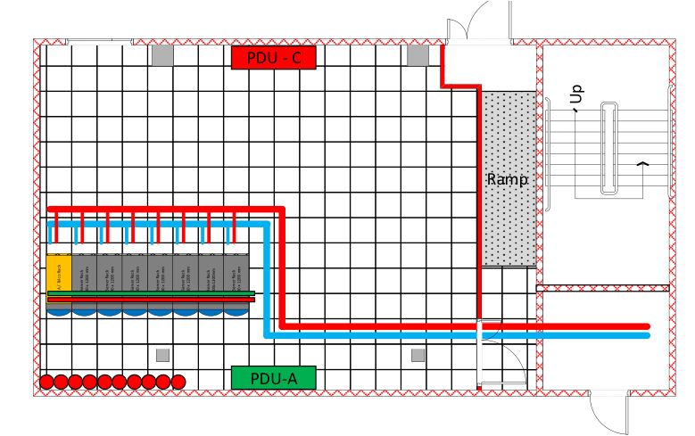
Figure 1: Data-centre layout - phase 1 (8 racks, 150kW), completed in 2019.
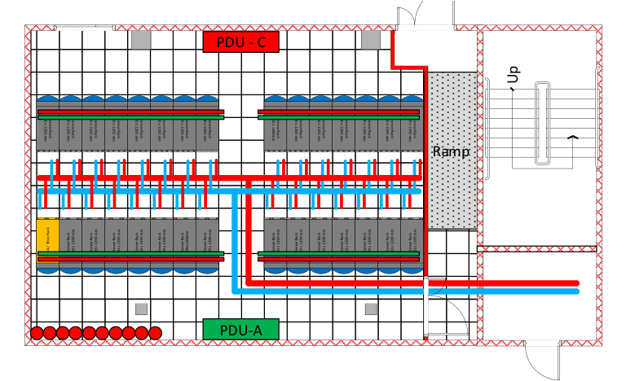
Figure 2: Data-centre layout - phase 3 (30 racks, 300kW), planned for 2025.

Copenhagen data-centre inauguration event
The official inauguration of the Copenhagen data-centre took place on October 21, 2019, with 70 guests from ESS partner organisations, universities etc., including representatives from the Danish ministry and ESS council.
More detail of the event in the ESS news article (29/10 -19):
https://europeanspallationsource.se/article/2019/10/29/ready-turn-data-discoveries
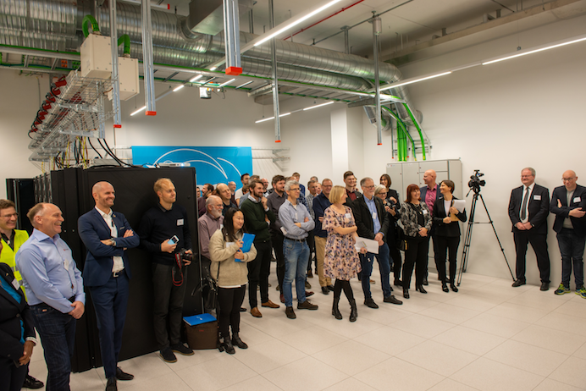
Figure 3: Inauguration event
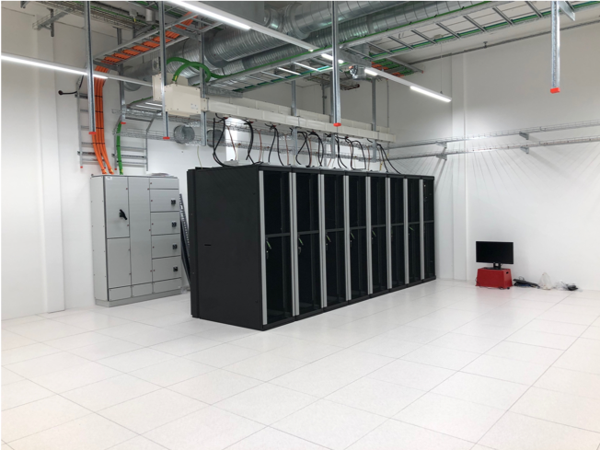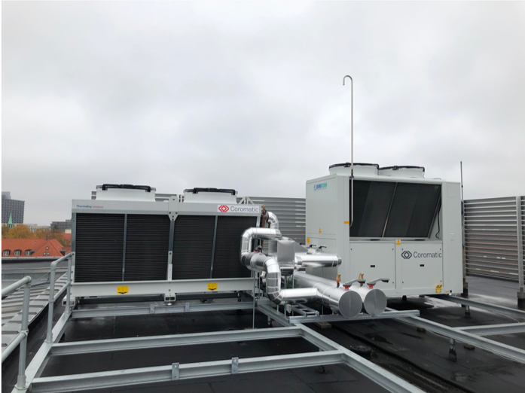
Figure 4: Data-centre racks (left) - Free-cooler and chiller (right)

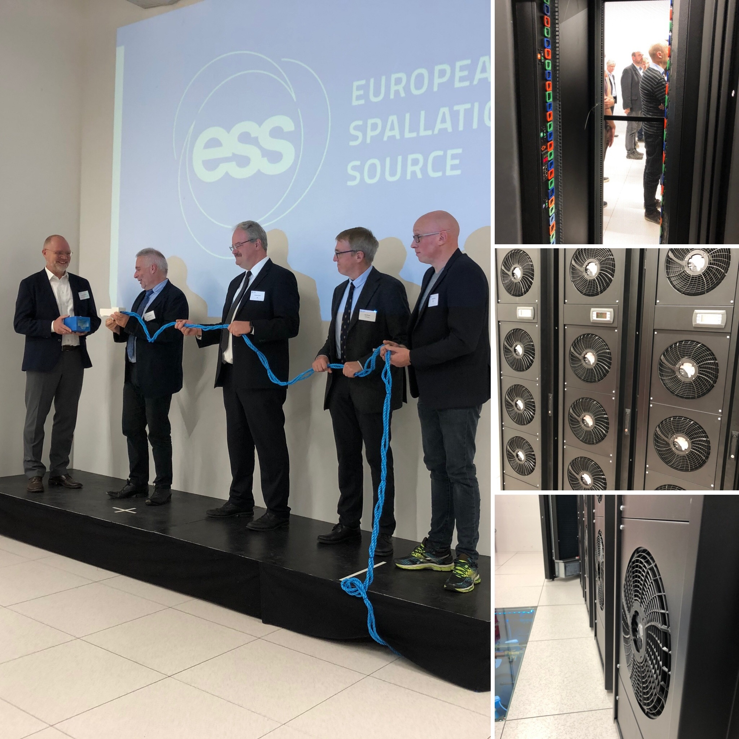
Figure 5: Symbolic joining of the ethernet connectors between Denmark and Sweden - co-hosts to the European Spallation Source: FROM LEFT: Hans Müller Pedersen (Director General of the Danish Agency for Science and Higher Education), John Womersley (Director General of ESS), Andreas Schreyer (ESS Director for Science), Kurt Nørgaard Clausen (Vice Chair of the ESS Council) and Jonathan Taylor (Head of DMSC).

Copenhagen data-centre verification and validation
The Copenhagen data-centre verification & validation was performed as a Site Acceptance Test, where the various components were tested according to a pre-defined testing scheme.
The SAT included 8 main points:
- Visual inspection of all facilities and components
- Normal operations (e.g. verification of measured temperatures within design parameters)
- Test of error-states (e.g. triggering of correct alarms at service outages or flood-/leakage-detection)
- Redundancy test of power infrastructure at interruption/outage of mains power
- Capacity-test at full load of cooling and UPS-system according to design parameters
- Test of active rear-door heat-exchange function at interruption of power
- Test of chiller at load
- Test of free-cooler function, including bypass
The report on the Site Acceptance Test (available in Danish only) is available upon request.
Testing points 1,2,4,6-8 were passed at first SAT session on Aug. 21, 2019, where test 3 (monitoring) was postponed due to interfacing challenges with the monitoring system, and test 5 (full load test) partly failed (sufficient UPS battery capacity was not supplied for the required amount of time for the specified partial load).
During a follow-up test on Sep. 4, 2019, test 5 fully passed (the issue was caused by a configuration setting in the UPS module that caused the UPS to cut out at low power-draws – changing this setting enabled the UPS-system to pass the duration test).
After extended configuration of the modbus communication interfaces, monitoring systems came online and test 3 was passed on Nov. 29, 2019.

Appendix 2 – on-site data-centre
Main DMSC functions of the on-site data-centre:
- Online environment (capacity/hosting)
  - Data acquisition (DAQ)
  - Experiment control
  - Data-Analysis-as-a-Service for active experiments
- Failover services
- Secondary storage

On-site data-centre layout
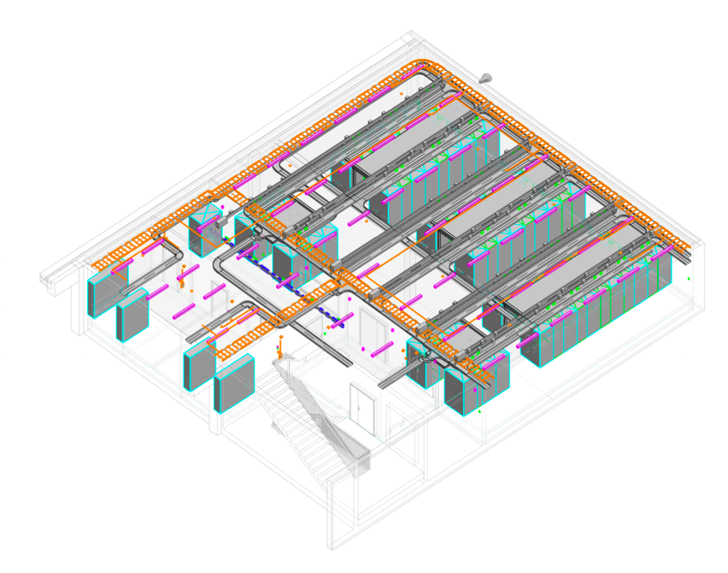
Figure 6: Design layout for the on-site data-centre (located in H01, Central Utilities Building)

Onsite data centre – status
Construction work on the onsite data-centre is currently ongoing, and is scheduled to be completed by January 2020, with DMSC access expected to be available from March 2020.
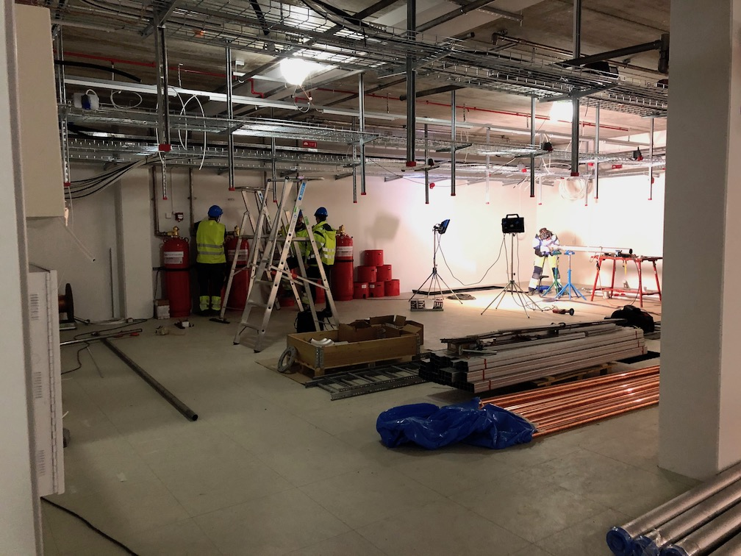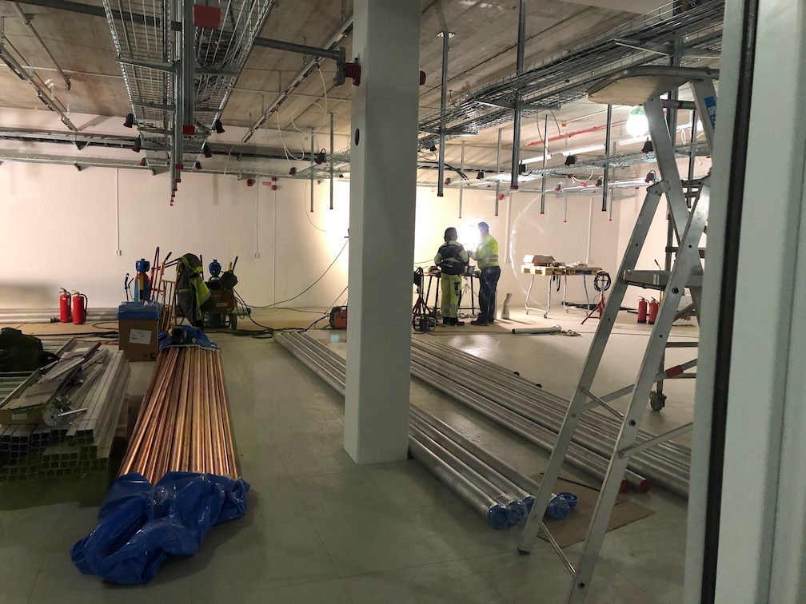
Figure 7: Onsite data-centre under construction (pictures from Nov. 11, 2019)

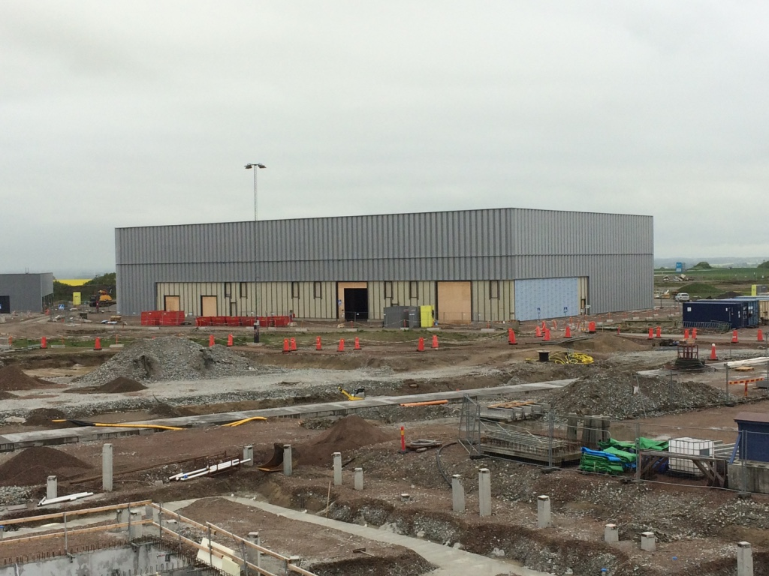
Figure 8: H01 (CUB) building - May 24, 2017. Data-centre is located in the corner (left) of the building.

Appendix 3 – Data link tests
As described in section Data link performance, a number of performance and viability tests have been performed to evaluate the performance and reliability of the data link connection.

Performance tests
The performance tests have primarily been performed with the PerfSonar network monitoring suite.
Persistent PerfSonar tests across the data link were initiated on Nov. 05, 2019, but due to configuration tuning and conditions on the site side of the link, an uninterrupted long-baseline period of testing is not yet available.
A sample performance graph from a stable testing period (Dec. 4-9, 2019) can be seen in Figure 9.
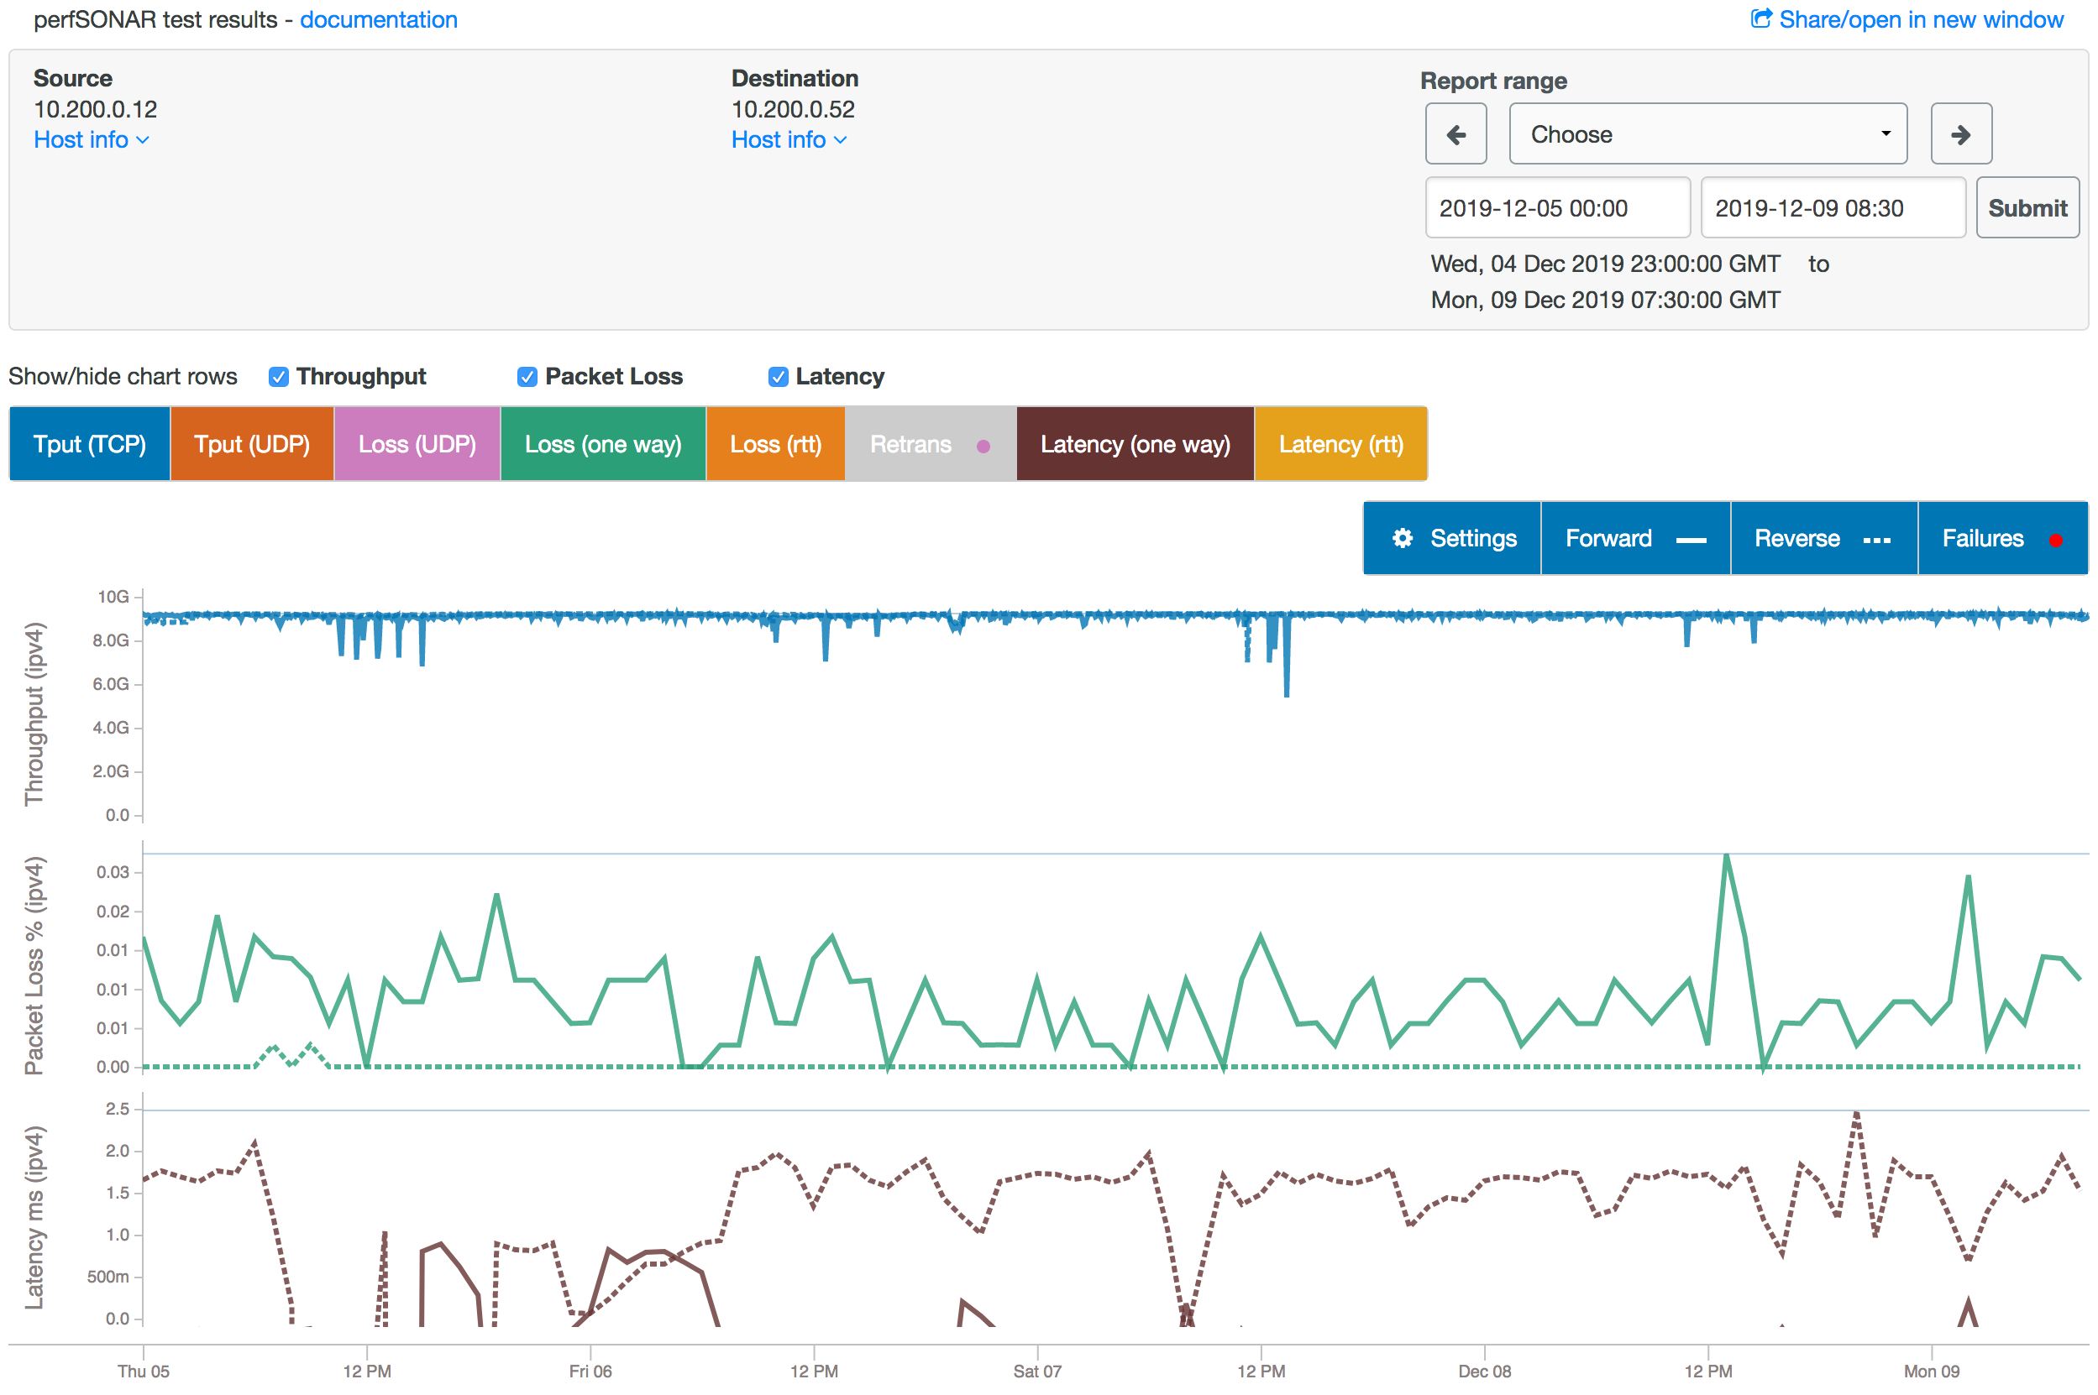
Figure 9: Performance test from Dec. 4-9, 2019 – both forward and reverse direction are shown.
The throughput tests are run for 5 min. every 10 min., using the nuttcp tool (proved more reliable during testing of UDP traffic than iperf3 (commonly used network testing tool)), with a minimum of network performance (just basic tcp stack) tuning on the servers involved.
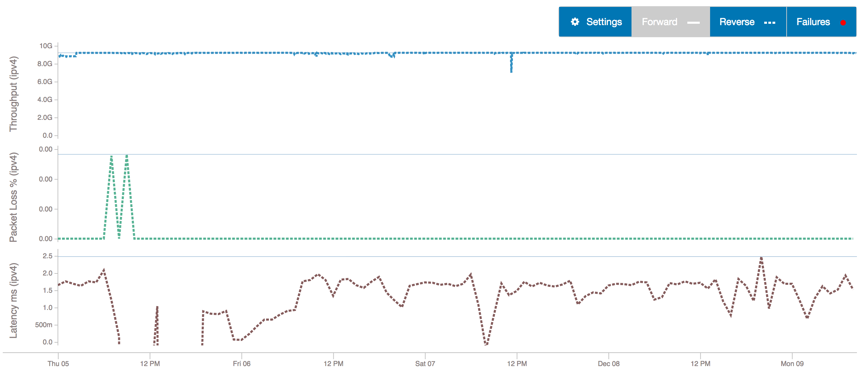
Figure 10: Same as above - reverse direction only (for clarity)
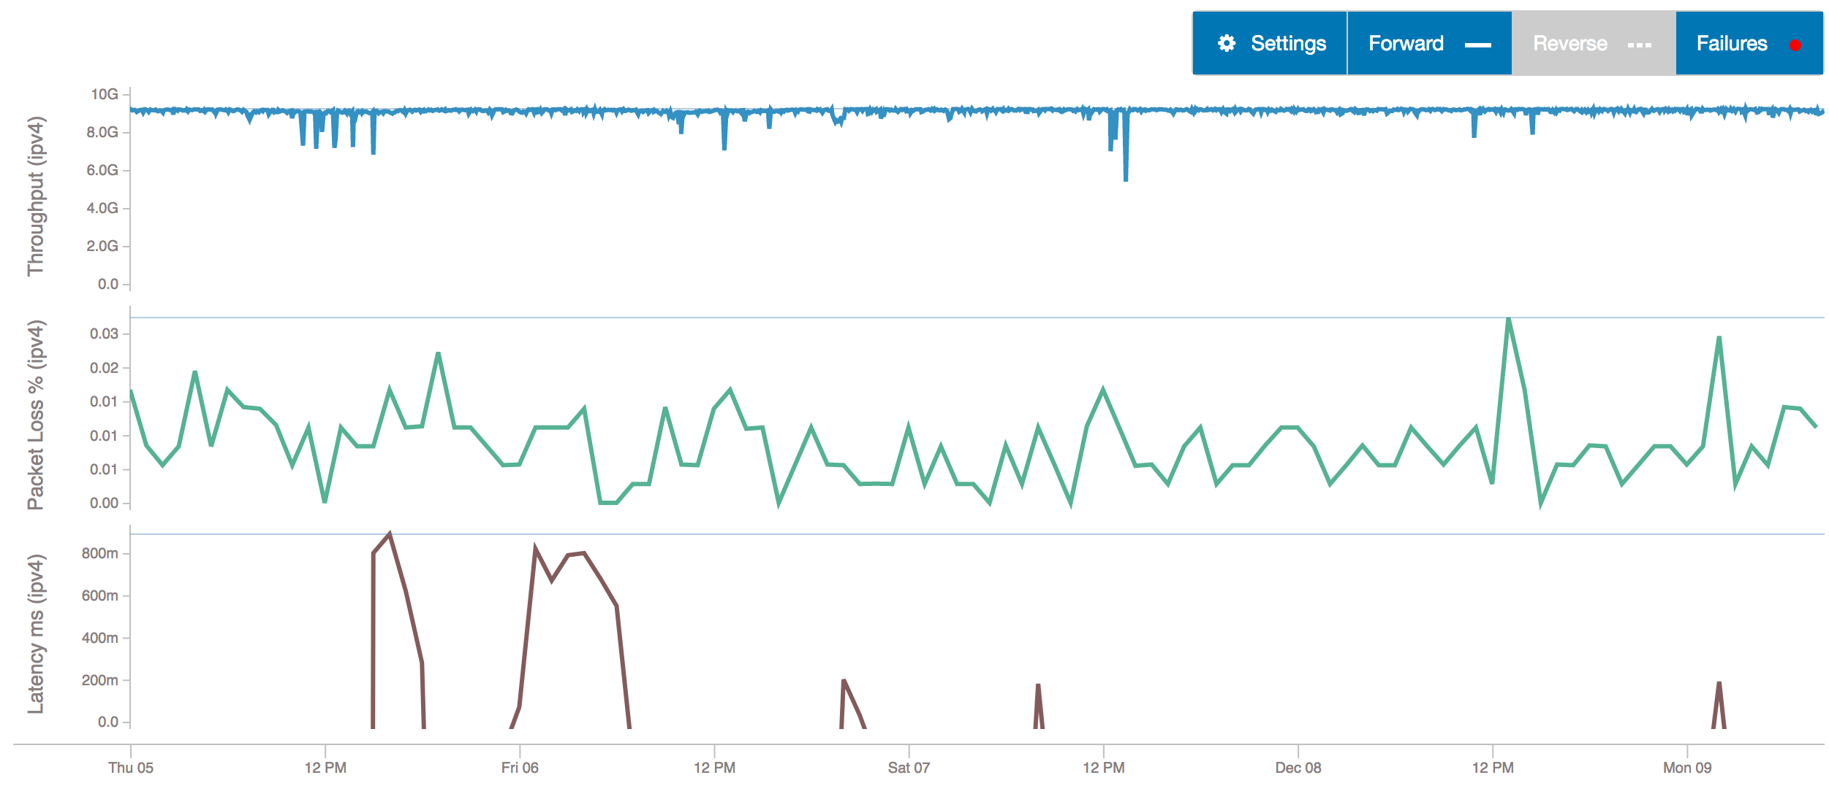
Figure 11: Same as earlier - forward direction only (for clarity)
As can be seen from Figure 10 (reverse direction) and Figure 11 (forward direction), there seem to be some asymmetry with respect to throughput stability, packet loss and latency between the two directions. It is suspected that this is a symptom of the particulars of the test equipment and methodology used, rather than an asymmetry in the data link performance, e.g. doing saturation throughput tests will increase the likelihood of lost packets on the same channel.
In Figure 12, throughput plots from the two switches involved in the test (one on each side of the data link) can be seen. The tests here were performed on Dec. 10, 2019, in 2 sets with a 12 hour interval, each test was run for 1 hour.
Minor irregularities can be seen during the transfer (the ‘wiggles’ on ‘the plateaus’) for some of these tests. While such irregularities will be further analysed when more stable conditions (hardware, methodology, location) have been obtained, these irregularities are not expected to cause appreciable issues during real data transfer conditions.
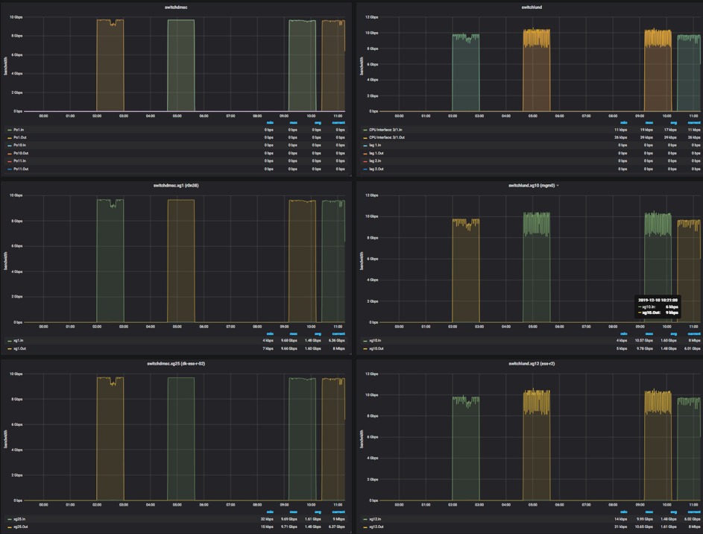
Figure 12: Throughput plots from switch monitoring

Viability tests
As described in section 3.3.2.2, a number of viability tests were performed to evaluate the fitness-of-purpose of the data link for the planned DMSC services.

Deployment and provisioning test
As a practical test of the viability of data link for connecting the DMSC infrastructure services, the four test-servers on site were provisioned with profiles from the LDPC-stack, enabling a Live Data workflow right out of the box – see Figure 13 for a sample screenshot of the Live Data workflow on the freshly provisioned servers.
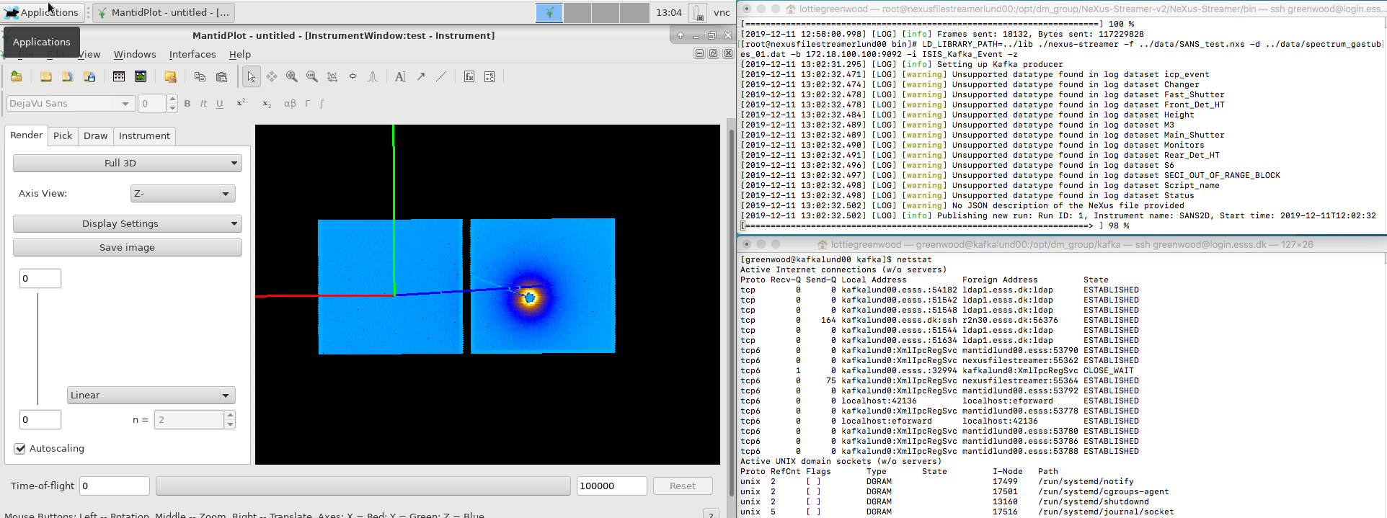
Figure 13: Sample screenshot showing Mantid visualisation as part of a Live Data workflow, following server provisioning through the data link

Data transfer
As described in section 3.3.2.2, a number of data transfer tests were performed to test viability and reliability of data transfer across the data link.
The expected maximum data transfer rate would be about 1 GB/s.
A summary of the different file transfer tests can be seen in Table 6.
Table 6: Sample data transfer tests
File transfer test | Test details | Throughput
scp | 6.85 GB ISO file – hdd to ssd (raid) | 220 MB/s
scp | 6.85 GB ISO file – ramdisk to ramdisk | 227 MB/s
rsync | File list (5) – 9.7GB total | 176 MB/s
ftp | 6.85 GB ISO file – ramdisk to ramdisk | 593 MB/s
FIO (NFSv4.1) | Sequential read, 4 GB data, 16 MB blocksize | 931 MB/s

The FIO (Flexible I/O) test is a synthetic I/O test aimed at simulating a defined job-load. In this test, the following parameters were used while simulating I/O to a NFSv4.1-mounted (32 threads) ramdisk across the data link:
[root@mgm0 nfsr0n38]# fio --randrepeat=1 --ioengine=libaio --direct=1 --gtod_reduce=1 --name=test4read --filename=test4read --bs=16M --iodepth=64 --size=4G --readwrite=read
test4read: (g=0): rw=read, bs=(R) 16.0MiB-16.0MiB, (W) 16.0MiB-16.0MiB, (T) 16.0MiB-16.0MiB, ioengine=libaio, iodepth=64
fio-3.7
Starting 1 process
test4read: Laying out IO file (1 file / 4096MiB)
Jobs: 1 (f=1): [R(1)][83.3%][r=448MiB/s,w=0KiB/s][r=28,w=0 IOPS][eta 00m:01s]
test4read: (groupid=0, jobs=1): err= 0: pid=82837: Tue Dec 10 15:40:21 2019
read: IOPS=55, BW=888MiB/s (931MB/s)(4096MiB/4611msec)
bw ( KiB/s): min=819200, max=950272, per=99.32%, avg=903460.57, stdev=41694.59, samples=7
iops : min= 50, max= 58, avg=55.14, stdev= 2.54, samples=7
cpu : usr=0.04%, sys=19.89%, ctx=4331, majf=0, minf=542
IO depths : 1=0.4%, 2=0.8%, 4=1.6%, 8=3.1%, 16=6.2%, 32=12.5%, >=64=75.4%
submit : 0=0.0%, 4=100.0%, 8=0.0%, 16=0.0%, 32=0.0%, 64=0.0%, >=64=0.0%
complete : 0=0.0%, 4=99.5%, 8=0.0%, 16=0.0%, 32=0.0%, 64=0.5%, >=64=0.0%
issued rwts: total=256,0,0,0 short=0,0,0,0 dropped=0,0,0,0
latency : target=0, window=0, percentile=100.00%, depth=64

Run status group 0 (all jobs):
READ: bw=888MiB/s (931MB/s), 888MiB/s-888MiB/s (931MB/s-931MB/s), io=4096MiB (4295MB), run=4611-4611msec
[root@mgm0 nfsr0n38]#
Ramdisks were used in the test to limit the dependency of the test of the data link on the storage systems used.

Glossary
Term | Definition
BOI | Beam On Instruments
CPH | Copenhagen
CUB | Central Utility Building
DAQ | Data Acquisition
DeIC | Danish e-Infrastructure Consortium
DMSC | Data Management and Software Center
DST | Data Systems and Technology group
EOC | End Of Construction
ICS | Integrated Control Systems division
IT | ESS IT division
L2 | OSI Level 2
MPLS | Multiprotocol Label Switching
LDPC | Live Data Proof of Concept
NORDUNET | Nordic Gateway for Research and Education
OSI | Open Systems Interconnection Reference Model
SAT | Site Acceptance Test
SUNET | Swedish research network provider
VPN | Virtual Private Network

references
- PerfSonar: https://www.perfsonar.net
- FIO: https://fio.readthedocs.io/en/latest/fio_doc.html

Document Revision history
Revision |  | Reason for and description of change | Author | Date
2 | Update and status on milestones and tests |  | Brian Lindgren Jensen | 2019-12-11
1 | First draft |  | Jesper Rude Selknaes | 2019-08-15

LDPC is Live Data Proof of Concept, and is a DMSC integration effort to facilitate service integration between the different components (DAQ, reduction, analysis, visualisation) required for the Live Data service (to be used during active experiments to pipeline experiment data into a live visualisation).

