IKON19

Control hutches
Report for IKON19
Author(s): Gabor Laszlo | Date/time of session:  [Monday, 29 September 2020, 14.30-14.45]

Introduction
NSS is going to procure four hutches for instrument teams: NMX, LOKI/FREIA, ODIN and TBL

Status of the Procurements

NMX
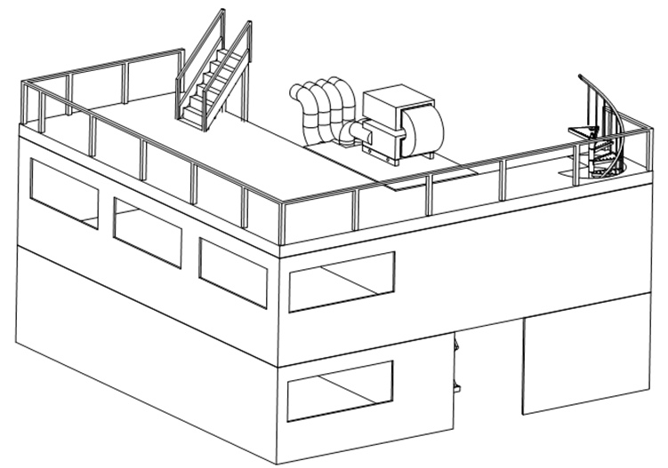
We have published the NMX tender at the beginning of summer without success.
Status: exploring potential suppliers

LOKI/FREIA
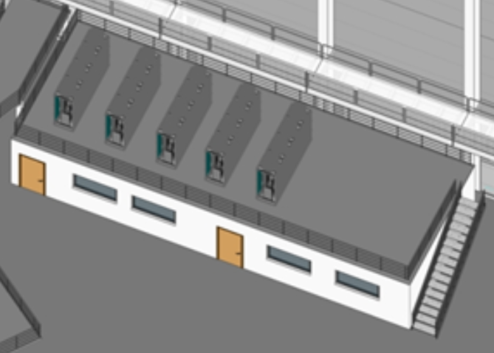
We have published the LOKI/FREIA tender during the summer without success.
Status: exploring potential suppliers

ODIN
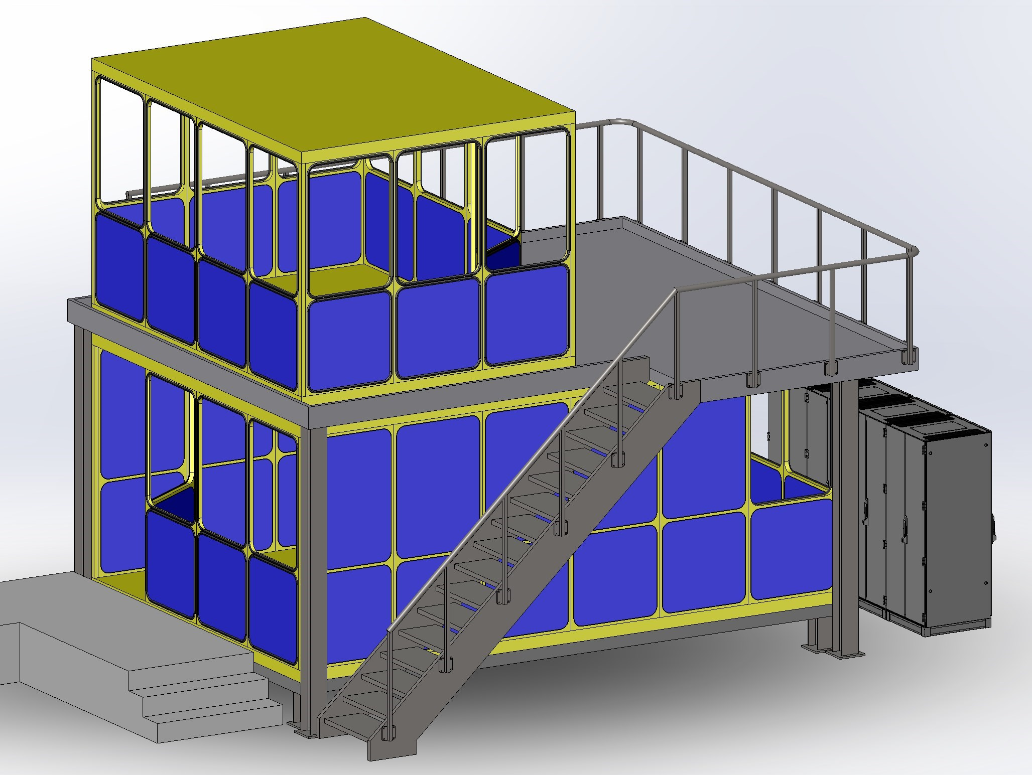

ESS Procurement has decided not to publish the tender before we find the reasons of the failed procurements and agree on the way forward.

TBL
The procurement has been postponed until we have an agreed strategy.

Lessons learnt and potential strategies
- The projects are relatively small and complex the suppliers don´t like these kind of challenges.
- Many companies reported that the scope of the hutch tender is not in their profile.
- Some of them reported that the timing was not right and they did not have the resources to answer.
- Typically, we define requirements instead of specifying solutions, that is not what these suppliers used to. It gives the impression that we don´t know exactly what we want. We have the following options:
- Joint procurements, to create a larger project to be able to invite larger companies.
Disadvantage: Larger companies has larger overheads. In some cases, the price can be significantly higher
- Choose specific solutions and minimize the number of general requirements.
Disadvantage: limits the range of suppliers
- Break down the projects to sub-systems. Expand the scope of the common utilities project to fit out the hutches and find suppliers for the hutch structures separately.
Disadvantage: additional administrative load and resource allocation for ESS.

We are still negotiating and discussing different options with the suppliers.

- Skanska Direkt
- Lindner AG
- DC-Supply
- Jacobs CMS UK Field Solutions
- MOE
- Constructor Sverige AB
- https://www.indus.se/
- https://www.moelven.com/se/
- https://www.pcsmodulsystem.se/
- Lindner

