Course Title  PANOSC Training of Teachers Feb-Mar 2021 | Subject (level)  Blended/Online learning (faculty)
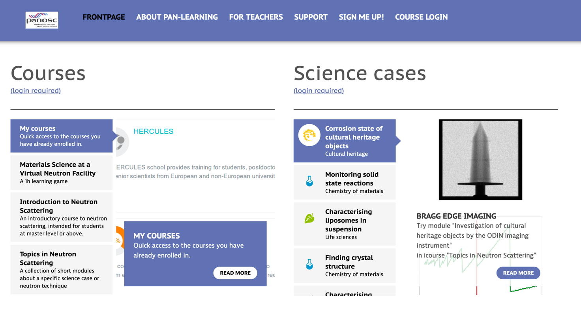
Short description of course
The intention of the course is to foster uptake of the pan-learning.org digital platform. The course aims to realize this intention by having participants focus on hands-on experiences with the platform. Hands-on experiences will be put into contexts by interactive lectures, where participants get to reflect on their own work in relation to educational research. The course is held on Zoom and Gather.town.

Course learning outcomes  After the course, participants will be able to use the pan-learning.org online platform to  - create activities, lessons and courses  - make decisions on how to facilitate student learning in online and blended environments based on science and physics education research  - implement decisions in lesson and course design.  Furthermore, participants will be able to use their experiences with the pan-learning platform to:  - Provide constructive feedback on peers’ lesson plans  - Reflect on feedback provided by others and use that feedback to make changes to consider changes to own online and blended lessons.  - Plan and conduct a lesson study with peers. | Relation to programme learning outcomes  “training potential content providers and training providers in how to best use the platform for their needs, with the aim of developing hands-on content for the e-learning portal.”
Summary of necessary teaching materials
PaNOSC_workshop_DAY 1.pptx, PaNOSC_workshop_DAY 2.pptx, PaNOSC_workshop_DAY 3.pptx
Templates for lesson plans, course plan and lesson study
Zoom room
Gather.town venue
Short instruction videos

Expected products and outcomes from workshop
Activities and presentations of activities
Lessons that could be implemented along with lesson plans
Course descriptions
Plans for lesson studies involving other participants

Expected participant prerequisites
Expertise in physics/scattering physics

Course plan
# | Lesson title | Learning goals
1 | Welcome and Introduction | NA
2 | Participants learn to use practical features | After this session, participants will be able to  - Follow instructions to use the pan-learning.org website to create a quiz, an online lecture, a simulation, and an interactive problem using the pan-learning platform.
3 | Making your own activity | After this session, participants will be able to  - Outline an interactive learning activity; a quiz, an online lecture, a simulation, or an interactive problem, which could be implemented using the pan-learning platform  - Create and test parts of the interactive learning activity with or without guidance of a facilitator
4 | Presentation of activities | After this session, participants will be able to  - Present and explain their own interactive learning activity to colleagues  - Provide feedback that can be used by others to improve their interactive learning activity  - Use feedback to make changes to own interactive learning activity.
5 | Active digital and blended learning | After this session, participants will be able to  - Use educational research to discuss own lessons and interactive learning activities.  - Argue for and against possible changes to own lessons and interactive learning activities using educational research
6 | Feedback in digital and blended environments | After this session, participants will be able to  - Discuss research on feedback in digital and blended learning environments  - Use research-based methods to plan for feedback own interactive lesson
7 | Designing lessons for active learning | After this lesson, participants will be able to  - Analyse a lesson designed for active learning in a blended environment in terms of a research-based framework.  - Discuss how to design a blended or digital active learning lesson using pan-learning.org
8 | Use activities in own lessons | After this session, participants will be able to  - Create and finalize own blended or digital lesson using own or others’ interactive learning activities on pan-learning.org.
9 | Presentation of lessons | After this session, participants will be able to  - Present and explain their own ‘pan-learning.org interactive lessons’ to colleagues  - Provide feedback that can be used by others to improve their ‘pan-learning.org interactive lessons’.  - Use feedback to make changes to own ‘pan-learning.org interactive lessons’.
10 | Lesson studies as a way to iteratively develop teaching | After this session, participants will be able to  - Discuss lesson studies as a way to develop their pan-learning lessons.  - Plan for a group lesson study for a ‘pan-learning.org interactive lessons’
11 | Course design | After this session, participants will be able to  - Use pan-learning.org to design a simple digital or blended course.  - Discuss central principles of course design in relation to own course.
12 | Prepare for interim period | NA

Short description of lesson |  | Short didactical argument
1 | Welcome and Introduction  Participants arrive and are introduced to us and each other.  Aim of course shown: For participants to be able to design, develop and use hands-on content for e-learning portal. | Uptake of any new technology is reliant on network formation and support. The welcome session is essential for beginning network formation. Furthermore, it lays the groundwork for participation, since it is established that is allowed for people to speak here.
2 | Participants learn to use practical features  This long session (interrupted by lunch) aims at giving participants hands-on experience with creating wiki-text, quizzes, annotated videos, simulation tool, and Jupyter in the e-learning platform. These are meant as small tasters with focus on functionality. | We want to give participants the possibility for immediate hands-on tinkeren from the get-go. They will probably end up having a lot of questions, which often function as generators of motivation for learning more.
3 | Autonomous work: Making your own activity  Here, participants choose one type of activity (wiki-text, quiz, annotated video, simulation tool, or Jupyter notebook), and design an activity relevant to learning in their field/a course they are teaching or will teach. The activity need not be done, but participants need to be able to present it for other participants next day. We provide assistance during the work. | It is essential that participants get something which is their own product (at least to some extent). We will make sure to have participants consider making something they might actually use. This makes the rest of the course more authentic, which fosters uptake and learning.
4 | Presentation of activities  Participants present their activities to other participants. The exact way this is done is dependent on number of participants. Based on pre-defined criteria relevant for learning physics, participants provide feedback to presentations. | Explaining your own work, listening with the intent of providing feedback, and using feedback to make changes are effective ways of learning now material.
5 | Active digital and blended learning  An interactive lecture about research into active learning in digital and blended learning environments. Will contain activities where participants are asked to couple presented research with own activities. | Having worked hands-on, a session with a focus on the available research may help participants settle on choice, make revisions, and argue for/against their choices.
6 | Feedback in digital and blended environments  An interactive lecture about how to facilitate and provide feedback (both automated and non-automated) in digital and blended environments. Will contain activities where participants are asked to couple presented research with own activities. | Feedback is an essential part of any learning process, so designing feedback in digital and blended learning environments is an important task
7 | Designing lessons for active learning  This lesson begins with an observation/analysis of an example lesson, which illustrates a particular principle for designing active learning. Participants analyze the example and derive a model for teaching with active learning. We then discuss pros and cons of the model for teaching, including underlying research. | Active learning often goes against our intuitions as teachers. Therefore, models have been developed to help design active learning lessons. By analyzing a description or video of such a lesson, the aim is to better be able to use the underlying teaching model in own work.
8 | Autonomous work: Use activities in own lessons  Here, participants use the model for active learning derived in the preceding lesson to begin their own lessons. It should be lessons that they are going to teach at some point. The lessons need not be done, but participants need to be able to outline how the lesson would proceed for other participants next day. To assist this work, we provide a template designed for this purpose as well as assistance. | It is essential that participants get something which is their own product (at least to some extent). We will make sure to have participants consider making something they might actually use. This makes the rest of the course more authentic, which fosters uptake and learning.
9 | Presentation of outlines of lessons  Participants present their activities to other participants. The exact way this is done is dependent on number of participants. Based on pre-defined criteria relevant for learning physics, participants provide feedback to presentations. | Explaining your own work, listening with the intent of providing feedback, and using feedback to make changes are effective ways of learning now material.
10 | Lesson studies as a way to iteratively develop teaching  In this lecture, we introduce the concept of lesson studies. Through examples, we show how one can target specific areas to observe, provide feedback and make changes. Participants work with designing a lesson study when using the e-learning platform. | While outside of the comfort-zone of many teachers, having others observe and analyze your lesson with predefined criteria in hand, is one of the most powerful ways to develop teaching. This is why we introduce the method here.
11 | Course design  In this lecture participants will, through examples, work with some of the central principles for active learning course design. Participants work with applying these principles to the present context. | Ultimately, participants should make courses using the pan-learning platform. By working with an example, the probability of this happening increases.
12 | Prepare for interim period  In this activity, participants outline what they are going to do and when they are going to do it in the interim period. We hope to make small-group constellations of participants who will spar with each other during the period. | This will hopefully make it easier for participants to set goals and for facilitators to help participants realize their goals.

Reflection log
Period | Place | Reflection

