STAP report – BIFROST
1st of April 2021

Installation progress:
Due to the pandemic, installation has slowed down since the last STAP. We were able to finish the cave and beam stop installation and have started installing the sample stack. The FAT of the spectrometer tank is complete, and the shipping of the vessel is currently ongoing. Once the vessel arrives, we will plan installation at a suitable time when the lockdowns are less likely. The tank installation is not on the critical path.
Detector system:
We have had progress on the detector electronics issue. The company CAEN has integrated the ILL firmware, that does Gaussian filtering and charge division, on the R5560 digitizer, the ESS standard for LoKI and likely all He-3 tube instruments. They are able to port only the core functionality of the firmware, and straightforwardly link it to the standard interface to the backend electronics and event formation unit at the ESS. We therefore have a plan for the full readout chain from tube to DMSC, one that is supported by the ESS detector group.
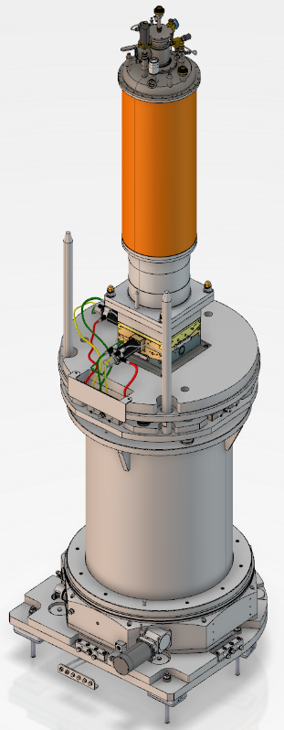
We have gone out for tender for the detector tubes, and we expect an offer in April. The detector triplet grounding scheme has been redesigned, and the finished triplet prototype is soon to be shipped to the ESS. As we only need one digitizer at BIFROST, we are able to procure this early, and therefore test the entire detector readout chain in good time. This could prove essential for successful hot commissioning.
Figure 1: Sample stack on BIFROST
Beryllium filter:
We have gone for tender and received two bids, one of which is acceptable. We should be able to have a kickoff meeting in the spring. After having signed that contract and placed and order for detectors, we will have completed the major external procurement efforts. This is a special milestone for the core team, as budget uncertainty will be lower and as the paper workload will diminish.
Orange cryostat and sample stack:
We are currently going through the TG-3 process for the orange cryostat. We have decided to lengthen the cryostat, to make it a better fit for a dilution stick, and make it a similar height as the magnet, making access much easier from our stationary sample platform. We already have the rotation stage and goniometer, and the full stack should be installed by Autumn 2021.
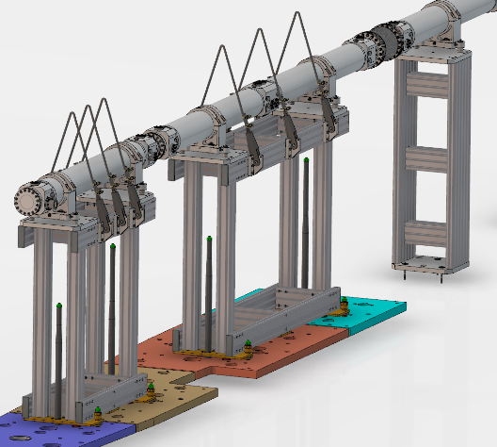
Guide system:
Figure 2: Remote handling section of the guide system near the monolith
We are currently going through the final TG-3 for the remaining subsystems of the guide, and are soon ready for manufacturing. The project of the guide and associated housing is generally on track.
Chopper system:
We have transferred the scope of producing the BIFROST choppers to the ESS. They will manufacture 1 double disc 14 Hz chopper, two single disc 14 Hz choppers, and the fast 210 Hz pulse shaping chopper, excluding the carbon fibre disc which is procured externally. This will reduce the risk on the partners, and make utilities design easier, as those are already in place for the common chopper project. Maintaining the choppers during operation will also be more straightforward. We had the kick-off meeting in December, and will have the PDR meeting on the 15th of April. The spindles/drives have been procured already whilst the discs are out for tender.
Beamline shielding:
Figure 3: Beamline shielding block for BIFROST
The company Padacar is producing the shielding blocks for the BIFROST beamline, and they will be installed by Autumn 2021, progressing on schedule.

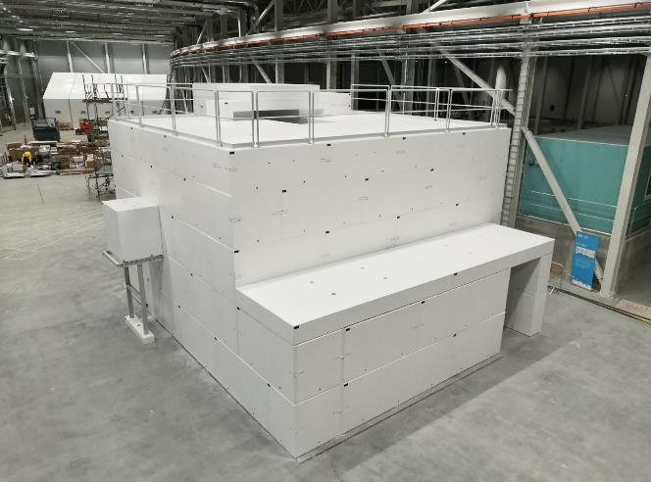
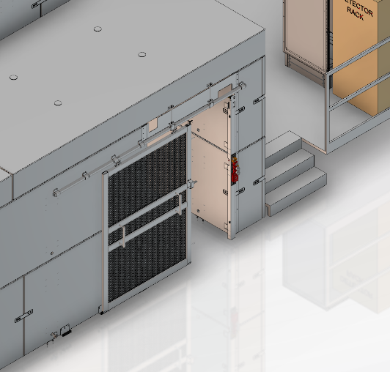

Figure 4: (left) Access door design. (Right) The finished cave

Infrastructure, electrical cabling and utilities
Having the both the cave and hutch installed allows us to work on many minor components, access doors, stairs, sample access platforms, power distribution board, network cabling, and some of the racks can also be installed after which they can be slowly fitted out. Cabling and utilities are currently the largest financial uncertainty on the budget. We are joining the common utilities project, the common electrical utilities project and we have already signed over the motion control effort to the ESS. We see a lot of this as a necessity moving forward, for ESS to properly be able to maintain BIFROST after handing over the instrument. However, there is a coordination challenge, since partner cash will be the funding source which is therefore where the risk is. We see presence at, and interaction with, at the ESS by the partners as essential to make this work.
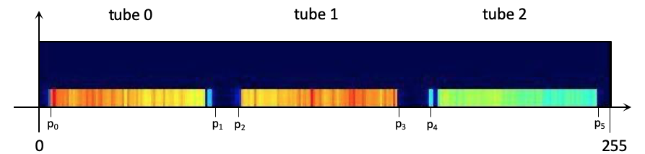
Figure 5: Definition of the tubes from the output of the charge division using prototype data as a starting point. The resistors generate a gap between tubes in x, so they can be separated.
Software and hot commissioning
Gregory Tucker has now started as the data scientist on BIFROST and CSPEC, which is very positive. Gregory is now generating an overview of the data reduction and calibration challenges. We have worked with Morten Jagd Christensen to define the digital numbering of all the detectors, and a method to separate tubes and pixelate the position. We are currently working on a more detailed plan for hot commissioning, with the partners, the core team and the data scientist. We hope to have something detailed to present at the Autumn STAP meeting in 2021.
General state of the project
We are in general good shape, even though we have been slowed down by Covid-19. We are using our budget contingency, but we have no large budget overruns at this point. In 2021, we hope to complete the tank installation, and by early 2022, we hope to have most of the secondary spectrometer installed. Our current target date is still December 2022, even though the beam-on-target date is drifting, since a lot can go wrong in installation and hot commissioning. In 2021, we will ramp up activities in software and hot commissioning planning. In 2022, we hope to be able to move motors from the hutch using the day-1 software, and look at prototype data generated using day-1 data flow.

