Neutron Beam Extraction System (WBS 12.4.2.4) System Solution and Description

SDD-Sol, Neutron Beam Extraction System

 | Name | Role/Title
Owner | J.F. Koning  Bengt Jönsson | System engineer  Mechanical Designer
Reviewer | Rikard Linander | WPM, Monolith Systems
Approver | Eric Pitcher | Head of Target Division

NOTE: The authoring instruction box should be deleted from the document before it is finalised
Authoring instruction
This document is a standard template. Please remove any headings not needed
- Instruction text is placed between text entry points shown as << >>.
- Header and Footer information in Controlled Documents are mandatory and must not be changed manually. It contains document attributes which will be updated automatically when document is checked in to Chess.
- Title field between the two bold lines on first page must not be changed as that contains similar attribute information which will display the title.
- Follow the ESS Authoring Guide ESS-0025989
- Please use Insert Cross-reference when referring to references.

Table of content | Page
1. Introduction 3
1.1. Objective of this document 3
1.2. Scope of the document 3
2. Technical solution 4
2.1. Mechanical design 4
2.1.1. PBIP components 5
2.1.1.1. Optical slices 6
2.1.1.2. Support structure 6
2.1.1.3. The full PBIP assembly 6
2.1.2. Mechanical design considerations based on requirements 8
2.1.3. Location and layout 9
2.1.4. Pipe routing 10
2.1.5. P&ID 10
2.1.6. Maintenance and handling solutions 10
2.2. Radiation protection and shielding 11
3. Description of system and components behaviour 11
3.1. ESS Operational Modes 11
3.2. Target modes (beam related) 11
3.3. Start-up and shut-down modes 11
3.4. Maintenance mode 11
3.5. Abnormal system operation 11
4. Documentation 12
4.1. Reference drawings and specifications 12
5. Models 12
5.1. Geometrical models 12
5.2. Analysis models 12
6. Safety assessment 12
6.1. Radiation safety assessment 12
7. Glossary 12
8. references 12
Document Revision history 13

Introduction

Objective of this document
The main objective of this document is to describe solutions, layout and detailed functions needed to fulfil the requirements listed in System Description Document – Requirements for NBEX [1]

Scope of the document
To achieve the object of this document, the following topics are covered:
- Technical solutions for the PBIP system in the Target Station in chapter 2
- Operational modes explained in chapter 3
- Chapter 4 and 5 contain references to all existing and planned documentation and models relevant for the system engineering.
- Chapter 6 assesses the safety aspects of the system design.

NBEX structure
The NBEX system is divided into four subgroups. See [2]
- NBPI, Neutron Beam Port Insert
- FA, Flange Assembly
- LSS, Light Shutter Assembly
- TS, Tool System
This document will follow this structure.

Technical solution
This chapter describes the chosen technical solution and presents justification that each of the requirements listed in the system description [1] is fulfilled.

Mechanical design

NBPI

Figure 1 Functional breakdown of NBPI
Two configurations of the NBPI, with or without space for beam guides. The dotted lines apply when NBPI is to guide neutrons.
Two variants of NBPI is presented here: 2 in 1 Insert, ESS-0049597 and NBPI one piece, ESS-0057335. The 2 in 1 insert have better performance in many areas but are also more complex.

Guide Housing [GH]
Neutron Beam Window [NBW]
Insert Flange [IF]
Insert Shielding [IS]

Figure 2 ESS-0049597, 2 in 1 Insert

Integrated Guide Housing [GH] + Insert Shielding [IS]
Neutron Beam Window [NBW]
Figure 3 ESS-0057335, NBPI one piece

FA

LSS

TS
The TS contains the tools required for remote handling of the NBEX system components.

IET

Figure 4 Functional breakdown of IET
Floor Unit
NBPI Exchange
Figure 5 IET CAD model, ESS-005377
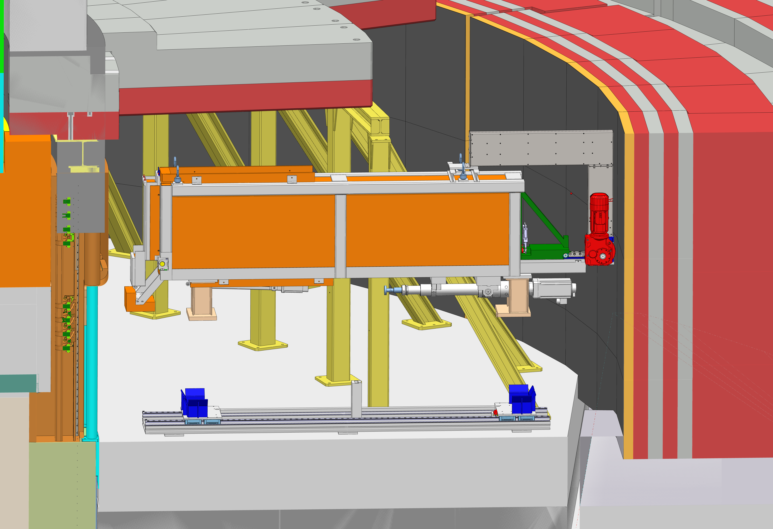
NBPI Exchange being lifted into Floor Unit
Floor Unit in position on floor in Experiment hall
Figure 6 Transport of IET
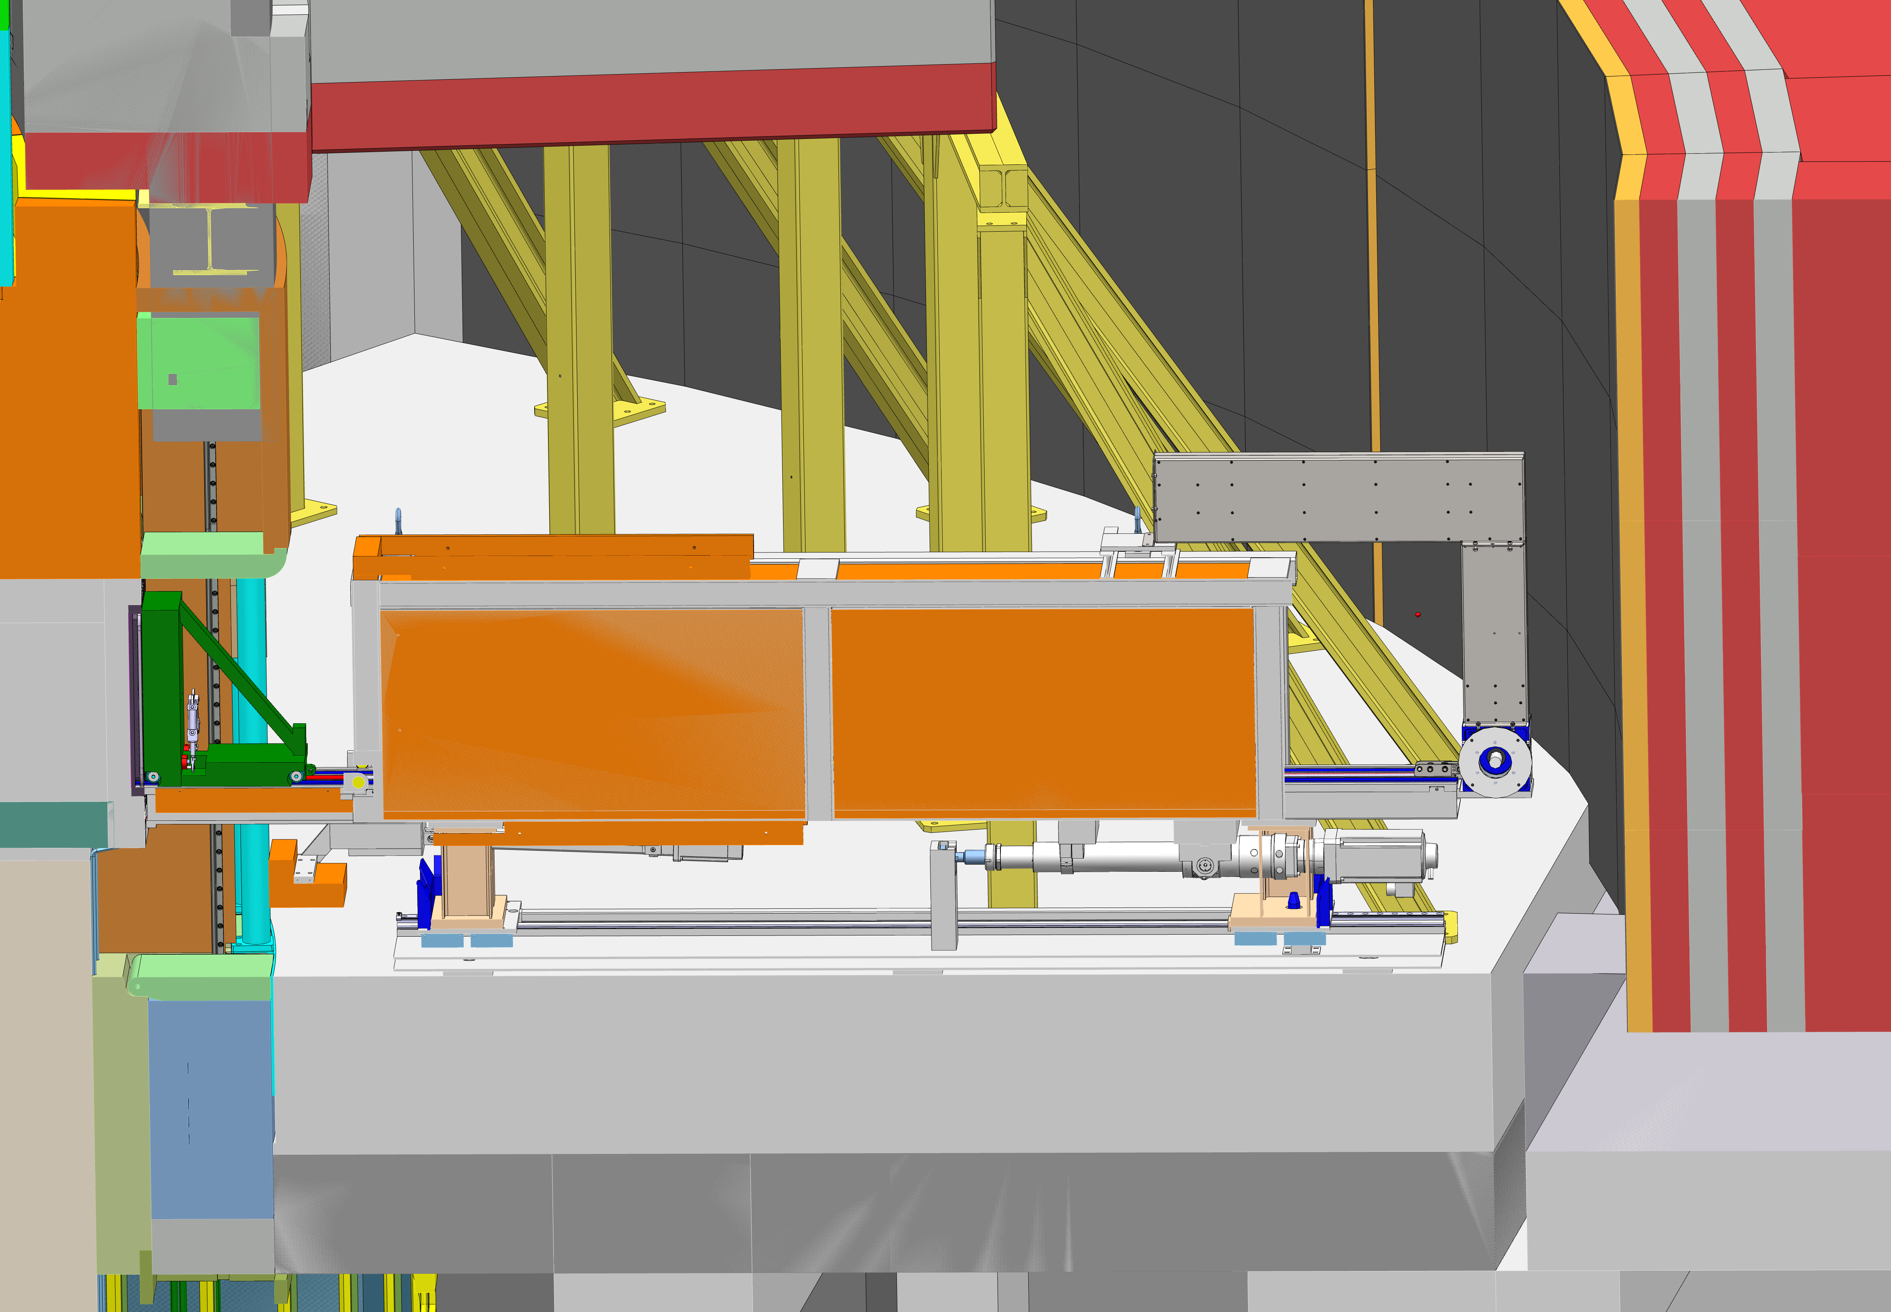
2. NBPI exchange pulled towards monolith
3. Carrier pushed forward
1. Draw bridge lowered
Figure 7 IET in insert exchange position
Key holes in NBPI
Key locking devices
IET Carrier
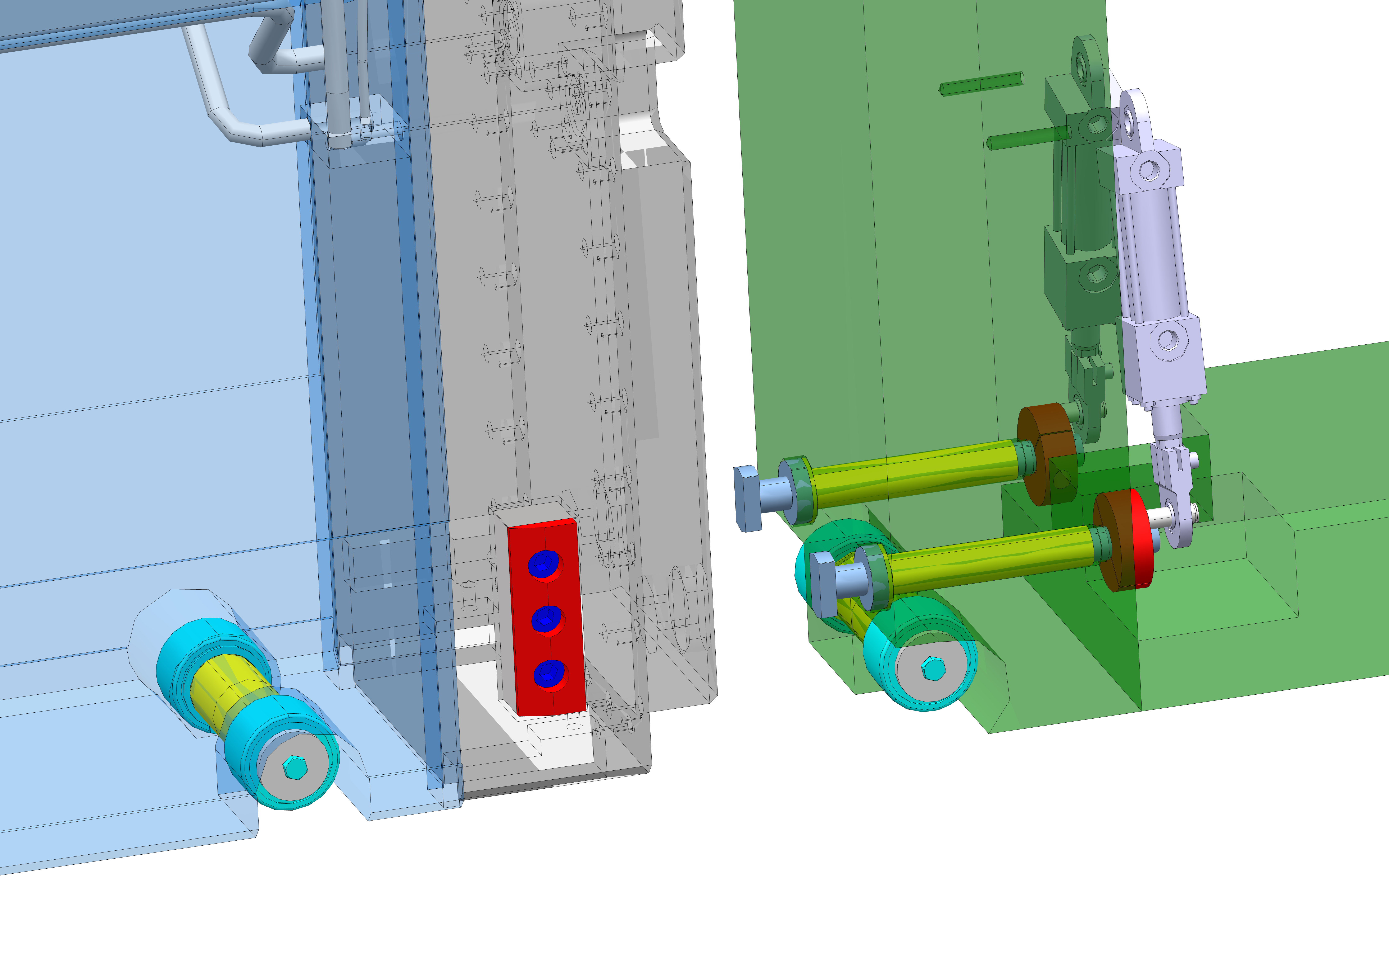
Figure 8 Docking NBPI to IET
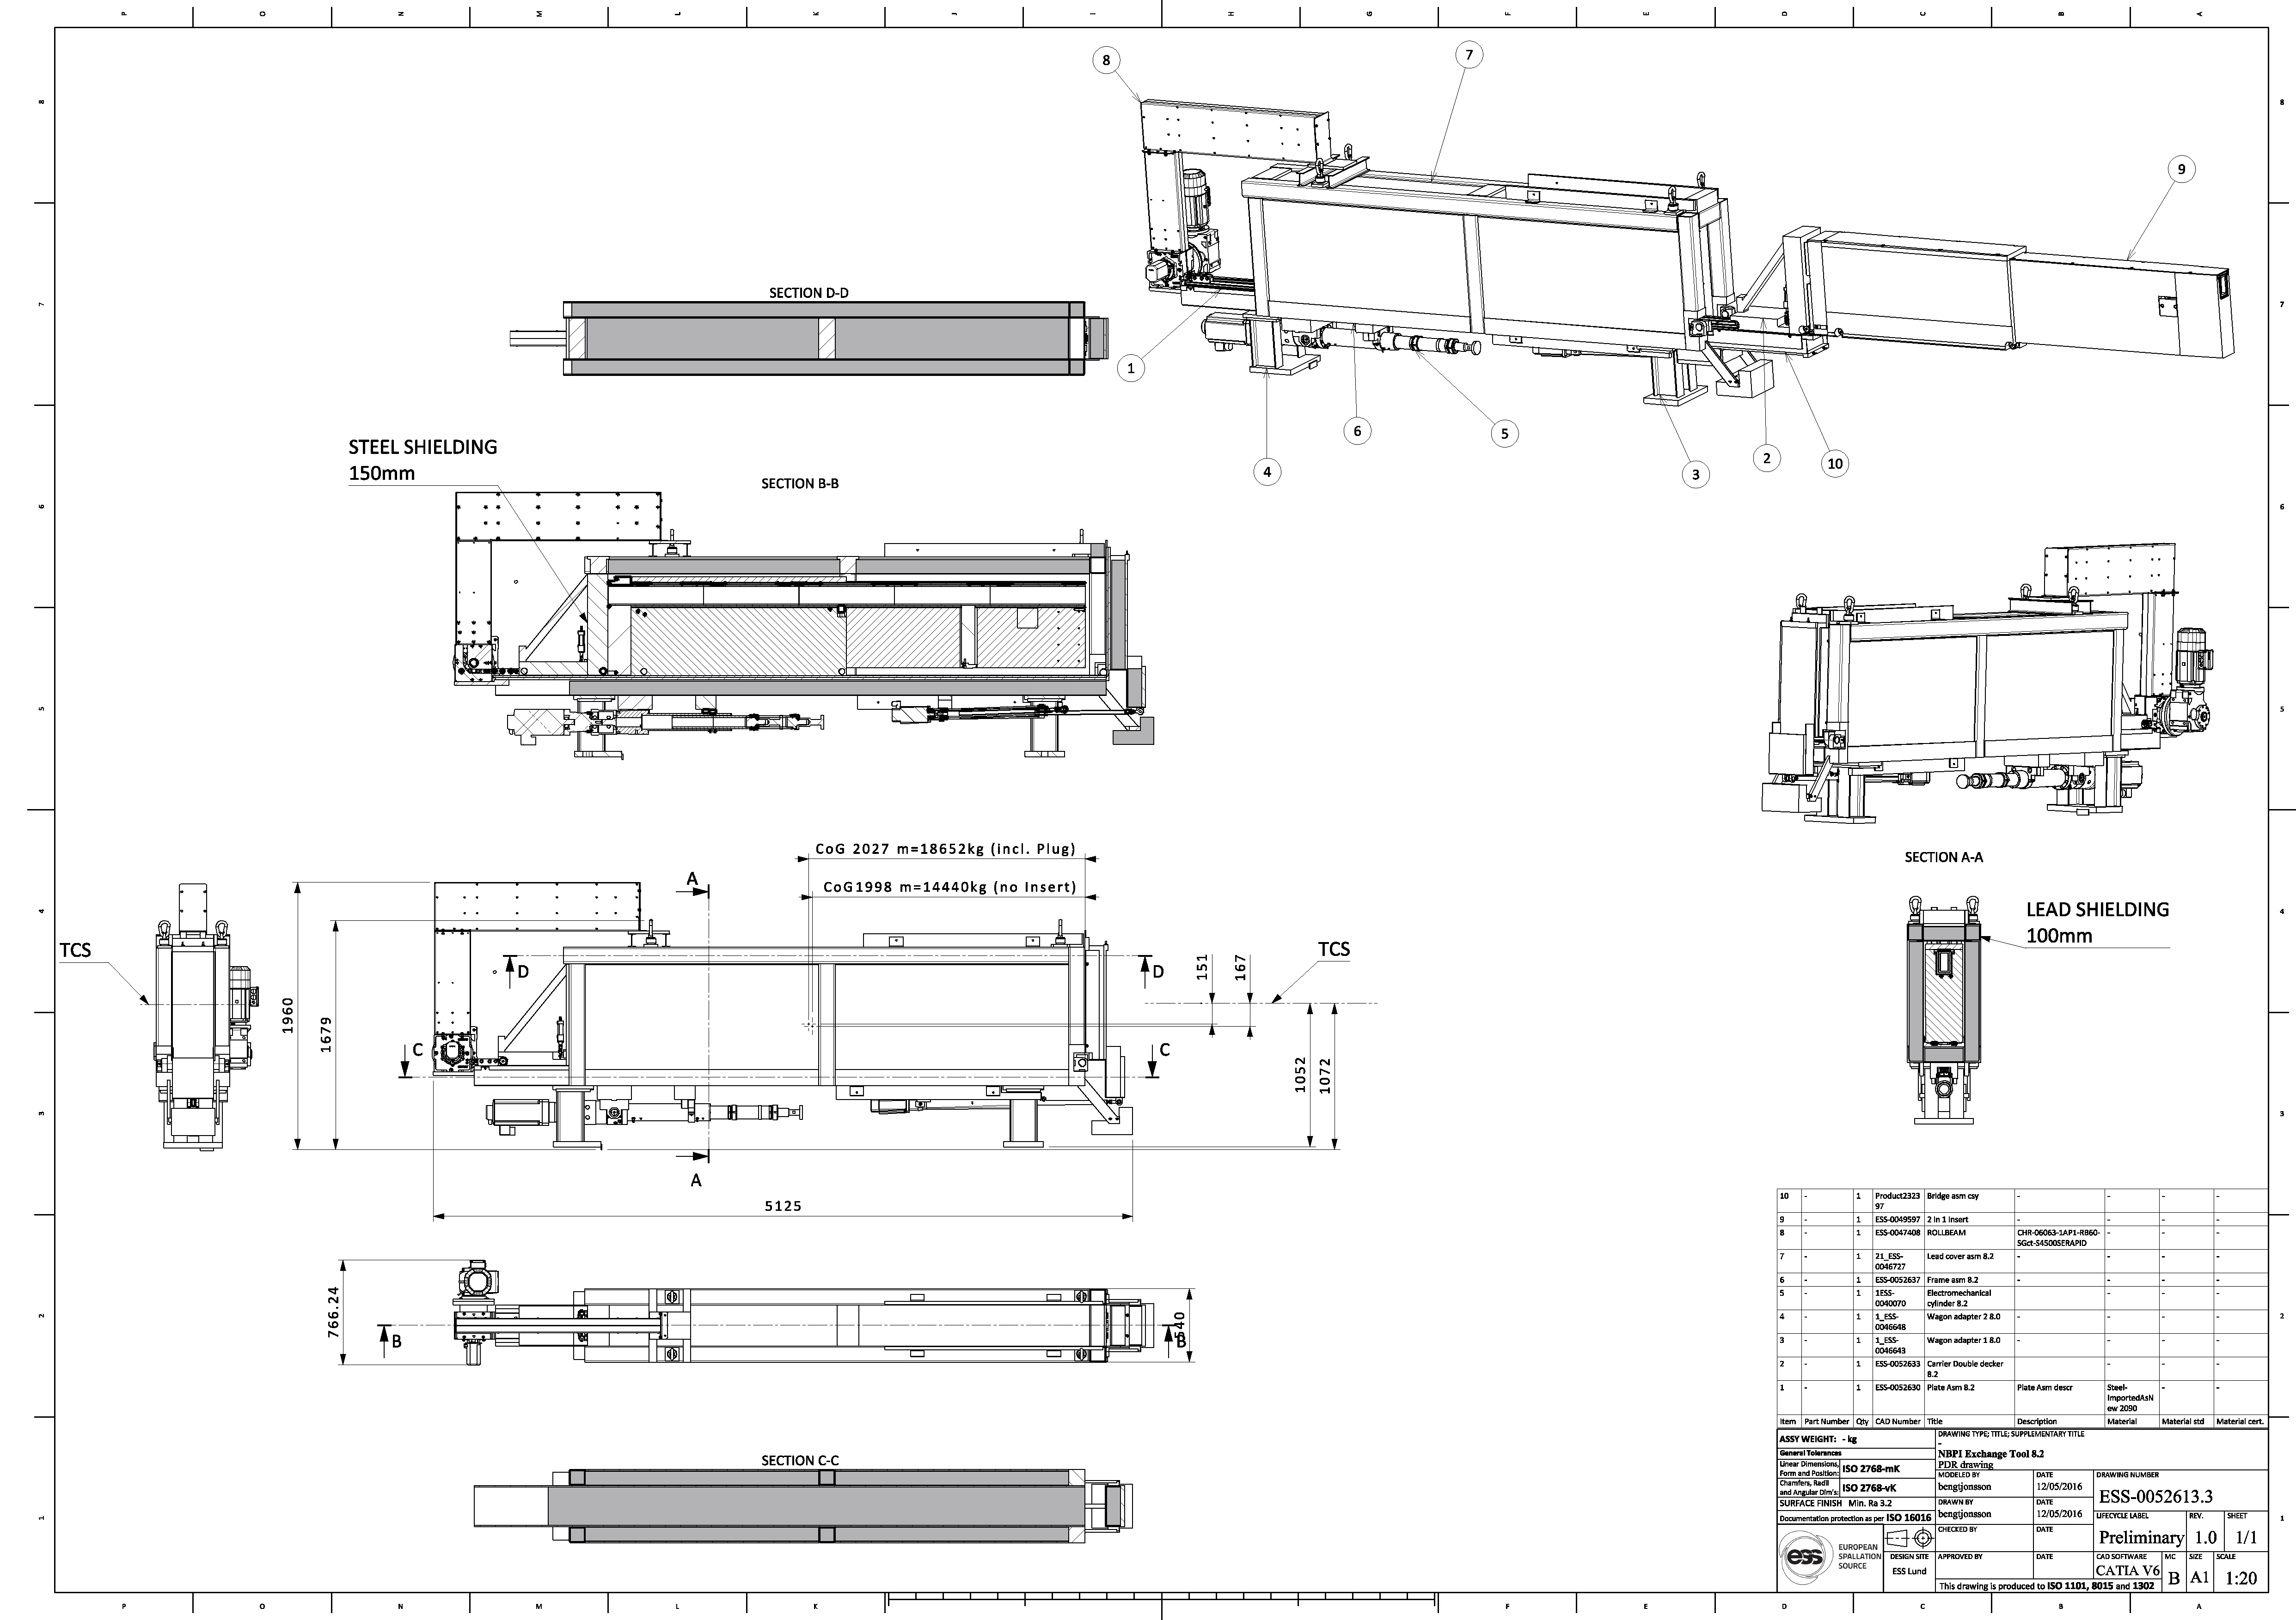
Figure 9 ESS-0052613 NBPI Exchange Tool, Shielding of activated Insert

The Proton Beam Instrumentation Plug has several requirements that govern the mechanical design of the assembly. The need for cooling, the need for replicable and accurate alignment and to be independently replaceable are key features.
The plug acts as a structure holding the Proton Beam Instrumentation in place and offers support, shielding and cooling as well as space allocation for cabling, optical paths and cooling pipes going to the top of the Monolith.
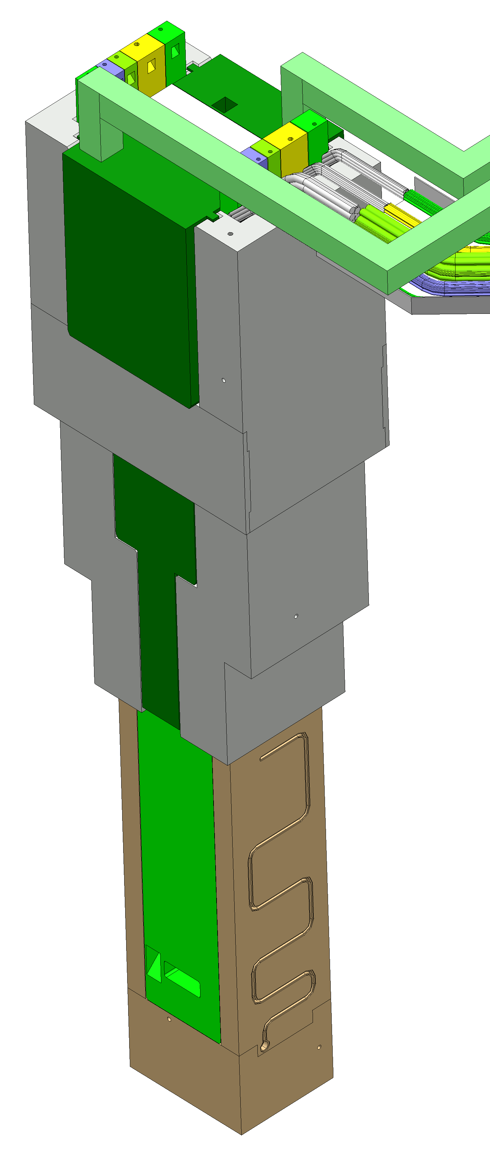
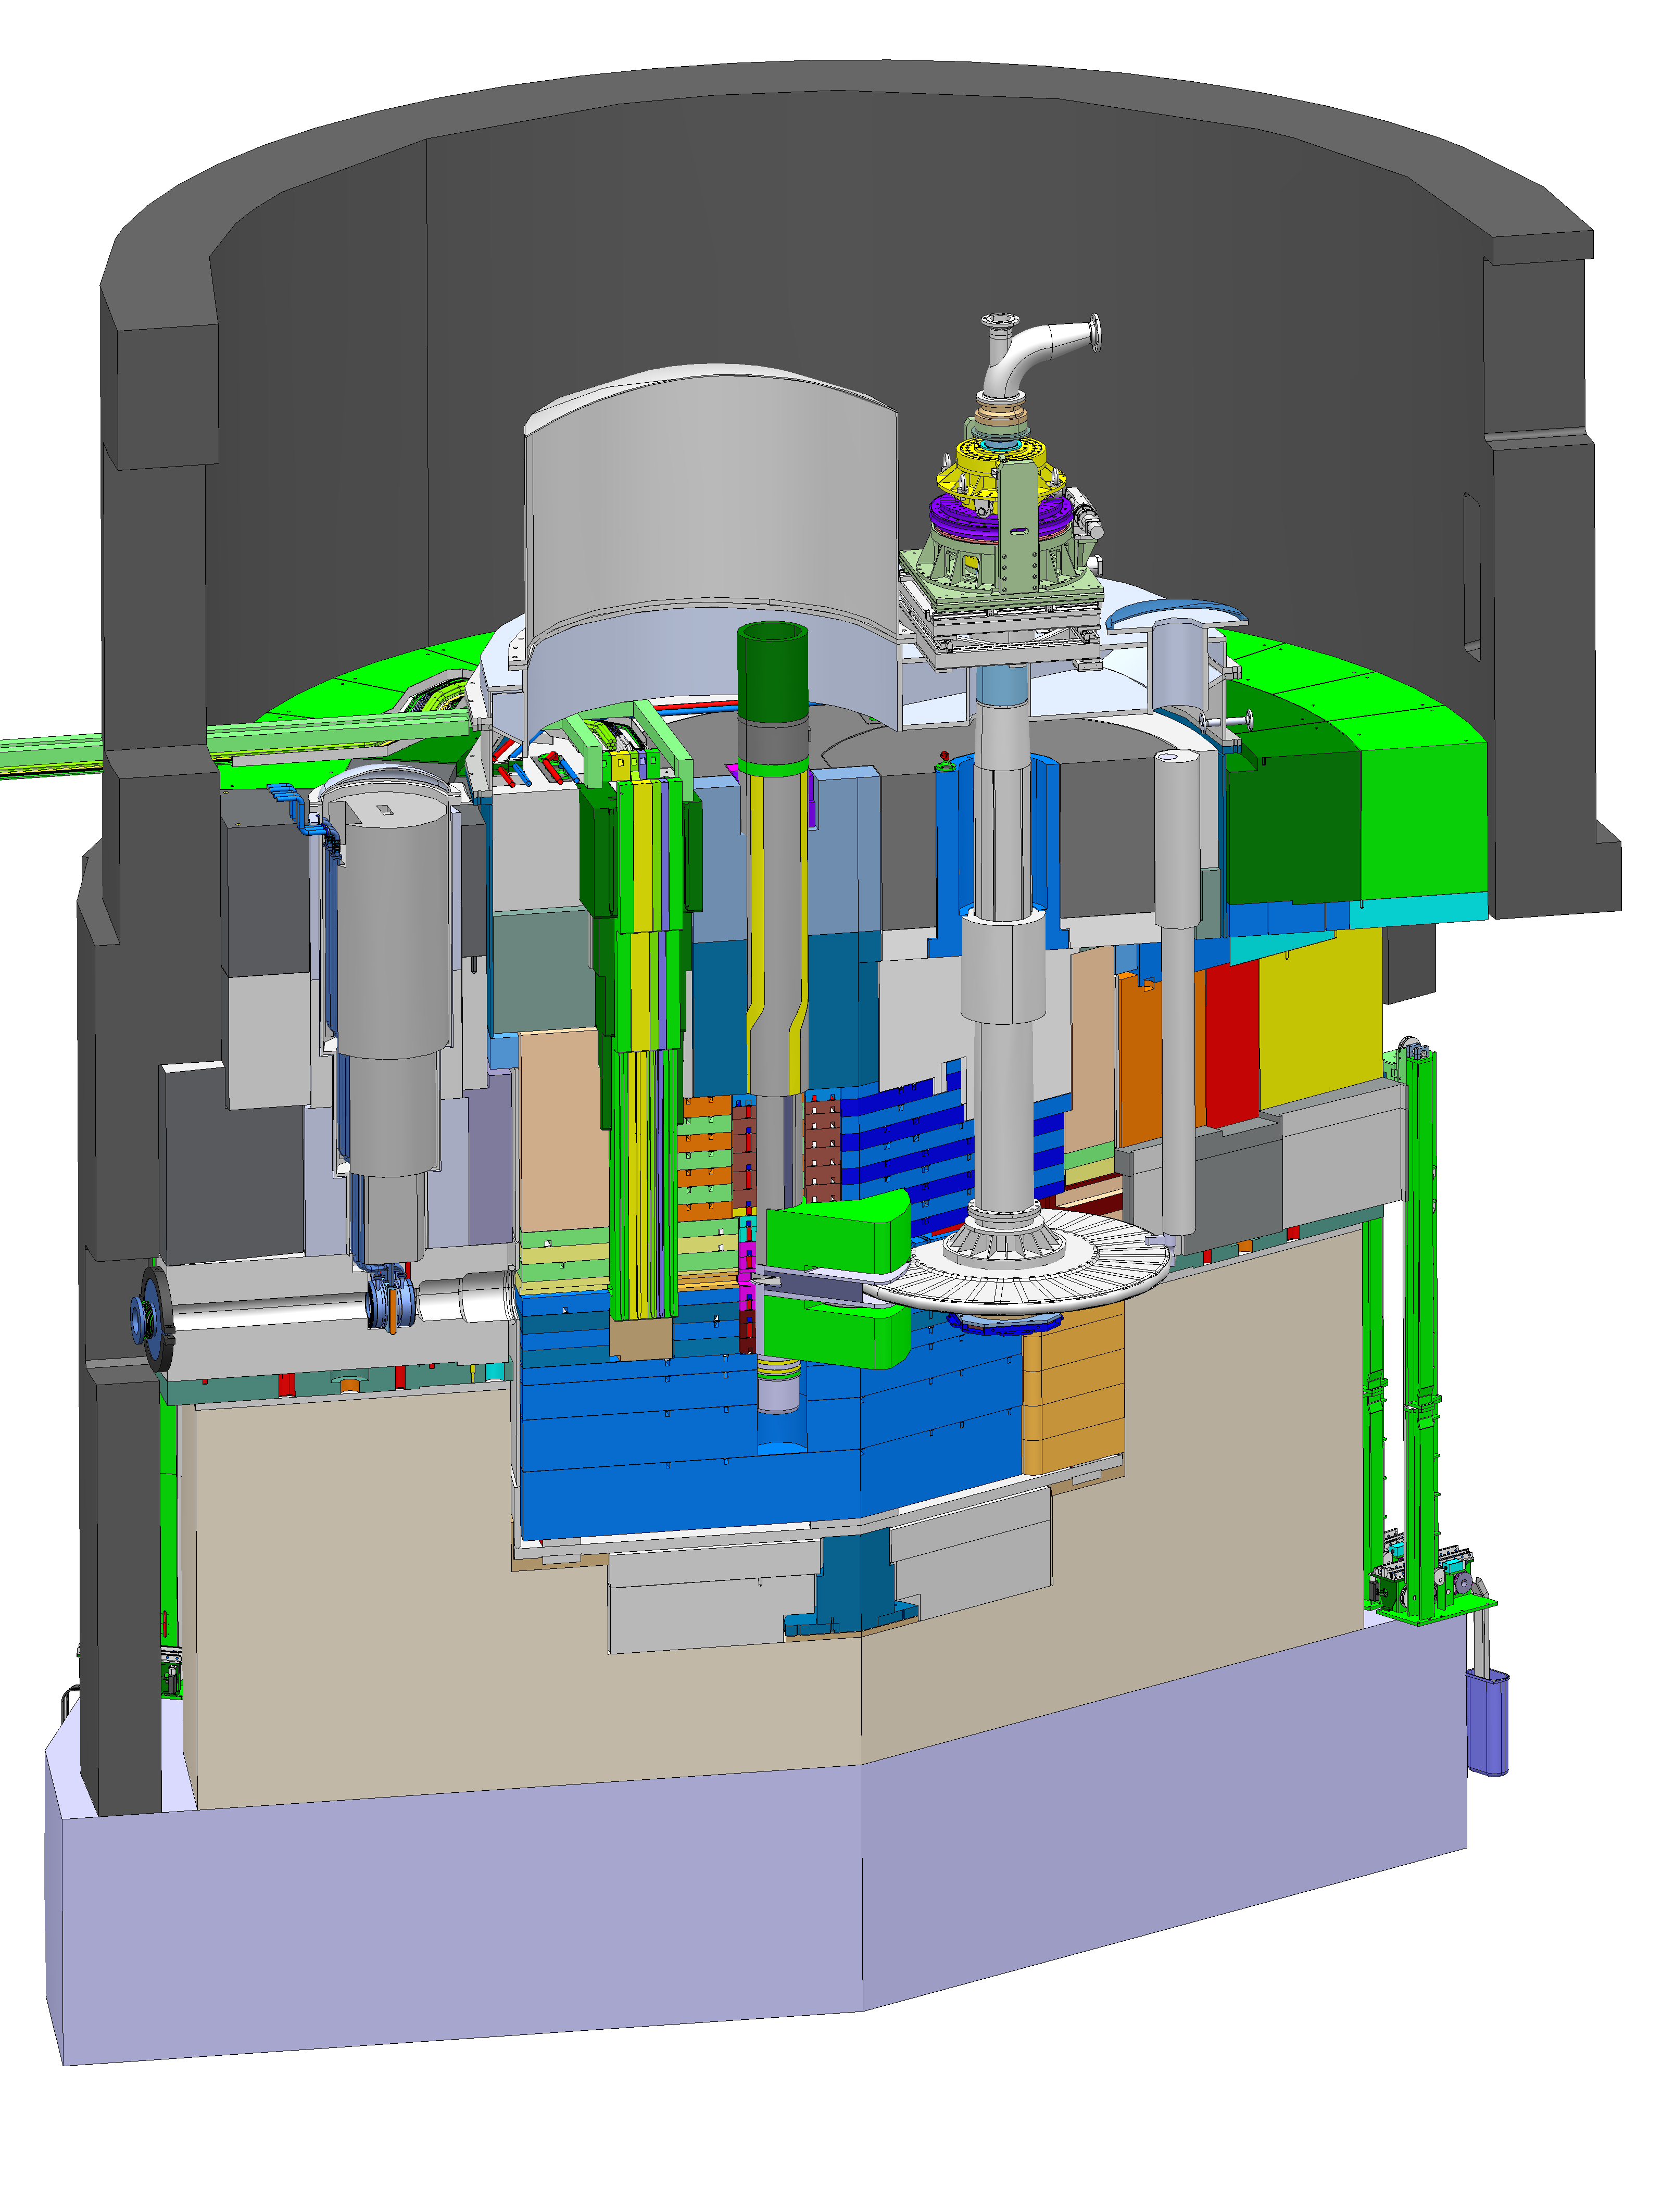
The Proton Beam Instrumentation Plugs main functions are:
- Provide housing for the Proton Beam Instrumentation (PBI)
- Transfer the structural loads from the components
- Keeping the shielding function of the Monolith
And the sub functions are:
- Cooling of the plug structure and the structure that holds the instrumentation
- Possibility to change instrumentation independently of each other
- Vertical extraction of the structure
- Enable handling and exchange of the plug when spent
- Provide positioning and alignment
- Provide support for the cables and optics
The outer dimensions of the plug structure of the PBIP is an agreement between the shielding system within the monolith and the PBIP itself [2] . It is as large as possible without imposing on other systems. The inner dimensions are based on the agreement with Proton Beam Instrumentation, as the main function of the plug structure is to provide housing for the PBI [3] .
The design is based on a flexible approach having one separate slice for each piece of instrumentation covered by uncooled shielding and optics blocks.

PBIP components
The PBIP consists of the following components:
- Five actively cooled slices acting as housing for the Proton Beam Instrumentation – All individually removable
- Two optical blocks to assure an optical path all the way to the top of the monolith
- A cooled support structure for alignment and insertion
- Shielding to prevent streaming
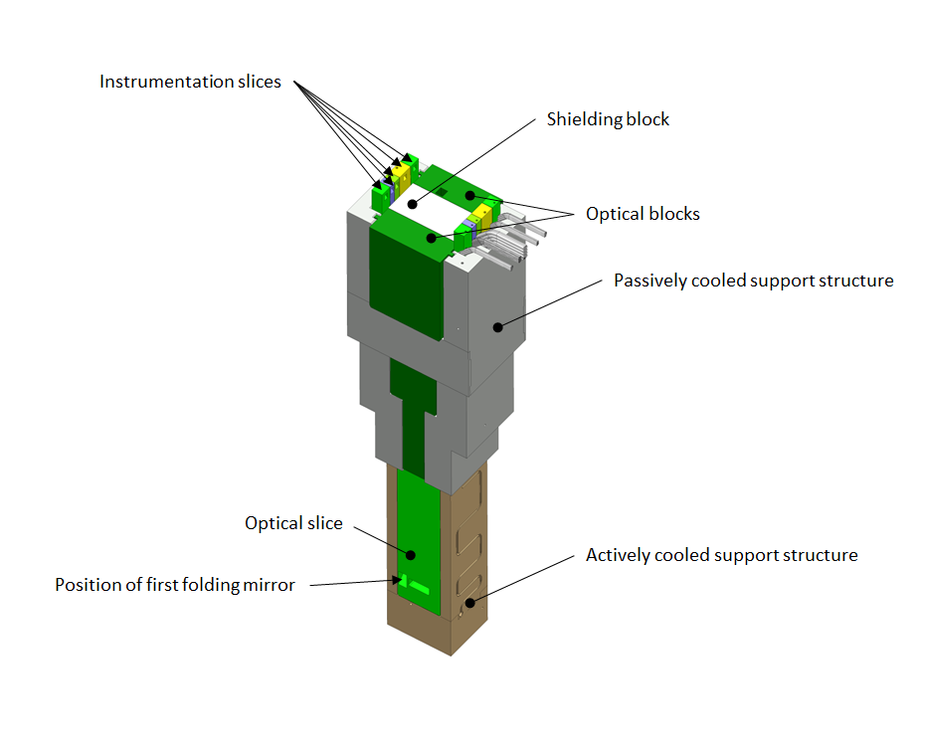
Figure 10 Full assembly of the PBIP
Figure 1 shows the full assembly of the PBIP. The five different slices are shown in bright colors. The optical slices are complimented with an optical block (dark green) each to provide an optical path to the top of the monolith. The rest of the structure (grey and brown) is for support and alignment. Each slice is aligned on an alignment mandrel that sits in the support structure and supported on the bottom surface of the slice. Wings are included on the sides for steering and on the upper part of them; the gap tightens to keep the slice within the tolerances. The optical blocks are aligned in the support structure and on top of the optics slices.
The dimensions of the full plug structure are: 4810x1180x860

Optical slices

Support structure
To carry the structural load, provide cooling and alignment, all the PBIP slices is inserted into a support structure. This structure is resting on the baseplate of the monolith vessel and is supported on the sides by the shielding structure of the Monolith. It is aligned using the same way as the shielding for the rest of the monolith, by using guide pins. The lower part of the support structure is actively water cooled and includes slots for the alignment wings of the PBIP slices as well as alignment mandrels on the bottom of the structure. The upper part of the structure does not require active cooling and only have alignment features for the optical blocks, not the slice. The water cooling for the lower support structure runs through the upper part.
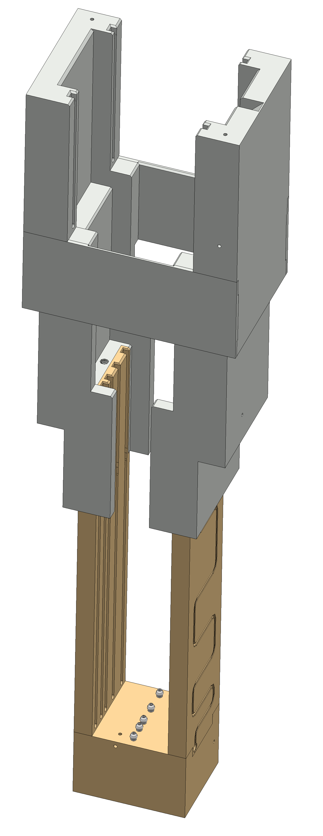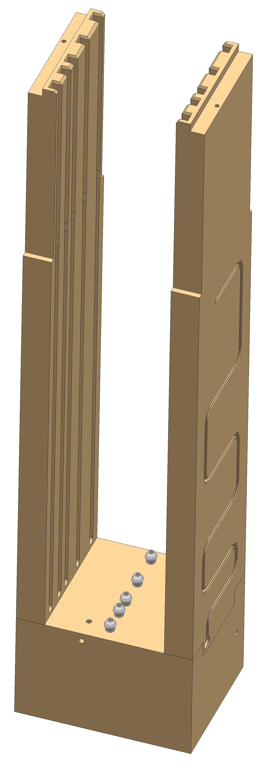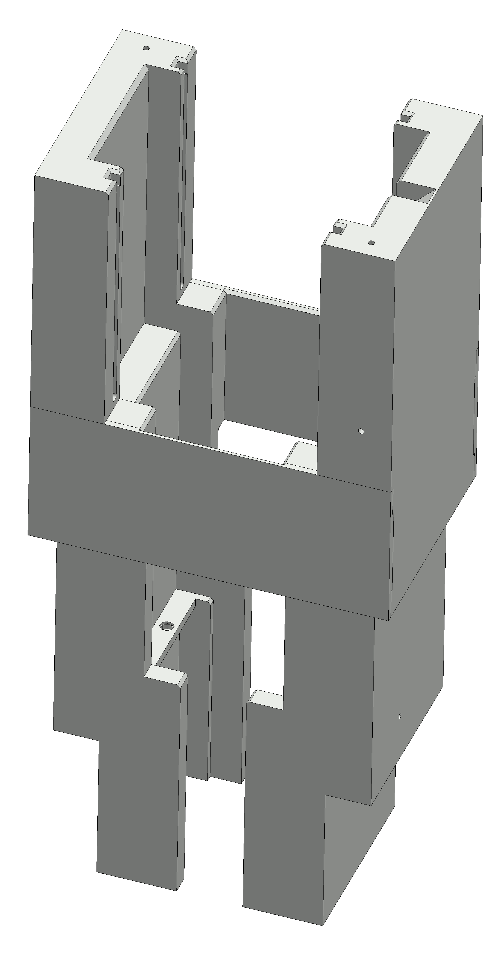

The full PBIP assembly
The PBIP structure is accessible after removal of the Moderator cap of the Monolith vessel.
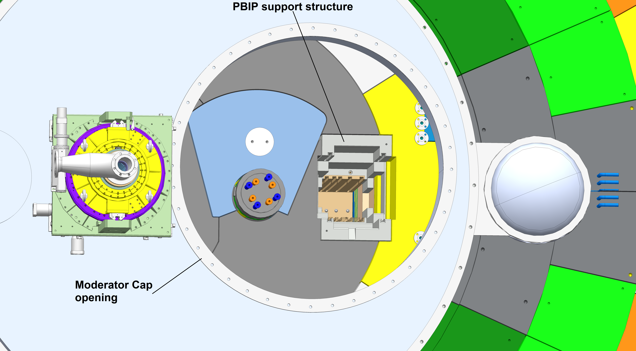
The support structure sits between the moderator assembly and the wall of the monolith vessel surrounded by shielding. Each slice can be individually placed and extracted to ease maintenance or replacement.
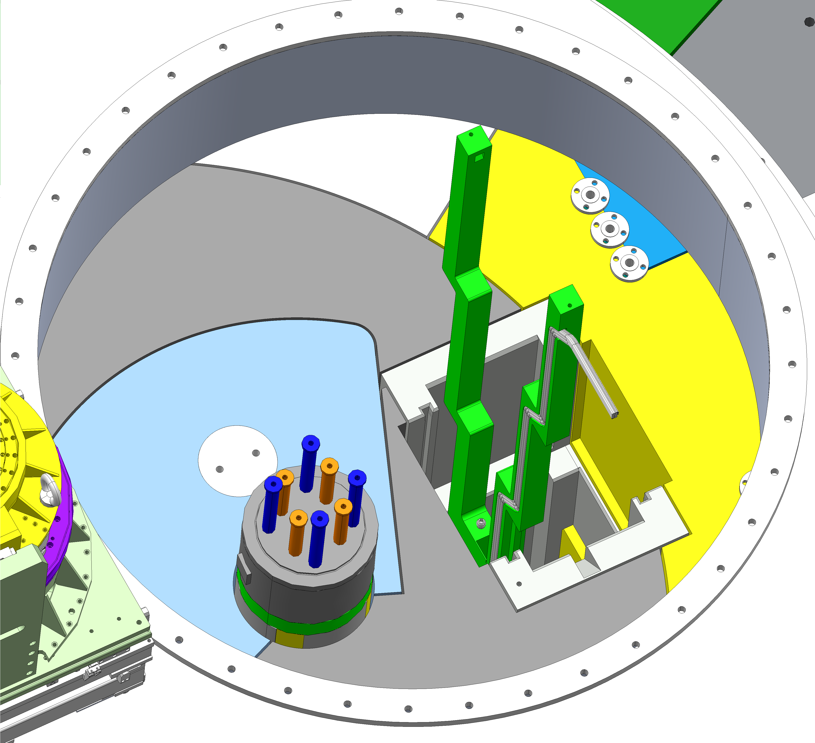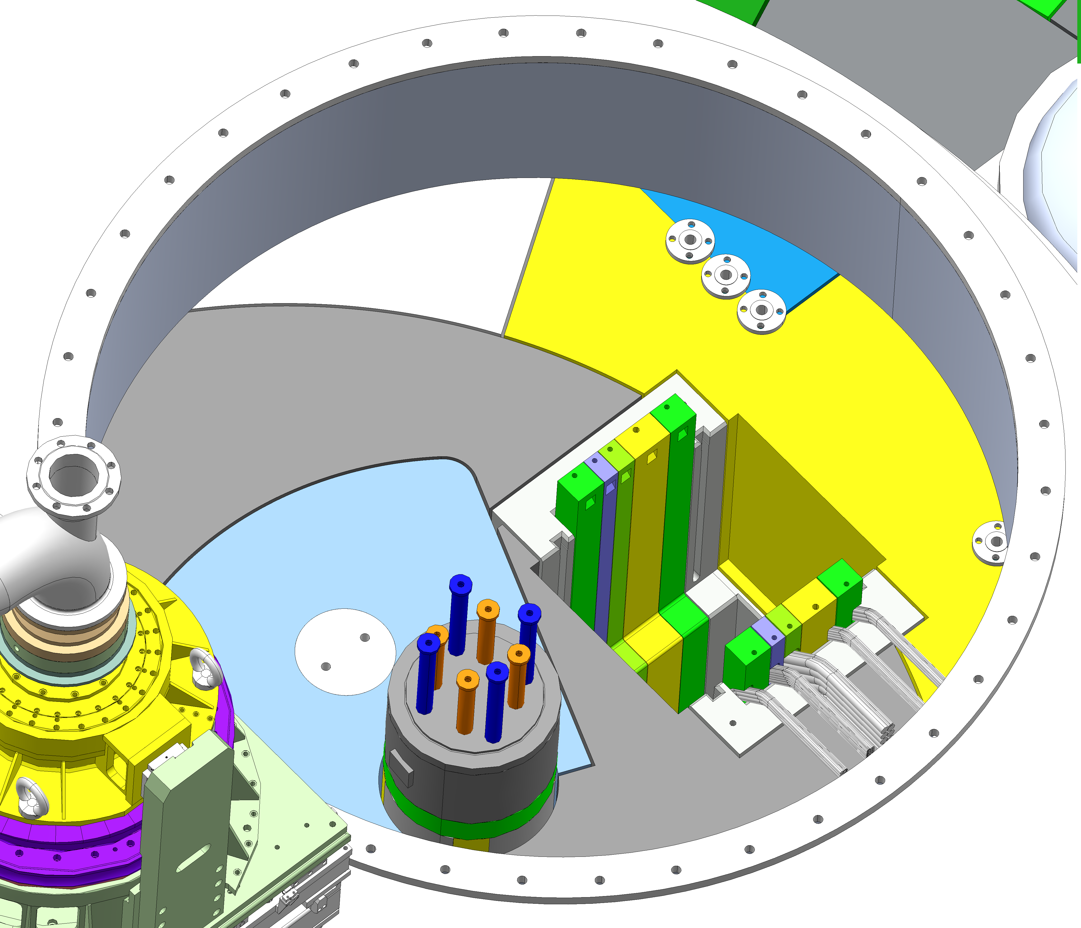

The slices are all aligned using the slots in the lower support block and corresponding alignment features of the slices. The position of the slices cannot be changed as the thicknesses of the components are different. From left to right, the order is optics slice downstream, aperture slice, grid monitor slice, beam position monitor slice and last optics slice upstream.
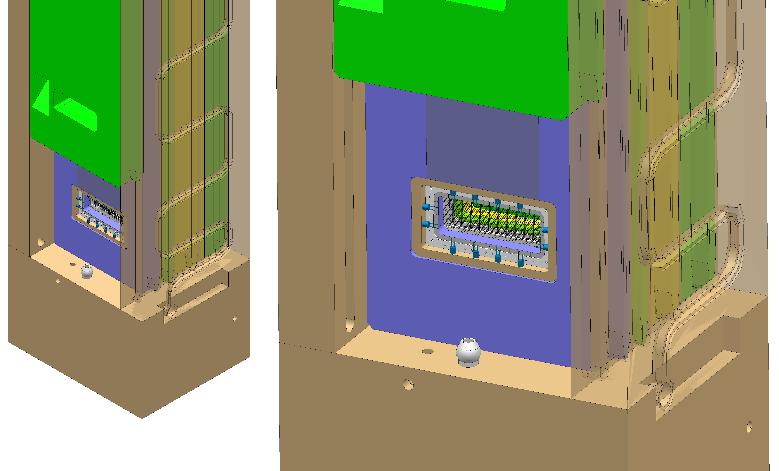
The optical blocks can be placed over the optics slices and the shielding block put in place
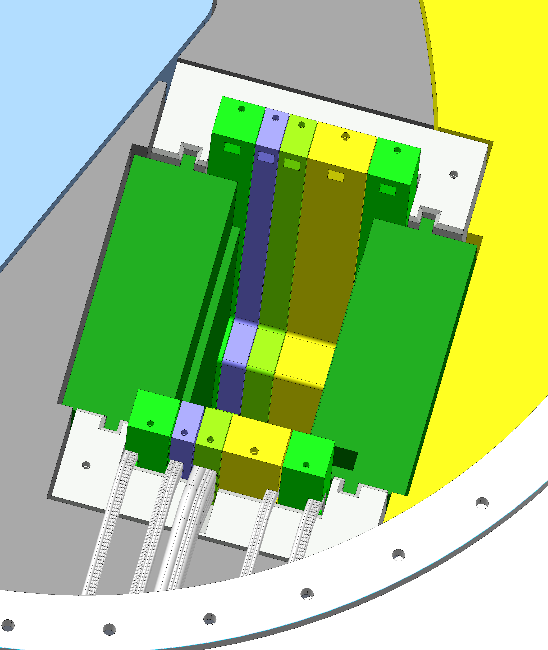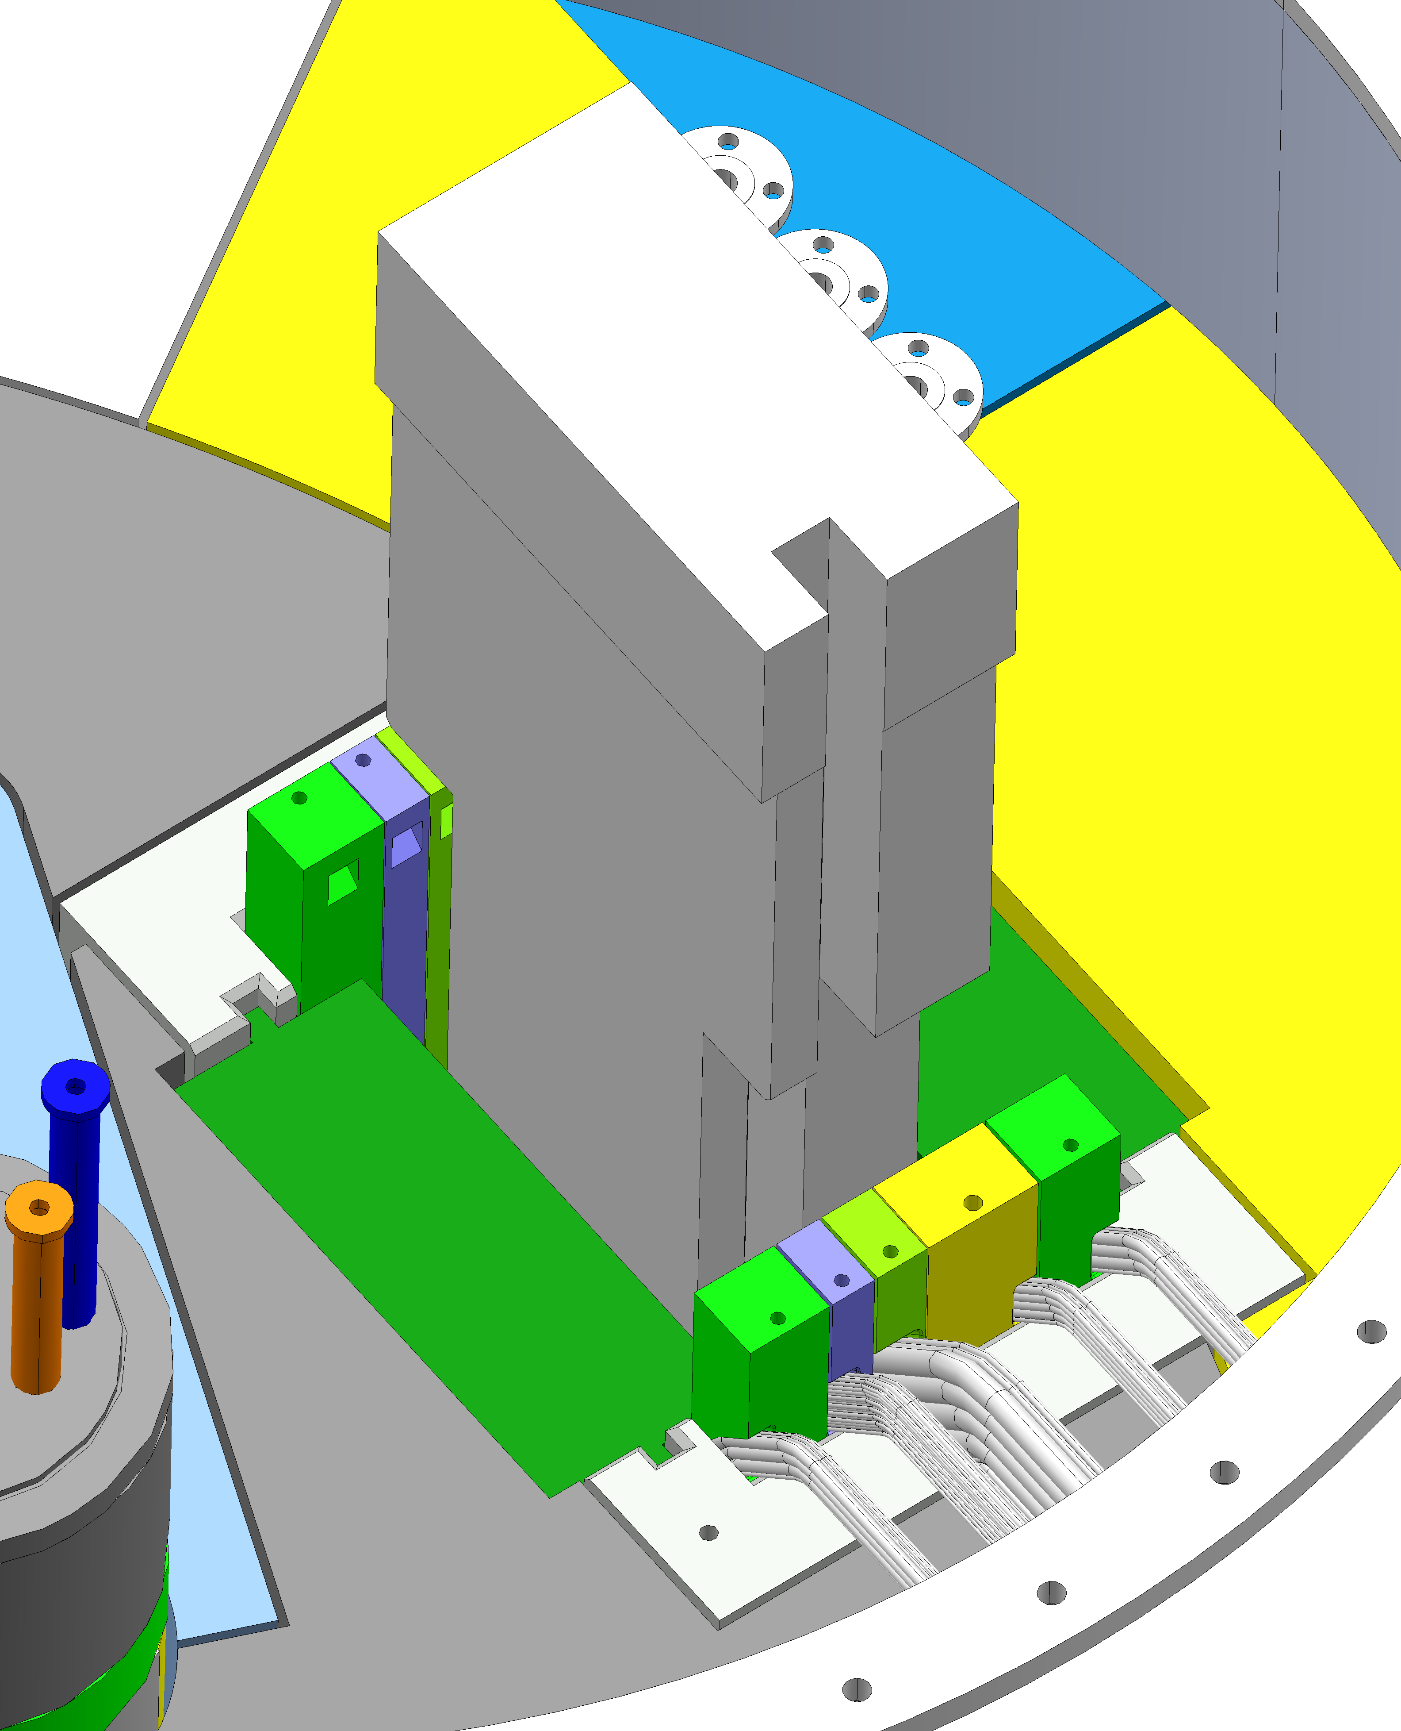

Finally the cabling, water cooling pipes and optics path that runs on top of the monolith can be connected.

Mechanical design considerations based on requirements
To make sure all requirements in SDD-Req is fulfilled, the chosen functions of the PBIP is based on the following requirements and interfaces identified in [1]
Design consideration | Requirement reference in SDD-Req [1]
Lifetime of the different components of the plug | PBIP-001, PBIP-036, PBIP-037
Radiation protection and occupational safety | PBIP-002, PBIP-029, PBIP-030
Choice of material | PBIP-003, PBIP-047
Handling considerations | PBIP-004 – PBIP-011
Testing | PBIP-012 – PBIP-014, PBIP-016
Geometrical constraints | PBIP-017, PBIP-021, PBIP-025, PBIP-026, PBIP-028, PBIP-048, PBIP-053 – PBIP-055
Penetrations, piping, leakage | PBIP-015, PBIP-018, PBIP-020, PBIP-044
Environmental constraints | PBIP-019, PBIP-031, PBIP-035, PBIP-041
Heat transfer and cooling | PBIP-022, PBIP-023, PBIP-034, PBIP-052, PBIP-056, PBIP-057, PBIP-060, PBIP-061, PBIP-062
Modular design | PBIP-024, PBIP-043, PBIP-059
Alignment | PBIP-027, PBIP-049, PBIP-051
Connections | PBIP-028, PBIP-18, PBIP-015
Operational modes | PBIP-032
Structural support and construction rules | PBIP-033 PBIP-038
Manufacture | PBIP-039, PBIP-040, PBIP-050
Maintenance and replacement | PBIP-042, PBIP-045, PBIP-046, PBIP-058

Location and layout
The PBIP is positioned inside the Monolith between the Target Wheel and the Proton Beam Window. In relation to TCS, the Target Coordinate System which is (0,0,0) in the middle of the Monolith, the PBIP coordinate system is placed on a distance of 1730 mm from TCS, i.e. (1730,0,0).
The optical instrumentation of the PBIP is looking at the Target wheel in one direction and the Proton Beam Window in the other direction and is in regard to the position of the mirrors placed 1822-1825 mm upstream the PBW, depending on where on the surface of the PBW the mirror is looking (assuming a panpipe design) and 1377 mm downstream the surface of the Target Wheel, see the figure below
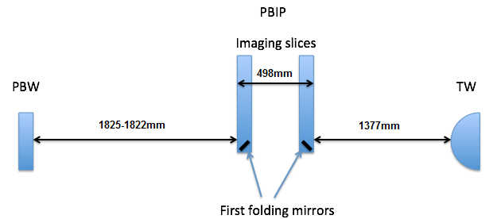
Figure 11 PBIP distances

Pipe routing
All pipe connections are welded and the pipes are seamless to avoid any leakage. The cooling channel is milled into the structure with a welded or bolted lid on top, going up to the extraction arms. Here the channel is drilled horizontally and vertically (for stepping), then plugged, and runs to the top of the component where a pipe is welded to the connection. The pipes are routed from the plug, through the connection ring, to the outside of the monolith vessel where they are connected to the cooling system for the shielding and plugs.

P&ID
See ESS-0040858 for the P&ID of the Shielding and Plugs cooling system.

Maintenance and handling solutions
Each slice has remote handling features in their extraction arms. When the component is due for replacement or maintenance, which is during one of the scheduled maintenance periods, the cabling and piping is disconnected and the pipes are blown dry to remove residual moisture. The top most shielding block is removed. At this point a floor valve and a cask is introduced and placed on the monolith vessel lid. The floor valve is opened, the gripper tool attaches to the slice that is to be replaced, and the component is hoisted into the cask.

After extraction, the component is taken to Active Cells where it is treated, intermediately stored and shipped off site.

Radiation protection and shielding
Calculations of the radiation shielding capability of the PBIP will be performed at a later stage when the optical path has been more set. Basic hand calculations show no need for additional shielding above what is included in the design today. The moderator cap provides additional space on top of the PBIP if such shielding should be needed.

Description of system and components behaviour

ESS Operational Modes
ESS has defined 4 operational modes: Maintenance, Studies on Target, Start up, and Production [4]

Target modes (beam related)
Target Station has defined 4 modes derived from the ones above: Target Maintenance, Studies on Target, Start up, and Production

Start-up and shut-down modes
The cooling of the PBIP is the only function of the Plug that is not passive. The instrumentation is handled by the Beam Instrumentation group and as such not listed in this document. The cooling of the PBIP is controlled by the Shielding and Plugs cooling system and the modes for the system is included in [5]

Maintenance mode
Maintenance of the PBIP will only be done during the Target maintenance mode.
The lifetime of the slices are 2 years, but for flexibility the PBIP is accessible every sixth month during one of the scheduled maintenance periods.

Abnormal system operation
Abnormal system operation will have no impact on the PBIP structure as it is passive.

Documentation

Reference drawings and specifications
ESS-0008848.2 shows a drawing of the basic geometry of the Proton Beam Instrumentation plug including the different slices.

Models

Geometrical models
For the geometrical model, see Catia model ESS-0008848

Analysis models
Thermomechanical calculations have been done on the PBIP structure and show no need for cooling of the upper parts (optical blocks and shielding block). The cooling channels need to be detailed when the design is more complete, i.e. before a CDR, but show a good start for keeping the displacement requirements defined by BIG in [3]
For Analysis report, see [7]

Safety assessment

Radiation safety assessment
Refer to the hazard analysis done for the monolith [6] .
None of the identified risks are unique for the PBIP.

Glossary
Term | Definition
<<Sample term>> | <<Sample explanation >>
FA | Flange Assembly
IET | Insert Extraction Tool
NBEX | Neutron Beam Extraction
NBPI | Neutron Beam Port Insert
TCS | Target Coordinate System
TS | Tool System

References
- ESS-0032915, SDD-Req NBEX
- ESS-0055988, NBEX Structure

Document Revision history
Revision | Reason for and description of change | Author | Date
1 | First issue | <<Name>> | <<YYYY-MM-DD>>
 | <<Keep only full number revisions when approving document>>

