|  |
| --- |
|  |
|  |
| *Name the document using the Department+Document type+Document No +Date* |
| *ESS-Information-0.1-1Sept11* |
|  |
|  |
|  |
| Motion study for the fast beam shutter system proposed for FREIA |
|  |
|  |

|  |  |  |
| --- | --- | --- |
|  | **Name** | **Affiliation** |
| **Authors** | Stewart Pullen, | ESS |
| **Reviewers** | Anders Standström  Hanna Wacklin | ESS |
| **Approver** | Rob Connatser  Ken Andersen | ESS |

Table of content

Table of content 2

1. Introduction: 3

2. Equations used: 3

3. Calculations: 3

4. Slit 3 shutter 5

4.1 Stage 1: 5

4.2 Stage 2: 6

5. Feasability of this system 7

5.1 Estimating Voice coil requirements to provide this series of motions. 7

5.2 Sensitivity analysis of the distance and mass parameters 9

5.3 Service Life 13

5.4 Conclusion 14

6. Possible links to the ESTIA project 14

7. Document Revision History 14

8. Appendix A: Email Correspondance with BEI Kimco 15

9. Appendix B: LA24-20-008Z Details 19

# Introduction:

The aim of this report is to assess the feasibility of a precision multi slit system and fast beam shutter system proposed for the FREIA Reflectometer. The systems will allow the FREIA reflectometer instrument to have three separate angular incidences which can be used by sequential pulses from the target.

The positioning of the slit blades is fairly evolved and outlined in the FRIEA Instrument proposal document. These motions are an evolution of systems currently in place on other reflectometers at various institutes. Their evolutions will mostly focus on compact assembly of the motion systems into a small technical package. This is a task for detailed design and not the focus of this study.

This study will focus on the motions required for the placement of the absorbers in their necessary position to open and close their assigned slit opening in a defined sequence. Calculations are made to assess what requirements a motion technology would need to provide. In this case, voice coils (linear motors) are assessed for ability to meet the motion requirements. The study only focuses on the mechanical position and not on the electrical control loops and feedback system. This aspect of the system would be developed in a subsequent stage of the project.

# Equations used:

To calculate acceleration:

$$a=\frac{V_{f}-V_{o}}{t}$$

To calculate distance:

$$d=V_{o}t+0.5at^{2}$$

To calculate Peak force:

$$F_{P}=F_{L}+F_{m}$$

$$F_{P}=m(a±g)$$

To calculate Root Mean Square (RMS) force:

$$F_{RMS}=\sqrt{\frac{{\left(F_{1}\right)}^{2}×t_{1}+{\left(F_{2}\right)}^{2}×t_{2}+{\left(F_{3}\right)}^{2}×t_{3}+…+{\left(F_{n}\right)}^{2}×t_{n}}{t_{1}+t_{2}+t_{3}+…+t_{n}}}$$

# Calculations:

The slit shutter needs to open and close within a 15ms timeframe. The three shutters work sequentially being open for a single pulse and then closing before the start of the next pulse where it will remain closed for the subsequent 2 pulses. As one slit closes another opens, this action occurs simultaneously during the transition between slits which is the 15ms window at the tail end of any given pulse, see Figure 1. Each slit is open for a duration of 56ms. The total time for one full motion cycle is 0.213sec (3 pulses).

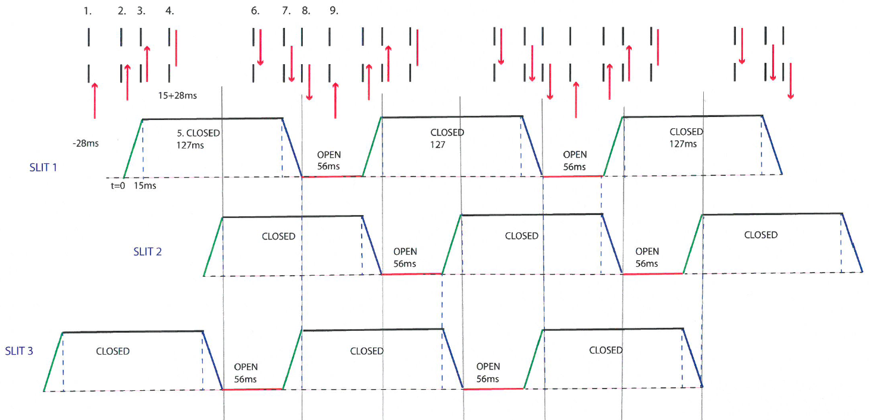

Figure 1: Sequences of shutter open and close timing

The vertical position of the slit is modifiable within distinct ranges. This has the effect of modifying the angular range of the incident beams on the sample. The slit gap is modified relative to the vertical position of the slit. The worst case from a motion perspective is that by slit three at 4° where the slit gap is 13.95mm. This will be the scenario used as it provides that largest distance that an absorber would need to move across in the allowable 15ms. It also provides force requirements for the larger of the absorbers that would be required.



Table 1: Slit locations and gap sizes

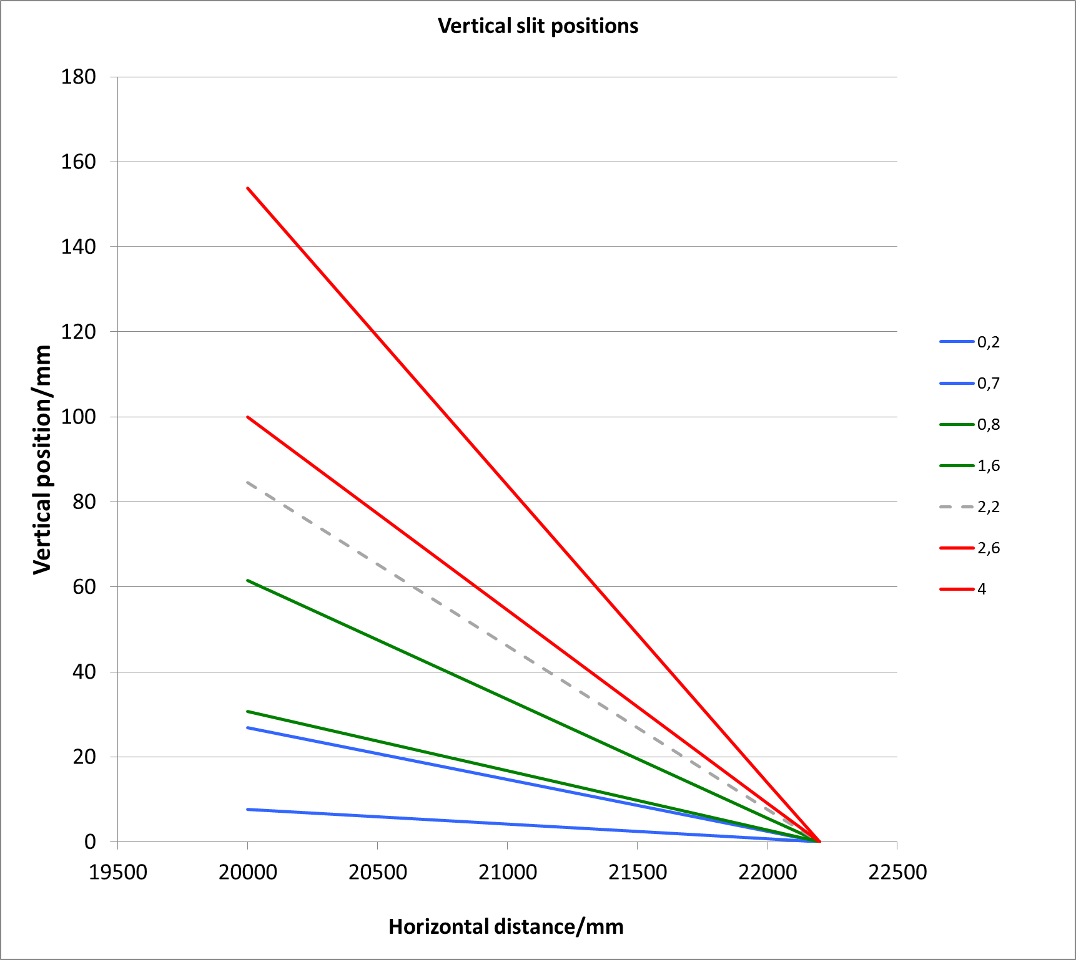

Slit 3

Slit 1

Slit 2

Figure 2: Slit gap position ranges

The motion can be divided into 2 stages:

* Stage 1 – Initial acceleration, 7.5ms
* Stage 2 – Decelerate to rest, 7.5ms

Some overlap between the slit blades and the absorber can be assumed to allow lead-in and lead-out accelerations, but the transition across the slit shall take no more than 15ms. The amount of overlap will be determined by an appropriate value for acceleration and peak velocity. These appropriate values vary between technologies and load (absorber and connection mechanism). The calculation adds a 1mm overlap at the top and bottom of the absorber to ensure no leakage of neutrons between the slit blade and the absorber.

# Slit 3 shutter

To assess the worst case, we are looking at the slit 3 shutter which has the largest gap that needs to be closed (13.95mm).

## Stage 1:

Accelerating from rest to peak velocity at midpoint of motion.

This assumes a 1mm overlap between the top and bottom of the absorber and slit blades.

Distance to travel = 16mm/2 = 8mm

This is half the gap height for which the absorber may accelerate. It also allows the absorber to clear the slit gap by 1mm.

Acceleration:

$$d=V_{o}t+0.5at^{2}$$

d = 0.008m

Vo = 0 m/sec

t = 0.0075 sec

$$a=\frac{0.008}{0.5{×0.0075}^{2}}$$

**a= 284.44 m/sec2**

Peak velocity:

$$a=\frac{V_{f}-V_{o}}{t}$$

Vo = 0 m/sec

t = 0.0075 sec

a = 284.44 m/sec2

**Vf = 2.13 m/sec**

## Stage 2:

Decelerating from peak velocity at midpoint of motion to rest at the end of the stroke.

$$d=V_{o}t+0.5at^{2}$$

d = 0.008m

Vo = 2.13 m/sec

t = 0.0075 sec

$$a=\frac{0.008-(2.13 ×0.0075)}{0.5{×0.0075}^{2}}$$

**a= -284.44 m/sec2**

Verify that deceleration results in 0 velocity at end of cycle.

$$a=\frac{V_{f}-V_{o}}{t}$$

Vo = 2.13 m/sec

t = 0.0075 sec

a=-284.44 m/sec2

***Vf = 0 m/sec***

Peak Force:

For the purpose of this calculation this absorber is assumed to be made from B4C and have dimensions as follows:

H = 16mm W = 50mm T = 5mm

Volume = 4000mm3

Density of B4C = 2.52 g /cm3

Mass of shutter (M) ≈ 10 g

F =0.01 X (284.44+9.81)

***FP = 2.9 N***

# Feasability of this system

## Estimating Voice coil requirements to provide this series of motions.

In order to assess the feasibility of a voice coil providing this motion a theoretical voice coil specification is produced with the following parameters.

Stroke = 16 mm

Payload mass = 10 g

Coil Mas = 27 g[1]

Peak Acceleration = 284.44 m/s2

Peak Force (FP):

FL = Force due to load under gravity (10+27) = 37 g = 0.037 X 9.81 =0.36297 N

Fm = Acceleration of mass = 0.037 X 284.44 = 10.52428 N

$$F_{P}=10.88725 N$$

Root-Mean-Square Force (FRMS):

FS1 = Stage 1 Open force = (0.037 X 9.81) + (0.037 X 284.44) = 0.36297 + 10.52428 = 10.88725 N

FS2 = Stage 2 Open force = (0.037 X 284.44) - (0.037 X 9.81) = 10.52428 – 0.36297 = 10.16131 N

FS3 = Dwell in open position = 0.037 X 9.81 =0.36297 N

FS4 = Stage 1 Close force = (0.037 X 284.44) - (0.037 X 9.81) = 10.52428 – 0.36297 = 10.16131 N

FS5 = Stage 2 Close force = (0.037 X 9.81) + (0.037 X 284.44) = 0.36297 + 10.52428 = 10.88725 N

t1 = Acceleration = 0.0075 sec

t2 = Deceleration = 0.0075 sec

t3 = Dwell = 0.056 sec

t4 = Acceleration = 0.0075 sec

t5 = Deceleration = 0.0075 sec

t6 = Dwell = 0.127 sec

tTotal = 0.213 sec (equivalent of three full pulses)

$$F_{RMS}=\sqrt{\frac{2×\left[\left(118.5322×0.0075\right)+\left(103.2522×0.0075\right)\right]+\left(0.13175×0.056\right)}{0.0075+0.0075+0.056+0.0075+0.0075+0.127}}$$

$$=\sqrt{\frac{3.334144}{0.213}}$$

$$=3.96 N$$

## Sensitivity analysis of the distance and mass parameters

To assess the sensitivity to minor changes to the parameters, a sensitivity analysis is performed to see what the impacts of changes to the distance and mass parameters are and how they may impact of the technology requirements.

The relationship between distance traveled, the peak acceleration and the peak velocity is a linear one when considering that the time to open or close the slit gap is constant.

**Multiplication factor for the peak acceleration as a function of distance to travel is:**

$a=\frac{1}{0.5{×t}^{2}} d$.

t = 0.0075 sec

$a=35555.56×d \left(m/\sec^{2}\right)$

**Multiplication factor for the peak velocity as a function of distance to travel is:**

$$a=\frac{V_{f}-V_{0}}{t}$$

$$35555.56×d=\frac{V_{f}}{0.0075}$$

$$V_{f}=266.67×d \left(m/sec\right)$$

Both of these functions are plotted in Figure 3 for a distance range from 1mm to 35mm.

Figure 3: Acceleration, Velocity and Mass Graph

**Multiplication factor for the Force as a function of the absorber mass is:**

Here the time to cross the gap is held constant at 0.0075sec and the distance is maintained at 16mm. The load mass includes the absorber component mass and the actuator coil mass combined.

Peak Force:

$$F_{P}=m×a$$

$$F_{P}=m ×(284.44+9.81)$$

$$F_{P}=294.25 ×m \left(N\right)$$

RMS Force:

$$F_{RMS}=\sqrt{\frac{2×\left[\left({{(F}_{S1})}^{2}×t_{1}\right)+\left({\left(F_{S2}\right)}^{2}×t_{2}\right)\right]+\left({\left(F_{S3}\right)}^{2}×t_{3}\right)}{2×\left(t_{1}+t_{2}\right)+t_{3}+t_{6}}}$$

$$F_{RMS}=\sqrt{\frac{2×\left(649.373m^{2}+565.6623m^{2}\right)+5.3892m^{2}}{0.213}}$$

$$F_{RMS}=106.93×m \left(N\right)$$

Both these functions are plotted in Figure 4 for masses 5g – 150g

Figure 4: Force (Peak and RMS) and Load Mass

**Peak force as a function of distance and mass (constant time):**

$$a=\frac{d-\left(V_{0}×t\right)}{0.5×t^{2}}+g$$

$$F_{P}=m×\left(\frac{d}{0.5×t^{2}}+g\right)$$

$$F_{P}=m×\left[(35555.56×d)+9.81\right] \left(N\right)$$

Figure 5: Peak Force as a fn of distance and mass (constant time)

An increase in mass has a larger impact on the resulting peak force than by an increase in distance to be traveled.

**RMS force as a function of distance and mass (constant time):**

$$F_{RMS}=\sqrt{\frac{2×\left[\left({\left(m×\left(35555.56d+9,81\right)\right)}^{2}×0.0075\right)+\left({\left(m×\left(35555.56d-9.81\right)\right)}^{2}×0.0075\right)\right]+\left(m×5.4936\right)}{0.213}}$$

Figure 6: RMS Force as a fn of distance and mass (constant time)

An increase in mass has a larger impact on the resulting RMS force by an increase in distance to be traveled but only by a very marginal amount.

## Service Life

On cycle occurs every 0.213 seconds which mean that the operating frequency is 4.6948Hz.

$$Cycles per hr=4.6948×3600$$

$$Cycles per hr=16901.41$$

The system would reach 1,000,000 cycles in approximately 60Hrs.

In order to achieve a service interval of 6 months, this would be the minimum acceptable; the system would need to operate for 4380Hrs. Here I am assuming continuous operation during the longest operational time before a facility shut down. This creates a requirement for a service interval of circa 74 Million cycles.

BEI Kimco has indicated that the voice coil technology will be suitable for this service interval. Further, they have indicated that the technology may be suitable up to 1 year operation and that only relatively minor servicing of the lead wires on the brushless assemblies (see Appendix A and B for further details).

## Conclusion

It appears that the shutter system that is proposed is possible, particularly if considering the use of voice coils to provide the motions as described. Service interval of the coils would be between 6 – 12 Months.

It appears unlikely that any subtle changes to the parameters are likely to move the performance requirements outside that that a voice coil could possibly provide (within some limits). This may increase the size of the coil needed particularly for the largest of the three absorbers required.

The impact of any guide-fields may have on the voice coil would also need to be assessed during the design stage and could be tested on a proof of concept prototype. Impacts can be mitigated through the application of sufficient magnetic shielding, but this is a task for detailed design.

The main engineering effort would need to be placed on the design of the Slit and Shutter assemblies. The packaging of the motion technology in the assembly will require some thought which would like be the focus of detailed conceptual design. The linkage between the slits and the shutter will need careful consideration to ensure any vibration is sufficiently dampened. A proof of concept prototype would then follow to test the actual performance of the design and further planning should come from what is known at that point in time.

# Possible links to the ESTIA project

The requirements of the FREIA slit and shutter system seems feasible with motion technology that is currently available. The ESTIA slit system requires some development work, particularly in the selection and application of a technology. It seems that the development of the FREIA and ESTIA slit systems can make use of the same technology as both require high acceleration, repetitive and relatively precise motion. The development work for the FREIA slit system and the early ESTIA slit development work would complement each other. The projects would begin to diverge outside the technology application and testing. Component layout and technical design of the respective systems will be distinctly different. The slit system development projects would benefit by starting together with shared engineering effort and would naturally diverge at an appropriate time. A common engineering effort across both slit system development projects would be useful.

# Document Revision History

|  |  |  |
| --- | --- | --- |
| **Version** | **Reason for revision** | **Date** |
| 1.0 | New Document (Draft) | 24/09/2014 |
| 1.1 |  |  |

# Appendix A: Email Correspondance with BEI Kimco

Email correspondence with Jorden Harvey at BEI Kimco.

Dear Stewart,

It looks to me that we are well within your range on this actuator and it would be a good fit for your application. Based only on the specification data, this would be the first actuator that I would have recommended.

Please see the attached (below) image for the expected maximum range that this actuator could perform based on the data you provided me.

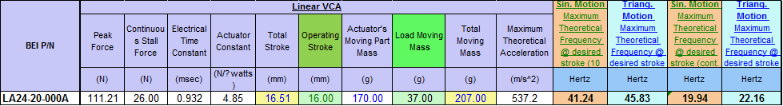

(Embedded image moved to file: pic30066.gif)

For your life cycle requirements, I believe that this actuator would be adequate with your demands of about 74 million cycles, possibly up to your one year mark. The only thing that we have seen in the past with similar actuators is that the lead wires may be damaged over time. As such, we have the exact same actuator design as the LA24-20-000A, but with a more flexible and durable "Cooner" cable, which I would expect to last much longer. Please see the attached drawing for your reference. (See attached file: LA24-20-008Z.pdf) (Appendix B).

It is worth noting that all of our actuators are rated up to 155 degrees C, and I imagine your application would have a robust cooling system to keep everything operating well within this range during the prolonged use.

As far as the radiation and other magnetic fields that you mentioned, we have little experience with RAD protection, but it is something that we could look deeper into if the need arises. I would need more information on the magnetic fields to provide feedback, but like you said, we should figure out the feasibility first before going here.

If you would like pricing information, please provide me with the number of units that you are interested in. Our pricing is dependant on the quantity of units sold.

I hope this helps. I am at your disposal if you need anything else.

Best regards,

_________________________________________________________

Jorden HARVEY | Sales Prospector/Marketing Specialist

BEI Kimco - 1499 Poinsettia Ave, Suite #160 - Vista, CA 92081 - USA

Tel: (760) 597-7042 | Fax: (760) 597-6320

E-mail: [sales@beikimco.com](mailto:sales@beikimco.com) | Web <http://www.beikimco.com>

_________________________________________________________

CONFIDENTIALITY NOTICE: This correspondence may contain technical data, as defined in ITAR 22 CFR or the EAR 15 CFR. The recipient is advised and hereby acknowledges that such technical data, relating to export controlled items under the ITAR or the EAR may not be exported, disclosed or transferred to any foreign person whether in the United States or abroad, without first complying with all relevant requirements including the requirement for obtaining any written export authorization from the U.S.

Department of State, Directorate of Defense Trade Control or the Department of Commerce’s Bureau of Industry & Security or otherwise make and document the determinations that an export licensing exemption applies, as the case may be. Diversion contrary to U.S. law is prohibited.

***Please consider the environment before printing this e-mail***

Stewart Pullen To

<[Stewart.Pullen@esss.se](mailto:Stewart.Pullen@esss.se)> "[sales@beikimco.com](mailto:sales@beikimco.com)" <[sales@beikimco.com](mailto:sales@beikimco.com)>

cc

01/23/2015 12:03 AM

Subject

RE: BEI Kimco Web Request - European Spallation Source (ESS)

Dear Jorden,

Thank you for the reply.

The requirements for one specific application we are currently looking at (there are others) is:

|----------------------------+------------|

|Stroke |16mm |

|----------------------------+------------|

|RMS Force |3.96N |

|----------------------------+------------|

|Peak Force |10.887N |

|----------------------------+------------|

|Peak acceleration |284.44m/sec2|

|----------------------------+------------|

|Peak velocity |2.13m/sec |

|----------------------------+------------|

|Load (including coil) |37g |

|----------------------------+------------|

|Cycles per second |4.69Hz |

|(extend-retract) | |

|----------------------------+------------|

The system is run continuously with short breaks maybe once a week. Longer breaks for maintenance every 6months (this is where we could change out a coil if needed). Ideally we would like to run a full year without changing coils.

This looks like 1,000,000 cycles would take approx. 60hrs. I would need in the a 4380hrs between maintenance (minimum) which will be of the order of 74,000,000 cycles between service.

This is a diagram of the cycle that we would require 3 coils to actuate sequentially:

(Embedded image moved to file: pic26412.jpg)

The other issue to point out is that this technology would be deployed on a Neutron Refectometer instrument at the worlds brightest spallation source (European Spallation Source) currently being constructed, so I will need to consider performance in environments where it may be exsposed to radiation and strong magnetice fields, but this is something to consider later, for the momement I just want to be sure that the technology will provide a reasonable service life and interval.

Thank you for your help.

Regards,

Stewart Pullen

Lead Instrument Engineer

Scientific Projects Division

European Spallation Source ESS AB

P.O Box 176, SE-221 00 Lund, Sweden

Visiting address: ESS, Tunavägen 24, Lund

Mobile: +46 721 79 22 21

Phone: +46 46 888 3221

Switchboard: +46 46 888 3000

E-mail: [Stewart.Pullen@esss.se](mailto:Stewart.Pullen@esss.se)

[www.esss.se](http://www.esss.se)

The European Spallation Source is a Partnership of 17 European Nations

committed to the goal of collectively building and operating the world's

leading facility for research using neutrons by the second quarter of the

21st Century

-----Original Message-----

From: [sales@beikimco.com](mailto:sales@beikimco.com) [<mailto:sales@beikimco.com>]

Sent: den 22 januari 2015 20:58

To: Stewart Pullen

Subject: BEI Kimco Web Request - European Spallation Source (ESS)

Dear Mr. Pullen,

Thank you for your inquiry.

I understand that you are looking for more information on our LA24-20-000A in terms of life cycle data. I do not have anything specific to this actuator as far as that, but I will say that all of our VCAs are rated at least in the millions of cycles range. Our housed VCAs, which contain bushings, have lasted more than 50 million cycles, and have only had issues beyond that with the bushings themselves. Since the LA24-20-000A in un-housed and does not contain bushings, I would expect it to last even further beyond that. What kind of life cycle requirements were you expecting to need?

I may be able to give you more information if you can provide me with some of your requirement data, such as: stroke, required force, frequency, load moving mass, any special circumstances, etc. I would also be interested to learn a little more about your application as well.

If you need anything else, please let me know.

Best regards,

_________________________________________________________

Jorden HARVEY | Sales Prospector/Marketing Specialist

BEI Kimco - 1499 Poinsettia Ave, Suite #160 - Vista, CA 92081 - USA

Tel: (760) 597-7042 | Fax: (760) 597-6320

E-mail: [sales@beikimco.com](mailto:sales@beikimco.com) | Web <http://www.beikimco.com>

_________________________________________________________

CONFIDENTIALITY NOTICE: This correspondence may contain technical data, as defined in ITAR 22 CFR or the EAR 15 CFR. The recipient is advised and hereby acknowledges that such technical data, relating to export controlled items under the ITAR or the EAR may not be exported, disclosed or transferred to any foreign person whether in the United States or abroad, without first complying with all relevant requirements including the requirement for obtaining any written export authorization from the U.S. Department of State, Directorate of Defense Trade Control or the Department of Commerce’s Bureau of Industry & Security or otherwise make and document the determinations that an export licensing exemption applies, as the case may be. Diversion contrary to U.S. law is prohibited.

***Please consider the environment before printing this e-mail***

______________________________________________________________________

This email has been scanned by the Symantec Email Security.cloud service.

For more information please visit <http://www.symanteccloud.com>

______________________________________________________________________

This email has been scanned by the Symantec Email Security.cloud service.

For more information please visit <http://www.symanteccloud.com>

______________________________________________________________________

# Appendix B: LA24-20-008Z Details

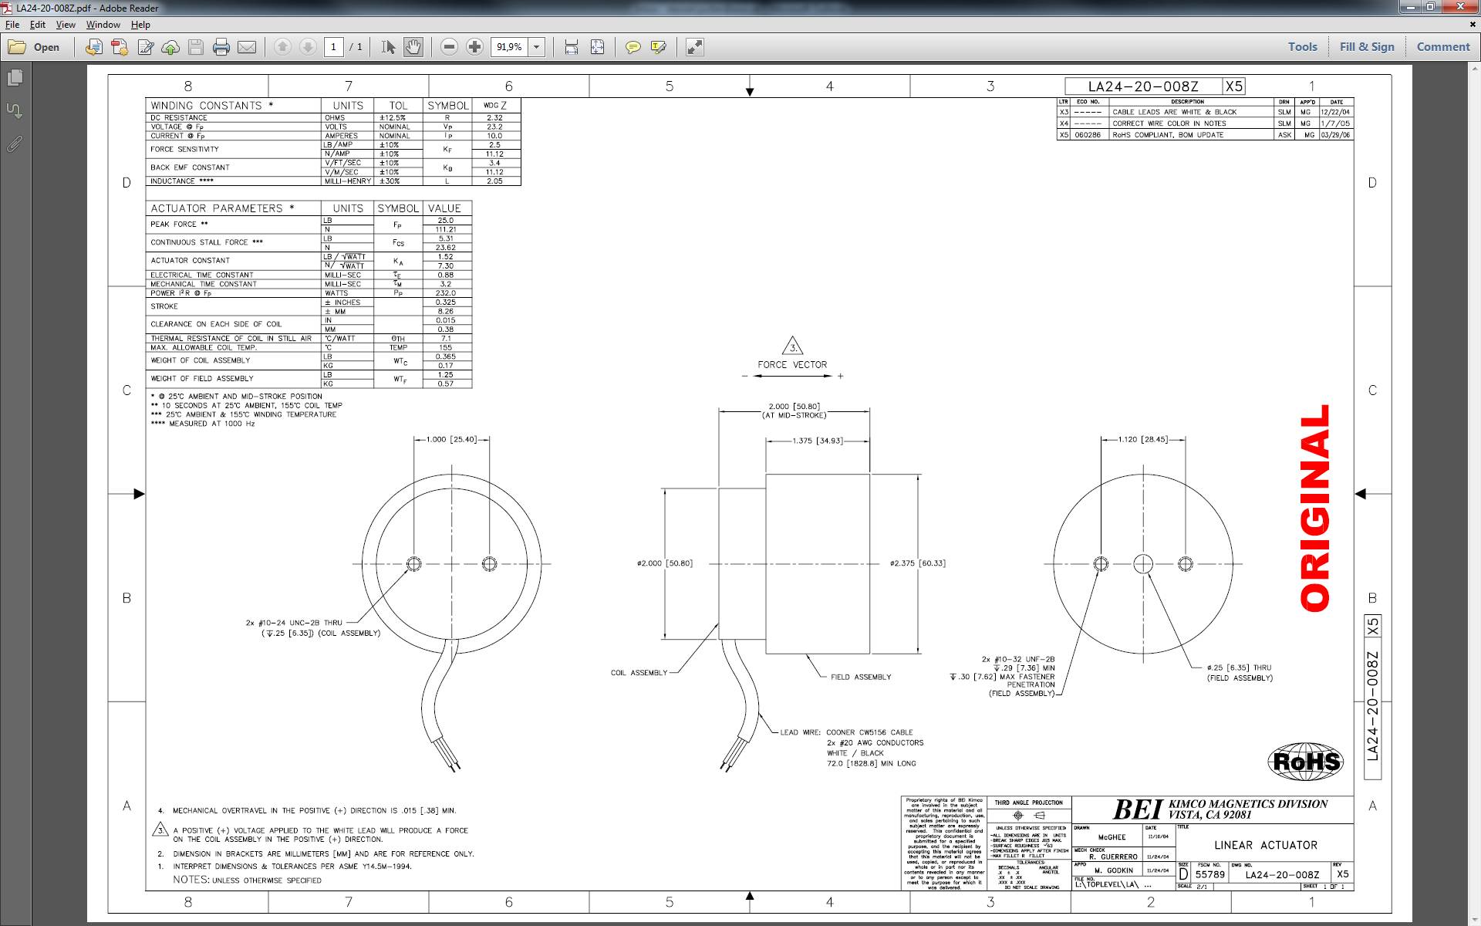

1. Note: the coil mass is estimated from an existing coil with similar stroke requirements, Moticont LVCM-025-029-01. This coil and its mass may not be adequate to provide the necessary force but is used as a best guess of a coil mass.