ESS Construction Update APRIL 2016

ESS signed a collaboration contract with Skanska in February 2014. After preparatory works during the summer, construction commenced in September 2014. The first building handover is scheduled for September 2016, when ESS Accelerator Division is given partial access to the Cryo Compressor Building.

Accelerator Tunnel (G01)
A 537-meter long in-situ cast tunnel, connected to the G02 Gallery Building via 27 stubs. The first major building to reach structural completion, two months ahead of original schedule. First base slab cast in December 2014, last top slab 5th of April 2016.

Next steps for the tunnel are the completion of the interior, remaining stubs and retaining wall. Handover to ESS is scheduled for 2017.

Materials used:
Concrete: 16,500 m³
Reinforcement: 2075 tons

Total number of castings:
45 bottom slabs
92 walls
87 top slabs
Stubs: 7x27 castings
Retaining wall: 34 wall castings, 9 foundations

In the autumn of 2015 castings peaked with an average 20 casting sessions per week.

ESS overall progress
23 buildings are included in the scope. Works have commenced in 15.

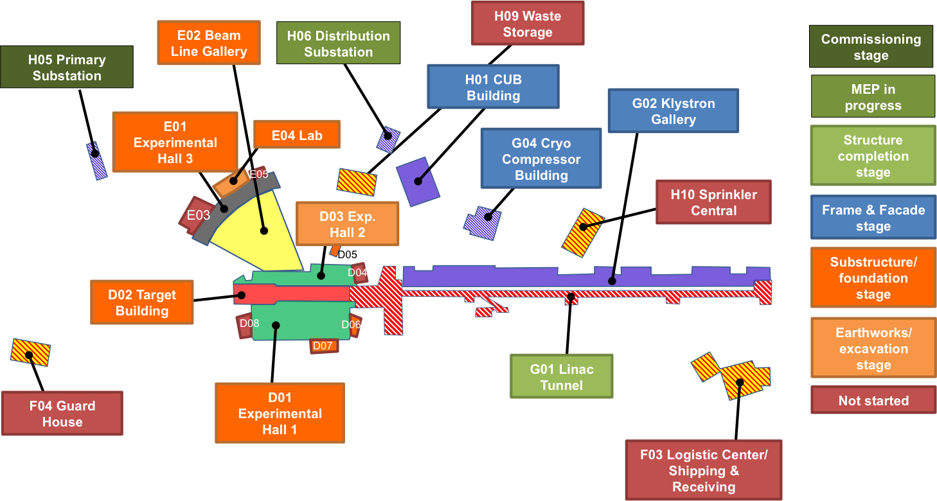
Target/Piling (D- & E-buildings)

- Concrete Piles: 3836/5905 (65%)
- Steel Core Piles: 211/356 (59%)
- Bored Piles: 44/63 (70%)
- Sheet Piles: 10,337 m² (100%)

Preparatory concrete works for the Target Building will start in late spring 2016.

Total number of staff on site: 346

Office Staff: 147 (whereof Trade Contractors: 33)
Site Operatives: 199 (whereof Trade Contractors: 167)

