Preliminary System Design Description for the ESS Test Beamline

 | Name | Role/Title
Owner | Gabor Laszlo | NSS Lead Engineer
Reviewer | <<Name>> | <<Role/ Title>>
Approver | Shane Kennedy | NSS Project Leader

Table of content | Page
1. Purpose of the document 4
2. SYSTEM CHARACTERISTICS 4
2.1. System purpose 4
2.2. System overview 4
3. HARDWARE DESCRIPTION 6
3.1. Instrument layout overview 6
3.2. Monolith Insert 9
3.3. Gamma Shutter Insert 9
3.4. Flight Tubes 9
3.5. Stationary Collimator 9
3.6. Adjustable Collimator and Pinhole Diaphragm 9
3.7. Pinhole Diaphragm 11
3.8. Double Disk Chopper 11
3.9. Support system 11
3.10. Heavy Shutter 12
3.11. Sample environment 13
3.12. Detector 13
3.13. Beam Stop 13
3.14. Cave Shielding 13
3.15. Instrument Control 14
3.16. Personnel Safety System, PSS 14
4. PRELIMINARY SAFETY ASSESSMENT 14
5. Glossary 15
6. references 15
Document Revision history 15

list of tables
Table 1 Main parameters of the instrument components 6
Table 2 Main parameters of the instrument components 12

list of Figures
Figure 1 ESS Test Beamline PBS 5
Figure 2 TBL location (W11) 6
Figure 3 W11 Beam-port and view on the moderator 6
Figure 4 Main components of the instrument 7
Figure 5 Main geometrical parameters of the instrument 8
Figure 6 TBL layout 8
Figure 7 Pinhole-chopper assembly 9
Figure 8 Collimator-Pinhole assembly 10
Figure 9 3D view of the Support bench 11
Figure 10 3D view of the Heavy Shutter with bellow interfaces 12
Figure 11 Details of the Heavy Shutter 12

Purpose of the document
The Preliminary System Design Description of the ESS Test beamline describes the system architecture and the physical layout of the instrument. The hardware descriptions result from the design work based on the functional requirements (1) as well as the constraint requirements that have been identified at this point. The purpose of this document is to:
- Provide a documented description of the design of the instrument that can be reviewed and approved by the stakeholders in a Tollgate review,
- Provide a description of the instrument in enough detail that its component parts can be designed in detail (“design-to specification”),
- Provide a description of the hardware and software system components in sufficient detail to assess whether they fulfil the functional requirements
- Discuss the expected scientific performance of the instrument

SYSTEM CHARACTERISTICS

System purpose
- A test beamline is to be built at the ESS. Initially it is to be used to verify that the project has successfully delivered beam on target, and to characterize the pulsed neutron beam emitted from the upper moderator (time structure, spatial distribution, energy dependence etc.)
- It will also be used to characterize the moderator for the purpose of calibration of neutron beam instruments, to provide data to inform the development detectors and data processing systems
- In the longer term it will serve in development of key neutron technologies (such as optical components, choppers and detector systems) and will provide valuable data for moderator development over the operating life of the ESS.

System overview
You can find the main components of the system in Figure 1 in the extract from the PBS diagram of the instrument.
The main beam shaping components of the beamline will be funded by BrightNESS and provided by the Wigner Institute. This part of the system will be used in the Budapest reactor to characterize the cold source. The remaining components will be provided by ESS.
The instrument will provide a full view of the moderator (45mmx293mm view) and the pre-moderator through a pinhole, like a camera obscura. With the help of the chopper we can see the performance of the moderator at different wavelengths.
Wigner team
Optics-Shielding
Choppers
Detectors
Electrical engineering
DMSC
Vacuum
ESS team
Figure 1 ESS Test Beamline PBS

HARDWARE DESCRIPTION

Instrument layout overview
The instrument is located at beam-port W11 in the west sector. Most of the components will be located inside the bunker except the sample table and the detector.
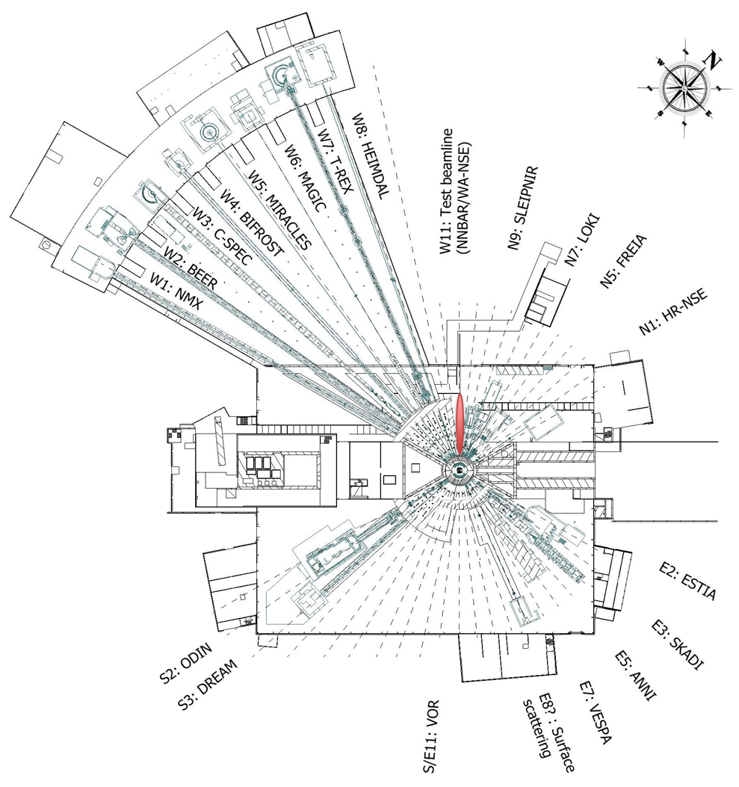
Figure 2 TBL location (W11)
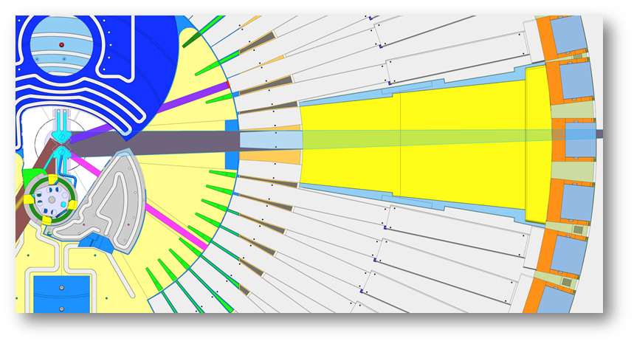
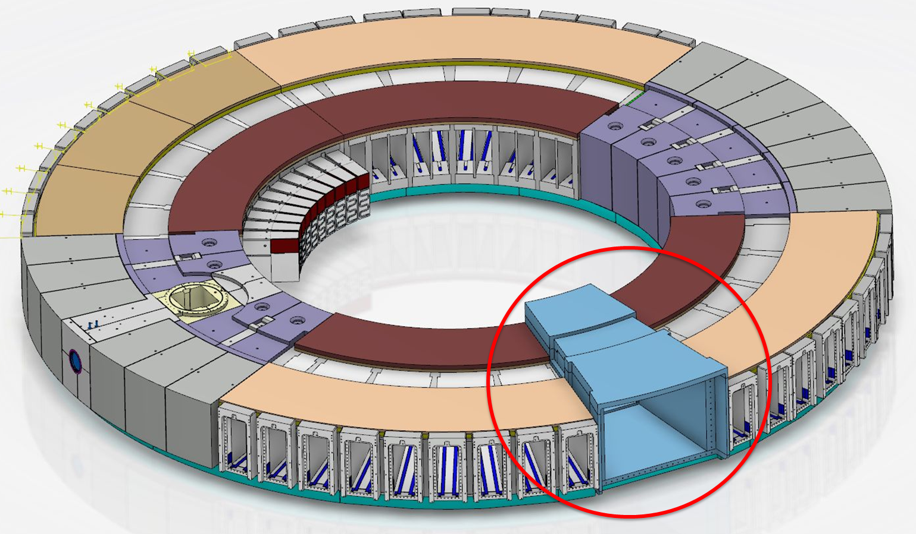
Figure 3 W11 Beam-port and view on the moderator
You can find a conceptual view of the main components in Figure 4 and the main geometrical parameters in Table 1 and Figure 5. Also there is an additional view of the bottom moderator in the drafts, which is only a space-holder, showing the maximum space-claim of the beam. The only reason why we need it is to plan for an additional insert in the bunker wall to make the future beam extraction cheaper.

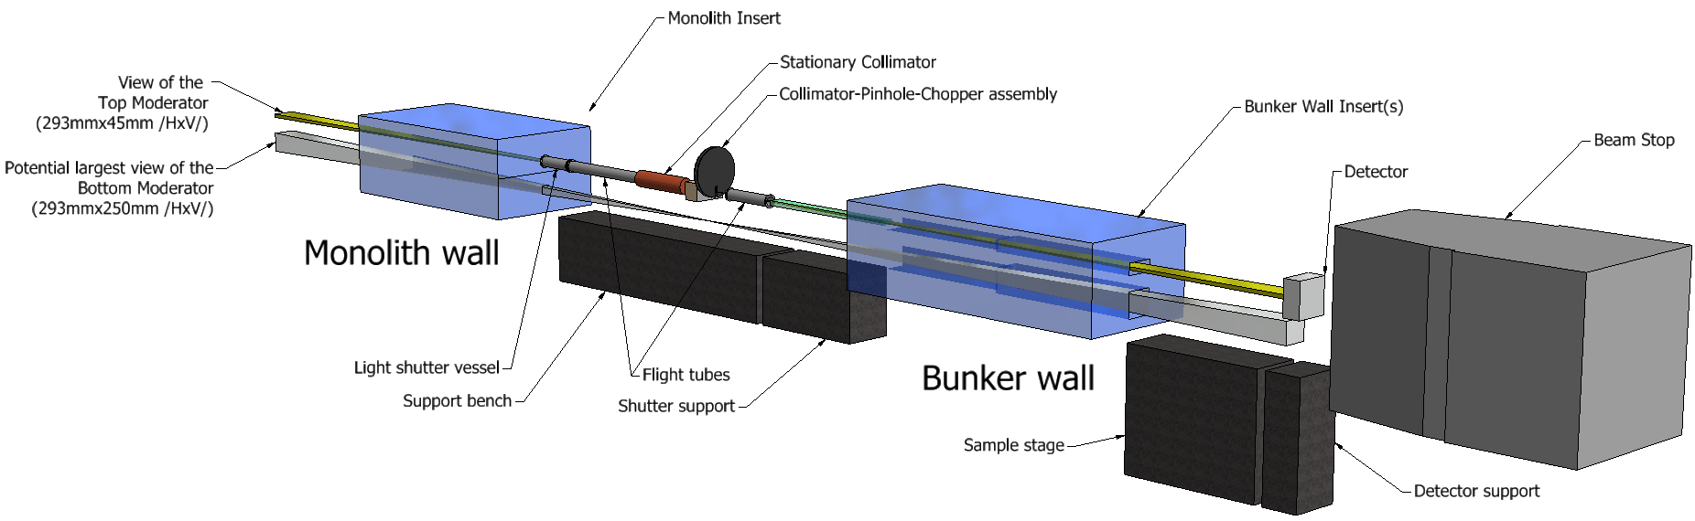
Figure 4 Main components of the instrument

Nr | Component Name | Distance from TCS | Properties
1. | Monolith Insert | 2.7m-5.5m (2.8m) | Penetration (2mm clearance around the beam):  204.5mmx35.2mm-108.5mmx20.9mm (Hz x V)
2. | Gamma Shutter Insert | 5.5m-6m (0.5m) | ID120mm / covered with 5mm B4C attenuator inside
3. | Flight Tube 1. | 6m-7.4m (1.4m) | ID120mm / covered with 5mm B4C attenuator inside
4. | Stationary Collimator | 7.4m-8.2m (0.8m) | OD200mm, ID90mm-60mm  /Copper with lead shielding around
5. | Adjustable Collimator | 8.3m-8.5m (0.2m)  /±200mm/ | 310mmx260mm (Hz x V), Ø3mm 15deg cone angle  /Initial composition: Fe+Pb+borated HDPE+Pb+Fe/  Adjustment range: H:±80mm, V:±30mm  Accuracy: 0.1mm
6. | Pinhole Diaphragm | 8.5m /±200mm/ | 1mm thick Cd, Ø0.5mm, Ø1mm, Ø1.5mm, Ø2mm, or removed from the beam
7. | Double Disk Chopper | 8.6m /±200mm/ | D=500mm, 2000RPM
8. | Flight Tube 2. | 8.8m-9.6m (0.8m) | ID120mm /covered with 5mm B4C attenuator inside
9. | Heavy Shutter | 9.6m-11.4m (1.8m) | Attenuator: 120mmx140mm*1800mm  /Pb+HDPE+B4C+Copper+Pb/ (with 20mm Pb around)
10. | Bunker Wall Insert | 11.5-15m (3.5m) | Steel insert.  Penetration: (22mmx118mm-41mmx241mm) (Hz x V)  /Beam size (mm):  Pinhole at 8.3m: 18.3x113.9-36.6x236.8  Pinhole at 8.5m: 16.9x104.4-34.8mmx224.4
11. | Detector | 17m | Area: 300mmx300mm
12. | Beam Stop | 17.5m

Table 1 Main parameters of the instrument components

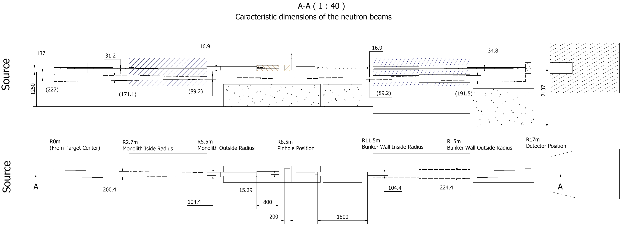
Figure 5 Main geometrical parameters of the instrument
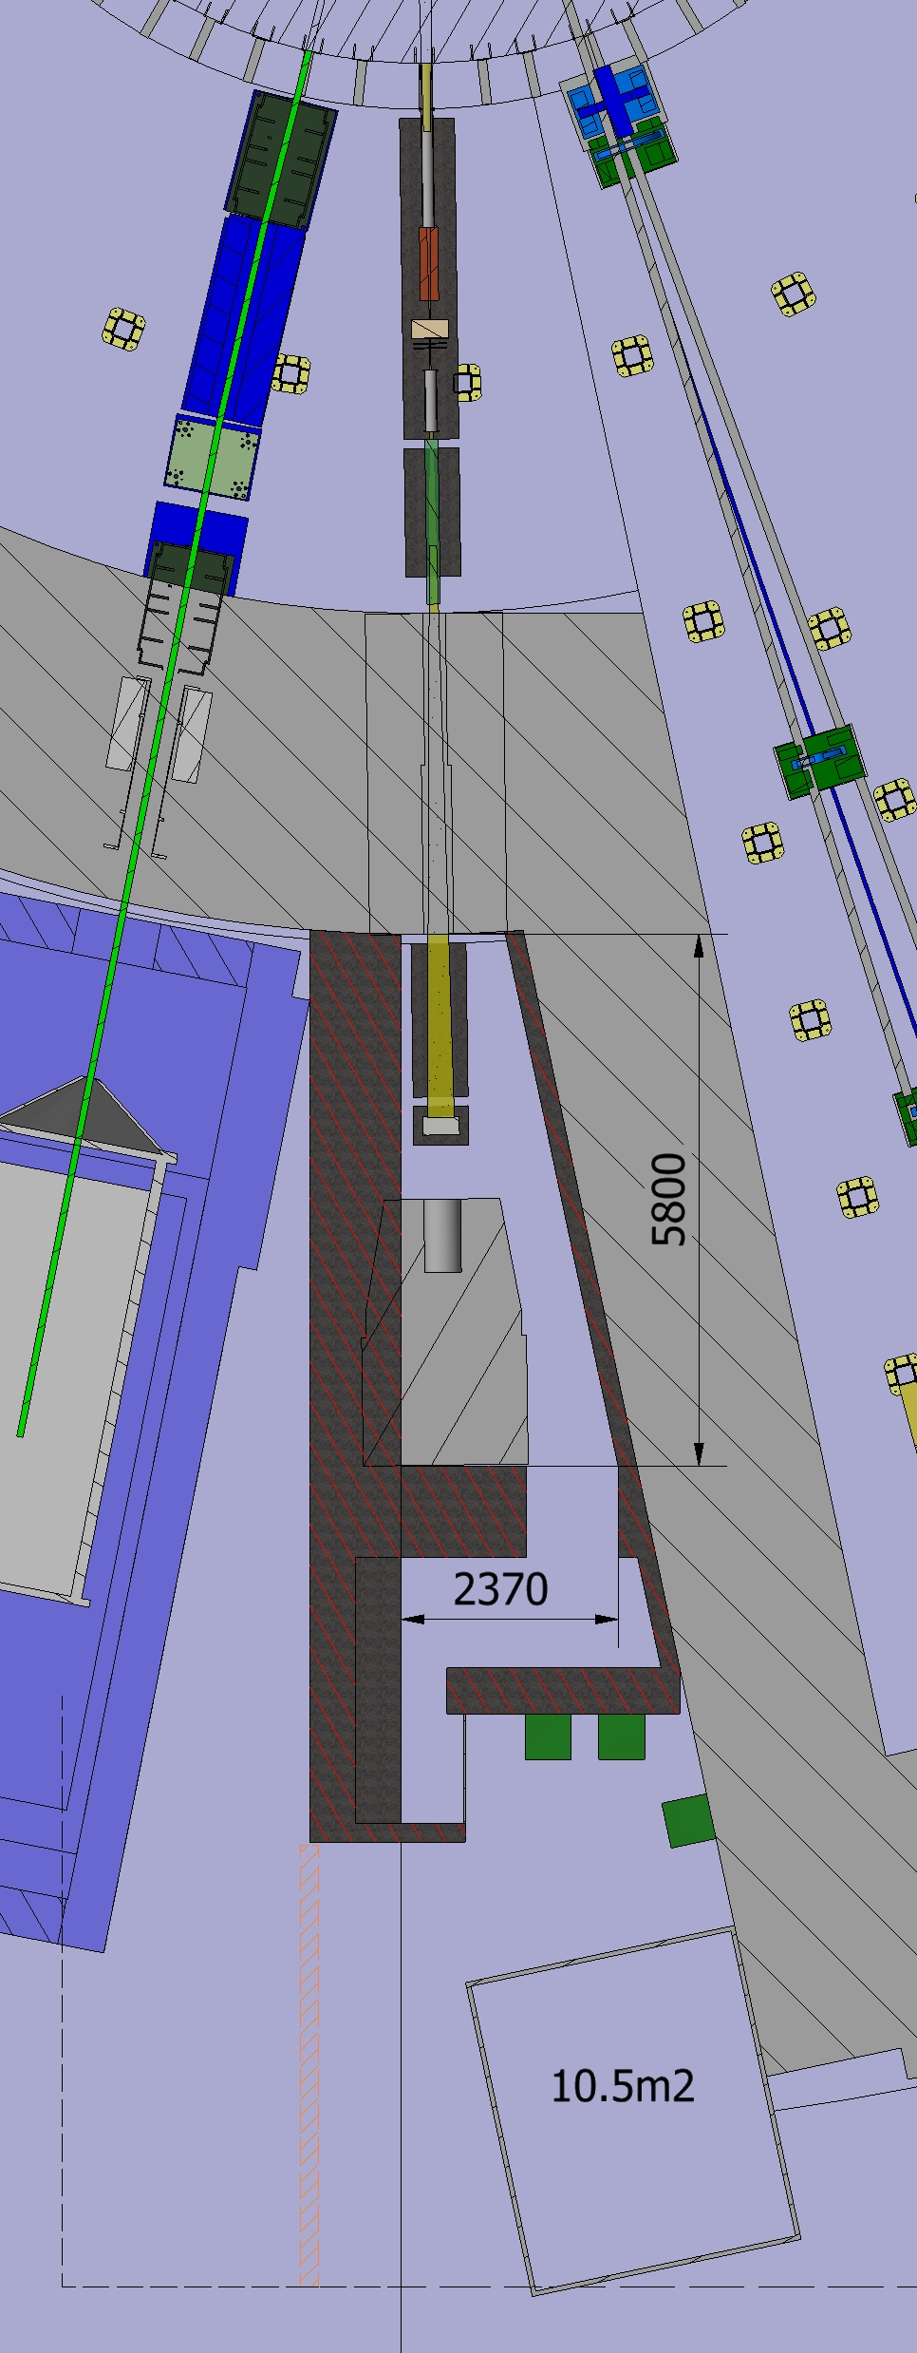
Infratructure conduit
Experimental Cave
Integrated Beam-stop
Control Hutch
Control Cabinets
Figure 6 TBL layout

Monolith Insert
The TBL insert will be designed by Target similarly to the other beamlines. It doesn´t have optical components, only a hole in the insert block that is 2 mm larger(around) than the estimated (upper) beam. There will be no provision for the measurement of the bottom moderator. No absorbing coating is needed. The insert will work as the first collimator of the system. The atmosphere of the insert cavity has to be separated from the bunker atmosphere, but apart from it we don’t have atmospheric requirements for the insert.

Gamma Shutter Insert
In order to avoid the generation of un-contained activated air, we are going to use a pressure vessel (pipe with neutron windows) in the gamma shutter. It will be filled with argon (?). The tube will be made of aluminium, with a borated layer inside.

Flight Tubes
We are using evacuated(?) tubes in order to avoid the generation of un-contained activated air. The first one will be between the light shutter and the stationary collimator, integrated with the collimator. It means that it will have a common atmosphere with the collimator, and the collimator will have a beam window downstream. The tube will be made of steel, with a borated layer inside.

Stationary Collimator
The stationary collimator will be a component that will be provided by ESS, since it is not necessary for the reactor environment. It will be sitting on a common stage with the Pinhole-Chopper assembly. The collimator will be made of a copper cylinder with a tapering hole in the middle. As it was mentioned it will be integrated with the flight tube upstream and will have a beam window downstream.

Adjustable Collimator and Pinhole Diaphragm
The Adjustable collimator will be part of the Pinhole-Chopper assembly (see figure 7).
Attenuator
Collimator and pinhole translation mechanism
Adjustable collimator
Double disk chopper
Pinhole
Figure 7 Pinhole-chopper assembly

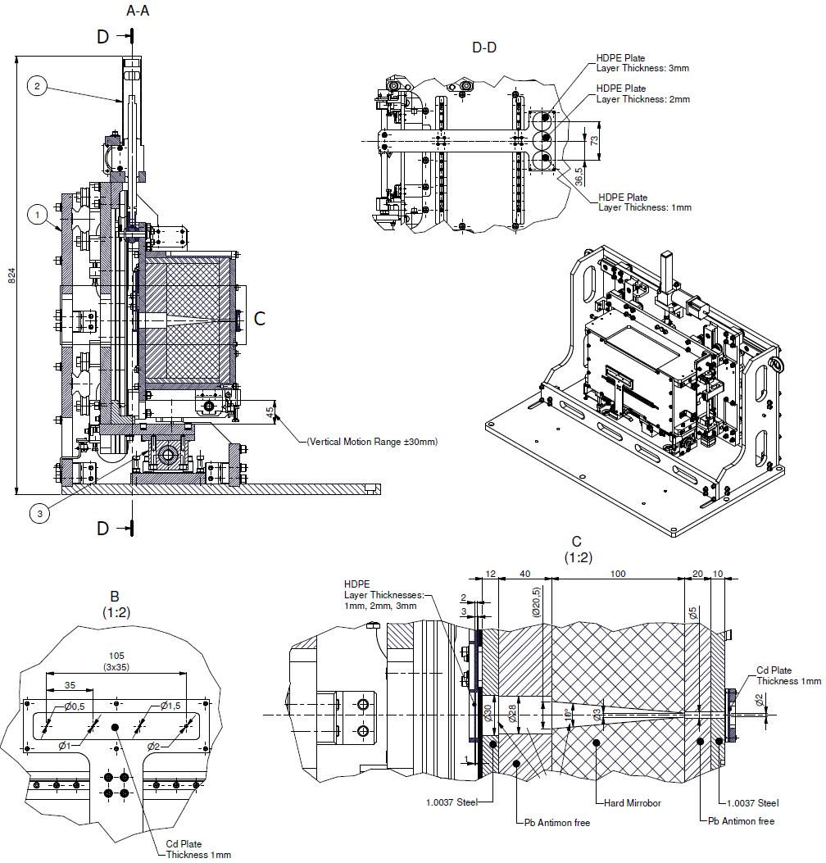
Figure 8 Collimator-Pinhole assembly
The geometry and dimensions are in figure 8. In the original setup it is composed of steel, lead and B4C, but we are planning to replace it with something that is more suitable for the spallation source.
The downstream surface of collimator has a conical hole with a diameter 3 mm at the exit with 10°- 20° cone angle towards the target monolith.
The collimator is mounted on a motion stage, so it is possible to remotely fine align it. There are two additional sub-assembly mounted on the collimator those are moving together with it:
- Remotely changeable set of attenuators with four positions (upstream)
- Remotely changeable set of pinholes with five positions (downstream)
The purpose of the attenuator set is to tailor the flux according to the detector capacity. The options for the attenuator are 1mm, 2mm, 3mm HDPE or no attenuator in the beam.

Pinhole Diaphragm
As it was mentioned before the Pinhole Diaphragm will be mounted on the adjustable collimator, so it will move together with that. The pinhole assembly will have 5 positions: Ø0.5mm, 1mm, 1.5mm, 2mm and no pinhole in the beam.
The pinhole will be made of a 1mm thick cadmium plate.

Double Disk Chopper
The double chopper consists of two discs with a 20 mm wide and 70 mm deep slit (radial cut). The disk diameter is 500 mm, according to available space at BNC.
The maximum speed of the chopper is 2000 RPM. The chopper should be mounted on the base-plate of the pinhole assembly by a bench mount including vibration damping. The disks should rotate in the same direction (?). The drive is synchronized to an external signal (-T0 accelerator signal). The two discs should rotate synchronized as well in master-slave connection to change the width of the slit.

The Chopper will be mounted a common base-plate with the collimator-pinhole assembly and will be handled together in case of remote handling. There will be kinematic mounts under the base-plate for accurate replacement, and a lifting frame with one lifting point according to the ESS guidelines. Also guiding features will be designed for remote handling in cooperation with the ESS chopper team.

Support system
The Stationary Collimator, Collimator-pinhole-chopper assembly and the flight tubes will be installed on a common bench.
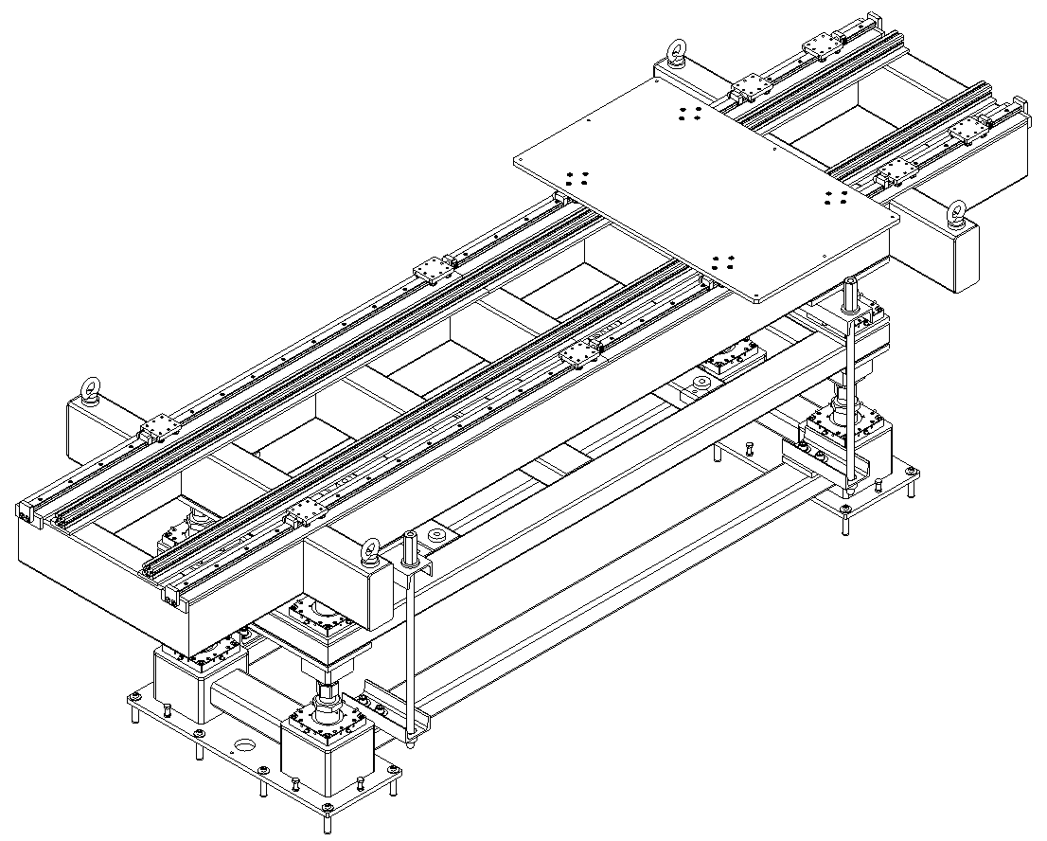
Figure 9 3D view of the Support bench
The girders top forms an optical bench, with easy to use riders for flexible installation of additional equipment (not included) and to change steplessly the position of the fixed items without additional alignment. The girder should be put in place and removed by crane from above, with all equipment mounted and pre-aligned outside. It is equipped with 3 point kinematic stand for the fast and precise (±0,02 mm) removal and reinstall. The mechanical height adjustment of the cinematic mount should be ±20 mm. Although the in the actual setup only the top moderator will be tested there is already provision for the easy testing of the bottom moderator by a removable spacer component.
The length of the bench is 2.7m in order to fit through the roof without removing the cross-beam at 9m.

Heavy Shutter
The TBL Shutter will be the prototype of the ESS standard Heavy Shutter.
Figure 10 3D view of the Heavy Shutter with bellow interfaces
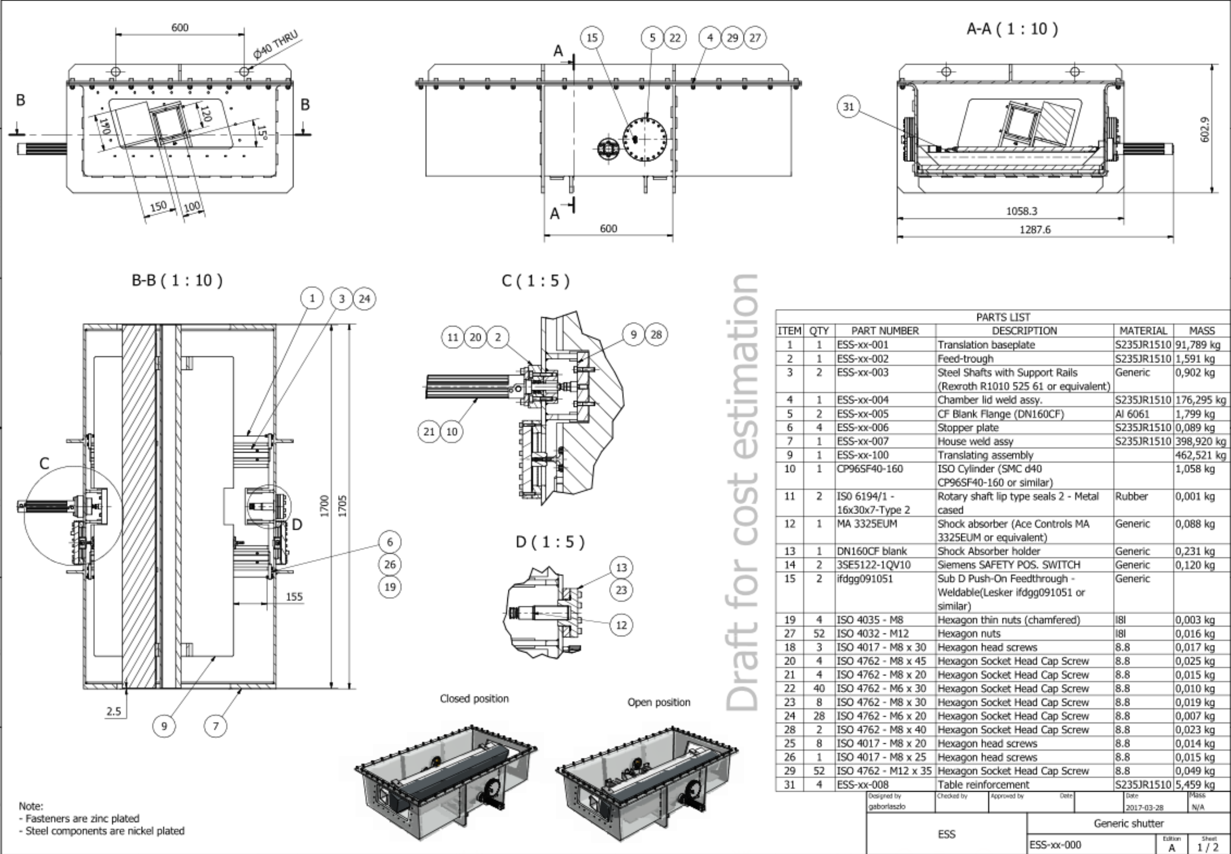
Figure 11 Details of the Heavy Shutter

It is a simple translating shutter, moved by a pneumatic cylinder. Instead of having a horizontal translation it is tilted to achieve failsafe operation. In case of power/pressure failure, it will close automatically. The vacuum housing of the shutter will be separated by beam windows on both sides. The expected accuracy is better than ±0.02mm.

Sample environment
The primary objective is the characterization of the source. The possible future measurements will be worked out later. In the first build the sample area will be in the 2m gap between the detector and the bunker wall. We are going to have a simple table for sample placement without any motion system.

Detector
The minimal set of detectors foreseen is a subset of the prototypes from the BrightnESS project (from tasks 4.1-4.3), and a test detector from BNC-Wigner as part of the project. These would have the following characteristics:
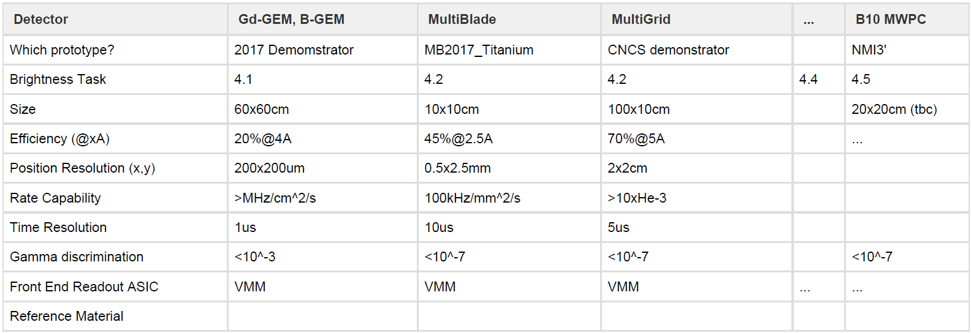
Table 2 Main parameters of the instrument components
All detectors will be available and integrated from 31.8.2018. Some may be available earlier.
There will be also a monitor detector in the cave connected to the PSS system.

Beam Stop
The Beam Stop has to be able to accept the full beam assuming the chopper and shutter are in the full open position, no attenuator and diaphragm in the beam. The Stop is cup-like with its axis parallel to the incoming beam, its inner core is iron. There is a cavity in the beam-stop. It is 500mm long, 400mm wide and 120mm high. The wall of the cavity is 250 mm steel that is in a concrete block. The concrete thickness is 3m after the steel core. These numbers are preliminary values and have to be optimized during the shielding analysis.

Cave Shielding
The shielding has to absorb the radiation to fulfil the dose requirements of 1.5 µSv/h in the supervised area. The design also has to limit the background for the instrument.
The walls will contain 200 mm steel, and 600 mm concrete. These numbers are preliminary values and have to be optimized during the shielding analysis.
You can see the layout in figure 6. The cave wall design will be modular in order to increase the thickness if necessary.

Instrument Control
Hardware and software solutions for motion control and automation will be developed in close collaboration with ESS Motion Control & Automation Group (MCAG) following standards and best practises for the key technologies and components used at ESS that are still being defined. All motors and actuators are anticipated to be “off the shelf” products that can easily be controlled by commercially available components.
There will be 5 controlled motion axis in the system, but we are planning to add 7 additional axis for future developments.
The Chopper control will be designed according to the NSS Chopper Team standards and guidelines.

Personnel Safety System, PSS
A PSS system will be designed and provided by ESS and the instrument team to allow safe operation with regards to access to the instrument and its components.
The PSS interfaces will be the following:
- Shutter safety switches
- Beam monitor
- Bunker clearance signal
- Cave interlock
- Cave warning lights

PRELIMINARY SAFETY ASSESSMENT
The main hazard present at all instruments is ionizing radiation. The shielding protects personnel outside the instrument from radiation hazards. Users will need to have access to the experimental cave without being exposed to radiation. This is achieved with the heavy shutter. The light shutter (not part of the ODIN work package) located immediately outside the target monolith stops radiation emanating from the target, when the proton beam is not on target and allows maintenance work to be performed on downstream components. The Personnel Safety System (PSS) interlocks the areas (such as the experimental cave) when the shutter is open. Additional radiation alarm will be installed inside the cave. It will also be connected to PSS to prevent personnel entering the experimental cave if a radiation leak has been detected. A search procedure ensuring that no people are inside is required to close the interlock and open the shutter. All interlocked spaces shall have emergency stop buttons that close the appropriate shutter to prevent radiation exposure. All shutter systems are designed to fail closed. No additional safety system will be installed because there are no other risks expected which are not related to radiation hazard. A first-aid kit will be available for users in the instrument hutch. The administrative control will include training of all users and personnel working at the instrument. The training will include the walkthrough of the instrument, identification of all potential hazard situations and appropriate response. All instrument related training materials will be available on the instrument website. Hard copies of those documents will be available at the control hutch. ESS access training will have to be taken in advance as well.

Glossary
Term | Definition
<<Sample term>> | <<Sample explanation >>

references
- <<Sample reference to CHESS document: ESS Document (ESS-00XXXXX)>>

Document Revision history
Revision | Reason for and description of change | Author | Date
1 | First issue | Gabor Laszlo | <<YYYY-MM-DD>>

