|  |
| --- |
|  |
|  |
|  |
|  |
|  |
|  |
|  |
|  |
| Detailed analysis of bunker roof support steel structure |
|  |
|  |

Document Revision history

|  |  |  |
| --- | --- | --- |
| Revision | Reason for revision | Date |
| 1 | New Document |  |

|  |  |  |
| --- | --- | --- |
| List of Authors | List of Reviewers | List of Approvers |
| Möller, Mikael | Anders Olsson | Zvonko Lazic |

Summary

Herein, structural analysis of the D01, D02 and D03 bunker steel structures is reported. The analysis demonstrates complience with code requirements on resistance.

Table of Contents

Summary 3

1. Introduction 6

2. Prerequisites 6

2.1. General 6

2.2. Design code 7

2.3. Loads 8

2.3.1. Dead load 8

3. Analysis 8

3.1. R6 columns 8

3.2. Remaining columns – handbook analysis 8

3.2.1. Centrically loaded column 9

3.2.2. Eccentrically loaded column 9

3.2.3. D01 & D03 foot plate bolts 10

3.3. Remaining columns – nonlinear FEA 12

3.3.1. D01 & D03 – centrically loaded column 12

3.3.2. D01 & D03 – eccentrically loaded column 16

3.3.3. D02 – centrically loaded column 20

3.3.4. D02 – eccentrically loaded column 23

3.4. D01 & D03 column footing anchoring 24

3.5. Consideration of D02 slab cracking status 26

3.6. D02 column footing anchoring 28

3.7. Anchor forces at buckling collapse 30

3.8. Beams – handbook analysis 31

3.9. Analysis including beams and semi-rigid connection to column 32

3.10. Stability considerations for D01 & D03 during seismic event 38

3.10.1. General 38

3.10.2. Radial resistance of steel frame 39

3.10.3. Design of anchors for lift and shear from radial load 43

3.10.4. Resistance of column base to lift and shear from radial load 44

3.10.5. Design of diagonal strut for radial load 44

3.11. R6 circular beam 45

References 51

Appendix 1 Nominal Column loads 52

Appendix 2 r6 beam dimensions and loads 53

# Introduction

Herein, structural analysis of the D01, D02 and D03 bunker steel structures is reported.

# Prerequisites

## General

The bunker steel structure has several design drivers, in addition to resistance to normal operating loads, such as lack of space, radiological shielding, seismic loading, requirements on remote removability of structural elements such as beams and columns during maintenance and so forth. As a result, the appearance of the structure and its detailing is somewhat unorthodox.

The bunker (one side) is shown overall in Figure 1. The bunkers are divided into the D02 bunkers and the D01 & D03 bunkers. The supporting structures are separated by a dilataion joint allowing D02 to move freely from D01 & D03 during a seismic event. The D02 steel structure is shown in Figure 2 (R6 columns not included in that figure). The D01 & D03 steel structure is shown in Figure 3.

The structures have no stabilizing diagonal struts due to space constrains in the bunker cavity; hence stability relies on the columns being clamped at the base.

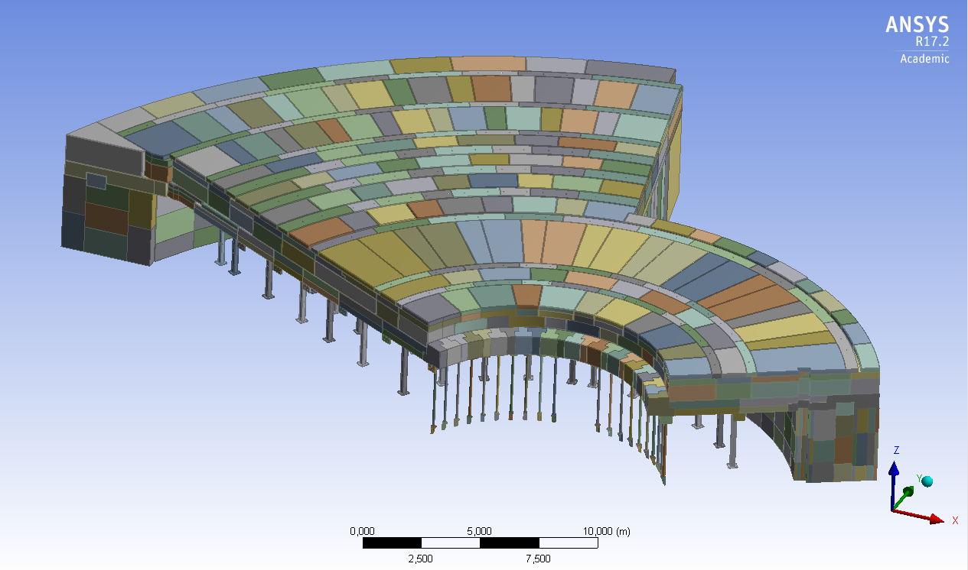

Figure 1. One side of bunker.

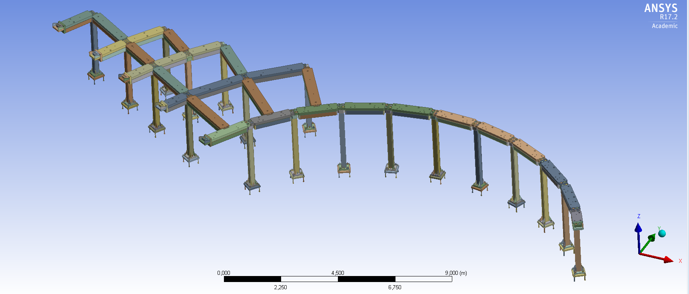

Figure 2. D02 steel structure without R6 columns.

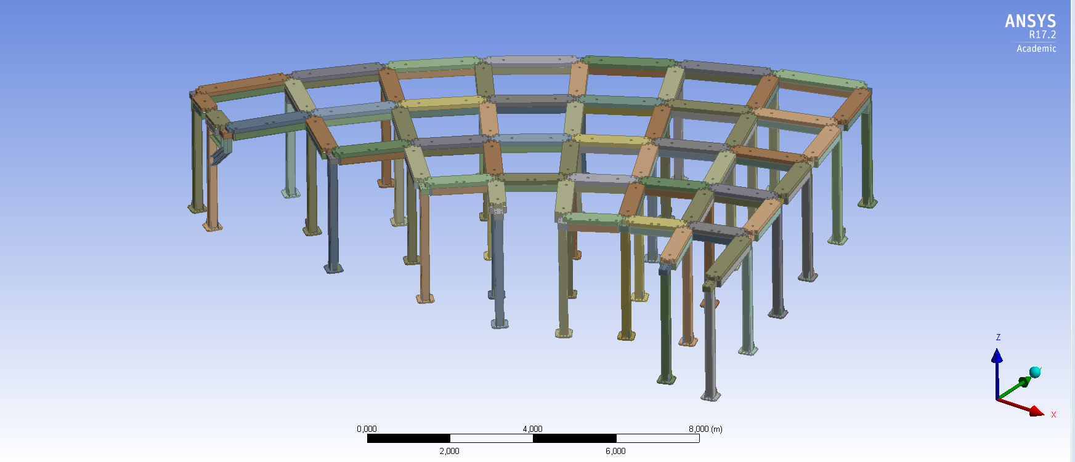

Figure 3. D01 / D03 steel structure.

## Design code

At ESS, the general code framwork is RCC-MRx, [1]. The bunker is however not credited in any accidental analysis, [2] and hence, it is not classified with respect to radiological safety and therefore conventional industrial EN-standards apply. Therefore, the EC0, [3], and the EC3, [4], formally apply. The former contains applicable load factors and combinations, the latter contains design rules. However, as for design rules, it is permitted to use alternative rules provided the rules are not given as principles. To avoid the tedious rules of EC3, the handbook BSK, [5], is used where applicable.

## Loads

### Dead load

The dead load from bunker roof is 6.6 tonnes / m2. The unfactored column loads from this are given in [6] and repeated in Appendix 1. As seen the maximum column load is in R12 and it is some 470 kN.

During maintenance, removed shielding blocks are possibly stacked on top of adjacent roof portions, increasing the loads in these portions. To account for that, the column loads are increased by 50 %.

# Analysis

## R6 columns

The maximum nominal load on the R6 column is kN. Including the extra 50 % and partial factor on dead weight yields design load

kN

The dead weight of the beams adds a few kN which is neglected throughout this report. The buckling length is mm and hence slenderness is for a VKR 100 x 100 x 8 S355 is



Buckling curve [a] in BSK yields



Hence resistance

kN

## Remaining columns – handbook analysis

Remaining columns are VKR 200 x 200 x 10 S355 both in D01, D02 and D03. The footing differs between D01 & D03 and D02. The flexibility of the footing affects the column resistance but this cannot be addressed with any accuracy in handbook analysis. Instead, the design of the footing is conducted subsequently by means of nonlinear FEA so as to ensure a rigid enough footing.

The steel structure consists of columns with clamped bases, connected to radial and circumferential beams at the column tops via semi-rigid joints. Obviously the resistance of such a structure to vertical loads is larger than the resistance of the same set of culumns without the connected beams. However, for the resistance to vertical loads the beneficial effect of the connected beams is initially neglected and a free cantilever column is considered.

### Centrically loaded column

The maximum nominal load on the remaining columns is kN. Including the extra 50 % and partial factor on dead weight yields design load

kN

The buckling length is mm and hence slenderness is for a VKR 200 x 200 x 10 S355 is



in which the factor  accounts for flexibility of the footing. This factor is lacking in EC3. Buckling curve [a] in BSK yields



Hence column resistance

kN

For comparison, not accounting for flexibility of the footing would yield



Buckling curve [a] in BSK yields



Hence column resistance

kN

### Eccentrically loaded column

Consider a line of columns for which the load from one span is removed. This reduces the vertical load by a factor of 2, hence

kN

However, it introduces an eccentricity moment due to the fact that the load is not applied centrically on beams. The maximum eccentricity in load application is 100 mm in relation to beam CL and hence bending moment is.

The bending resistance is

kNm

And hence the BSK interaction yields



from which column resistance for the eccentricity case is

kN

For comparison, not accounting for the flexibility in the footing would yield



from which column resistance for the eccentricity case is

kN

### D01 & D03 foot plate bolts

Due to the cast-in anchor plates, the footing arrangement of D01 & D03 needs to be different from D02[1] from installation & tolerances reasons, and the foot plate bolting shall transfer all loads to anchor plate. The foot plate bolts sit on 300 x 300, see Figure 4 below. Their resistance should be about the same as the column resistance. Obviously the resistance interaction of the column differs from that of the bolt group but as a simplification the individual resistancies of the bolt group should minimum equal those of the column, i.e kN pure buckling resistance and kNm pure bending resistance.

At the buckling resistance there is a second order base moment  in addition to the compressive force. The cross sectional axial resistance (no buckling) is

kN

and the cross-sectional resistance interaction for a VKR according to BSK



In which . Hence



which gives second order base moment at buckling collapse

kNm

Hence, required resistance of bolt

kN

The resistance of an M36 8.8 bolt with is

kN

So we either go for M39 8.8 or M36 10.9. Designers choise.

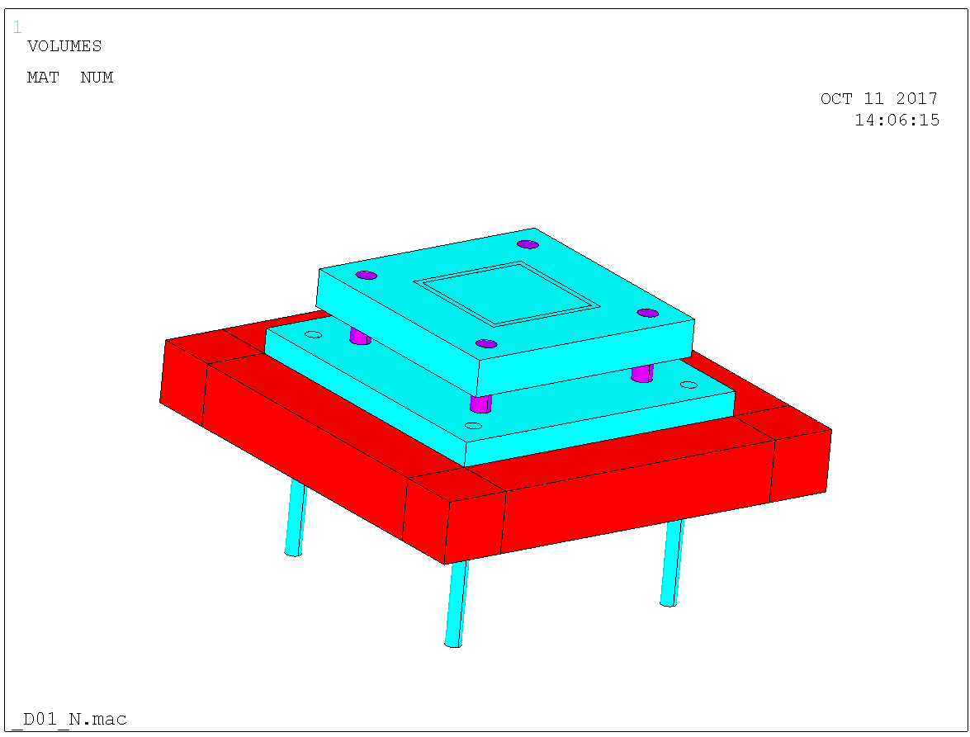

Figure 4. D01 & D03 column footing. Red is concrete, blue is S355 and magenta is 10.9 or 8.8.

## Remaining columns – nonlinear FEA

In order to ensure no ensure no detrimental effect of the flexibility of the footing is omitted; nonlinear finite element analysis – accounting for non-linear geometry and plasticity – of the complete assembly is conducted. The anchor plates of D01 & D03 are cast-in, as opposed to the anchor plates of D02 which are post-installed. For that reason the footings differ between D01 & D03 and D02 so they are addressed separately. The design of the anchoring itself is conducted in sections further down in the report.

### D01 & D03 – centrically loaded column

The model is shown in Figure 5 with close-up in Figure 4. The red block is concrete. The anchor plate is cast-in so in reality its upper surface is in level with the concrete upper surface, but in the model the anchor plate sits on the concrete which is irrelevant for the analysis. Contact elements are arranged between the concrete and the bottom surface of the anchor plate. The column foot plate sits on the anchor plate via four bolts. The anchor plate is 500 x 500 x 40 mm and the anchors sit on 400 x 400.

For comparison the case of a fixed column foot plate is initially analysed. The resistance is

kN

according to Figure 6, which corresponds excellent to the BSK resistance kN in section 3.2.1 above. Now, accounting for flexibility in the footing, column foot plate bolts M36 10.9 and 60 mm foot plate yields resistance

kN

according to Figure 7 which is slightly more than the BSK resistance kN in in section 3.2.1 above.

Bolts to M36 8.8 instead of M36 10.9 lowers the resistance to  kN according to Figure 8.

For comparison the combination M36 8.8 and foot plate 40 mm yields resistance kN according to Figure 9. The combination M30 8.8 and foot plate 30 mm – which appears fully reasonable – lowers the resistance to  kN according to Figure 10.

In conclusion then, the strength and stiffness of the footing arrangement is of quite some importance for the buckling resistance of the clamped column and M36 10.9 foot plate bolts and foot plate 60 mm S355 is to be used.

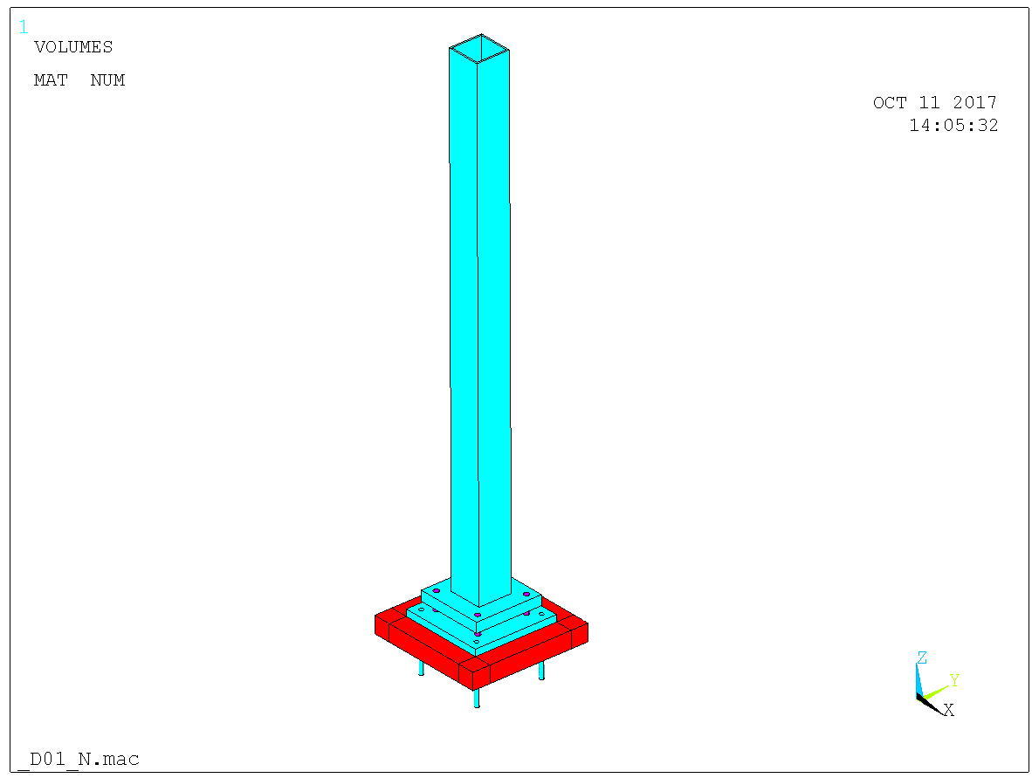

Figure 5. Model.

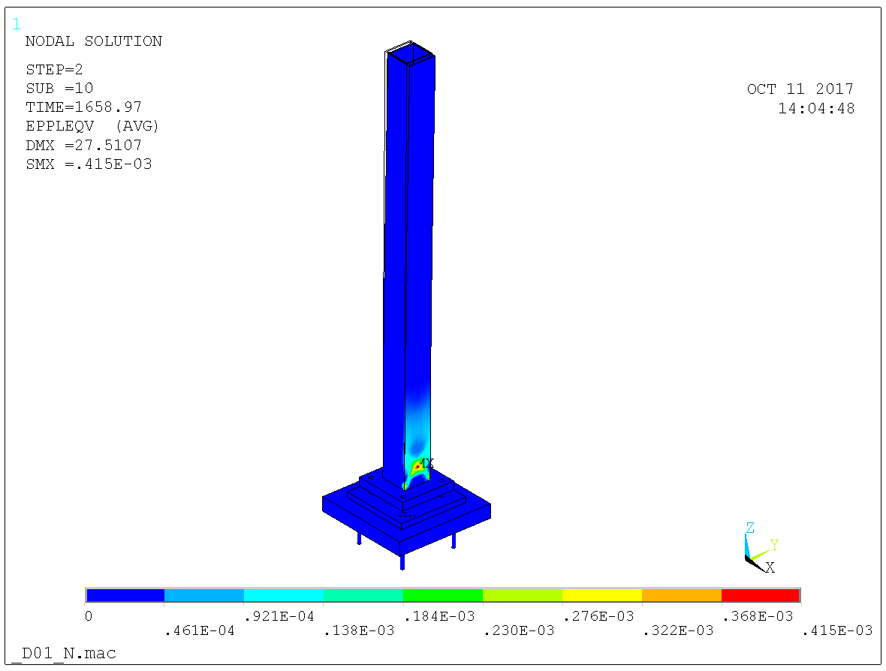

Figure 6. Foot plate completely fixed yields resistance 1660 kN. Plastic strains.

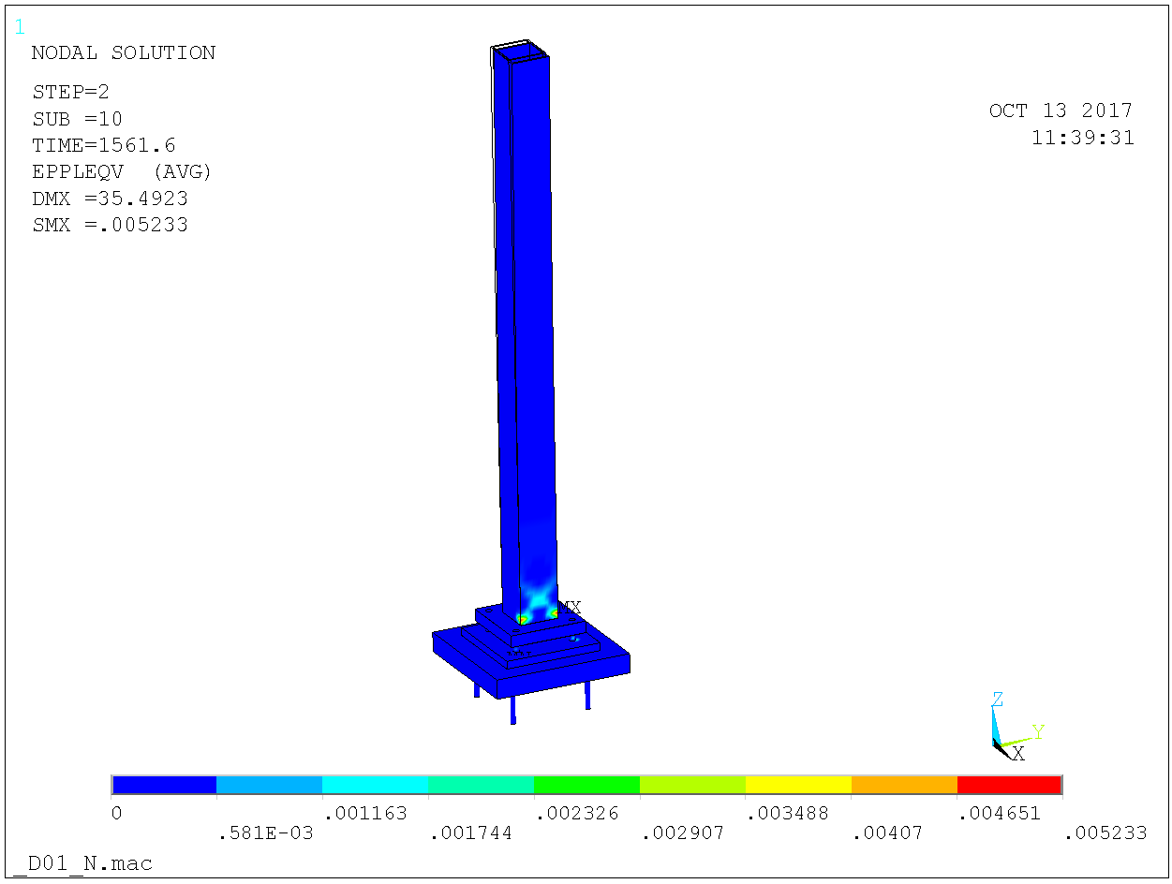

Figure 7. Foot plate bolts M36 10.9 and foot plate 60 mm yields resistance 1560 kN. Plastic strains.

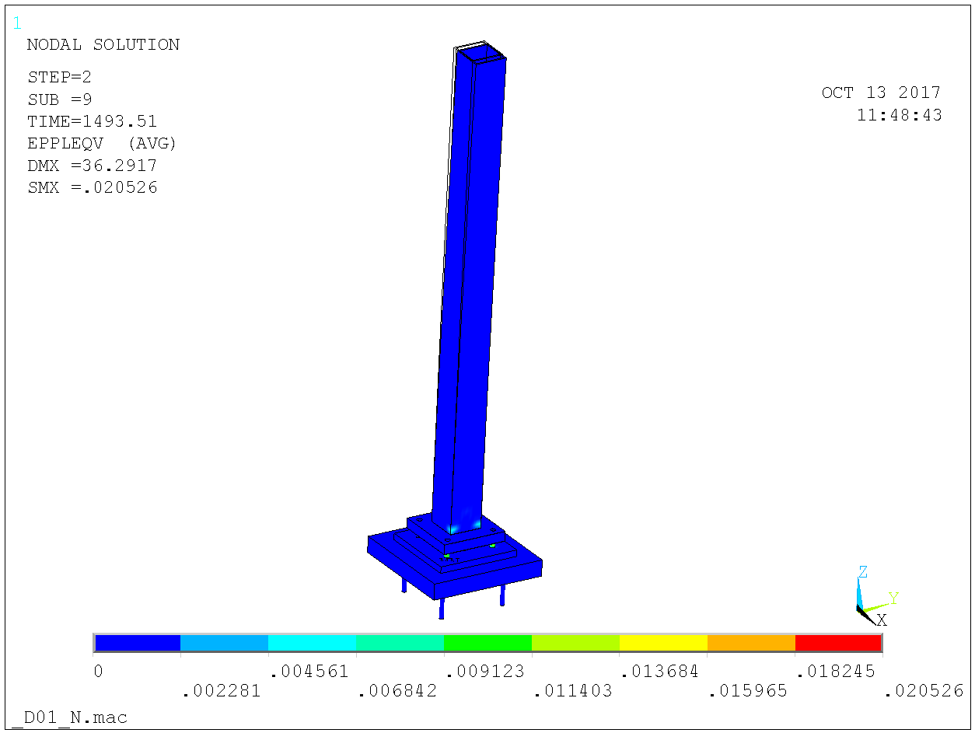

Figure 8. Foot plate bolts M36 8.8 and foot plate 60 mm yields resistance 1495 kN. Plastic strains.

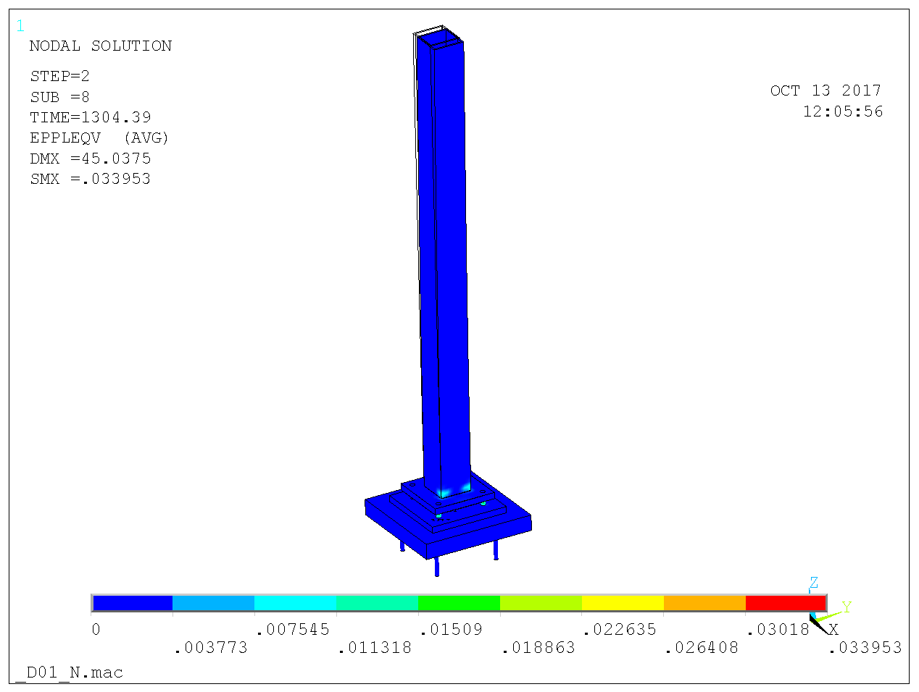

Figure 9. Foot plate bolts M36 8.8 and foot plate 40 mm yields resistance 1305 kN. Plastic strains.

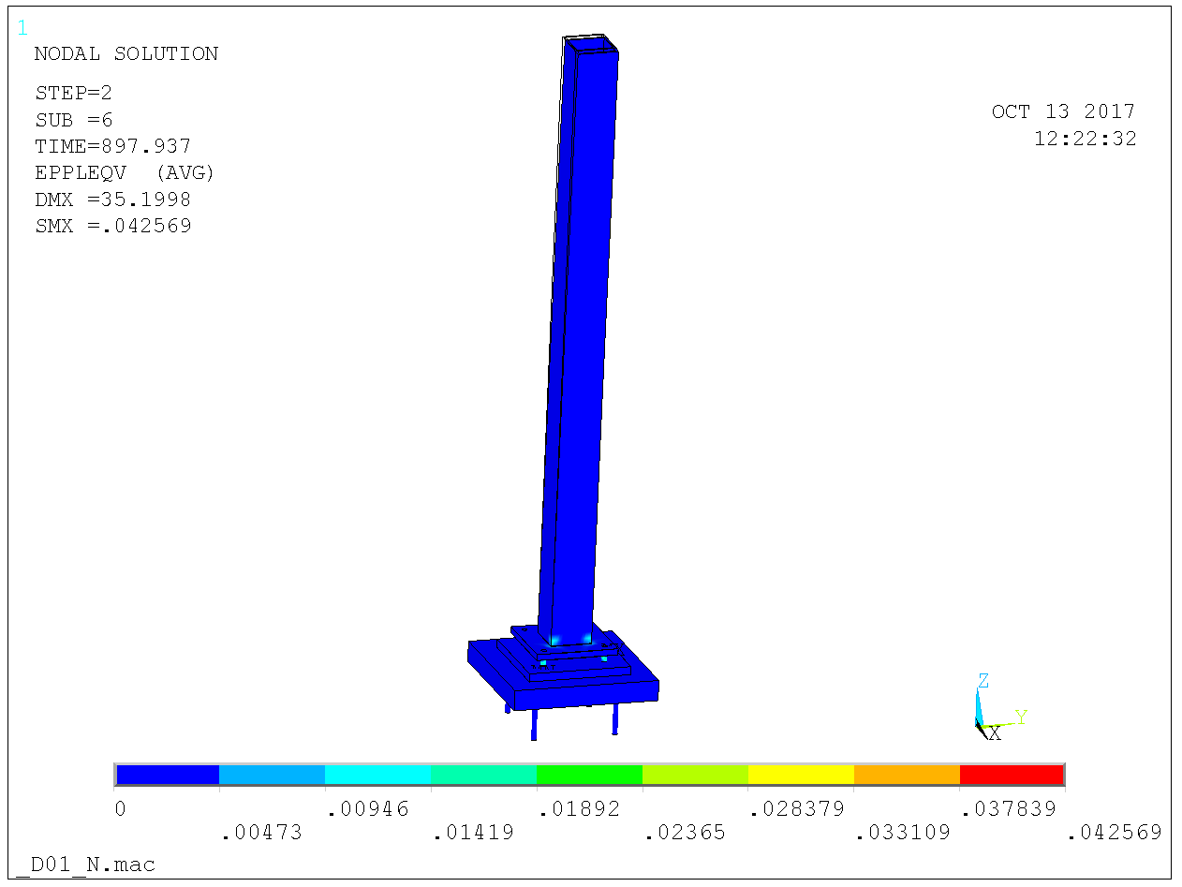

Figure 10. Foot plate bolts M30 8.8 and foot plate 30 mm yields resistance 895 kN. Plastic strains.

### D01 & D03 – eccentrically loaded column

Maximum eccentricity of load is 100 mm and hence the column is loaded with a centric axial force and a moment at the column top. The same analysis route as in 3.3.1 is repeated for this case. Starting out for comparison with a completely fixed column foot plate yields resistance

kN

according to Figure 11 below. This case is to be compared with the BSK resistance  kN in section 3.2.2 above and obviously the agreement is excellent.

Accounting for flexibility and using foot plate bolts M36 10.9 and 60 mm foot plate yields resistance  kN according to Figure 12. The corresponding BSK resistance is kN. Changing to bolts M36 8.8 yields about the same resistance according to Figure 13 and hence this case does not punish the bolts as much as the centric load. Reducing the plate to 40 mm lowers the resistance to  kN according to Figure 14 and the – apparently reasonable – M30 8.8 bolts and 30 mm foot plate yields only kN resistance according to Figure 15.

So the conclusion from 3.2.1 remains – M36 10.9 foot plate bolts and 60 mm foot plate.

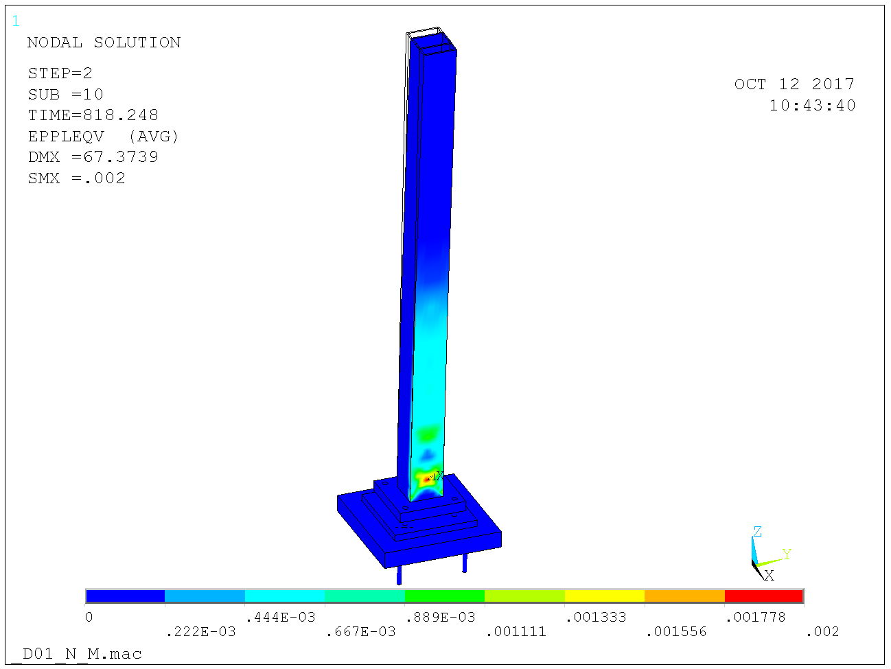

Figure 11. Foot plate completely fixed yields resistance 820 kN. Plastic strains.

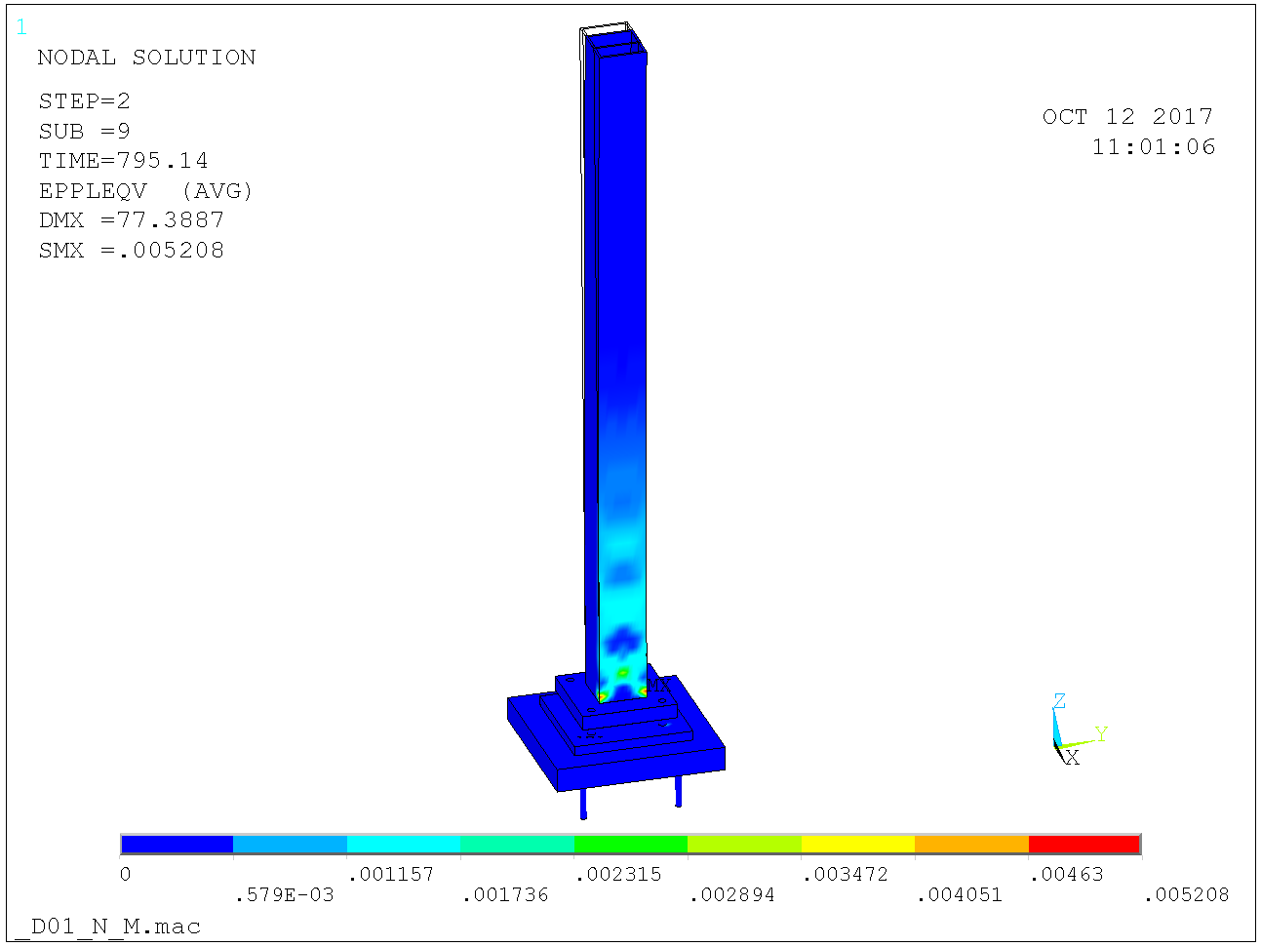

Figure 12. Foot plate bolts M36 10.9 and footplate 60 mm yields resistance 795 kN. Plastic strains.

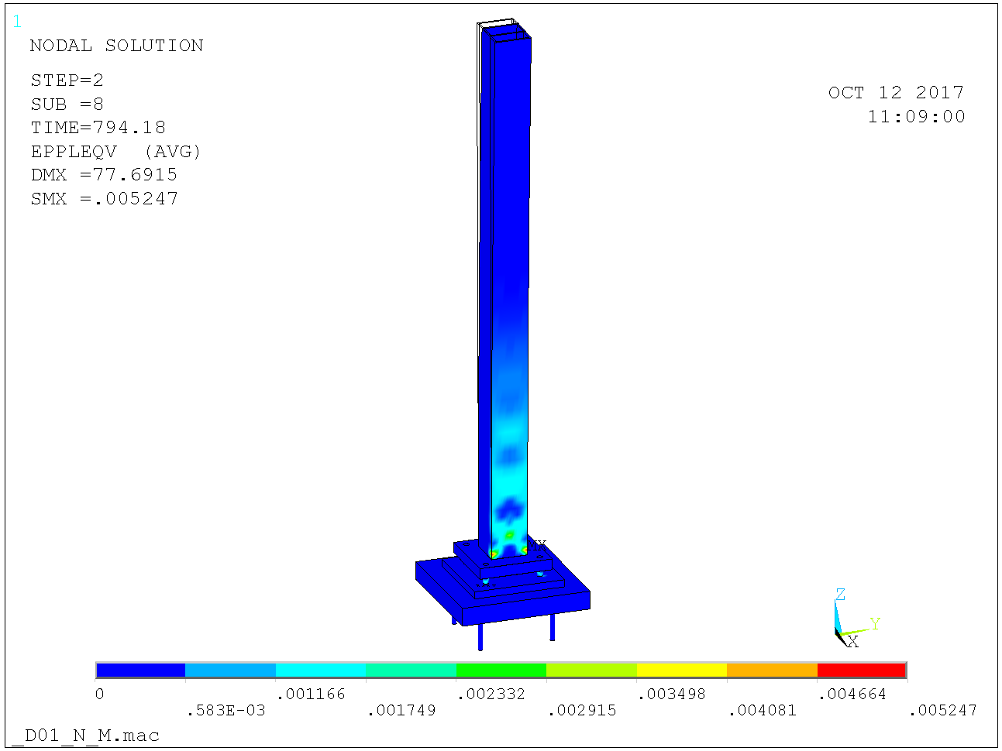

Figure 13. Foot plate bolts M36 8.8 and footplate 60 mm yields resistance 795 kN. Plastic strains.

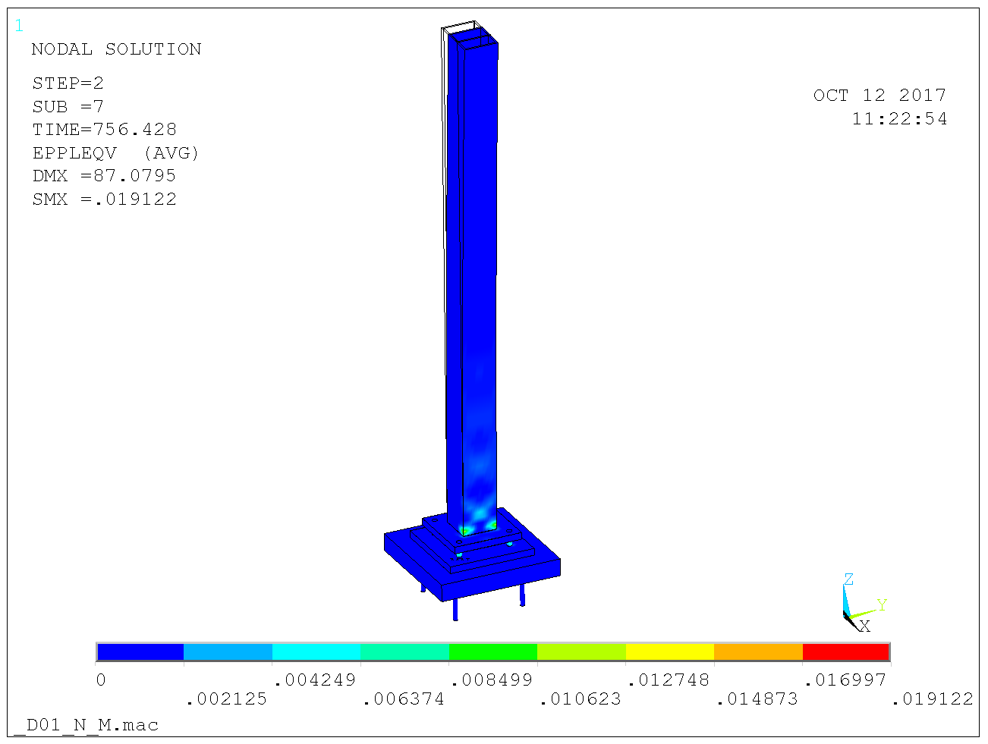

Figure 14. Foot plate bolts M36 8.8 and footplate 40 mm yields resistance 755 kN. Plastic strains.

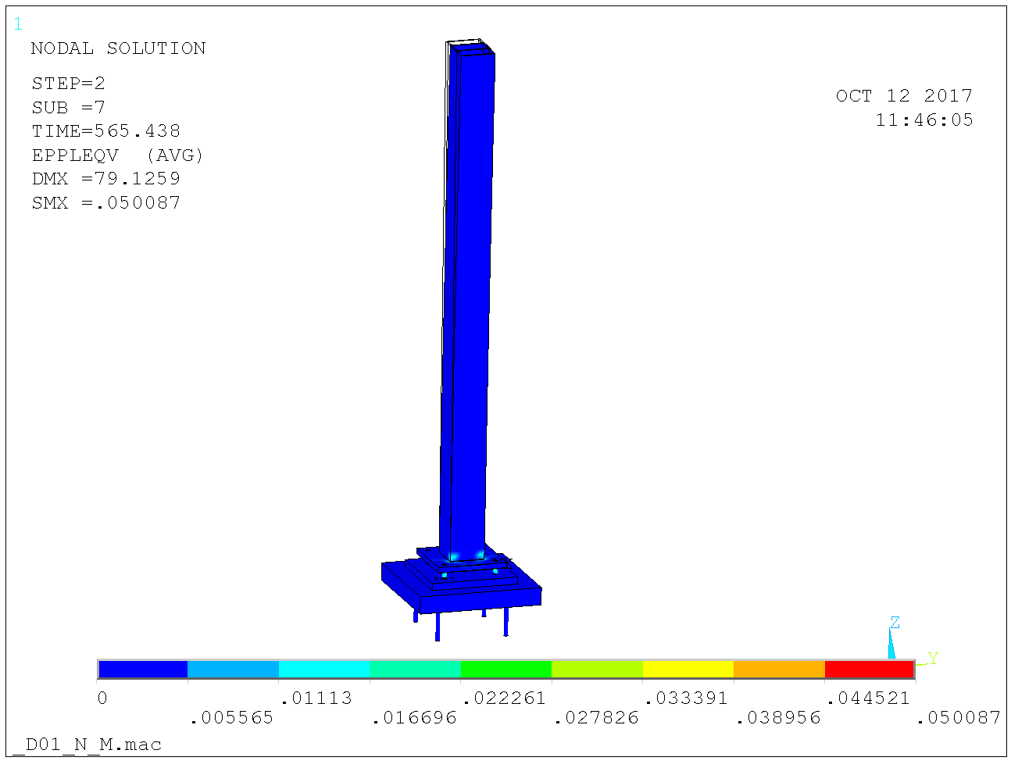

Figure 15. Foot plate bolts M30 8.8 and footplate 30 mm yields resistance 565 kN. Plastic strains.

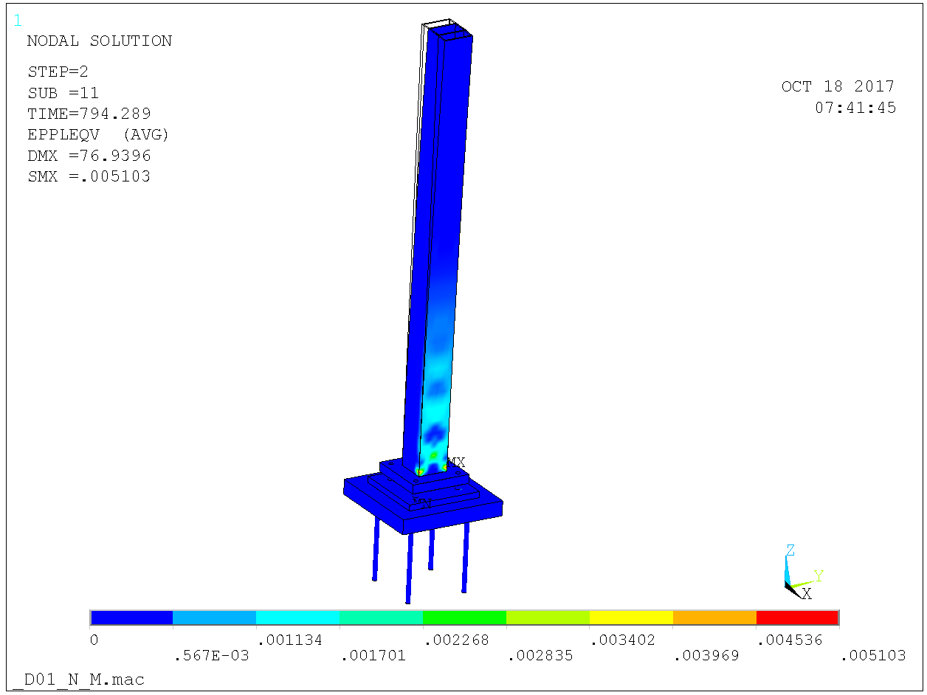

Figure 16. Foot plate bolts M36 10.9 and footplate 60 mm yields resistance 795 kN also for anchor length 680 mm. Plastic strains.

### D02 – centrically loaded column

The model is shown in Figure 17 with close-up in Figure 18. The red block is concrete. Contact elements are arranged between the concrete and the bottom surface of the anchor plate and between the top surface of the anchor plate and the bottom surface of the column foot plate. The anchor plate is 500 x 500 x 35 mm and the anchors sit on 400 x 400. The foot plate is 400 x 400 and the foot plate bolts sit at 300 x 400.

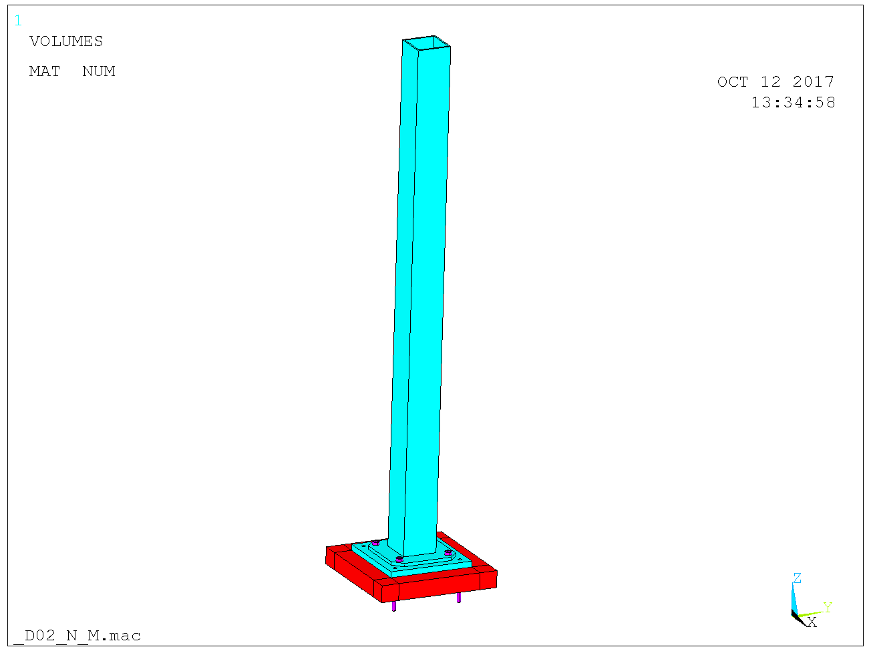

Figure 17. Model.

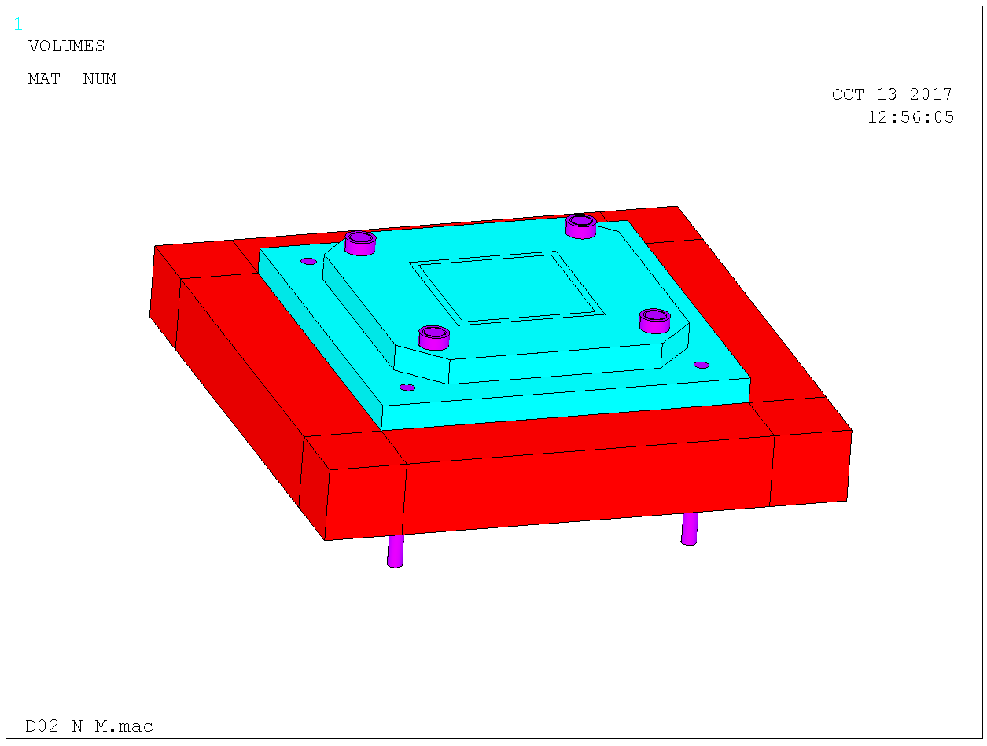

Figure 18. Close-up. Red is concrete, blue is S355 and magenta is 10.9 or 8.8.

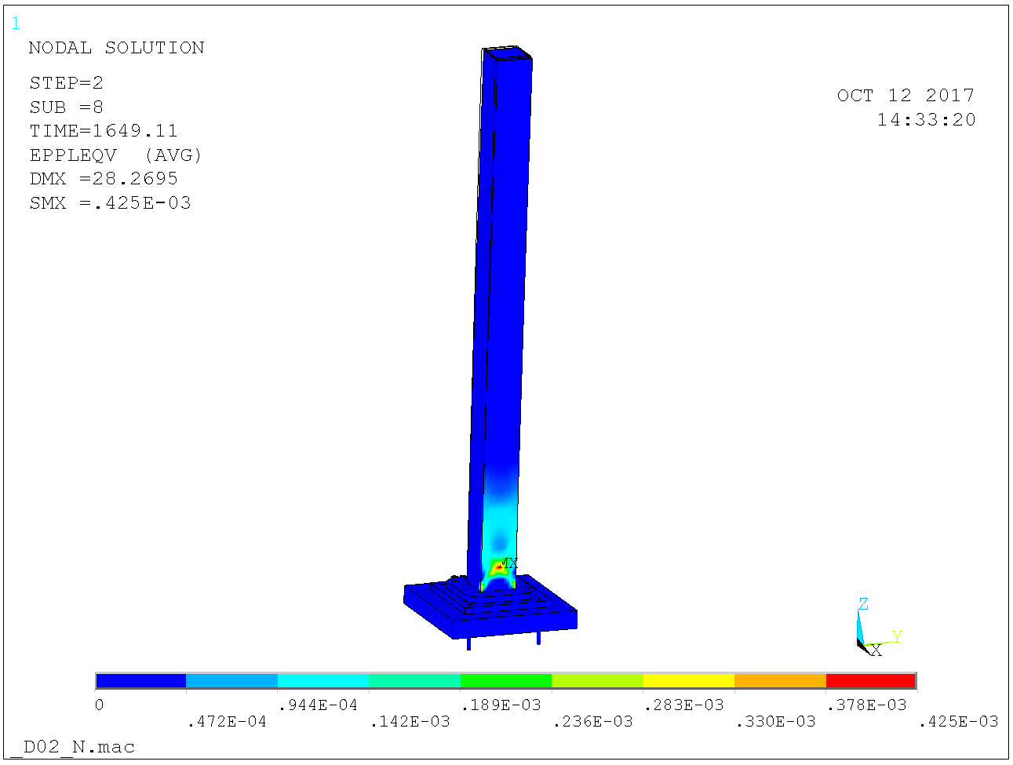

Figure 19. Foot plate completely fixed yields resistance 1650 kN. Plastic strains.

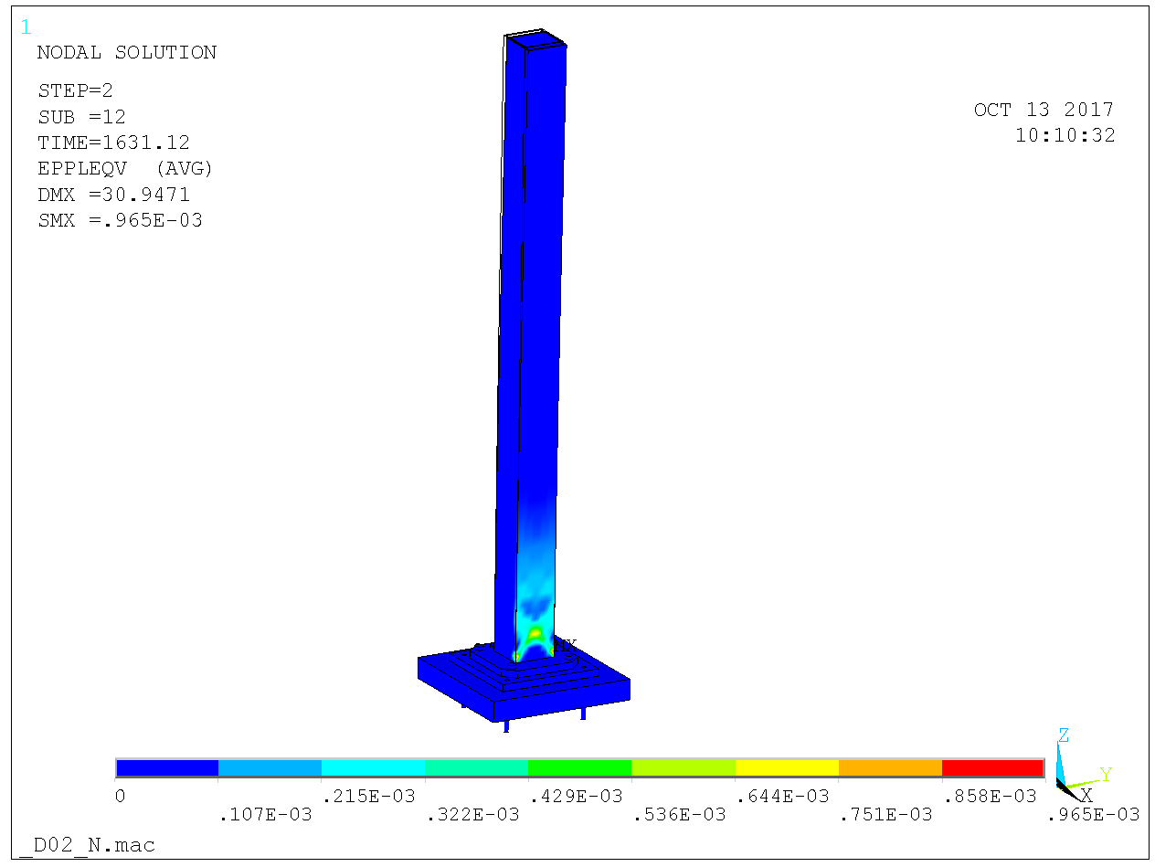

Figure 20. Foot plate bolts M30 8.8 and foot plate 35 mm yields resistance 1630 kN. Plastic strains.

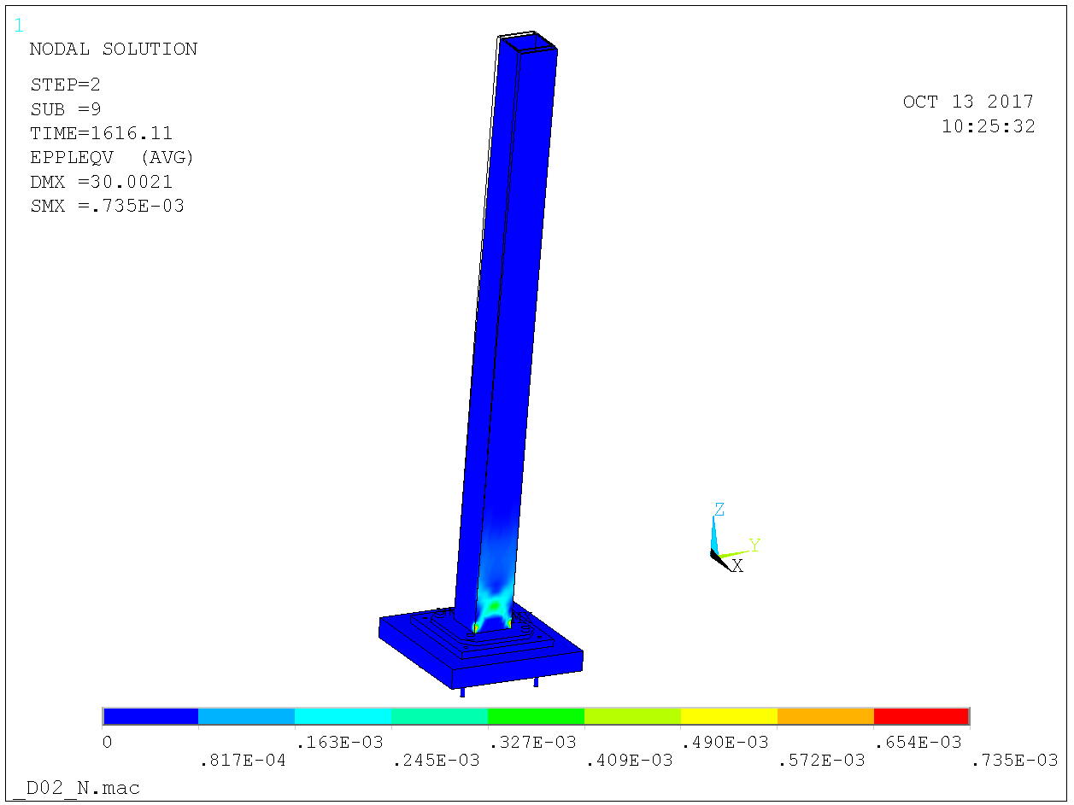

Figure 21. Foot plate bolts M30 8.8 and foot plate 20 mm yields resistance 1615 kN. Plastic strains.

### D02 – eccentrically loaded column

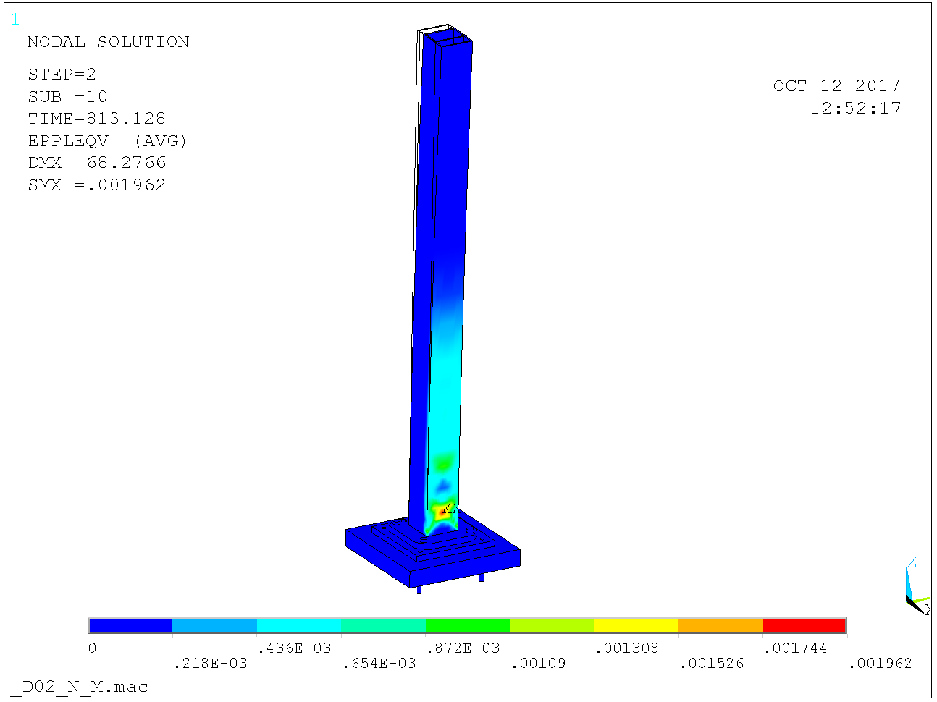

Figure 22. Foot plate completely fixed yields resistance 815 kN. Plastic strains.

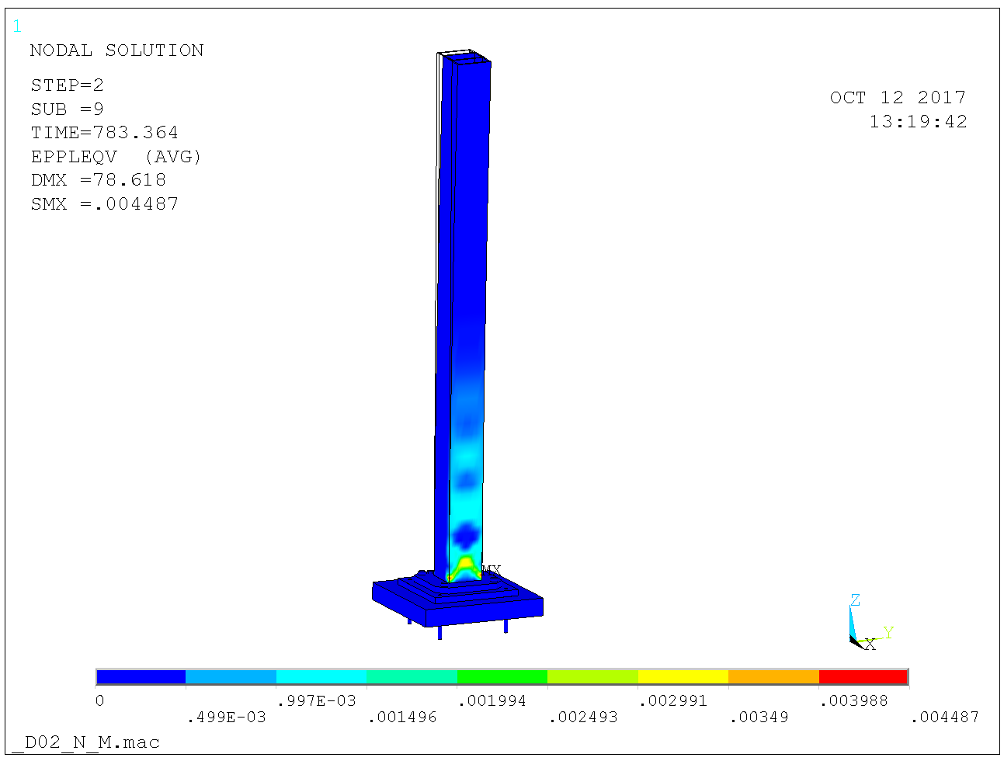

Figure 23. Foot plate bolts M30 8.8 and 35 mm footplate yields resistance 785 kN. Plastic strains.

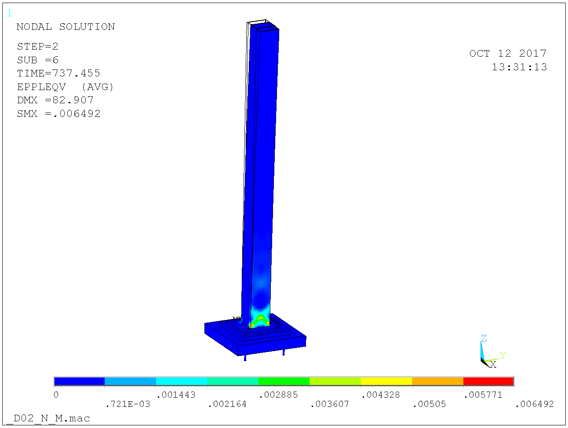

Figure 24. Foot plate bolts M30 8.8 and 20 mm footplate lowers resistance to 735 kN. Plastic strains.

## D01 & D03 column footing anchoring

The D01 and D03 slabs are supported by piles cc 1500 hence there are small bending moments from transversal loads considering the thickness 500 + 750 mm in the bunker area. However, due to the design of the slabs, there are significant constraints causing the plate to crack from shrinkage. For that reason, the anchors are designed assuming cracked concrete.

In normal operating, including the eccentric case, the anchors are not loaded. The anchors may however be loaded in tension from accidental loads, arising e.g. from collision with lifted objects.

In accidental limit state it holds for anchor concrete failure modes  according to CEN/TS 1992-4-1, [7] and obviously for steel it holds.

The anchor plate is 500 x 500 and the anchors sits on 400 x 400 and the arrangement is cast-in. Taking anchor depth mm yields design resistance for two anchors in concrete C40/45 according to CEN/TS 1992-4-2, [8],

 kN

Head diameter twice the anchor diameter yields pull-out resistance

kN

Anchor diameter 30 mm S355 yields resistance for two anchors based on yield strength

kN

The anchor resistance kN transforms into a column base bending resistance which depends on the concrete pressure distribution. Consider a case with horizontal force applied on the column top and no vertical force. Applying a horizontal force 53 kN at column top yields column top displacement 65 mm according to Figure 25 below. The contact pressure distribution and magnitude are shown in Figure 26 and gives sum of anchor force kN on the two back anchors which is about the design concrete cone resistance.

Hence, the design resistance of the column base in pure bending is 160 kNm in the accidental limit state.

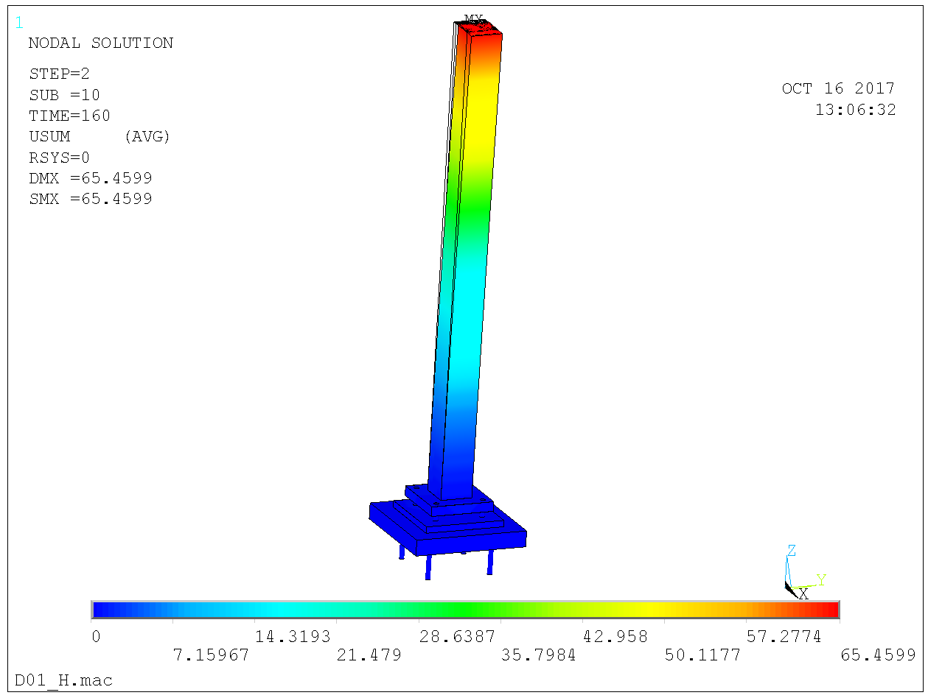

Figure 25. Top displacement 65 mm from 53 kN horizontal force giving 160 kNm clamping moment at column foot.

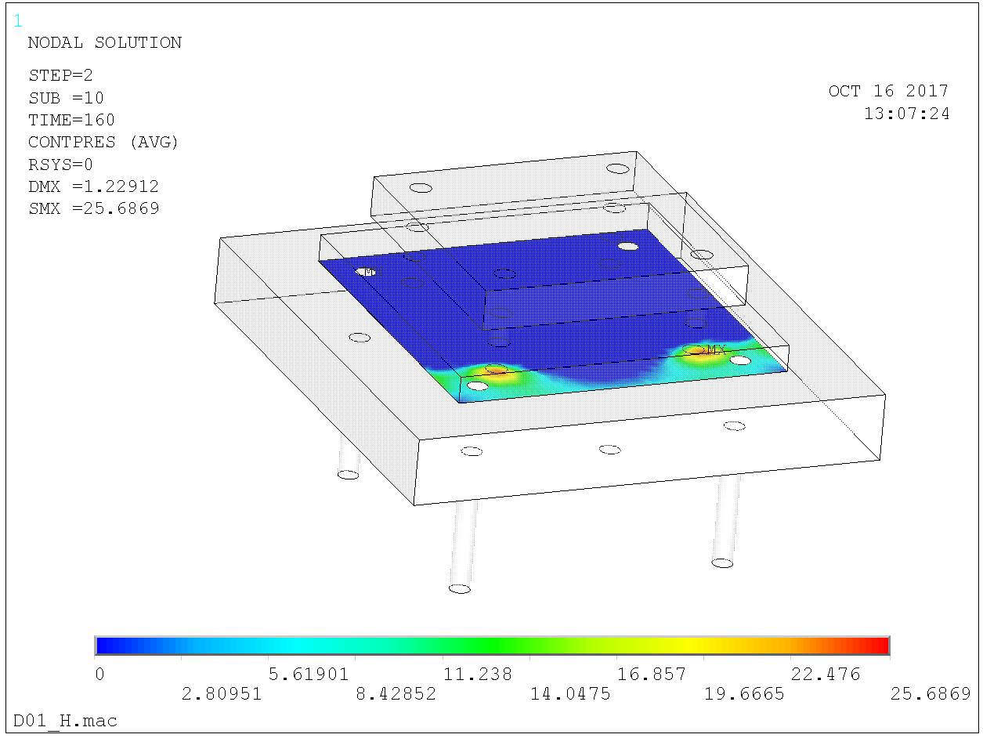

Figure 26. Distrubution and magnitude of concrete pressure at clamping moment 160 kNm. Yields tensile force 420 kN on the two back anchors.

## Consideration of D02 slab cracking status

The bunker roof is normal operating approx. 7 ton/m2. Instrument loads say approx. 3 ton/m2. Hence total approx. 10 ton/m2. This is significantly smaller than the 30 ton/m2 as given in the load specification.

A symmetry model according to Figure 27 is used for stress analysis of the D02 slab. The tensile principle stresses from 10 ton/m2 + DW are shown in Figure 28 and as seen nowhere does the tensile stress exceed the concrete mean tensile strength MPa.

The shrinking stresses should be minor for the MCS and hence we conclude that the D02 slab may be considered uncracked for anchor resistance considerations.

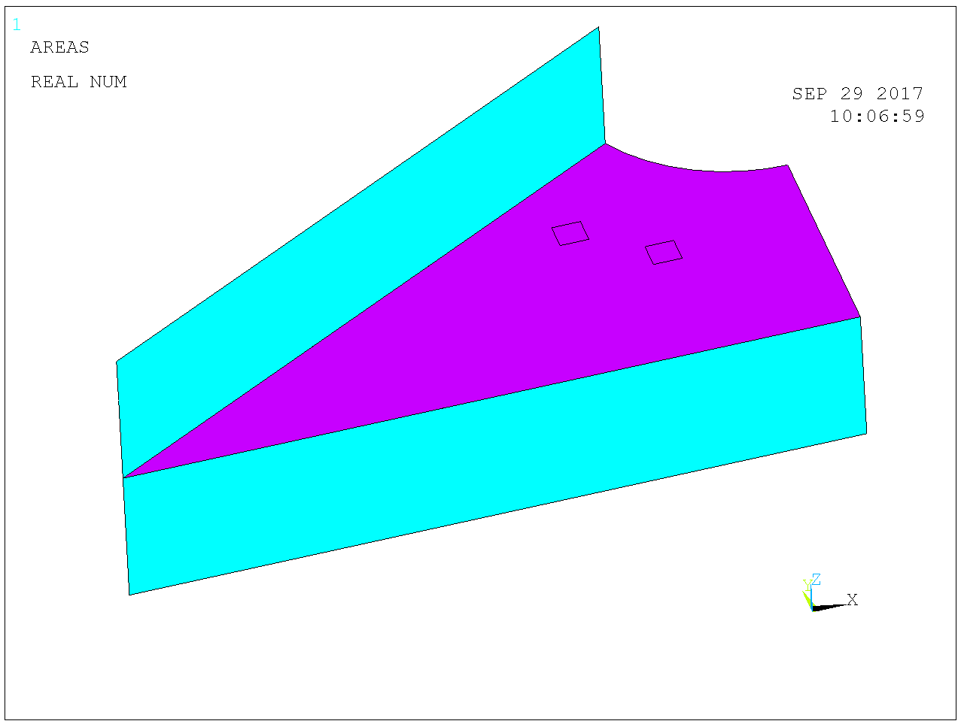

Figure 27. D02 slab, symmetry model, walls included to capture the constraint flexibility at supports.

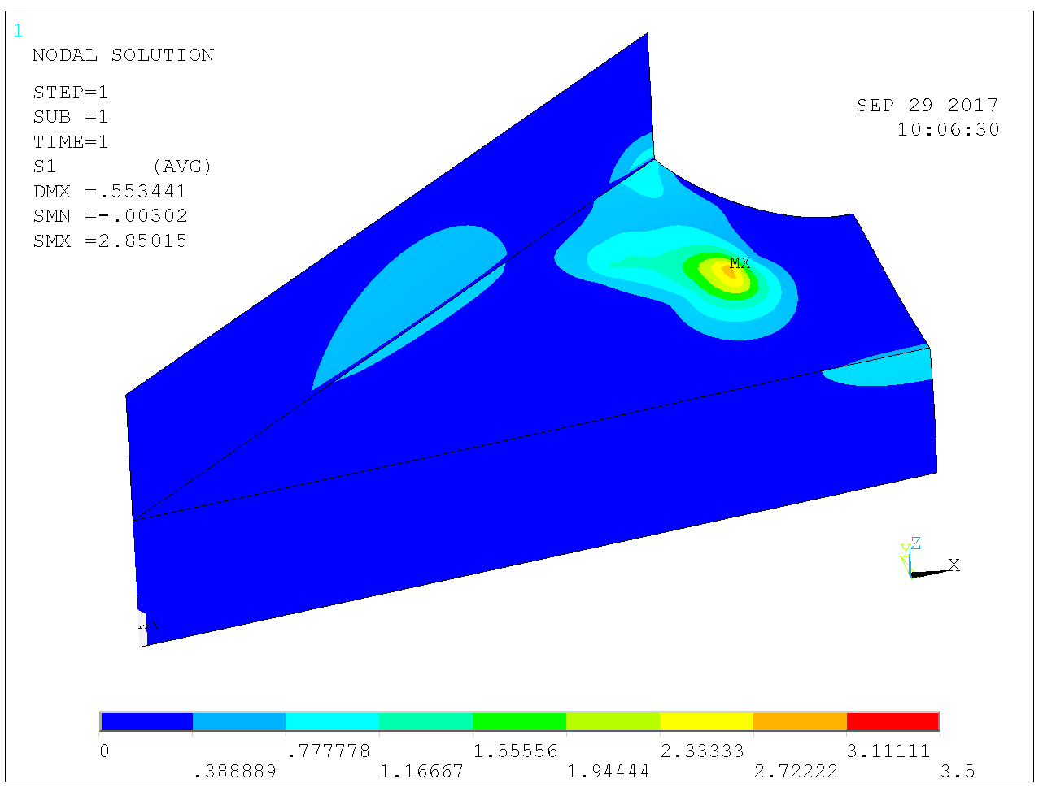

Figure 28. Tensile principle stresses from 10 tonnes/m2 uniform load. Maximum lower than concrete mean tensile strength .

## D02 column footing anchoring

The D02 slab was concluded uncracked for anchor resistance considerations above. Hence the characteristic concrete cone resistance of a Hilti-HDA M20 in C20/25 concrete is kN according to Hilti Fastening Technical Manual. We have spacing mm and C35/45 concrete with . Moreover, due grout, the anchoring depth is reduced to mm from the original . Hence, the design concrete cone resistance for two anchors is in the accidental limit state

 kN

Characteristic resistance with respect to steel failure is  kN per anchor according to Hilti Fastening Technical Manual and hence design resistance for two anchors using 

 kN

The anchor resistance kN transforms into a column base bending resistance which depends on the concrete pressure distribution. Consider the same case as for D02 above.

Applying a horizontal force 50 kN at column top yields column top displacement 70 mm according to Figure 29 below. The contact pressure distribution and magnitude are shown in Figure 30 and gives sum of anchor force kN on the two back anchors which is about the design concrete cone resistance.

Hence, the design resistance of the column base in pure bending is 150 kNm in the accidental limit state.

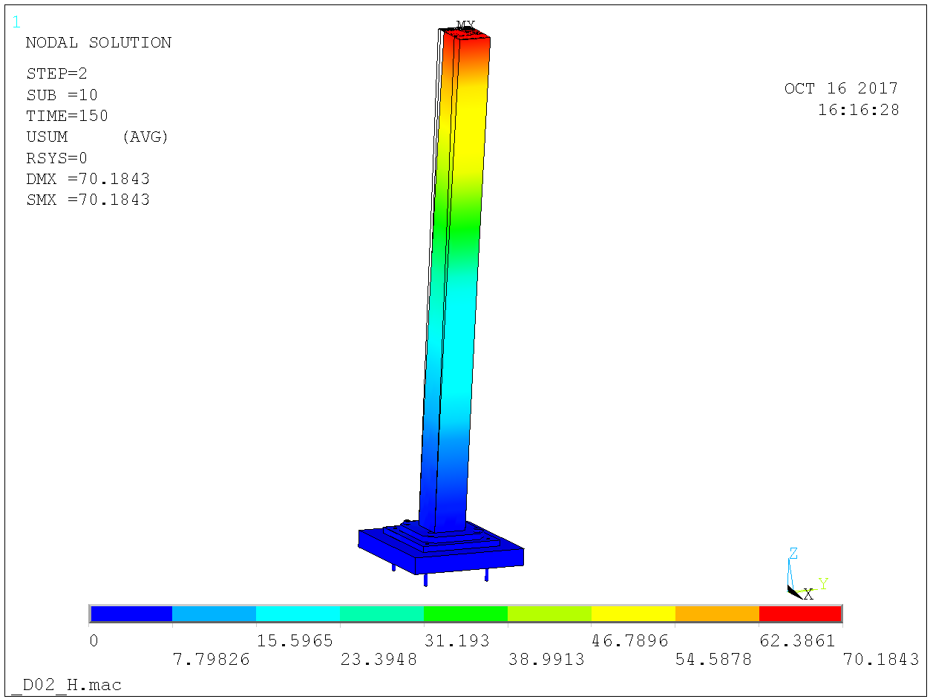

Figure 29. Top displacement 70 mm from 50 kN horizontal force giving 150 kNm clamping moment at column foot.

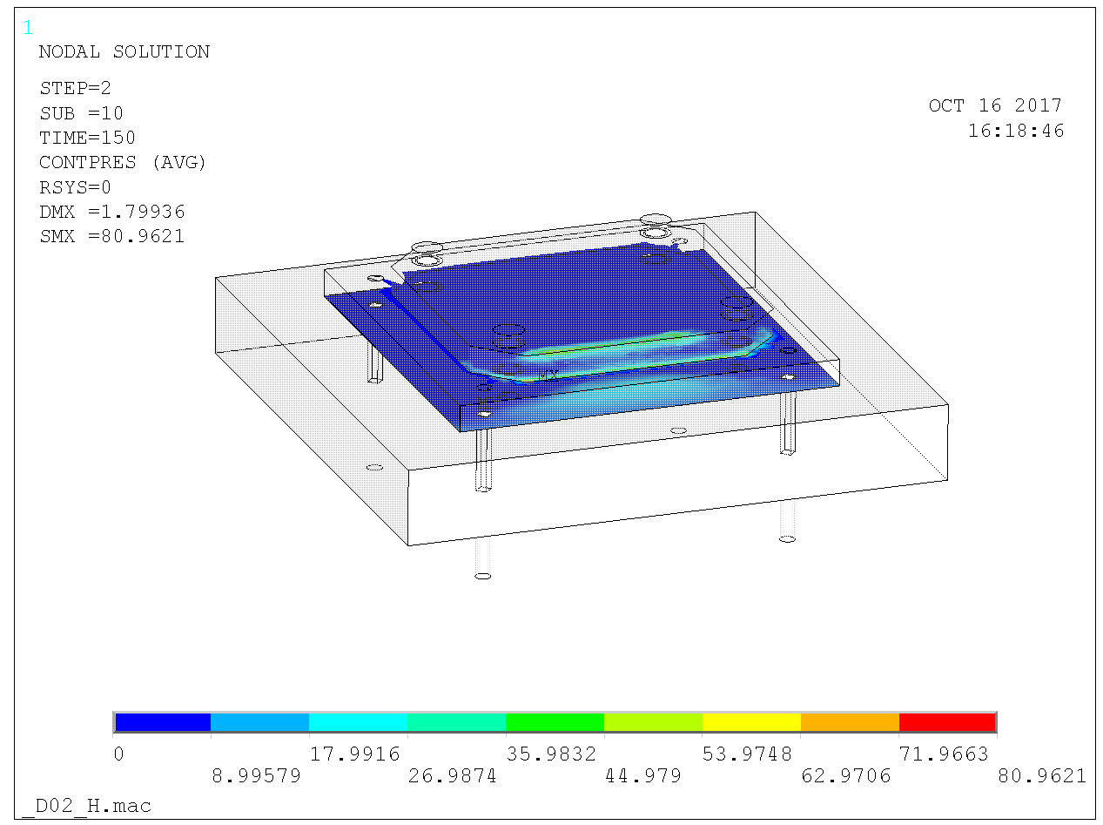

Figure 30. Distrubution and magnitude of concrete pressure (and contact pressure between foot plate and anchor plate) at clamping moment 150 kNm. Yields tensile force 350 kN on the two back anchors.

## Anchor forces at buckling collapse

The footing deformations and stresses prior to buckling collapse for the eccentric loading are shown for D01 & D03 in Figure 31 and for D02 in Figure 32 below. The corresponding tensile anchor forces are 50 kN and 150 kN, respectively, on the back two anchors. The reson for the higher anchor load for the D02 footing is that this footing yields a different distrubution of concrete pressure than the D01 & D03 footing.

In the ultimate limit state it holds for concrete cone failure and hence the design resistance for the D02 footing anchors in the ultimate limit state is for two anchors

 kN

And hence the resistance of the anchors are sufficient by far to deliver the column base clamp.

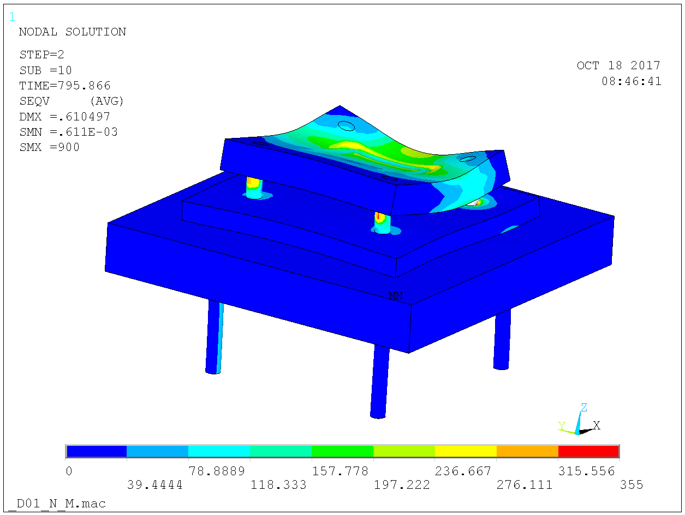

Figure 31. D01 & D03 footing. Anchor tensile force 50 kN on two anchors at buckling collapse for 795 kN for eccentric loading.

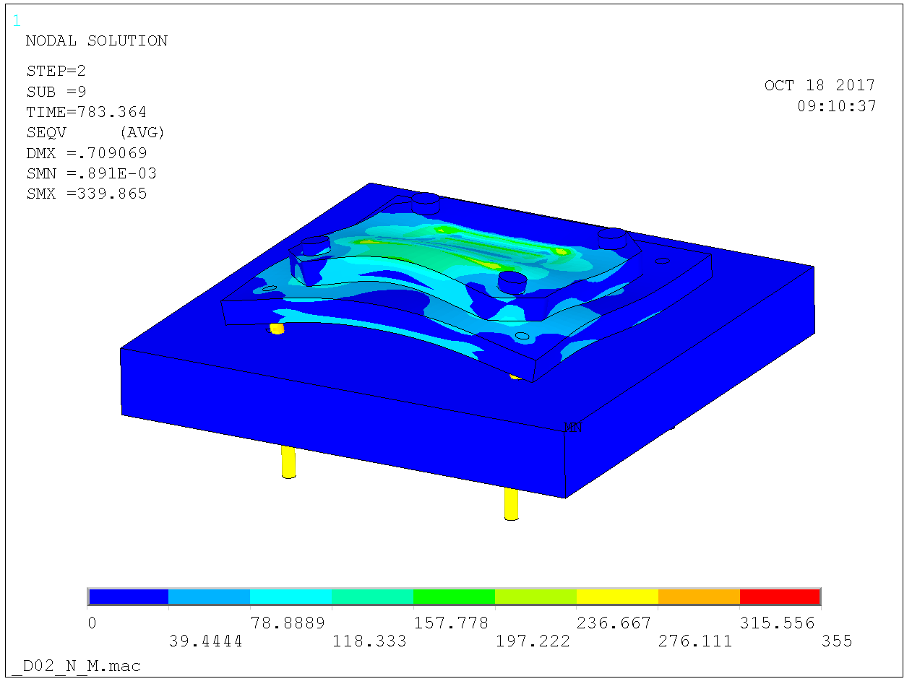

Figure 32. D02. Anchor tensile force 150 kN on two anchors at buckling collapse for 785 kN for eccentric loading.

## Beams – handbook analysis

The beam cross-section consists of an upper flange 400 x 100 S355 mm to which a VKR 400 x 200 x 10 S355 is welded below. The somewhat unorthodox top flange is there for shielding purposes.

The maximum design column load kN is for columns in R12 in which the circumferential columns spans 2.55 m. The shielding blocks are symmetrically positioned on the beam such that the beam is loaded by four concentrated loads – two at midspan and two close to supports. Hence, the design shear load and bending moment are

kN

kNm

The shear resistance of the VKR 400 x 200 x 10 webs alone is

kN

As for bending, obviously the beam is overly strong – both the the top flange and the VKR would resist the bending individually. Nonetheless the resistance is computed. The area of the VKR 400 x 200 x 10 is 11500 mm2 and the plastic neutral axis is positioned a distance into the top flange, given by



so mm and the bending resistance is

kNm

The design shear stress of the weld is

MPa

so for equal resistance to the web the weld needs to be

mm

## Analysis including beams and semi-rigid connection to column

The analysis above did not account for the beneficial effect of the semi-rigid beam to column connection. In the analysis below, these affects are accounted for.

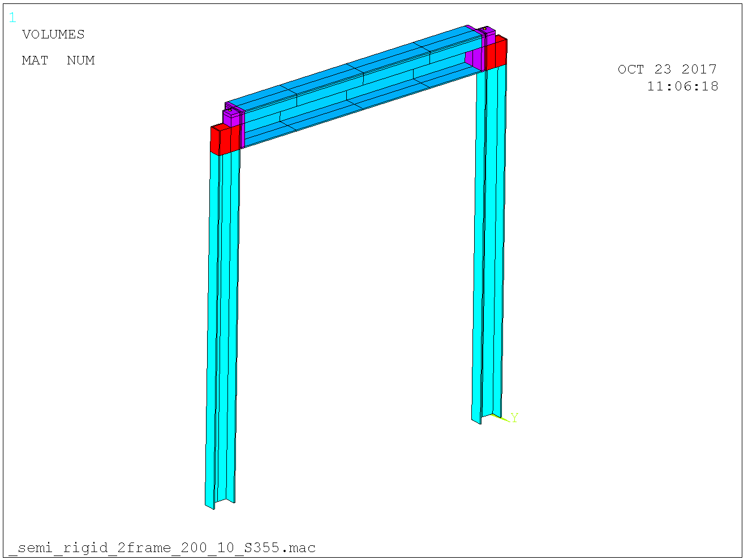

Figure 33. Symmetry model. Base clamped. Loads appled in the beam quarter-points.

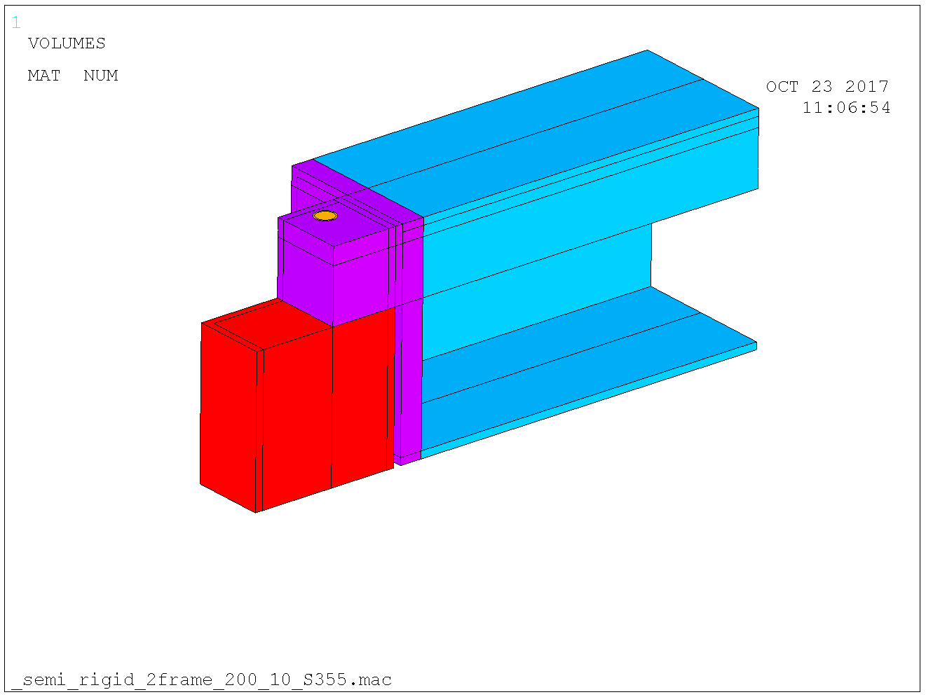

Figure 34. Close-up semi-rigid connection between column and beam. Contact elements between column top and beam lip.

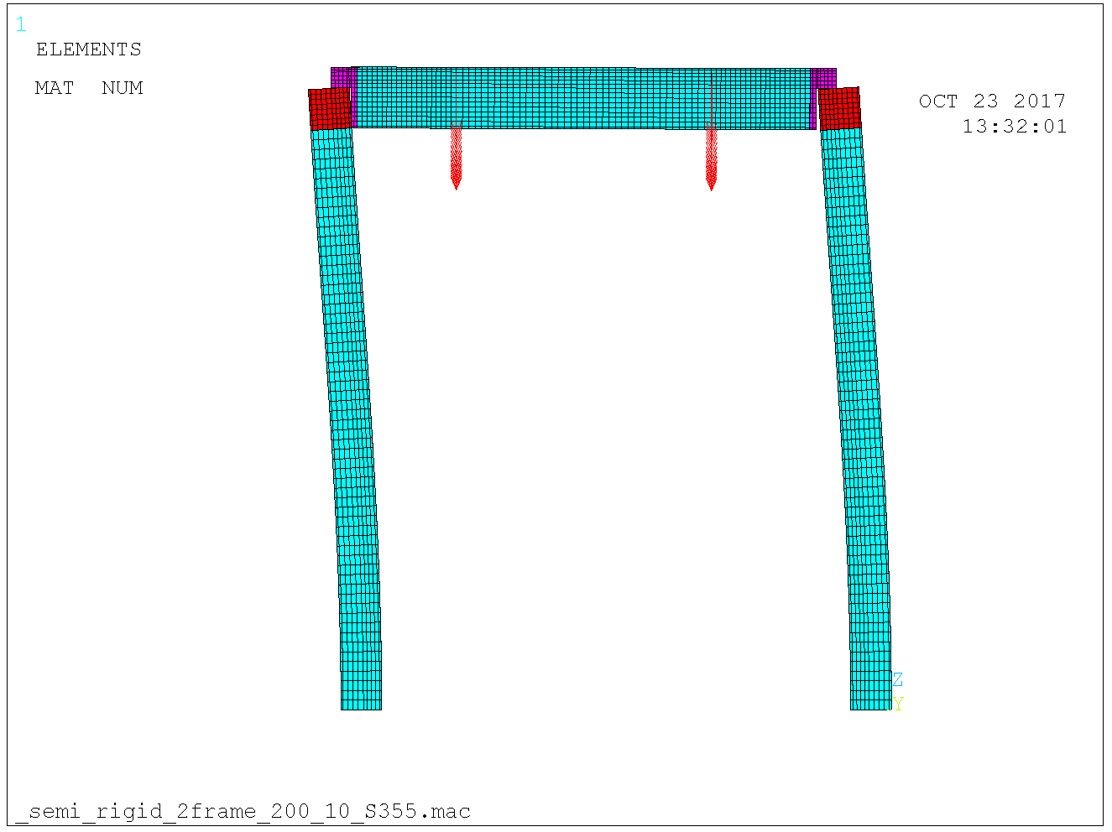

Figure 35. Initial imperfection 15 mm in the sway direction. Exxagerated 10 times for visibility.

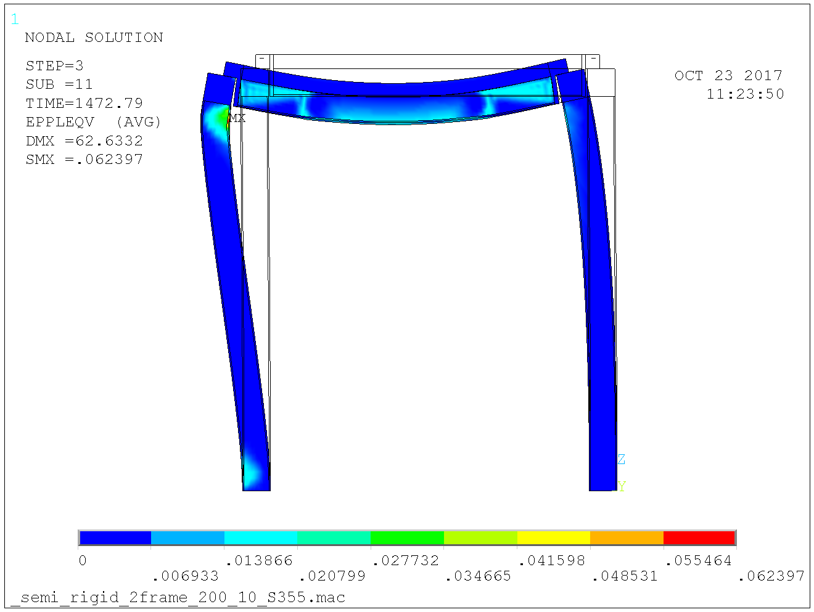

Figure 36. Resistance 1470 kN per column. Design load 475 kN.

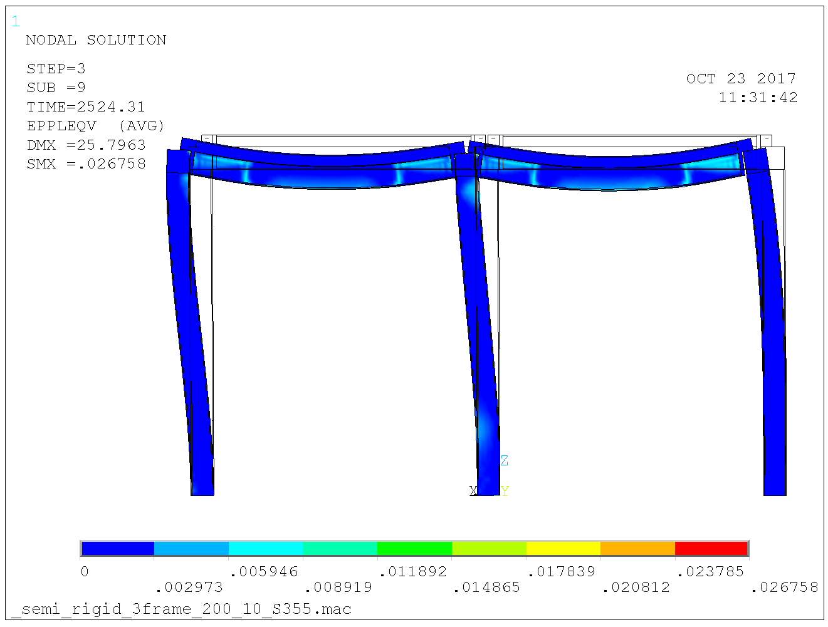

Figure 37. Adding a row of columns. Resistance 2540 kN on center column and half that amount on outer columns. Design load 950 kN on center column and half that amount on outer columns.

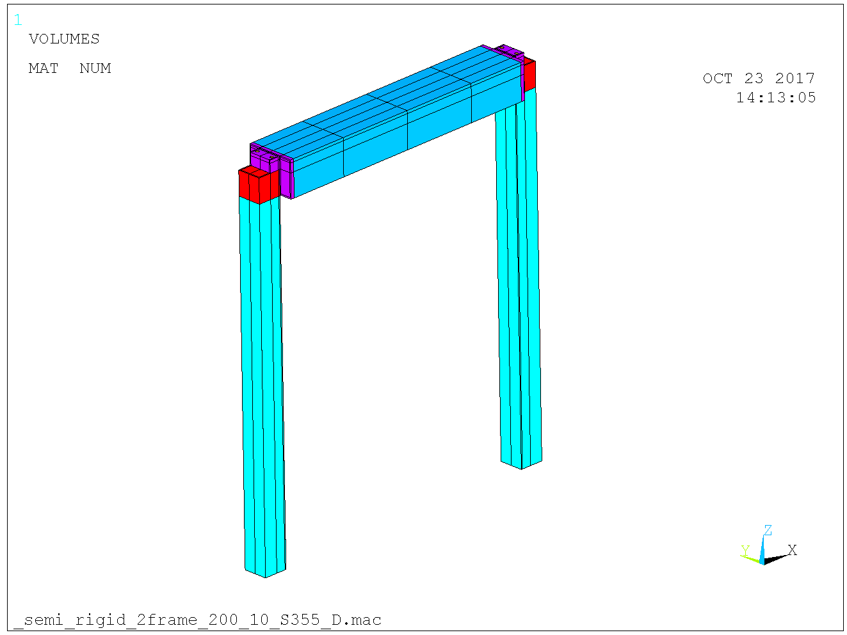

Figure 38. Non-symmetry model. Loaded in the beam quarter-points from one side only wich implies 100 mm eccentricity.

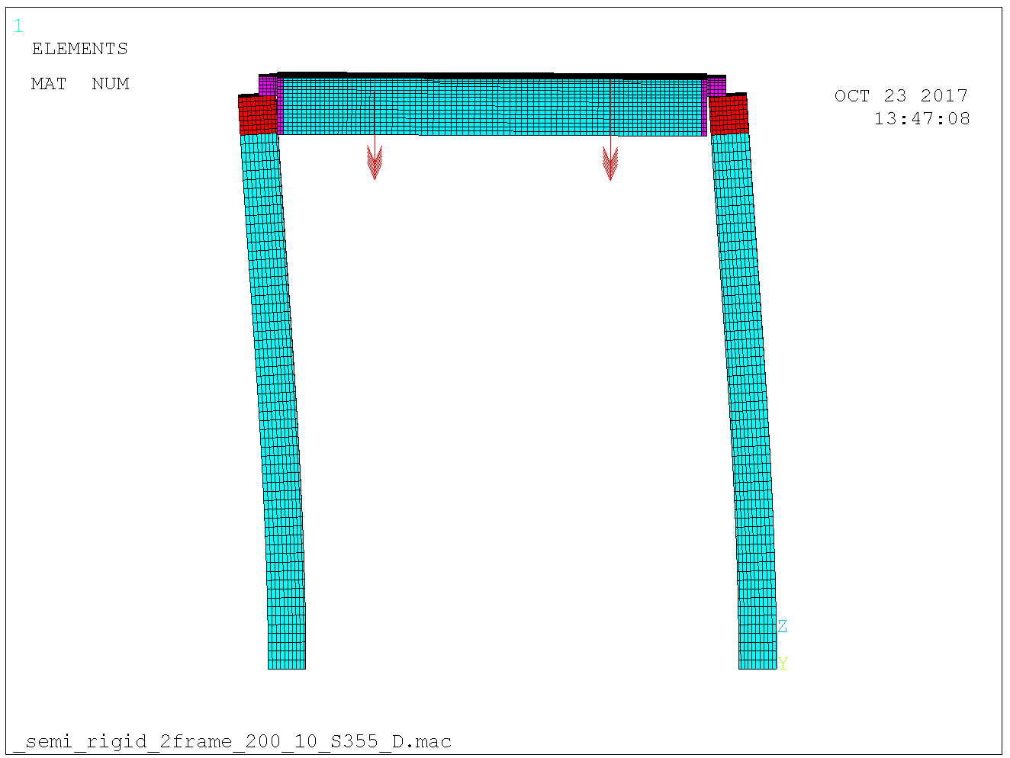

Figure 39. Initial imperfection 15 mm in the sway direction. Exxagerated 10 times for visibility.

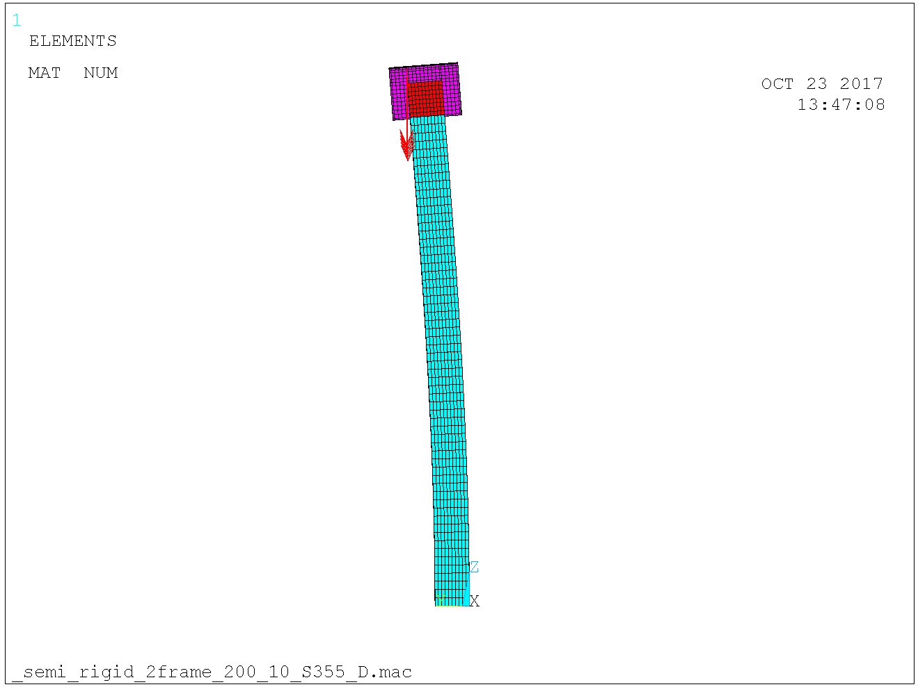

Figure 40. Initial imperfection 15 mm also in the other direction. Exxagerated 10 times for visibility. Load eccentricity 100 mm.

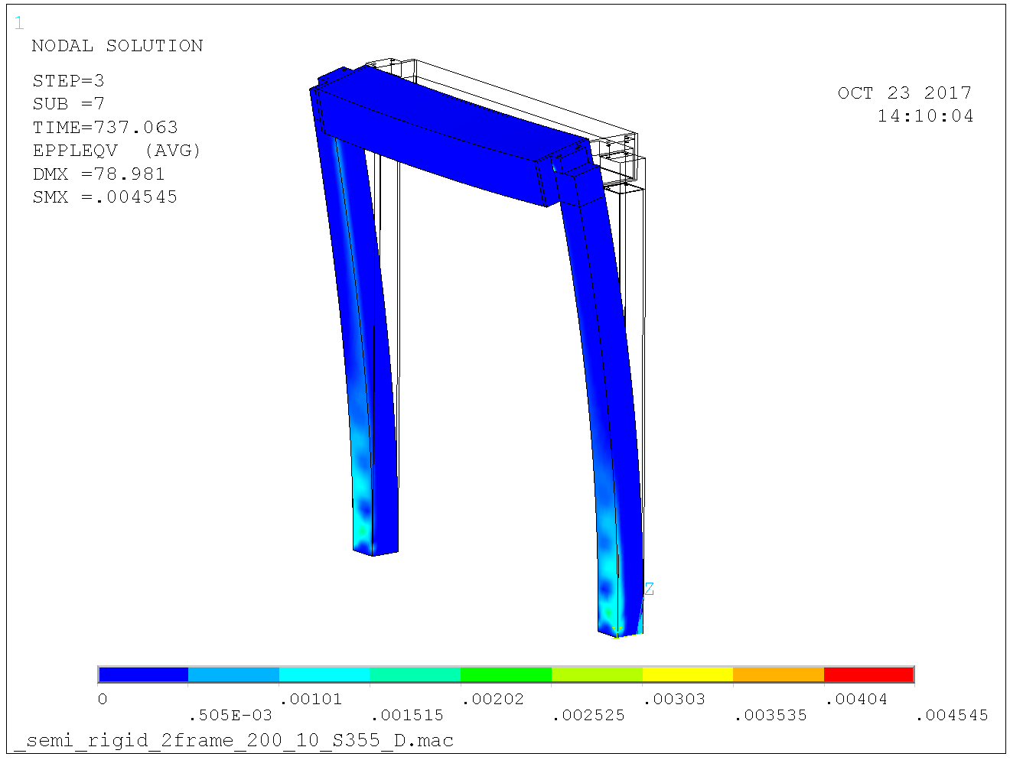

Figure 41. Resistance 740 kN per column. Design load 240 kN. The reason for the resistance not reaching the 820 kN for a fully clamped base as in section 3.3.2 and 3.3.4 is biaxial bending of the column due to beam reaction not being centric on the column top.

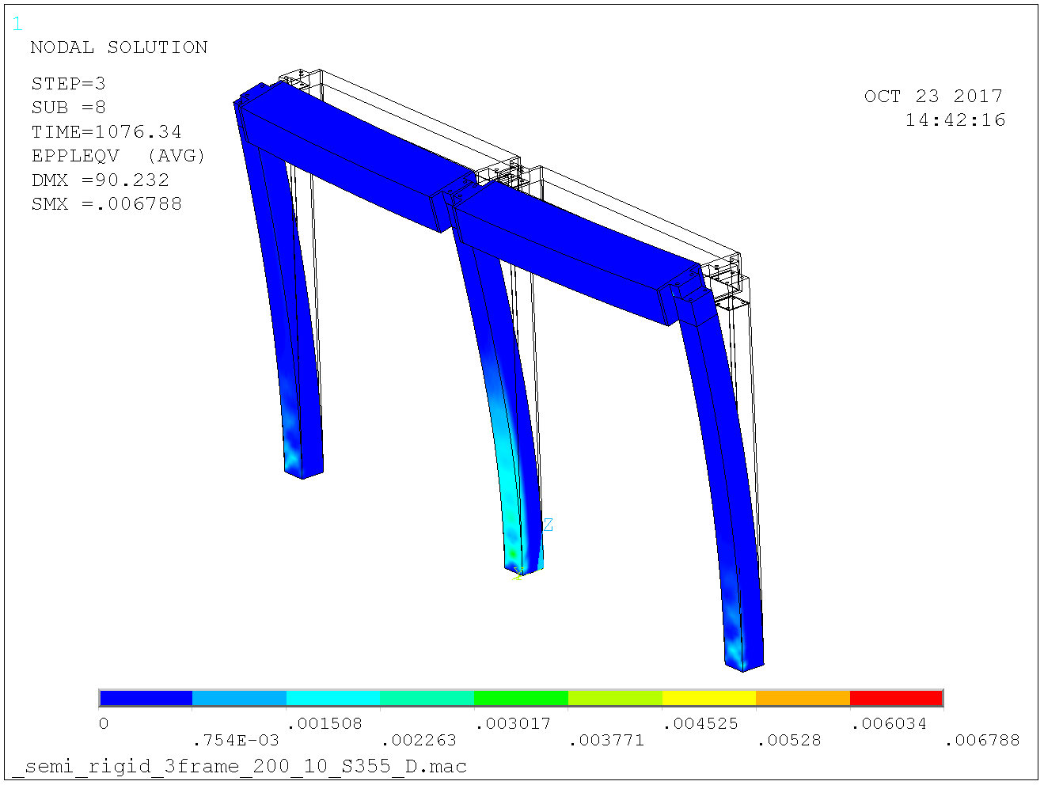

Figure 42. Adding a column yields resistance 1080 kN on center column and 540 kN on outer columns. Design loads 475 kN and 240 kN respectively.

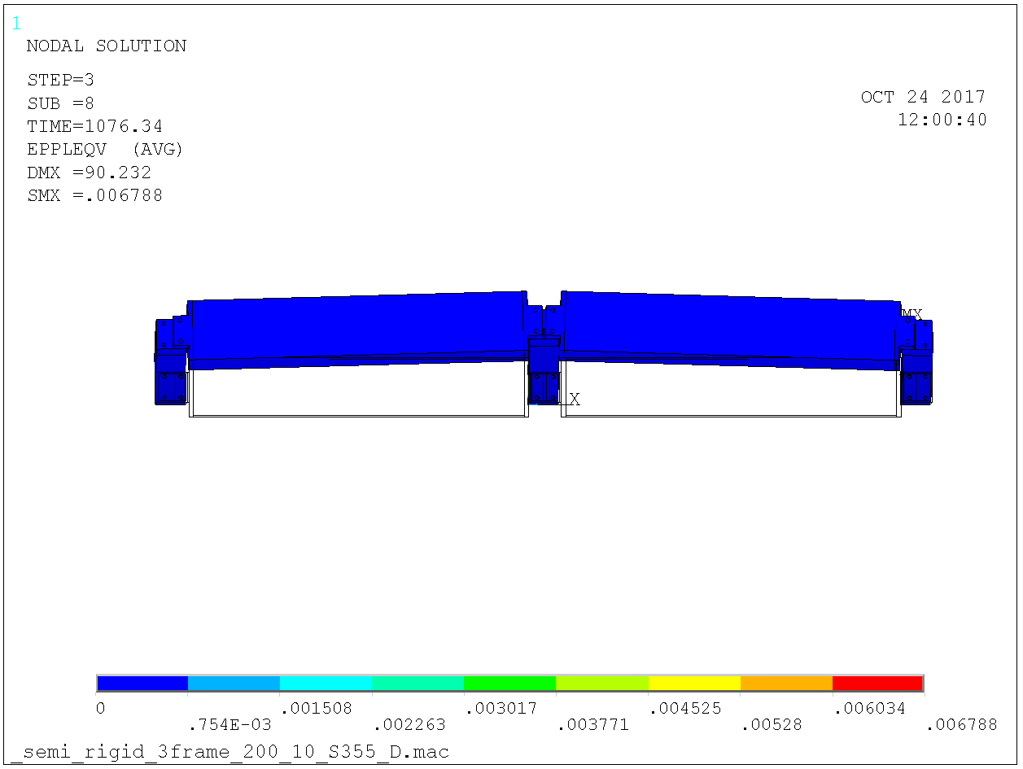

Figure 43. The reason for the resistance exceeding the 820 kN for a fully clamped base as in section 3.3.2 and 3.3.4 is the outer columns help resisting buckling of the center column since these have less load. Increasing the number of columns will yield resistance 820 kN for the center columns (idealized clamped case, some 790 kN for the real case with some flexibility of the column base).

## Stability considerations for D01 & D03 during seismic event

### General

Lateral stability in D02 structure is arranged by i) circumferential beams being connected to the diagonal walls and ii) shear connectors between the shielding blocks and the circumferential beams in R6 and R9 which creates a horizontal diaphragm. By this stabilizing system the D02 may resist an H4 seismic event. This is demonstrated in a separate report, [10].

This is not the case for D01 & D03 bunker. The bunker is an unbraced free-standing structure with clamped column bases and semi-rigid beam to column connections. In addition, there are no in-house response spectra derived för the D01 & D03 bunker floors. Hence we have no seismic loads for D01 & D03 bunker and it follows that it is not possible to demonstrate sufficient resistance to an H4 seismic. Therefore, according to [11], the D01 & D03 bunker may collapse as long as it does not collapse inwards.

This is accomplished by arranging radial struts such that the inwards radial resistance is larger than the outwards resistance by a sufficiently large factor. In collaboration with Cowi, the designer of the D01 & D03 bunker slab, a factor 1.25 was judged sufficient.

The outwards radial resistance is determined by the frame alone, i.e. the clamped columns and the beams, which are connected to the columns via semi-rigid connections.

### Radial resistance of steel frame

The outwards radial resistance is determined by model in Figure 44 below. Using small deformation analysis, i.e. no account for buckling, yields lateral resistance per column approximately 95 kN according to Figure 45 - Figure 47 below. Including a vertical load 300 kN and accounting for large deformations reduces this to 90 kN according to Figure 48 and Figure 49 below, hence minor second order effects.

The same resistance may be demonstrated by analytical confirmation as follows. The bolts are M30 10.9. Beam lip contact length to column top is 90 mm and the bolts placed centrically. Hence the nominal maximum clamping moment of the semi-rigid connection is

kNm

The maximum clamping moment is the plastic resistance of the VKR 200 x 200 x 10 column i.e

kNm

Hence, with column length 3.0 m, the limit radial resistance is

kN

In excellent agreement with the finite element results.

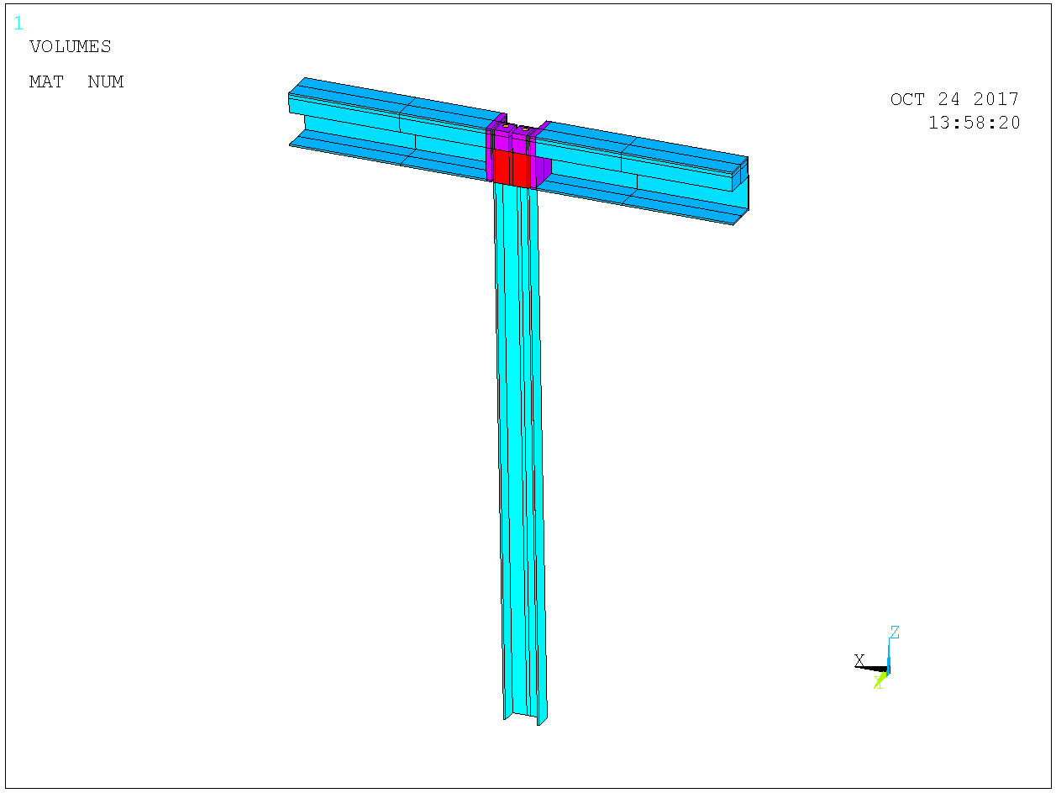

Figure 44. Symmetry model for determining the radial resistance of the frame.

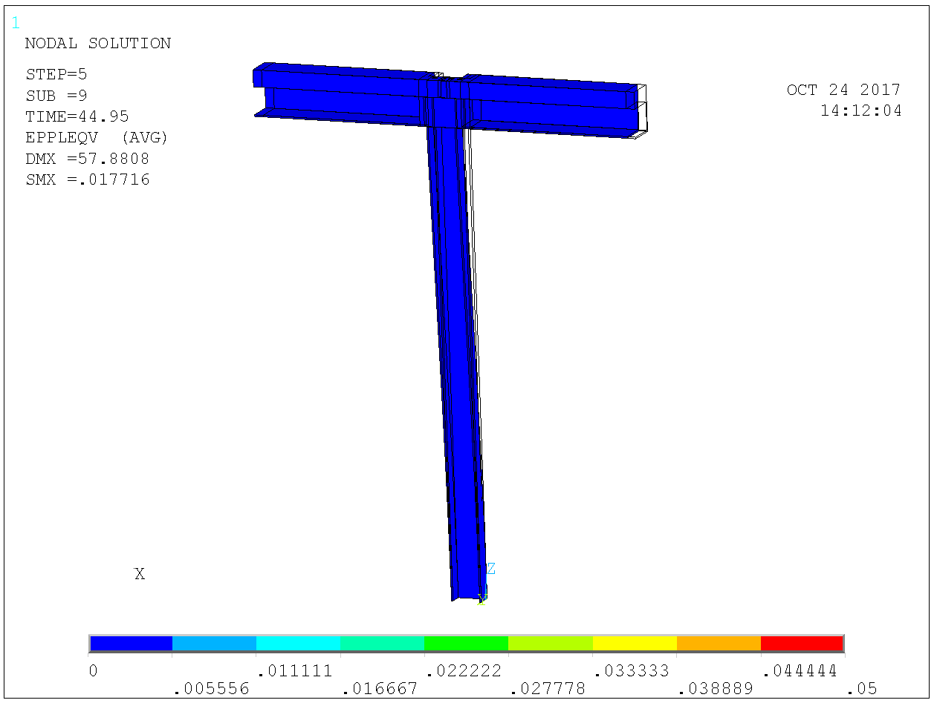

Figure 45. Plastic strains and deformations for 45 kN on symmetry model i.e. 90 kN per column. Small deformation analysis i.e. no account for buckling.

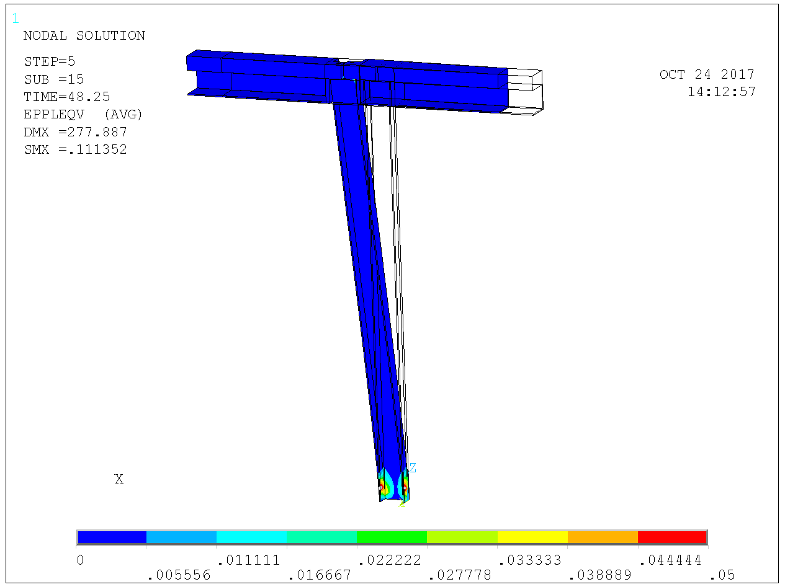

Figure 46. Plastic strains and deformations for 48 kN on symmetry model i.e. 96 kN per column. Small deformation analysis i.e. no account for buckling.

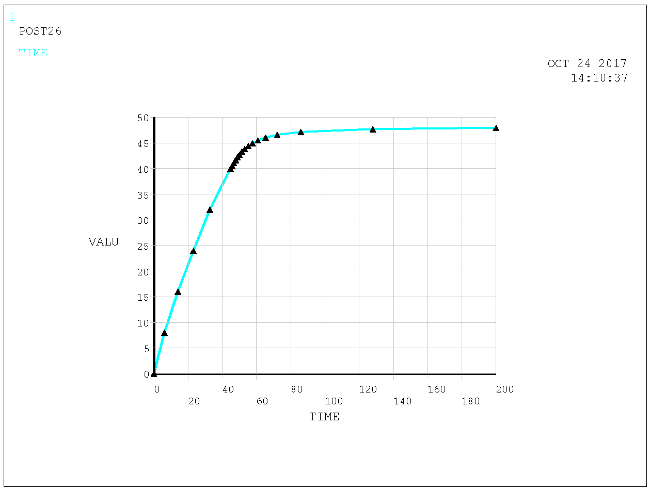

Figure 47. Radial load vs displacement. Small deformation analysis i.e. no account for buckling.

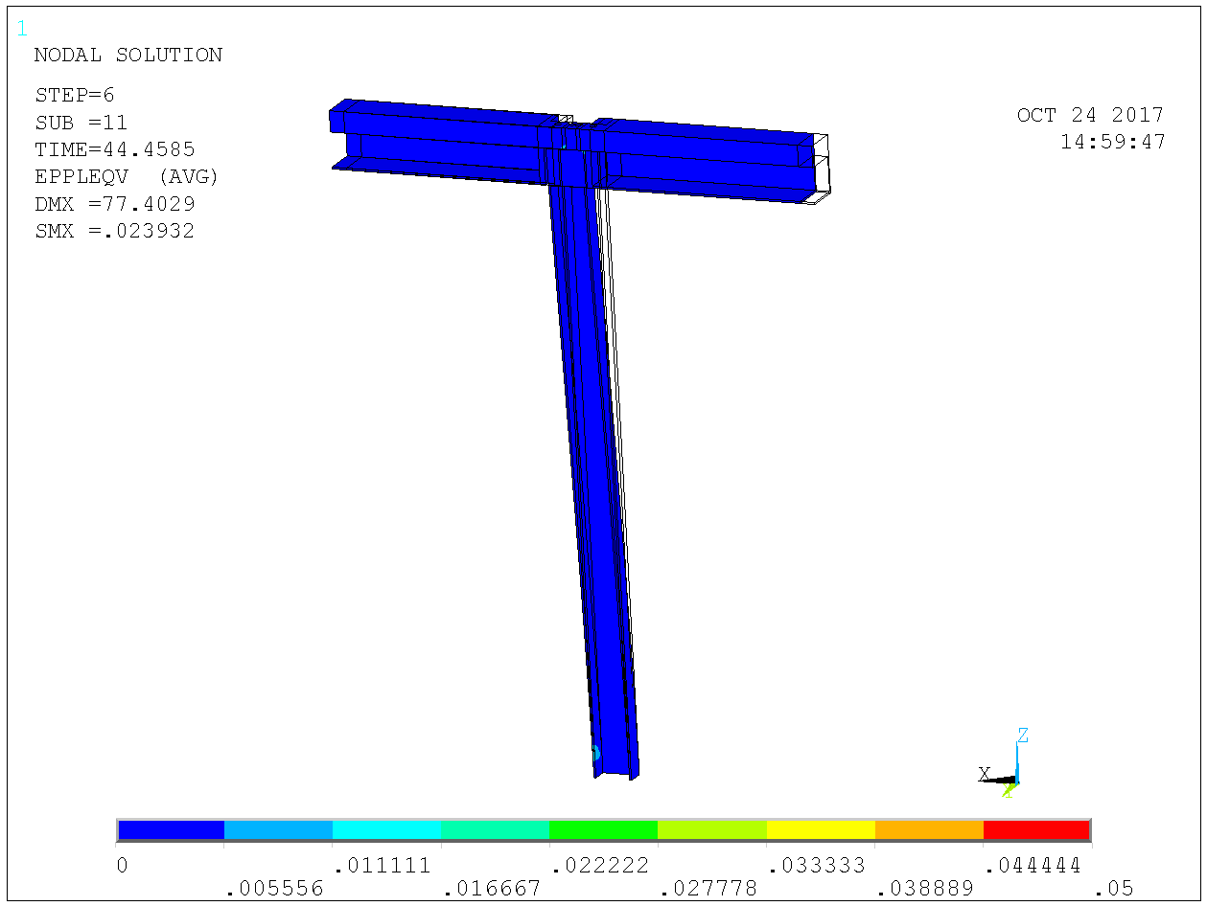

Figure 48. As above but large deformation analysis i.e. accounting for buckling. Column load 300 kN i.e. 150 kN on symmetry model. Plastic strains and deformations for 45 kN on symmetry model i.e. 90 kN per column. Displacement 77 mm as compared to 57 mm for small deformation analysis above. Displacement scale 1:1.

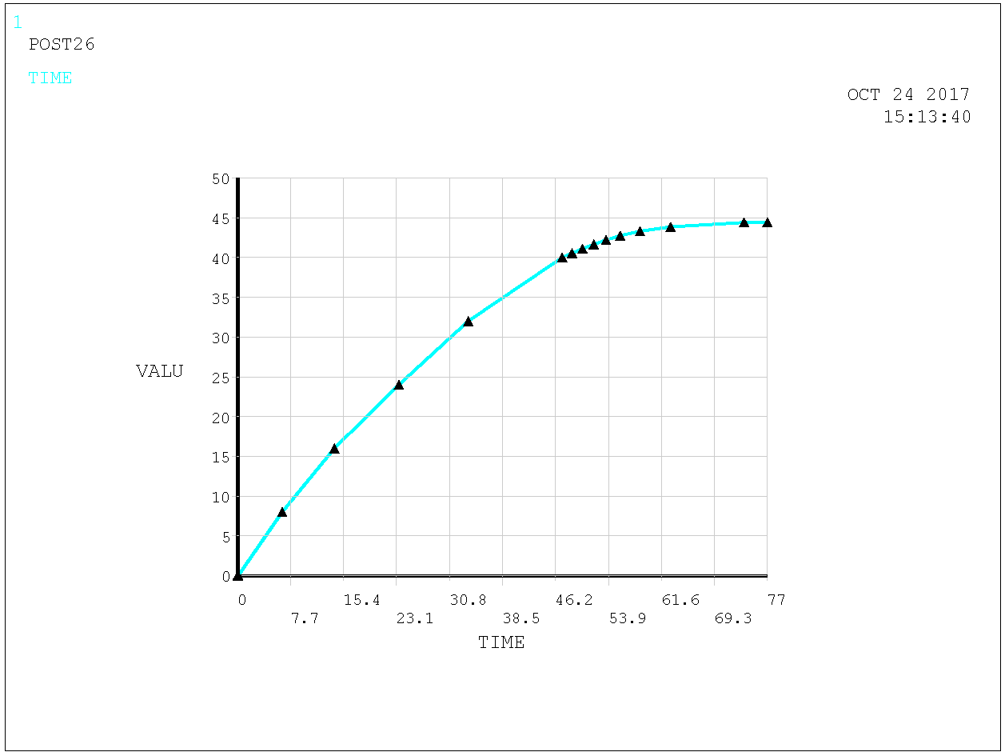

Figure 49. Radial load vs displacement. Large deformation analysis i.e. buckling accounted for. Refuses to converge above 45 kN on symmetry model i.e. 90 kN per column.

There are at most 6 columns in a radial row meaning a radial force

kN

needs to be resisted by the strut. The column spacing is 2 m and column height is 3 m hence the lift to anchor in the concrete is

kN

### Design of anchors for lift and shear from radial load

Anchors sitting on square 400 mm and going 680 mm deep. It holds in accidental limit state and hence design concrete cone resistance for four anchors in concrete C40/45 according to CEN/TS 1992-4-2, [8],

 kN

Shear pryout resistance is twice the concrete cone resistance and hence usage ratio for combined loading is



Steel anchors diameter 40 mm S355 has resistance in accidental limit state

kN tensile

kN shear

Combined usage ratio



Head diameter twice the anchor diameter yields pull-out resistance

kN

### Resistance of column base to lift and shear from radial load

Loads  kN vertical and  kN radial is resistad by the column base arrangement as shown in Figure 50 below. The footing arrangement is the same as the other D01 & D03 columns.

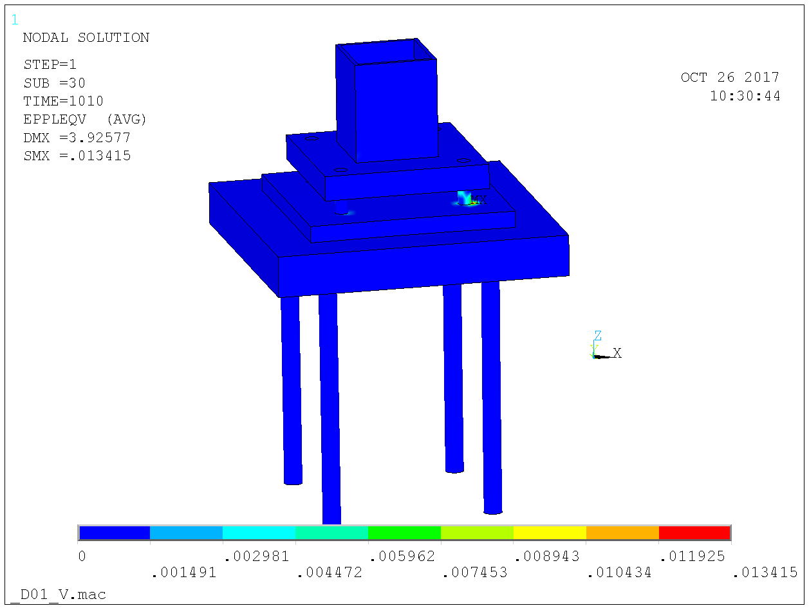

Figure 50. Plastic strains for lift force 1010 kN and horizontal force 675 kN, applied centrically at the bottom of column foot plate.

### Design of diagonal strut for radial load

The diagonal strut is there to resist inward radial forces without providing resistance radial outwards forces. In general, a wire is then the preferred structural element. However, Cowi are conducting siesmic analysis of the building / concrete slab and their model includes the bunker steel structure. A wire would make their analysis model non-linear which is highly unwanted. So we opt for a strut with some compression resistance however much smaller than the tensile resistance.

The strut force is

 kN

Using massive square section S355 we need an width

mm

So diagonal strut 60 x 60 mm S355.

Slenderness



Buckling curves in BSK stops at slenderness 2.0 and use of formulas are tedious. EC3 curve c gives



Hence, outwards radial resistance one order of magnitude less than the inward resistance.

## R6 circular beam

At R6, 23 (22 at the other side) columns support the circular R6 beam. The R6 beam is a box beam with an eccentric upp flange 1100 x 150 mm for shielding reasons. The overall dimensions are shown in Appendix 2. The upper flange is in the analysis of the box beam set to 50 mm and the box beam is taken width x height = 650 x 500 mm box beam with 10 mm thickness in webs and bottom flange. The final design will not have smaller thickness than that.

As shown in Appendix 2, there are eccentricties in the loads from above in relation to column support. This translates into a torsional moment at each end support.

The torsional moment from the 2 ton/m2  width 0.85 m skirt shielding inside R6 is

 kNm/m

The torsional moment from the 6.6 ton/m2  width 3/2=1.5 m shielding outside R6 is

 kNm/m

The skirt shild blocks will be mounted first and they will be there counteract the torque from the outside shielding. This is conservatively neglected in the analysis of the beam as follows and only shielding outside R6 is considered.

Load factor and accounting for 50 % overload from stacking yields total design load from shielding outside R6

kN

The analysis model is shown in Figure 51 - Figure 54. The eccentricity in the model is 170 mm. Analysis results in terms of stress in Figure 55. As seen the stresses are moderate, less than 50 MPa and in reality they will be even smaller since thicknesses in the model are on safe side.

The torque reaction on each side some kNm according to Figure 56. For a straight beam the value would have been kNm at each side and the difference is due to curvature of beam.

The reaction 125 kNm is however exxagerated since the counteracting torque from skirt shilding was not accounted for in the beam analysis. Correcting for this, the design torque reaction would be

kNm

The necessity of the anchor plates being able to resist torsion moments at R6 was pointed out to Sweco in an e-mail from Senad Kudomovic 2017-07-27 showing loads and eccentricities. This was replied to by Helmer Palmgren 2017-08-03 in which it was stated the torsional resistance is +/- 100 kNm.

The design of the box beam end connection to the concrete anchor plate needs to resist the torque reaction. This will be demonstrated subsequently in a later version of this report.

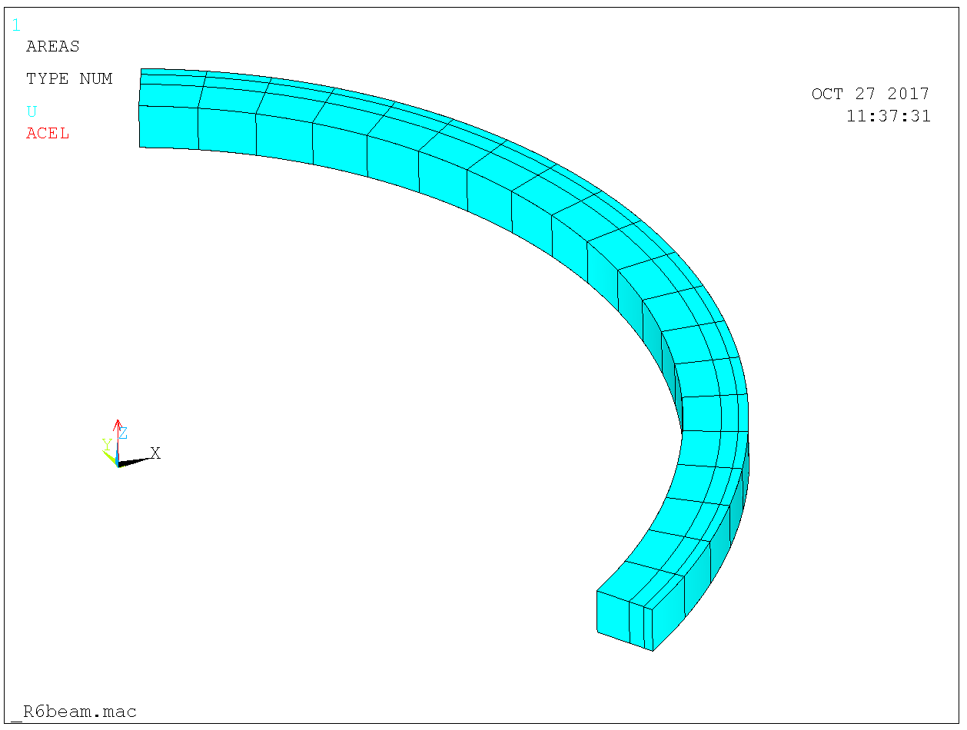

Figure 51. Model. Ends connected to a center node via rigid spider web beams and center node constrained translationally in all directions and in rotation along circumferential axis (torque constraint).

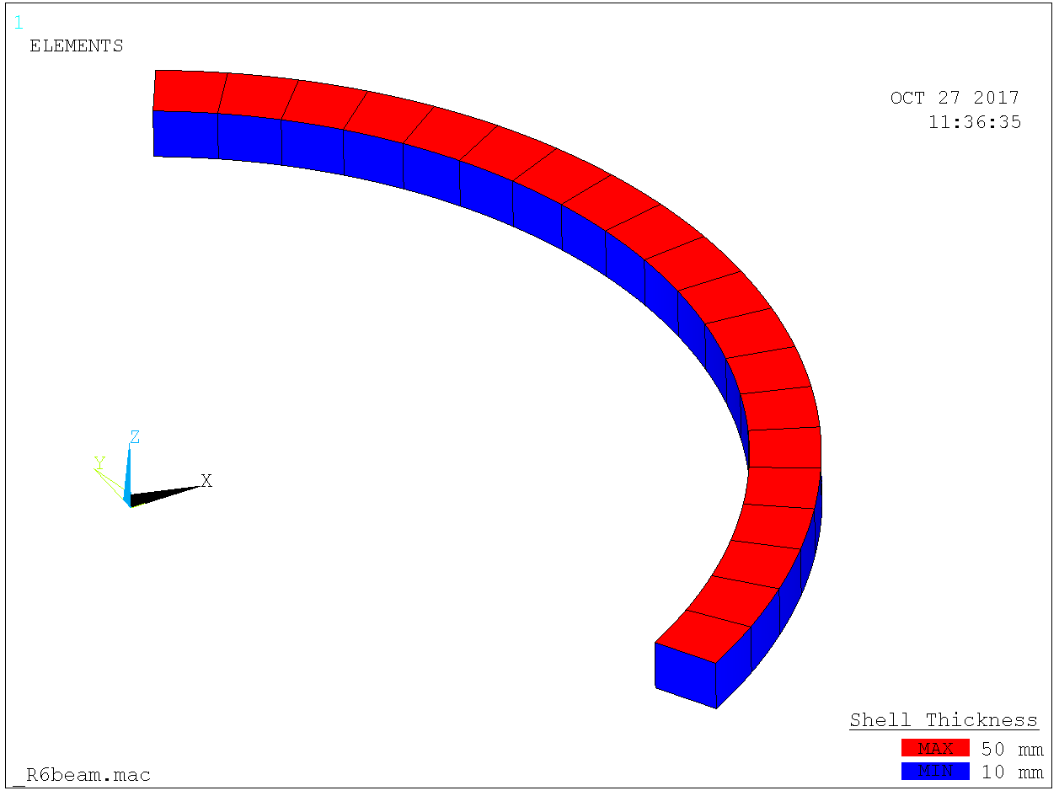

Figure 52. Model thicknesses.

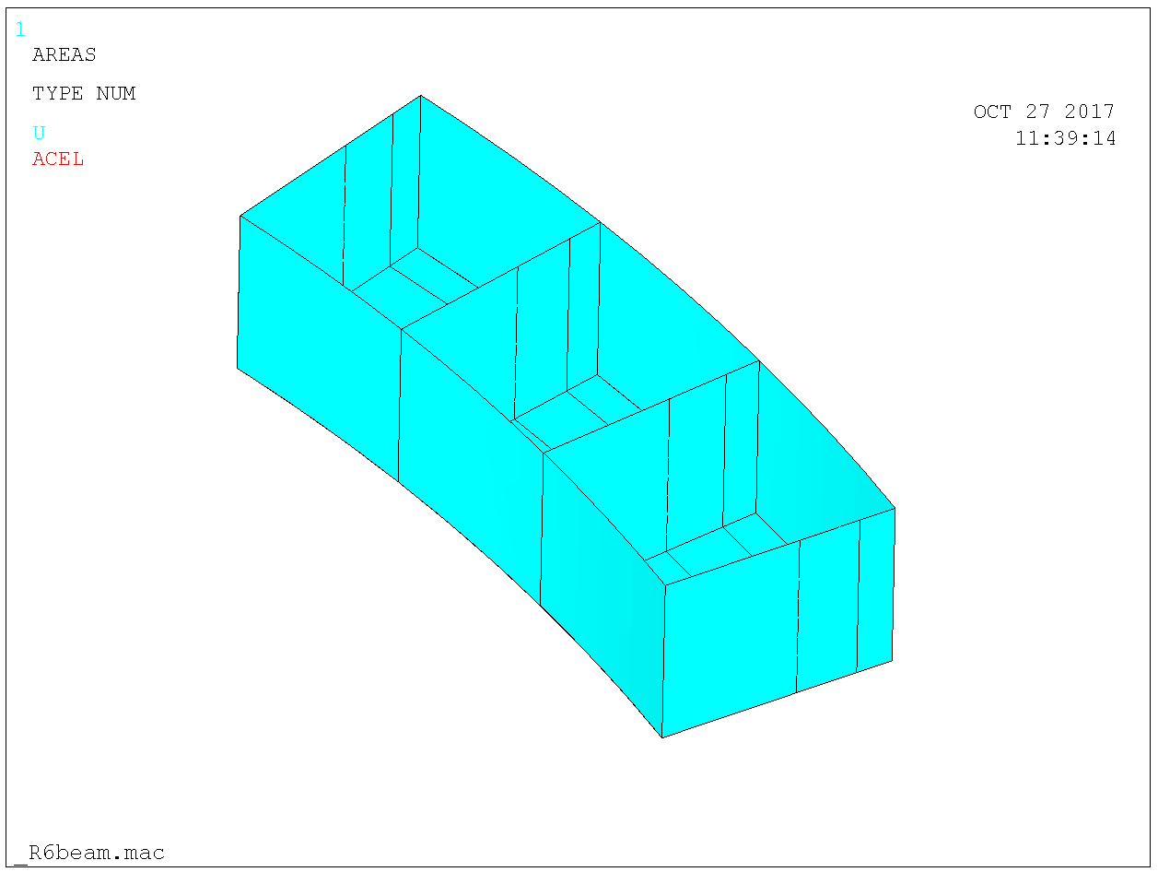

Figure 53. Close-up. Internal stiffeners at columns.

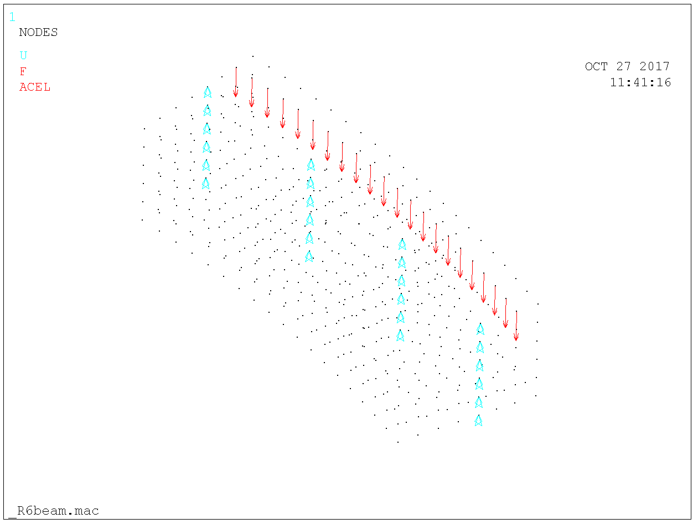

Figure 54. Vertical cansitaints at columns and line load with eccentricity 170 mm.

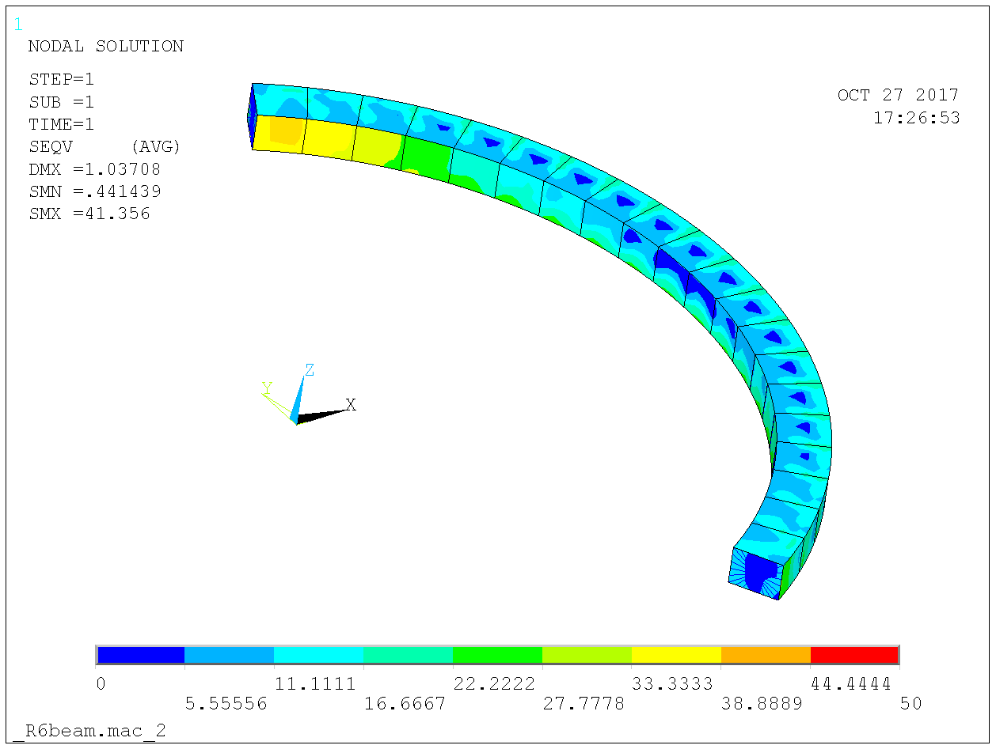

Figure 55. Resulting stresses are moderate, less than 50 MPa.

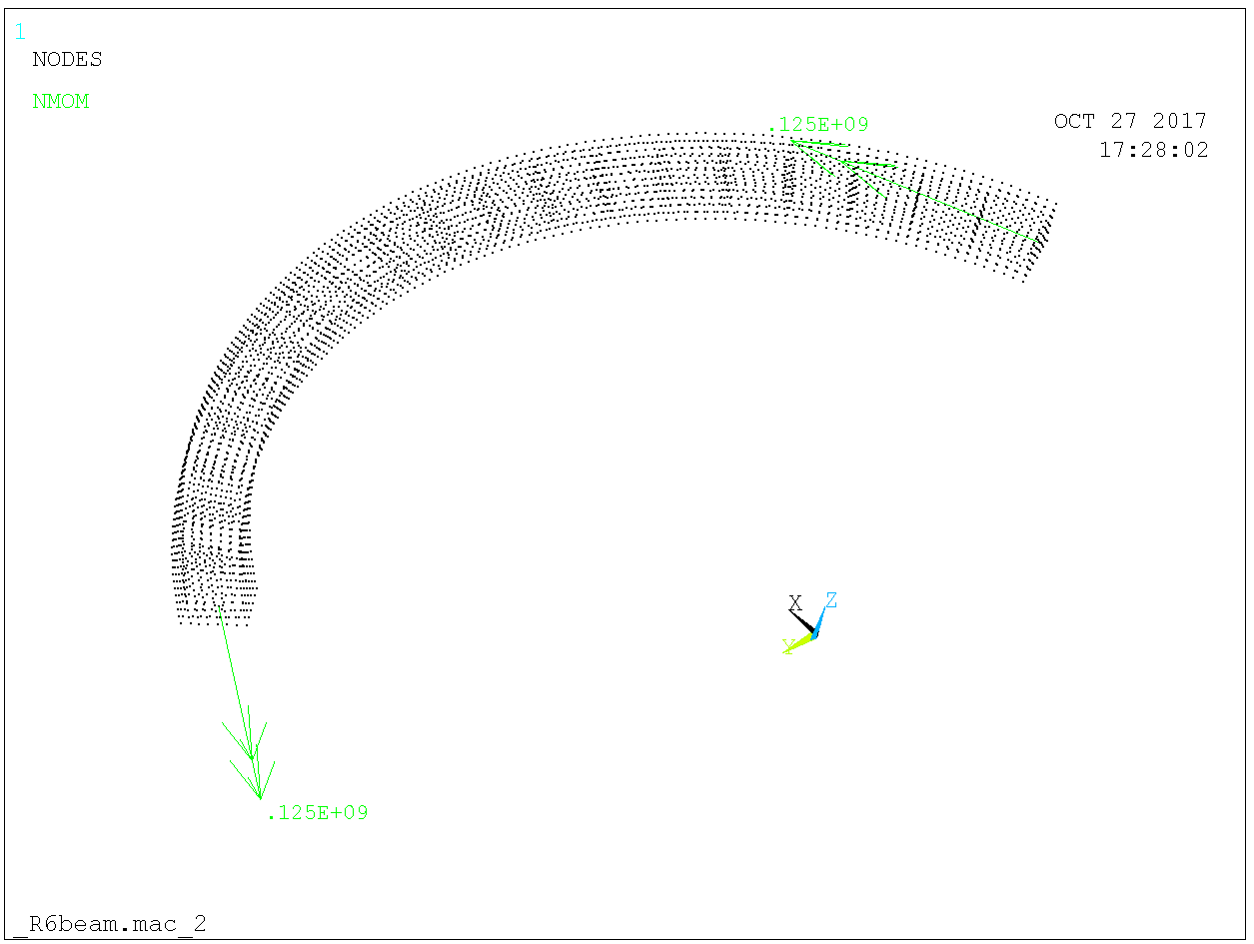

Figure 56. Reaction torque 1s25 kNm per side.

# Conclusions

The analysis demonstrates complience with code requirements on resistance.

# References

1. RCC-MRx.
2. Refernce to classification.
3. SS-EN 1990*. Eurocode – Basis of design*.
4. *Eurocode 3: Design of steel structures – Part 1.1: General rules and rules for buildings*. SS-EN 1993-1-1:2006.
5. *BSK 99*. *Boverkets Handbok om Stålkonstruktioner* (eng. Handbook on Steel Structures by The Swedish National Board of Housing, Building and Planning).
6. ESS-0084435 rev 4. *Mass distribution over pillars*.
7. *Design of fasteners for use in concrete – Part 4-1: General.* CEN/TS 1992-4-1.
8. *Design of fasteners for use in concrete – Part 4-2: Headed fasteners*. CEN/TS 1992-4-2.
9. *Eurocode 2: Design of concrete structures – Part 1-1: General rules and rules for buildings.* SS-EN 1992-1-1.
10. *Seismic analysis of D02 Bunker steel structure.* ESS-0XXXXXX.
11. *D01 & D03 need not stand for H4 Seismic.*

# Appendix 1 Nominal Column loads

Table 1. Column loads (tonnes) from bunker roof weight, NW sector.

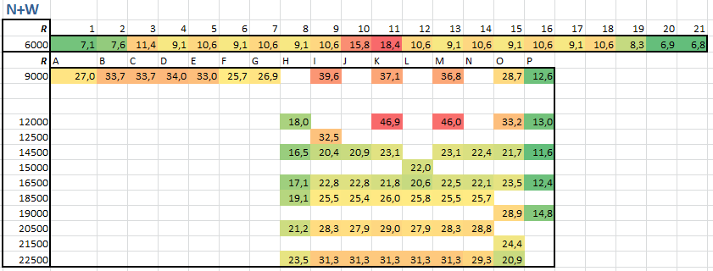

Table 2. Column loads (tonnes) from bunker roof weight, SE sector.

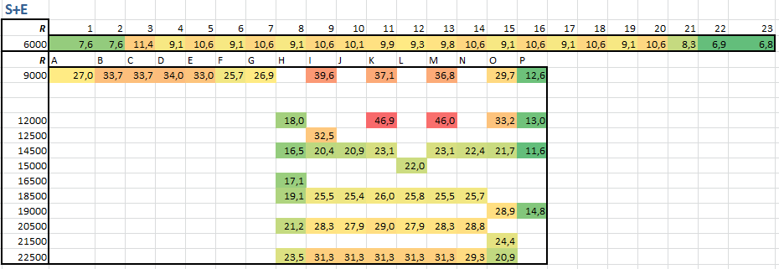

# Appendix 2 r6 beam dimensions and loads

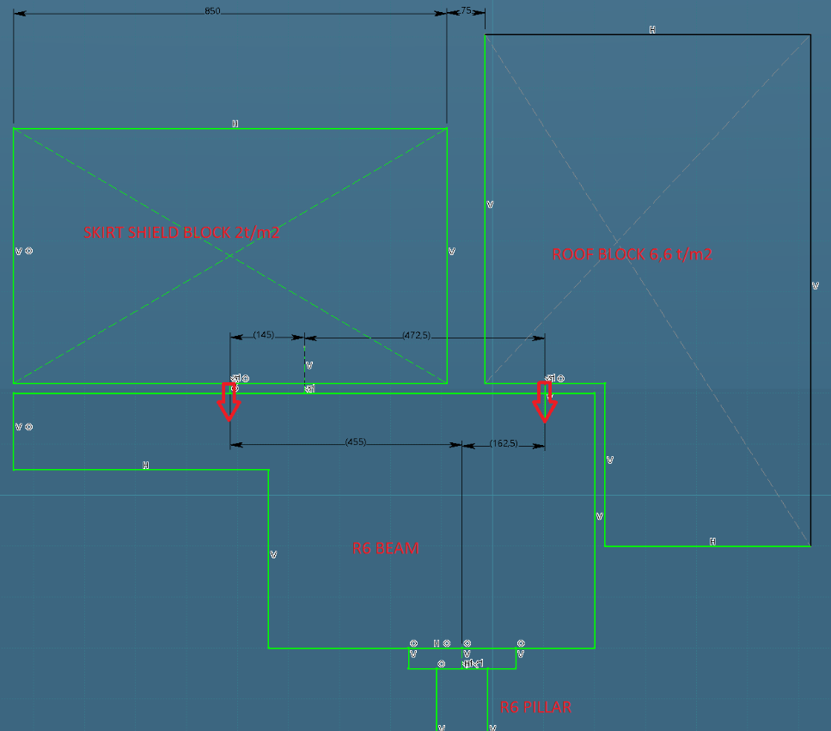

1. Possibly, D02 will have the same design as D01 & D03.