Seismic analysis of D02 bunker structure

Document Revision history
Revision | Reason for revision | Date
1 | New Document

List of Authors | List of Reviewers | List of Approvers
Möller, Mikael | Anders Olsson | Zvonko Lazic

Summary
Herein seismic analysis on the D02 bunker steel structures is reported.

Table of Contents
Summary 3
1. Introduction 5
2. Prerequisites 5
2.1. General 5
2.2. Loads 5
2.2.1. Vertical seismic 5
2.2.2. Horizontal seismic 6
3. Horizontal seismic 9
References 13

Introduction
Herein seismic analysis on the D02 bunker steel structures is reported.

Prerequisites

General
The bunker steel structure has several design drivers such as lack of space, seismic loading, removability of structural elements during maintenance and so forth.
The requirement for lateral bracing during a seismic event was initially met by the introduction of radial struts from roof at R9 to floor at approx R10 in combination with a circumferential beam at R9, connecting to the diagonal walls at both ends. This structural solution was however highly unwanted due to space requirements.
For that reason, a system by which the steel shielding blocks are horizontally connected to the R6 and R9 circumferential beams was opted for. The shear connections creates a diaphragm system between R6 and R9, transferring lateral seismic loads to the R6 and R9 circumferential beams connection points to the diagonal walls.

Loads
The current dead weight of the bunker roof is 6.6 ton/m².
The seismic loading consists of lateral vibrations and vertical vibrations. The lateral vibrations are resisted by the horizontal diaphragm system and give no column loads. The horizontal seismic is analysed using response spectrum analysis with response spectra as given in [1]. The column load from vertical seismic are extracted explicitly from the dynamic analysis in [1] and are given in terms of ratio between seismic load and static load.

Vertical seismic
As for vertical seismic loads, there were early indications of very high vertical accelerations of the bunker roof. Following a series of progressive improvements of the dynamic analysis model, [1], and elaborating with column stiffnesses, the vertical loading has been brought down to ± 1g.
This is essential since it eliminates the need of vertical strap-down of the shielding blocks which would be excessively inconvenient during maintenance. It does however put some restrictions on the column cross-sectional areas as these need be kept small enough to bring the seismic accelerations down. The column cross-sections cannot go beyond VKR 100 x 100 x 8 in R6, 200 x 200 x 8 in R9 and 200 x 200 x 10 elsewhere. As for the R9 columns, this means use of steel grade S690.

Horizontal seismic
Horizontal seismic loads are given in terms of response spectra according to Figure 1 - Figure 5 below. The envelope of the four anchoring points is used for analysis. Due to the high damping in the layers of shielding blocks during horizontal vibrations, the 7 % damping values are used.

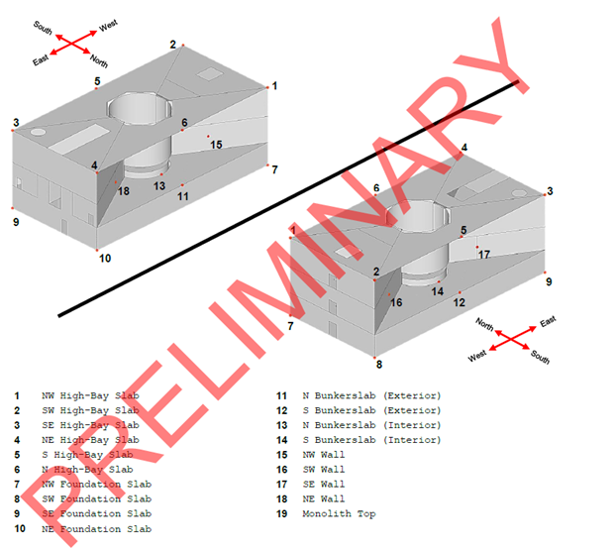
Figure 1. Points for extraction of response spectra. East-West is direction 1.

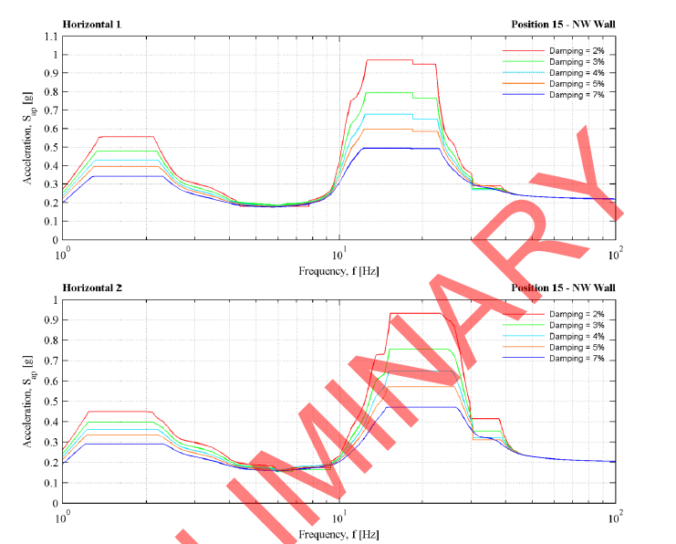
Figure 2. Horizontal spectra position 15.
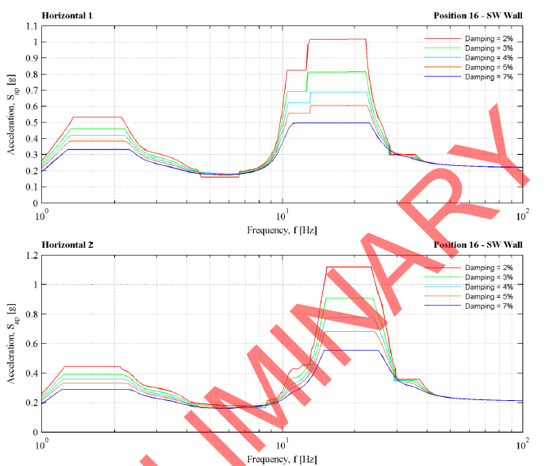
Figure 3. Horizontal spectra position 16.

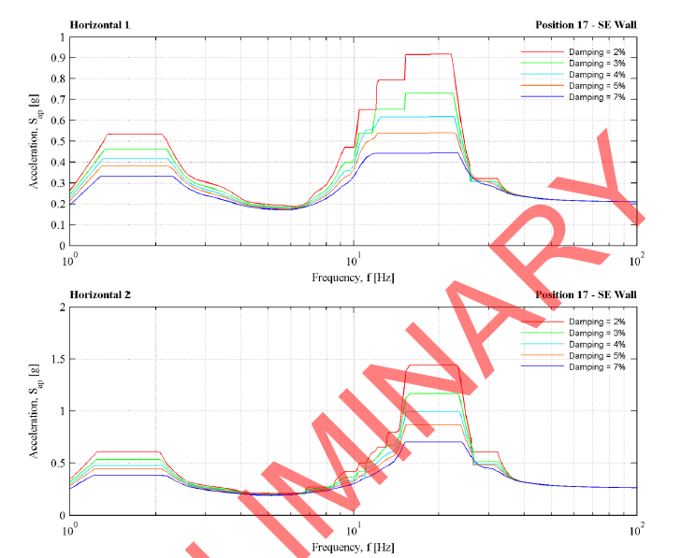
Figure 4. Horizontal spectra position 17.
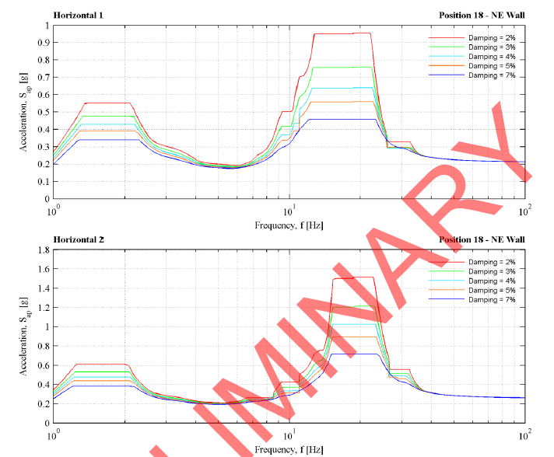
Figure 5. Horizontal spectra position 18.

Analysis of Horizontal seismic
The horizontal seismic is analysed by means of response spectrum analysis. The analysis model is shown in Figure 6. The steel layer of the shielding blocks are horizontally connected to the R6 and R9 circumferential beams via shear connectors which generates diaphragm action, providing horizontal stability.
The first three eigenmodes are shown in Figure 7 – Figure 9. The resulting stresses in the structure are shown in Figure 10. As seen, the overall stresses are moderate.
Simultaneously to the beam stresses from seismic are the beam stresses from shielding. However, at earthquake the load factor is and the 50% extra load due to stacking is not present. This reduces the bending from shielding which is sufficient by far to accommodate the extra stresses from horizontal seismic.
The reactions to the diagonal wall connections are maximum 1360 kN in the circumferential direction and 640 kN in the radial direction for R6 and 720 kN in the circumferential direction and 620 kN in the radial direction for R9 according to Figure 11. The remaining connections are subjected to much smaller loads.
The R6 connection is addressed in [2]. At R6 the shear connection is subjected to shear load
kN.
Shear connectors 2 M36 12.9 bolts resist
kN
in which the factor 1.2 is resistance factor for tensile strength.
Shear force in shear connectors between steel shielding block and R6 & &9 beam is
kN
according Figure 12. Shear resistance of a D=50 mm 8.8 pin is
kN

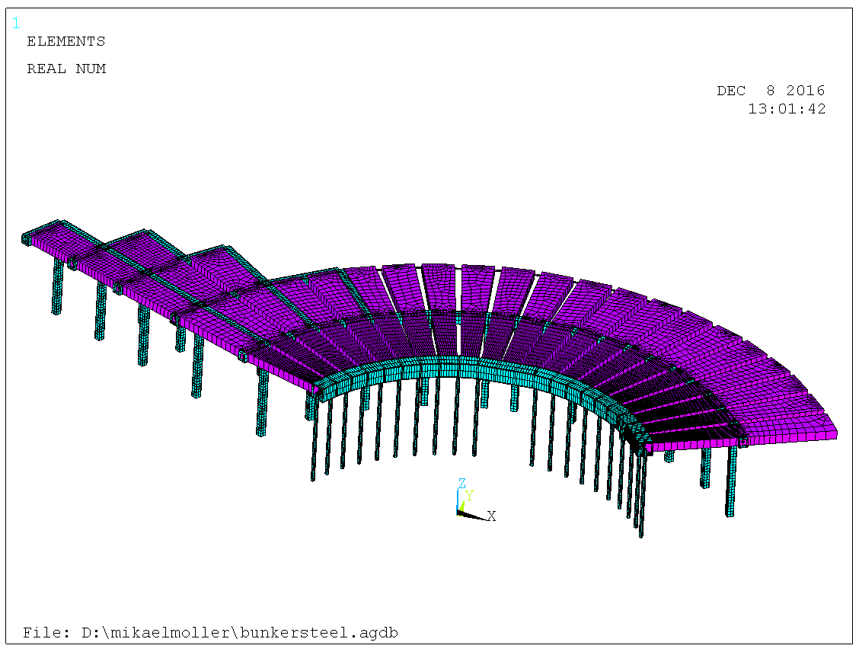
Figure 6. Model for seismic analysis. Steel plate 0.3 m with adjusted density so as to generate 6.6 ton/m².

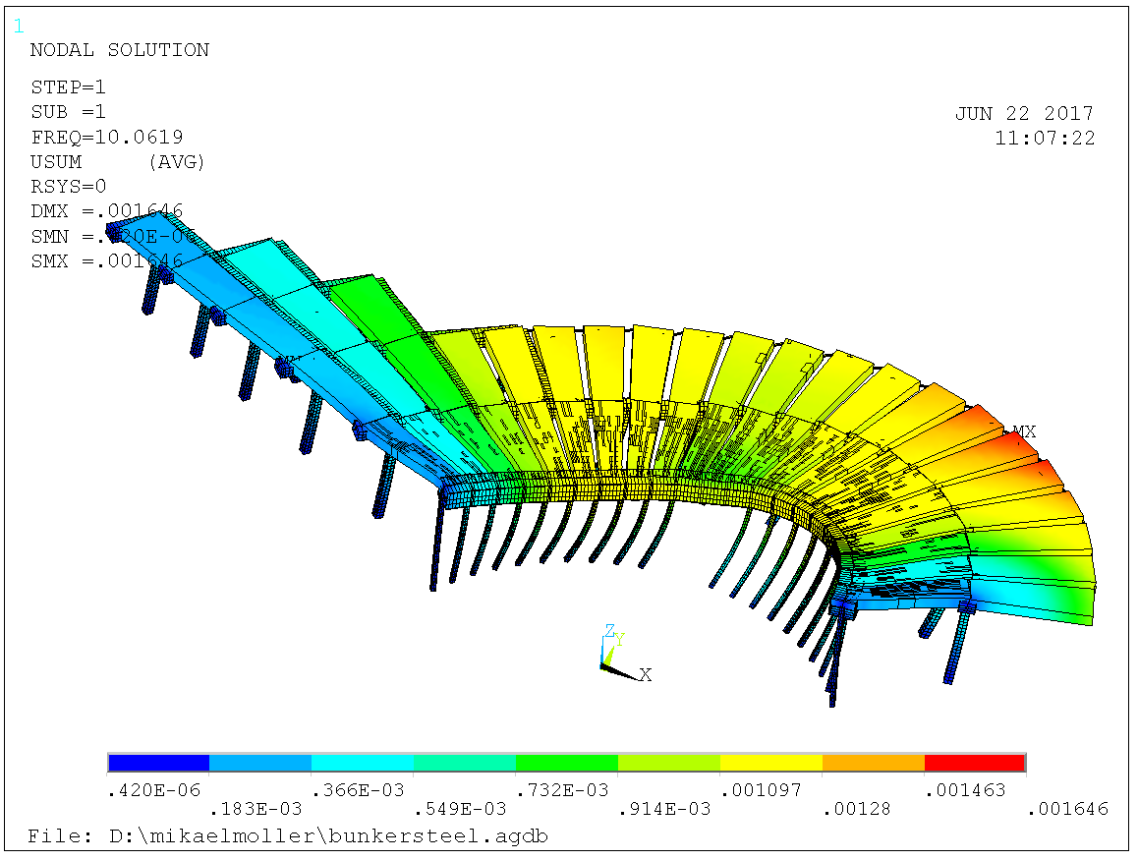
Figure 7. First eigenmode at 10 Hz.

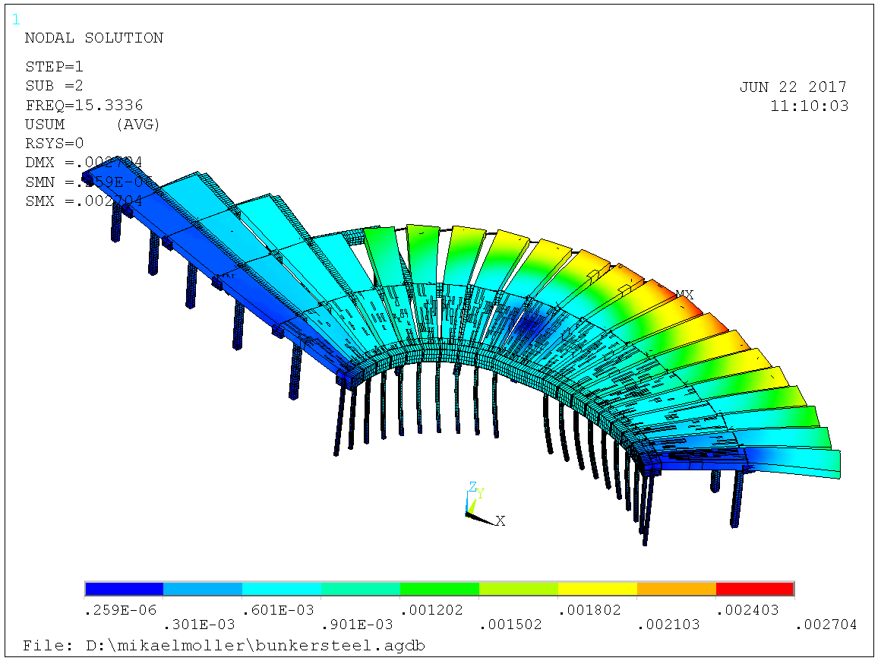
Figure 8. Second eigenmode at 15 Hz.

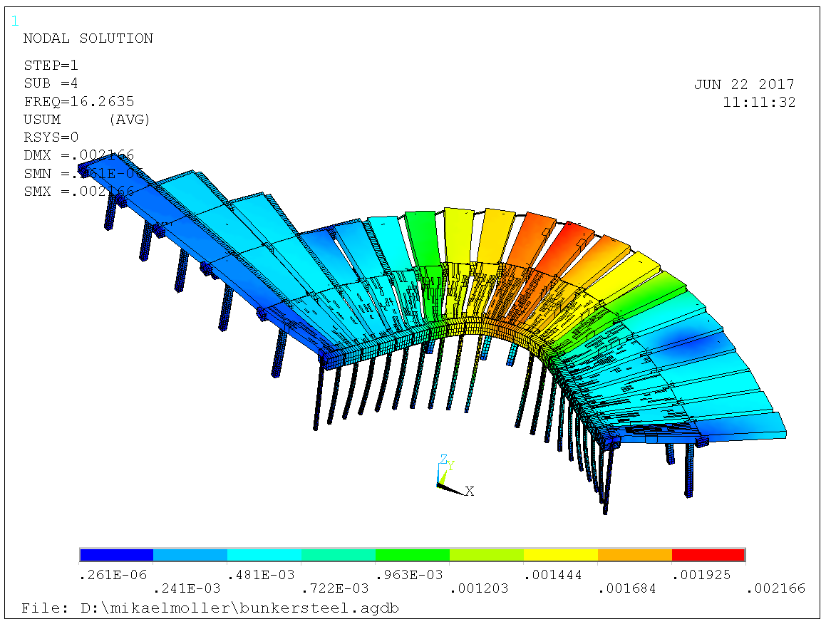
Figure 9. Third eigenmode at 16 Hz.

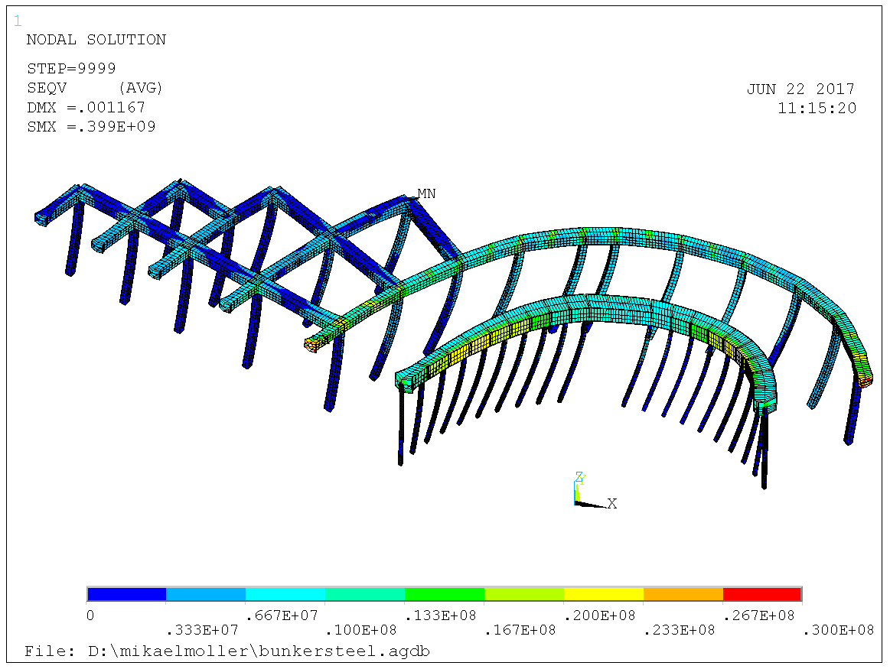
Figure 10. Moderate stresses in the structure, contour scale limit 30 MPa.

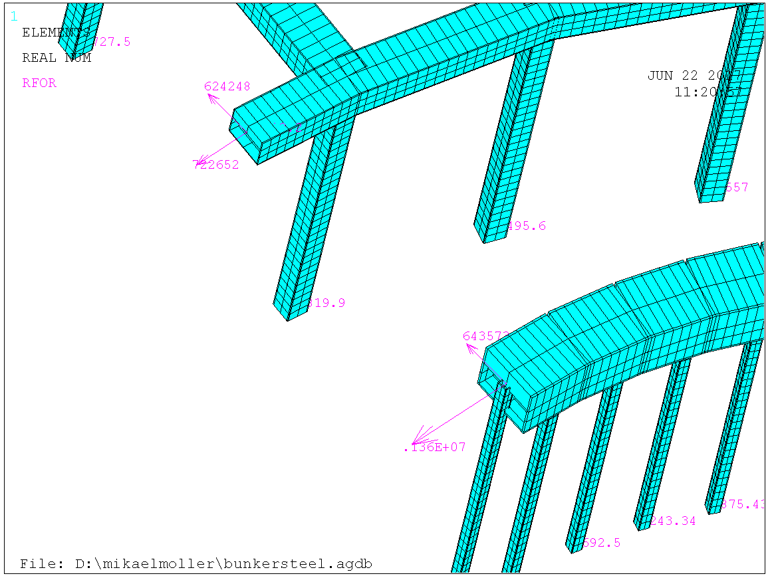
Figure 11. Rection forces at diagonal walls in maximum 1360 kN circumferential and 640 kN radial in R6 and & 720 and 620 kN in R9, respectively.

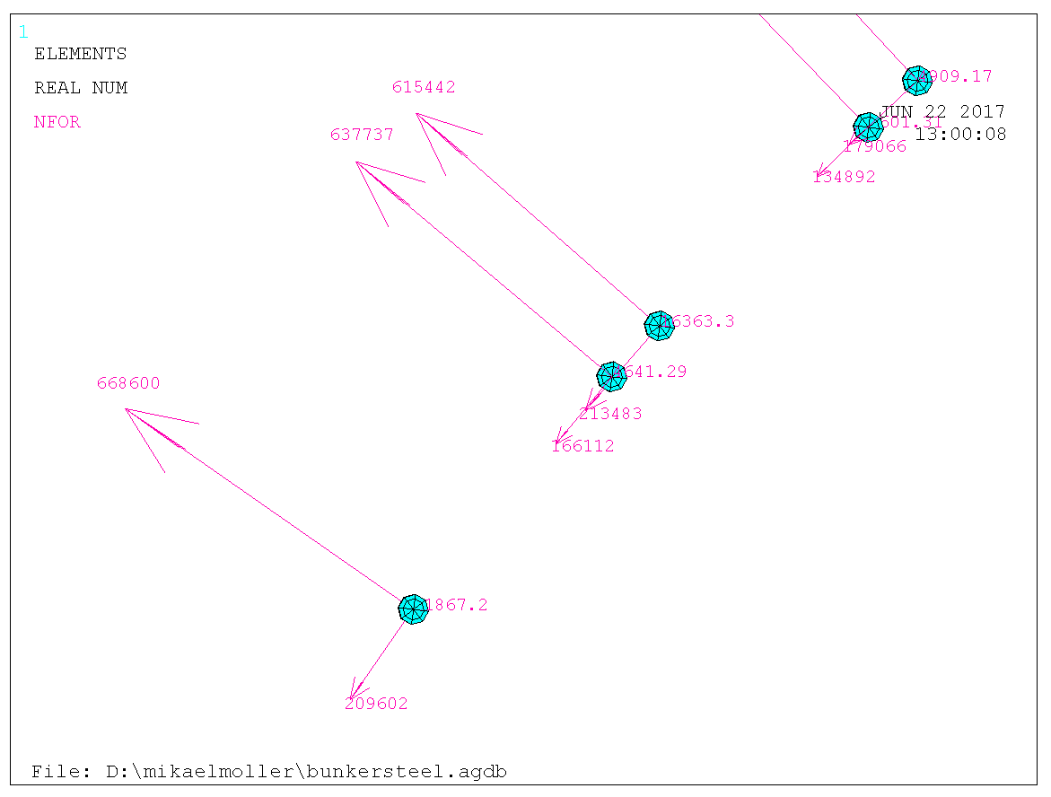
Figure 12. Shear force in shear connectors between steel shielding and R6 & R9 beams approx 700 kN.

References
- ESS- Monolith Civil Structure (MCS) Seismic In-Structure Response Spectra (ISRS). Scanscot preliminary report 13416/R-10.
- Calculation report R6 beam. ESS report ESS-0191677.

Sweco mitigated these reactions by subseqent analysis of their own, to maximum 900 kN in the circumferential direction. Sweco designs the concrete anchoring.

