Activation Study of Various Alloys in the Beam Extraction Area

 | Name | Role/Title
Owner | P. Bentley | Group Leader – Neutron Optics and Shielding Group
Reviewer | D. Ene | Researcher – Radiation Protection Group
Approver | O. Kirstein | Division Head – Instrument Technologies
Distribution list

Table of content | Page
1. Executive Summary 4
2. Purpose 4
3. Scope 5
4. Contributors 5
5. Currently Forbidden Materials 5
6. Method 7
7. Contact Dose Rate Requirements 8
8. Results 9
8.1. Overview of Material Types 9
8.2. Allowed Aluminium Alloys 10
8.3. Allowed Copper Alloys 11
8.4. Allowed Steels 12
8.4.1. Allowed Mild Steels 12
8.4.2. Allowed Low cobalt stainless steels 12
8.5. Allowed Antimony-Free Lead Alloys 13
9. Material Definition Files 13
9.1. acx490.mat 13
9.2. aisi1005.mat 14
9.3. al5083.mat 14
9.4. al5754.mat 15
9.5. al6061.mat 15
9.6. al6065t6.mat 16
9.7. al6082.mat 16
9.8. al7075.mat 17
9.9. alMgSiCu.mat 17
9.10. borofloat.mat 18
9.11. c87500.mat 18
9.12. c87600.mat 18
9.13. c91300.mat 19
9.14. c95300.mat 19
9.15. isisMildSteel.mat 20
9.16. naFloat.mat 20
9.17. nbk7.mat 21
9.18. onozukaE.mat 22
9.19. pb50006.mat 22
9.20. pb50021.mat 23
9.21. pb51121.mat 24
9.22. ss304l.mat 24
9.23. ss316l.mat 25
9.24. zircaloy4.mat 25
10. Activation Tables After 30 Day Cooldown 25
10.1. ACX-490 25
10.2. AISI-1005 26
10.3. Al-5083 26
10.4. Al-5754 26
10.5. Al-6061 26
10.6. Al-6065-T6 27
10.7. Al-6082 27
10.8. Al-7075 27
10.9. Al 28
10.10. AlMgSiCu 28
10.11. Borofloat 28
10.12. C87500 28
10.13. C87600 29
10.14. C91300 29
10.15. C95300 29
10.16. Cu 29
10.17. Fe 30
10.18. Mild-steel 30
10.19. Na-Float 30
10.20. NBK-7 30
10.21. Onozuka-E 31
10.22. L-50006 31
10.23. L-50021 31
10.24. L-51121 31
10.25. SS-304L 32
10.26. SS-316L 32
10.27. W 32
10.28. Zircaloy4 33
11. References 33
12. Glossary 33
Document Revision history 33

Executive Summary
A variety number of different alloys are studied to evaluate contact dose rates as a function of time close to the neutron beams. Based on these inputs, a list of allowed materials and a list of forbidden materials are presented meeting ALARA dose rate objectives for different maintenance schemes.

Purpose
This document is a list of materials that are considered to be allowed for use. This is a standard issued by NOSG that restricts the materials that can be used in areas experiencing high neutron fluxes, particularly in the bunker area, but more generally along the beam axes, in order to meet access requirements for maintenance, and to adhere to the ALARA principle (“As Low As Reasonably Achievable”).

Scope
This document is intended to apply to any material within 1 metre of a high flux region, which mostly will apply to the beam axis, but could apply to other regions depending on scattered beams etc. Ongoing neutronics studies, particularly of the bunker, will guide this development as the project matures. The beam spectrum changes significantly after you lose line of sight of the target, and leave the bunker. For this reason, this page will result in two documents, one for the bunker area, and one for cold/thermal beams outside line of sight. The grey area of straight beams outside the bunker will require subsequent effort.

Contributors
- Gabor Laszlo
- Zvonko Lazic
- Iain Sutton
- Gunter Muhrer
- Douglas Di Julio
- Stuart Ansell
- Valentina Santoro
- Ida Bergstrom
- Lena Johansson
- Per Persson
- Tsitohaina Randriamalala
- Nikolaos Tsapatsaris

Currently Forbidden Materials
Tungsten
Allowed only in T0 chopper hammer.
Europium
PPB levels in sand and aggregates in concrete may be unacceptable, and these isomer processes (long lived excited states) appear to be not fully modelled in some of the physics software.
Antimony
Standard alloying ingredient in lead and some bronzes. Antimony-free lead must be ordered specially, but other impurities are problematic at very low levels (Silver, gold later in this table).
Cobalt
Impurity in nickel, finds its way into Ni-based stainless steels and other Ni components, making many stainless steels a waste issue. Some high-energy channels produce Co-60 (via e.g. $(n,α)$ reaction in copper) but this can be acceptably low for hands-on maintenance (see copper below).
Uranium
Depleted uranium shielding has been used as “free” high performance fast neutron shielding at some accelerator facilities, but it breeds Pu amongst other problematic elements.
Inconel
NiCr alloy typically used in aerospace, and consequently choppers. It can only be used in chopper hammers and nowhere else.
Zinc
Zinc activates fairly strongly in brasses (Zn-65, 100s $μ Sv/h$ contact dose), and when used as plating in mild steel it forms oxides as fine white powder. Even though Ni may contain a little Co impurity, all plating on mild steel near the neutron beams needs to be Ni.
Silver
Impurity in lead and other heavy metals, Ag-110 is a problem above 0.02% by mass in lead.
Gold
Impurity in lead and other heavy metals, 0.01% by mass is borderline.
Tin
Ingredient in bronzes (where shielding from other materials seem to reduce the activation significantly) but also zircaloy4, which creates a long term issue in the form of Sb-125 (10 $μSv/h$ contact dose).
Hafnium
Generated in tungsten.
Iridium
Sometimes used as a convenient soft metal seal.
Scandium
Tantalum
Generated in tungsten.
Terbium
Thorium
Strontium
Cesium

Method
The calculations were performed using PHITS v3.0 [1] to generate the spallation products, and the output from the resulting dchain tally was processed using dchain v2001 (part of the PHITS package) to yield the activation as a function of time.
In fig. 1, a geometry of the PHITS simulation is sketched, where the cell used for the activation calculations is labelled “106”.
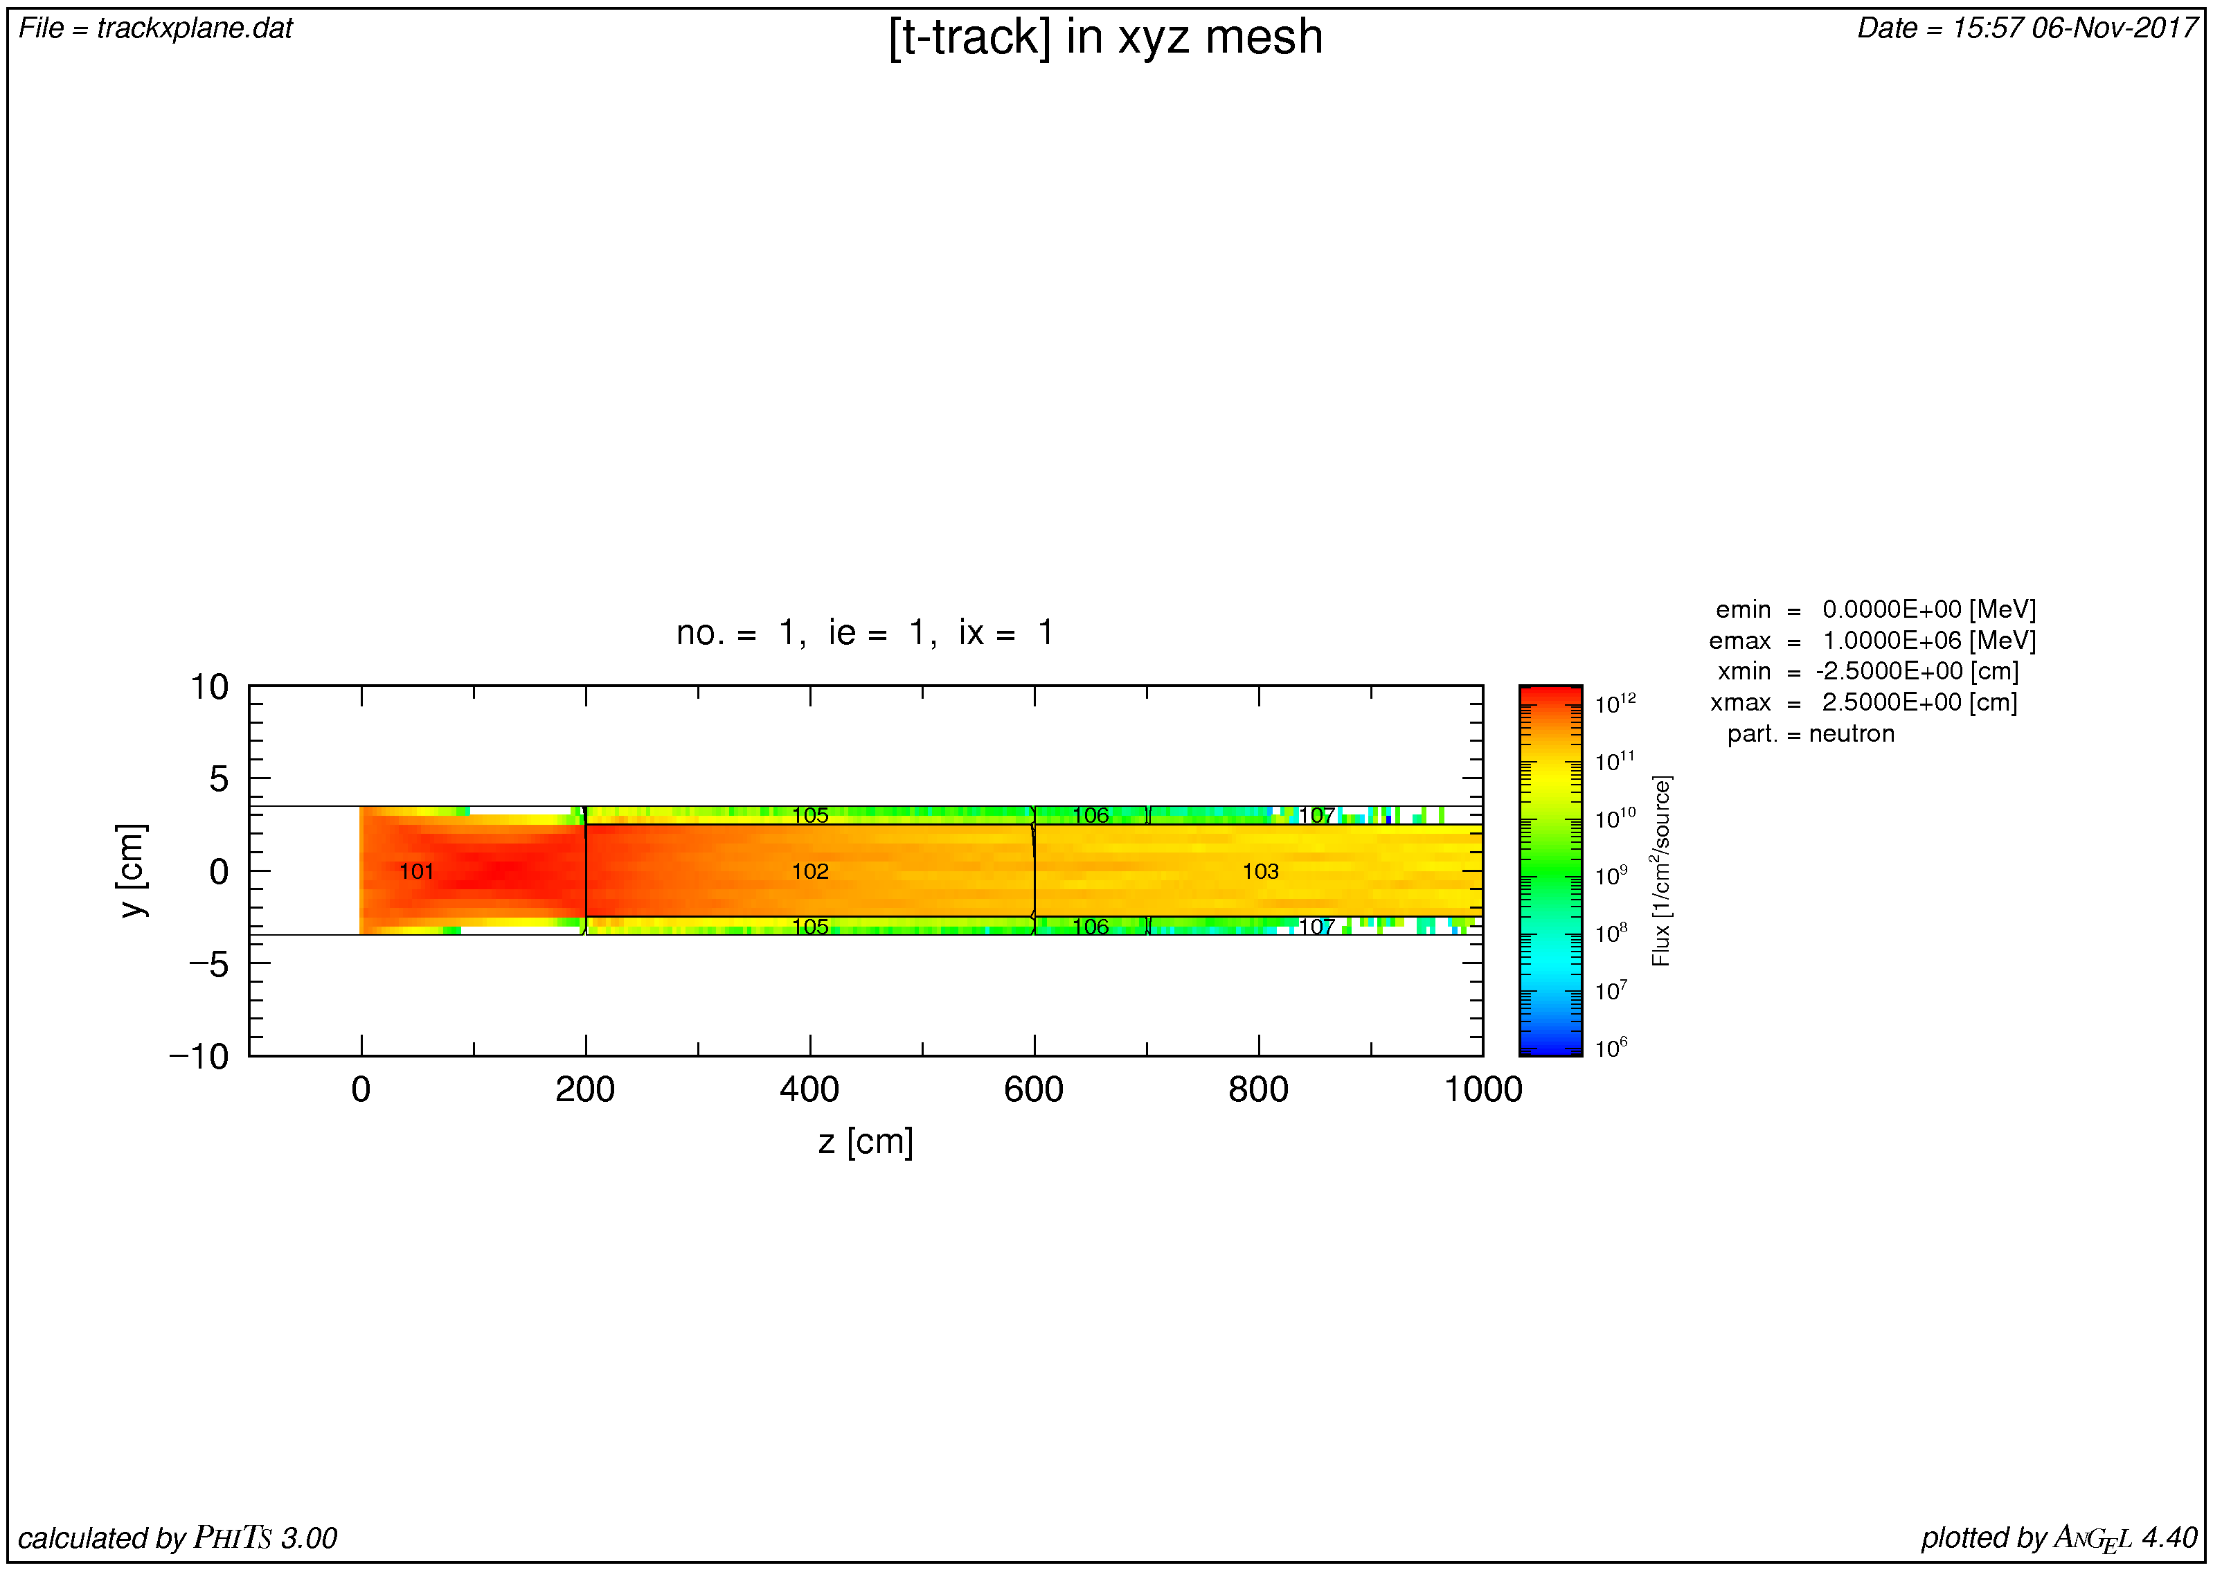
Figure 1: Geometry of the simulation, in this case AISI 1005 mild steel.
Supermirror physics is turned on, with an m-value of 3.0. The current NMX source term (from Valentina Santoro) was used as a source spectrum. 50,000 source trajectories were used, with duct-source variance reduction to illuminate uniformly between 2-8 m and dpf=1.0E-02. The results were benchmarked against similar calculations, performed independently by two people in the target division using MCNP and CINDER, and were in good agreement.
The time evolution of the contact dose was calculated by dchain version 2001, and integrated over a 20x20 cm² area. If there is a different integral standard at ESS this can be adjusted extremely quickly.
For the stainless steels, it was assumed that the total Co impurity of Ni was 0.2%, as described by Outokumpu as their nuclear-grade requirement.

Contact Dose Rate Requirements
If the dose rate is below 3 $μSv/h$, we assume that it is OK for hands-on maintenance.
If the dose rate is below 25 $μSv/h$, we assume that it meets the requirements for rad-workers to perform hands-on maintenance. The ALARA principle still needs to be used fully in the design process, so materials in this category need to be minimised in favour of those below the 3 $μSv/h$ category.
If the dose rate is above 25 $μSv/h$, we assume that the material is unacceptable.

Results

Overview of Material Types
In fig. 2, a representative selection of compliant alloys are shown. This figure should be used as a guide to the optimisation of the worker dose rate, in order to minimise it as much as possible. For example, for structural supports, vacuum housings, etc., there is an obvious benefit in all cases to use approved aluminium alloys wherever possible.
For shielding things become slightly more complex. For access after 3 days there is a clear advantage in the use of lead and copper instead of steel. On the other hand, a 1 day access is the opposite - lead and copper would actually increase the dose rate compared to steel. It is therefore imperative that realistic working plans are used for this optimisation. It is not acceptable to assume and design for a 1 day working access, when in reality the equipment cannot be disassembled faster than 4 days. To do so would permanently place the workers in a blue radiation zone instead of a green radiation zone. In the following sections, it is generally assumed that the longer shutdowns are more strongly weighted, since that is where worker dose would mostly accumulate.
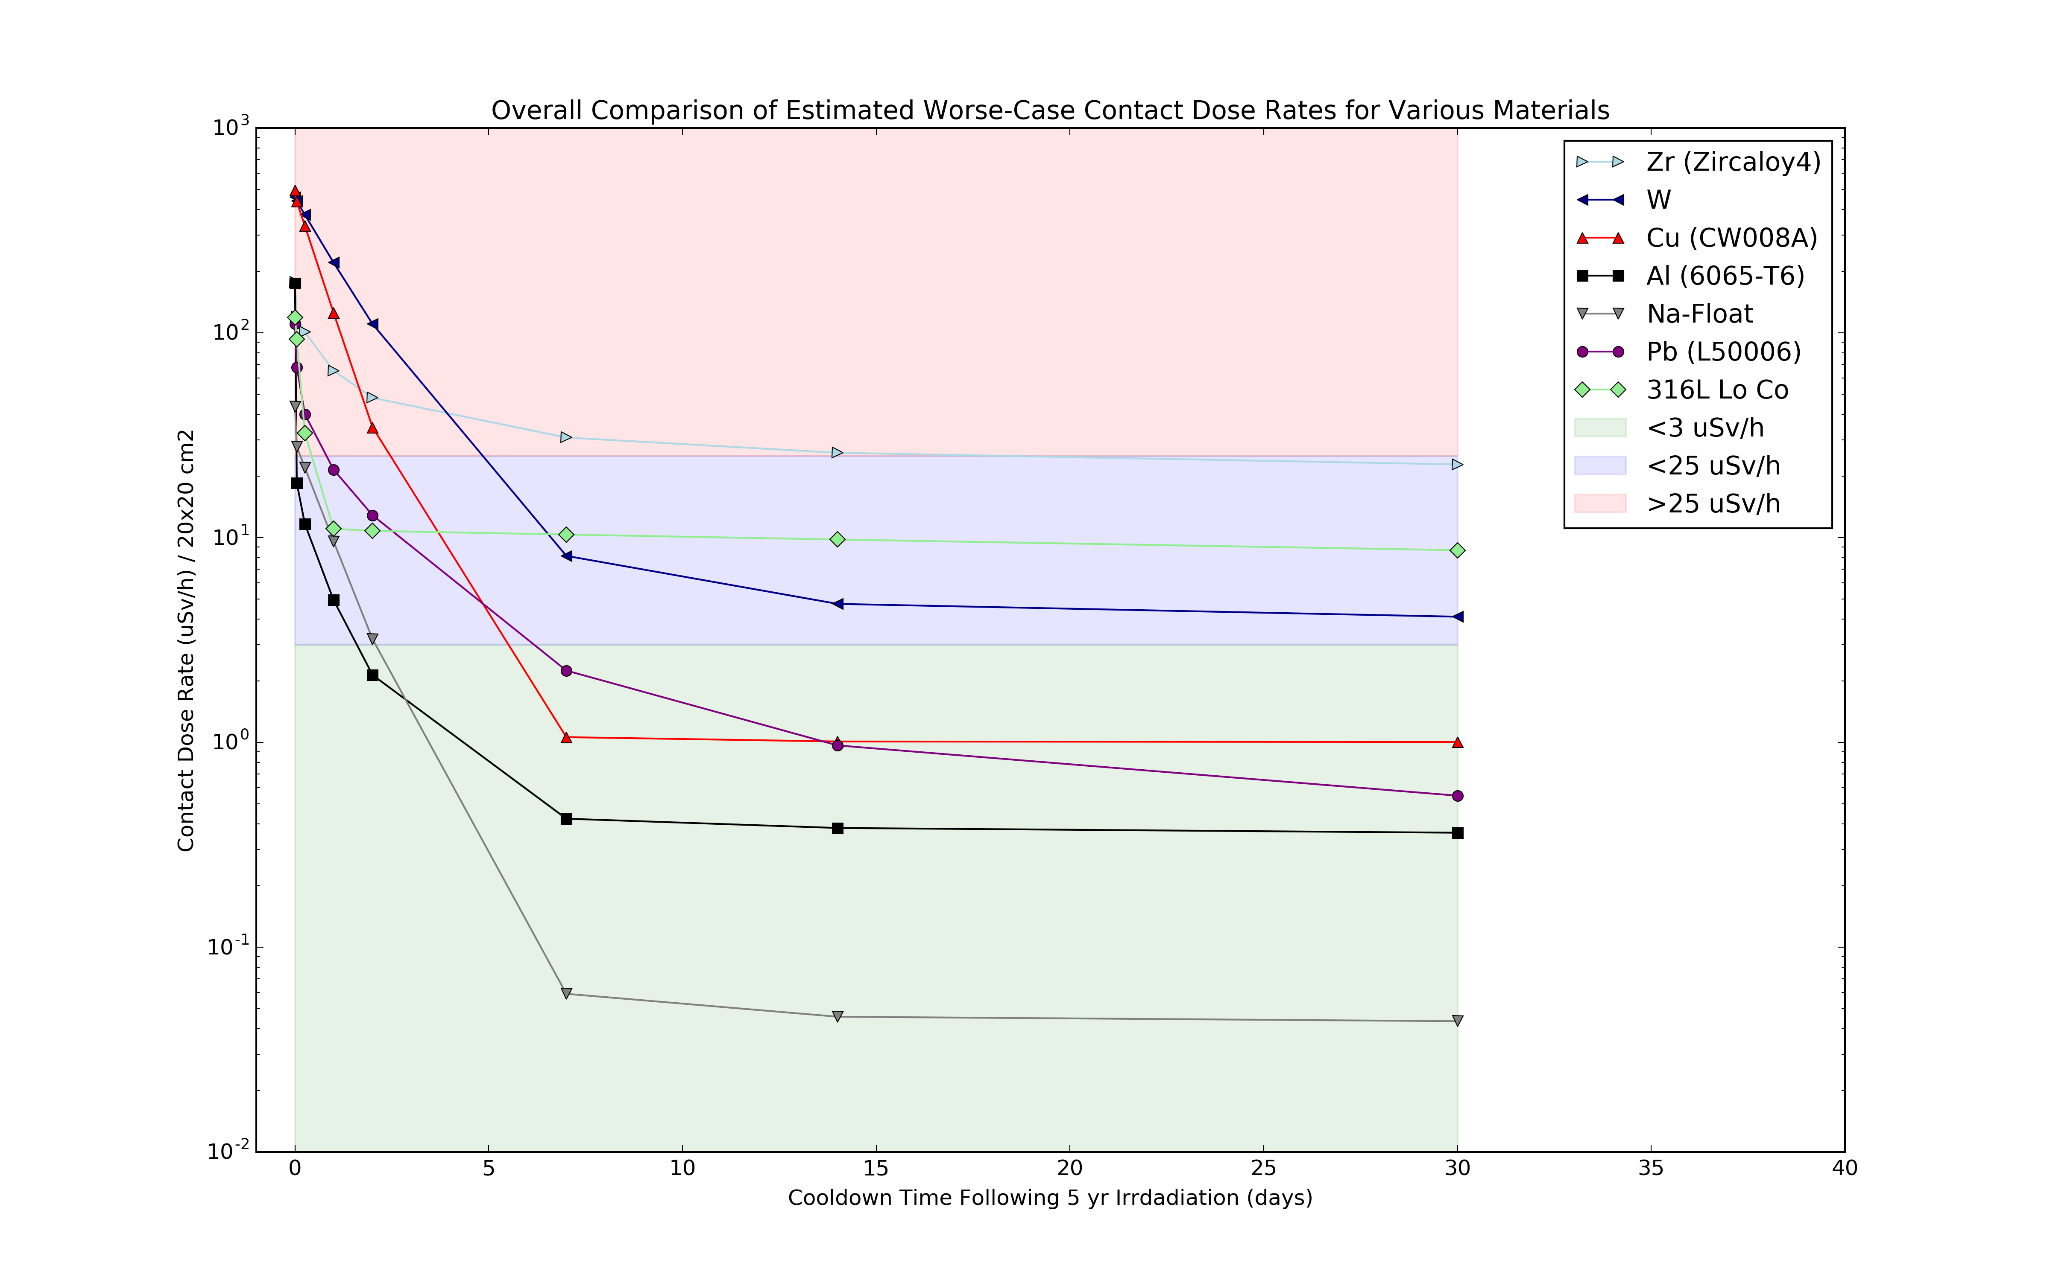
Figure 2: Simulated contact dose rates for various materials, as a material guide for worker dose minimisation in the bunker area.
In the following sections, we examine the types of alloy by category.

Allowed Aluminium Alloys
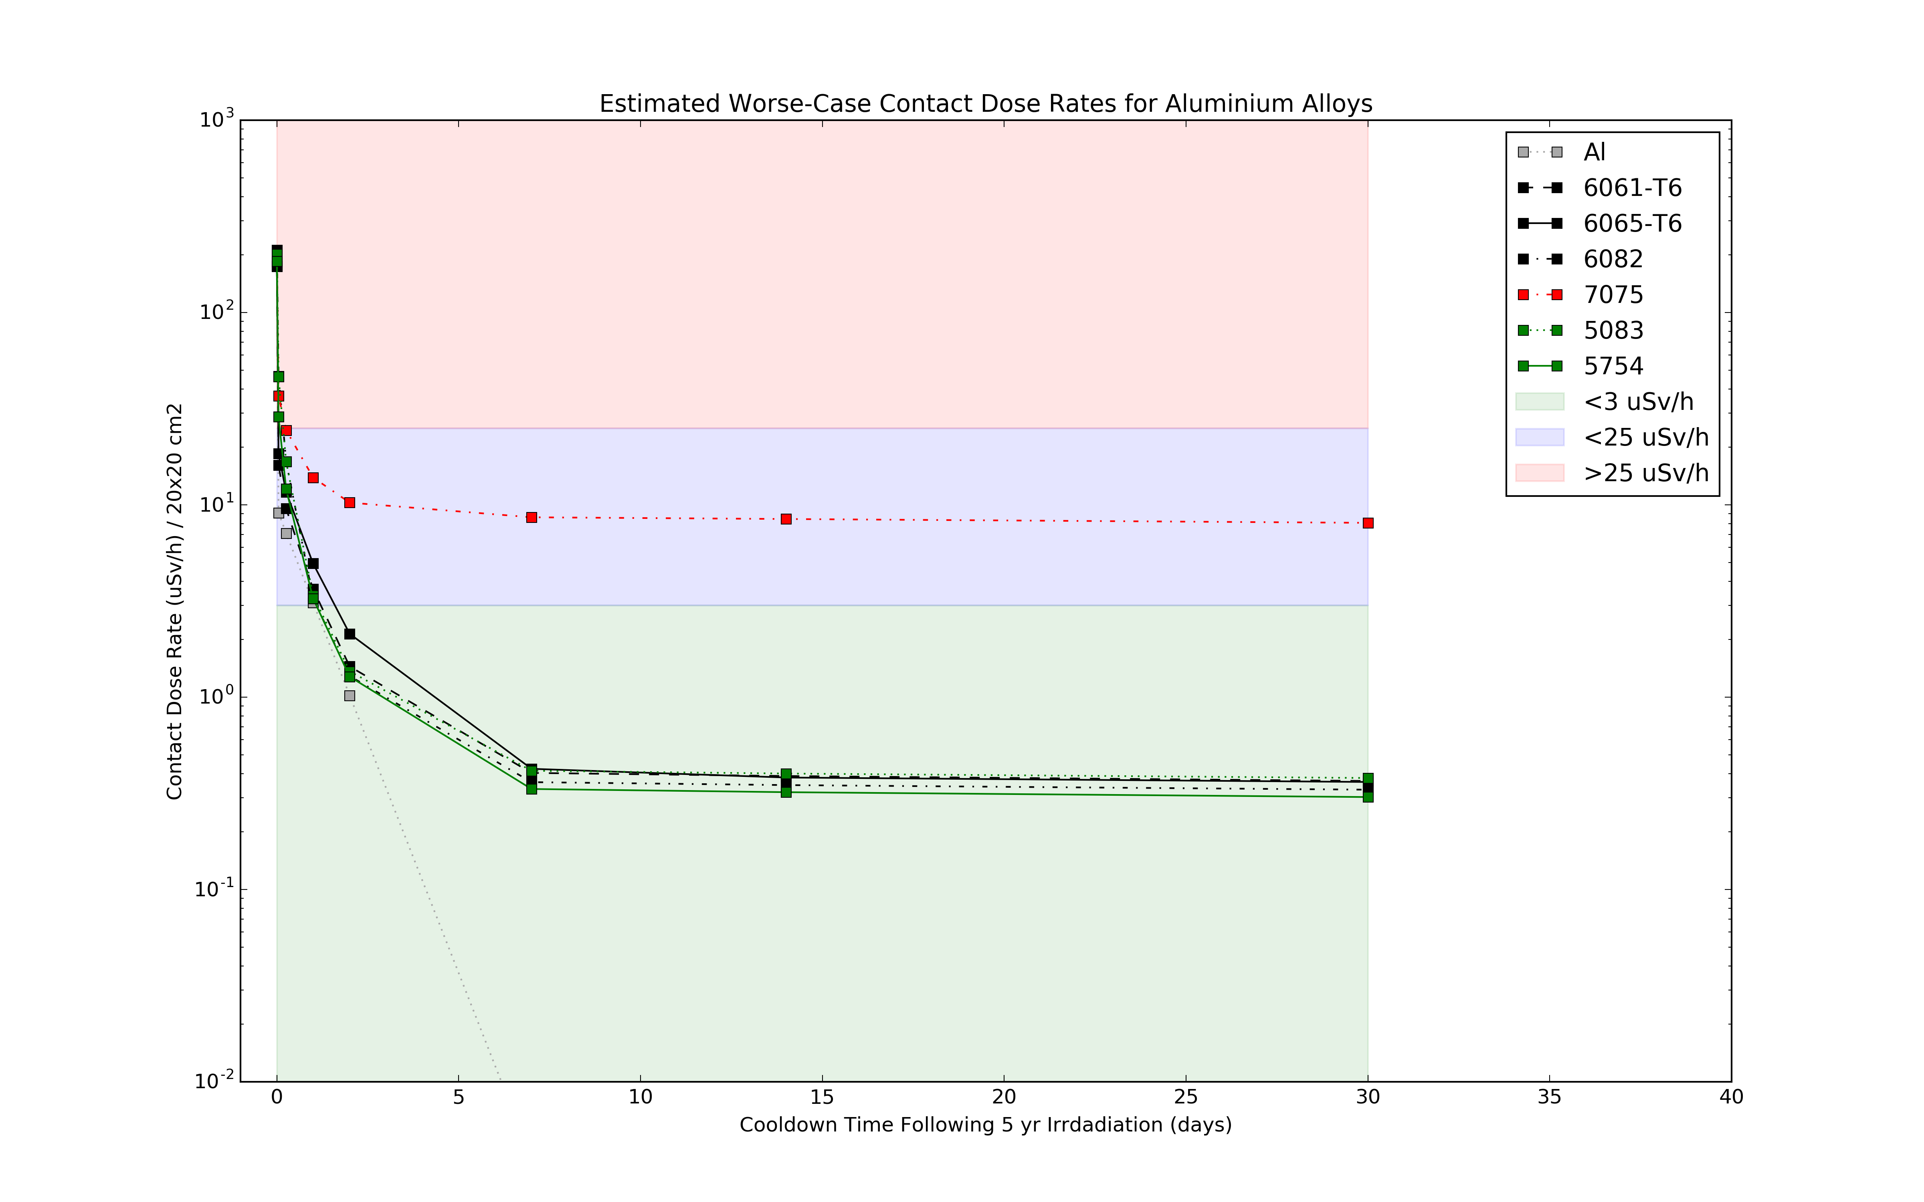
Figure 3: Simulated contact dose rates for different aluminium alloys in the bunker area.
Allowed materials providing hands-on maintenance after 1-2 days:
- 6061-T6
- 6065-T6
- EN AW 5083
- EN AW 5754
- EN AW 6082 (DIN AlMgSi1)

Allowed Copper Alloys
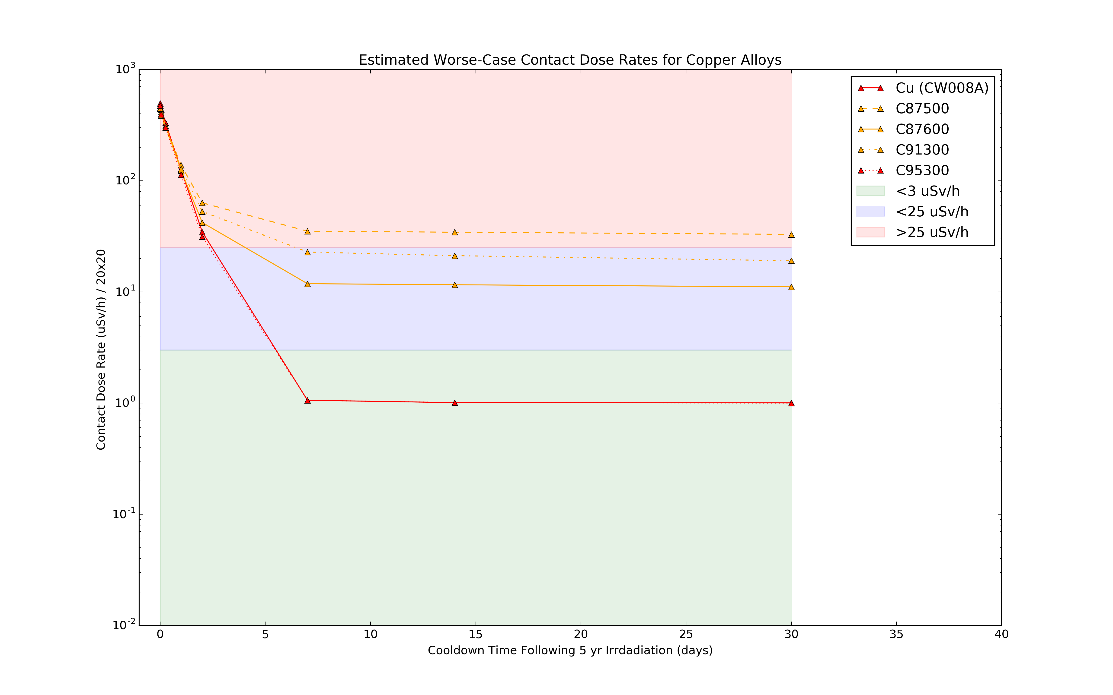
Figure 4: Simulated contact dose rates for different copper alloys in the bunker area.
Hands-on maintenance after >7 days. The residual activation after 1 month (contact dose is around 1 $μSv/h$ even at the monolith wall) is dominated by tiny amounts of Co-60, which are produced from copper via $(n,α)$ reactions.
Alloys must be antimony-free and low cobalt. Many bronzes have lead, antimony, or nickel with cobalt impurities. There is one currently allowed bronze that meets the requirements.
- CW008A or equivalent
- C95300 is almost identical to pure copper in terms of activation
CW008A can be used for guide substrates, but equally can be used in other high-flux regions (e.g. bunker) as shimming material with good cool-down properties (ALARA).

Allowed Steels
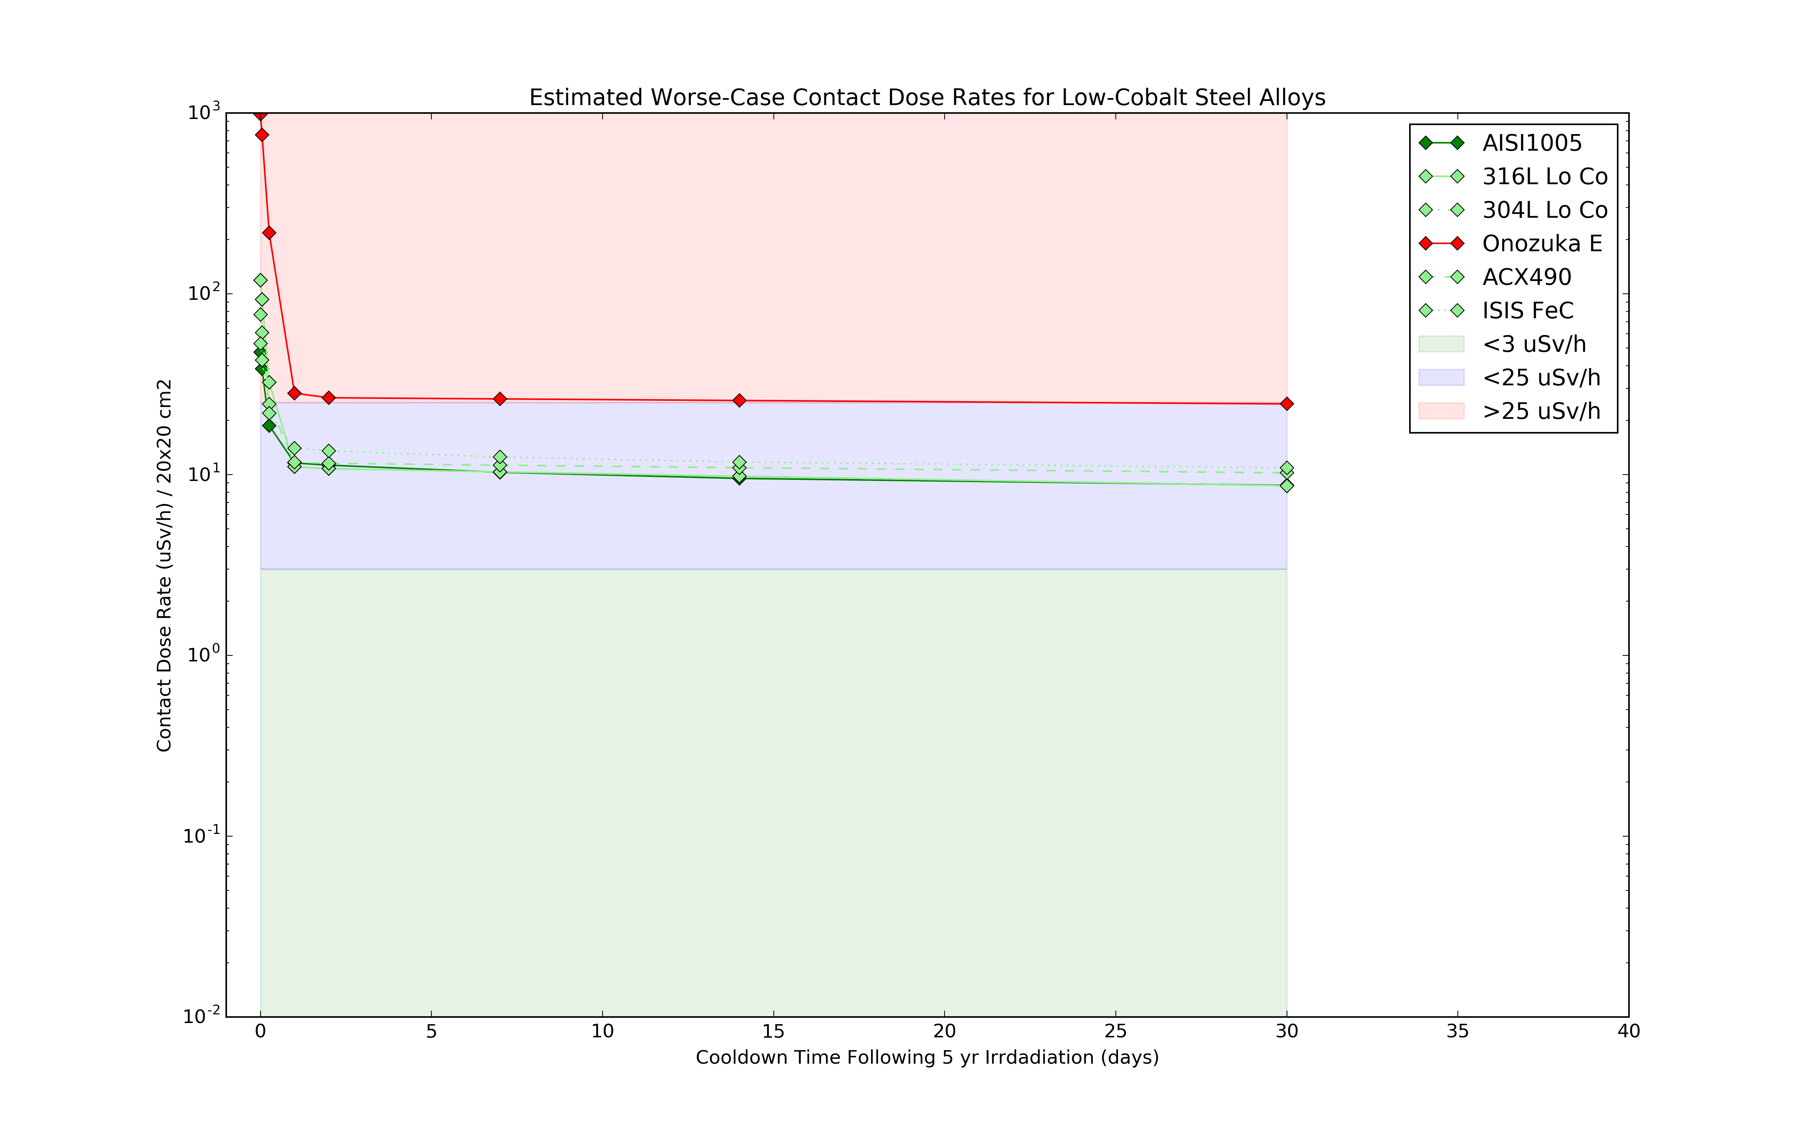
Figure 5: Simulated contact dose rates for different steel alloys in the bunker area.
Only use this where their use is essential, and cannot be fulfilled by approved aluminium, copper, or bronzes. All of these materials allow rad-worker maintenance only:

Allowed Mild Steels
- AISI 1005-1025
- EN10025 S275JR /1.0044
- ASTM A36
- EN 10025 S235JR /1.0037
- ASTM A570 Grade 33

Allowed Low cobalt stainless steels
- ACX490
- 304L low cobalt
- 316L low cobalt

Allowed Antimony-Free Lead Alloys
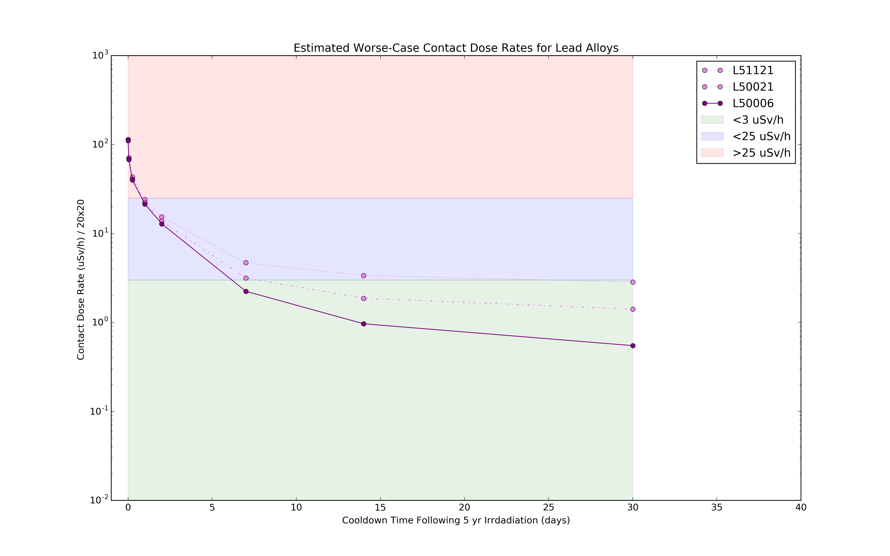
Figure 6: Simulated contact dose rates for different lead alloys in the bunker area.
Antimony and silver content will be measured as part of site acceptance testing. Bordeline cases (L51121 that needs 30 days cooldown) are to be avoided.
- L50006 - hands-on access after 1 week
- L50021 - hands-on access after 2 weeks

Material Definition Files
The materials definitions are based on the data in the following tables.
Raw PHITS input files are available on request and/or in NOSG repositories.
Note that due to a bug in PHITS v3.0, carbon is entered as C-12 rather than C.
This is not considered to be a significant problem, since the isotopes of carbon are not dominant contributors to contact dose compared to the other materials in the inventory.

acx490.mat
Table 1: Material definition of acx490.mat
Element | Weight %
Fe | 79.875
C12 | 0.04
Si | 1.0
Mn | 1.0
P | 0.04
S | 0.015
Cr | 18.0
N | 0.03

aisi1005.mat
Table 2: Material definition of aisi1005.mat
Element | Weight %
Fe | 99.5
C12 | 0.06
Mn | 0.35
P | 0.04
S | 0.05

al5083.mat
Table 3: Material definition of al5083.mat
Element | Weight %
Al | 92.55
Cr | 0.25
Cu | 0.1
Fe | 0.4
Mg | 4.9
Mn | 1.0
Si | 0.4
Ti | 0.15
Zn | 0.25

al5754.mat
Table 4: Material definition of al5754.mat
Element | Weight %
Al | 94.35
Cr | 0.3
Cu | 0.1
Fe | 0.4
Mg | 3.6
Mn | 0.5
Si | 0.4
Ti | 0.15
Zn | 0.2

al6061.mat
Table 5: Material definition of al6061.mat
Element | Weight %
Al | 96.15
Mg | 1.2
Ti | 0.15
Si | 0.8
Fe | 0.7
Cu | 0.4
Cr | 0.35
Zn | 0.25
Mn | 0.15

al6065t6.mat
Table 6: Material definition of al6065t6.mat
Element | Weight %
Al | 94.7
Bi | 1.5
Mg | 1.2
Ti | 0.1
Si | 0.8
Fe | 0.7
Cu | 0.4
Cr | 0.15
Zn | 0.25
Mn | 0.15
Pb | 0.05

al6082.mat
Table 7: Material definition of al6082.mat
Element | Weight %
Al | 95.35
Si | 1.3
Fe | 0.5
Cu | 0.1
Mn | 1.0
Mg | 1.2
Cr | 0.25
Zn | 0.2
Ti | 0.1

al7075.mat
Table 8: Material definition of al7075.mat
Element | Weight %
Al | 87.32
Cr | 0.28
Cu | 2.0
Fe | 0.5
Mg | 2.9
Mn | 0.3
Si | 0.4
Ti | 0.2
Zn | 6.1

alMgSiCu.mat
Table 9: Material definition of alMgSiCu.mat
Element | Weight %
Al | 98.5
Mg | 1.0
Ti | 0.75
Si | 0.6
Fe | 0.35
Cu | 0.325
Cr | 0.195
Y | 0.125
Mn | 0.075

borofloat.mat
Table 10: Material definition of borofloat.mat
Element | Weight %
Si | 82.0*28/60.0
O | 82.0*32/60.0
Al | 1.5*27/75.0
O | 1.5*48.0/75.0
Na | 4.0*23.0/55.0
O | 4.0*32.0/55.0
K | 0.5*78.0/94.0
O | 0.5*16.0/94.0
B | 12.0*22.0/70.0

c87500.mat
Table 11: Material definition of c87500.mat
Element | Weight %
Cu | 79.0
Pb | 0.09
Zn | 16.0
Al | 0.5
Si | 5.0

c87600.mat
Table 12: Material definition of c87600.mat
Element | Weight %
Cu | 88.0
Pb | 0.09
Zn | 7.0
Fe | 0.2
Mn | 0.25
Si | 5.5

c91300.mat
Table 13: Material definition of c91300.mat
Element | Weight %
Cu | 78.49
Sn | 19.0
Pb | 0.25
Zn | 0.25
Fe | 0.25
Ni | 0.5
Sb | 0.2
P | 1.0
S | 0.05
Al | 0.005
Si | 0.005

c95300.mat
Table 14: Material definition of c95300.mat
Element | Weight %
Cu | 87.5
Fe | 1.5
Al | 11.0

isisMildSteel.mat
Table 15: Material definition of isisMildSteel.mat
Element | Weight %
B | 3.99E-05
C12 | 1.20E-03
N | 8.99E-05
Al | 1.25E-03
Si | 9.96E-04
Mn | 4.00E-03
P | 5.00E-04
Si | 4.00E-04
Fe | 9.86E-01
Co | 2.00E-04
Cu | 1.50E-03
Ni | 1.00E-03
Cr | 1.14E-03
Mo | 1.00E-03
Nb | 1.00E-04
V | 1.00E-04
Ti | 1.00E-04

naFloat.mat
Table 16: Material definition of naFloat.mat
Element | Weight %
Si | 73.0*28/60.0
O | 73.0*32/60.0
Al | 0.15*27/75.0
O | 0.15*48.0/75.0
Ca | 9.0*40.0/56.0
O | 9.0*16.0/56.0
Mg | 4.0*24.0/16.0
O | 4.0*16.0/16.0
Na | 14.0*23.0/55.0
O | 14.0*32.0/55.0
K | 0.03*78.0/94.0
O | 0.03*16.0/94.0
Ti | 0.02*22.0/54.0
O | 0.02*32.0/54.0
Fe | 0.1*112/160.0

nbk7.mat
Table 17: Material definition of nbk7.mat
Element | Weight %
Si | 73.0*28/60.0
O | 73.0*32/60.0
B | 10.0*22.0/70.0
O | 10.0*48.0/70.0
Al | 0.25*27/75.0
O | 0.25*48.0/75.0
Mg | 1.25*24.0/40.0
O | 1.25*16.0/40.0
Na | 10.0*23.0/55.0
O | 10.0*32.0/55.0
K | 5.0*78.0/94.0
O | 5.0*16.0/94.0
Ca | 0.25*40.0/56.0
O | 0.25*16.0/56.0
Ba | 0.25*137.0/153.0
O | 0.25*16.0/153.0

onozukaE.mat
Table 18: Material definition of onozukaE.mat
Element | Weight %
Fe | 61.161
C12 | 0.025
Si | 0.51
Mn | 24.6
P | 0.025
S | 0.007
Ni | 0.03
Cr | 13.4
Mo | 0.01
V | 0.01
N | 0.219
Co | 0.003

pb50006.mat
Table 19: Material definition of pb50006.mat
Element | Weight %
Pb | 99.9807
Sb | 0.0005
As | 0.0005
Sn | 0.0005
Cu | 0.001
Ag | 0.001
Bi | 0.015
Zn | 0.0005
Te | 0.0001
Ni | 0.0002

pb50021.mat
Table 20: Material definition of pb50021.mat
Element | Weight %
Pb | 99.97
Sb | 0.0005
As | 0.0005
Sn | 0.0005
Cu | 0.001
Ag | 0.0075
Bi | 0.025
Zn | 0.001
Te | 0.0001
Ni | 0.0002
Fe | 0.001

pb51121.mat
Table 21: Material definition of pb51121.mat
Element | Weight %
Pb | 99.896
Sb | 0.001
As | 0.001
Sn | 0.001
Cu | 0.08
Ag | 0.02
Bi | 0.025
Zn | 0.001
Ni | 0.002

ss304l.mat
Table 22: Material definition of ss304l.mat
Element | Weight %
Fe | 65.045
C12 | 0.03
Mn | 2.0
P | 0.045
S | 0.03
Si | 0.75
Cr | 20.0
Ni | 11.8
Co | 0.2
N | 0.1

ss316l.mat
Table 23: Material definition of ss316l.mat
Element | Weight %
Fe | 65.645
Cr | 17.0
Ni | 11.8
Co | 0.2
Mo | 2.5
Mn | 2.0
Si | 0.75
P | 0.045
C12 | 0.03
S | 0.03

zircaloy4.mat
Table 24: Material definition of zircaloy4.mat
Element | Weight %
Zr | 98.24
Sn | 1.45
Fe | 0.21
Cr | 0.1

Activation Tables After 30 Day Cooldown

ACX-490
Table 25: Main contributors to contact dose in alloy / material ‘ACX-490’ after 30 days of cooldown, assuming 20x20 cm² illumination.
Element | A | Contact Dose (uSv/h) | % Contrib
Mn | 54 | 9.2972 | 90.92
Cr | 51 | 0.47188 | 4.61
Fe | 59 | 0.45672 | 4.47

AISI-1005
Table 26: Main contributors to contact dose in alloy / material ‘AISI-1005’ after 30 days of cooldown, assuming 20x20 cm² illumination.
Element | A | Contact Dose (uSv/h) | % Contrib
Mn | 54 | 8.0852 | 92.66
Fe | 59 | 0.58372 | 6.69
Mn | 52 | 0.054864 | 0.63

Al-5083
Table 27: Main contributors to contact dose in alloy / material ‘Al-5083’ after 30 days of cooldown, assuming 20x20 cm² illumination.
Element | A | Contact Dose (uSv/h) | % Contrib
Zn | 65 | 0.315668 | 83.08
Mn | 54 | 0.05368 | 14.13
Cr | 51 | 0.006872 | 1.81

Al-5754
Table 28: Main contributors to contact dose in alloy / material ‘Al-5754’ after 30 days of cooldown, assuming 20x20 cm² illumination.
Element | A | Contact Dose (uSv/h) | % Contrib
Zn | 65 | 0.260356 | 86.09
Mn | 54 | 0.0298136 | 9.86
Cr | 51 | 0.0084552 | 2.80

Al-6061
Table 29: Main contributors to contact dose in alloy / material ‘Al-6061’ after 30 days of cooldown, assuming 20x20 cm² illumination.
Element | A | Contact Dose (uSv/h) | % Contrib
Zn | 65 | 0.332348 | 90.63
Mn | 54 | 0.0177492 | 4.84
Cr | 51 | 0.0100564 | 2.74

Al-6065-T6
Table 30: Main contributors to contact dose in alloy / material ‘Al-6065-T6’ after 30 days of cooldown, assuming 20x20 cm² illumination.
Element | A | Contact Dose (uSv/h) | % Contrib
Zn | 65 | 0.332984 | 91.92
Mn | 54 | 0.0178852 | 4.94
Cr | 51 | 0.0043328 | 1.20

Al-6082
Table 31: Main contributors to contact dose in alloy / material ‘Al-6082’ after 30 days of cooldown, assuming 20x20 cm² illumination.
Element | A | Contact Dose (uSv/h) | % Contrib
Zn | 65 | 0.263572 | 79.79
Mn | 54 | 0.055688 | 16.86
Cr | 51 | 0.0071432 | 2.16

Al-7075
Table 32: Main contributors to contact dose in alloy / material ‘Al-7075’ after 30 days of cooldown, assuming 20x20 cm² illumination.
Element | A | Contact Dose (uSv/h) | % Contrib
Zn | 65 | 8.0192 | 99.47
Mn | 54 | 0.0227216 | 0.28
Cr | 51 | 0.0080444 | 0.10

Al
Table 33: Main contributors to contact dose in alloy / material ‘Al’ after 30 days of cooldown, assuming 20x20 cm² illumination.
Element | A | Contact Dose (uSv/h) | % Contrib
Al | 26 | 3.33936e-05 | 99.99
Na | 22 | 4.7964e-09 | 0.01
Na | 24 | 3.1982e-14 | 0.00

AlMgSiCu
Table 34: Main contributors to contact dose in alloy / material ‘AlMgSiCu’ after 30 days of cooldown, assuming 20x20 cm² illumination.
Element | A | Contact Dose (uSv/h) | % Contrib
Mn | 54 | 0.0087176 | 29.89
Sc | 46 | 0.0059476 | 20.39
Y | 88 | 0.005854 | 20.07

Borofloat
Table 35: Main contributors to contact dose in alloy / material ‘Borofloat’ after 30 days of cooldown, assuming 20x20 cm² illumination.
Element | A | Contact Dose (uSv/h) | % Contrib
Be | 7 | 0.00787 | 67.57
Na | 22 | 0.00377768 | 32.43
K | 40 | 4.4816e-08 | 0.00

C87500
Table 36: Main contributors to contact dose in alloy / material ‘C87500’ after 30 days of cooldown, assuming 20x20 cm² illumination.
Element | A | Contact Dose (uSv/h) | % Contrib
Zn | 65 | 32.0532 | 97.32
Co | 60 | 0.88372 | 2.68
Fe | 59 | 6.6652e-06 | 0.00

C87600
Table 37: Main contributors to contact dose in alloy / material ‘C87600’ after 30 days of cooldown, assuming 20x20 cm² illumination.
Element | A | Contact Dose (uSv/h) | % Contrib
Zn | 65 | 10.1768 | 91.58
Co | 60 | 0.90364 | 8.13
Mn | 54 | 0.0305824 | 0.28

C91300
Table 38: Main contributors to contact dose in alloy / material ‘C91300’ after 30 days of cooldown, assuming 20x20 cm² illumination.
Element | A | Contact Dose (uSv/h) | % Contrib
Sb | 125 | 5.7608 | 30.20
Sb | 124 | 5.726 | 30.02
Sn | 113 | 4.4352 | 23.25

C95300
Table 39: Main contributors to contact dose in alloy / material ‘C95300’ after 30 days of cooldown, assuming 20x20 cm² illumination.
Element | A | Contact Dose (uSv/h) | % Contrib
Co | 60 | 0.9318 | 93.07
Mn | 54 | 0.059656 | 5.96
Fe | 59 | 0.0094664 | 0.95

Cu
Table 40: Main contributors to contact dose in alloy / material ‘Cu’ after 30 days of cooldown, assuming 20x20 cm² illumination.
Element | A | Contact Dose (uSv/h) | % Contrib
Co | 60 | 1.00424 | 99.98
Zn | 65 | 0.000197116 | 0.02
Fe | 59 | 6.3968e-06 | 0.00

Fe
Table 41: Main contributors to contact dose in alloy / material ‘Fe’ after 30 days of cooldown, assuming 20x20 cm² illumination.
Element | A | Contact Dose (uSv/h) | % Contrib
Mn | 54 | 41.712 | 95.27
Fe | 59 | 1.45964 | 3.33
Mn | 52 | 0.357452 | 0.82

Mild-steel
Table 42: Main contributors to contact dose in alloy / material ‘Mild-steel’ after 30 days of cooldown, assuming 20x20 cm² illumination.
Element | A | Contact Dose (uSv/h) | % Contrib
Mn | 54 | 8.0892 | 74.09
Co | 60 | 2.18172 | 19.98
Fe | 59 | 0.5474 | 5.01

Na-Float
Table 43: Main contributors to contact dose in alloy / material ‘Na-Float’ after 30 days of cooldown, assuming 20x20 cm² illumination.
Element | A | Contact Dose (uSv/h) | % Contrib
Na | 22 | 0.0351968 | 80.86
Be | 7 | 0.0069076 | 15.87
Mn | 54 | 0.00112828 | 2.59

NBK-7
Table 44: Main contributors to contact dose in alloy / material ‘NBK-7’ after 30 days of cooldown, assuming 20x20 cm² illumination.
Element | A | Contact Dose (uSv/h) | % Contrib
Na | 22 | 0.0265244 | 76.64
Be | 7 | 0.0074824 | 21.62
Ba | 131 | 0.00044112 | 1.27

Onozuka-E
Table 45: Main contributors to contact dose in alloy / material ‘Onozuka-E’ after 30 days of cooldown, assuming 20x20 cm² illumination.
Element | A | Contact Dose (uSv/h) | % Contrib
Mn | 54 | 23.6912 | 96.30
Cr | 51 | 0.314112 | 1.28
Co | 60 | 0.294936 | 1.20

L-50006
Table 46: Main contributors to contact dose in alloy / material ‘L-50006’ after 30 days of cooldown, assuming 20x20 cm² illumination.
Element | A | Contact Dose (uSv/h) | % Contrib
Tl | 202 | 0.160564 | 29.23
Ag | 110m | 0.142428 | 25.93
Au | 195 | 0.139156 | 25.33

L-50021
Table 47: Main contributors to contact dose in alloy / material ‘L-50021’ after 30 days of cooldown, assuming 20x20 cm² illumination.
Element | A | Contact Dose (uSv/h) | % Contrib
Ag | 110m | 1.00432 | 71.06
Tl | 202 | 0.160564 | 11.36
Au | 195 | 0.139156 | 9.85

L-51121
Table 48: Main contributors to contact dose in alloy / material ‘L-51121’ after 30 days of cooldown, assuming 20x20 cm² illumination.
Element | A | Contact Dose (uSv/h) | % Contrib
Ag | 110m | 2.42536 | 85.12
Tl | 202 | 0.160564 | 5.64
Au | 195 | 0.139156 | 4.88

SS-304L
Table 49: Main contributors to contact dose in alloy / material ‘SS-304L’ after 30 days of cooldown, assuming 20x20 cm² illumination.
Element | A | Contact Dose (uSv/h) | % Contrib
Mn | 54 | 4.11 | 47.35
Co | 58 | 3.59612 | 41.43
Cr | 51 | 0.51084 | 5.89

SS-316L
Table 50: Main contributors to contact dose in alloy / material ‘SS-316L’ after 30 days of cooldown, assuming 20x20 cm² illumination.
Element | A | Contact Dose (uSv/h) | % Contrib
Mn | 54 | 4.11 | 47.35
Co | 58 | 3.59612 | 41.43
Cr | 51 | 0.51084 | 5.89

W
Table 51: Main contributors to contact dose in alloy / material ‘W’ after 30 days of cooldown, assuming 20x20 cm² illumination.
Element | A | Contact Dose (uSv/h) | % Contrib
Hf | 175 | 2.79904 | 68.12
Ta | 182 | 1.29932 | 31.62
W | 181 | 0.0069512 | 0.17

Zircaloy4
Table 52: Main contributors to contact dose in alloy / material ‘Zircaloy4’ after 30 days of cooldown, assuming 20x20 cm² illumination.
Element | A | Contact Dose (uSv/h) | % Contrib
Y | 88 | 11.5416 | 50.70
Nb | 95 | 4.5476 | 19.98
Zr | 95 | 3.4162 | 15.01

References
1. T. Sato, K. Niita, N. Matsuda, S. Hashimoto, Y. Iwamoto, S. Noda, T. Ogawa, H. Iwase, H. Nakashima, T. Fukahori, K. Okumura, T. Kai, S. Chiba, T. Furuta, & L. Sihver, Particle and heavy ion transport code system phits. J. Nucl. Sci. Technol., 50 (2013) 913–923.

Glossary
Term | Definition
PHITS | Particle and Heavy Ion Transport Code System
ALARA | As Low As Reasonably Achievable

Document Revision history
Revision | Reason for and description of change | Author | Date
1 | First issue | P M Bentley | 2017-11-17

