Installation and Labelling - Bunker Mid Wall Blocks

 | Name | Role/Title
Owner | Thorbjörn Lindwall | Mechanical Design Engineer
Reviewer | Sebastian Lyrbo | Mechanical Design Engineer
Approver | Zvonko Lazic | Bunker Project Leader
Notified | Iain Sutton  Oliver Kirstein  Ken Andersen  Shane Kennedy | Neutron Scattering Systems Senior Engineer  Head of Instrument Technologies Division  Head of Instruments and Neutron Beams Division  Interim Deputy Science Director and Project Leader

Table of content | Page
1. Scope 3
2. Blocks LabelLing 3
2.1. Labels requirements 3
3. Blocks installation and uninstalltion 5
4. references 7
5. List of figures 7
Document Revision history 7

Scope
This document gives instruction how to label mid wall blocks, as well as it instructs how to perform an installation, or an uninstallation of the Bunker walls.

Blocks LabelLing
Bunker walls are built of nearly 550 blocks and every block has its own, unique destination. Wall blocks are not interchangeable, thus in order to avoid errors during an installation, each block must be labelled - painted numbers on sides and on top of each block.
Blocks should be labelled in accordance with their title, which describes destination of a block. ESS-0135537 will be used as an example:
- CAD number of the block: ESS-0135537
- Title of the block: MW.1.T MID WALL TOP
- Label of the block: MW.1.T
- MW.1.T label stands for (for more details please refer to Section 3 of this document):
  - Mid West Sector
  - Wall position 1
  - Top layer
Some blocks are universal for different destinations, thus their titles do not describe the final installation place. Nevertheless, they must be marked with a unique label. ESS-0109707 will be used as an example:
- CAD number of the block: ESS-0109707
- Title of the block: MW.X.L MID WALL LOWER
- Labels of the blocks: from MW.1.L to MW.12.L (12 blocks in total)
Any “X” mark in a block title represents a universal block. A spreadsheet with block CAD numbers and corresponding labels will be delivered to a manufacturer (reference to be advised).

Labels requirements
Labels should be easily visible for a crane operator, as well as for people working on the ground. Labels requirements are (details of the font to be advised):
- Bright color, contrasting with a blocks color surface (see Figure 2)
- Orange color is forbidden
- Font size height 200-300mm, To Be Decided with supplier
- Label painted on the sides and on top of the block (see Figure 1)

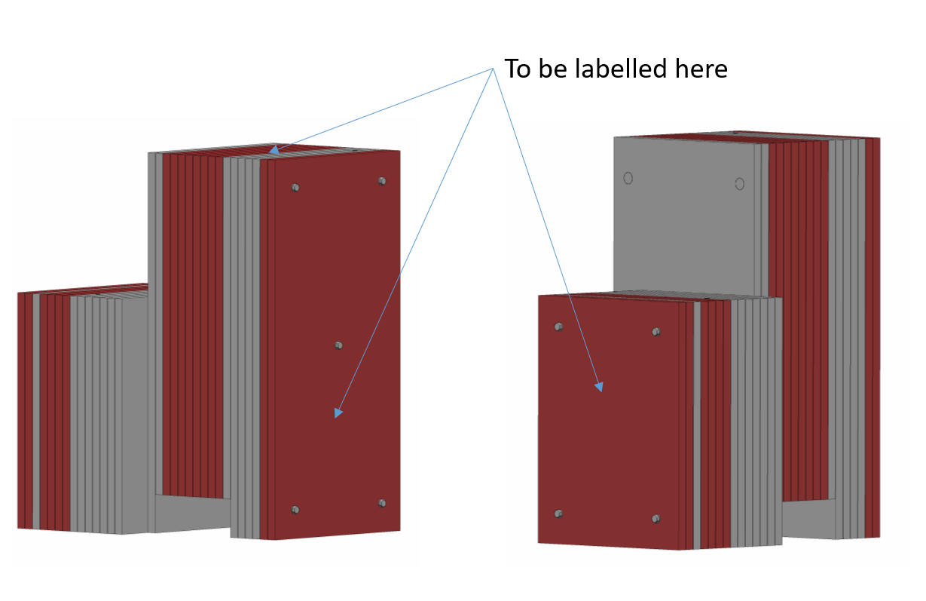

Figure 1 - Position of block labels

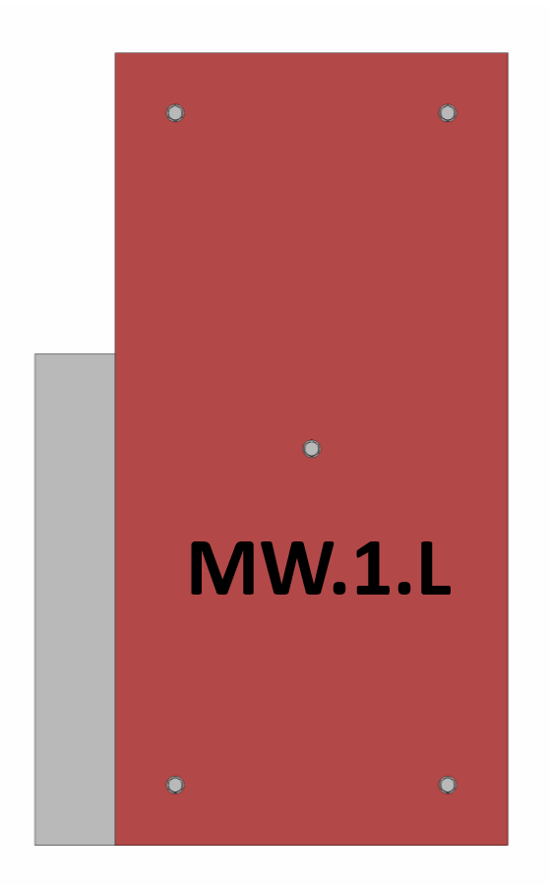
3. Blocks installation and uninstallation
Figure 2 – An illustrative label
The Mid Wall blocks design require a specific sequence. The strategy during an installation is to start with the lower layer then the top layer.
- Blocks are not interchangeable,
- Blocks have to be installed and uninstalled layer by layer (lower layers have to be installed first - see Figure 3)
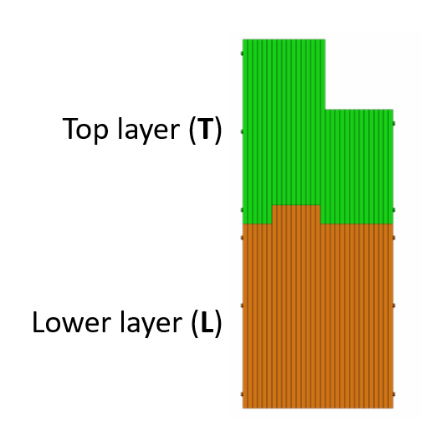
Figure 3 – Wall composition
In order to avoid mistakes during an installation, each block will be marked, as described in Section 2 of this document. Every label gives four information about a block position and it is defined as follows:
[sector].[block position].[layer]
- [sector] – MW (Mid West) or ME (Mid East)
- [block position] – 1 to 15 (where 1 is the innermost block seen from center of the bunker)
- [layer] – Lower or Top
For the sake of an example, MW 2.L label stands for:
- Mid West Sector
- Position 2
- Lower layer
Please see Figure 4 for illustration, ESS-0053441 Wall Top Assm

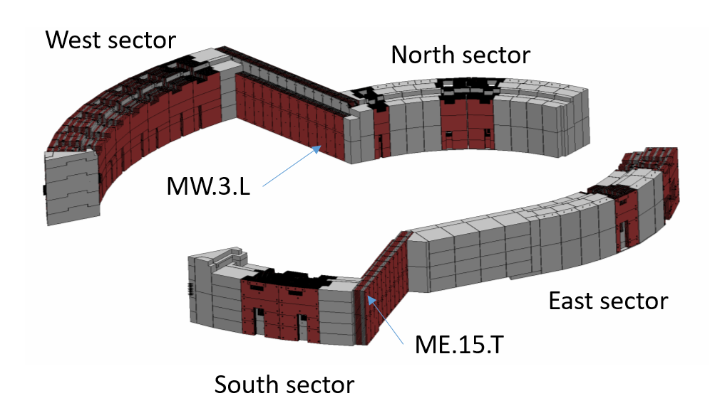
East sector starts with position 3, this is due to the reduced south-east sector.
Figure 4 - Bunker Walls

references

ESS-0053441 - Wall Top Assm.
ESS-0109716 – Mid Wall East
ESS-0109717 – Mid Wall West

List of figures
Figure 1 - Position of block labels 4
Figure 2 – An illustrative label 4
Figure 3 – Wall composition 5
Figure 4 – Bunker Walls 6

Document Revision history
Revision | Reason for and description of change | Author | Date
1 | First issue | Thorbjörn Lindwall | 2017-11-29

