Comparison of Neutronics Models of the Bunker

 | Name | Role/Title
Owner | P M Bentley | Group Leader – Neutron Optics and Shielding
Reviewer | V Santoro | Scientist – Neutron Optics and Shielding
Approver | O Kirstein | Division Head – Instrument Technologies
Distribution list | Z Laszic  Peter Jacobsson  Gunter Muhrer  Arno Hiess  Shane Kennedy  Andreas Shreyer | Project Lead – Bunker  Director – ES&H  Shielding Coordinator  NSS Licensing  NSS Project Leader  Science Director

Table of content | Page
1. Executive Summary 3
2. Contributors 3
3. Introduction 3
4. IFE Calculations 4
4.1. Conclusions from IFE Model 4
5. JPARC Calculations 4
5.1. Conclusions from JPARC Model 5
6. ESS Calculations 5
7. Discussion and Conclusions 6
8. References 7
9. Glossary 7
Document Revision history 8

Executive Summary
A comparison is made between three independent bunker neutronics models. The models show good agreement between ESS, IFE and FZJ experts, and conclude that the design is at the limit of what is neutronically achievable.

Contributors
- Comblayer/MCNP model by Stuart Ansell (ESS, Sweden)
- FLUKA model and analysis by Rodion Kolevatov (IFE, Norway)
- PHITS model and analysis by Kazuo Takeda (RIST, Japan)
- Discussions: Doug DiJulio, Valentina Santoro, Stuart Ansell, Nataliia Cherkashyna.

Introduction
Outside the spallation Target Monolith of the ESS, there is a region within which the considerable beamline shielding of each instrument would overlap with that of the neighbouring beamlines. Further compounding the problem are a great many choppers and other hardware that require large spaces to be created within this region. Drawing on lessons learned from other spallation source projects, to simplify the integration efforts of the shielding, and provide a single solution to a critical area, a common shielding bunker was created. This bunker strongly resembles conceptually similar structures at PSI, in Switzerland, and the ILL, in France, scaled for the higher energy neutron radiation of the ESS source.
The Neutron Optics and Shielding Group (NOSG) provides technical support to this project. In recent weeks there have been the conclusion of two critical, external contributions to the work in the periphery of the team members.
The first is the conclusion of a collaborative effort begun in summer 2017, to cross-check NOSG neutronics models and variance reduction techniques with experts from Japan. Specifically, comparisons were made between GEANT4 and PHITS, and afterwards between MCNP and PHITS.
Another objective was to participate in PHITS training to exploit some of the fairly unique and useful features of this code, such as duct-source variance reduction and dchain activation analysis.
The second activity was considerable advances in the work of IFE in supporting shielding work on the instruments, which was presented at a recent workshop hosted by NOSG in Lund.
One interesting output of these studies was identified: that both the ESS CSPEC beamline used as an example, and the work related to the neutronics on BIFROST, are necessarily providing independent neutronics models of the bunker. As such, the efforts of NOSG have been complemented by external collaborators, who have a proven track record in neutronics calculations, with the aim to have the best possible shielding designs for ESS.
The purpose of this short report is to compare these models, and draw useful conclusions from such a comparison.

IFE Calculations
This work was presented at a recent shielding workshop at ESS [1]. It was performed using FLUKA [2], and is a model of the BIFROST beamline.
The fast neutron simulation is shown in fig. 1.
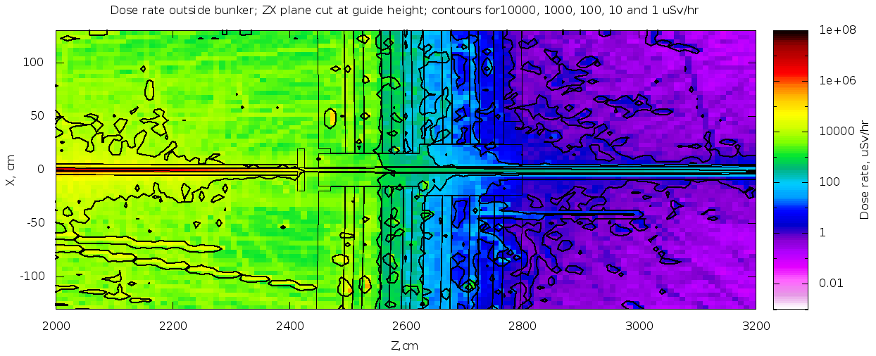
Figure 1: Fast neutron simulation of the bunker with the BIFROST beamline geometry, using FLUKA [2].

Conclusions from IFE Model
- The dose rate is dominated by neutrons
- Streaming of intermediate energy neutrons through the bunker wall plug affects the dose, leading to a suggestion to add polyethylene near the wall penetration.

JPARC Calculations
This work was part of a variance reduction collaboration between ESS and JPARC, and written up in a recent report that is (at the time of writing) in the final draft stage [3]. The model was built using PHITS [4], and is a model of the CSPEC beamline. The beamline is curved out of line of sight in the bunker.
The model and simulated dose rate contributions are shown in fig. 2.
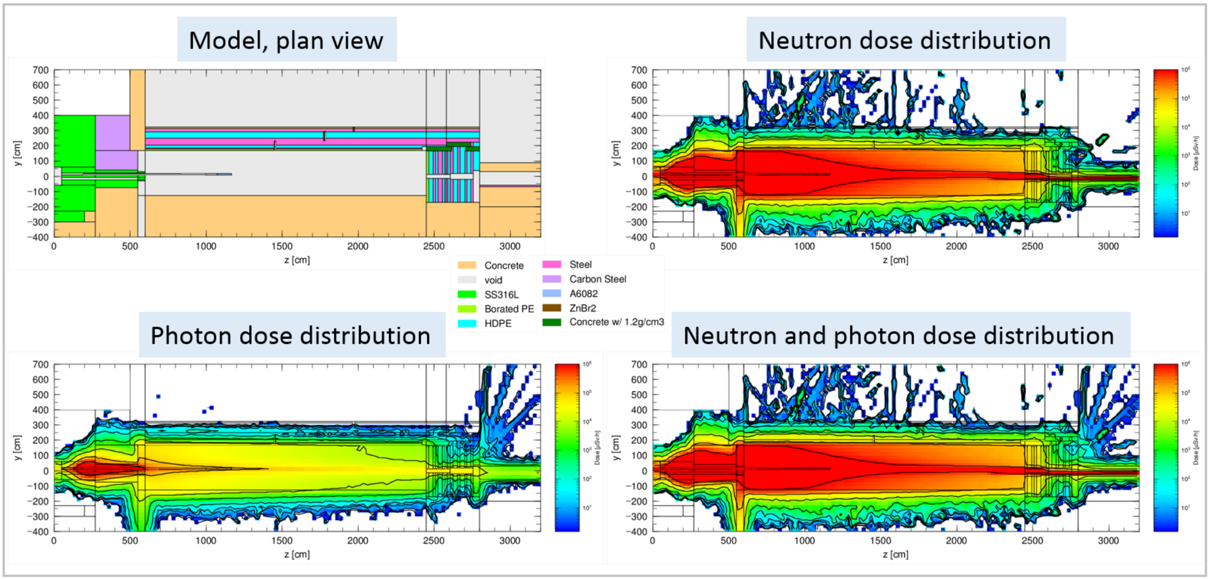
Figure 2: Bunker neutronics model in PHITS [4] using the CSPEC beamline geometry.

Conclusions from JPARC Model
- The roof and wall appear to meet the dose rate objectives for neutron dose, but there is no obvious opportunity to remove shielding
- Around the wall penetration there appears to be a need for additional shielding. However, unlike the BIFROST beamline in sec. 6 additional gamma shielding is likely needed.
This last point is interesting. Both the CSPEC beamline and the BIFROST beamlines are curved out of line of sight within the bunker, and should have similar characteristics when they emerge at the bunker wall. Conversely, one of the beamlines seems to require additional gamma shielding, and the other additional fast neutron shielding. Subtle variations in geometry tend to have strong effects on the high energy albedo in this way, and we should prepare for similar variations on the rest of the instrument suite.

ESS Calculations
This model was built using CombLayer with MCNP output [5].
The simulated dose rate above the bunker roof is shown in fig. 3, and the dose distribution through the wall is shown in fig. 4.
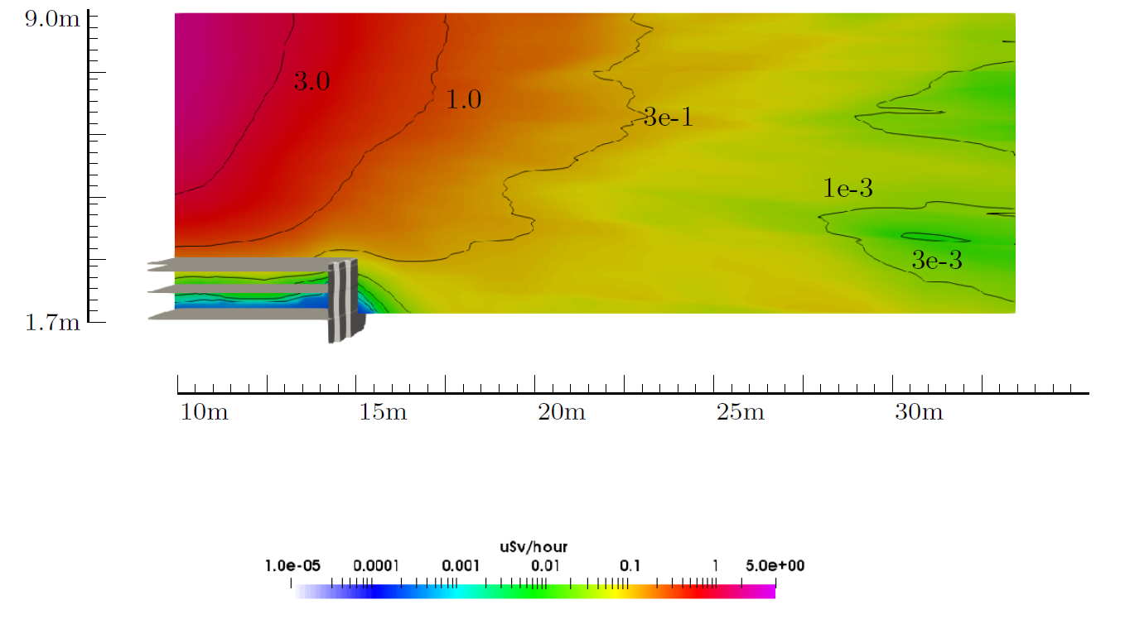
Figure 3: Bunker roof neutronics model in MCNP [5].
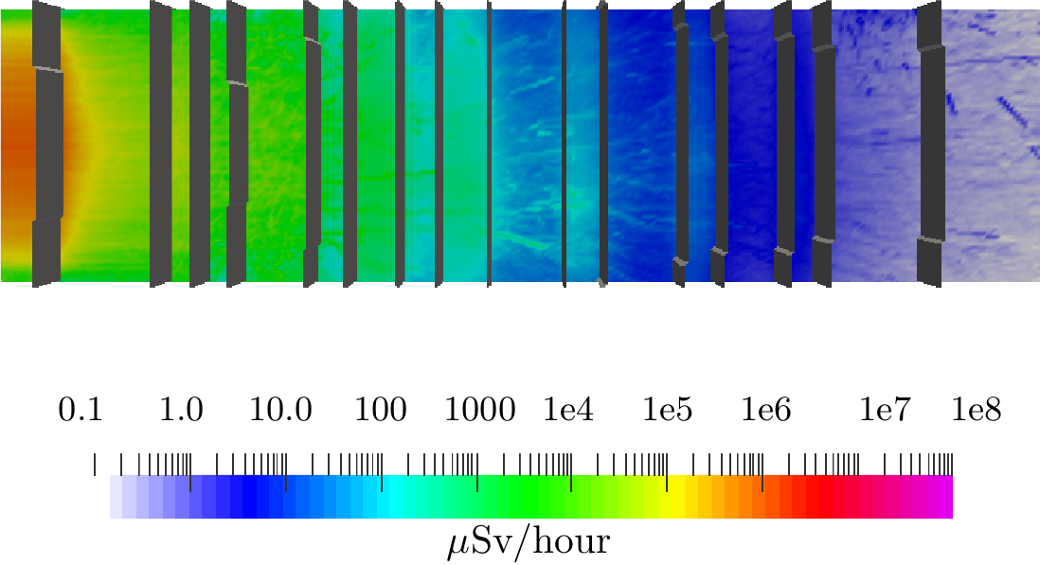
Figure 4: Bunker wall neutronics model in MCNP [5].
The roof shows elevated radiation towards the source, similar to that in sec. 7 and sec. 6. The wall simulation is somewhat different, in that there is no neutron guide penetration. This is rather interesting, because without the wall penetration it appears that a few cm of the final polyethylene could be removed. However, readers should not be encouraged to pursue this line of thought based on a general case, since sec. 7 and sec. 6 so clearly show the opposite is true with a more realistic beamline penetration, both within line of sight and out of line of sight.

Discussion and Conclusions
Bunker models have been created by three different teams using three different nuclear codes. All three codes used are approved for ESS radiation transport safety calculations [6]. Comparison between the models show excellent agreement.
The neutronics safety calculations are in all cases compatible with the requirements of achieving simulated doses of 1.5 $μ$Sv/h, with a confidence factor of 2 giving an expected measured dose of 3 $μ$Sv/h, with the exception of the upstream half of the bunker roof close to the target monolith. Some of the documentation urges caution [3] due to the approximations used with the source term, namely using a homogeneous source that discards energy and angle correlations, and using NMX spectrum rather than the CSPEC spectrum. However, the CSPEC beamport would be expected to have a lower contribution at the highest energies, and the angular correlation would put higher energy neutrons preferentially on one side of the beam. These details would not change the dose rates by more than a few 10's of %, and would be within the factor of 2 confidence that is built into the requirements for ESS safety [6].
Finally, it should be noted that both realistic wall penetration models indicate that some additional shielding is likely required when interfacing with the instrument shielding. This should be anticipated on the majority of beamlines in the region where the neutron guides emerge from the bunker wall.

References
1. R. Kolevatov, Update from IFE: HEIMDAL and BIFROST beamlines (ESS; ESS Instrument Shielding Workshop, 2017).
2. A. Fasso, A. Ferrari, J. Ranft, P. R. Sals, G. R. Stevenson, & J. M. Zazula, FLUKA92. Proc. 1st Workshop on Simulating Accelerator Radiation Environments (SARE 1), Los Alamos Report, LA-12835-C (1994) 134–144.
3. K. Takeda & K. Niita, Report on beam line design for neutron scattering facility of ESS. (2017).
4. T. Sato, K. Niita, N. Matsuda, S. Hashimoto, Y. Iwamoto, S. Noda, T. Ogawa, H. Iwase, H. Nakashima, T. Fukahori, K. Okumura, T. Kai, S. Chiba, T. Furuta, & L. Sihver, Particle and heavy ion transport code system PHITS. J. Nucl. Sci. Technol., 50 (2013) 913–923.
5. MCNP, MCNP — a general monte carlo n-particle transport code, version 5 (Los Alamos National Laboratory - LA-UR-03-1987, 2003 (Revised 2008)).
6. G. Muhrer, ESS procedure for designing shielding for safety (ESS-0019931, 2015).

Glossary
Term | Definition
NOSG | Neutron Optics and Shielding Group
IFE | Institute for Energy Technology, Norway
RIST | Research Organisation for Information Science and Technology, Japan
MCNP | Monte-Carlo N-Particle code, from Los Alamos USA
FLUKA | A multi-particle transport code from CERN, Switzerland
PHITS | Particle and Heavy Ion Transport Code System, from JAEA, Japan
PSI | Paul Scherrer Institut, Switzerland
ILL | Institut Laue Langevin, France
GEANT4 | A C++ toolkit for the simulation of the passage of particles through matter, from CERN, Switzerland

Document Revision history
Revision | Reason for and description of change | Author | Date
1 | First issue | P M Bentley | 2017-11-27
2 | Correction of name of instrument used in an example; minor language change in some locations; added acknowledgement of discussions. | P M Bentley | 2017-12-01

