DM--SD-TBSIDDH09- System Description H09 Waste Building.docx

 | Name | Role/Title
Owner | Boris Kildetoft | Building owner
Reviewer | Per Persson  Ulrika Agnvik  Fredrik Jörud  Fredrik Tidholm  Bertil Winér  Magnus Leonardson  Ronny Sjöholm  Patrik Persson  Frank Kezerle  Martin Hansson | Stakeholder  Security Officer  Fire  Radiation Protection Technician  Occupational Health and Safety Engineer  System Manager el  MEP Advisor  System owner HVAC  System owner Architectural and Structural  System owner Process
Approver | Fredrik Österberg | CF Baseline Team Lead

1. Introduction 4
1.1. Purpose of the document 4
2. System purpose 5
2.1. System purpose 5
3. Concept of operations 6
3.1. System stakeholders 9
3.2. Operational Scenarios 10
3.2.1. States of operation 14
3.3. Life cycle 14
3.4. Context & interfacing systems 14
3.4.1. Applicable standards 17
3.4.2. Environmental, Health, Safety and Security 17
3.4.3. Radiological safety important system parts 18
3.5. Maintenance concept 20
4. System characteristics 20
4.1. System functionality overview 20
4.1.1. Structure 21
4.1.2. HVAC 21
4.1.3. Process 22
4.1.4. Electrical 22
4.1.5. Control and Monitoring 22
4.1.6. Transport 23
4.2. Logistics 23
4.2.1. Personnel logistics 23
4.3. Constraints to the system 26
5. Risks 26
5.1. Early identified risks and mitigations 26
6. Glossary 27
7. References 27
Document Revision history 29

list of Figures
Figure 1 H09 Waste Treatment Facility Building conceptual diagram 5
Figure 2 The building is divided into a high part and a lower part 6
Figure 3 Offices and staff areas 7
Figure 4 Process areas and workshops 7
Figure 5 Zoning principle; red equals hotter 8
Figure 6 Position of H09 and culvert from D05 in respect to the target wheel and HEBT Loading bay. 11
Figure 7 Scenario diagram 13
Figure 8 ESS system interfacing with H09 Waste Treatment Facility Building 14
Figure 9 Location of H09 15
Figure 10 H09 Interfaces with other SI Systems 16
Figure 11 H09 Building Sub Systems 21
Figure 12 Logistics on Level 100 of H09 Waste Treatment Facility Building. 24
Figure 13 Logistics on Level 110 of H09 Waste Treatment Facility Building. 24
Figure 14 Logistics on Level 115 of H09 Waste Treatment Facility Building. 25
Figure 15 Logistics on Level 090 of H09 Waste Treatment Facility Building. 25

Introduction

Purpose of the document
This document is a description and rationale of the expected operations of the H09 Waste Treatment Facility Building. It is a platform for stakeholder consensus to ensure that the system that is built is operationally feasible and serves its purpose. This document describes the system H09, which includes building and utilities. All system requirements and conditions on H09 the Waste Treatment Facility Building are listed in the respective Sub-system see 4.1.

System purpose

System purpose
H09 Waste Treatment Facility Buildings is a part of the ESS Site Infrastructure (SI).
ESS will produce intermediate-, and low level radioactive waste. The waste will, depending on its type, be treated and stored in two separate facilities. High irradiated intermediate level waste from the target will be treated and intermediate stored in the hot cell, located in the target building D02. All other (intermediate- and low level) waste will be treated and intermediately stored in the waste treatment facility (H09). The building also provides space for grouting of radioactive resin and sludge, temporary intermediate waste storage, purification of liquid radioactive waste, decontamination, hot works, sorting, workshop, nuclide characterisation, chemical storage, chemical lab, rad lab, storing of water samples, control room, changing rooms, staff areas for administrative work as well as technical areas for electricity, COM, HVAC, fire sprinkler etc. a conceptional diagram of H09 and its main interfaces is found in Figure 1.
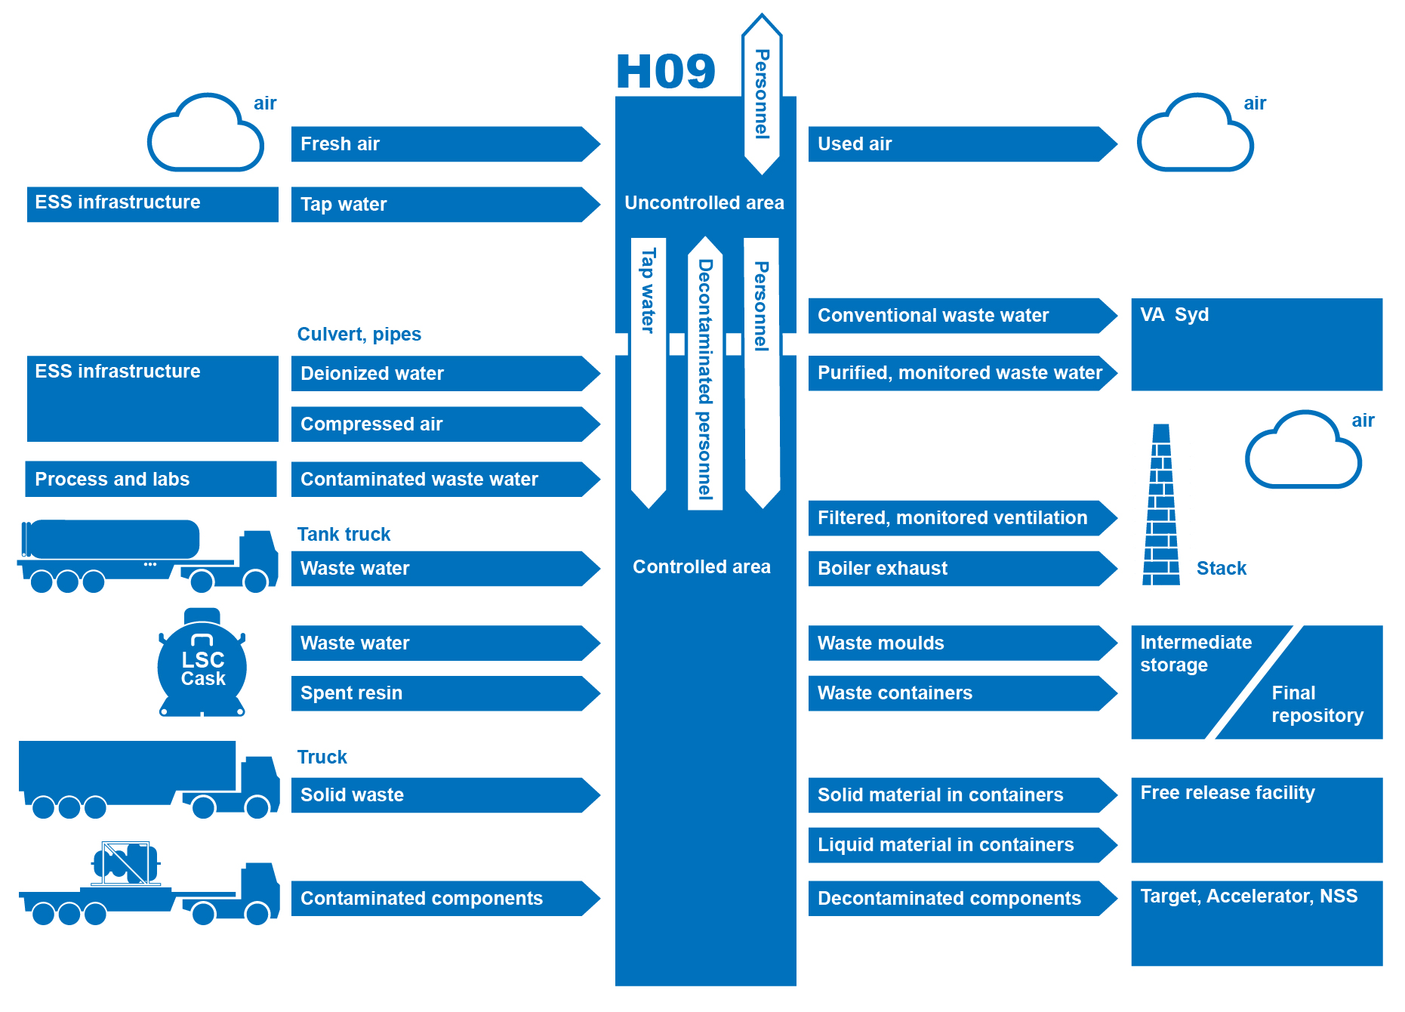
Figure 1 H09 Waste Treatment Facility Building conceptual diagram

Concept of operations
The building is situated between the expansion area for the E-buildings in the south-west, and the circular road to the north and the D05 utility building and associated ducting route to H01 in the east.
The building is divided into a higher and a lower part as illustrated in Figure 2. The high part contains all main functions and areas for controlled and uncontrolled ventilation.
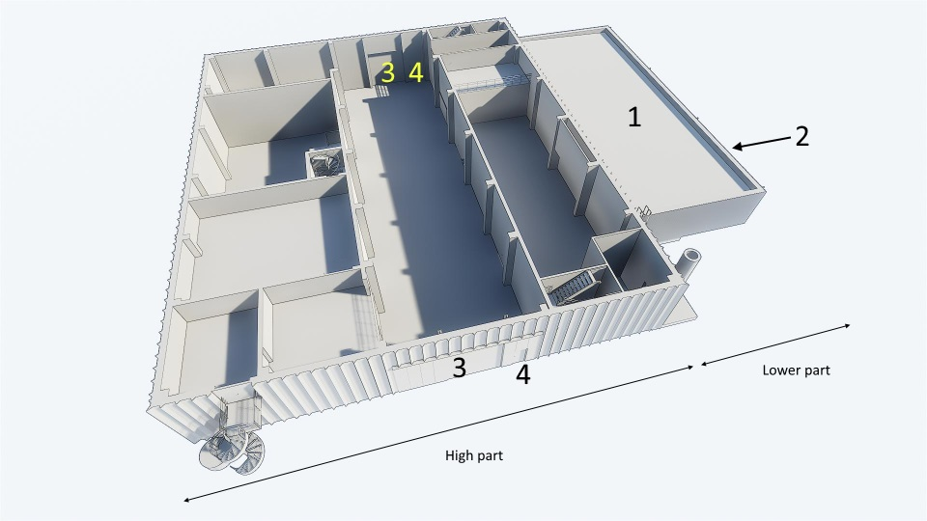
Figure 2 The building is divided into a high part and a lower part
The lower part (1) contains staff offices, changing rooms and various technical areas as illustrated in Figure 3. The staff entrance is situated on the north-east side of the lower part (2). Both sides of the building are equipped with a large loading door (3) and one regular door (4) to access the overhead crane hall H09.100.1009 in the controlled area. It will also be possible to access a subterranean culvert connecting H09 to the D-buildings.
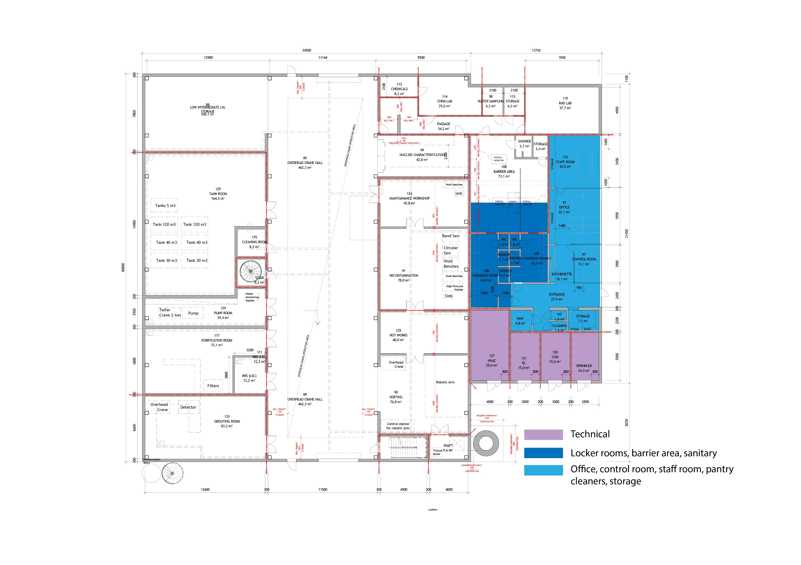
Figure 3 Offices and staff areas
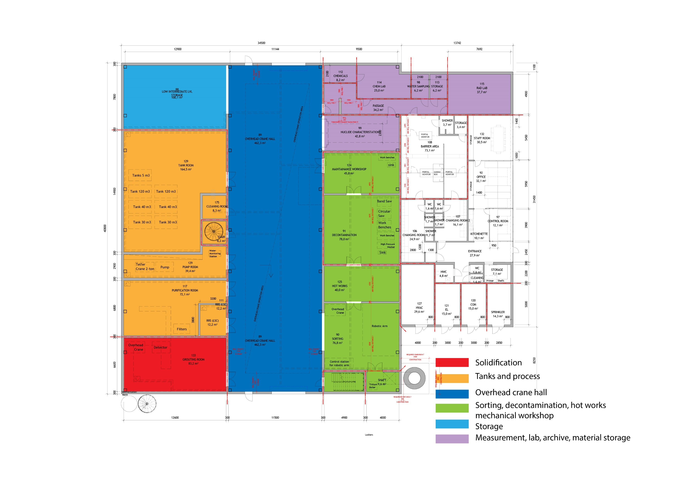
Figure 4 Process areas and workshops
The H09 design is built on the concept that radioactive material causing high dose rate levels shall be treated in the part of the building that is closest to the target wheel, i.e. the main D-building. The part of the building, containing the rad lab that requires as low background radiation as possible, is situated as far from the target wheel as possible as illustrated in Figure 6. The waste flow follows the same route, where waste is to be received via the gate closest to the target wheel, and after processing in the waste building to be dispatched via the gate furthest away from the target wheel.
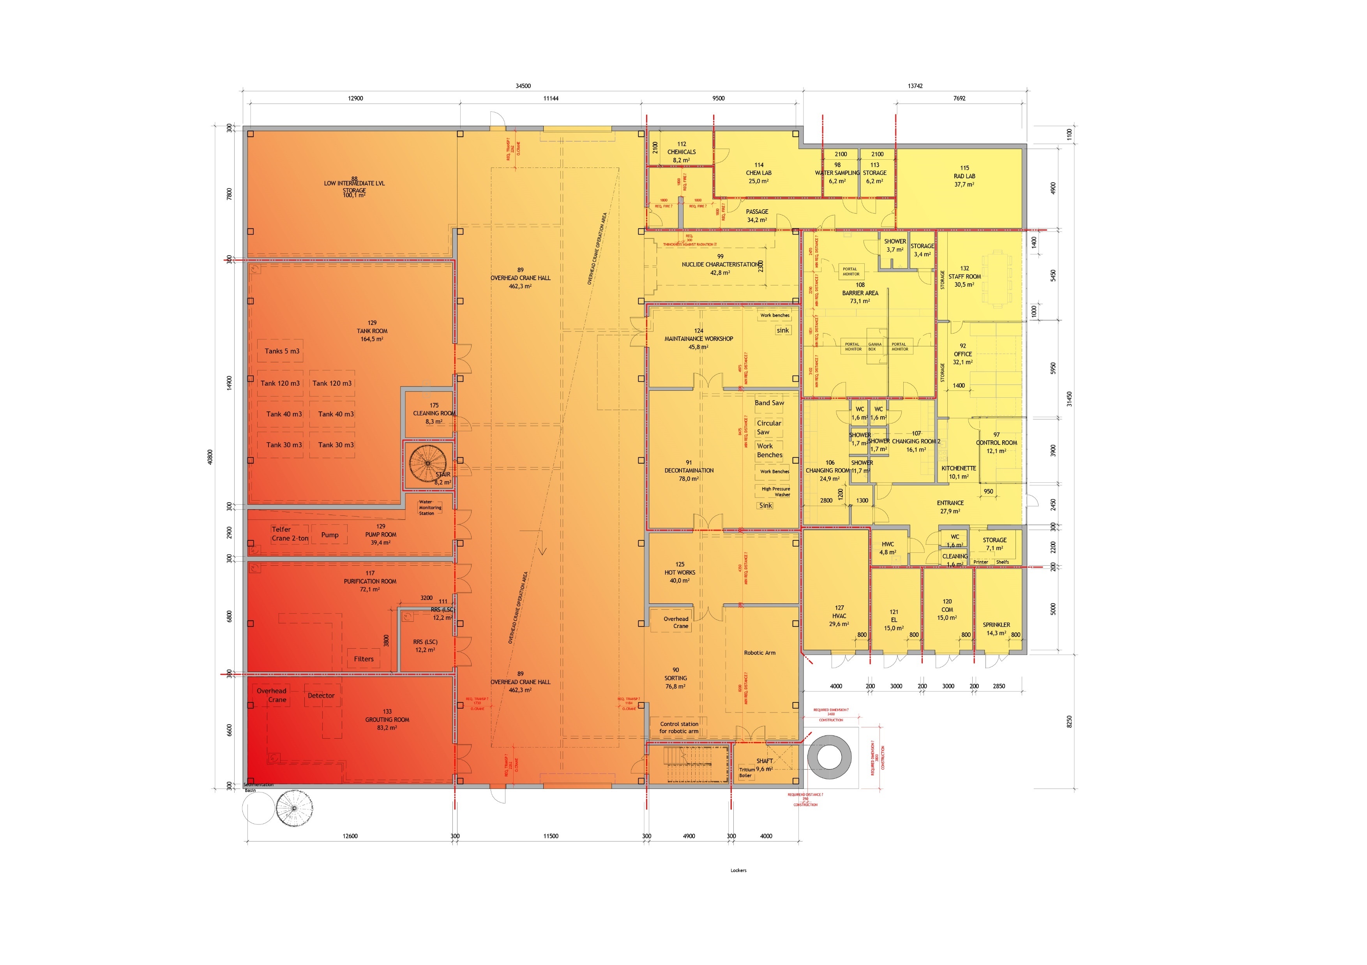
Figure 5 Zoning principle; red equals hotter
Liquid waste water will mainly be received via pipes running in the subterranean culvert from the main building to H09. There is also an alternative way of receiving fluids via a liquid intake in the resin reception station H09.100.1003. The fluids are stored in tanks located in room H09.100.1007 before it is processed and purified in the purification room H09.100.1002. When the liquid waste is purified, and evaluated to be released, it will be released to the conventional sewage system connected VA-SYD. The building is configured to receive and deliver ion resin and liquid waste from mobile vessels via connections in room H09.100.1003.
Solid waste is sorted, segmented, processed, decontaminated and compacted in the north-east part of the building. In case larger objects are received, the treatment operations are carried out in the overhead crane hall H09.100.1009. Solid waste that is awaiting transport to another facility where it could be free released, or where it will be disposed, is temporarily stored in the low and intermediate level waste storage area H09.100.1008 which is constructed to store a mass up to 550 Tons.

System stakeholders

Stakeholder | Stakeholder group | Representing stakeholder
CF | Operation | Facility provider  VA-SYD
 | Regulators | Environment Court  Brandmyndigheten  Miljö och hälsovårdsmyndigheten  Arbetsmiljöverket  Lunds Kommun  VA-SYD  Insurance provider
Target | Users | Target Installation  In kind contributors
 | Interfacing system | AD  NSS
 | Operators | Target maintenance
Accelerator | Users | Accelerator Installation  In kind contributors
 | Interfacing system | ES&H
 | Operators | Accelerator maintenance
NSS | Users
 | Interfacing system | TD
 | Operators | NSS maintenance
ES&H and Q | Operation | Facility management provider  Waste management
 | Users | Räddningstjänsten  VA-SYD
 | Regulators | SSM  Brandmyndigheten  Arbetsmiljöverket
 | Negative stakeholders | Intruders
Integrated Control System, including Personal Safety System | Interfacing system
Machine directorate | ? | ?
Science directorate | ? | ?

Operational Scenarios
ESS has defined a number of scheduling modes according to “Updated Report on Operations” [1]. The ESS operational modes does not implement any additional access restrictions on H09, as this is a separate building, not directly affected by the beam in G01, or scattered neutrons in the D and E buildings.
- Radioactive solid waste and ion exchange resin is expected to be delivered to H09 by vehicle and mainly during shut down periods
- As this enables maintenance or replacement of contaminated components and ion exchange resin, in ion exchange filters in target and accelerator buildings.
- Liquid waste from NSS is expected to be delivered during all operation modes, this is not expected to be contaminated with radioactivity, but it needs to be controlled before released to VA-Syd.
- Liquid waste from accelerator and target is expected to be received during all operation modes.
- Liquid waste from target and NSS are expected to be delivered to H09 via pipes in the culvert connecting to D05. As there is no pipe connection for liquid waste transport from the accelerator, water from the accelerator needs to be transported to H09 via a container. For this reason, the building is equipped with a reception station in room H09.100.1003 for receiving and delivering both water and ion exchange resin.
A simulated use case for receiving of solid waste from the accelerator tunnel G01:
A Medium Energy Beam Transport (MEBT) to be sent from the accelerator G01 HEBT Loading bay to the waste building H09.
The MEBT is removed from the accelerator line, when disconnecting the MEBT, additional waste is created in the form of gaskets, screws, bolts etc. The MEBT is packed into plastics, while the additional waste is loaded into a mould or other suitable waste package. Both waste package and MEBT are then moved to the HEBT Loading bay see position in Figure 6.
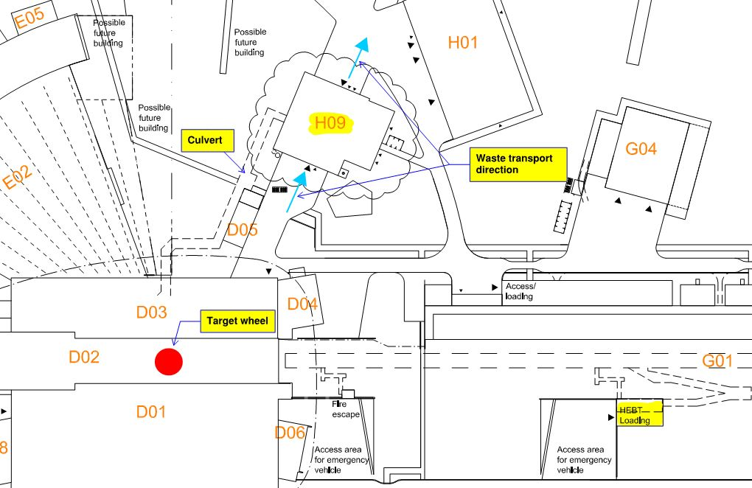
Figure 6 Position of H09 and culvert from D05 in respect to the target wheel and HEBT Loading bay.
Before the MEBT and the waste package are given permission to leave, RP-personal shall make a radiological classification of the waste. When this is done, the waste is categorized and marked, wrapped and marked again. Finally the wrapped MEBT is transported to H09 via a transport vehicle in accordance with ESS-0122078 - “ESS Rules in External / Internal Transportation of Dangerous Goods” to the waste treatment facility and ”Darwin 910117029”
Should the MEBT or waste package have a dose rate of over 10 mSv, the transport to the waste treatment facility needs to be done out of normal working hours.
The transport is ordered by the waste foreman, and the timing of the transport is planned in according to the ESS door opening schedule routines.
The transport is received via the loading door in H09 closest to the target (see Figure 6), and brought into the overhead crane hall H09.100.1009 where it is weighed and documented in accordance to special dedicated instructions into the waste database ESS waste tracking system (SVALA) as raw waste.
In this scenario, the waste is transported to the intermediate storage in H09.100.1008, due to the current work load in H09. It rests in this room before space and resources are available in H09 so that work on the MEBT and the waste package may be resumed.
If the MEBT is contaminated or activity is induced into its components, it is transported to the decontamination room H09.100.1021 where it is carefully unwrapped and decontaminated. The MEBT is transported to the workshop where waste treatment takes it apart.
Pieces of the MEBT that is only partly activity induced, are brought to the hot works room H09.100.1022 where it is segmented into suitable pieces.
The level of activation and contamination for each piece is examined by the waste staff, and parts that has not been activated are decontaminated and selected to be returned to accelerator or sent for free release and recycling.
Parts of the MEBT that are not to be reused in the accelerator and that are partly activated beyond hope for free release, are cut in the hot works room, to separate the contaminated parts from the parts that may be sent for free release. Parts that may not be sent for free release are compacted before they are stored or packed for shipping.

Temporary storing in H09.100.1008 awaiting space and resources in H09

No
MEBT is transported to the workshop where waste treatment takes it apart
Piece is Contaminated?
Activity are induced?
Decontaminate the piece in decontamination room H09.100.1021
Yes
Yes
No
Needed as spare part?
The piece is brought to hot works room H09.100.1022 where it is segmented into suitable pieces.

The piece is delivered to other storage outside H09, but remains in the waste database ESS waste tracking system (SVALA) as raw waste until it is used.
00
Yes

For transport from ESS
For free release
For casting in moulds
Separation into different fractions
No
compacting
compacting
Packing
Packing
Packing
Temporary storing in H09.100.1008 awaiting transport from H09 in accordance to Transport plan for the radioactive waste from ESS-0052862

Figure 7 Scenario diagram

States of operation
States of operation are described in section 3.4.3

Life cycle
H09 Waste Treatment Facility Buildings life cycle follows the operational plan for ESS. “Concepts of Operations for the Site Infrastructure System” [2]

Context & interfacing systems
The H09 Waste Treatment Facility Buildings is interfacing with all the ESS subsystems.

Figure 8 ESS system interfacing with H09 Waste Treatment Facility Building

H09 Waste Treatment Facility Building is located as illustrated in Figure 9.
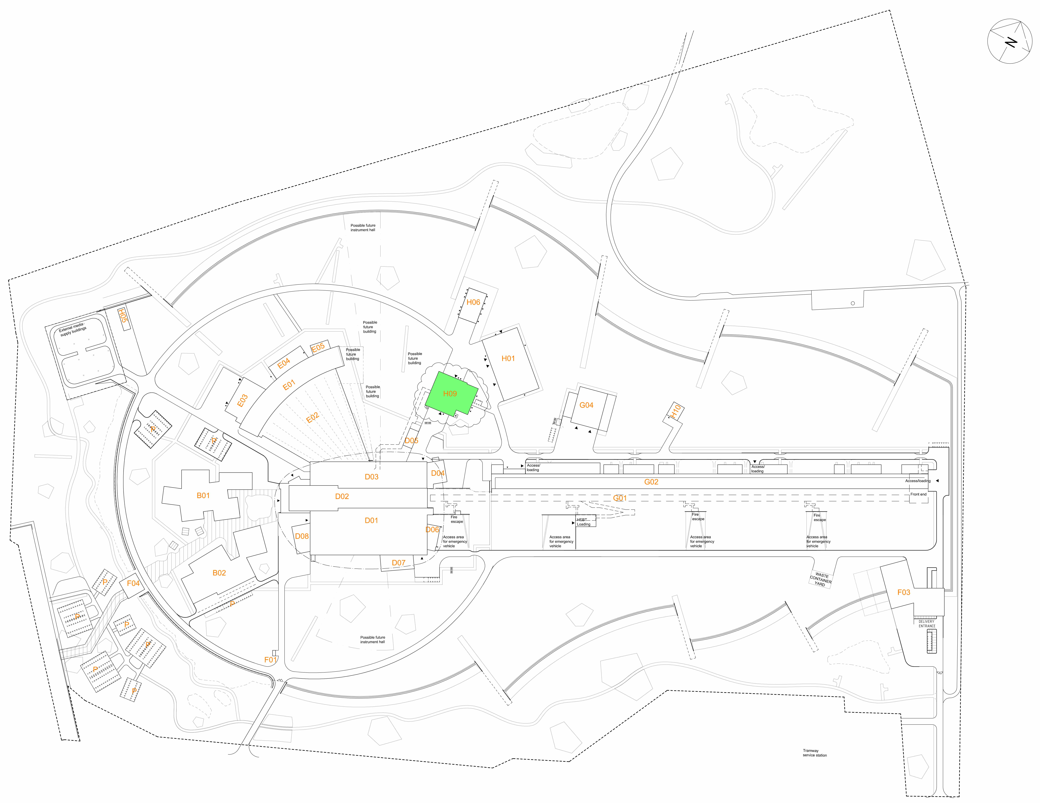
Figure 9 Location of H09
The interfaces between H09 and other buildings and their subsystems is illustrated in Figure 10.

Figure 10 H09 Interfaces with other SI Systems
D01 Experimental Hall 1 produces Risk Waste Water and radioactive solid waste.
D02 Target Building produces Risk Waste Water, Radiological Waste Water and radioactive solid waste.
D03 Experimental Hall 2 produces Risk Waste Water and radioactive solid waste.
D04 Laboratory Experimental Hall 2 produces Risk Waste Water and radioactive solid waste.
D05 Substation provides process power.
D07 Laboratory 1B Experimental Hall 1 produces Risk Waste Water and radioactive solid waste.
D08 Laboratory 1A Experimental Hall 1 produces Risk Waste Water and radioactive solid waste.
E01 Experimental Hall 3 produces Risk Waste Water and radioactive solid waste.
E03 Laboratory 3A Experimental Hall 3 produces Risk Waste Water and radioactive solid waste.
E04 Laboratory 3B Experimental Hall 3 produces Risk Waste Water and radioactive solid waste.
H01 Central Utility Building generates Cooling, Heating, Deionized water and compressed air.
H10 Sprinkler Building provides sprinkler water to the whole ESS.

Applicable standards
The applicable standards are mentioned in each sub system description. See 4.1.

Environmental, Health, Safety and Security
H09 will contain a radioactive inventory of waste products. This requires the exterior to be resistant to mechanical penetration by for example an accidental collision with a vehicle. Access is restricted and requires all doors and openings to the building to be locked and monitored. Staff access during normal operation is through a designated barrier area only. Operational routines for opening loading doors to the overhead crane hall H09.100.1009 and upkeeping the ventilation of the main hall are described in section 3.4.3.
Sustainability
Environmental Court Ruling
ESS has received its judgement from the Environmental Court consisting of permits, conditions and commitments applicable to the whole facility found in ESS-0012603 – “Deldom Mål nr M 1007-12 ESS”. The judgement constrains among others the handling of chemical products and hazardous waste, generation of noise, lowering of groundwater level and pollution of water.
Material Selection
Built in products shall be evaluated regarding to their content of hazardous substances according to “CF Plan for Sustainable Selection of Materials” [3]. The evaluation restricts the use of hazardous substances which may have carcinogenic, mutagenic, endocrine disrupting, toxic, allergenic or ozone-depleting properties. The aim is to phase out these substances throughout a products life cycle.
All sustainability related have been documented according to systems engineering and are listen in “CF Sustainability requirements” [5].
Health and safety
The buildings will be designed and built according to CF Control of OHS
“CF control of OHS” [6]
“CF Occupational Health and Safety Requirements for Design” [7]
“CF Occupational Health and Safety Requirements for Construction” [8]
Security
Access to H09 Waste Treatment Facility Buildings will be restricted and limited.
Principles are described in “ESS Plan Physical Protection” [9]. Access principles are described in chapter 3.5.3 and 4.2.1 below.

Radiological safety important system parts
At ESS the document “ESS rule for identification and classification of safety important components” [11], describes the methodology for identifying the radiation safety functions within ESS.
H09 Waste Treatment Facility Building limits the radiation exposure internally during normal operation and maintenance by zoning adapted to the radiation levels and different prevailing operation modes and circumstances. The zoning is based on the document “ESS Radiation Protection Strategy for Employers” [12] and “Definition of Supervised and Controlled Radiation Areas” [13].
The access to the building and the different zones inside is controlled and the logistics for personnel and goods will be adapted to the defined radiation zoning. The zoning is represented in the plan drawings. The transportation of radioactive or otherwise dangerous goods between different users and H09 will be adapted to “ESS Guideline in external/internal transportation of dangerous goods” [16].
The H09 permanent staff as well as contractors and visitors that need access to controlled areas will be educated and trained in procedures and risks connected to radiation and the facility and recurrently notified and alerted about the prevailing situation and circumstances in and around H09 operations.
The main entrance and exit in/out to/from the controlled area contain a permanent barrier between public and controlled area containing necessary individual protective equipment and radiation monitoring equipment for humans and goods. Inside the controlled area it will be possible to establish local temporary and/or permanent barriers.
Control of air ventilation
H09 will be divided into several different air zones to reduce air born contamination to staff and to the public. Two separated HVAC systems will service the different zones.
In the Overhead crane hall H09.100.1009 there will be 2 large access doors and 2 normal sized doors to the outside of H09. For this reason, the ventilation system will have 2 different modes. Normal operation mode, and Door opening operation mode.
Normal operation mode:
During normal operation, the HVAC system ensures that all air in the building is monitored, filtered and exhausted through the ventilation stack. A permanent under pressure secures potential leakage of air through the structure.
Door opening operation mode:
To ensure that no uncontrolled air born contamination will exit H09 through the outer gates in H09.100.1009, there will be a function which controls the outer doors and gates in H09.100.1009 and only allow opening of them under the following conditions:
- The ventilation system shall be fully operational in all parts of the controlled area in H09.
- All doors and gates to rooms inside H09 which are openings to the overhead crane hall H09.100.1009 are closed and locked, and have been this for the time frame it takes to fully ventilate H09.100.1009.
* Closed and locked doors and gates to rooms in H09 shall only be possible to opened via emergency opening function(s). This feature concerns as well radiation safety as security issues.
* If emergency opening function are used to open any locked door to H09.100.1009, an alarm will inform personal about the situation.
- When closing the outer doors to H09.100.1009, the ventilation of H09.100.1009 shall be started automatically and the ventilation shall return from to Normal operation mode.
Liquid Waste
H09 Waste Treatment Facility Building collects, separates and contains the different waste water fractions coming from different producers at ESS.
The conventional waste water coming from public (White) wet areas inside H09 are directly connected to the municipal sewage system. “Non-radioactive waste management plan” [17].
The waste water from supervised areas at ESS (risk waste water) is transferred through a separate pipe system to H09 Waste building for sampling, treatment and purification before release to the municipal sewage system [18]. Waste water from producers that are not connected to H09 via pipe system, such as waste water from the accelerator is transported to H09 via a tank, and the waste water is pumped from here into the process system via a connection in the Resin reception station H09.100.1003. It will also be possible to dispose of liquid waste via a second connection in the resin reception station.
Solid Waste
Solid waste from Supervised areas will be collected and stored in separate bins/fractions. The waste bins will be transported to the Sorting room H09.100.1023 for sampling, treatment and decontamination before disposal.
Solid waste from public areas will be collected and stored locally. The waste will be divided in Paper, plastics, combustible waste and small amounts of hazardous waste such as electronic waste (batteries, light bulbs). “Non-radioactive waste management plan” [17].
Surface Treatment
The floor areas within H09 as well as in the H09 part of the culvert will be surface treated in accordance with “DM--DT-TBSIDDD02-Surface treatment” [19].

Maintenance concept
Over all Maintenance is described in “Concept of Operation for ESS” [20]

System characteristics

System functionality overview
H09 Waste Treatment Facility Building main purpose is to house functions for:
1. Handling and processing of radioactive waste, consisting mainly of solid, liquid and mixed waste.
2. Decontamination of components that are going to be serviced, re-used, free released, recycled or any combination of these.
3. Segregation of waste types that are subject to different types of treatment, clearance and/or discharge.
4. Compaction and volume reduction.
5. Temporary storage of radioactive waste.
6. Conditioning, packing and characterization of radioactive waste that is going to be transported out from ESS.
7. Controlled area maintenance workshop devoted for maintenance of processing utilities.
8. Decontamination of firetrucks.
Managing of radioactive waste includes collection, handling, pretreatment, treatment, conditioning, characterization, transport and storage of all types of radioactive waste that is produced within the ESS facility. The need for management of radioactive waste in a dedicated facility relates directly to SSM top requirements for ESS operations [1].
H09 is connected to the target station building denoted with D02 in Figure 2 via a subterranean culvert with ducting for transport of waste liquids produced in these buildings, electric- and signal cabling, and process systems.
H09 is dimensioned for 6 full time equivalent (FTE).
H09 Waste Treatment Facility Building Sub systems are described below:

Figure 11 H09 Building Sub Systems

Structure
The architectural design of the building is described in ESS-0066113 -“ DM--SD-TBSIDDH09-System Description H09 Structure”. [21].
The structural design of the building is described in ESS-0145084 - “DM--SD-DEPDDDH09-Basis of Structural Design.docx”
The architectural and structural design is based on the requirements found in ESS-0082503 “DM--SR-TBSIDDH09-System Requirements H09 Structure.xlsx”

HVAC
The HVAC design of the building is described in ESS-0066112 “DM--SD-TBSIDDH09-System Description H09 HVAC.docx” [22]. The systems described in the HVAC systems are:
- Domestic Water System
  - Potable Water System
  - Non Potable Water System
- Vacuum System
- Waste Water System
  - Conventional Waste Water System
  - Risk Waste Water System
- Storm Water System
- Cooling Water System
- Heating Water System
- Ventilation System
  - Conventional Ventilation System
  - Process Ventilation System
- Fire Extinguishing System
  - Sprinkler System
The HVAC design is based on the requirements found in ESS-0082489 “DM--SR-TBSIDDH09-System Requirements H09 HVAC.xlsx”

Process
The process design of the building is described in the ESS-0066109 – “DM--SD-TBSIDDH09-System Description H09 Process” [23]. The systems described in the Process systems are:
- Cooling Water Low temp (CWL) Main distribution for cooling applications
- District Heating Low temp (DHL) Main distribution for heating applications
- Instrument Air (IAR) Main distribution for control applications and general needs of pressurized air
- De-ionized Water (DIW) Main distribution for local cooling applications
- Piping for Risk Waste Water and Radiological Waste Water from D&E buildings to Waste Building
- Main distribution of lab gases.
- Ion-exchange resin handling and storage.
The process design is based on the requirements found in ESS-0082494 – “DM--SR-TBSIDDH09-System Requirements H09 Process.xlsx”

Electrical
The Electrical systems of the building is described in ESS-0066114 - “DM--SD-TBSIDDH09-System Description H09 Electrical” [24]. The systems described in the Electrical systems are:
- Low Voltage
  - Low Voltage Power
  - Lighting
  - Ducting systems
  - Grounding
- Extra Low Voltage
  - Fire alarm System
  - Integrated Security System
  - Communication Systems
  - Other ELV
The electric design is based on the requirements found in ESS-0066114 – “DM--SD-TBSIDDH09-System Description H09 Electrical.docx”

Control and Monitoring
The Control and Monitoring design of the building is yet not described, when described, it will be done in ESS-0056198 - “DM--SD-TBSIDDH09-System Description H09 C&M” [25]. The systems described in the C&M systems are:
- Door interlock system
- Domestic Hot Water System
- Risk Waste Water System
- Cooling Water System
- Heating Water System
- Ion-exchange resin control system
- Process control system
- Room control in rooms with fan coils
- Room control in rooms with radiators and chilled beam
- Conventional Ventilation Systems
- Process Air Systems
- Lightning control
- Lifts and cranes
- Alarms from the low voltage electrical system

Transport
The transport system of the building is described in ESS-0046980- “DM--SD-TBSIDDH09-System Description H09 Transport” [26]. The systems described in the Transport systems are:
- Forklift.
- Overhead cranes.
- Telfers.
- Wall mounted robot arm for sorting.
The transport design is based on the requirements found in ESS-0082507 - “DM--SR-TBSIDDH09-System Requirements H09 Transport.xlsx”

Logistics

Personnel logistics
H09 Waste Treatment Facility Building
From the main entrance in the uncontrolled area of the building, staff can reach offices, control room, staff areas and changing rooms. From this point on access is provided to the controlled side. Access is controlled and monitored. In the controlled area, all rooms are connected to the man overhead crane hall. Access to stairs allows passage to upper floors as well as to the culvert connecting H09 to D05.
In case of emergency several emergency exits are available.
How People and Goods move in H09 Waste Treatment Facility Buildings and between outside and buildings is described in the figures below.
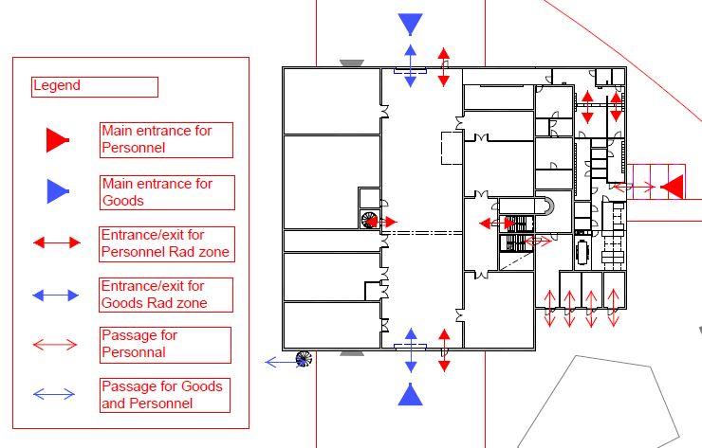
Figure 12 Logistics on Level 100 of H09 Waste Treatment Facility Building.

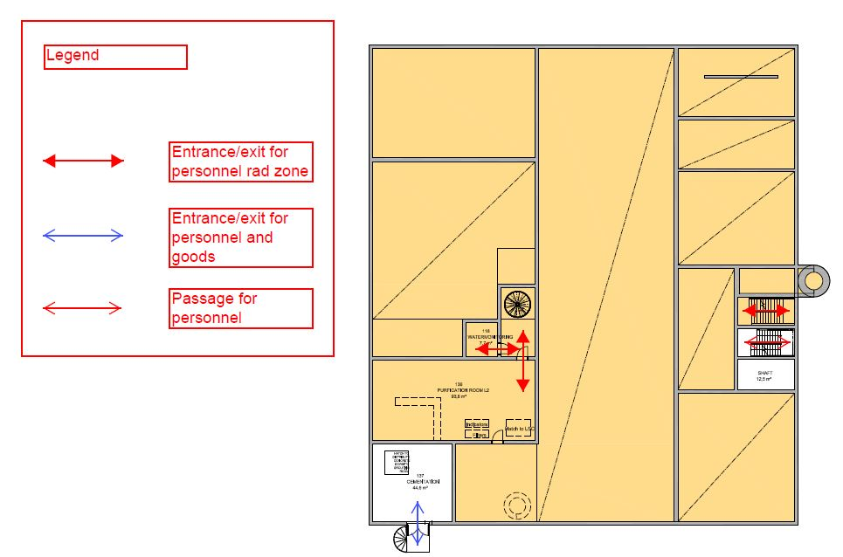
Figure 13 Logistics on Level 110 of H09 Waste Treatment Facility Building.
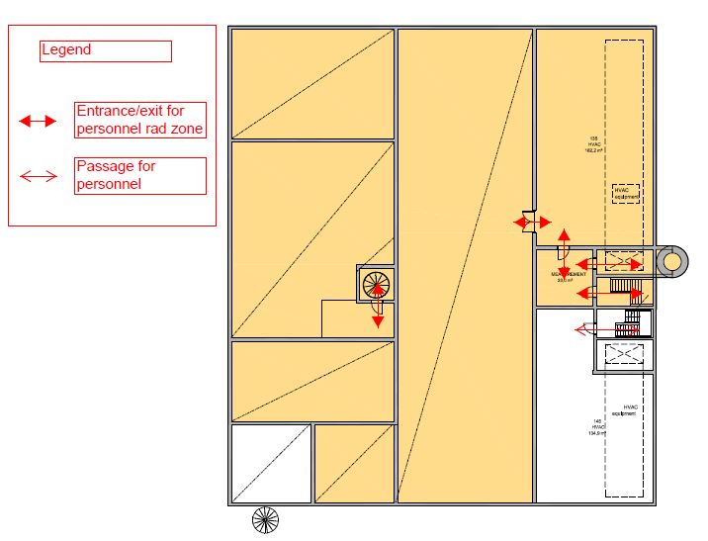
Figure 14 Logistics on Level 115 of H09 Waste Treatment Facility Building.
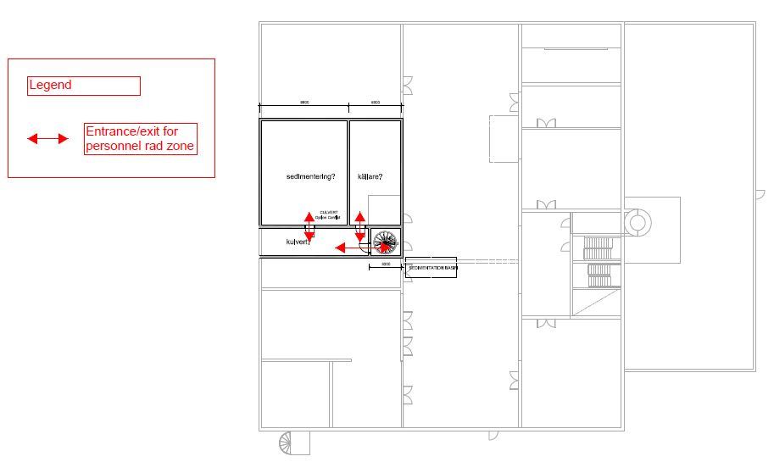
Figure 15 Logistics on Level 090 of H09 Waste Treatment Facility Building.

Goods logistics
There are two large loading doors for vehicles in H09.100.1009 Overhead Crane Hall. The goods can be unloaded by the overhead crane or the forklift and transported to the different rooms for further treatment.
H09.110.1002 Cementation room has a large door for loading of cement bags from the outside.
H09.100.1009 Overhead Crane Hall has a main, large capacity overhead crane. H09.100. 1023 Sorting room, H09.100.1022 Hot Works room, H09.100.1021 Decontamination room, H09.100.1020 Maintenance workshop, H09.110.1007 Storage, H09.100.1004 Pump room, are serviced by a common overhead crane reaching across all rooms. H09.100.1001 Grouting room and H09.110.1002 Cementation room have separate, small overhead cranes for lifting and transporting goods and equipment locally. Pump room H09.100.1004 has a telfer for service of pumps and motors.
In H09.100.1023 Sorting room there is also a wall mounted robot arm used for sorting radioactive waste.

Constraints to the system
H09 will not handle high level radioactive waste.

Risks
ES&H radiation hazard analysis is under development and provides the basis for risk mitigation and HVAC ventilation selection in the H09 project.

Early identified risks and mitigations
A number of top level risks where early identified in the project and has hence been mitigated accordingly.
Risk | Explanation | Mitigation
Internal flooding | Spill of radioactive water or start of sprinkler system may cause radiation to leak out from H09 | A system of thresholds, sumps and drains will collect spilled liquid and transport it to a wastewater tank H09-TA012 positioned in the basement H09.090.1001.  If H09-TA012 is overfilled, the water will fill the basement. The size of the basement is able to assemble more than 100 m³ waste water. See Drains and thresholds in H09 ESS-0185517
Ion-exchange resin spill | Ion-exchange resin may be leaking wen emptying the transport container. | Area where resin is handled are designed to be shield from accidental spray and to be decontaminated in a controlled manner.  An extra ion-exchange resin tank is placed under the area where ion-exchange resin is handled and connected to drains in the floor in order to minimize the spill, the dose to the workers, and to allow to recover the spilled ion-exchange resin. See ESS-0224679
Earthquake and Fire | Collapse of the structure exposing the inventory to the outside via a Fire. | H09 is designed to hold a low radiation content. In case of a collapse contamination will be limited.
Direct radiation to the outside of the building | Treatment of radioactive material inside the building may cause a dose to people outside the building. | The thickness of all outer walls as well as applicable inner walls has been increased to 300 mm in order to reduce the radiation to the outside.  All building elements are constructed to stop line of sight. See Basis of design ESS-0145084
Fire | A fire in any room may spread radionuclides to the surrounding | The whole building is equipped with as well fire alarm system as automatic fire extinguishing system (water sprinkler). The system is a part of HVAC and described in the System Description H09 HVAC ESS-0066112
Tank rapture | A tank raptures and radioactive fluids contaminates the building and its surrounding. | All tanks are placed within embarkments able to withhold 100% of the content of the largest tank + 10% of the content of all the other tanks.  All embarkments are equipped with pumps placed in sumps that makes it easy to remove the liquid.

Glossary
Term | Definition
CF  TD  NSS  AD  EHS  OHS | Conventional Facility  Target Division  Neutron Scattering System  Accelerator division  Environment Safety and Health  Occupational Health and Safety

References

[1] | ESS-0011768, Updated Report on Operations.
[2] | ESS-0027562, DM--DT-DEDDGD----SI Concept of Operation.
[3] | ESS-0012582, EN--AA-MAQU------CF Plan for Sustainable Selection of Materials.
[4] | ESS-0045937, EN--AA-MAEN------ESS BREEAM design quality assurance.
[5] | ESS-0031401, EN--AA-MAQU------CF Sustainability requirements.
[6] | ESS-0003301, HS--AA-MAQU------CF Control of Occupational Health and Safety.
[7] | ESS-0003171, HS--AA-MAQU------CF Occupational Health and Safety Requirements for Design.
[8] | ESS-0003552, HS--AA-MAQU------CF Occupational Health and Safety Requirements for Construction.
[9] | ESS-0041572, ESS Plan Physical Protection.
[10] | “ESS rule for identification and classification of safety important components, ESS-0016468”.
[11] | ESS-0016468, ESS rule for identification and classification of safety important components.
[12] | ESS-0003520, ESS Radiation Protection Strategy for Employees.
[13] | ESS-0001786, “Supervised area" versus 3rd Safety barrier.
[14] | ESS-0051603, NSS zoning document - part I (safety).
[15] | ESS-0057612, A00-4Z---1-D--------.
[16] | ESS-0122078, ESS Guideline in External / Internal Transportation of Dangerous Goods.
[17] | ESS-0011802, Non-radioactive waste management plan.
[18] | Project report for the ESS waste management by Platom, ESS-0096729.
[19] | ESS-0052793, DM--DT-TBSIDDD02-SurfaceTreatment.
[20] | ESS-0003640, ESS Concept of Operations Description.
[21] | ESS-0066113, DM--SD-TBSIDDH09-System Description H09 Structure.
[22] | ESS-0066112, DM--SD-TBSIDDH09-System Description H09 HVAC.
[23] | ESS-0066109, DM--SD-TBSIDDH09-System Description H09 Process.
[24] | ESS-0066114, DM--SD-TBSIDDH09-System Description H09 Electrical.
[25] | ESS-0056198, DM--SD-TBSIDDH09-System Description H09 C&M.
[26] | ESS-0046980, DM--SD-TBSIDDH09-System Description H09 Transport.

<< This list is generated by the “reference function” in Word. Go to the tab “References” and choose “Insert Citation” to add references. It is OK to do this manually if preferred. >>

Document Revision history
Revision | Reason for and description of change | Author | Date
1 | First issue.  Review comments are found in ESS-0154142 | <<Name>> | <<YYYY-MM-DD>>

