DM--SD-DEPDDDH09-Basis of Structural Design.docxDM--SD-DEPDDDH09-Basis of Structural Design.docx

 | Name
Owner | Andreas Abrahamsson
Reviewer | Frank Kezerle, Boris Kildetoft, Per Persson
Approver

Table of content | Page
1. INTRODUCTION 4
2. DESCRIPTION OF STRUCTURE 4
2.1. Function 4
2.2. Location 4
2.3. Geometry 5
2.3.1. Process part 5
2.3.2. Office part 5
2.3.3. Culvert 5
2.3.4. Stack foundation 6
2.4. Structural systems and materials 6
2.4.1. Process part 6
2.4.2. Office part 7
2.4.3. Culvert 7
2.4.4. Stack foundation 7
3. DESIGN REQUIREMENTS 7
3.1. Codes and standards 7
3.2. Safety class 7
3.3. Consequence class 8
3.4. Life cycle 8
3.5. Sustainability 8
3.6. Durability and environmental conditions 8
3.7. General deflection limits 8
3.8. Geotechnical parameters 8
3.9. Foundation 8
3.10. Fire protection 9
3.11. Radiation safety 9
3.12. Seismic Design 10
3.13. Moisture 10
4. DESIGN OF CONCRETE STRUCTURES 10
4.1. Concrete 10
4.2. Reinforcement 10
5. DESIGN OF STEEL STRUCTURES 11
5.1. Steel structures in general 11
5.2. Ventilation stack 11
5.3. Runway beams, overhead crane 11
6. LOAD CONDITIONS 11
6.1. Permanent actions 11
6.2. Variable actions 11
6.3. Accidental actions – exceptional 12
7. LOAD CASE COMBINATIONS 13
8. References 14
symbols 15
Document Revision history 15

list of tables
Table 4.1 Material partial safety factor for concrete 10
Table 4.2 Material partial safety factor for reinforcement 10
Table 5.1 Material partial safety factor for steel 11

list of Figures
Figure 1 Location of H09 4
Figure 2 H09, parts of building 5
Figure 3 Joint in precast concrete wall with radiation shielding requirements 9
Figure 4 Upstand of in-situ cast concrete 9

INTRODUCTION
This document presents the basis of design for the structure of the H09 Waste Building as part of the larger ESS project. It will present the applicable loads acting on the structures, load case combinations, analysis methodology, and requirements for the structure and design principles.
This document should be read together with both Architectural and Structural drawings of the building.

DESCRIPTION OF STRUCTURE

Function
H09 Waste Treatment Facility Building is a part of ESS Site Infrastructure and is designed to treat and store selected intermediate-, and low-level waste produced in the ESS facility. The building also provides laboratories and office spaces for ES&H permanent staff. Further reading, see [1]

Location
H09 Waste Treatment Facility is located on the northeast corner of the site, between D05 and H06 and adjacent to the circular road, see Figure 1 below.
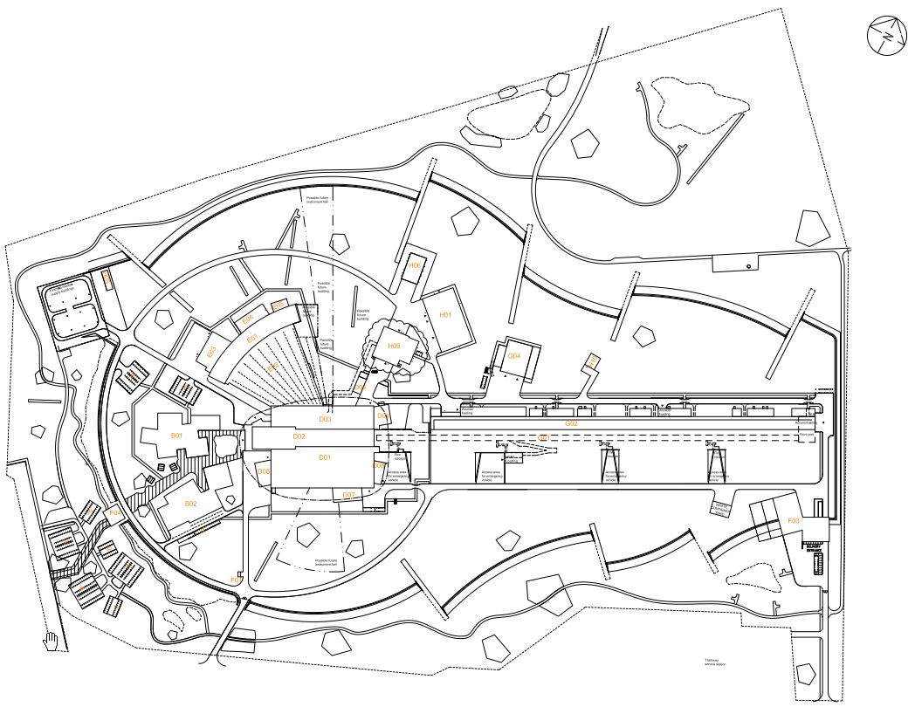
Figure 1 Location of H09

Geometry
From a structural point of view, the H09 building consists of four different parts, see Figure 2 below.
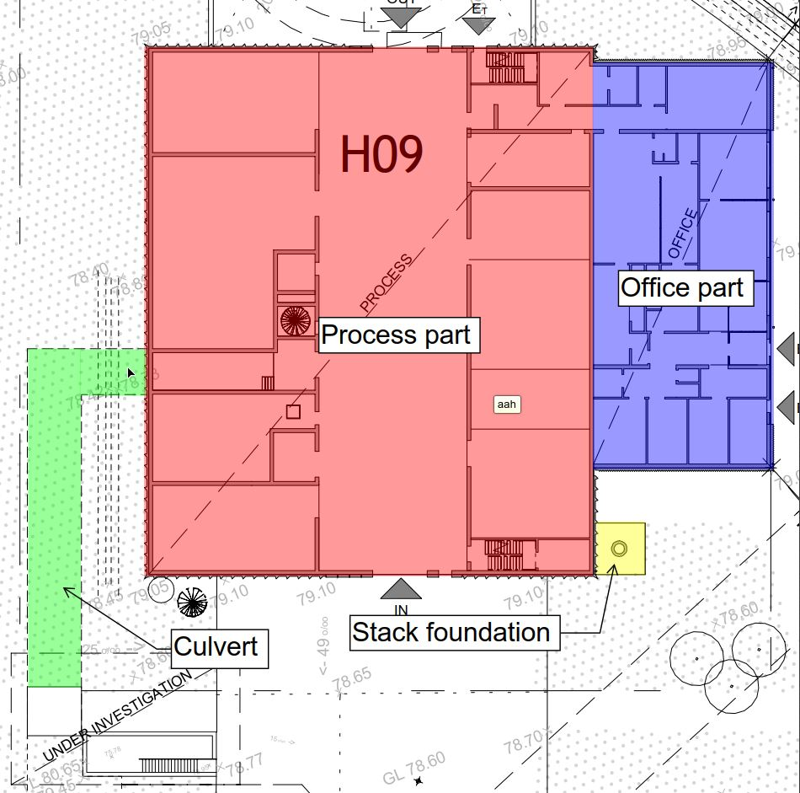
Figure 2 H09, parts of building

Process part
This is the main part of the building, with a footprint of approx. 41x35 metres, and a building height of approx. 12 metres. The middle span, and part of the left span, are full height from the bottom floor to the ceiling. A smaller part of the left span has a second floor/mezzanine for process functions. The right span has a second floor/mezzanine for HVAC areas. The structure shall support an overhead traverse crane in the middle span, and also some smaller overhead traverse cranes in the rooms in the left and right spans. This part of the building mainly accommodates the controlled area.

Office part
This part connects to the process part on the northeast side, and has a footprint of approx. 32x14 metres, with a building height of approx. 4 metres. This part of the building mainly accommodates the uncontrolled area.

Culvert
H09 is functionally connected to the target station (D02) via a subterranean culvert on the southwest side of H09. The culvert part has a length of approximately 40 metres, starting from the perimeter of H09 (at the H09 basement level) and ending at the staircase in building G05.

Stack foundation
Foundation for a ventilation stack, with height approx. 25 metres, located just outside the east corner of the process part.
For further reading, please see Technical Baseline Structural drawings.

Structural systems and materials
(for reference, see Figure 2)

Process part
The structure is built up by columns and beams of precast concrete. A concrete structure will provide sufficient fire protection without having to use gypsum fire protection boards, which would result in more working time, and likely to not comply with the requirements stated in [2]. Since this part of H09 accommodates a heavy industrial environment, the risk of accidental impacts, e.g. from forklifts, need to be considered, and from that point of view concrete columns offers better protection.
The roof, as well as the mezzanine floors, are made of HD/F slabs (precast pre-stressed hollow core slabs). This enables longer spans and therefore a more flexible layout, without supporting walls that would be difficult to remove in the future. However, a disadvantage of using HD/F-slabs is that there will be more limitations for future penetrations in the slabs.
The exterior walls are constructed of horizontal precast concrete elements, with the purpose of contributing to the reduction of radiation levels to the outside environment. Several internal walls need to be in concrete for radiation shielding purposes.
For the overall stability of the building, the roof concrete slabs shall be designed as horizontal load bearing and be able transfer the stability loads to the stabilizing concrete walls, both exterior and interior.
The process part will be built using a high level of prefabrication, due to buildability reasons and to shorten the construction time on site, in order to optimize the time schedule for the project in general.
Foundation is done by in-situ cast concrete strip footings, connecting to the floor slab. Floor slab in general needs to be watertight, Tightness class 1, to prevent leaking of contaminated water. To avoid leaking through the walls, the floor slab in general also has an upstand of in-situ cast concrete, see 3.11 below. For general requirements of the foundation, see 3.9. Part of the building has an in-situ cast basement, connection to the culvert on the same level. All parts of the basement need to be watertight, tightness class 1.

Office part
The structure is built up by steel columns and steel trusses, with exception for the northern part, which accommodates a radiation lab etc. This will be built with precast concrete walls due to radiation shielding requirements.
The roof structure is corrugated steel sheeting. The corrugated steel roofing sheet shall be designed as horizontal load bearing structure with sufficient stiffness to transfer the stability loads to the steel wind bracing and the concrete walls in the north. The structure and the stabilizing units of the office part, shall be independent from the process part.
Foundation is done by in-situ casted concrete strip footings, connecting to the floor slab. The north part of the foundation is made as a slab with uniform thickness, with watertight concrete and an upstand to prevent leaking of contaminated water. All pits (e.g. for cables, pumps etc) below FFL are cast with watertight concrete, with Tightness class 1. For general requirements of the foundation, see 3.9.

Culvert
The culvert is generally built with in-situ cast, watertight concrete, with Tightness class 1. See also 3.9 for requirements.

Stack foundation
The foundation is made as an in-situ cast concrete slab with uniform thickness. See also 3.9 for requirements.

DESIGN REQUIREMENTS

Codes and standards
The following codes and standards will be used for the design of H09.
- Swedish building code “Boverkets Byggregler BBR 25”
- EKS10 [3]
- Eurocodes, in applicable parts.
- Design manual Structural, Conventional Facilities [4]

Safety class
Safety classes according to §13 in [3]:
Floor level 100, Safety class 1
Foundation, retaining walls, Safety class 2
Otherwise, Safety class 3

Consequence class
Building is assumed to belong to consequence class 3, because it accommodates dangerous materials and processes. Risk analysis shall be performed in detail design phase.

Life cycle
Structural elements are designed for a life span of 50 years if the elements are accessible for maintenance. If the elements are not accessible for maintenance, they are designed for a life span of 100 years. [4]
All members, except for foundations/floor slabs, basement walls and culvert in general, are identified as easily accessible for maintenance.

Sustainability
Materials used shall be in accordance with [5].

Durability and environmental conditions
Exposure classes for concrete according to table 5 in [4].
Corrosion classes for steel according to table 7 in [4].

General deflection limits
According to table 4 in [4]

Geotechnical parameters
The geotechnical design is based on the parameters stated in [6]. Ground preparations shall be in accordance with advices in AMA Anläggning, where applicable.

Foundation
Foundation and floor slab for the office part needs to be separated from the process part, due to acoustic reasons.
Foundation for the ventilation stack needs to be independent from the building foundation, to prevent vibrations from the stack from transfer to the building structure.
Expansion joints is needed at the connection between the culvert and the basement. All expansion joints need to be watertight.
All foundation shall have a drainage layer of crushed aggregate, with thickness of minimum 250mm.
Also see requirements in 3.11

Fire protection
The Fire safety strategy report [7] states that the building is classified as Br2, with occupancy class Vk1. All structural members, both vertical and horizontal, need a fire resistance rating of R60.

Radiation safety
As stated in [8], radiation shielding is needed in the perimeter walls of the controlled area, and some interior walls also. Since the walls are precast concrete elements, the weakest point, from a radiation perspective, will be the joints between the elements. These joints require special consideration, and the precast elements need to be designed with an overlap to eliminate “line of sight”, see Figure 3. The gap between the elements shall be filled with a type of mortar, details to be decided later.
To prevent leakage of radioactive water to the outside environment, or between the rooms, the precast concrete walls need to stand on an upstand of in situ cast concrete, see principle in Figure 4. This base, and its connection to the floor slab, needs to be watertight, and the joint will require special consideration. Minimum height of the base is 150mm above FFL.
The tank room needs a base of in situ casted watertight concrete, with a minimum height of 1500mm, to prevent leakage in case of flooding from the tanks.
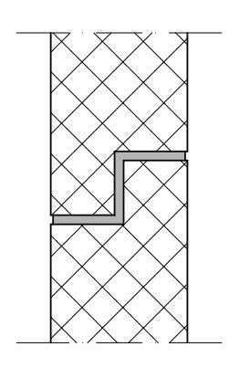 | 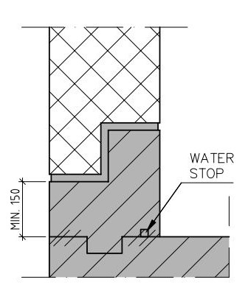
Figure 3 Joint in precast concrete wall with radiation shielding requirements | Figure 4 Upstand of in-situ cast concrete

Seismic Design
At this stage, there is no seismic requirements for the H09 facility, as stated in [8].

Moisture
Moisture design shall be performed in accordance with the requirements stated in [9].

DESIGN OF CONCRETE STRUCTURES

Concrete
Table 4.1 presents the material partial safety factor for concrete properties according to [10]

Table 4.1 Material partial safety factor for concrete
Design situation | Partial safety factor, $γ_{c}$
Persistent and transient | 1.5
Exceptional | 1.2

Reinforcement
The reinforcement will consist of K500C reinforcement bars. Table 4.2 presents material partial safety factors for reinforcement according to [10].
Table 4.2 Material partial safety factor for reinforcement
Design situation | Partial safety factor, $γ_{s}$
Persistent and transient | 1.15
Accidental | 1.0

Nominal material properties for the reinforcement:
Yield strength: ${\text{f}}_{\text{yk}}=500$ MPa
E-modulus: ${\text{E}}_{\text{cm}}=200$ GPa.

DESIGN OF STEEL STRUCTURES

Steel structures in general
Table 5.1 presents material partial safety factors for steel according to [11].
Table 5.1 Material partial safety factor for steel
Design situation | Partial safety factor, $γ_{s}$
Persistent and transient | 1.0
Accidental | 1.0

Steel materials according to table 8 in [4].

Ventilation stack
Design is performed according to regulations stated in [12].

Runway beams, overhead crane
Design is performed according to regulations stated in [13].

LOAD CONDITIONS
The loads acting on the structure have been categorised as permanent, variable or accidental loads. The loads presented in the following sections are the presented with their characteristic values.

Permanent actions
- Self weight
The self weight of the structures and equipment shall be considered.
Self weight of installations is assumed to be 0,5 kN/m²

Variable actions
- Snow load
s_{k} = 1,5 KN/m². Snow concentrations (e.g. on roof adjacent to a taller building) shall be considered.

- Wind load
V_{b} = 26 m/s. Terrain Category 1.

- Imposed loads
Live loads shall be considered, see load plans in structural drawings.

- Loads from overhead cranes
Overhead cranes with capacities according to [14] shall be considered. Loads, and operating classes of the cranes shall be acquired from Transport System Owners in detail design phase.

- Loads from forklift
According to part 1-1, chapter 6.3.2.3 in [15]. Forklift are assumed to be of class FL5, which will meet the requirement of lifting capacity of minimum 5 tons as stated in [14]. Loads from forklift can occur simultaneously with live loads and loads from vehicles.
Loads from forklift can occur in any point in the following areas:
H09.100.1001 Grouting room
H09.100.1003 RRS (LSC)
H09.100.1008 Low intermediate lvl storage
H09.100.1009 Overhead crane hall
H09.100.1019 Nuclide characterisation
H09.100.1020 Maintenance workshop
H09.100.1021 Decontamination
H09.100.1022 Hot works
H09.100.1023 Sorting

- Loads from vehicles
Loads from ATB12K+transport vehicle should be considered. Weights and geometry, see [16].
Loads from ATB 12K+transport vehicle is assumed to occur in any point in a strip zone of approximately 6 metres width in room H09.100.1009, Overhead crane hall. Loads from ATB 12K+transport vehicle can occur simultaneously with live loads and loads from forklift.

Accidental actions – exceptional
- Exceptional internal water pressure
Water pressure on tank room walls in case of flooding shall be considered in the design. Water level is assumed to be 1,5 metres over FFL.
- Accidental actions from forklifts
According to part 1-7, chapter 4.4, in [15]:
F_{d}=5*W, where W is the sum of the net weight and hoisting load of a loaded truck.
Height of impact: 0,75 m above floor level.

- Accidental actions from cranes
Loads shall be acquired from Transport System Owners in detail design phase.

- Accidental actions from load drops
F_{k}=10 kN according to [4]

LOAD CASE COMBINATIONS
According to Annex A1 in [17]. Effects of actions that cannot occur simultaneously due to physical or functional reasons do not need to be considered together in combination of actions.

References

[1] | ESS-0066113, DM--SD-TBSIDDH09-System Description H09 Structure.
[2] | PAKT / TBY – Technical regulations for surface treatment.
[3] | EKS 10, Boverket.
[4] | ESS-0003980, DM-AA-DEPDGDPS-Design Manual Structural.
[5] | ESS-0031401, EN--AA-MAQU------CF Sustainability requirements.
[6] | ESS-0005223, G02-DT-TBSIGD----GDR.
[7] | ESS-0002381, BR01DT-TBSIGDPS--Fire Safety Strategy Report.
[8] | ESS-0082503, DM--SR-TBSIDDH09-System Requirements H09 Structure.
[9] | ESS-0068129, DM--DT-DEDDGD----General Moisture Safety Programme.
[10] | SS-EN 1992-1, Swedish Standards Institute.
[11] | SS-EN 1993-1, Swedish Standards Institute.
[12] | SS-EN 1993-3, Swedish Standards Institute.
[13] | SS-EN 1993-6, Swedish Standards Institute.
[14] | ESS-0046980, DM--SD-TBSIDDH09- System Description H09 Transport.
[15] | SS-EN 1991-1, Swedish Standards Institute.
[16] | ESS-0149584, DM--DT-DEPDGDPS--Radioactive Waste Transport Container ATB12K and applicable vehicles.
[17] | SS-EN 1990, Swedish Standards Institute.
[18] | ESS-0006406, AK01RA-DEPGGDPS--General review of acoustic design.

symbols
Symbol | Description

Document Revision history
Review comments to this document are made in ESS-0155076
Revision | Reason for and description of change | Author | Date
0.1  0.2  0.3  0.4  0.5 | First issue  Updated draft  Updated after Tyréns internal review  Review comments from System Owner  Updated after CF internal review | Andreas Abrahamsson  Andreas Abrahamsson  Andreas Abrahamsson  Frank Kezerle  Andreas Abrahamsson | 2017-09-29  2017-10-04  2017-10-11  2017-10-20  2017-11-06

