DM--SD-TBSIDDH09-System Description H09 Structure.docx

 | Name | Role/Title
Owner | Frank Kezerle | System Owner
Reviewer | Per Persson  Boris Kildetoft  Frank Kezerle  Tobias Hörnfeldt | Waste manager  Building owner  System owner architectural and structural  Requirement engineer
Approver | Boris Kildetoft | Building owner

Table of content

Table of content………………………………………………………………………….2
1. Introduction 3
1.1. Purpose of the document 3
1.2. Definitions, acronyms and abbreviations 3
1.3. References 3
2. Structure Purpose 6
3. Concept of operations 7
3.1. System Stakeholders 7
3.2. Operational Scenarios 8
3.3. Life cycle 8
3.4. Context & interfacing systems 8
3.4.1. Applicable standards 10
3.4.2. Environmental, Health, Safety and Security 11
3.4.3. Radiological safety important system parts 12
3.5. Maintenance concept 12
4. System characteristics 14
4.1. System functionality overview 14
4.2. Conceptual solution of the system 14
4.3. Constraints to the system 16
5. Risks 17
Document Revision history 17

Introduction

Purpose of the document

System Description H09 structure is a description and rationale of the expected operations of the H09 structure from an architecturally functional point of view. It is a platform for stakeholder consensus to ensure that the system that is built is operationally feasible. This is a sub document of the System Description H09 Waste treatment facility [1]. All system requirements and conditions on H09 Structure are listed in the requirement document [2]. It is part of the technical baseline for the detailed design.
Chapter 2 briefly defines the structures purpose, whereas Chapter 3 describes the context of the structure and its interfaces to other systems and organisations from a black box perspective, while Chapter 4 describes the architecture of the structure and conceptual solutions.

Definitions, acronyms and abbreviations
Abbreviation | Explanation of abbreviation
CF  TD  EHS  OHS  WW  WWR  RWWS  SW  AD  NSS  SSM | Conventional Facility  Target Division  Environment Safety and Health  Occupational Health and Safety  Waste water system  Waste water system, risk (Int/Ext to H09)  Radiological waste water system (Ext to H09)  Storm Water  Accelerator division  Neutron Scattering System  Strålsäkerhets Myndigheten / Swedish Radiation Safety Authority

References

[1] ESS-0047239 “DM--SD-TBSIDDH09- System Description H09 Waste Building”
[2] ESS-0082503 “DM--SR-TBSIDDH09-System Requirements H09 Structure”
[3] ESS-0004020 rev. 2 “Waste management Plan for the ESS facility”
[4] “DM--DT-TBSIDDD02-Surface treatment”
[5] ESS-0013533 “Design Manual Accelerator Buildings / G01, G02 & G04”
[6] Planning and Building Act (2010:900)
[7] Planning and Building Ordinance (2011:338)
[8] Byggvarubedömningen (BVB)
[9] ESS-0087555 ”SKBs Acceptanskriterier för avfall till SFR”
[10] ”SS-EN 1993-2:2006; Eurokod 3 Dimensionering av stålkonstruktioner Del 3-2: Skorstenar”
[11] ”Svenska Stålbyggnadsnormer N1-N4”.
[12] ESS-0002381 “Fire Safety Strategy“
[13] ESS-0004722 “Fire and Explosion Safety Program”
[14] ESS-0006406 “AK01RA-DEPGGDPS--General review of acoustic design”
[15] ESS-0149469 “H09 Acoustic Design Report”
[16] PAKT / TBY – “Technical regulations for surface treatment”
[17] ESS-0012582 “Sustainable Selection of Materials”
[18] ESS-0031401 “CF Sustainability requirements”
[19] ESS-0068129, General Moisture Safety Programme
[20] ESS-0058749 “ESS accessibility report”
[21] ESS-0051197 “Environmental Monitoring Plan”
[22] ESS-0087557 rev. 1 “Changeroom Design, Operation and Maintenance A Nuclear Industry Code of Practice”
[23] ESS-0016468 “ESS rule for identification and classification of safety important components”
[24] ESS-0000004 rev. 5 “General Safety Objectives”
[25] “DM--DT-TBSIDDD02-Surface treatment”
[26] ESS-0003640 “ESS Concept of Operations Description”
[27] ESS-0005513, Valid Sitewide Plan, A01-01---1-A-----001
[28] ESS-0001572 – ”Säkerhetskyddsanalys ESS ERIC”

Structure Purpose

As a result of ESS operations, the facility will produce numerous residual waste products that are radioactive. This radioactive waste, depending on its type, will be treated and stored in two separate facilities. Selected intermediate level waste from the target will be treated and stored in the hot cell, located in the target building D02. All other (intermediate- and low level) radioactive waste will be treated, stored, and transported in and from the waste treatment facility (H09) to another location for disposal. H09’s architectural solutions are designed to enable and accommodate the treatment processes defined in ESS-0004020 Waste management Plan for the ESS facility [3].

Concept of operations

System Stakeholders

ESS internal Stakeholder | Stakeholder group | External stakeholder represented by ESS internal Stakeholder
CF | Operators | Facility management provider
 | Regulators | Environmental Court  Brandmyndigheten  Miljö och hälsovårdsmyndigheten  Arbetsmiljöverket  Lunds Kommun  Insurance provider  VA-Syd
Accelerator | Waste producers | SSM
 | Operators | Accelerator maintenance
Target | Waste producers
NSS | Waste producers
ES&H | Users | Räddningstjänsten  SKB  SAKAB  Studsvik
 | Regulators | SSM  Brandmyndigheten  Arbetsmiljöverket
 | Negative stakeholders | Intruders
Integrated Control System, including Personal Safety System | Interfacing system

Operational Scenarios
H09 Waste Treatment Facility Building is part of ESS Site Infrastructure (SI), it is designed to treat, store and prepare for transport selected intermediate and low-level waste produced by the ESS facility. The building also provides laboratories and office spaces.
For more in-depth description of the operational process see, see chapter 3.2 in “System Description H09 Waste Building” 1[1].

Life cycle

The life cycle of the H09 Waste Treatment Facility Building follows the operational plan for ESS, the majority of structural elements incorporated in the H09 Structure are designed and for a required life span of 50 years, Unless the elements are not accessible for maintenance then the life span shall be 100 years.
In order to reduce demolition costs the surfaces of H09 is treated accordingly “DM--DT-TBSIDDD02-Surface treatment” [4]. Also, the types of pipes cast into the slab are very limited, they only include certain parts connected to the WW and WWR (waste water and waste water system, risk is this correct?), all parts of the RWWS (Radiological waste water system) will be transported in pipes that are not cast into the slab.

Context & interfacing systems

H09 Waste Treatment Facility is located on the northeast corner of the site, between D05 and H06 and adjacent to the circular road.
H09 is connected to the D02 target station building via a subterranean culvert passing under D03 and running tight against D05, the culvert mainly contains process pipes for transporting waste liquids that are produced in various buildings, along with electric/signal cabling, and process systems.
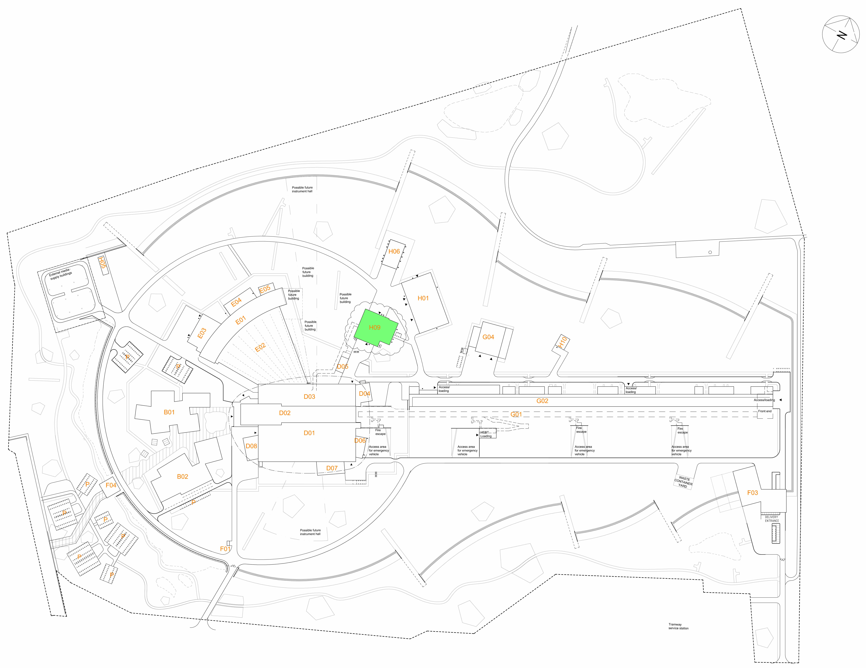
Figure 1. Location of H09
Figure 2 Interface diagram of H09 Structural
H09 Structure has interfaces to other systems as defined in Figure 2 and in the text below.

ES&H | H09 Waste management building provides a structure that includes radiation protection for ES&H functions housed in the building including staff amenities.
A Site wide | H09 Waste management building has a structural interface to VA-Syd via A Site wide for release of free release water into the sewage system and the Storm water system in order to protect H09 from external flooding. The A site wide requires the culvert of the building to be under the ground level in order to allow for surface water to exit the surrounding area in case of external flooding due to heavy rain.
H09 HVAC | H09 Waste management building accommodates HVAC systems related to handling contaminated and non-contaminated air. HVAC supplies WW and SW interface to A-sitewide, and distributes supply heating, cooling etc through the building. For details see ESS-0066112.
H09 Electrical | H09 Waste management building accommodates electrical systems for the main purpose of decontamination, also to support of the buildings day-to-day functions. For details see ESS-0066114.
H09 Process | H09 Waste management building accommodates the spaces required for the radiation management Process System to operate properly and has been designed in close dialogue with the Process team. For details see ESS-0066109.
H09 Transport | H09 Waste management building internal layout is designed facilitate transport equipment related to the buildings primary function waste management, in addition supporting daily work, logistics, necessary maintenance work and repairs. For details see ESS-0046980.
H09 ELV | Waste building H09 supply space for ELV in H09.100.1052. For details see ESS-0066114.
H09 Fire and Explosives | Waste building H09 is designed in accordance to relevant fire regulations such as means of egress, materials, fire compartments and structural fire resistance. The building accommodates an automatic sprinkler system and sprinkler mains. The central is found in H09.100.1051. For details see ESS-0002381, for fire compartments see ESS-0150420.

Applicable standards
H09 is designed in accordance to “Design Manual Accelerator Buildings / G01, G02 & G04, ESS-0013533” [5].
Design follows relevant chapters and sections of the Planning and Building Act [6], and the Planning and Building Ordinance [7].
Built in products in H09 will be certified according to Byggvarubedömningen [8] (Building Material Assessment, BVB).
The system is designed in accordance to Waste Management Plan for the ESS facility 3[3] as well as ESS-document Acceptanskriterier för avfall till SFR [9] (Acceptance criteria for waste to SFR).
The wall thickness of the ventilation stack is dimensioned according to SS-EN 1993-2:2006; Eurokod 3 Dimensionering av stålkonstruktioner, Del 3-2: Skorstenar [10] (Dimensioning of steel constructions, Part 3-2: Chimneys) and Svenska Stålbyggnadsnormer N1-N4 [11] (Swedish Steel Construction Norms).

Environmental, Health, Safety and Security
Means of egress, materials, fire compartments and structural fire resistance conforms with the description in ESS-0002381 “Fire Safety Strategy” [12].
ESS-0004722 “Fire and Explosion Safety Program” shall be applied for prevention of damages resulting from fire or explosion as an initiating event. [13]
H09 shall conform with description in ESS-0006406 “General review of acoustic design” [14] and ESS-0149469 “H09 Acoustic Design Report” [15].
All materials and all surfaces in the controlled area, (included Barrier area H09.100.1016 and changing room floors in H09.100.1061 and H10.100.1066) will be chosen according to PAKT / TBY – “Technical regulations for surface treatment” [16] in order to ease decontamination.
Materials used will be in accordance to ESS-0012582 “CF Plan for Sustainable Selection of Materials” [17], and ESS-0031401” CF Sustainability requirements” [18].
H09 shall conform with description in ESS-0068129 General Moisture Safety Programme [19].
H09 will be accessible according to applicable laws and regulations, with certain dispensations. This is defined in ESS accessibility report [20].
Space and penetrations reserved for equipment devoted to environmental monitoring and samplings, in accordance to ESS-0051197 rev.2 “Environmental monitoring plan” [21].
Design of changing room is done considering the ESS-document ESS-0087557 rev. 1 “Changeroom Design, Operation and Maintenance A Nuclear Industry Code of Practice”. [22]

Radiological safety important system parts
General considerations have been taken to “ESS rule for identification and classification of safety important components” [23].
The concrete walls of H09 shall contribute to shielding in conjunction with mobile shielding blocks, sufficient to insure that the dose rate outside H09 is at an acceptable level, as specified in the ESS-document ESS-0000004 rev. 5 “General Safety Objectives”. [24]
As mentioned a large extent the necessary shielding will be achieved with movable concrete shielding blocks. The floor areas where such shielding is required are dimensioned to house the anticipated functions as well as temporary shielding blocks. A functional user point load plan should be devised in DD ex E02.
Applicable doors, gates and openings have been placed in consideration to radiation sources in order to minimise the dose exposure to the staff as well as facilitate communications within the building.
The position of each different space in the building is selected according to the planned activity and the anticipated radiation levels of this space so that the most highly radioactive areas will be placed as far away from the staff rooms as possible, and as close to the target wheel as possible. The staff rooms and radiological-laboratory are positioned as far as possible from the target wheel in order to minimize the radiation to the staff from both waste in the waste building and the target.
The floor areas within the workshops and basement level in H09 Waste Treatment Facility Buildings will be surface treated in accordance with “DM--DT-TBSIDDD02-Surface treatment” [25].
Uncontrolled and unmonitored gaseous and liquid leakage of radionuclides is prohibited through the design of the structural construction and HVAC systems.

Maintenance concept

H09 Structure common parts and installations will follow ESS Facilities Management plan for maintenance.
All surfaces within the controlled area shall be according to PAKT / TBY – “Technical regulations for surface treatment” 16[16] to ease cleaning and maintenance.
All pipes and functions in the RWWS shall accommodate for inspections.
All openings and doors in all rooms except H09.100.1007 shall be designed so that the equipment can move in and out without needing to be demolished.
Over all maintenance is described in “ESS Concept of Operations” [26].

System characteristics

System functionality overview
Designed for treatment and storage of intermediate-, and low level waste, the building will house functions for:
- Handling and processing of radioactive waste, consisting mainly of solid, liquid and mixed waste.
- Decontamination of components that are going to be serviced, re-used, free-released, recycled or any combination of these.
- Segregation of waste types that are subject to different types of treatment, clearance and/or discharge.
- Compaction and volume reduction.
- temporary storage of radioactive waste.
- Conditioning, packing and characterization of radioactive waste that will be transported out from the ESS facility.
- Controlled area maintenance workshop devoted for maintenance of processing utilities.
- Decontamination of firetrucks.
The building is divided into two principal zones; a controlled and an uncontrolled area. The controlled area is referring to the parts of the building where all handling of radioactive waste or contaminated material as described above is taking place.
The uncontrolled area is referring to spaces where radiation is not above normal levels and contains mainly the office areas. H09 is dimensioned for 6 full time equivalent (FTE) working in the office area. The office will also contain a control room, a meeting space for 10 people and a space for a break with coffee machine and kitchenette. The office part also contains the dressing rooms and a Barrier Area that is the sole entrance to the controlled area for personnel. The barrier area acts as buffer zone between the controlled area and the uncontrolled area. The dressing rooms are dimensioned for a maximum capacity of 16 people (10+6) with one larger and one smaller room.
Access from the culvert into H09 is done through a basement level. The basement also contains a sedimentation basin meant to contain water from the fire suppression system from the controlled area that may be contaminated, it is accessed through a hatch located in room H09.100.1002.

Conceptual solution of the system
The building is organized as two connected volumes, where the controlled area defines a larger volume and the uncontrolled area a smaller volume. The exceptions in the larger volume is the uncontrolled cementation room H09.110.1002 and room H09.115.1001 for uncontrolled ventilation, including the staircase to this room. The exceptions in the smaller volume is the lab areas etc. including the barrier area H09.100.1016.
The large volume for the controlled area consists of three levels (100, 110, 115) served by 4 separate staircases. It is organised around a bigger full height hall containing an overhead crane where heavy goods can be unloaded and transported to the adjacent rooms for further treatment. On the second level, some spaces are reserved for storage and functions related to grouting and water treatment. The third level (115) contains HVAC rooms for both controlled and uncontrolled area, as well as a room dedicated for monitoring of the ventilation stack.
The structure for the large volume consists of precast concrete columns and precast concrete beams, in four supporting lines. The roof and the floor for level 110 and 115 consist of precast hollow core slabs, spanning in east-west direction. The perimeter walls of the controlled area are made of precast concrete, to contribute with sufficient radiation shielding to the outside. There are also internal walls of precast concrete, with shielding functions. All precast concrete walls, both exterior and interior, stands upon an upstand of in-situ concrete, to ensure water tightness in case of leakage of contaminated water and helps the building to withstand external flooding. The concrete walls also serve as stabilisation for the columns- and beam system and functions as radioactive protection.
The smaller volume with windows and entrance facing east, containing uncontrolled spaces and controlled laboratories, is a single level steel structure, with columns and roof truss beams, supporting the roofing. Some walls are made of precast concrete, and act as both vertical supports, and stabilising structure. This is where all the windows of the H09 building are found, providing the open plan office and staff room with natural light.
The personnel enter H09 Waste Treatment Facility Building via the main entrance to the east at level 100. A central foyer gives direct access to barrier area, office, associated control room, storage and technical spaces.
Personal and goods logistics are described in detail in chapter 4.2.1 of “System Description H09 Waste Building” 1[1].
The façade of the building is designed in accordance to Design Manual Accelerator Buildings / G01, G02 & G04, ESS-0013533 [22]. The larger volume are covered in custom bend steel plates C14 and the smaller volume in steel plates C11. Doors, gates, windows and louvres are placed within a alucobond cladding which has been reviewed by the project lead architect.
External staircase to cementation room shall be integrated with adjacent façade material (C14) for maintaining a homogenised expression.

Constraints to the system
The architectural development of the building has been affected by a few constraints, some of the more significant are related to the buildings footprint and size of the envelopes.
The position of the building is defined by the valid site wide plan [27]. The footprint shall not interfere with existing or planned roads or pipework. The distance between the road lane and the building needs to be at least 3.0 m. The free space from the pipes to the building needs to be at least 3.5 m. The culvert connecting H09 with D02 limits the westwards position.
The height of the building is regulated by transport documentation to be developed in DD phase, the height of the ventilation stack is set to approximately 25m.
Consideration to levels of radiation has been a dictating aspect throughout the design work and have been the major constraint in the layout of the functional spaces. This is relating to both the waste treated and stored in the H09 building and the target. Aspects of radiological safety is further explained in chapter 3.4.3. of this document.
Some of the technical equipment such as overhead cranes have not been investigated in detail and might result in further constraints to the system in a detail design phase.

Risks
Tank room walls will not be demountable, meaning tanks will require out-transportation through then buildings available openings.
Windows have been limited to the office part of the building, this is partly due to safety reasons as windows are considered an increased risk of intrusion.
A further investigation of the overhead crane, as mentioned in chapter 4.3 of this document, might result in slight adjustments of the building height during the DD phase.
The final dimensions of the outer walls shall be coordinated to conform with module dimensions of the façade material. This might result in minor adjustments in a detail design phase.
The internal layout of the laboratories has not been fully investigated and might be subject of further change in detail design.
A thorough risk analysis can be found in ESS-0001572 Säkerhetskyddsanalys ESS ERIC (Security Protective Analysis) [28].

Document Revision history
Review comments are found in ESS-0155076
Version | Reason for revision | Date
1.0 | New document | 2015-06-01
1.1 | Made some initial changes/Tobias | 2017-09-01
1.2  1.3  1.4  1.5  1.6 | Initial draft / Viggo  Updates per input from relevant disciplines / Viggo  Document finalized for review / Viggo  Review with comments /Frank Kezerle  Update with review comments incorporated / Viggo | 2017-09-15  2017-09-19  2017-09-20  2017-10-25  2017-11-03

