|  |
| --- |
|  |
|  |
|  |
|  |
|  |
|  |
|  |
|  |
|  |
|  |
|  |

|  | Name |
| --- | --- |
| **Owner** | Martin Hansson, System Owner |
| **Reviewer** | Martin Hansson, System Owner |
| **Approver** | Boris Kildetoft, Building Owner |

Table of content

Table of content 2

1. Introduction 3

1.1. Purpose of the document 3

1.2. Definitions, acronyms and abbreviations 3

2. Referenser 3

3. System Purpose 4

4. Concept of operations 4

4.1. System Stakeholders 4

4.2. Operational Scenarios 5

4.2.1. States of operation 5

4.3. Context & interfacing systems 6

4.3.1. Applicable standards 6

4.3.2. Environmental, Health, Safety and Security 7

4.3.3. Radiological safety important system parts 7

4.4. Maintenance concept 7

5. System characteristics 7

5.1. System functionality overview 7

5.2. Conceptual solution of the system 7

5.3. Description of mechanical equipment 11

5.4. Description of control and regulation systems 12

5.5. Constraints to the system 13

6. Risks 13

Document Revision history 13

# Introduction

## Purpose of the document

This document is a description and rationale of the expected operations of the H09 Process system which is part of H09 Waste Building. It is the preliminary design of the H09 Waste Building. It is a platform for stakeholder consensus to ensure that the system that is built is operationally feasible. Requirements on the system are listed in the System Requirements Specification [1].

## Definitions, acronyms and abbreviations

|  |  |
| --- | --- |
| Abbreviation | Explanation of abbreviation |
| H09 | Waste Building |
| CWL | Cooling Water Low temp |
| CWM | Cooling Water Mid temp |
| CWH | Cooling Water High temp |
| DHL | District heating Low temp (ESS) |
| IAR | Instrument Air |
| DIW | De-ionized Water |
| N2G | Nitrogen gas |
| CF | Conventional Facilities (organisation) |
| SI | Site Infrastructure (system) |
| CUB | Central Utilities Building |
| RWWS | Radiological Waste Water System |

# References

|  |  |
| --- | --- |
| [1] | ”ESS-0046903, DM--SR-TBSIDDD02-System Requirements D02 Process”. |
| [2] | ”ESS-0043566, SI Process”. |
| [3] | ”ESS-0007857, CF Design manual Technical systems”. |
| [4] | ”ESS-0035298, Process Design Instructions”. |
| [5] | ”ESS-0046901, Process Flow Charts D and E buildings”. |
| [6] | ”ESS rule for identification and classification of safety important components, ESS-0016468”. |
| [7] | ”Envelope drawings from AD, ESS-0006000”. |

# System Purpose

Main function of H09 Process is to provide:

* Handling system for Waste Water generated by ESS
* Unit Operations for decontamination of Liquid Waste
* Cooling Water Low temp (CWL) for cooling applications
* District Heating Low temp (DHL) for heating applications
* Instrument Air (IAR) for control applications and general needs of pressurized air
* De-ionized Water (DIW) for local cleaning and decontamination applications
* Nitrogen gas (N2G) for general use
* Piping for Radiological Waste Water (RWWS) from D02 to Waste Building

General definitions of the systems are found in the Site Infrastructure System Description for Process. [2]

# Concept of operations

## System Stakeholders

The main stakeholders for H09 Process are:

* Target Division
* Science Directorate
* CF HVAC systems
* H01 Central Utility Building Process system

## Operational Scenarios

Operation of Process system handling Utility Supply will vary between maximum loads and very low loads as described in Site Infrastructure description [2] No planned shutdown of these Process systems for service or maintenance is foreseen.

### States of operation

The Process Waste Liquid Handling System is Batch wise operated. The basic operation philosophy is described as follows:

* Liquid Waste is received into one in the three pairs of parallel tanks.
* When the level reaches 75% or for any other reason the flow of Waste Water is directed to the other parallel tank and the Waste is sampled and analysed in the laboratory in house.
* Depending on the results of the Analysis, one or more of the following Unit Operations is used to decontaminate the Liquid Waste:
  + Oil Separator
  + Mechanical Filtration
  + Ultra-Filtration
  + Ion Exchange Resin Filtration
  + Evaporator
  + Boiler
* The Waste Water is recycled and analysed to verify that the decontamination is completed.
* Decontaminated Waste is transferred to one of two Release Tanks, sampled, analysed and if specifications are met released to Domestic Sewer. The sample is put in storage for reference.
* If contaminants are present which are not possible to treat in the Process system described, the specific batch of Waste Water is shipped via tank truck for treatment outside H09. This may include potable water contaminated with chemicals.
* Spend Ion Exchange Resin is transferred to a dedicated hold tank to let the radioactivity decay and is later solidified together with filtration sludge into concrete moulds for final storage.

## Context & interfacing systems

Figure 1: Context diagram of H09 Process (with subsystems). Blue systems are fed by the H09 Process. Green systems are feeding the systems. Orange systems have a spatial interface.

|  |  |
| --- | --- |
| H01 Process | H09 Process is supplied by H01 Process via D04. |
| Target Waste system | H09 Process purifies Liquid Waste from Target |
| H09 Structure | H09 Structure is providing required space for H09 Process. |
| D/E Waste system | H09 Process purifies Liquid Waste from Target |
| Domestic Sewer | H09 Process is transferring purified Waste Water to Domestic Sewer (VA Syd) |
| H09 HVAC | H09 Process is providing CWL and DHL. |

All Process media conditions, except for N2G, is set and controlled at H01 CUB and comply with stakeholder requirements.

### Applicable standards

Design shall follow CF Design Manual [3] and Process Design Instructions [4].

### Environmental, Health, Safety and Security

See SI Process [2]

### Ra**d**iological safety important system parts

Piping for Radiological Waste Water and Risk Waste Water needs to be designed and installed according to ESS radiological classification.

Other CF Process system must not be subject to SSM (Swedish Radiation Safety Authority) related requirements. When connecting to CF Process systems it is within the responsibility of the connecting party to establish safety critical barriers when needed.

## Maintenance concept

H09 Process systems mainly consist of tanks and piping system with low maintenance requirements. Some replacement of leaking valves and gaskets can be expected at long intervals.

The installed pumps require planned or condition based maintenance.

The installed Unit Operations (filters, Ion Exchange unit, boiler) require planned and condition based maintenance.

# System characteristics

## System functionality overview

The Process systems in the building consist of tanks, pumps, distribution piping, control valves and block valves for interfacing with Utility Consumers, Waste sources and Domestic Sewer.

In addition, there are several Unit Operation necessary for decontamination, see 5.2

## Conceptual solution of the system

A schematic overview can be seen in Process Flow Charts [5] and is described as follows:

The capacity for the water treatment shall be sized so that the largest volume (laboratory waters 120 m3 / two weeks) can be treated. This gives the system the capacity of 0,5 m3 – 1 m3 per hour.

The purpose of the waste water treatment is to get rid of the radioactivity in the water in order to be able to discharge the water into the municipal sewage network. At the moment it is impossible to estimate exact amount of activity that has to be removed. Also the chemical composition of the water (total solid content, total dissolved particles, colloidal particles and tritium content) will have a huge impact on what kind of treatment phases are required.

**The treatment concept here is based on very conservative approach. The technologies are chosen so that even the worst possible water source can be treated and discharged.** The secondary waste generation of the equipment is minimized by choosing the technologies based on best available technology.

First, most of the larger particulates in the waste stream must be removed to prevent fouling in the next stages of treatment. Best option for particle filter is back washable mechanical filter for several reasons. First of all, the filter cleans itself when pressure differential between inlet and outlet increases too high. Another threshold can be set for the contact dose rate of the filter device. The cleaning process does not interrupt normal operation. The cleaning water with the hot particles is guided to a small retention tank or drum. Second, there are no parts that require changing and therefore no secondary waste is generated. Examples of the mechanical filter are presented in Figure 7 and Figure 8.

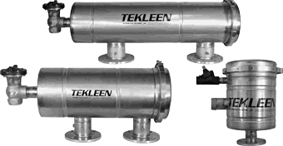

Figure 7. Tekleen back washable mechanical filter



Figure 8. Eaton tubular back washable mechanical filter

Next treatment phases will be determined by the water composition. Cooling waters usually contain activated corrosion products in various forms (ionic salts or colloidal particles). Spill and floor drain waters are high in particle content. Waters from laboratories may contain chemicals and radioactive substances. The rough comparison of the contaminant removal capabilities of different technologies is presented in Figure 9.

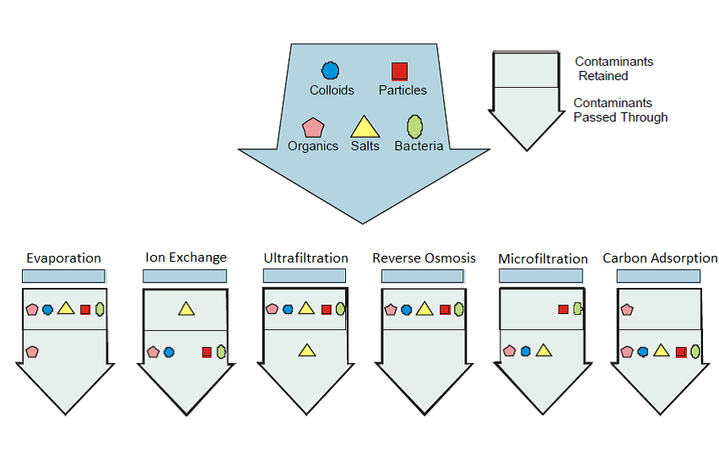

Figure 9. Contaminant removal capabilities of different technologies

To be able to process all of the possible contaminants in the waste water streams, the equipment must be able to remove particulates, salts, organics and colloids in an efficient way.

Ultrafiltration + Ion exchanger

Ultrafiltration technology has been studied and used widely in mainly because discharge requirements have become so strict. Ultrafiltration has been proven very effective in removing colloidal particles and organics from the stream. The technology generates a retentate stream which is usually very small compared to the permeate stream. From past experiences this equipment was used to treat 30 m3 of waste water and the concentrate amount was only 2 liters. Decontamination efficiency was also very high. The activity level at the beginning was 25 000 Bq/l and the permeate had only 20-100 Bq/l of the activity left.

The permeate from ultrafiltration may still contain some radioactive ions. Mixed bed ion exchanger removes salts in ionic form from the waste stream. Ion exchanger column is loaded with ion exchange resins. Resins are chosen based on the nuclides that need to be removed. Purolite and Amberlite nuclear grade resins are widely used. All of the radioactivity will be contained in the resins and the resins have to be changed periodically. The saturated resins will be solidified in cement. The Westinghouse manufactured ion exchanger column is presented in Figure 10.



Figure 10. Ion exchanger column

Overall treatment phases are presented in Figure 11.

Backwashable mechanical filter

Ultrafiltration

Ion exchanger

Discharge to VA-SYD

Tritium treatment

Concentrates

Filter backwash water

Resins

UF retentate

Drying / solidification

Solidification

Optional phase for cooling waters

Discharge to atmosphere

Figure 11. Mechanical filter + Ultrafiltration + Ion exchanger

## Description of mechanical equipment

Equipment that is described here are **based on the option #1** that was previously discussed. In a separate appendix (ANNEX #7) a process flow chart for waste water treatment is presented.

Collection tanks (5 tanks, room 1H9-01) are connected to the pumps at the room 1H09-17. Each tank shall have its own pump to prevent cross-contamination. The pumps shall have capacity to pump 5 kg/s. The waste waters from the tanks are pumped to the mechanical filter first (room 1H09-02). **Each treatment stage shall have a bypass line so that the stages can be used independently from each other**.

Mechanical filter has two outlet connections. One outlet flows to the tank/drum/container that will store the backwashing water. The other outlet is connected to the ultrafiltration device.

Ultrafiltration device has two outlet connections. One outlet flows to the same tank/drum/container that is used for mechanical filter. The water from this outlet contains the concentrated water that will not pass the UF membrane. The other outlet (UF permeate) will be connected to the ion exchanger column.

The ion exchanger column has an inlet from UF device and an outlet to the release tanks. There shall also be an optional connection to the tritium treatment equipment. The column itself has also filling and emptying flanges. Filling of the column is done by simply pouring the resins into the column. The emptying process requires a connection to the resin collection tank which is located at the same room. The outlet from the column requires a resin catcher filter with approximately 200µm pore size to prevent any resin beads from escaping.

Piping systems should generally be designed for low pressure drop to achieve stable service conditions. Typical values are <1,5 m/s for liquid and <15 m/s for gas. For other services or short piping, higher values can be accepted.

See 4.2.1 for a detailed Operation Description of the H09 Process system.

## Description of control and regulation systems

All of the pumps and valves shall be operated from the local control room 1H09-23.

Collection and release tanks shall be equipped with water level indicators to be able to initiate the purification or release cycle at a given threshold.

Mechanical filter shall have pressure drop measurement and a dose rate measurement in order to determine the need for backwashing.

Ultrafiltration device shall have pressure drop measurement in order to determine the need for membrane changing.

The ion exchanger column shall have conductivity measurement after the column in order to determine when the resins have become too saturated.

There shall be sampling points after each purification step in order to determine the effectiveness of the treatment stage.

Alarm signals shall be visible from the local (waste building) control and the ESS main control room.

Programmed sequences for using parts of the system, sub sequences and different unit operations depending on analysis results shall be available to operators via the control system.

## Constraints to the system

The Process system is designed based on specified requirements for operations 2025. No allowances are made for future requirements.

# Risks

Risk analyses of Process systems, Hazop or similar, shall be carried out in Detailed Design. Identified risks and performed actions shall be part of Detail design delivery package.

Document Revision history

| Version | Reason for revision | Date |
| --- | --- | --- |
| 1.0 | New document | 2017-09-04 |
|  |  |  |
|  |  |  |