BR01DT-TBSIGDPS--Fire Safety Strategy Report.docx

 | Name | Role/Title
Owner | Björn Yndemark | Fire Engineer, CF
Reviewer | Fredrik Jörud | Fire Engineer, ES&H
Approver | Fredrik Österberg | CF Baseline Team Lead

Table of content | Page
Introduction 6
1. DESIGN input Parameters for Fire Safety 8
2. DESIGN METHODOLOGY 19
3. MEANS OF EGRESS 20
3.1 Evacuation strategy 20
3.2 Travel distance 24
3.3 Escape width 25
3.4 Accessibility, hardware 25
4. MATERIALS, SURFACE FINISHES AND COATINGS 26
4.1 Ceiling, walls and floor coating 26
4.2 Coating on smaller surfaces, not including escape route 26
4.3 Exterior Walls 27
4.4 Roof coating 28
4.5 Interior linings or combustible materials within escape routes 28
5. PREVENTION OF FIRE SPREAD BETWEEN FIRE COMPARTMENTS 28
5.1 Fire separating structure 28
5.2 Fire Compartmentation 29
5.3 Special areas/Construction parts 39
6. FIRE SPREAD BETWEEN BUILDINGS 40
7. STRUCTUrAL FIRE RESISTANCE 40
7.1 General 40
7.2 Accelerator tunnel (G01) 43
7.3 CUB (H01) 43
7.4 Gallery building (G02), Compressor building (G04), H05, H06, D05 and HEPT Loading Bay 44
7.5 Target (D02) and Experimental Halls 1 (D01), 2 (D03), 3 (E01) and Guide Hall (E02) 44
7.6 Instrument office and labs. buildings D04, D06, D07, D08, E03, E04 and E05. 49
7.7 Sprinkler building, H10 50
7.8 Waste treatment building (H09) 50
7.9 Inner ceilings 50
8. VENTILATION SYSTEMS 51
8.1 Protection from the spread of smoke 51
8.2 Protection from the spread of fire 51
8.3 Detection 52
8.4 Materials and construction 52
8.5 Coal filters 53
8.6 HVAC and RGEC in the Target 53
9. FIRE SAFETY PROVISIONS 53
9.1 Sprinkler system 54
9.2 Portable fire extinguishers 60
9.3 Standpipes 60
9.4 Smoke ventilation 60
9.5 Alarm system 61
9.6 Lighting and signage 65
10. FIRE SERVICE INTERVENTION 66
10.1 Fire service provisions and accessibility 66
10.2 Residual Fire water 67
10.3 Intervention plan 68
11. FLAMMABLES 68
12. EXPLOSIVE ATMOSPHERE 68
13. Verification plan 68
14. References (INternal) 69
15. References (APPENDICIES) 70
Document Revision history 70

list of tables
Table 1. Building classification of different buildings. 16
Table 2 Activity classification (according to BBR 20 Section 5:21) within the buildings 17
Table 3 Coating requirements on structures and internal linings. 26
Table 4 Requirements of partitioning constructions Br1 28
Table 5 Fire compartmentation. 29
Table 7.1 Seismic classification and demands on building structures for H3 and H4 events²⁾ 41
Table 2 Building structural elements G01 43
Table 3 Building structural elements CUB (H01) 43
Table 4 Building structural elements Gallery building (G02), Compressor building (G04), H05, H06, Front End building and HEPT Loading Bay 44
Table 5 Building structural elements in D01 and D03 44
Table 6 Building structural elements in D02 46
Table 7 Building structural elements in E01 and E02. 49
Table 8 Building structural elements D04, D06, D07, D08, E03, E04 and E05. 49
Table 9 Building structural elements H10. 50
Table 2 Building structural elements H09 50
Table 10 Proposed protection level for the different areas. 53
Table 11 Hazard classifications etcetera in the Gallery. 56
Table 12 Hazard classifications, system types, density, area of operation, duration. 57
Table 13 List of sprinkled rooms in Target and Instrument buildings (divided into different building levels and different buildings). 58
Table 14 Hazard classifications etcetera in Target and Instrument buildings 59
Table 15 Hazard classifications etcetera in building H10 59
Table 15 Hazard classifications etcetera in building H09 60

list of Figures
Figure 1. Site plan. 8
Figure 2: Part of the accelerator tunnel and one emergency staircase. 9
Figure 3: Part of the front end building (level 090). 9
Figure 4: Part of the HEBT loading bay (level 090). 10
Figure 5: Compressor building (G04). 10
Figure 6: Part of the gallery building (G02). 11
Figure 7: Target. 12
Figure 8: Experimental hall 1 (D01). 13
Figure 9: CUB (H01). 14
Figure 10: Waste treatment facility building (H09). 15
Figure 11: Principle fire compartmentation. Dashed dotted line (red) indicates fire compartment wall, EI 60. 32
Figure 12: Principle fire compartmentation. Dashed dotted line (red) indicates fire compartment wall, EI 60. 32
Figure 13: Principle fire compartmentation. Dashed dotted line (red) indicates fire compartment wall, EI 60. 33
Figure 14: Principle fire compartmentation. Dashed dotted line (red) indicates fire compartment wall, EI 60. 33
Figure 15: Principle fire compartmentation. Dashed dotted line (red) indicates fire compartment wall, EI 60. 34
Figure 16: Principle fire compartmentation in the tunnel. Dashed dotted line (red) indicates fire compartment wall, EI 60. 34
Figure 17: Principle fire compartmentation in HEPT loading bay. Dashed dotted line (red) indicates fire compartment wall, EI 60. 35
Figure 18: Principle fire compartmentation in the HEBT loading bay. Dashed dotted line (red) indicates fire compartment wall, EI 60. 35
Figure 19: Principle fire compartmentation in the front end room. Dashed dotted line (red) indicates fire compartment wall, EI 60. 36
Figure 20: Principle fire compartmentation in the tunnel/front end. Dashed line (blue) indicates fire wall REI 60-M. 36
Figure 21: Principle fire compartmentation in the Compressor building (G04). Dashed dotted line (red) indicates fire compartment wall, EI 60. 37
Figure 22: Principle fire compartmentation in the Cryo Tunnel Line CTL (G04). Dashed dotted line (red) indicates fire compartment wall, EI 60. 37
Figure 23: Principle fire compartmentation in CUB (H01) level 100. Red dotted line indicates fire compartment wall, EI60. 38
Figure 24: Principle fire compartmentation in CUB (H01) level 120. Red dotted line indicates fire compartment wall, EI60. 38
Figure 25: Principle fire compartmentation in H05 level 100. Red dotted line indicates fire compartment wall, EI60. Outer walls are not fire rated. 39
Figure 26: Principle fire compartmentation in H06 level 100. Red dotted line indicates fire compartment wall, EI60. Outer walls are not fire rated. 39
Figure 27. Schematics for sprinkler basins and pumps. 55
Figure 28 Principle of connection of Central Units 62

Introduction

Fire Safety Strategy
The objective of this report is to provide a coordination document for the design team communicating the requirements for fire and life safety in the project. The purpose of this document is to show how fire protection of the herein described buildings can be ensured. This report applies as a basis for the fire protection and fully covers requirements according to Act for Planning and Building. In addition, requirements will apply on protection for ionising radiation and protection of property and liability as described in ESS-0002642 [A] and ESS-0001051 [B] and ESS-0043151. Fire related requirements of radiation safety are incorporated to a certain extent. Fire protection of barriers for radiation safety- and radiation safety related functions will be specified in a later version, when those systems need of protection are specified and lined out in the facility.
This version of the document has been prepared during the baseline team work of H09 building but it also describes the requirements for other buildings, establishing the solutions and developing the preliminary design (PD) as the basis for the detailed design.
Campus buildings (B01-B10) and F02 are not included in this fire safety strategy report because they have another building owner. H09 is to be included when the preliminary design of that building is finalized.
The level of the documentation is “preliminary design” (“systemhandling”). There will be no “for construction version” of this document but the document will be revised to an “as built version” when all the buildings are finalized.

Drawings
This version of the Fire Safety Strategy has been based on the draft architect drawings, dated 27-09-2017.

Revisions
This version of the document has been prepared during the baseline team work of H09 and it describes the requirements for that and other buildings, establishing the solutions and developing the preliminary design (PD) as the basis for the detailed design.
Revised sections are marked with a solid line.

QA
This document is subject to quality control in accordance with WSP’s quality system certified to ISO 9001 and ISO 14001. This means that another fire engineer reviews the conditions and the reported practice of fire protection. A separate review report is produced.
This document is review by Fredrik Jörud, Fire Safety Engineer at ES&H. This revision is reviewed with regard to completions for H09 building on a “Systemhandling-level”. The review does not mean that all text from previous revisions are approved.

DESIGN input Parameters for Fire Safety
The first part of the report is to guide the fire brigade and to get a quick overlook of the project. There are multiple purposes with the report; Satisfy the local authorities and collect all fire related requirements to the detailed design team.

Site description
ESS will locate its facility on a 74.2 hectare site situated northeast of the town of Lund in the region of Scania in southern Sweden. The site is located between Odarslövsvägen and the E22 highway at kv. Östra Odarslöv 13:5.
The ESS site is located on a ridge of gently sloping hills. The ground level in the area varies between 74 and 82 m above sea level, with the highest part in the south-western corner of the site.
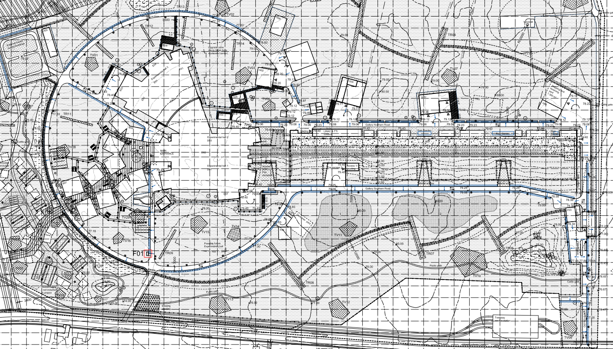
Figure 1. Site plan.

Building description
Accelerator tunnel (G01)
In the accelerator, a proton beam is produced. The ion source is the starting point, producing ions that are accelerated along the structure of the accelerator towards the target station. The accelerator building houses the accelerator and contains three main parts;
- Accelerator tunnel, cut and cover, with culverts for waveguides to the gallery building and emergency exits.
- The front end building, including underground housing for the ion source and staging area.
- HEPT Loading Bay
The structural design of the accelerator tunnel comprises a non-piled, in-situ cast, reinforced concrete tunnel with in-situ cast, reinforced concrete stubs and emergency exits. The tunnel section is 6.0 by 3.5 m, and stubs 1.2 m and 1.8 m wide connecting to the wall of the gallery building. The emergency exit structure will be chicane-shaped for shielding purposes.
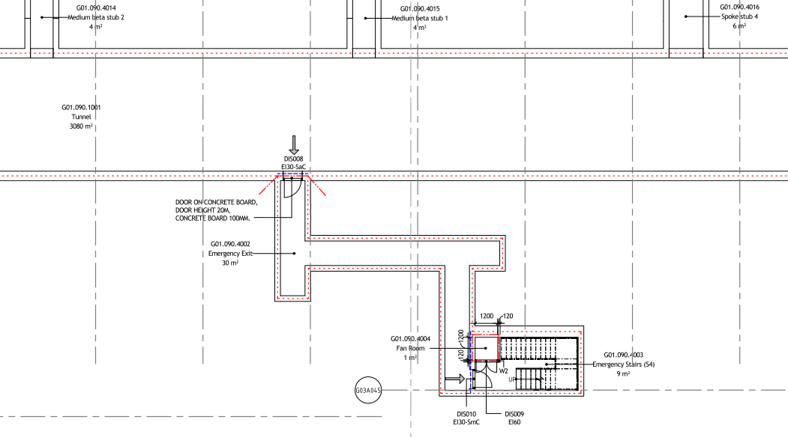
Figure 2: Part of the accelerator tunnel and one emergency staircase.
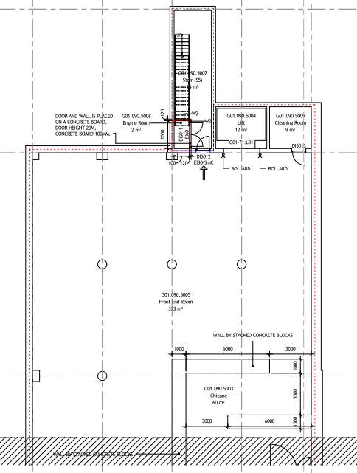
Figure 3: Part of the front end building (level 090).
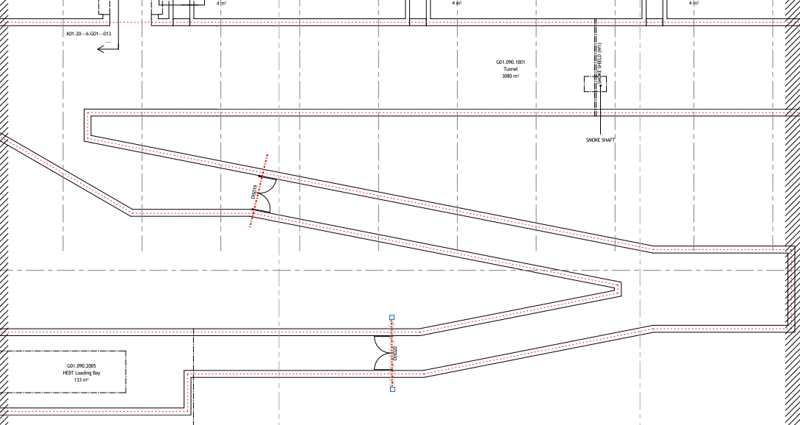
Figure 4: Part of the HEBT loading bay (level 090).
Cold box hall (part of G02) and compressor building (G04)
The cryogenic system consists of: the linac cryoplant that provides cooling for cryomodules; the test and instruments cryoplant that provides cooling for test stands and liquid helium for instruments; the target cryoplant that provides 16 K helium cooling for the target hydrogen moderators, and the distribution system that connects the linac cryoplant to cryomodules. The linac cryoplant and test/instrument cryoplant share common gas management and storage systems.
The vacuum system provides vacuum for the linac beam line, target system and instrument lines.
The G04 building is a one storey building with a mezzanine of less than 500 m².
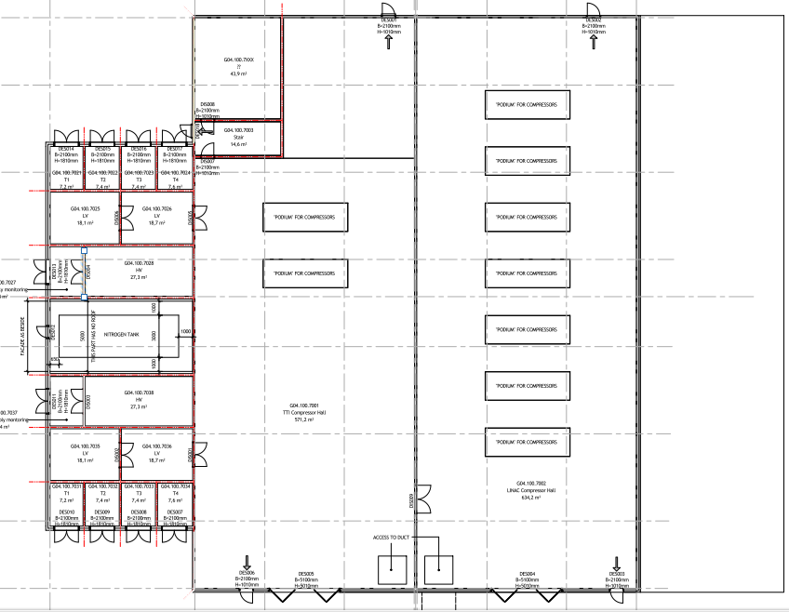
Figure 5: Compressor building (G04).
Gallery Building (G02)
The gallery building is a building housing radio frequency power sources, klystrons and modulators, which will be located at surface level and run parallel to the accelerator tunnel. The westernmost part of the gallery building will house test stands and provide testing and validation of both RF equipment (klystrons and modulators) and cryomodules. Cryogenic connections to cryomodules in the test stands will prototype similar connections in the linac tunnel.
Additional adjacent facilities along the northern facade will include HVAC, cooling substations, switchgears/transformers, and COM. The gallery and the adjacent parts will be spatially separated due to ﬁre protection requirements.
The gallery will provide a width of about 16 m and a clear height of about 5.5 m. The gallery will interconnect with the accelerator tunnel via reinforced concrete stubs.
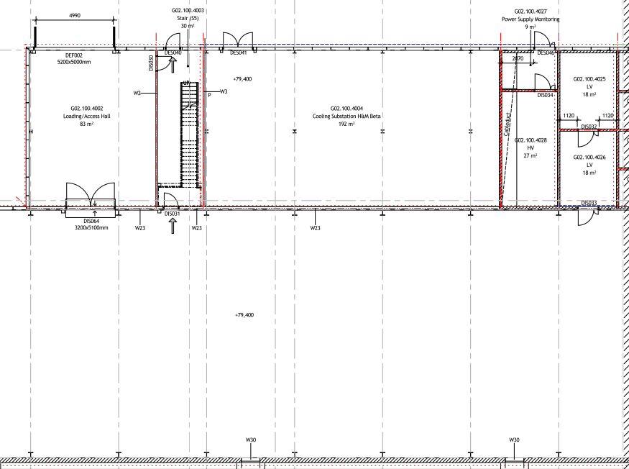
Figure 6: Part of the gallery building (G02).
Target (D02)
At the target station, the proton beam hits the target and the neutrons are produced by the clash. The target in itself is a highly complicated piece of machinery enclosed in a number of servicing systems and safety barriers. The safety barriers, are safety barriers for ionising radiation and the barriers are protected from fire according to their need of safety functionality in case of a fire. Increased fire protection is in general design considered for:
- D02 structural fire resistance (REI 120- M) for central parts of D02
- D02 automatic suppression to compensate from hazardous manual intervention to achieve quick extinguishing
D02 main components will include;
- Accelerator-to-target tunnel;
- Target monolith;
- Servicing cells for cooling and other systems;
- Handling cells for activated materials;
- A high bay area above the monolith to service inserts by overhead crane;
- Space allocated for services and safety barrier systems

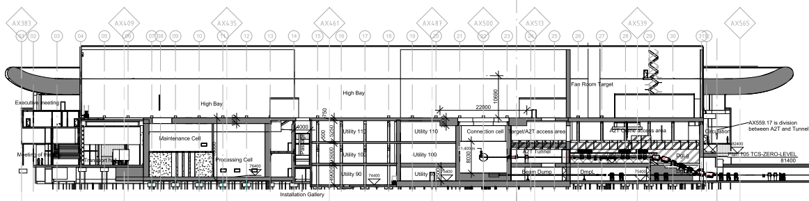
Figure 7: Target.
Instrument Halls (D01, D03 and E01)
The experimental halls contain the instrument stations where the neutrons from the source are applied to the samples and detected by the instruments. Instruments in themselves range in space allocation from a couple of square meters up to large installation of hundreds of square meters. The neutron guides leading up to the instruments are planned at lengths ranging from about 10 m up to 156 m. The 156 m extensions of the neutron guides are likely to require a separate enclosure, leading to the experiment hall. Instruments will be built and altered during the entire lifetime of ESS and therefore require ﬂexible and expandable building concepts. Experimental halls will contain;
- Experimental hall for instruments and their support systems and lifting devices;
- User laboratories close to the instrument stations;
- Control hutches and oﬃces at the instruments inside the hall;
- Mechanical, electrical and optical workshops and support laboratories and
- Oﬃces and meeting rooms in adjacent areas
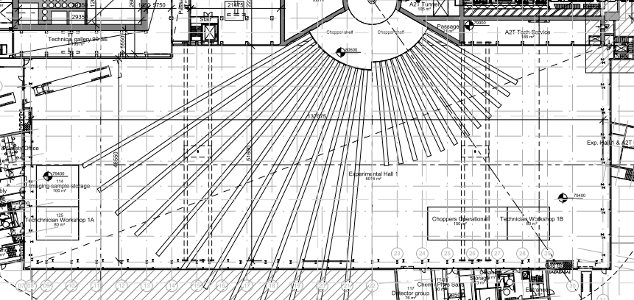
Figure 8: Experimental hall 1 (D01).
Lab. buildings (D04, D07, E03 and E04)
The lab-buildings contain users’ laboratories, meeting rooms and offices. The buildings are two or three storey buildings directly linked to the Instrumental halls. The purpose of these laboratories is to provide users of instruments the possibility to prepare research and follow up on experiments. The laboratories are divided into several categories according to scientiﬁc use.
Central Utility Building, CUB (H01)
In order to optimize ESS support systems, technically as well as economically, there is need to locate some of the systems’ main equipment centrally on the site. This is preferably done in one central utility building, the CUB.
The CUB will contain the following systems / equipment:
- Water cooling system / (heat pumps/cooling machines), heat exchangers, pumps and valves.
- Compressed air system / compressors, dryers, ﬁlters, buﬀer tanks.
- Process water system (Deionized makeup water). / water treatment eq.
- Heating system / heat exchangers, pumps and valves.
- Electrical supply (for CUB equipment) / MV-switchgear, Transformers, LV-switchgears.
The CUB is a three storey building.

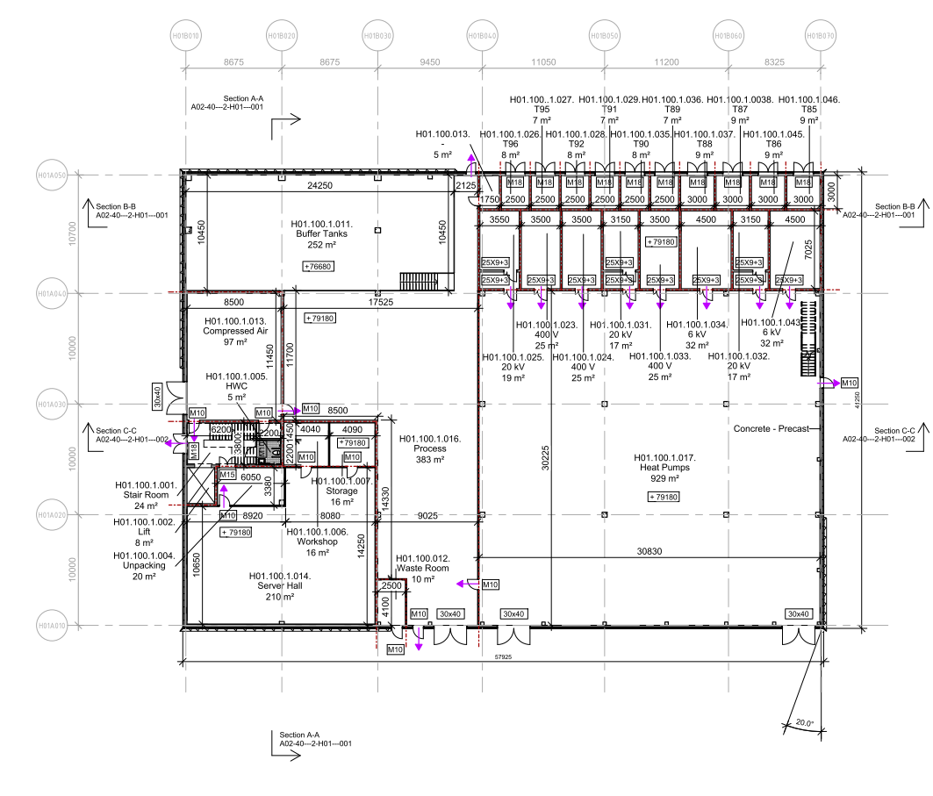
Figure 9: CUB (H01).

Waste treatment facility building, (H09)
As a result of ESS operation, residual products in form of radioactive waste will occur. The waste will, depending on its type, be treated and stored in two separate facilities. Selected intermediate level waste from the target will be treated and stored in the hot cell, located in the target building D02. All other (intermediate- and low level) waste will be treated and stored in the waste treatment facility (H09).
Managing of radioactive waste includes collection, handling, pretreatment, treatment, conditioning, characterization, transport and storage of all types of radioactive waste that is produced in the ESS facility. The need for management of radioactive waste in a dedicated facility relates directly to SSM top requirements for ESS operations.
H09 is connected to the target station building denoted with D02 via a subterranean culvert with ducting for transport of waste liquids produced in these buildings, electric- and signal cabling, and process systems.

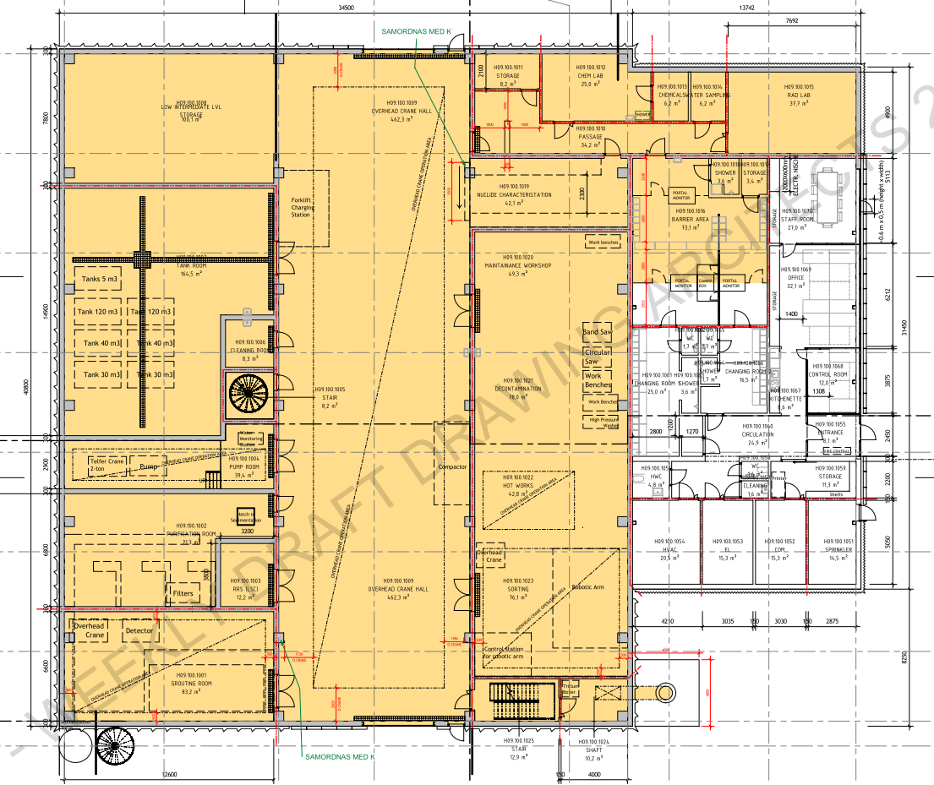
Figure 10: Waste treatment facility building (H09).
Buildings position
The buildings are situated within ESS plant in Lund, kv. Östra Odarslöv 13:5.

Buildings classification
The building classification is based on such factors that affect the possibility for occupants to safely evacuate and the risk of injury in case of fire. The safety of emergency rescue personnel is also considered in a systematic manner. According to BBR the possibilities to evacuate is based on the height and volume of the building, the activities to be conducted in the building, the number of people that are simultaneously estimated to be present in the building and the evacuee’s possibilities to reach a place of safety themselves.
Table 1. Building classification of different buildings.
Building number | Building classification
D01 | Br1*
D02 | Br1
D03 | Br1*
D04 | Br1*
D05 | Br3
D06 | Br1*
D07 | Br1*
D08 | Br1*
E01 | Br1*
E02 | Br1*
E03 | Br1*
E04 | Br1*
E05 | Br1*
G01 | Br1
G02 | Br3
G04 | Br3
H01 | Br1
H05 | Br3
H06 | Br3
H09 | Br2
H10 | Br3
*Br1 because they are connected without firewall to other parts (“buildings”) classified as Br1.

Fire load
The buildings are all assumed to have a fire load less than 800 MJ/m² (floor area). Exceptions from that are the gallery building G02 where flammable liquids (cooling oil) are used in Klystrons and Modulators. The fire load in the Gallery is assumed to be less than 1600 MJ/m² (floor area). In the detailed design, fire loads of every room must be verified. For radiation safety, transient fire loads have to get considered.
Combustible shielding in the experimental halls and the guide hall must, in some parts, be enclosed and protected against fire. Due the fire load requirements the total acceptable amount of exposed borated PE must be limited to 75.800 kg in building D03 and to 139.000 kg in building D01. This has been analyzed in ESS-0010747 [C].

Fire service intervention
The intervention of the fire brigade has been discussed with the fire authorities. The fire service is expected to begin an intervention operation within the normal response time, i.e. within 10 minutes.
The fire strategy, due to the Building Act, does not rely on the intervention of the fire service.
Automatic suppression system shall be installed wherever manual firefighting cannot be achieved. Critical areas where firefighting cannot be achieved is identified in ESS-0004674 [D].

Building occupation and occupancy ratio
Parts of the premises/buildings (accelerator tunnel and parts of the Target building) will consist of technical areas where only temporary work is expected to take place during repair and maintenance. In case of an audit up to 50 persons can stay in those work places.
No area is classified as a public assembly, i.e. maximum number of occupants is 150 persons.
People present within the buildings assumed to have good knowledge of the escape routes and the geometry of the building. Visitors must be guided.
Table 2 Activity classification (according to BBR 20 Section 5:21) within the buildings
Activity classification | Premises
AC 1 | D,E,F,G, H-buildings

Regulations and Standards
Applicable standards and regulations:
- PBL (2010:900) and PBF (2011:338), Plan- och bygglagen samt Plan- and byggförordning
- Boverkets Byggregler, BFS 2011:26 to 2013:14, BBR 20, Boverket 2011
- Boverkets report and general advice about application of European construction standards (euro codes), EKS 9
- Utrymmen för elektriska kopplingsutrustningar för lågspänning, SS 4362101 (Low Voltage)
- High Voltage, SS-EN 61936-1
With respect to signage, emergency lighting, fire extinguishers and evacuation plans, relevant parts of the below legislation are also accounted for:
- Arbetarskyddsstyrelsens författningssamling, AFS (Work Environment Act and Directive 2006/42/EC on Machinery)
- Lagen om skydd mot olyckor, LSO (Civil Protection Act)
Regarding the handling of fire-hazardous and explosives, relevant parts of the below legislation also must be considered (not fully included yet):
- Swedish Civil Contingencies Agency, ordinance (Myndigheten för samhällsskydd och beredskaps författningssamlingar) SRVFS
- ATEX-direktivet
- Radiation protection Act as interpreted by ESS-0004722 Fire & Explosion Safety program.

Buildings Products and material
Materials and products that are used must have known qualification on those elements that are important for building capacity to meet the requirements of the fire safety design. Capacity of the products will be certified by CE-labelling, approval or testing. Products that are certified by CE-labelling do not imply that the product is deemed to meet Swedish requirements for buildings, but only that the developer should have confidence in the declaration provided. Qualifications required appear in this document.
Cables shall be fire retardant and non-corrosive in compliance with ESS-0034035 [E]. Best performance is to be obtained from Thermoset cables (TC).
Electrical equipment should in general comply with minimum IPX2 in sprinkled areas and with minimum IPX3 of safety systems part of ionising radiation barriers.
Electrical cabinets should in general have a drainage hole in the bottom and be placed on a pedestal high enough to keep the electronics above the drainage curbing of the specific area and to allow any water that gets inside the cabinet to drain.

The owners ambition
The owner has expressed a fire safety level that is above what is deemed by the BBR. The overall fire safety ambition from the owner is presented in ESS-0002642 [A]. The requirements in that report are divided into radiation safety protection and property loss protection. Below, all requirements regarding radiation safety protection are implemented and marked with red text. Requirements mentioned in ESS-0002642 [A] regarding property loss protection that are not yet implemented are marked with italics. These requirements may, or may not, depending on the stakeholder, be included in the design during the detailed design. The requirements regarding property loss protection that are higher than required by current building legislation are marked with blue text.
The owner’s ambition for fire protection is higher than required by current planning and building legislation with reference to property protection and radiation safety protection.

Fire safety during construction
Fire safety during construction shall be considered and is documented separate from the fire safety strategy, see ESS-0003967 [F].

DESIGN METHODOLOGY

Prescriptive design
The fire safety design is essentially based on a prescriptive based approach.

Analytical design
An analytical design approach is used in:
- the Accelerator tunnel G01,
- the Gallery building G02,
- the Target building D02
- the Instrument Halls D01, D03, E01/E02
- the Waste treatment building H09
to verify the evacuation strategy and the intervention of the fire brigade.
The analytical design of the tunnel and the Gallery is presented in Appendix A [A-1] and the analytical design of the Experimental Halls in Appendix D [A-4].
Parts of the structure for the Target building (High Bay) and the Instrument buildings (Experimental halls 1, 2 & 3) are verified analytically to obtain a joint fire-resistance class regarding structural fire protection in case of fire. Verification shall be in accordance with the EKS. The analytical design and required verifications are presented in Appendix E [A-5].
An analytical design approach is used for the roof covering of building G02. This is presented in Appendix B [A-2].

The analytical design of the H09 building will be presented in the detailed design of the building.

MEANS OF EGRESS

Evacuation strategy
All rooms where people are present more than occasionally should have access to at least two independent means of escape. At least one fire separated evacuation route or exit shall be accessible from each floor. Access to a single escape route may be acceptable for premises which only serve as temporary occupancy with a travel distance not exceeding the maximum limit. An escape route is an exit directly to the street or the equivalent, or terrace, yard etc. from where a street or the equivalent can be easily reached. An escape route can also be a space in a building that leads from one compartment to such an exit. This may be relevant in technical control facilities and parts of the Target building.
Evacuation is generally through staircases, to other fire compartments or directly to the open air (from the ground floor).
When clarifications are needed detailed requirements for each building are presented below.
Evacuation routes are marked in drawing series “A-5” (D and E-buildings) and generally in A-drawings for each building.
Areas without an independent escape route, are listed below together with justification of the deviance, e.g. the area is designed for temporary occupation only, or ground floor area and maximum 30 m distance to reach open air.

Accelerator tunnel (G01) including front end and the HEBT loading bay
Four (4) staircases and through the front end building from the tunnel
One hatch in the slab of the A2T part of the tunnel. The A2T hatch is not credited based on fire hazard but to handle the personal safety due to helium leakages in the tunnel. The fire hazard of G01 is assessed as analytical design in [A-1].
One door/stair from the front end building on the 090 level. During maintenance, an escape route to the tunnel also will be available. In practice the evacuation route via the tunnel will be marked as evacuation route manually as part of the workpermit.
The HEBT loading bay level 090 is a technical area used for equipment access to the tunnel where only temporary work is expected to take place. During operation, only one escape route is available. During maintenance, another escape route to the tunnel is available. In practice the evacuation route via the tunnel will be marked as evacuation route manually as part of the workpermit.
One door from the HEBT loading bay level 100 (temporary occupation)

Gallery building (G02)
One door every 68 meters (as a maximum distance)
One door/stair from HVAC and other technical rooms (temporary occupation)
Two doors from cold box hall
Two doors from the cryo control room.
Two doors from the cryo control office. One to a staircase and one to another fire compartment (and trough a spinal stair to the 100 level).

Compressor building (G04) and the Cryo Line Tunnel CTL
Two doors from each hall
The CTL is a technical culvert where only temporary work is expected to take place during repair. No ordinary escape routes are designed. When temporary work is planned special administrative procedures with temporary escape routes, need to be undertaken.

Target building
Level 090
Technical gallery
Two staircases; One connected to the outside and one connected to D03 (Experimental Hall 2)
Utility
One door to the culvert and one door to a staircase
Culvert
Six stairs (temporary occupation)
One door to the Utility staircase
Level 100
Transport hall
Two doors
Utility
One door to the Experimental Hall 2.
Staircase to the High Bay or the passage
A2T tunnel
One hatch in the slab connecting to a spiral staircase that ends in D03 (the Experimental Hall 2), (temporary occupation).
Office
Two doors
Level 110
Technical gallery
Two staircases; One connected to the outside and one connected to D03 (the Experimental Hall 2)
Utility
One staircase but in two different directions; up and down. The staircase is divided into two fire compartments which enables two different escape possibilities from the current level.
A2T access area
One door to a staircase that ends in the High Bay (temporary occupancy)
Office
Two staircases
Level 120
Office/dressing rooms
Two staircases
A2T technical supply routing
To a staircase inside D03 (the Experimental Hall 2), (temporary occupancy)
Level 125
High Bay
Two staircases; one connected to the outside and one connected to the Experimental Halls
Door to Fan room target
HVAC
Two staircases and one door to the High Bay
Level 140
HVAC
Two staircases; one connected to the High Bay and one connected to the circulation (to the outside)
Level 150
HVAC
Two staircases; one connected to the High Bay and one connected to the circulation (to the outside)

Instrument Halls
Experimental Hall 1 (D01)
Five doors
Five doors from the circulation path
Experimental Hall 2 (D03)
Four doors
Three doors from the circulation path
Experimental Hall 3 E01)
Four doors
Guide Hall (E02)
Openings towards E01 (Experimental Hall 3)
Ladders to the top of the shielding blocks and into D03 (Experimental Hall 2)
(temporary occupation)

Instrument labs/offices
D04
Door to Experimental Hall 2
One staircase connected to the outside
D07
Door to Experimental Hall 1
One staircase connected to the outside
D08
Two staircases connected to the outside
E03
Two doors to the outside
Two doors to Experimental Halls 3
Two staircases from level 110 connected to the outside
E04
Two staircases connected to the outside

CUB (H01)
Heat Pumps
One door to the outside
One door to process room
Process room
Two doors to the outside
Server room
One staircase (temporary occupancy)
Compressor room
One staircase
One door to process room
Level 120
One staircase (temporary occupancy)

H09
The ground floor is evacuated through two doors (adjacent to the gates).
The HVAC rooms on the first floor is evacuated through the controlled HVAC room to a staircase.
The upper parts of the purification room and the storage room on first floor is evacuated through a staircase on the outside of the building.
The office part is evacuated through two doors.

H10
A single escape route is acceptable in the H10 building (temporary occupation and ground floor area with a travel distance not exceeding 30 m).

Escape from electrical areas etc.
Areas of electrical assemblies for low voltage (<1000 V AC or 1500 V DC) shall conform to SS 436 21 01.
Areas of power installations with nominal voltages above 1kV AC shall conform to SS EN 61936-1. Following areas are of concern:
- H05
- H06
- Switchgear rooms
In addition to BBR21 the following requirements are considered in the design:
- escape route width shall exceed 800 mm but can be reduced to 500 mm once a cabinet door is opened for maintenance.
- doors in escape route must have a push bar, be opened in the escape direction and not have any closing mechanism
- the travel distance shall not exceed 20 meters. If the aisle exceeds 10 meters at least two escape routes are needed.
- door from high voltage electrical assemblies (switchgear rooms) shall be opened by an emergency handle according to SS 4362104 (push bar).
- the area immediately outside an escape route shall be at least 1.5 x 2.0 m²

Travel distance
The travel distance to the nearest escape route or fire compartment shall not exceed 45 meters in general where common path of travel is calculated using a factor of 2. In sprinkled areas 60 meters travel distances are allowed (e.g. culverts, technical gallery and utility in the Target building).
The travel distance within the Culvert system to the nearest escape route shall not exceed 60 meters.
The travel distance within the accelerator tunnel to the nearest escape route shall not exceed 65 meters. Analytical design (CFD-calculations) is used and the analysis is presented in Appendix A [A-1].
The travel distance within the Gallery (G02 building) to the nearest escape route shall not exceed 50 meters (one way direction). Analytical design (CFD-calculations) is used and the analysis is presented in Appendix A [A-1].
The travel distance within the Instrument Halls shall not exceed 80 meters. Analytical design (CFD-calculations) is used and the analysis is presented in Appendix D [A-4]. Evacuation from Bunker area is not yet analysed.
The travel distance in areas of high power installations shall not exceed 20 meters. If the aisle exceeds 10 meters at least two escape routes are needed. This is applicable for switchgear rooms but not applicable for G01 and G02 in general.
The travel distance within the H09 building exceed 45 meters. Analytical design (CFD-calculations) will be used and the analysis is presented in the detailed design of the building.

Escape width
Escape routes shall have a clear width of at least 0.90 meters. Head height shall be no less than 2.10 meters.
Doors either within or to an escape route shall have a clear width of at least 0.80 meters and a minimum head height of at least 2.00 meters.
Clear width of straight stairs shall be measured between the boundary surfaces (walls) where handrails and other associated provisions are allowed to protrude a maximum of 0.1 meter.
Aisles in high power installation rooms shall have a width of at least 800 mm. In front of loose parts or doors the clear width shall always exceed 500 mm.
The distance between a door and the first step of a stair shall be at least 0.8 meters.

Accessibility, hardware
Doors either within or leading to an escape route shall be easily operable, with a downward pressure and easily identifiable as exits. They shall be outward operable in the direction of escape. In rooms with only a few people (< 30 people), who has good local knowledge; doors can open inwards or manually opened slide doors can be used.
Locking handle is accepted, if the number of people is low (< 50 people) and if the people are expected to have good local knowledge, however safety covers are not accepted.
The opening function of a door within or leading to an escape route shall overcome all possible locking arrangements that may be locked when people are occupying the premises. Escape doors with night-lock shall be fitted with interlocks to an essential function such as lights or burglar alarms that the doors cannot be locked during normal operation.
Doors shall be easy to open. Door handles shall be placed of a height about 1.0 above floor. Opening power for a door shall fall short of 150 N, affixed to the handle.
Door from high voltage electrical assemblies (switchgear rooms) shall be opened by an emergency handle according to SS 4362104. The area immediately outside an escape route shall be at least 1.5 x 2.0 m².

MATERIALS, SURFACE FINISHES AND COATINGS
Materials in building components and fixtures shall have such characteristics or be part of building elements in such a way that they in case of a fire does not cause ignition or rapid fire spread and do not develop large amounts of heat or smoke.
Material in the ceiling, walls and fixtures shall not be deformed in case of a small fire and not collapse or in any other way be deformed such that the risk of injury increases.

Ceiling, walls and floor coating
Please see below the minimum required class of coatings. The requirements in Table 2 below are based on the safety level in a Br1 building. Therefore, the safety level regarding coatings for some building (Br2 and Br3 buildings) are higher than the recommended level in BBR.
Table 3 Coating requirements on structures and internal linings.
Surface | Minimum required class
Ceiling generally | B-s1,d0*
Walls generally | C-s2,d0
Ceilings and walls in escape routes | B-s1,d0*
Floors in escape routes | C_{fl}-s1
Floors in high hazard rooms (Gallery, tunnel and Target building) | A1_{fl}
Elevator machine room and elevator cage | B-s1,d0*
* The coating shall be attached onto material in a class not lower than A2-s1,d0 (non- combustible material). Combustible material is protected by ignition protected coating K₂10/B-s1,d0.

Coating on smaller surfaces, not including escape route
For smaller construction parts where the effects of the coating can be neglected regarding the fire scenario the coating may be of a lower class than stipulated within chapter 4.1 above, however not lower than class D-s2,d0 (class III).
Piping covering a smaller area (< 20%), can be performed with isolation of piping isolation class which correspond to the requirements on adjacent surfaces of walls, ceilings and similar.
This means that the piping isolation class:
- BL-s1,d0 (PI)
If the piping covers a larger area (> 20%) the isolation is performed in class A2_{L}-s1,d0 or in the same class as the adjacent surfaces of the walls, ceilings and similar.
Borated PE in the Instrumental Halls will not fulfil the general required classification of surface lining materials. If the amount of PE is kept within the range given in ESS-010747 [C] the performance still can be verified.

Exterior Walls
Exterior walls shall be designed such that
- the partitioning function is maintained between fire cells,
- the dispersion of fire inside the wall is limited,
- the risk of the dispersion of fire along the surface of the façade is limited,
- the risk of personal injury as a result of falling parts of the outer wall is limited.
Exterior wall constructions, which when tested in accordance with SS-EN 13501-2 with a fire impact in accordance with section 5 meet the requirements in item 1 above.
Exterior walls that only contain material of at least class A2-s1,d0 or that are partitioned in such a way that a fire inside the wall is prevented from spreading beyond a partitioning construction meet the requirements in item 2 above.
Exterior walls meet the requirements in item 3 above if they are made in at least class A2-s1,d0. As an alternative, the requirements can be met by covering the outside of the outer wall with material in at least class D-s2,d2 if the building has a maximum of two floors or if the building is equipped with an automatic extinguishing system and the outer wall in the bottom floor is made of material in at least A2-s1,d0.
Exterior wall constructions that pass testing in accordance with SP FIRE 105, 5th edition meet items 1, 2, 3, and 4 above.
In general exterior walls and roofs will be constructed of non-combustible material. All exceptions from this must be verified.
It is accepted to use Kingspans KS1000 X-DEK panels in the roof construction above the Experimental Hall 1 and 2. This is evaluated in Appendix C [A-3].
It is accepted to use Alucobond plus panels as façade lining in building H05, H06 and G04. This is evaluated in Appendix C [A-3].

Roof coating
Roof coatings shall be constructed using non-combustible materials (A2-s1,d0), or with roof coating in class B_{ROOF} (t2) (class T).
Other roof coating materials are considered acceptable in The Gallery building G02 and it is verified using an analytical design approach. The analytical design and required verifications are presented in Appendix B [A-2]. The materials of concern are grass.

Interior linings or combustible materials within escape routes
No furniture, furnishings, open waste bins or other combustible materials are accepted in the escape routes.
If wiring or other combustible pipes must be placed in any escape routes except the emergency staircases from the tunnel G01, these shall be placed behind the vertical surface. For example, a suspended or fixed ceiling which are carried out with surface B-s1,d0 on the vertical surface, shall provide protection between the installations and the below lying escape route.

PREVENTION OF FIRE SPREAD BETWEEN FIRE COMPARTMENTS

Fire separating structure
All fire separating structures and buildings components shall meet the specified fire resistance classes from both sides, i.e. regardless of which side of the design/construction part fire occurs, unless otherwise documented.
Partitioning constructions in buildings of class Br1 should be designed in at least the fire technical class indicated in Table 4.

Table 4 Requirements of partitioning constructions Br1
Building part | Fire technical class at fire load f (MJ/m2)
 | f ≤ 800 | f ≤ 1600 | f > 1600
Partitioning construction in general and tiers of beams above cellar | EI 60 | EI 120 (EI 60*) | EI 240 (EI 120*)
* For buildings that are to be protected with an automatic water sprinkler plant.

Partitioning constructions in buildings of class Br 2 and Br 3 should be constructed in at least class EI 30. Because of property protection all partitioning walls are constructed in at least class EI60.
Classifications of walls are marked on the architectural drawings. Sketches of D and E-buildings is presented in ESS-0088114 and Appendix F [A-6].

Windows and glass partitions
Windows and glass partitions placed within a fire compartmentation line shall generally be constructed in the same class as the partition line in which they are placed.
Between service cell and adjacent surveillance room there will be led-glass. Fire test of oil filled glass for ocular inspection is presented in ESS-0006687 [G].

Doors
Windows and glass partitions located in a fire compartmentation shall generally have the same fire rating as the wall in which they are mounted. In general doors shall meet class EI₂ 60-C or EI₂ 30-C.
Doors connecting to escape routes shall meet class EI₂ 30-S_{a}C.
Door connecting to staircases shall meet class EI₂ 30-S_{m}C.
Doors expected to remain open during daily operations shall be equipped with automatic closers and hold open devices, such as magnetic hold open devices or door closers with built-in automation, which automatically closes when there is smoke in the vicinity of the door. The doors must also be able to be closed manually by push button.
Electrical high voltage drift rooms shall not be equipped with door closers.

Penetration and installations
Penetrations in fire separating walls and structures shall be fire sealed in accordance with an approved method for fire sealing and product of the same fire rating as the penetrated construction.

Fire Compartmentation
The general fire compartmentation approach of the different building is presented below in Table 3. Basic principles are presented in figures below and in Appendix F (D- and E-buildings) [A-6].

Table 5 Fire compartmentation.
Building | Space
Accelerator tunnel (G01) | - The tunnel is one fire compartment.  - The tunnel shall be separated from Gallery building.  - The tunnel shall be separated from the CTL Gallery.  - The tunnel shall be separated from the Front End building with a fire wall, REI 60-M  - Staircases  - HEBT loading bay
Gallery building** (G02) | - Test facilities shall be separated from the rest of the Gallery.  - Non-sprinkled parts shall be separated from sprinkled parts**.  - Transformers*  - Electrical rooms (LV, HV and COM).  - HVAC rooms  - Cryo control room  - Transformers*  - Electrical rooms (LV, HV and COM).  - HVAC rooms  - Cryo control room  - Cryo office room  - Linac Cold Box Hall  - The Gallery building is separated from the tunnel. The wall between the Gallery and the stubs will be fire rated (EI 60).  - Lounge and changing rooms  - Sprinkler room  - Cooling substations  - Front end building (level 090).
Compressor building (G04) | - Transformers (EI60)*  - Electrical rooms (LV, HV and COM)  - UPS  - Heating substation  - The CTL Gallery shall be separated from the tunnel, the Gallery and the compressor building
CUB (H01) | - Transformers (EI60)*  - Electrical rooms (LV, HV and COM).  - Staircase (including elevator)  - Process room  - Compressed air room  - Heat pumps room  - Server Hall  - Ventilation room  - Process equipment room  - COM  - Switchgear rooms (incl battery room)  - Workshop/storage behind server hall
Target (D02) | - High Bay***  - Hydrogen storage room  - Processing maintenance cell  - Monolith and connections cells  - Utility  - Technical gallery  - Emergency HVAC room  - A2T access  - Transport hall***  - Culverts  - HVAC (several fire compartments)  - Staircases  - Elevator shafts not included in staircases  - Office  - Changing rooms  - The Target shall be separated from the Instrument Halls
Instruments (D01, D03, D04, D05, D07, D08, E01, E02, E03, E04) | - Experimental Hall 1  - Experimental Hall 2  - Experimental Hall 3 and guide hall (E02)  - Offices  - Labs  - Workshops  - Staircases  - HVAC rooms  - Elevator shafts not included in staircases
Waste treatment building (H09) | - Purification, pump and tank rooms  - Grouting room  - Chem lab  - Rad lab  - Chemical storage  - Workshop  - HVAC controlled  - HVAC uncontrolled  - Office  - Sprinkler  - El and COM  - Stairs
Sprinkler building (H10) | - All building is one fire compartment
*The fire resistance is depending on the amount of oil (>1000 l => EI90). If oil is used, K-classified oil is assumed.
**An alternative solution with 5 fire sections has been studied and has been dismissed. Conventional facilities has together with the Accelerator division decided to install a wet pipe water sprinkler system in the Gallery.
***An analysis is done that studies the consequences of having the High Bay and the Transport Hall in one fire compartment [A-6]

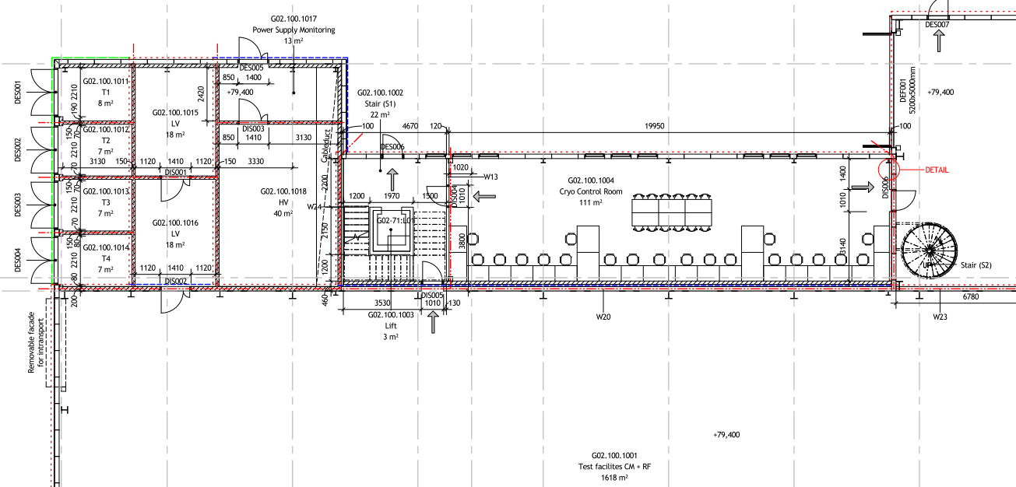

Figure 11: Principle fire compartmentation. Dashed dotted line (red) indicates fire compartment wall, EI 60.
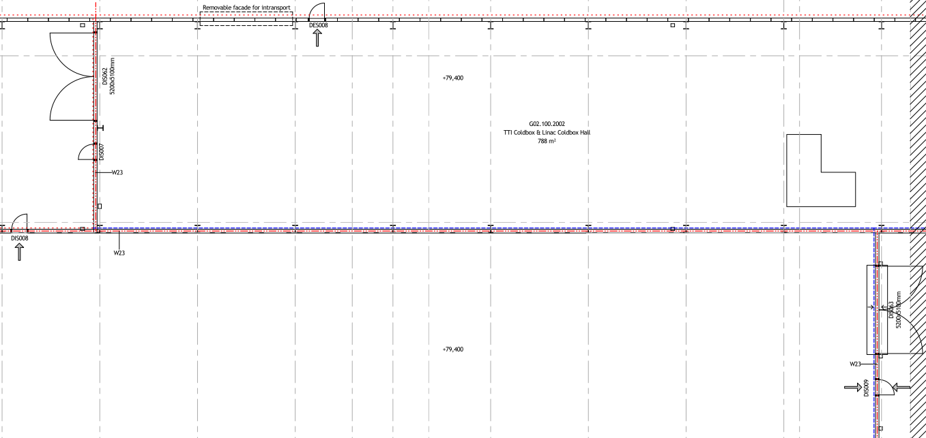
Figure 12: Principle fire compartmentation. Dashed dotted line (red) indicates fire compartment wall, EI 60.

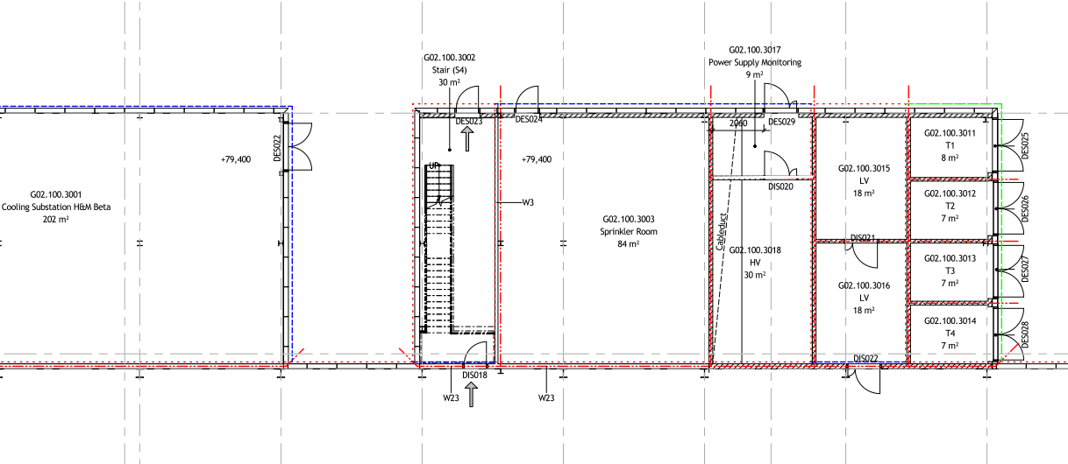
Figure 13: Principle fire compartmentation. Dashed dotted line (red) indicates fire compartment wall, EI 60.
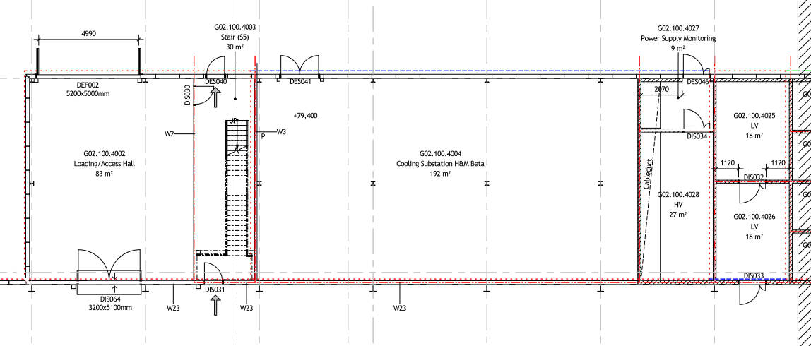
Figure 14: Principle fire compartmentation. Dashed dotted line (red) indicates fire compartment wall, EI 60.

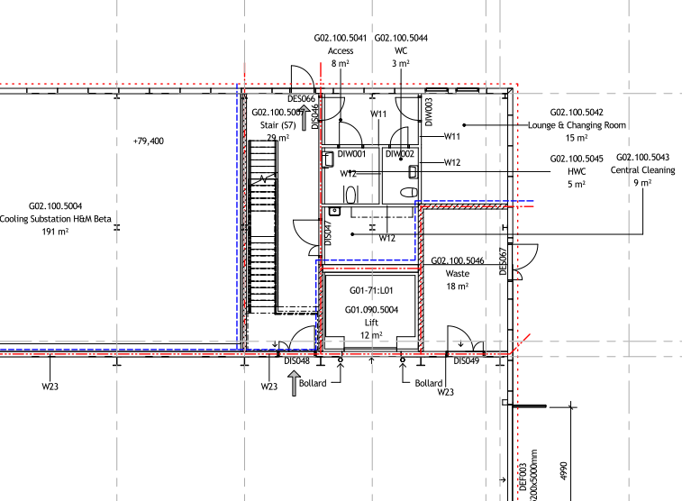
Figure 15: Principle fire compartmentation. Dashed dotted line (red) indicates fire compartment wall, EI 60.
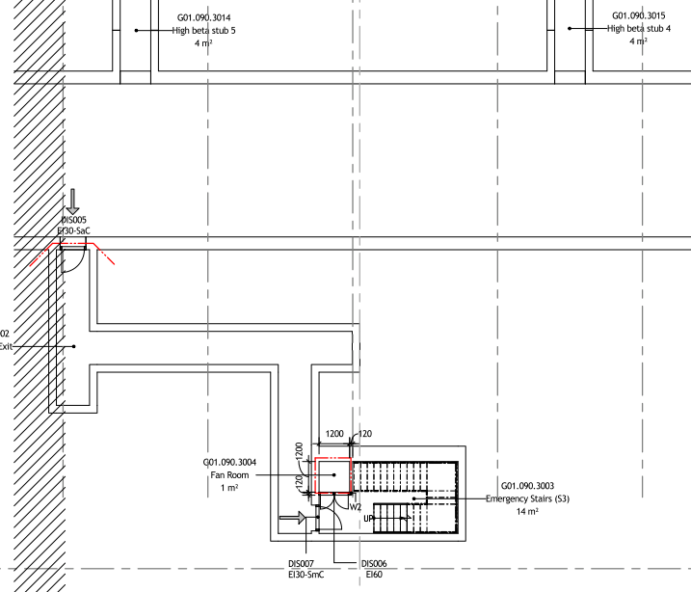
Figure 16: Principle fire compartmentation in the tunnel. Dashed dotted line (red) indicates fire compartment wall, EI 60.
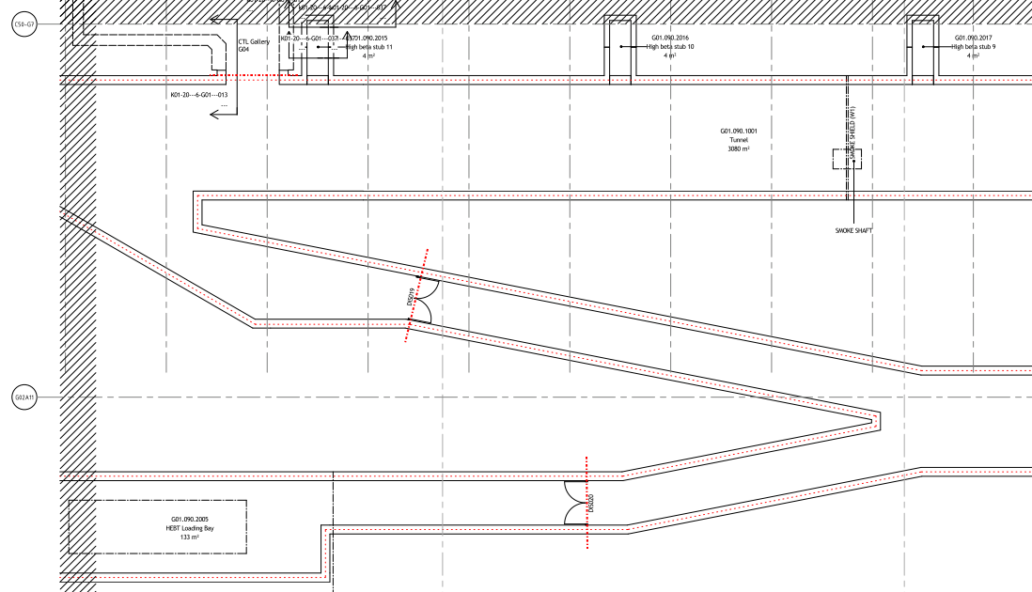
Figure 17: Principle fire compartmentation in HEPT loading bay. Dashed dotted line (red) indicates fire compartment wall, EI 60.
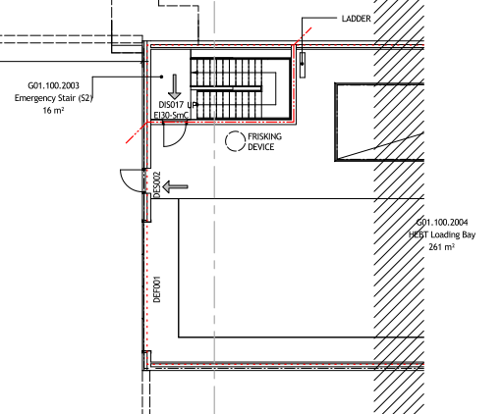
Figure 18: Principle fire compartmentation in the HEBT loading bay. Dashed dotted line (red) indicates fire compartment wall, EI 60.
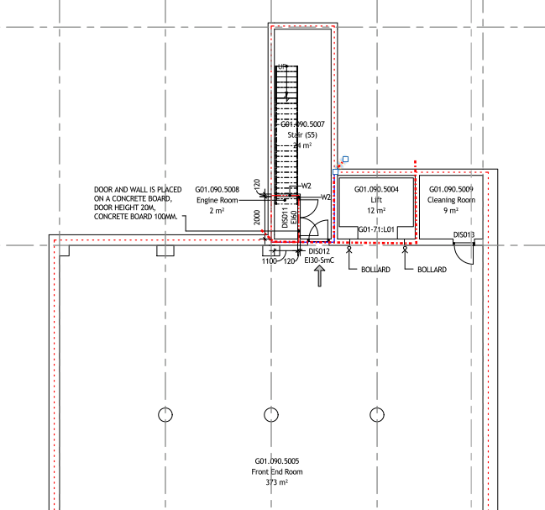
Figure 19: Principle fire compartmentation in the front end room. Dashed dotted line (red) indicates fire compartment wall, EI 60.
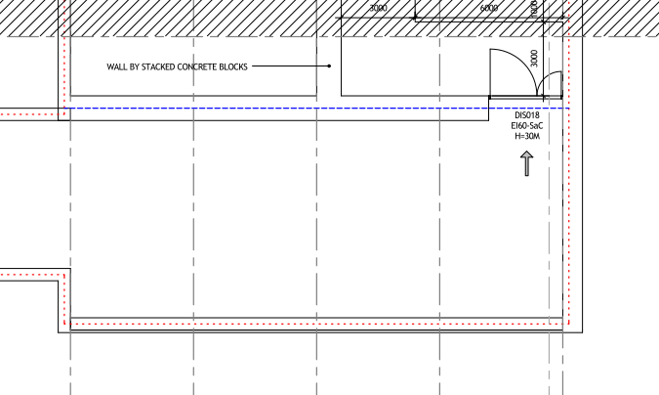
Figure 20: Principle fire compartmentation in the tunnel/front end. Dashed line (blue) indicates fire wall REI 60-M.

Figure 21: Principle fire compartmentation in the Compressor building (G04). Dashed dotted line (red) indicates fire compartment wall, EI 60.
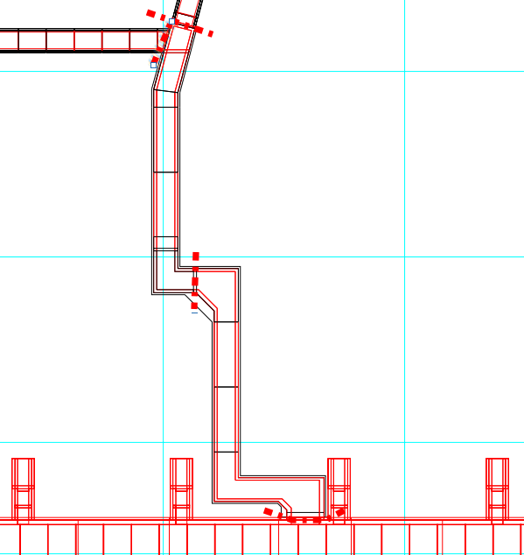

Figure 22: Principle fire compartmentation in the Cryo Tunnel Line CTL (G04). Dashed dotted line (red) indicates fire compartment wall, EI 60.

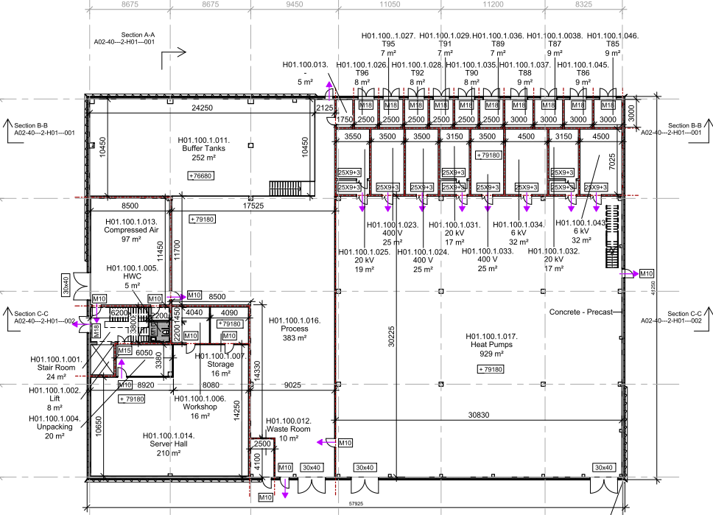
Figure 23: Principle fire compartmentation in CUB (H01) level 100. Red dotted line indicates fire compartment wall, EI60.
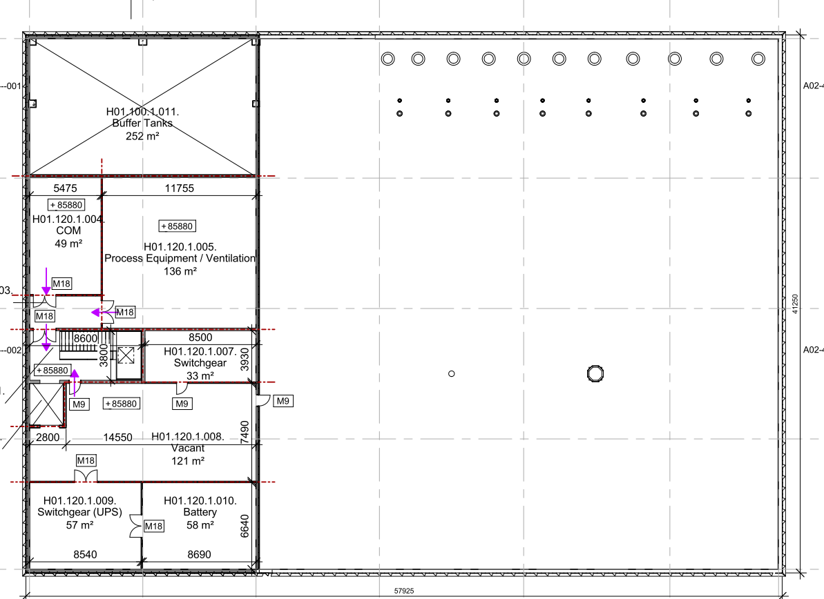
Figure 24: Principle fire compartmentation in CUB (H01) level 120. Red dotted line indicates fire compartment wall, EI60.
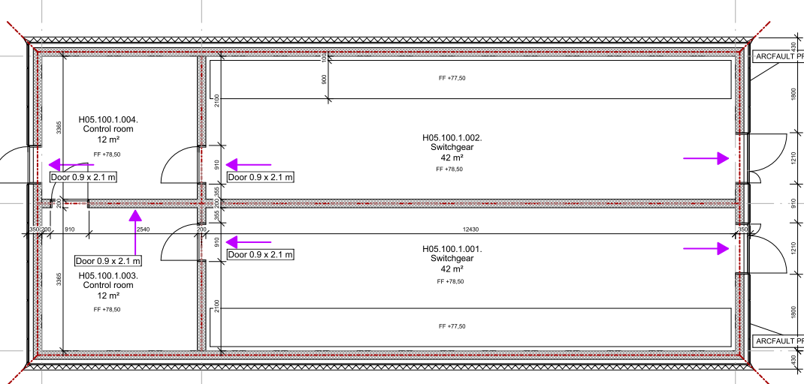
Figure 25: Principle fire compartmentation in H05 level 100. Red dotted line indicates fire compartment wall, EI60. Outer walls are not fire rated.

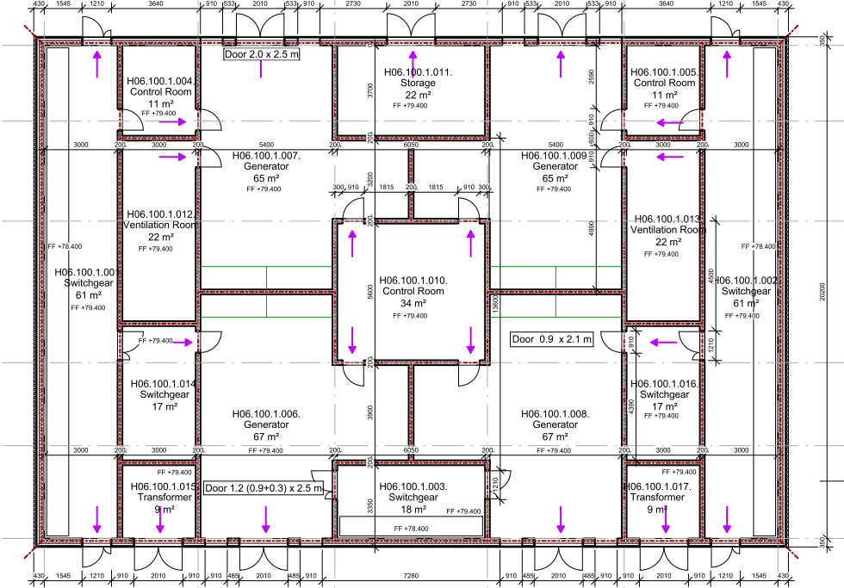
Figure 26: Principle fire compartmentation in H06 level 100. Red dotted line indicates fire compartment wall, EI60. Outer walls are not fire rated.

Special areas/Construction parts

Elevator
Elevators are located in the same fire compartment as the stairways, or in its own fire compartment. When not located within stairwells, elevator doors shall meet at least class EI₂60, verified by SS-EN 81-58 or EI30/E60 and the elevator shaft shall be provided with smoke exhaust.
A fire shall not cause blackouts in the elevator machinery while critical conditions may arise for the people staying in the elevator car. To prevent this, the power cable to the elevator machinery shall be fire-safe in the corresponding class EI 30 or be performed with feature fire rated cable according to standard IEC 60331. Please note that the protection of the cable is only needed in the same fire compartment which also can give rise to critical conditions in the car. As an alternative to the fire rating of the cable, the elevator can be performed such as to automatically go to nearest landing zone during power failure.
Smoke ventilation of the elevator shall be in accordance with chapter 9.4.
Any shafts (ventilation, plumbing and electricity) shall be constructed such that the compartment boundaries are maintained even at the shaft excavation. This can be solved by re-casting the floor or construct with fire rated shaft walls, or a combination thereof.

Installation floors
Installation floors shall be constructed using non-combustible materials. Compartment walls shall be continued down to the floor surface and not be located on top of installations floors.

FIRE SPREAD BETWEEN BUILDINGS
Buildings shall be designed with satisfactory protection against spread of fire between buildings.
Satisfactory protection is achieved if buildings are built with a distance exceeding 8 m or if the spread of fire between buildings is limited by protection corresponding to the highest requirement for fire cells or fire walls in each building. Buildings that are connected must be separated by a fire wall.
The accelerator tunnel shall be separated from the front end building / the Gallery with a fire wall, REI 120-M.
ESS-002624 [A] requires fire walls of REI 120-M between Target and Instrument Halls. Walls between Target and Experimental hall 1 and 2 are to be designed to prevent a fire spread, i.e. REI 120 M. Walls can be designed with a resistance of EI120 but the celling steel framework can be designed without any fire protection (unprotected), see Appendix E [A-5]. This analysis is be revised from impact of Bunker fire.

STRUCTUrAL FIRE RESISTANCE

General
Load bearing components shall be classified into fire safety classes based on the risk of personal injury if part of the building collapses during a fire. Please see tables below for the requirements regarding structural fire resistance.
The design may be done according to both classification and natural fire. For design in accordance with the classification (nominal temperature time curve), building components shall be constructed so that collapse does not occur during the period specified in tables below.
The design process and the design documentation shall comply with the requirements given in chapter 1 of the Design Manual ESS-0003980 [O]. The design, the check-up of the design and the design documentation shall also comply with §21, §23, §25, §29 and §30 in EKS 10 (in addition to the requirements given in EKS 9) as well as SSM 15-36 and SSM 15-1027 [P]. The general advices shall be applied. Note that intermediate steps and partial results to be reported in the design documentation to ensure a proper understanding of the calculations.
When designing according to a natural fire model, structural elements shall be designed for a fully developed fire. If it can be shown that a flashover cannot occur, the design can be performed for a local fire. This approach is used in the Instrument Halls and in the High Bay. The analytical design and required verifications is presented in Appendix E [A-5].
From a radiation safety perspective, the following main classification shall be assigned to D01, D02 and D03 buildings:
- Safety class (radiation safety),
- quality class (execution class etc.),
- leak-tightness class and
- seismic class.
This is decribed in “General design requirements General Civil Design Criteria (GCDC) for D01 D02 and D03” [Q].
ESS has decided ESS-0061819 [y] upon the seismic classification and corresponding demands for all types of H3 and H4 (including fire) events as specified in Table 7.1.
Table 7.1 Seismic classification and demands on building structures for H3 and H4 events²⁾
Building | Seismic category | Seismic demands in event class H3 and H4 | Demands for other H3 and H4 events than seismic
D01/D02/D03  steel structure  A2T, UB, TH and TG | N | Not to jeopardize any safety function or safety related function of SSCs in seismic category 1 or P.  As decided by ESH, the structures not to fall down¹⁾. | Same as for seismic
MCS  AC | P | Load-bearing function to be ensured. | Same as for seismic
D01/D02/D03 baseslab and foundation  TE | N | Not to jeopardize any safety function or safety related function of SSCs in seismic category 1 or P³⁾. | Same as for seismic
- Since not all safety analyses has been finalized, this demand has been decided upon.
- The demands in this table superseeds section 2.3 of the Design Manual (DM), if the demands herein are more stringent than the ones in DM.
- Acceptable behavior to be stated by the Responsible Designer during the detailed design, based on the decision and knowlegde on how all of the buildings interact. The general demand on the buiilding structures not to jeopardize is valid for direct as well as indirect effects/influences.

Accelerator tunnel (G01)
Table 2 Building structural elements G01
Fire safety class | Fire resistance class | Construction element
1 | 0 | Not relevant
2 | R15 | Not relevant
3 | R30 | Risers and landings within stairs that forms part of an escape route.
4 | R60 | Frame stabilizing grid (SK3)  Vertical construction elements (SK 3)  - walls  Horizontal construction elements (SK2)  - floors  - beams
5 | R90 | Not relevant

CUB (H01)
Table 3 Building structural elements CUB (H01)
Fire safety class | Fire resistance class | Construction element
1 | 0 | Not relevant
2 | R15 | Not relevant
3 | R30 | Risers and landings within stairs that forms part of an escape route
4 | R60 | Frame stabilizing grid  Vertical construction elements  - walls  Horizontal construction elements  - floors  - beams  Risers and landings within stairs that forms part of an escape route
5 | R90 | Not relevant

Gallery building (G02), Compressor building (G04), H05, H06, D05 and HEPT Loading Bay
Table 4 Building structural elements Gallery building (G02), Compressor building (G04), H05, H06, Front End building and HEPT Loading Bay
Fire safety class | Fire resistance class | Construction element
1 | 0 | All structural elements*
2 | R15 | Not relevant
3 | R30 | Not relevant
4 | R60 | Not relevant
5 | R90 | Not relevant
*If the area of mezzanines in every fire section is below 500 m².

Target (D02) and Experimental Halls 1 (D01), 2 (D03), 3 (E01) and Guide Hall (E02)
Natural fire model will be used to design the structural elements in the High bay and in the Instrument Halls. Calculations will determine that a flashover cannot occur and the design can be performed based on a local fire (thereby providing evidence so that probably no structural elements in the ceiling need to be fire rated or protected). Calculation are presented in Appendix E [A-5].
According to requirements from ES&H fire painting is not an acceptable solution in D01, D02 and D03.
Table 5 Building structural elements in D01 and D03
Fire safety class | Fire resistance class | Construction element
1 | 0 | Not relevant
2 | R15 | Not relevant
3 | R30 | Risers and landings within stairs that forms part of an escape route.
4 | R60/120* | Frame stabilizing grid (SK3)  Vertical construction elements (SK 3)  - columns  - walls  Horizontal construction elements (SK2)  - floors  - beams
5 | 0 | Not relevant
*See Appendix E [A-5] and a summary below.

Instrument Halls:
The local fire effect of a truck fire results in a steel beam temperature of 476 °C. This is below the critical steel temperature of 496 °C. The beams can be unprotected.
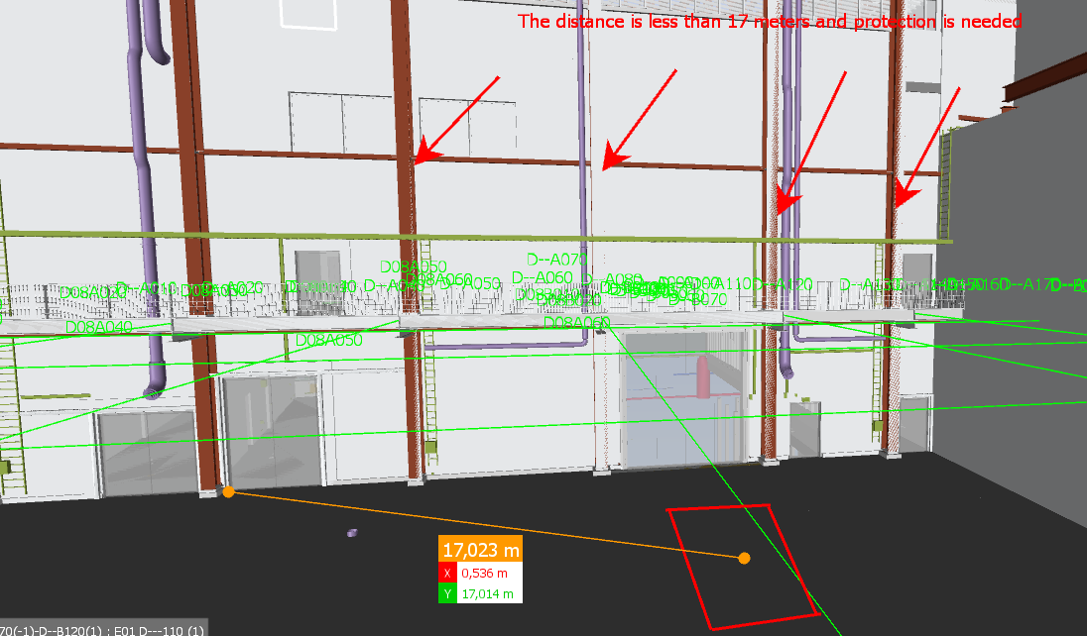
Figure 1 Columns located adjacent to the truck location. Columns closer than 17 meters need a protection of R120.
The effect on a column in case of a truck fire is calculated using a method in appendix C, SS-EN 1991-1-2. The time the column requires to withstand a fire is 120 minutes. In order to collapse the roof structure, two columns must collapse. Collapse of only one column will not affect the bearings of the roof structure. Columns needs to be fire rated for 120 minutes at a distance of 17 meters from the truck location. In the figure above, columns that need to be protected are marked with red arrows (two columns on both sides of the gate).
The same calculation is made for instrument caves as for truck fire, with the difference that the water sprinkler system restricts fire according to report ESS-0010747 [C] to 6 MW instead of 30 MW. The horizontal distance required is 8 meters for 120 minutes resistance. The distance can be measured from the centre of the instrument cave. Again at least two columns need to collapse to have the roof collapsing. Therefore, if the distance is less than 7 meters to one columns but more than 7 meters to the rest, no collapse will occur. To get a robust protection and protection against other fire scenarios e.g. cabinets and cable ladders all columns must be protected to R60.
The columns need to be protected up to the ceiling beams.
Columns that may affect the wall between Target and Instruments when collapsing must be cladded (and not fire painted).
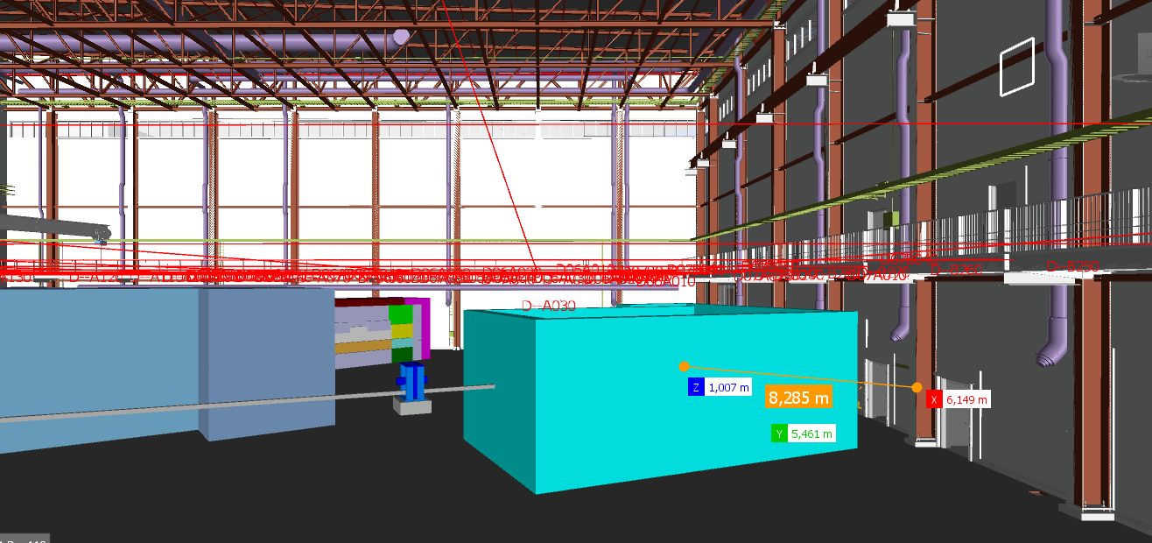
Figure 1. Screenshot from the instrument hall showing the distance between one instrument cave and a column. All columns in the area are to be protected R60.
Table 6 Building structural elements in D02
Fire safety class | Fire resistance class | Construction element
1 | 0 | Not relevant
2 | R15 | Not relevant
3 | R30 | Risers and landings within stairs that forms part of an escape route.
4 | R60/120* | Frame stabilizing grid (SK3)  Vertical construction elements (SK 3)  - columns  - walls  Horizontal construction elements (SK2)  - floors  - beams
5 | R90 | Not relevant
*See Appendix E [A-5] and a summary below.
High Bay:
In the case of a truck fire burning in steady-state with 30 MW, the highest temperature of the hot gas layer is achieved closest to the ceiling directly above the fire, where it reaches 375 °C maximum after 30 minutes. The mean temperature of the hot gas layer is approximately 260 °C at this time. This is below the temperature of 498 °C at which flashover occurs [A-6].
The local fire effect of a truck fire results in a steel temperature of 201 °C. This is below the critical steel temperature of 496 °C [A-6].

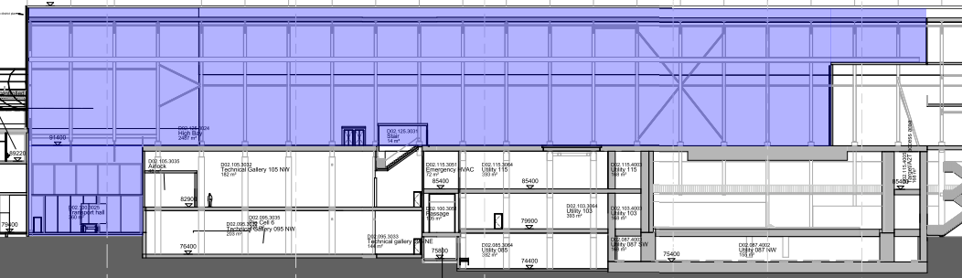
The steel temperature of an unprotected steel beam is due to the large height of the room with safe margin below the critical temperature.
Figure 1 Section of the High Bay.
A cable ladder is assumed to burn with 700 kW, and the burning part is assumed to be 1 m long and 0.4 m wide. Flame length and plume temperature in case of a cable ladder fire is calculated using the method in appendix C, SS-EN 1991-1-2. Through an iterative process, the closest safe distance between a cable ladder and the steel beam is found to be 4 meters to withstand a 2 h local fire. If the distance between beams and cable trays are more than 4 meters the beams can be unprotected. Otherwise, more detailed calculations are needed.
Due to the required REI 120-M wall between target and instrumental halls all columns in the High Bay need to be fire protected for 2h (R120). The columns should be protected up to the ceiling beam. Columns that may affect the wall between Target and Instruments when collapsing must be cladded (and not fire painted).
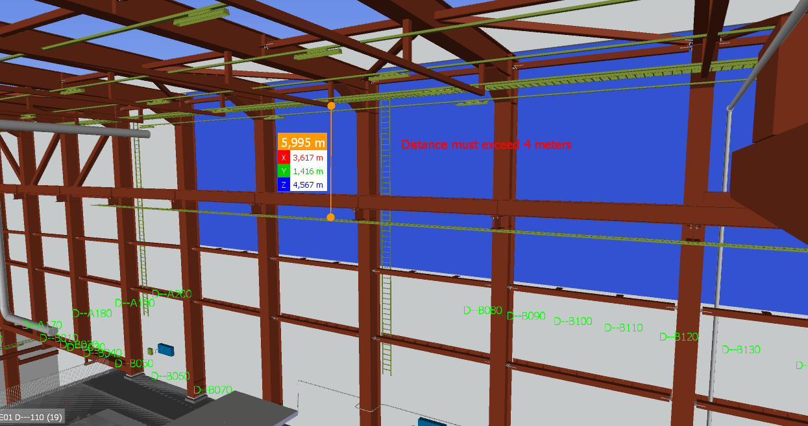
Figure 1. Screenshot of the High Bay showing the distance to a cable ladder. The distance between cable ladders and unprotected steel beam should be at least 4 meters.

Table 7 Building structural elements in E01 and E02.
Fire safety class | Fire resistance class | Construction element
1 | 0 | Not relevant
2 | R15 | Not relevant
3 | R30 | Risers and landings within stairs that forms part of an escape route.
4 | R0/R60* | Frame stabilizing grid (SK3)  Vertical construction elements (SK 3)  - columns  - walls  Horizontal construction elements (SK2)  - floors  - beams
5 | R90 | Not relevant
* The roof structure of E01 and E02 is designed according to a natural fire model (Appendix E) [A-5]. A flashover cannot occur and the structural elements can be designed using a local fire. The beams can be unprotected and the columns need to be protected up to the ceiling beams.

Instrument office and labs. buildings D04, D06, D07, D08, E03, E04 and E05.

Table 8 Building structural elements D04, D06, D07, D08, E03, E04 and E05.
Fire safety class | Fire resistance class | Construction element
1 | 0 | Not relevant
2 | R15 | Not relevant
3 | R30 | Risers and landings within stairs that forms part of an escape route.
4 | R60 | Frame stabilizing grid (SK3)  Vertical construction elements (SK 3)  - columns  - walls  Horizontal construction elements (SK2)  - floors  - beams  - overhead cranes
5 | R90 | Not relevant

Sprinkler building, H10
Table 9 Building structural elements H10.
Fire safety class | Fire resistance class | Construction element
1 | 0 | All structural elements
2 | R15 | Not relevant
3 | R30 | Not relevant
4 | R60 | Not relevant
5 | R90 | Not relevant

Waste treatment building (H09)
Table 2 Building structural elements H09
Fire safety class | Fire resistance class | Construction element
1 | 0 | Not relevant
2 | R15 | Not relevant
3 | R30 | Risers and landings within stairs that forms part of an escape route.  Frame stabilizing grid (SK3)  Vertical construction elements (SK 3)  - walls  Horizontal construction elements (SK2)  - floors  - beams
4 | R60 | A fire resistance rating of R60 is required for structural members supporting fire compartment walls and floors.
5 | R90 | Not relevant

Inner ceilings
Grids for suspended ceilings without a fire separation function shall be constructed such that they withstand a temperature of 300°C for 10 minutes without losing any load bearing capacity.

VENTILATION SYSTEMS

Protection from the spread of smoke
As the activity on the premises consist of industrial activity, the ventilation system designed to significantly prevent the spread of smoke between the different fire compartments.
To/from stairs which are escape routes the spread of smoke shall be prohibited.
In this case the spread of smoke should be prohibited due to property protection as the different fire compartments mostly consist of technical areas vital for the process and expensive equipment.

General solutions
Protection against smoke spread shall be obtained from any of the following options:
- The ventilation systems are carried out separate for each fire compartment all the way to outside.
- Smoke spread is prevented using smoke dampers having a fire rating of no less than class E 60 or/and with fire/smoke dampers, class EI 60. In case of fire the fan, the unit should shut down and all dampers close.
- Smoke spread is prevented using fans operating in the fire condition. The proposed design solution must be verified using a fire engineering approach that includes computer modelling.

Control and supervision
The control of fire functions shall be monitored via DUC/PLC which implies that it is constructed with the same reliability as the fire alarm control panel.

Protection from the spread of fire

Ventilation ducts etc.
Ventilation ducts shall be located and designed so that they, in case of fire, do not cause ignition of adjacent building components or fixtures outside the fire compartment which they are placed within for the time required.
Air handling installations penetrating fire separating elements or which are located in common spaces (shafts and fan rooms) and supplying different compartments shall be designed so that the fire rating between fire compartments is maintained (se section 5.2.3).
Duct penetrating fire compartmentation shall be isolated to achieve the same class as the penetrated construction. Where smoke dampers, in less than class EI 60, are mounted in the fire resistant construction no isolation of the ventilation duct is required.
The air handling units can be designed without fire dampers to one other fire compartment, i.e. the air handling unit is a part of another bigger fire compartment. In ducts penetrating other fire compartmentations smoke dampers, EI 60, are to be installed.
Ducts above the electrical equipment room are to be insulated, EI 60, throughout the HVAC room. Air handling units and fans do not need to be insulated but a heat radiation shield between the fans is to be mounted.
Accelerator tunnel (G01)
The protection of ducts (and batteries) in the emergency stairs is solved by applying a safety distance to combustible material and escaping people (outside the HVAC room). A gypsum board or similar shall be mounted below ducts and batteries (outside the HVAC room).
The Gallery (G02)
In ducts penetrating fire compartmentation smoke dampers, EI 60, are to be installed.
The air handling unit are designed without fire dampers to one other fire compartment, i.e. the air handling unit is a part of another bigger fire compartment. In ducts penetrating other fire compartmentations smoke dampers, EI 60, shall be installed.
The CUB (H01)
Ducts above the electrical equipment room shall be insulated, EI 60, throughout the HVAC room. Air handling units and fans do not need to be insulated but a heat radiation shield between the fans shall be mounted.
Shipping and receiving (F03)
In ducts penetrating fire compartmentation smoke dampers, E 60, are to be installed. No insulation of the ducts is needed due to the sprinkler installation in the building. An analytical design approach is used and the design is to be verified in the detailed design of the building.
The Experimental Hall 3 (E01)
Ducts penetrating the wall towards E04 can be insulated only on the E01 side of the wall. This is an analytical design and will be verified in the detailed design of the building.
The Compressor building (G04)
One inlet duct is only insulated directly at the penetration of the wall. A safety distance to combustible material is used.

Detection
Fire detection via a centralized fire alarm is acceptable.

Materials and construction
Material in air handling installations shall be of class A2-s1,d0.
Suspension of ventilation ducts serving multiple fire compartments shall be constructed in class no less than R60 at penetrations.

Coal filters
Fire protection of carbon filters is to be designed as follows, see ESS-0002642 [A] and ESS-0001051 [B]:
- Locate filters in separate fire compartment
- Monitor air temperature and activate automatic isolation of the airflow
- Provide for automatic water sprinkler to cool outside of filter vessel
- Provide for water spray systems inside the filter with manual hose connection. Too low flowrate can result in hydrogen production.

HVAC and RGEC in the Target
See ESS-0002642 [A].

FIRE SAFETY PROVISIONS
Parts of the facility that is not easily accessible for the fire brigade should be equipped with fire extinguishing systems [S]. Even fire hazards with a potential of very rapid fires should be equipped with automatic extinguishing systems.
A proposal regarding the level of protection is presented below for some of the planned areas. In addition to the below table a fire alarm shall be incorporated in accordance with chapter 9.5.1.
Table 10 Proposed protection level for the different areas.
Area |  | Protection
Accelerator tunnel |  | Pre-action sprinkler system  Smoke ventilation trough the stack
Gallery (in Gallery building) |  | Water sprinkler, due to large open area (more than 2500 m2)  Smoke hatches (0,3%)
Test facilities (in Gallery building) |  | Smoke hatches (1%)
Target in general |  | Extinguishing systems in rooms not available for the fire brigade, filter rooms, culverts and technical gallery
Target in detail | Processing and maintenance cell | Suppression system (if water sprinkler can be installed is to be verified)
 | Utility | Water sprinkler
 | Technical Gallery | Water sprinkler, due to the walking distance
 | A2T parts not available for the fire brigade | Water sprinkler
 | Culvert | Water sprinkler, due to sprinkler service line and the walking distance
 | Filter rooms | Water sprinkler
Instrument halls in general |  | Preparation for water sprinkler in instrument caves  Water sprinkler  Smoke ventilation
Waste building |  | Water sprinkler

According to ESS-002642 [A]:
“The maximum possible loss inside a fire compartment which can exceed “Major” consequences will be protected with automatic fire suppression system or any fire protection with justified equivalent reliability.”
“The maximum possible loss inside a fire compartment which can exceed “Catastrophic” consequences requires designated risk analysis for determination on additional protection activities. Supply of extinguishing agent for firefighting should be designed to prevent single failure or should single active components have a record for mean time between failures, to be justified by the risk analysis.”
An analysis of all fire compartments needs to be done to verify if any rooms need any additional fire protection.

Sprinkler system
Rules and Regulations
The automatic sprinkler system is to be installed in accordance with
SS-EN 12845:2004+A2:2009 Fixed firefighting systems - Automatic sprinkler systems - Design, installation and maintenance and Swedish supplementary “SBF 120:7”.
Materials
Materials for the sprinkler system is to be designed in accordance with EN 12259 Fixed firefighting systems - Components for sprinkler and water spray systems.
The water supply
The water supply for the sprinkler system (and the fire hydrant system) is to contain a total volume of 850 m³, supplied with one pressurizing electrical motor driven pump and one diesel driven pump. The pumps are made redundant. The operational volume of 850 m³ is based on the flow rate and the duration time of the sprinkler system in a fictive storage building together with the flow rate and the duration time of the fire hydrant system.
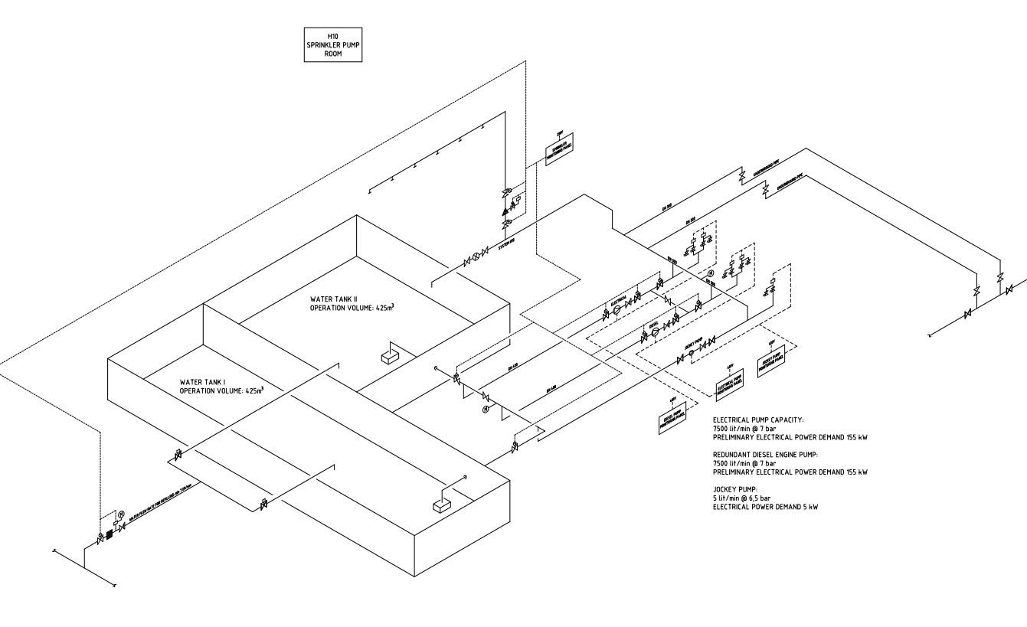
Figure 27. Schematics for sprinkler basins and pumps.
The separation of the water supply into two pools allows for redundancy during service of the pools.
The sprinkler building is intended to supply pressurized water to all sprinkler systems and hydrants in ESS. The water distributes by a pipe system around the ESS area. The hydrants as well as the sprinkler systems connect to this pipe system. Classification of hazards in the whole site is on-going. The design is based on a fictive 12.2 m high building with a storage height of 10.7 m and a hazard classification of HHS3.
The sprinkler systems water flow rate demands shall be supplied by one electrical pump with a capacity of 7500 litres/minute at 7 bar, and one redundant diesel engine pump. The electrical power demand is preliminary 155 kW. A pressure jockey pump maintenance the system pressure at approximately 10 bar.
Fire water supply is designed for only one on site fire at a time. 12 hours after first event it shall be possible to handle a second design fire event (a second fire must be postulated). The first design fire is described above and the second design fire is approximated to be a fire in one of the instrumental halls (the second most challenging fire).
Switchgear room feeding the electrical sprinkler pump shall be fire separated and the cable route shall be fire rated from switchgear room to sprinkler building.
The diesel driven pump shall be physically and galvanic separated from the electrical pump.
The fire water system, except from the electrical pump, shall be designed to handle a seismic event, H3 – but not to handle a combination of seismic event and a fire and a single failure. Buildings equipped with sprinkler are not necessarily seismic qualified but must have a shut off procedure of a leaking branch is a safety credited manual operation.
The fire water supply shall resist extreme freezing conditions, H3. Room temperature in sprinkler pump room shall be minimum 10 °C and in sprinkler valve room or cabinet minimum 15 °C.
Single failure and CCF is considered as follows 1) ordinary electrical pump is designed to go in to operation 2) in case of failure of the electrical pump the independent diesel driven pump goes in to operation activated on a low pressure gauge.

Gallery G02
In the Gallery a wet pipe water sprinkler system shall be installed.
Test facilities, technical rooms (cooling sub stations, HVAC, Electrical rooms, etc.) and dressing room parts are not sprinkled. Non-sprinkled parts shall be fire separated (EI 60).
A sprinkler control centre shall be installed within the building.
Hazard category and required water capacity is High Hazard Production 1, HHP1, with 8.0 liters/min over 260 m². The duration of water flow shall be no less than 90 minutes. According to FM Global datasheet 7-32 Ignitable Liquid Operations the design of the sprinkler system can be done based on hazard category for the surrounding occupancy if oil with higher flashpoint than 260 ˚C is used in the process.
Table 11 Hazard classifications etcetera in the Gallery.
 | Hazard classification | System type | Density (mm/min) | Area of operation (m2) | Duration (min)
The Gallery | HHP1 | Wet pipe | 8.0 | 260 | 60

Accepted deviations:
The sprinkler installation is not designed for any obstacles under the height of 5500 mm above the floor in G02.100.2.001. The level of obstacles must be checked after installation.
The height of the roof is calculated to the medium height of the trapezoidal metal sheeting.

Accelerator Tunnel (G01)
In the accelerator tunnel a water sprinkler system shall be installed because the tunnel is not easily accessible for the fire brigade.
The system shall be divided in eight single interlock pre-action systems. Two pre-action valves installed in four valve rooms, one in connection to each emergency exit. No standing water in tunnel is allowed to be exposed due to radiation.
Piping in stainless steel and Extended Side Wall Spray Sprinkler shall be installed in soffit along the south wall in Tunnel.
Electrical supervision, activation by fire detection systems and with manual shutdown option.
Hazard classification; OH2 (NFPA 13), 8.1 mm/min, 139 m².
The operation of single interlock systems are similar to dry systems except that these systems require that a “preceding” fire detection event, typically the activation of a heat or smoke detector, takes place prior to the “action” of water introduction into the system’s piping by opening the pre-action valve. The intent is to reduce the undesirable time delay of water delivery to sprinklers that is inherent in dry systems. Prior to fire detection, if the sprinkler operates, or the piping system develops a leak, loss of air pressure in the piping will activate a trouble alarm. In this case, the pre-action valve will not open due to loss of supervisory pressure, and water will not enter the piping.

Table 12 Hazard classifications, system types, density, area of operation, duration.
 | Hazard classification | System type | Density (mm/min) | Area of operation (m2) | Duration (min)
Tunnel | OH2 | Pre-action | 8.1 | 139 | 60
Sprinkler rooms | OH3 | Wet pipe | 5 | 216 | 60

Pipes shall be designed with fall (4/1000 and 12/1000) to drain the systems.

Target and Instruments
In the Target extinguishing systems shall be installed in rooms not available for the fire brigade and rooms containing filter vessels. The Experimental Halls are also to be sprinkled because of the assumed high fire load of those halls. Furthermore, instrument caves will be prepared for wet pipe fire suppression. Rooms expected to have protection are presented in Table 19.

Table 13 List of sprinkled rooms in Target and Instrument buildings (divided into different building levels and different buildings).
Level | D01 | D02 | D03 | D05 | D08 | E01 | E02 | E03
085 |  | Utility
090 | Installation Gallery | Installation Gallery | Installation Gallery
95 |  | Technical Gallery
100 | Experimental Hall 1 |  | Experi-mental Hall 2 | Sprinkler Room |  | Experi-mental Hall 3 | Guide hall | Sprinkler Room
 | Preparation for caves in Experimental Hall 1 |  | Preparation for caves in Experimental Hall 2 |  | Actinide lab HVAC
103 |  | Utility
105 |  | Technical Gallery
110 |  | Connection cell and A2T access area
 |  | Utility
115 |  | Emergency HVAC
120 |  | Connection cell and A2T access area
125 |  | HVAC room

A sprinkler room is located in building D05 supporting sprinkler system in the installation gallery (culvert system), the technical gallery, Utility, filter rooms, Experimental Hall 1 and 2 and a preparation to able sprinkler installation in Instrument caves in D01 and D03. Another sprinkler room is located in E03 to support sprinkler installations in the Experimental Hall 3 and a preparation to able sprinkler installation in instrument caves in E02.

 | Table 14 Hazard classifications etcetera in Target and Instrument buildings
 |  | Hazard classification | System type | Density (mm/min) | Area of operation (m2) | Duration (min) | Flow rate (l/min)
Installations gallery |  | OH3 | Wet pipe | 5 | 216 | 60 | 1500
Technical gallery |  | OH3 | Wet pipe | 5 | 216 | 60 | 1500
Utility |  | OH3 | Wet pipe | 5 | 216 | 60 | 1500
HVAC room |  | OH3 | Wet pipe | 5 | 216 | 60 | 1500
Instrument caves |  | OH3 | Wet pipe | 5 | 216 | 60 | 1500
Experimental Hall 1 |  | OH4 | Wet pipe | 5 | 360 | 90 | 2520
Experimental Hall 2 |  | OH4 | Wet pipe | 5 | 360 | 90 | 2520
Experimental Hall 3 |  | OH4 | Wet pipe | 5 | 360 | 90 | 2520
Guide Hall |  | OH4 | Wet pipe | 5 | 360 | 90 | 2520
Emergency HVAC room |  | OH3 | Wet pipe | 5 | 216 | 60 | 1500
Actinide lab HVAC |  | OH3 | Wet pipe | 5 | 216 | 60 | 1500
Sprinkler rooms |  | OH3 | Wet pipe | 5 | 216 | 60 | 1500

Sprinkler building H10
Water sprinkler system shall be installed to control fire in Sprinkler Pump Building.
The system shall be connected to wet system alarm check valve in a sprinkler valve room or a cabinet.
Table 15 Hazard classifications etcetera in building H10
 | Hazard classification | System type | Density (mm/min) | Area of operation (m2) | Duration (min)
All parts | OH3 | Wet pipe | 5 | 216 | 60

Waste treatment building H09
Water sprinkler system shall be installed to control fire in the waste treatment building.
The system shall be connected to wet system alarm check valve in a sprinkler valve room.
Table 15 Hazard classifications etcetera in building H09
 | Hazard classification | System type | Density (mm/min) | Area of operation (m2) | Duration (min)
Office | OH1 | Wet pipe | 5 | 72 | 60
Purification and storage | HHS | Wet pipe | TBD | TBD | 90

Portable fire extinguishers
All buildings (except accelerator tunnel) shall be provided with portable fire extinguishers. Hose reels or extinguishers shall be located such that the maximum travel distance to reach one of these does not exceed approximately 25 meters. Preferably, they are located adjacent to escape stairs and doors leading directly to the outside.
Portable fire extinguishers shall be of the type dry-powder extinguisher 6 kg, efficiency class 43A233BC. Within electrical areas portable fire extinguisher shall be of type carbon dioxide extinguisher 5 kg, efficiency class 89B.

Standpipes
Standpipes (dry) shall be installed in three stairwells (connecting to the High bay and the HVAC area) in the Target for supply of water in case of rescue service intervention.
Standpipes shall be designed in accordance with emergency services equipment. Standpipes shall be in accordance with SS 3112 (1) ”Brandmateriel – Stigarledning för brandsläckning”. Gaps in front of intakes shall be fitted with locks that open with a so called fire department key.

Smoke ventilation

Accelerator tunnel G01
The tunnel shall be smoke ventilated trough the stack. The temperature of the smoke and the particles in the smoke shall be analysed to verify that the fan and the filters can withstand the impact from the fire.

Gallery building G02
The Gallery building shall have the possibility to be smoke ventilated (trough smoke hatches). The Gallery requires 0.3% of the floor area and the Test facilities requires 1% of the floor area.
The smoke hatches shall be manually operated from a control panel in the sprinkler room of the building. The hatches are to be motorized.

Instrument Halls
The Instrument Halls shall have the possibility to be smoke ventilated (trough smoke hatches). These smoke hatches will be used to naturally ventilate combustion gases in the event of a fire. Smoke hatches are primarily for fire service intervention and will be manually operated by the fire service upon arrival at site. Gates at ground level will also be opened to enable supply air to enter the building. The capacity and requirement is verified in Appendix G [A-7].
A total smoke ventilation area of appr. 20 m² is needed in D01 and D03. E.g. can eight hatches with an area of 2.4 m² be used.
A total smoke ventilation area of appr. 41 m² is needed (totally) in E01 and E02. E.g. can sixteen hatches with an area of 2.6 m² be used.

Stairs/Elevator shafts
Stairs in Br1 buildings and elevator shafts shall be provided with a hatch of at least 1m² aerodynamic area. If the stair and the elevator are in the same fire compartment one hatch for that compartment is sufficient. Hatches for smoke ventilation shall be able to be opened with a push button at ground level. If opening of hatches requires power supply this shall be done so that electric cables are located in a fire compartment equivalent to class EI 30 or is installed with classified fire cable according to standard IEC 331.
Stairs to the tunnel (G01) are ventilated through doors.

Alarm system

Fire alarm
The fire alarm shall be installed throughout the facility and shall be designed according to SBF 110:6. The components of an automatic fire alarm can be verified in accordance with the SS-EN 54 series of standards with properties adapted to intended use. The components of a fire alarm in accordance with SS-EN 54-21 should be designed as type 1. The system shall be self-verifying and addressable. Type of system shall be adapted to the building occupancy.
The accelerator needs to be equipped with an aspirating smoke detector system due to significant reduction of estimated time between failures, resulting from impact of ionising radiation.
Communication to fire service department is required. An alarm storage delay of 3 to 5 minutes shall be used [V]
Location of fire department schedule/fire alarm panels will be verified in the detailed design of each project. The central units shall to be positioned in a serviceable position.

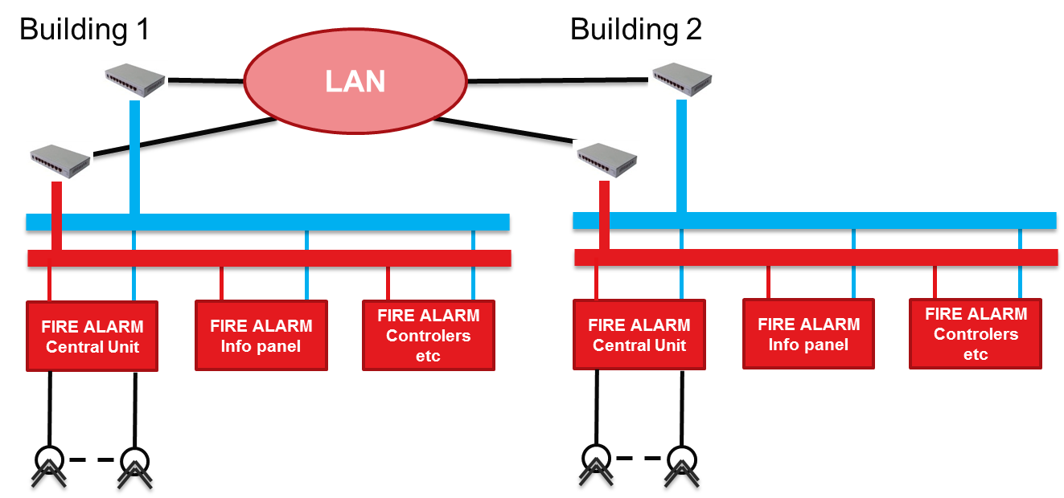
Figure 28 Principle of connection of Central Units
The plant is divided in different areas and each area will be covered by one central unit. At least one central unit shall be installed per cluster of buildings, e.g. “G” Accelerator buildings, “D” Target buildings etc. The fire alarm shall be connected to the supervisory system. Each central unit is to be connected to an overall system, supervisory system.
The fire alarm system shall send and receive signals to other systems. All functions related to fire safety shall be controlled directly from the fire alarm system.
The Software in the control panel shall be re-programmable and give full address information, like - "Fire in 1st floor zone A, men's locker room".
Site wide accepted deviations from SBF 110:6:
- No indication of covered detectors in locked rooms, i.e. switchgear rooms is needed (SBF 110:6 Section 3.2.5.2)
- No detection in cable pits is needed (SBF 110:6 Section 3.1.2)
Accepted deviations from SBF 110:6 in F03:
- No detection in moveable storage shelves is needed (SBF 110:6 Section 3.9.2).
Accelerator project (G01 and G02)
A fire alarm panel and a central unit, covering both G01 and G02, shall be located in the sprinkler room of the G02 building.
An aspirating smoke detector system shall be installed in the tunnel, the 090 level of the emergency stairs and in the Gallery. The system shall be subdivided according to the smoke management system described in Section 9.4. The central units shall to be positioned in a serviceable position. All other parts of the accelerator projects shall be equipped with smoke detectors. Heat detectors can be accepted in areas where smoke detection is not possible.
The stubs between G01 and G02 are totally enclosed and not accessible. No detection is to be installed in these stubs.
The smoke alarm system will automatically start the emergency alarm in each building.
The smoke alarm system will automatically close all fire dampers in each building.
The smoke alarm system will automatically close all fire rated doors in each building. When a fire alarm is triggered in a defined area, a signal shall be transmitted to each fire door system in that area.
Instrument project (D01, D03, D04, D05, D06, D07, D08, E01, E02, E03, E04, E05)
Location of fire alarm panels and the central unit are to be decided based on intervention plan ESS-0082818 “Municipal Rescue Service intervention plan” [W] and ESS-0087627 “Emergency Response Team intervention plan” [X].
The smoke alarm system shall automatically start the emergency alarm in each building. For exceptions see Section 9.5.2.
The smoke alarm system shall automatically close all fire dampers and fans in each building and in connection points to other adjacent buildings. Rooms that from a radiology point of view need to keep a dynamic confinement (e.g. rad lab in D08) are to be studied further in a certain fire analysis.
The smoke alarm system shall automatically close all fire rated doors in each building in connection point to other adjacent buildings. When a fire alarm is triggered in a defined area, a signal shall be transmitted to each fire door system in that area.
Target project (D02)
Location of fire alarm panels and the central unit are to be decided based on intervention plan ESS-0082818 “Municipal Rescue Service intervention plan” [W] and ESS-0087627 “Emergency Response Team intervention plan” [X].
The smoke alarm system shall automatically start the emergency alarm in each building. For exceptions see Section 9.5.2.
The smoke alarm system shall automatically close all fire dampers and fans in each building and in connection points to other adjacent buildings (conventional ventilation). Rooms that from a radiology point of view need to keep a dynamic confinement are to be studied further in a certain fire analysis.
The smoke alarm system shall automatically close all fire rated doors in each building in connection point to other adjacent buildings. When a fire alarm is triggered in a defined area, a signal shall be transmitted to each fire door system in that area.
Waste building (H09)
Location of fire alarm panels and the central unit are to be decided based on intervention plan ESS-0082818 “Municipal Rescue Service intervention plan” [W] and ESS-0087627 “Emergency Response Team intervention plan” [X].
The smoke alarm system shall automatically start the emergency alarm in the building.
The smoke alarm system shall automatically close all fire dampers and fans in the building (conventional ventilation). Rooms that from a radiology point of view need to keep a dynamic confinement are to be studied further in a certain fire analysis.
The smoke alarm system shall automatically close all fire rated doors in the building.

Evacuation alarm
An evacuation alarm shall be installed throughout the facility. The alarm at all buildings simultaneously, shall enable to get manually triggered from MCR and SMR [V].
The evacuation alarm shall be activated automatically by the fire alarm or sprinkler activation.
The sound level should not be less than 65 dB(A) in places occupied more than temporarily. The sound level should also be at least 10 dB(A) above the normal surrounding background level and should not be more than 115 dB(A) at a distance of one metre from the alarm device.
In rooms where high ambient noise is expected, this should generate two different kinds’ of signals such as with sound and light.
The evacuation signal should continue until the alarm has been reset. All alarm devices should be equipped with a sign that indicates the significance of the signal and an instruction of suitable action. An example of text may be “evacuation alarm – leave the building immediately when the alarm sounds/flashes”. The sign should be designed with white text on a red background and be legible from standing level below or beside the alarm device.
The evacuation alarms should be able to emit an evacuation signal for at least 30 minutes after an interruption of power of 24 hours. The evacuation alarm should automatically issue error signals in the event of faults in the wire network or power supply. An error signal should be designed such that it can be detected by persons in the building or at another location.
Acoustic or optical alarm devices shall be verified using SS-EN 54-3 or 54-23.

Accelerator projects (G01, G02 and G04)
Compressor halls and the Gallery (where high ambient noise is expected) need two different kinds’ of signals i.e. sound and light.
No auditability is required in the transformer rooms and in the CTL Gallery (when temporary work is planned special administrative procedures need to be undertaken).
Target and Instrument project
The smoke alarm system will automatically start the emergency alarm in each building. E.g. a fire alarm in building D08 should trigger the evacuation alarm in building D08. However, a fire alarm in building D01 or D03 shall trigger an evacuation alarm in both D01 and D03, and a fire alarm in building E01 or E02 shall trigger an evacuation alarm both in E01 and E02.
A fire alarm in the Installation Gallery only needs to trigger the evacuation alarm in the Installation Gallery.
No auditability is required in the transformer rooms.
Waste building (H09)
Parts of the building where high ambient noise is expected need two different kinds’ of signals i.e. sound and light.

Lighting and signage

Emergency lighting
Emergency lighting shall be installed throughout the facility in the G01 tunnel (incl. emergency stairs), the G02 Gallery building, the G04 Compressor building, the D02 Target building, the D01, D03, E01 Instrument Halls, culvert systems, control rooms and the G01/G02 Front End room, production part of the H09 Waste building. Emergency lighting is installed as a measure to secure safe evacuation and to provide light during fire brigade intervention.
Emergency lighting shall be installed immediately outside escape routes that lead out to the open.
The emergency lighting will be installed in accordance with SS-EN 1838 (60 s to full lighting is acceptable). It is accepted to have a delay of 10 s before emergency lighting is up and running.
The illumination level shall be a minimum of 15 lux (fulfils the requirement for high risk areas according to SS-EN 1838). 15 lux provides a good lightning for a fire service intervention.
Indoor access route general lighting strength shall be minimum 100 lux.
Every other source of general lighting in access routes shall be powered by separate fuse-boxes and earth to ground breakers.

Signage
Premises are equipped with backlit signage and shall be located adjacent to the escape routes and at direction changes on the way to an escape route. The lights for backlit signage shall always be activated during normal operation. In the accelerator tunnel luminescent signage must be used due to the high level of radiation. All these signage must have a special dedicated emergency light. Luminance for such signs shall be no less than 80 cd/m².
Additional signage for work areas can generally be designed with luminescent evacuation signs if there is enough external light to enter the premises. Within the service plans etc., signage shall be performed with alignment along the service corridors/stairs due to the amount of direction changes and dilatory installations which work less well with conventional signage using signs.
No signage is required in the transformer rooms and in the CTL Gallery (when temporary work is planned special administrative procedures need to be undertaken).
Signage shall be designed in accordance to AFS 2008:13. Backlit signage shall be designed such that a symbol height of at least 0,5 % of reading distance and illuminating of 1,5 %. Symbol size shall not be less than 60 mm.
Lighting shall be provided with emergency backup using either a central power supply or local battery for at least 60 minutes in case of power failure. If a central power supply source is chosen for emergency backup, the cabling shall be fire proof secured with a class not less than EI 30 or a functional fire rated cable according to standard IEC 60331.

FIRE SERVICE INTERVENTION

Fire service provisions and accessibility
Fire brigade intervention has been discussed with the fire authorities. The fire service is expected to begin an intervening operation within the normal response time, i.e. within 10 minutes.
An outer fire hydrant system, designed according to VAV P83. The distance between a fire hydrant and assembly point for emergency vehicle location must not exceed 75 m. Maximum distance between the emergency vehicle location and building entrance is 50 m. Stand pipes for connection to fire truck will have sufficient capacity to provide minimum two groups of smoke divers i.e. 1400 litres/min (approximately 350 litres at 6 bar per group and 2 x 350 litres for the smoke dive leaders). Fire water system will have sufficient capacity to supply minimum two groups of smoke divers + effective area for water suppression for 120 minutes.
Fire water supply shall be provided by minimum 100% capacity electric pump (two pumps of 50% each) and minimum 100% diesel driven pump.
Fire water supply diesel pump, basin, loop, hydrants and standpipes will meet “H3” earthquake spectra. Analysis is on-going. The “H3” spectra is defined in ESS-0006207 [H] and described in ESS-0002642 [A].
Fire pipe, basins and the equipment in the sprinkler building shall meet “H3” freezing demands according to ESS-0002642 [A]. E.g.the distribution loop shall, if located in a mixture of gravel and sands, be located at a depth of 1.9 m.
The water supply for the hydrant system shall contain of a pool of at least 168 m³ supplied with refill (from VA-Syd). The same pumps and pools as used for the sprinkler system are used for the fire hydrant system.
Continuous water supply from district water network for manual firefighting shall be provided by a crisis fire hydrant. The crisis fire hydrant is used when all pumps in the system are malfunctioning or if the water pools are empty. The crisis fire hydrant can be fed by the existing pump in F01 and must not be permanently or direct connected to the internal fire water system.
Manual power cut of high voltage machine equipment and emergency closure of beam shutters shall be provided to enable acceptable none hazardous rescue operations.
Personal Protection System shall be arranged to automatically stop accelerator in case of violated interlock for designated areas.
An emergency response team (ERT) shall support the municipal rescue service if an accident occurs. Required capacity is determined by the outcome of continuous risk analysis and workshop.
A decontamination track for the municipal rescue service crew and equipment shall be established in the waste building (H09).
αβγ-rad shall be measured and reported to On Site Commander before MRS arrival to point of access.
Doors to enter the LINAC- tunnel G01 shall be provided with view glass to notify visitor of entrance to hazardous environment.
The local fire rescue department (Räddningstjänsten Syd, RSyd) and the Swedish Radiation Safety Authority (Strålsäkerhetsmyndigheten, SSM) have certain requirements on this facility, e.g. it should be possible to have access to reliable and robust communication in case of an emergency at the facility. For this purpose the Rakel communication system is usually utilized by the police, ambulance and fire brigade. Also, the fire fighters at RSyd have their own analogue smoke diving radio communication system. In ESS-0068260 [I] possible technical solutions in order to meet the requirements from RSyd and SSM on reliable communication within the ESS facility, both inside the buildings and in tunnels below ground is evaluated.

Residual Fire water
The strategy for taking care of contaminated water has been analysed and is presented in ESS-0004481 [J].

Detailed requirements Accelerator building (according to the analysis in ESS-0004481 [J])
Building | Threshold height
G01 | Not applicable
G02 | 20 mm
G04 | 55 mm
D01, D03 | Water is collected in the technical gallery
D02 | Water is collected in the basement of D02
D06, D08 | Water is collected in the technical gallery
E | Water is collected in the basement of E03 and E04
H09 | Water is collected by floor drains connected to a tank, 100 m³

Detailed requirements other buildings
See ESS-0004481 [J].

Intervention plan
An intervention action plan shall be provided. The plans should also include in depth intervention operations information and are based on recommendations from the local fire authorities.

FLAMMABLES
Any handling of flammable materials shall be in accordance to Law (2010:1011) about flammable and explosive materials and its regulation and guidelines.

EXPLOSIVE ATMOSPHERE
According to the Swedish Civil Contingencies Agency regulation (SRVFS 2004:7) in regards to explosive atmospheres when handling flammable gases and liquids, the employer must prepare an Explosion Protection Document (EPD) for workplaces where explosive atmospheres may be present. The EPD shall be based on a risk assessment of the site. One part of the EPD is an area classification that outlines a description of hazardous areas where explosive atmospheres may be present. The EPD should also describe procedures and actions in the event of fire. Figure 1 shows an example of contents within the EPD. The area classification and documents containing information and instructions for the safe handling of flammable gases and liquids must be easily accessible for workers present within the affected areas.
The area classification shall outline where explosive atmospheres may be present. The area classification forms the basis for control of ignition sources, such as electrical and mechanical equipment which can cause heat or sparks, so that they can be removed or protected and also so that the necessary safety systems can be installed.
More detailed instructions are provided in ESS-0016950 [K].

Verification plan
The verification of the as built fire safety design is verified by inspections performed by responsible fire safety engineer (Björn Yndemark). Inspections are done before hand over of the different buildings. Associated with the inspection minutes are written and send to the local building authorities as a part of the “kontrollplan”. The control plan check point is the fire expert verification of installation in alignment of the ESS-0002381 required safety level. The control plan is for justification not only of requirement to get in compliance with the planning and building act, but also other legislative consequences resulting from the design of fire safety controlled by ESS-0002381. E.g. evacuation alarm strategy of the D-buildings to not violate any aspects of AFS2009:2 “Arbetsplatsens utformning” or fire safety of the instrument hall D-building to not jeopardize the fire section separating instrument building from the target building.
Additionally, the overall test and inspection plan at ESS is followed.

References (INternal)
- Fire Protection - Semi Detailed Requirements on Radiation Safety & Protection of Property: ESS Document (ESS-0002642)
- Protection against Fire and Explosion: ESS Document (ESS-0001051)
- Fire Protection of PE Radiation Shielding in the Experimental Halls: ESS Document: (ESS-0010747)
- Hazardous Operations: ESS Document (ESS-0004674)
- ESS Rules for the selection of materials in cables: ESS Document (ESS-0034035)
- Fire Safety Strategy During Construction: ESS Document (ESS-0003967)
- Fire Endurance Test of Oil Filled Radiation Shielding Windows: ESS Document (ESS-0006687)
- Seismic Ground Motion Hazard Assessment for the ESS site: ESS Document (ESS-0006207)
- Analog rökdykarradio och RAKEL - möte med MAXIV. ESS Document (ESS-0068260)
- Residual Fire Water Strategy Report: ESS Document (ESS-0004481)
- Risk Assessment and Area Classification Pilot Case: ESS Document (ESS-0016950)
- Verification and Validation FDS (ESS-0012525)
- Validation ARGOS (ESS-0012519)
- Validation TEMPCALC (ESS-0018708)
- Strålsäkerhetsmyndigheten (SSM), “Särskilda villkor till ESS-anläggningen i Lund, SSM 15-36,”: ESS Document (ESS-0015358)
- ESS, “Design Manual Structural, Conventional Facilities,”: ESS Document (ESS-0003980)
- General Civil Design Criteria (GCDC) for D01 D02 and D03: ESS Document (ESS-0061819)
- System Description D02 Structure: ESS Document (ESS-0039872)
- Decision Tool – Fire Extinguishing and Radiation Safety: ESS Document (ESS-0045897)
- Seismic load for diesel pump laboratory test F. Jörud Report: ESS document (ESS-0096591)
- Eathquake vulnearability design approach-Fire hydrant and sprinkler supply system B. Yndemark: ESS Document: ESS-).
- Emergency Preparedness Plan: ESS Document (ESS-0001133)
- Municipal Rescue Service intervention plan: ESS Document (ESS-0082818)
- Emergency Response Team intervention plan: ESS Document (ESS-0087627)
- General Civil Design Criteria for D01 D02 and D03: ESS Document (ESS-0061819)

References (APPENDICIES)
- Fire and Egress Analysis of Accelerator Buildings: ESS Document (ESS-0101695)
- Analysis of the fire resistance of the Gallery roof cover: ESS Document (ESS-0101755)
- Fire Protection Evaluation of Kingspan Roofing Panels: ESS Document (ESS-0017868)
- Fire and Egress Analysis of Instrument Buildings: ESS Document (ESS-0101767)
- Fire sketches for D and E buildings: ESS Document (ESS-0088114)
- Fire Resistance of Structural Elements in Target and Instrument buildings: ESS Document (ESS-0063223)
- Sizing of Smoke Hatches for the Experimental Halls: ESS Document (ESS-0149739)

Document Revision history
Revision | Reason for and description of change | Author | Date
00 | Draft | Björn Yndemark | 30.10.2012
01 | Draft includes Target | Björn Yndemark | 17.12.2012
02 | Accelerator part is updated with sprinkler  Comments from Fredrik Jörud are implemented | Björn Yndemark | 11.02.2013
03 | Accelerator is updated with new layouts to a “CF Baselines” version. Version 03 also includes fire and smoke analysis of the tunnel. | Björn Yndemark | 23.08.2013
04 | The report is updated due to delivery of “Preliminary Design” of the Accelerator project. New layouts of Accelerator, Target and Instruments are incorporated. Requirements regarding Radiation Safety and Property Loss are included. | Björn Yndemark | 31.01.2014
05 | The report is updated due to delivery of “Preliminary Design” of the Target and Instrument projects. New layouts of Target and Instruments are incorporated. Review comments from Fredrik Jörud are implemented. | Björn Yndemark | 26.06.2014
06 | The report is updated due to the building permit of building H01 (CUB). | Björn Yndemark | 26.09.2014
07 | The report is updated due to delivery of “Detailed Design” of building G01. Some minor changes for buildings G02, G04 and the CUB are also included. | Björn Yndemark | 31.10.2014
08  09 | The report is updated due to implementation of requirements for building F03.  The report is updated due to the start-up of “Detailed Design” of the Target/Instrument project. New layouts of Target and Instruments are incorporated. | Björn Yndemark  Björn Yndemark | 14.04.2015  15.06.2015
10  11 | The report is updated due to the CF baseline team work. The CF Baseline team is responsible for setting the requirements for the buildings, establishing the solutions and developing the preliminary design (PD) as the basis for the detailed design, agreements with stakeholders and target cost development. The goal is to fully integrate ES&H requirements (derived from SSM conditions) into the SI (CF) requirement specifications.  The report is updated due to the CF baseline team work for building F03 | Björn Yndemark  Björn Yndemark | 12.11.2015  19.01.2016
12 | The report is updated due to the CF baseline team work for building H10. New layouts of the Target building are incorporated. Sprinkler section of D02 and E02 is updated. Accepted deviations from SBF 110:6 are added. The report is updated due to the CF baseline team work for D and E-buildings | Björn Yndemark | 15.06.2017
13 | The report is updated due to the CF baseline team work for building H09 | Björn Yndemark | 03.10.2017

