DM--SD-TBSIDDH09- System Description H09 Transport.docx

 | Name
Owner | Marie Krets
Reviewer
Approver

Table of content

Table of content 2
1. Introduction 3
1.1 Purpose of the document 3
1.2 Definitions, acronyms and abbreviations 3
2. System Purpose 4
3. Concept of operations 4
3.1 System Stakeholders 4
3.2 Life cycle 5
3.3 Context & interfacing systems 5
3.3.1 Compliance with standards 6
3.3.1.2 Standards for Cranes 6
3.3.2 Environmental, Health, Safety and Security 7
3.3.3 Radiological safety important system parts - 7
4. System characteristics 8
5. Risks 9
6. Locations 10
7. References 10
8. Document Revision history 11

Introduction

Purpose of the document
System Description for H09 Transport is a description and rationale of the expected operations of the Transport Systems in H09 buildings and is part of the technical baseline.
It is a platform for stakeholder consensus to ensure the system that is built is operationally feasible.
The System Description for H09 Transport is a sub document to H09
General document [1]
System requirements to the H09 Transport are listed in the document [2].

Definitions, acronyms and abbreviations
Abbreviation | Explanation of abbreviation
CF  H09  NSS | Conventional Facilities  Waste Treatment Facility  Neutron Scattering Systems

System Purpose
The Transport systems within H09 consists of 7 overhead cranes, one wall mounted robot arm and one battery charged fork lift.
Room | Type | Capacity
H09.089 Overhead Crane Hall | Overhead Crane | 20 tons
H09.089 Overhead Crane Hall | Battery charged Fork lift | 5 tons
H09.090 Sorting | Overhead Crane | 5 tons
H09.90 Sorting | Wall mounted robot arm | 500 kg
H09.125 Hot Works | Overhead Crane | 5 tons
H09.128 Pump | Overhead Crane | 2 tons
H09.133 Grouting | Overhead Crane | 5 tons
H09.137 Cementation | Overhead Crane | 2 tons
H09.91 Decontamination  H09.124 Maintenance  H09.099 Nuclide Characterisation | Shared Overhead Crane | 5 tons

The transport equipment in H09 building shall essentially support and enable daily work, logistic and to enable the implementation of necessary maintenance and repair work on machinery, tools, components and instruments etc.

Concept of operations

System Stakeholders
Stakeholder | Stakeholder group | Representing stakeholder
NSS | Users
 | Operators
CF | Regulators | Swedish civil Contingencies Agency  Swedish Work Environment Authority (Arbetsmiljöverket)
 | Operators | Facility management provider

Life cycle
Life expectancy of the transport equipment is at least 20 years but ESS is expected to be in operation for 40 years. The equipment shall be constructed so that modernization and required updates can be performed to extend the service life by another 20 years.

Context & interfacing systems
The Transport system shall be functioning in +5°C to +40°C.
Transport system has the following interfaces.
Building H09 provides the cranes with necessary columns/supports for runway, barriers and gates for protection against falling etc.
Electricity supplies cranes with electric power. C&M monitors technical alarm signals from the cranes.

Figure 1: Context diagram H09 Transport

Compliance with standards

3.3.1.2 Standards for Cranes
BFS 2015:6 EKS 10 Building and planning regulations to amend the Agency's administrative provisions and general guidance (2011:10) on the application of the European construction standards (Eurocodes).
SS-EN13001-1:2015, Cranes-General design-part 1: General principles and requirements.
SS-EN13001-2:2014, Crane safety- General design-part 2: Load actions.
SS-EN13001-3-1:2012+A1:2013, Cranes-General design-part 3-1 Limited States and proof competence of steel structure.
SS-EN 13001-3-2:2014, Limit states and proof of competence of wires ropes in reeving systems.
SS 764 30 03 Cranes and lifting Appliances-Mechanisms-Design.
SS-EN13135:2013, Cranes-safety-design-requirements for equipment.
SS-EN 13557+A2:2008, Cranes-Control and control stations.
Machinery Directive 2006/42/EC 2nd Edition June 2010
SS-EN 61000-6-2 +C1, Electromagnetic compatibility (EMC) Part 6-2: Generic Standards-Immunity for industrial environment.
SS-EN 61000-6-4 +A1, Electromagnetic compatibility (EMC) Part 6-4: Generic Standards-Emission standards for industrial environment.
ELSÄK-FS 2008:1 including amendments according to ELSÄK-FS 2010:1 and ELSÄK-FS 2015:3.
ELSÄK-FS 2008:2 including amendments according to ELSÄK-FS 2010:2.
ELSÄK-FS 2008:3 including amendments according to ELSÄK-FS 2010:3.
ELSÄK-FS 2008:4 and general guidance of the applications ELSÄK-FS 1999:5
SS 436 40 00 Edition 2.

Environmental, Health, Safety and Security
In general, energy-efficient systems should be selected. Appliances and wiring should be lead-and halogen-free, environmentally harmful substances/emissions shall be avoided.
Sustainability according to “CF Sustainability Requirements” [3].
Energy Efficiency guideline, BREEAM ENE 06- Energy efficient transport systems [4] will apply.
Fire rating of doors [5] and fire operation functions.
Shielding according to EMC-directive.
The transportation of dangerous goods between the different producers to H09 follows the guidelines in [6].

Radiological safety important system parts
-

System characteristics

Name and location | Type | Capacity
H09-089:C01  Overhead Crane Hall | Overhead crane | 20 tons
H09-128:C02  Pump room | Overhead crane | 2 tons
H09-128:C03  Grouting room | Overhead crane | 5 tons
H09-090:C04  Sorting room | Wall-mounted Robot arm | 500 kg
H09-090:C05  Sorting room | Overhead Crane | 5 tons
H09.125:C06  Hot Works room | Overhead Crane | 5 tons
H09-091, 124, 099:C07  Decontamination room, Maintenance Workshop, Nuclide Characterisation | Overhead Crane | 5 tons
H09-137:C08  Cementation room | Overhead Crane | 1 tons

Functions and requirement are stated in the specific document [6], describing the interface between NSS and Site Infrastructure regarding transport to the H09 building.

For minimum hook coverage see [7] [8] [9] [10] [11] and [12].

  - System functionality overview
Name | Main Purpose
H09-089:C01  Overhead Crane Hall | The Overhead crane’s main purpose is loading and unloading of heavy equipment.
H09-089:C01  Overhead Crane Hall | The Overhead crane’s main purpose is loading and unloading of heavy equipment.
H09-128:C02  Pump room | The Overhead crane’s main purpose is enabling service of the pumps.
H09-128:C03  Grouting room | The Overhead crane’s main purpose is lifting and transporting of heavy equipment.
H09-090:C04  Sorting room | The wall mounted Robot arm’s main purpose is to sort radioactive material in their respective container.
H09-090:C05  Sorting room | The Overhead crane’s main purpose is lifting and transporting of heavy equipment.
H09-091, 124, 099:C06  Decontamination room, Maintenance Workshop, Nuclide Characterisation | The Overhead crane’s main purpose is lifting and transporting of heavy equipment.
H09-137:C07  Cementation room | The Overhead crane’s main purpose is lifting and transporting of cement bags (1 ton) and enabling filling of cement in the cementation equipment.

Risks

Locations
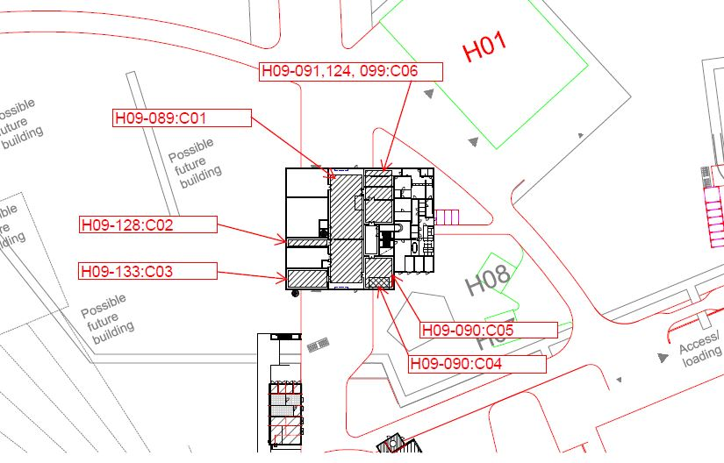
Fig 2 Crane locations on plan 100
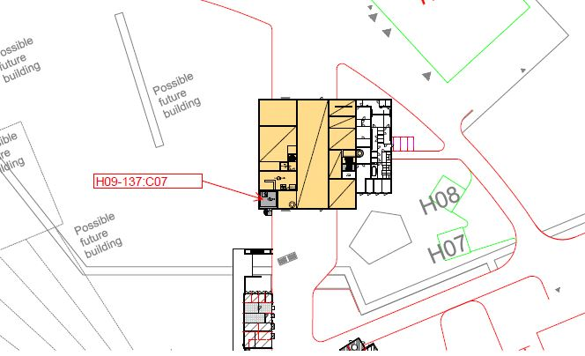
Fig 3 Crane locations on plan 110

References

[1] | ESS-0047239, DM--SD-TBSIDDH09-System Description H09 Waste Treatment Facility.
[2] | ESS-0082507, DM--SR-TBSIDDH09- System Requirements H09 Transport.
[3] | ESS-0031401, EN--AA-MAQU------CF Sustainability requirements.
[4] | ESS-011548 1 EN--AA-MAEN------ESS BREEAM manual Int 2013 3 Ene.
[5] | ESS-0002381, BR01DT-TBSIGDPS--Fire Safety Strategy Report.
[6] | ESS-0122078, ESS Guideline in External/Internal Transportation of Dangerous Goods.
[7] | ESS-0129198, H04-78---1-H09100001.dwg and ESS-0129194, H04-78---1-H09100001.pdf Hookprint H09-089 C01.
[8] | ESS-0129195, H04-78---1-H09100002.dwg and ESS-0129192, H04-78---1-H09100002.pdf, Hookprint H09-128 C02 and H09-133 C03.
[9] | ESS-0129193, H04-78---1-H09100003.dwg and ESS-0129196, H04-78---1-H09100003.pdf Hookprint H09-090 C04 and H09-090 C05.
[10] | ESS-0129200, H04-78---1-H09100004.dwg and ESS-0129197, H04-78---1-H09100004.pdf Hookprint H09-125 C06.
[11] | ESS-0129202, H04-78---1-H09100005.dwg and ESS-0129191, H04-78---1-H09100005.pdf, Hookprint H09-099, 124 and 091 C07.
[12] | ESS-0129201, H04-78---1-H09110006.dwg and ESS-0129199, H04-78---1-H09110006.pdf, Hookprint H09-137 C08

Document Revision history
Review comments to this document are made in ESS-0153938
Version | Reason for revision | Date
1.0 | New document | 2017-07-18

