AK02RA-DEPDDDH09-Acoustic Design Report.docx

 | Name | Role/Title
Owner | Zlatan Idnert /  Ann-Charlotte Thysell | Acoustic Consultants
Reviewer | Per Persson  Boris Kildetoft  Frank Kezerle | Waste manager  Building owner  System owner architectural and structural
Approver | Boris Kildetoft | Building owner

Table of content | Page
1. Background 3
2. Demands and Objectives 4
3. General Acoustic Demands and Recommendations 5
3.1. Airborne Sound Insulation 5
3.2. Impact Sound Insulation 6
3.3. Reverberation Time 7
3.4. Building Services Noise Limits 7
4. Design Recommendations 9
4.1. Slab 9
4.2. Pump Room 9
4.3. Externall Walls and Glazing 9
4.4. Suspended Ceilings 9
Document Revision history 10

list of tables
Table 1 Internal Airborne Sound Insulation criteria 5
Table 2 Impact noise criteria 6
Table 3 Reverberation time criteria 7
Table 4 Building Services Noise Criteria (continuous) 8
Table 5 Maximum allowed sound pressure levels in one-third octave bands 8

list of Figures
Figure 1 Concept of slab separation in H09 9

Background
In this report, applicable acoustic demands and objectives are listed for H09. Comments upon appropriate constructions are given.

Demands and Objectives
The ESS facility is, in general, not sensitive to vibration and sound. For G04, no vibration demands are expressed, hence, no vibration demands are set except to ensure no disturbances to the people within the buildings. The acoustic demands will be based on acoustic demands set in Sweden when applicable.
The following demands and recommendations are based on:
- Swedish standard SS 25268:2007, Acoustics – Sound classification of spaces in buildings – Institutional premises, rooms for education, preschools and leisure-time centres, rooms for office work and hotels.
- Environmental-impact assessment, ESS-0000007, issued 7th March 2012
- Traffic noise analysis, ESS-0000017, issued 31st October 2011
- The drawings are based on Architects drawings received on 2017-09-14

General Acoustic Demands and Recommendations

Airborne Sound Insulation
The demands regarding airborne sound insulation are set on the single-number quantity weighted sound reduction index R’w [dB], measured in field in accordance with SS-EN ISO 16283-1:2014, SS-EN ISO 717-1:2013 and SS 25268:2007.

Table 1 Internal Airborne Sound Insulation criteria
Room Type | R’w to and from another room  [dB] | R’w to and from a corridor  [dB]
Office | 35 | 30
Staff Room | 44 | 35
Control Room* | 35l | 30
Changing Room | 44/35** | 30
WC/HWC  Lab | 44/35**  44 | 30  30
*The Control Room is designed as an office according to Swedish Standard, as per instructions from the stakeholders. ** Between two WC:s.
Acoustic criteria for walls and doors regarding airborne sound reduction are shown in appendix A for building H09. Airborne sound insulation is measured as a sound level difference between two separate rooms, hence, the higher value of R’w, the better airborne sound insulation.
Interior doors shall be chosen with at least the airborne sound reduction set in the drawings, unless it cannot be shown that the demand on the whole partition can be fulfilled. It is assumed that the partitions reach the structural soffit. If the partitions do not reach the structural soffit, a horizontal transmission path for the sound via the void over the suspended ceiling is created. Special solutions are then required that must be approved by an acoustician.
The required demands will be verified by measurements performed by an acoustic consultant, in the completed building, i.e. including flanking transmission via connecting structures, installations, penetrations, etc.
Small openings such as gaps, cracks or holes will conduct airborne sounds, and can significantly reduce the sound insulation of a construction and must be avoided. Duct work and other types of wall penetrations must be treated so as to retain the rating of the partition.
Be aware that some suppliers might deliver information as laboratory values (most common for windows and glass sections), which are always at least 3 [dB] lower than measured in field. Whenever a laboratory value is given, an acoustician should be contacted to evaluate the difference between laboratory and field.
Whenever transfer units are used where sound insulation demands are set, the transfer units must be treated so as to retain the acoustic rating of the partition. The laboratory value Rw ref 1 [m²] of the transfer unit shall be chosen at least 5 [dB] higher than the rating of the door (in field). Some suppliers express the laboratory value ref 2 [m²], which then should be decreased by 3 [dB] to correspond to the demand using 1 [m²].
A final check of the demands on airborne sound insulation surrounding technical installation rooms has to be made when the sound power levels of the installations are determined.

Impact Sound Insulation
The demands regarding impact sound insulation are set on the single number quantity weighted standardized sound pressure level, L´nT,w [dB], measured in field in accordance with SS-EN ISO 140-7:1999, SS-EN ISO 717-2:2013 and SS 25268:2007. Impact sound level is measured as sound pressure level in the receiving room. Hence, the lower value of L´nT,w [dB], the better impact sound insulation.
Table 2 Impact noise criteria
Room Type | From a space with low impact noise load,  L’nT,w [dB] | From a space with high impact noise load,  L’nT,w [dB]
Office | - | 64
Staff Room | - | 60
Control Room | - | 64
Changing Room | - | -
WC/HWC | - | -

Areas which require impact sound insulation layer are shown in Appendix A. More detailed information on specific floor finishes will be provided in the Detailed Design report, after discussions with the Project Team.

Reverberation Time
Guidelines are given in the Swedish Standard SS 25268:2007 and are shown below for rooms applicable in ESS buildings H09:
Table 3 Reverberation time criteria
Room Type | Longest reverberation time, T20  [s]
Office | 0,5
Staff Room | 0,6
Control Room | 0,6
Entrance | 0,8

The demands regarding maximum allowed reverberation times shall be fulfilled in furnished rooms as an arithmetic average between the octave bands 250-4000 [Hz], where a specific octave band value is allowed to be 0.1 [s] larger than specified. In spaces where people stay more than temporarily, the reverberation time at the octave band 125 [Hz] is allowed to be 0.2 [s] longer. However, in spaces where good speech intelligibility is needed, only 0.1 [s] longer reverberation time at 125 [Hz] are allowed. Where people are staying only temporarily no demands are set in the 125 [Hz] octave band. The demands are only applicable to rooms with a volume less than 1500 [m³] or a ceiling height less than 4 [m].
It should be noted that the requirements are design targets rather than absolute specific performance requirements. Achievement of the design targets will result in good acoustic conditions for the intended function and use of each space but entirely dependent on the interior design and the selection and location of furnishings, fittings and equipment.

Building Services Noise Limits
The building services noise criteria are set as maximum allowed sound pressure level in furnished rooms. The criteria are set as an overall level. Hence, the demands for each separate installation must in many cases be set lower to ensure that the overall level fulfils the demand.
The criteria only includes sound pressure levels caused by the property's permanent installations in the building, installations such as laboratory equipment within the same room are not included. However, the airborne sound insulation of walls, roof and slab shall be chosen so that the sound pressure level in the adjacent rooms, from installations including laboratory equipment, are 8 [dB] lower than the overall permitted level.
The maximum sound pressure level, LAFmax, from intermittent and regularly occurring sounds cannot exceed the overall requirement for equivalent sound pressure level with more than 5 [dB]. For temporary use of equipment such as fume cupboard or similar equipment, controlled by the user, 20 [dB] higher values are accepted.
The building services noise criteria according to Sound Class B as per Swedish Standard 25268:2007 is presented in table 4.
Table 4 Building Services Noise Criteria (continuous)
Room Type | L_{pA}  [dB] | L_{pC}  [dB]
Office | 35 | 55
Staff Room | 35 | 55
Control Room | 35 | 55
Changing Room | 40 | -
WC/HWC | 40 | -

The C-weighted sound pressure level must not exceed the A-weighted sound pressure level by more than 20 [dB]. Deviations from the requirements of the C-weighted sound pressure level of installations are acceptable if no one-third octave band value in the table 5 below is exceeded.
Table 5 Maximum allowed sound pressure levels in one-third octave bands
One third octave band [Hz] | Sound Pressure levels in one-third octave bands [Hz]
 | 25 | 31,5 | 40 | 50 | 63 | 80 | 100 | 125 | 160 | 200
LpCeq ≤ 55 [dB] | 71 | 61 | 54 | 49 | 47 | 45 | 43 | 42 | 39 | 37
LpCeq ≤ 50 [dB] | - | 56 | 49 | 43 | 41,5 | 40 | 38 | 36 | 34 | 32

Noise Egress
The total noise level generated from the ESS noise sources is supervised by ÅF based on levels reported from each stakeholder. Any significant sound source at H09 must be reported to ÅF to verify whether there is a need for sound level improvements.

Design Recommendations

Slab
The ground slab shall be separated as shown in Figure 1 below, which will minimize disturbances from the controlled area.
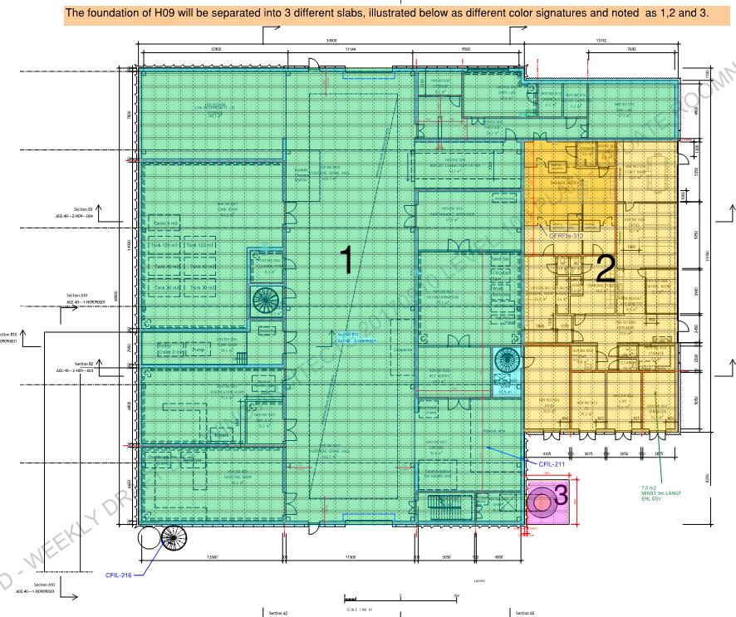
Figure 1 Concept of slab separation in H09

Pump Room
The Pump Room H09.100.1004 contains 6 pumps with a sound pressure level of 74 [dBA] (each). In order to reduce the noise to adjacent areas, the door to the pump room is to achieve a sound reduction of R’w 30 [dB]. The walls of the pump room are made of 300 [mm] concrete. Please note that small openings such as gaps, cracks or holes will conduct airborne sounds, and can significantly reduce the sound insulation of a construction and must be avoided. Duct work and other types of wall penetrations must be treated so as to retain the rating of the partition (R’w 44 [dB]).

External Walls and Glazing
The external walls of the H09 Building marked as 1 in Figure 1 above are 300 [mm] thick concrete. The office areas marked as 2 in Figure 1 above have glazing in the external eastern wall. These glazed areas are to be classified as Rw+Ctr 29 [dB], in order to reduce noise intrusion from E22-highway as well as ESS noise sources on site.

Suspended Ceilings
In order to achieve reverberation criteria, suspended ceilings will be required in the office areas, as well as in the changing rooms. 100% of the ceilings in these areas to be chosen as Sound Absorption Class A.
Please note, that there will be no suspended ceilings in the controlled areas due to radiation requirements from the stakeholders.

Document Revision history
Revision | Reason for and description of change | Author | Date
2  1 | Revision after comments from Tobias Hörnfeldt. Review comments are to be found in ESS-0155076  First issue | Ann-Charlotte Thysell and Zlatan Idnert  Ann-Charlotte Thysell and Zlatan Idnert | 2017-09-29  2017-09-18

